**Program 1:**

This is output of python program for cube sum of first n natural numbers.

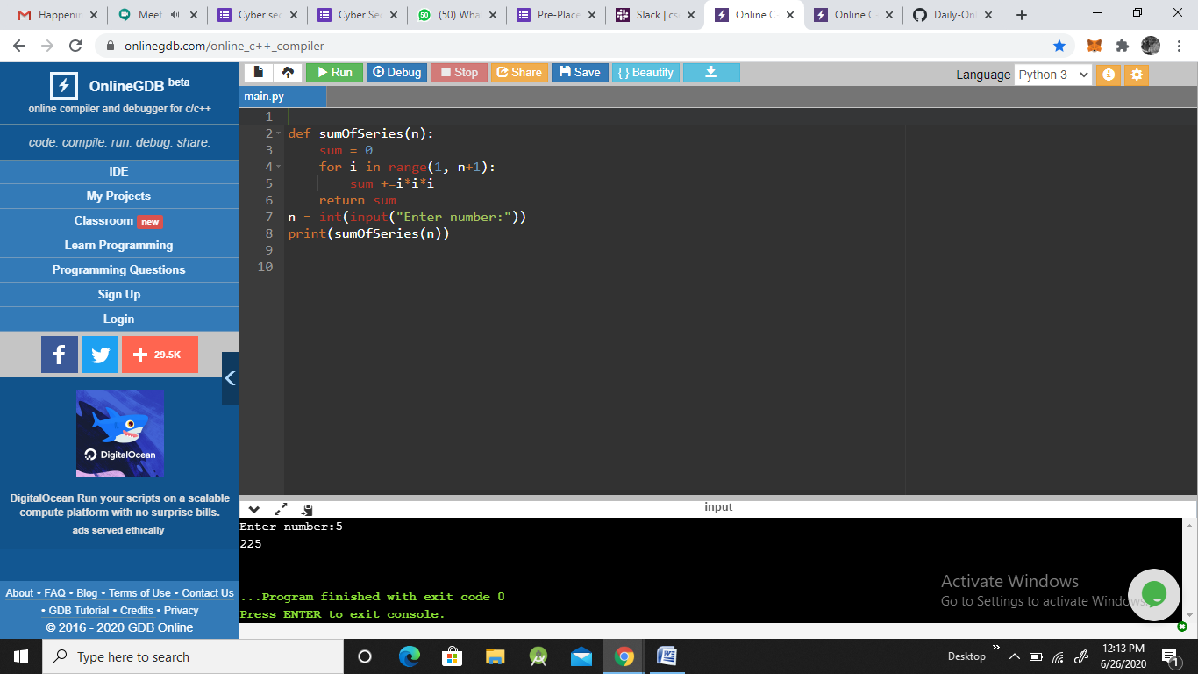

**Program 2:**

This is the output of java program to find quotient and reaminder.

