**DAILY ONLINE ACTIVITIES SUMMARY**

|  |  |  |  |  |  |  |  |  |
| --- | --- | --- | --- | --- | --- | --- | --- | --- |
| **Date:** | **26-05-2020** | | | | | **Name:** | **Varshitha** | |
| **Sem & Sec** | **6th - B** | | | | | **USN:** | **4AL17CS106** | |
| **Online Test Summary** | | | | | | | | |
| **Subject** | | **CGV** | | | | | | |
| **Max. Marks** | | **30** | | **Score** | | | **26** | |
| **Certification Course Summary** | | | | | | | | |
| **Course** | **Deep Learning Onramp** | | | | | | | |
| **Certificate Provider** | | | **MathWorks** | | **Duration** | | | **2hrs** |
| **Coding Challenges** | | | | | | | | |
| **Problem Statements:**  **1. Python Program to Print all Integers that Aren’t Divisible by Either 2 or 3 and Lie between 1 and 50.**  **2. Python Program to Check if a Number is a Palindrome.**  **3. Python Program to Count the Number of Digits in a Number.**  **4.Python Program to read a number n and print and compute the series “1+2+…+n=”.** | | | | | | | | |
| **Status: executed** | | | | | | | | |
| **Uploaded the report in Github** | | | | | **Yes** | | | |
| **If yes Repository name** | | | | | https://github.com/alvas-education-foundation/Varshitha.git | | | |
| **Uploaded the report in slack** | | | | | **Yes** | | | |

**Online Test Details: (Attach the snapshot and briefly write the report for the same)**

First IA of CGV

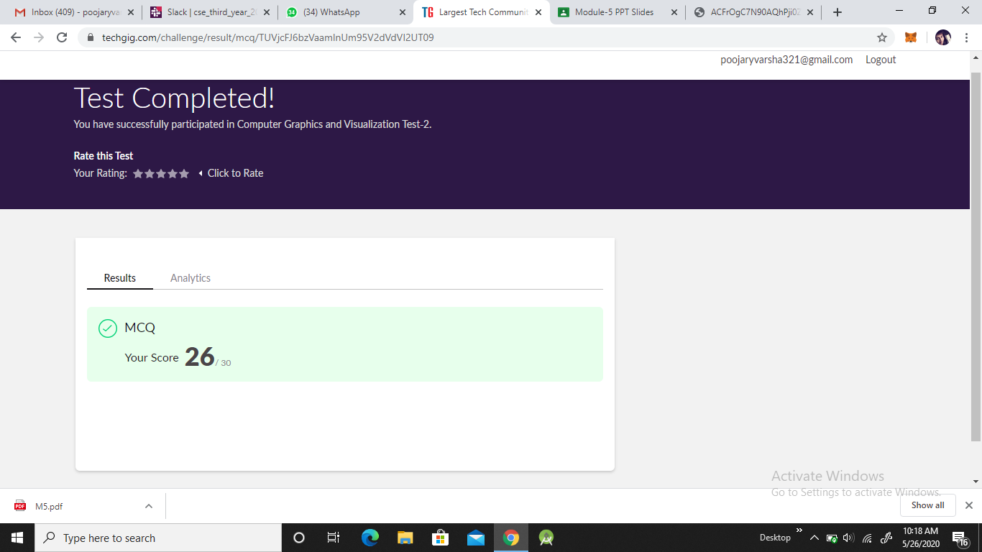

**Certification Course Details: (Attach the snapshot and briefly write the report for the same)**

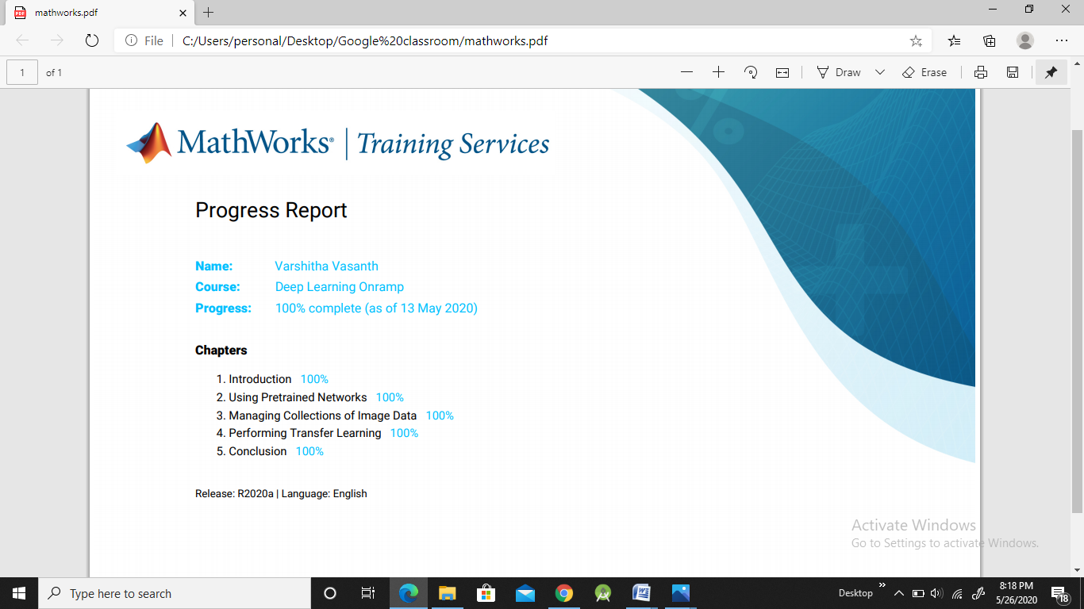

**Completed the overall certification course of " Deep Learning Onramp "**

**1. Cleared all assessments and quiz.**

**2. Obtained certificate of completion.**

**Coding Challenges Details: (Attach the snapshot and briefly write the report for the same)**

**Problem statements are available in the Github**:

https://github.com/alvas-education-foundation/Varshitha.git

**OUTPUT SCREEN-SHOTS:**

**Program1:**

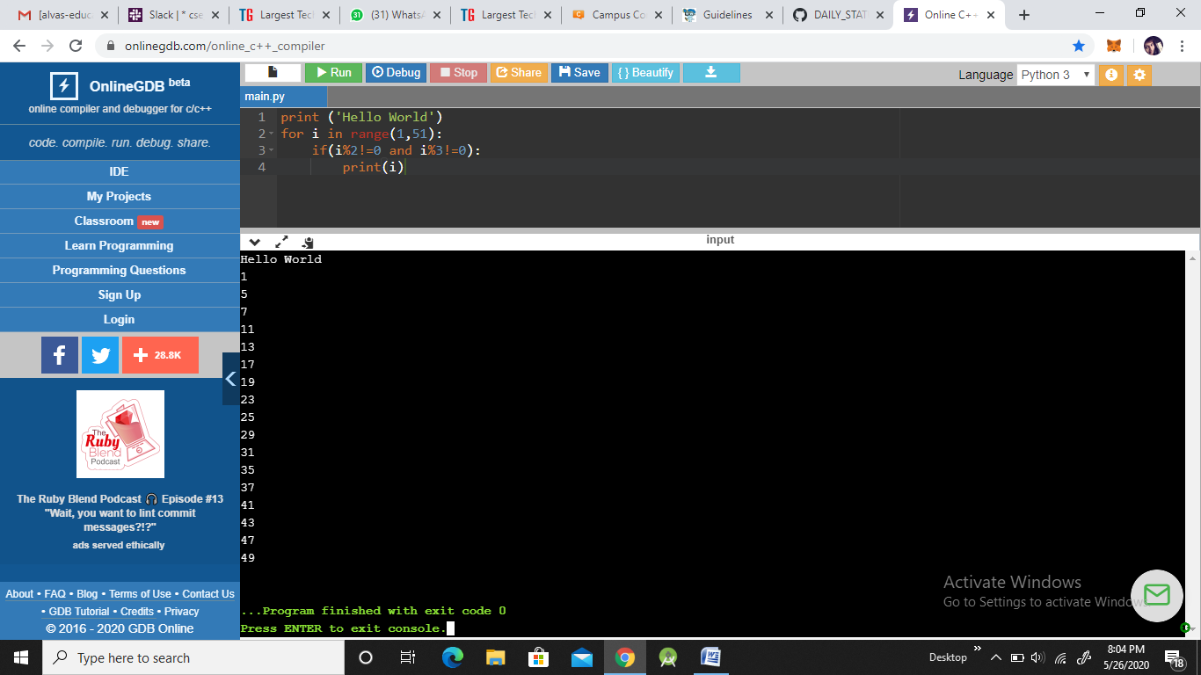

**Program 2:**

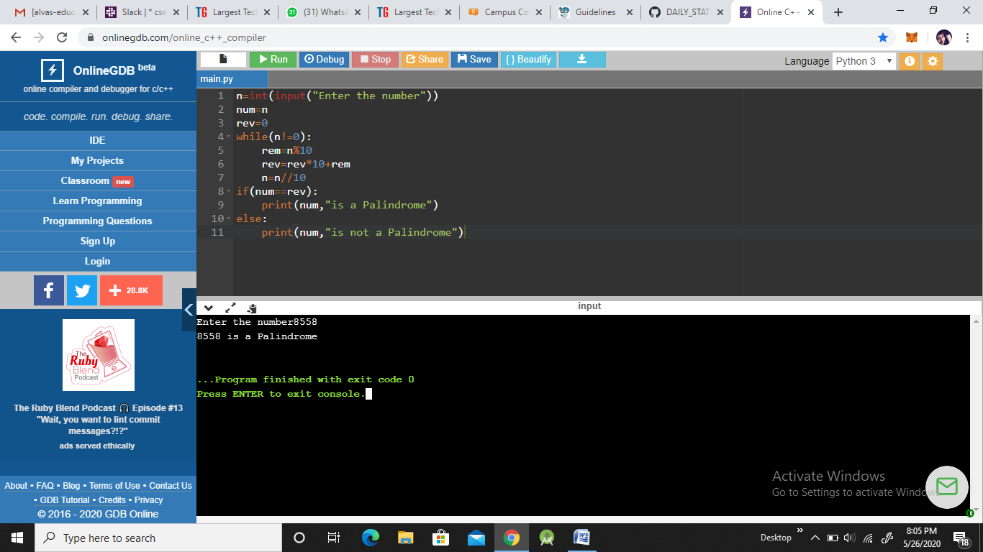

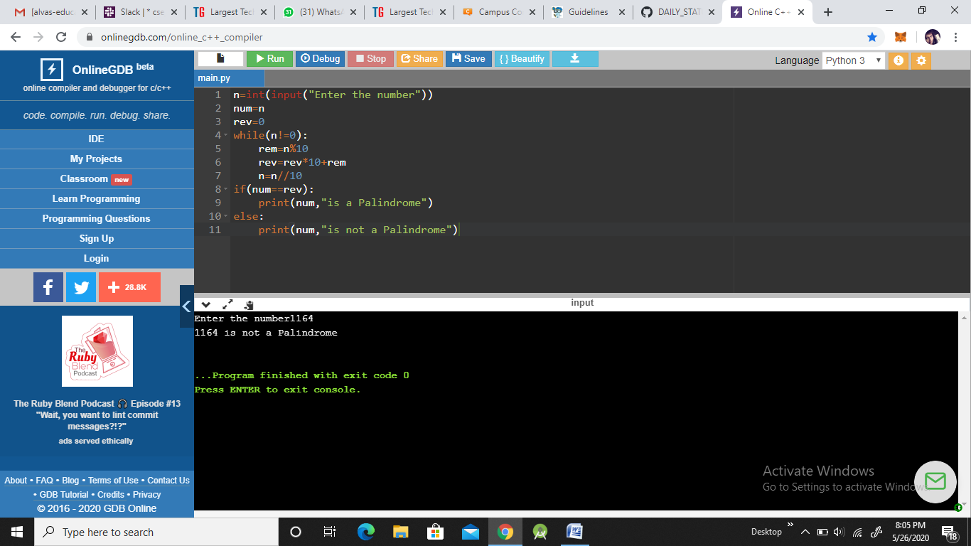

**Program3:**

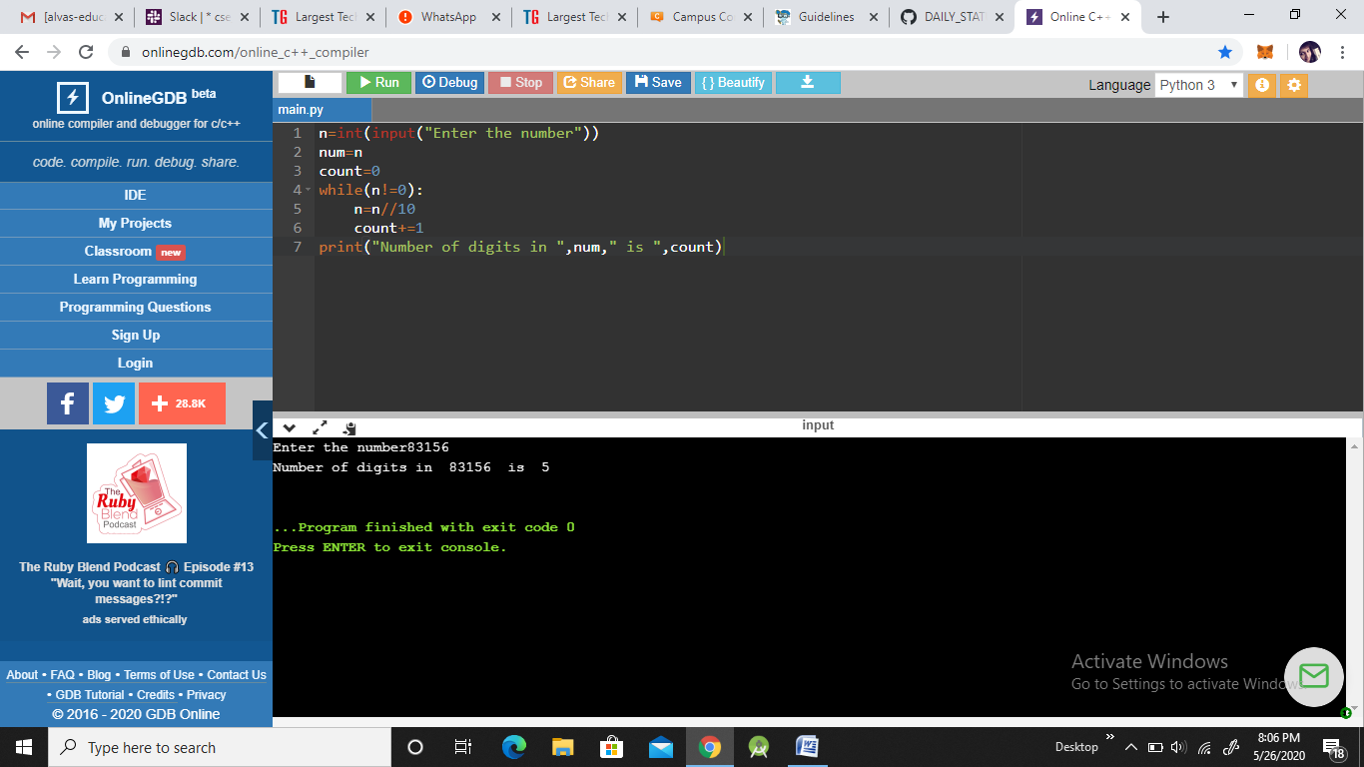

**Program4:**

