**DAILY ONLINE ACTIVITIES SUMMARY**

|  |  |  |  |  |  |  |  |  |
| --- | --- | --- | --- | --- | --- | --- | --- | --- |
| **Date:** | **29-06-2020** | | | | | **Name:** | **Varshitha** | |
| **Sem & Sec** | **6th - B** | | | | | **USN:** | **4AL17CS106** | |
| **Online Test Summary** | | | | | | | | |
| **Subject** | | **DBMS & SQL and Cyber Security** | | | | | | |
| **Max. Marks** | | **--** | | **Score** | | | **--** | |
| **Certification Course Summary** | | | | | | | | |
| **Course** | **--** | | | | | | | |
| **Certificate Provider** | | | **--** | | **Duration** | | | **--** |
| **Coding Challenges** | | | | | | | | |
| **Problem Statements: 1 C program.** | | | | | | | | |
| **Status: Executed** | | | | | | | | |
| **Uploaded the report in Github** | | | | | **Yes** | | | |
| **If yes Repository name** | | | | | <https://github.com/Varshitha019/Daily-Online-Coding> | | | |
| **Uploaded the report in slack** | | | | | **Yes** | | | |

**Quiz Snapshots:**

**Session 1:**

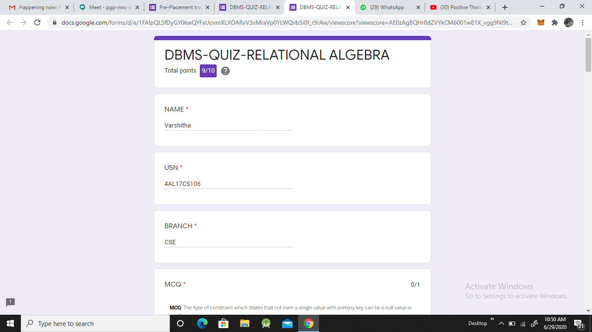

**Session 2:**

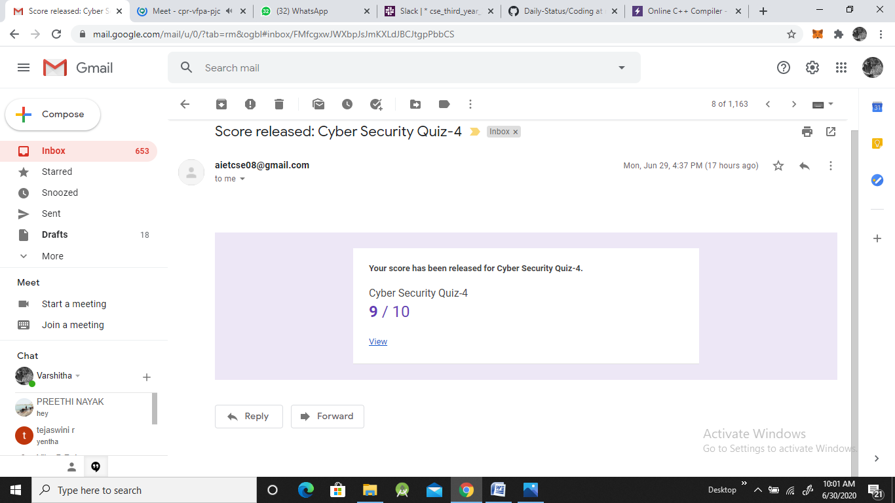

**Coding Challenges Details:**

Refer the github link for detail information : <https://github.com/Varshitha019/Daily-Online-Coding>

**Program 1:**

