**DAILY ONLINE ACTIVITIES SUMMARY**

|  |  |  |  |  |  |  |  |  |
| --- | --- | --- | --- | --- | --- | --- | --- | --- |
| **Date:** | **29-05-2020** | | | | | **Name:** | **Varshitha** | |
| **Sem & Sec** | **6th - B** | | | | | **USN:** | **4AL17CS106** | |
| **Online Test Summary** | | | | | | | | |
| **Subject** | | **OR test-2** | | | | | | |
| **Max. Marks** | | **30** | | **Score** | | | **30** | |
| **Certification Course Summary** | | | | | | | | |
| **Course** | **Cognitive class.ai**  **Machine learning with python** | | | | | | | |
| **Certificate Provider** | | | **IBM** | | **Duration** | | | **5hrs** |
| **Coding Challenges** | | | | | | | | |
| **Problem Statement: 2 java , 2 Python and 1 java program.**   |  | | --- | |  | |  | |  | |  | | | |  | | | |  | | | | | | | | | | | |
| **Status: executed** | | | | | | | | |
| **Uploaded the report in Github** | | | | | **Yes** | | | |
| **If yes Repository name** | | | | | https://github.com/Varshitha019/Daily-Online-Coding.git | | | |
| **Uploaded the report in slack** | | | | | **Yes** | | | |

Online Test Details: (Attach the snapshot and briefly write the report for the same)

IA of OR

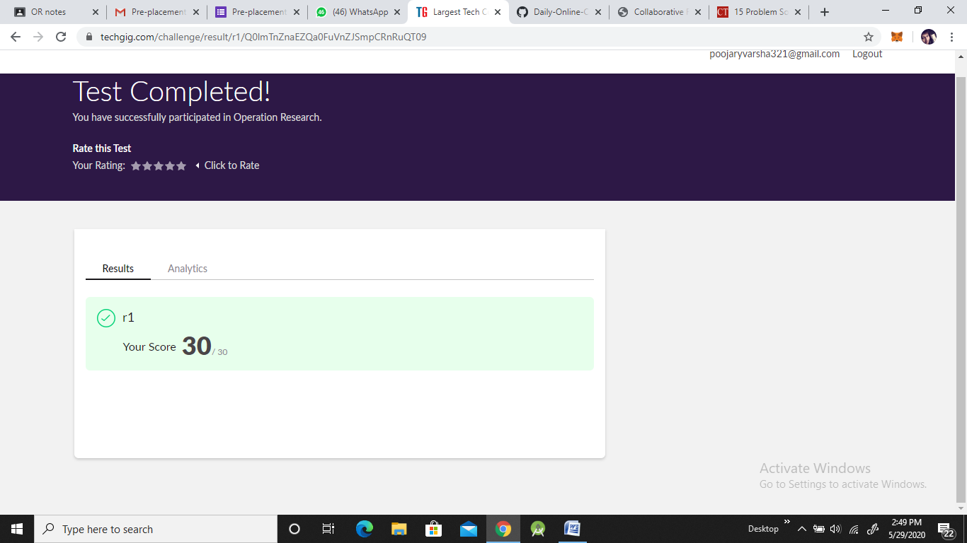

Certification Course Details: (Attach the snapshot and briefly write the report for the same)

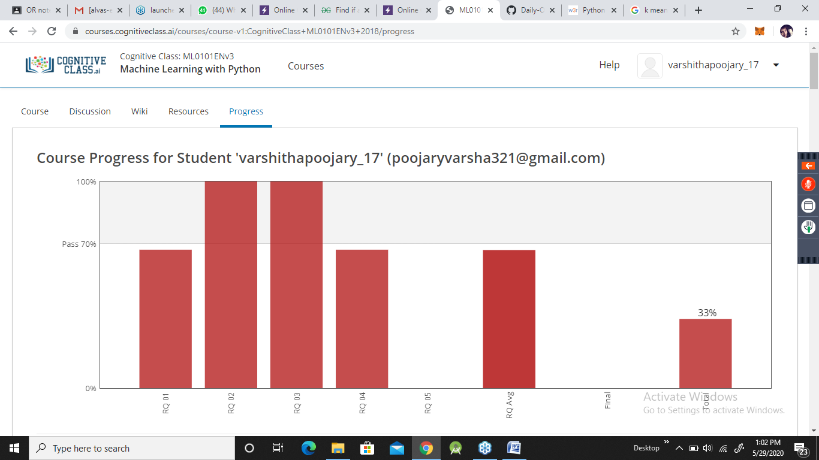

**Coding Challenges Details: (Attach the snapshot and briefly write the report for the same)**

**Problem statements are available in the Github**:

https://github.com/Varshitha019/Daily-Online-Coding.git

**OUTPUT SCREEN-SHOTS: Program 1**

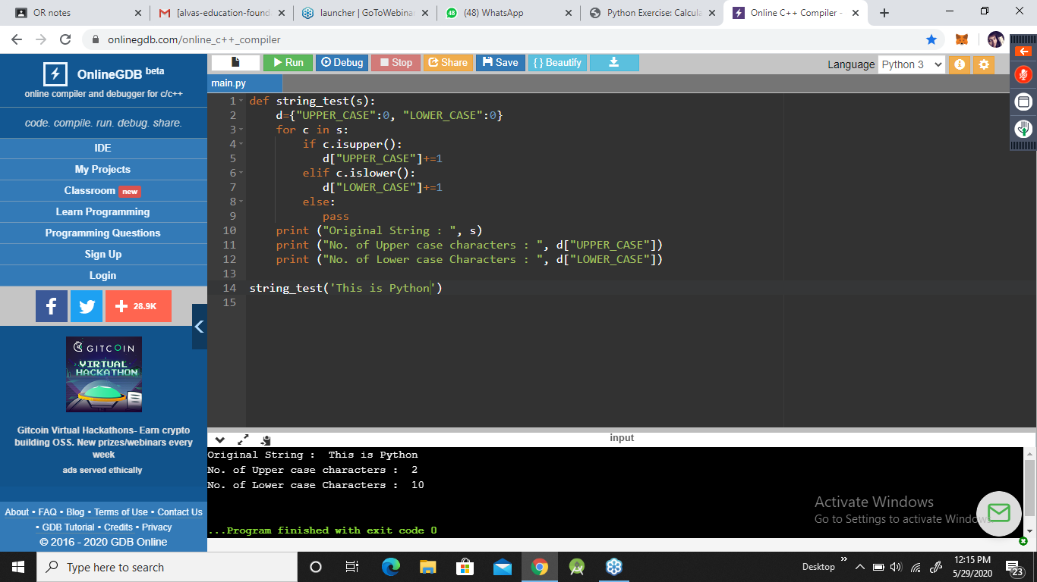

**Program 2:**

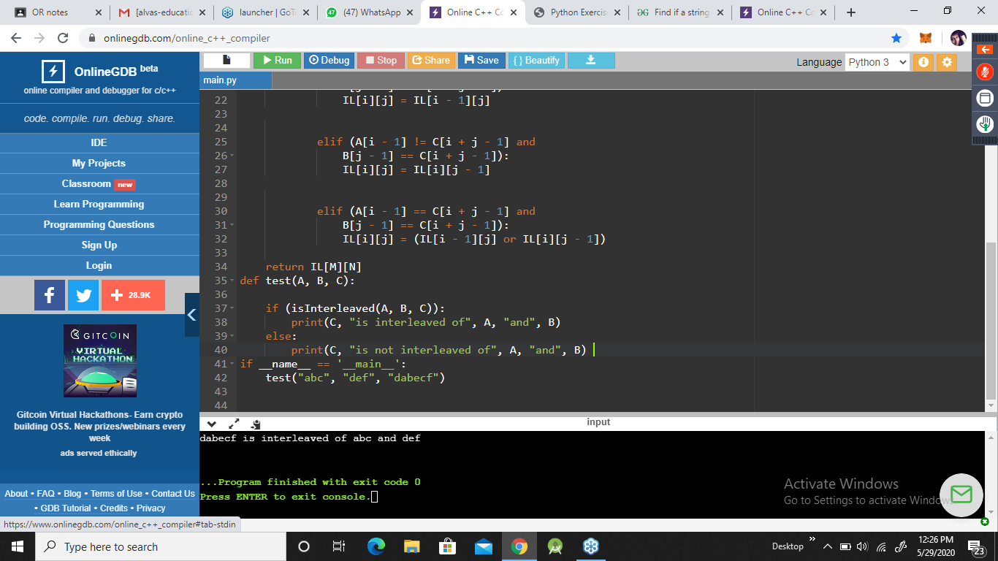

**Program 3:**

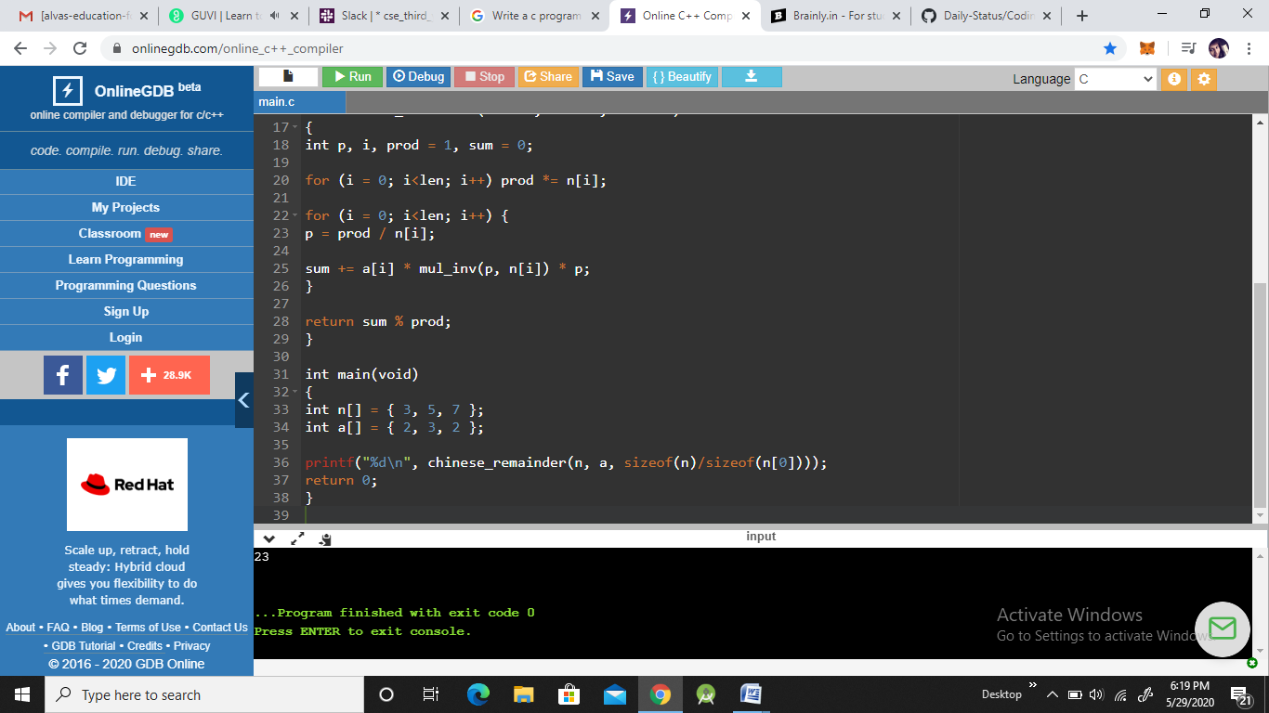

**Program 4:**

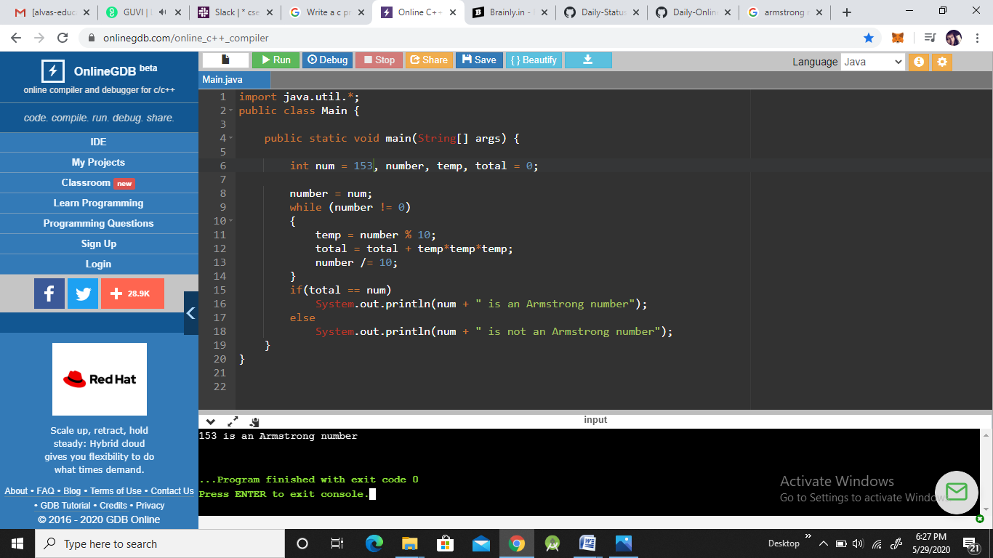

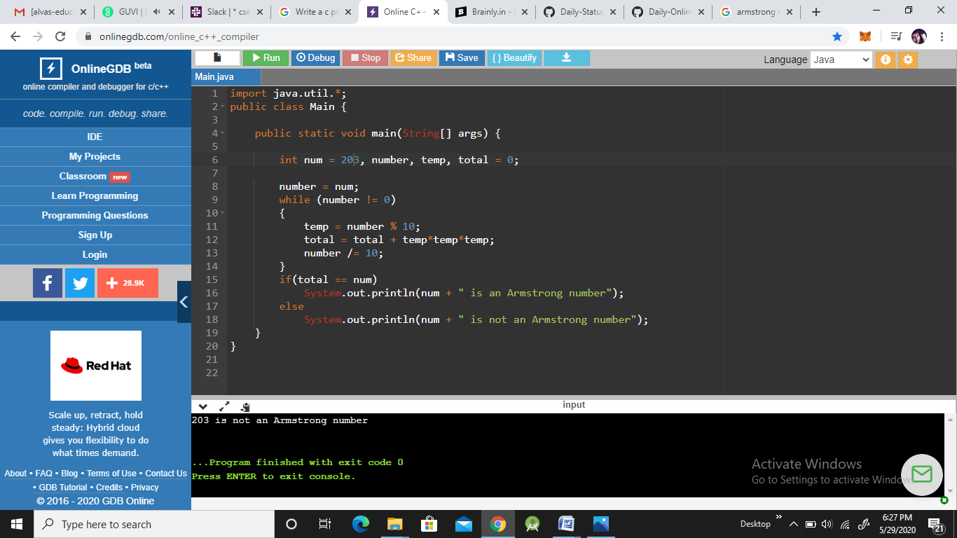

**Program 5:**