**DAILY ONLINE ACTIVITIES SUMMARY**

|  |  |  |  |  |  |  |  |  |
| --- | --- | --- | --- | --- | --- | --- | --- | --- |
| **Date:** | **31-05-2020** | | | | | **Name:** | **Varshitha** | |
| **Sem & Sec** | **6th - B** | | | | | **USN:** | **4AL17CS106** | |
| **Online Test Summary** | | | | | | | | |
| **Subject** | | **--** | | | | | | |
| **Max. Marks** | | **-** | | **Score** | | | **-** | |
| **Certification Course Summary** | | | | | | | | |
| **Course** | **Step into Robotic Process Automation** | | | | | | | |
| **Certificate Provider** | | | **RPA** | | **Duration** | | | **3hrs** |
| **Coding Challenges** | | | | | | | | |
| **Problem Statements: 1 Python and 2 C Programs.** | | | | | | | | |
| **Status: executed** | | | | | | | | |
| **Uploaded the report in Github** | | | | | **Yes** | | | |
| **If yes Repository name** | | | | | https://github.com/Varshitha019/Daily-Online-Coding.git | | | |
| **Uploaded the report in slack** | | | | | **Yes** | | | |

Certification Course Details: (Attach the snapshot and briefly write the report for the same)

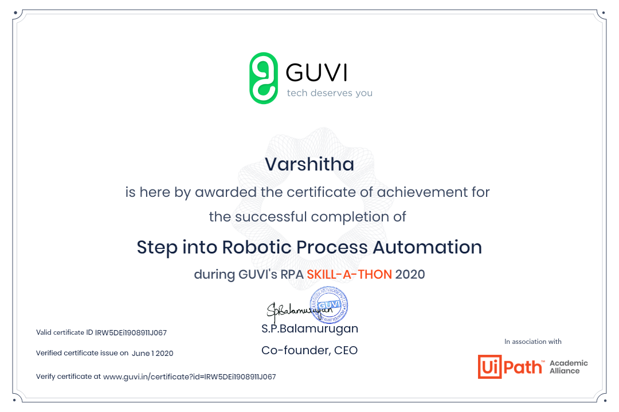

In today’s session for online certification successfully

completed the course of Robotic Process Automation by

Guvi’s RPA skill-a-thon which included youtube videos and

also mcq as the activity to progress further.

Coding Challenges Details: (Attach the snapshot and briefly write the report for the same)

**Program 1:**

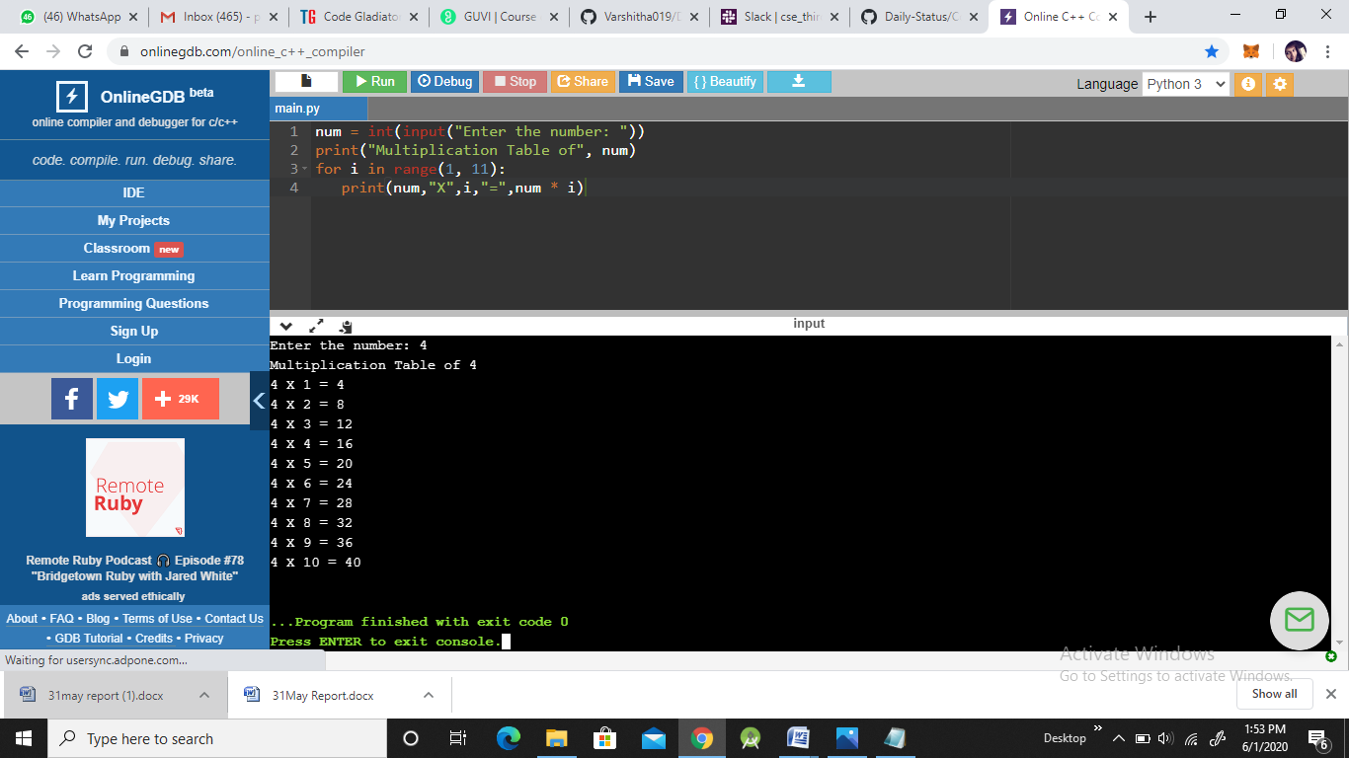

**Program 2:**

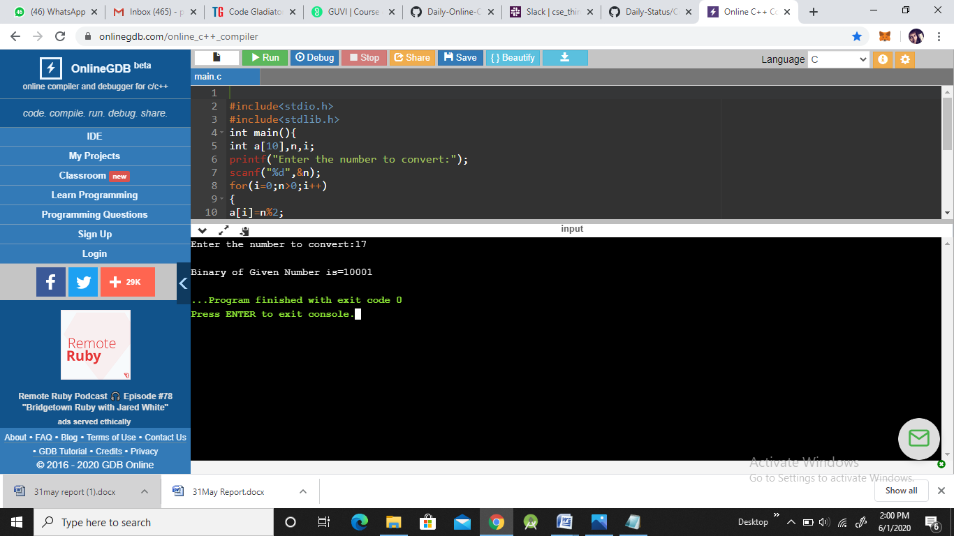

**Program3:**

