**DAILY ONLINE ACTIVITIES SUMMARY**

|  |  |  |  |  |  |  |  |  |
| --- | --- | --- | --- | --- | --- | --- | --- | --- |
| **Date:** | **18-05-2020** | | | | | **Name:** | **Varshitha** | |
| **Sem & Sec** | **6th - B** | | | | | **USN:** | **4AL17CS106** | |
| **Online Test Summary** | | | | | | | | |
| **Subject** | | **CNSC** | | | | | | |
| **Max. Marks** | | **60** | | **Score** | | | **32** | |
| **Certification Course Summary** | | | | | | | | |
| **Course** | **Python for machine learning** | | | | | | | |
| **Certificate Provider** | | | **Great learning** | | **Duration** | | | **1.5hrs** |
| **Coding Challenges** | | | | | | | | |
| **Problem Statements:**   1. **Write a C program to check whether two strings are anagram or not.** 2. **Using methods charAt() & length() of String class, write a program to print the frequency** of each character in a string 3. **Write down a java program to print even and odd numbers series respectively from two threads: t1 and t2 synchronizing on a shared object Let t1 print message “ping — >” and t2 print message “,—-pong”.** | | | | | | | | |
| **Status: executed** | | | | | | | | |
| **Uploaded the report in Github** | | | | | **Yes** | | | |
| **If yes Repository name** | | | | | https://github.com/alvas-education-foundation/Varshitha.git | | | |
| **Uploaded the report in slack** | | | | | **Yes** | | | |

Online Test Details: (Attach the snapshot and briefly write the report for the same)

First I A of CNSC

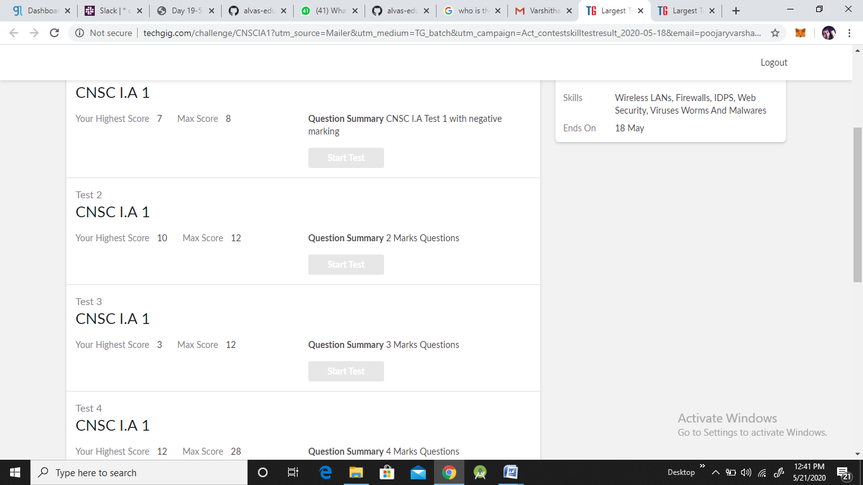

Certification Course Details: (Attach the snapshot and briefly write the report for the same)

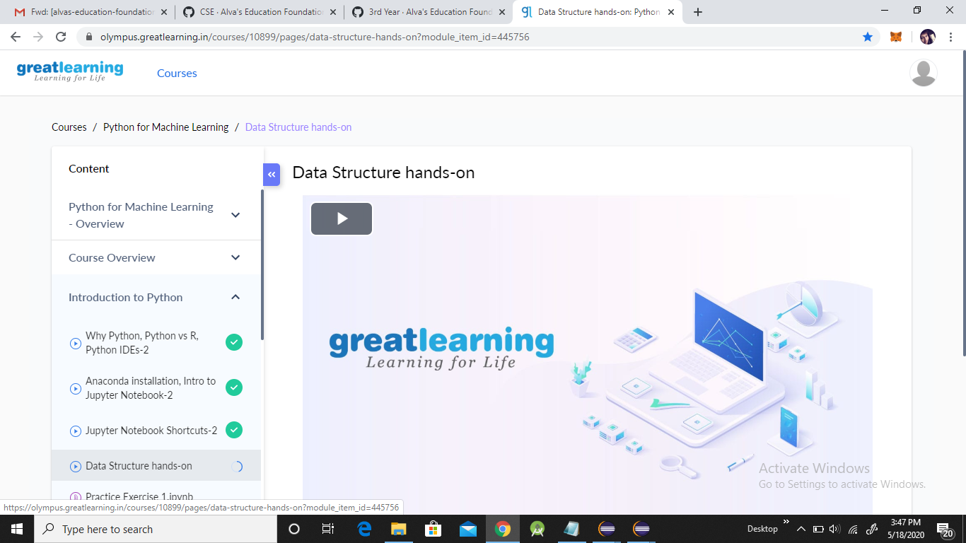

Coding Challenges Details: (Attach the snapshot and briefly write the report for the same)

Problem statements are available in the github

OUTPUT SCREEN-SHOTS:

**Program 1:**

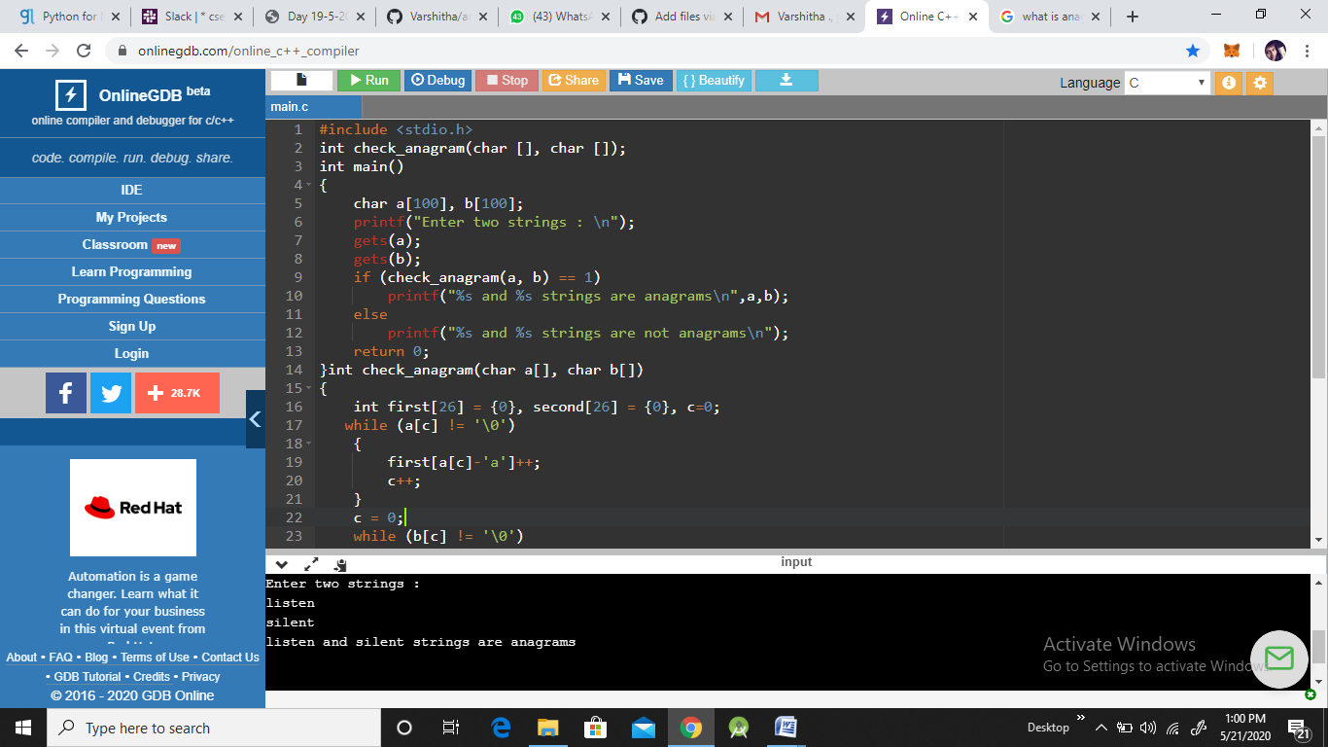

Program 2:

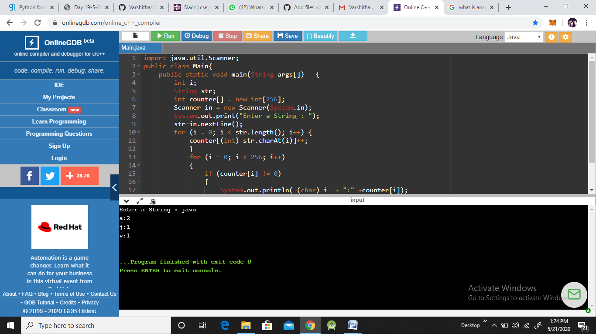

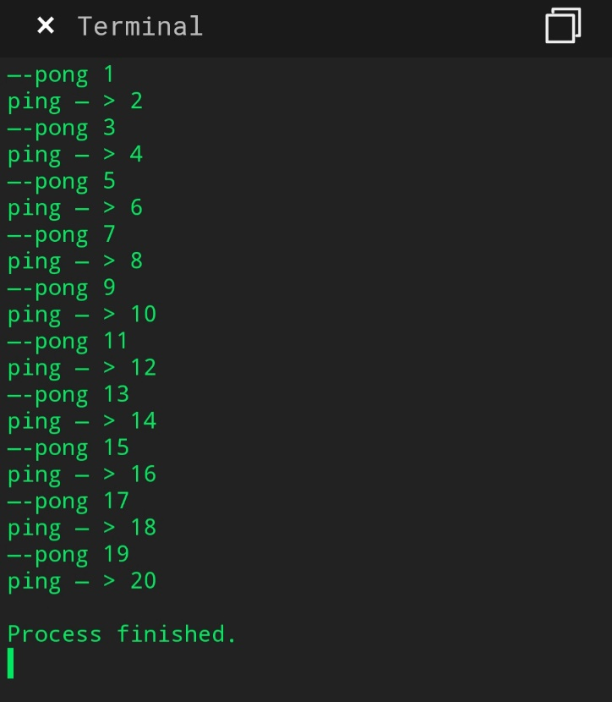Program 3: