**DAILY ONLINE ACTIVITIES SUMMARY**

|  |  |  |  |  |  |  |  |  |
| --- | --- | --- | --- | --- | --- | --- | --- | --- |
| **Date:** | **19-05-2020** | | | | | **Name:** | **Varshitha** | |
| **Sem & Sec** | **6th - B** | | | | | **USN:** | **4AL17CS106** | |
| **Online Test Summary** | | | | | | | | |
| **Subject** | | **Computer Graphics and Visualization** | | | | | | |
| **Max. Marks** | | **60** | | **Score** | | | **51** | |
| **Certification Course Summary** | | | | | | | | |
| **Course** | **Python for machine learning** | | | | | | | |
| **Certificate Provider** | | | **Great learning** | | **Duration** | | | **2hrs** |
| **Coding Challenges** | | | | | | | | |
| **Problem Statements: Two java programs and one c program.** | | | | | | | | |
| **Status: executed** | | | | | | | | |
| **Uploaded the report in Github** | | | | | **Yes** | | | |
| **If yes Repository name** | | | | | https://github.com/alvas-education-foundation/Varshitha.git | | | |
| **Uploaded the report in slack** | | | | | **Yes** | | | |

Online Test Details: (Attach the snapshot and briefly write the report for the same)

First IA of CGV

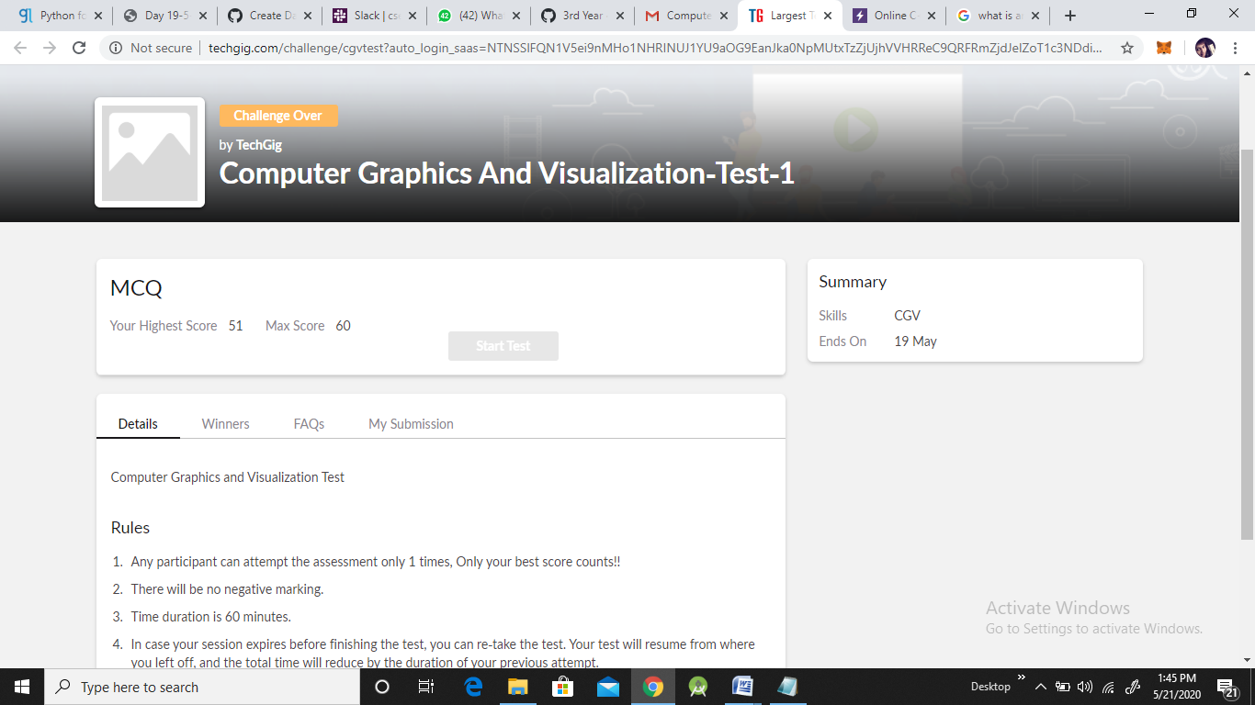

Certification Course Details: (Attach the snapshot and briefly write the report for the same)

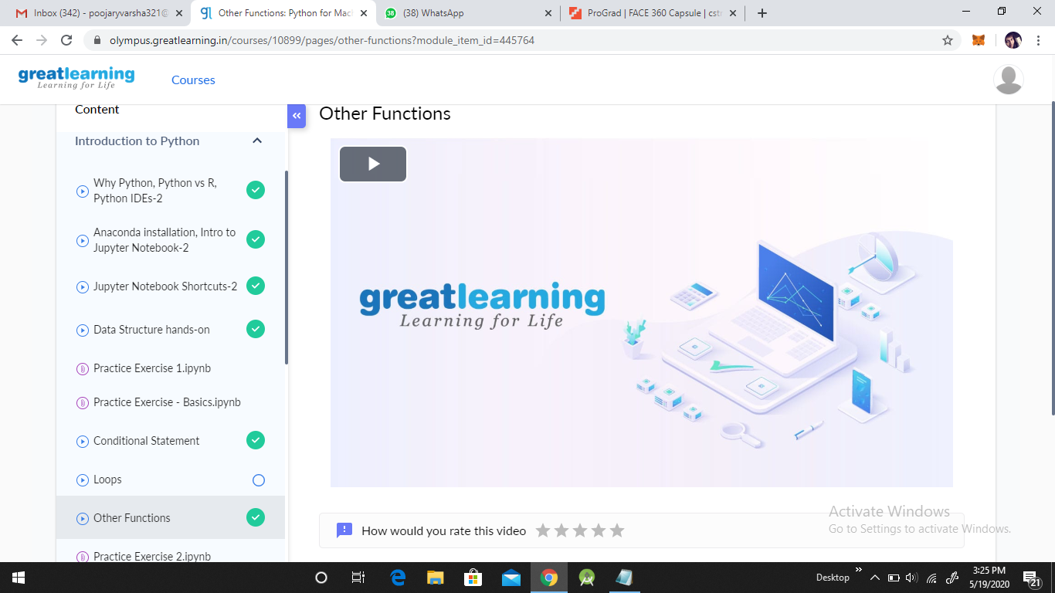

Coding Challenges Details: (Attach the snapshot and briefly write the report for the same)

Problem statements are available in the Github:

OUTPUT SCREEN-SHOTS:

**Program 1:**

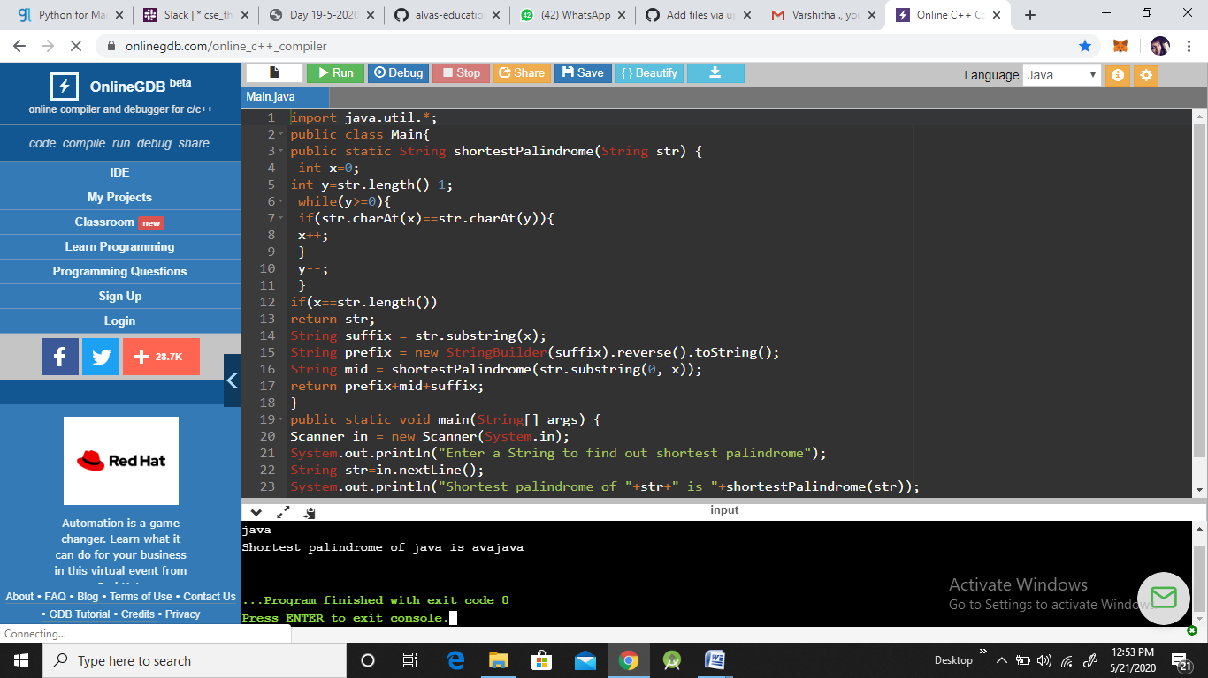

**Program 2:**

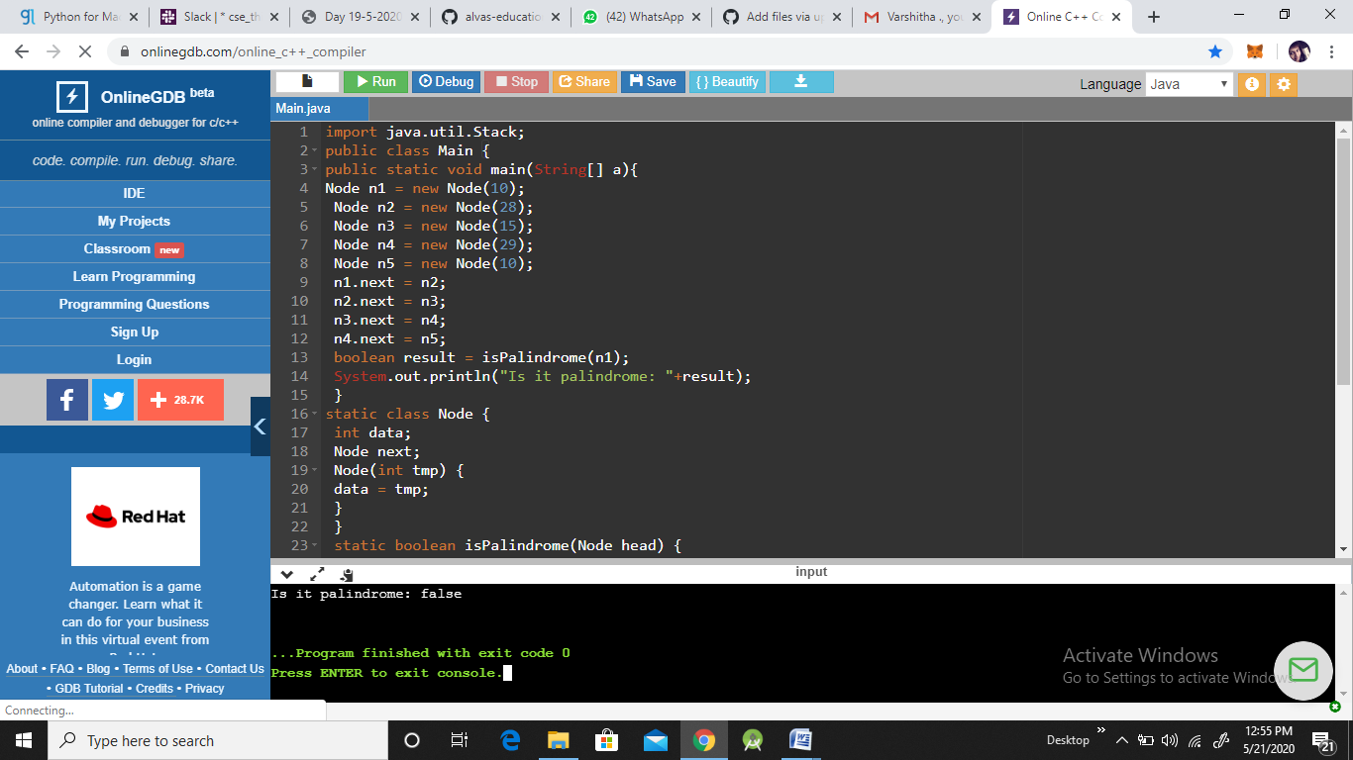

**Program 3:**

