**DAILY ONLINE ACTIVITIES SUMMARY**

|  |  |  |  |  |  |  |  |  |
| --- | --- | --- | --- | --- | --- | --- | --- | --- |
| **Date:** | **21-05-2020** | | | | | **Name:** | **Varshitha** | |
| **Sem & Sec** | **6th - B** | | | | | **USN:** | **4AL17CS106** | |
| **Online Test Summary** | | | | | | | | |
| **Subject** | | **Operating Systems** | | | | | | |
| **Max. Marks** | | **30** | | **Score** | | | **30** | |
| **Certification Course Summary** | | | | | | | | |
| **Course** | **Python for machine learning** | | | | | | | |
| **Certificate Provider** | | | **Great learning Adademy** | | **Duration** | | | **3hrs** |
| **Coding Challenges** | | | | | | | | |
| **Problem Statements:**   1. Write a java program to implement round robin scheduling algorithm. Calculate AVG WT AND TAT**.** 2. write a simple applet java program to check whether the given number is arm strong number or not. 3. Write a C program to construct a singly linked list by removing duplicate elements in the sorted linked list. 4. Write C Program to create Singly Liked List with n elements and reverse the elements. 5. Write a Java Program to Demonstrate a Basic Calculator using Applet. | | | | | | | | |
| **Status: executed** | | | | | | | | |
| **Uploaded the report in Github** | | | | | **Yes** | | | |
| **If yes Repository name** | | | | | https://github.com/alvas-education-foundation/Varshitha.git | | | |
| **Uploaded the report in slack** | | | | | **Yes** | | | |

Online Test Details: (Attach the snapshot and briefly write the report for the same)

First IA of OS

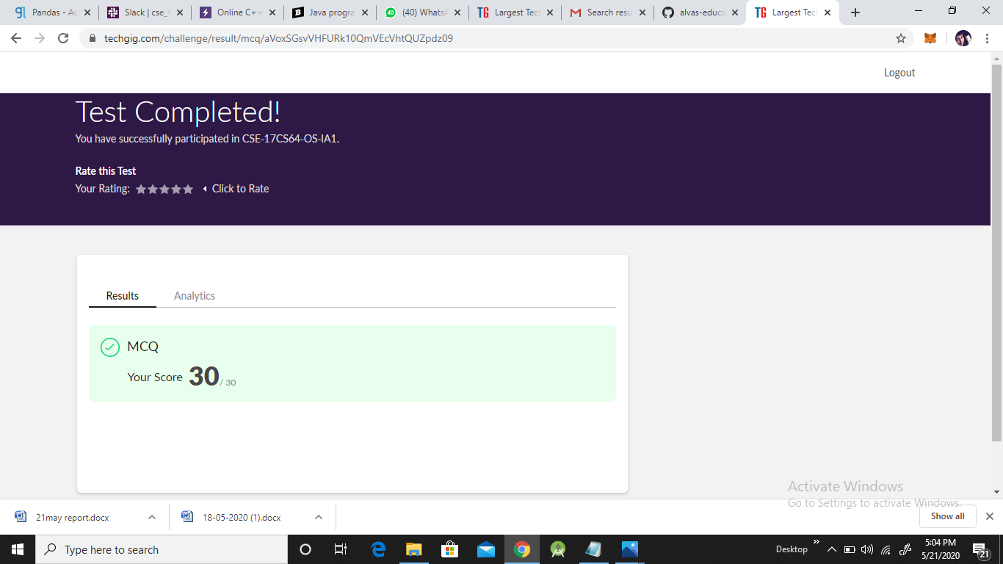

Certification Course Details: (Attach the snapshot and briefly write the report for the same)

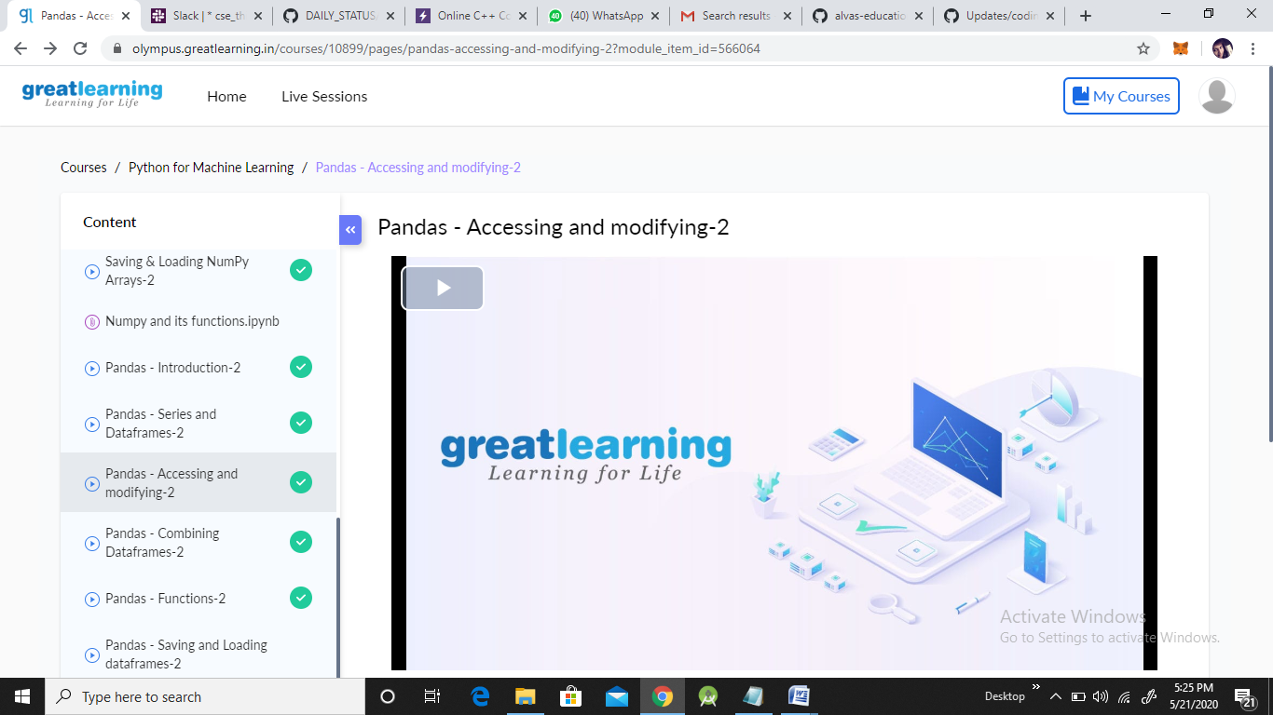

**Coding Challenges Details: (Attach the snapshot and briefly write the report for the same)**

**Problem statements are available in the Github**:

**OUTPUT SCREEN-SHOTS:**

**Program 1:**

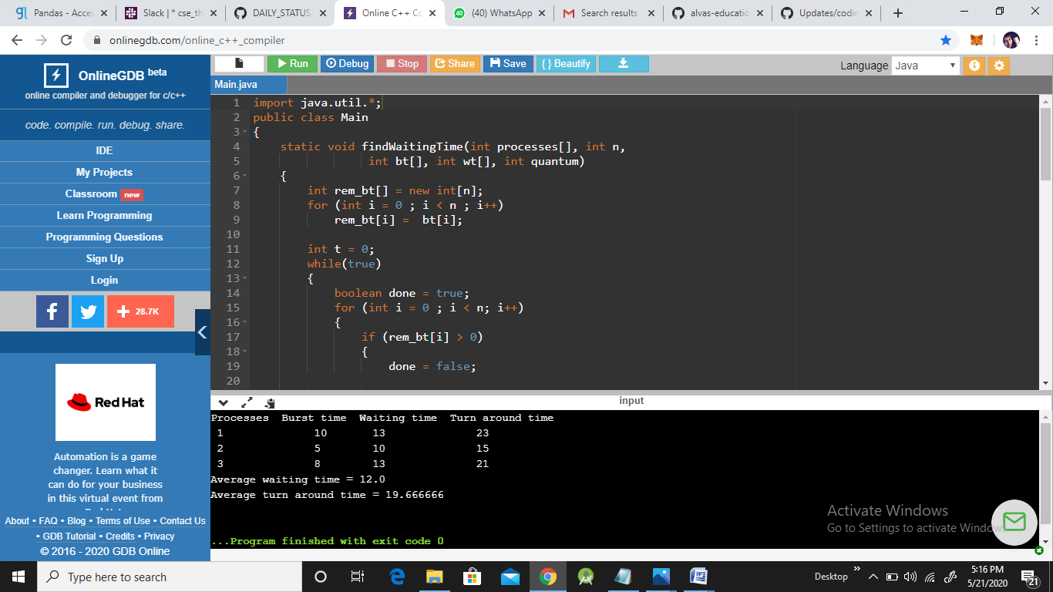

**Program 2:**

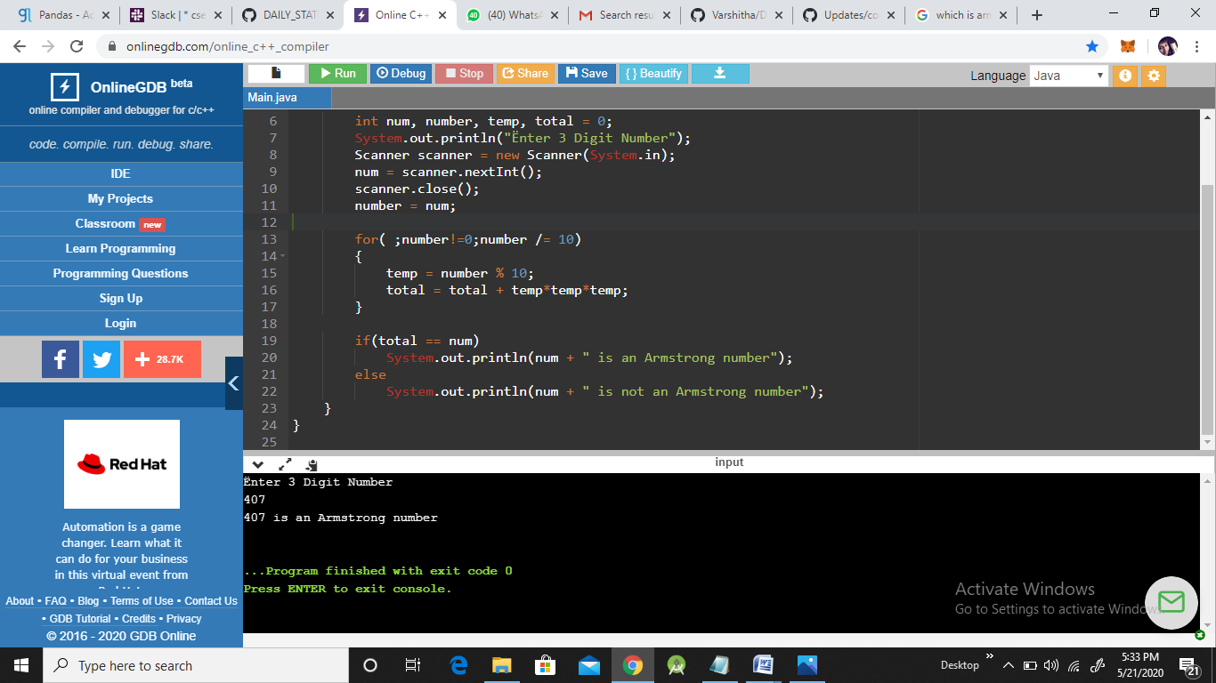

**Program3**:

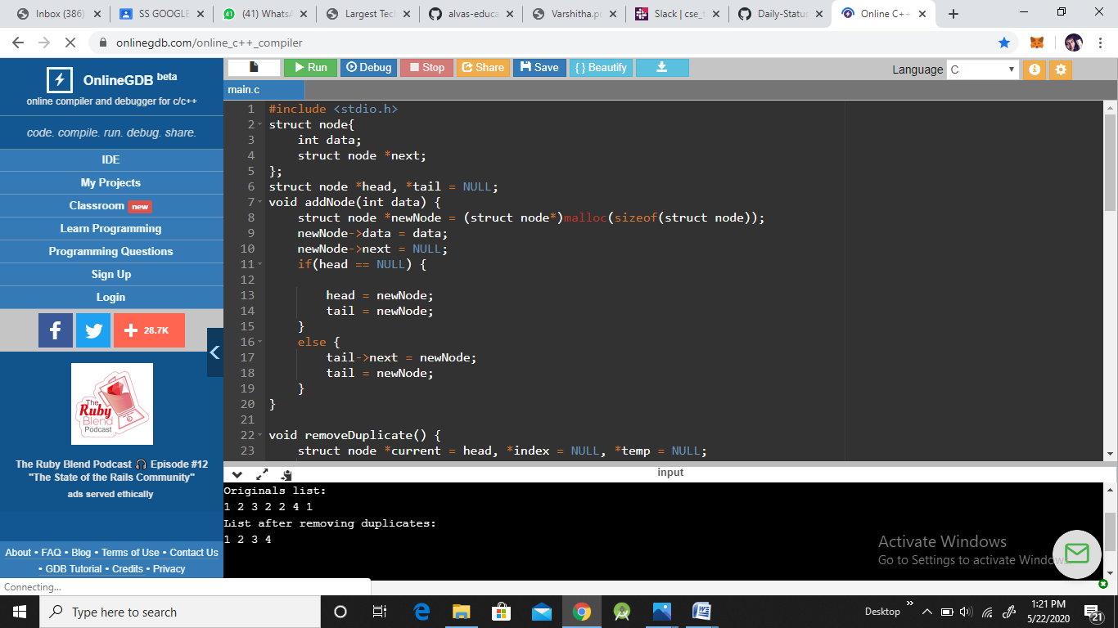

**Program 4:**



**Program 5:**

