SCHOOL OF COMPUTER SCIENCE AND ARTIFICIAL INTELLIGENCE |  |  |  |  | DEPARTMENT OF COMPUTER SCIENCE ENGINEERING
Program Name: B. Tech |  |  |  | Assignment Type: Lab |  |  | Academic Year:2025-2026
Course Coordinator Name |  |  |  | Venkataramana Veeramsetty
Instructor(s)Name |  |  |  | 1. Dr. Mohammed Ali Shaik  2. Dr. T Sampath Kumar  3. Mr. S Naresh Kumar  4. Dr. V. Rajesh  5. Dr. Brij Kishore  6. Dr Pramoda Patro  7. Dr. Venkataramana  8. Dr. Ravi Chander  9. Dr. Jagjeeth Singh
Course Code |  |  | 24CS002PC215 | Course Title |  | AI Assisted Coding
Year/Sem |  |  | II/I | Regulation |  | R24
Date and Day  of Assignment |  |  | 06-08-2025 | Time(s)
Duration |  |  | 2 Hours | Applicable to  Batches
AssignmentNumber:6.5(Present assignment number)/24(Total number of assignments)
 | Q.No. | Question |  |  |  |  |  | ExpectedTime  to complete
 | 1 | Lab 6: AI-Based Code Completion: Working with suggestions for classes, loops, conditionals  Lab Assignment 1: Intelligent Code Completion for Object-Oriented Programming  Objective: To explore AI-powered code assistants for writing Python classes, constructors, and methods through intelligent suggestions.  Suppose that you are hired as an intern at a tech company that develops inventory management systems. Your manager asks you to create a Product class and a Warehouse class with some basic methods. You have decided to use AI-powered code suggestions to help speed up development and reduce syntax errors.  Tasks to be completed are as below  1. Setup AI Coding Tool:  - Install and configure GitHub Copilot or Kite with VS Code or JetBrains IDE.  - Enable real-time code suggestions.  I have already installed the configured the GitHub Copilot with VS code.  2. Class Design Using AI Assistance:  - Begin defining a Product class with attributes: name, price, quantity.  - Use the AI suggestion feature to automatically complete the __init__() method.  - Add a method calculate_value() to return price * quantity.  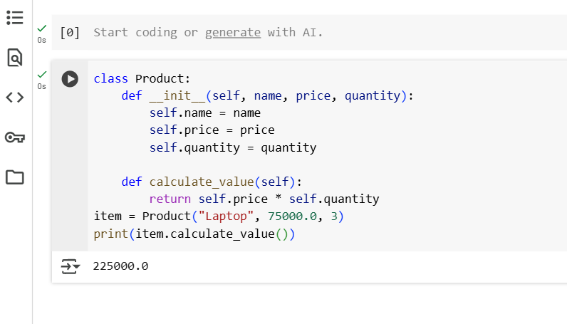  3. Create Another Class:  - Define a Warehouse class with a list of Product objects.  - Use code completion to help implement:  - A method to add a product.  - A method to display the most valuable product.  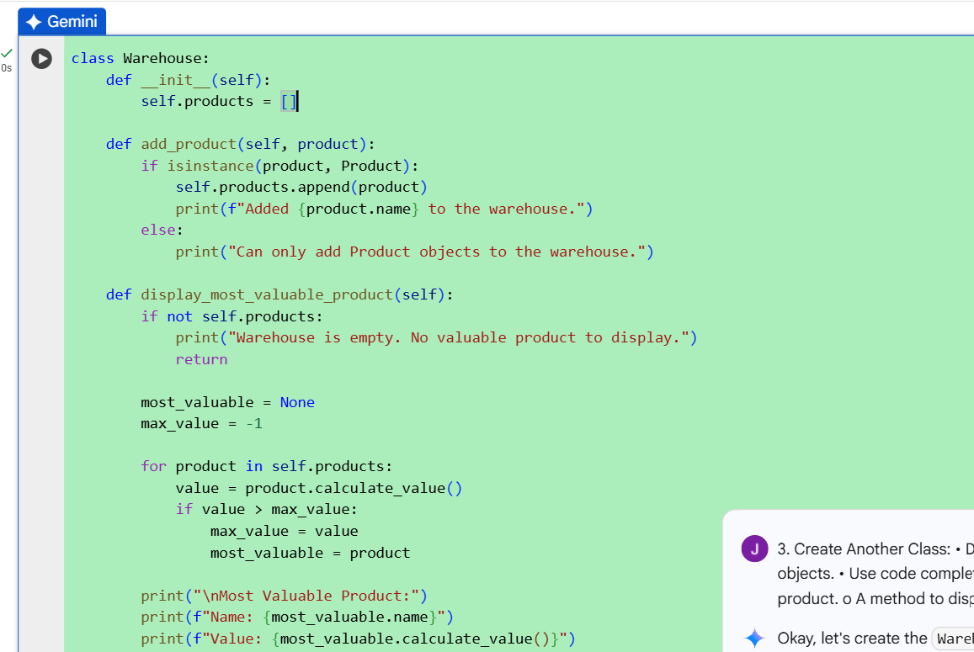  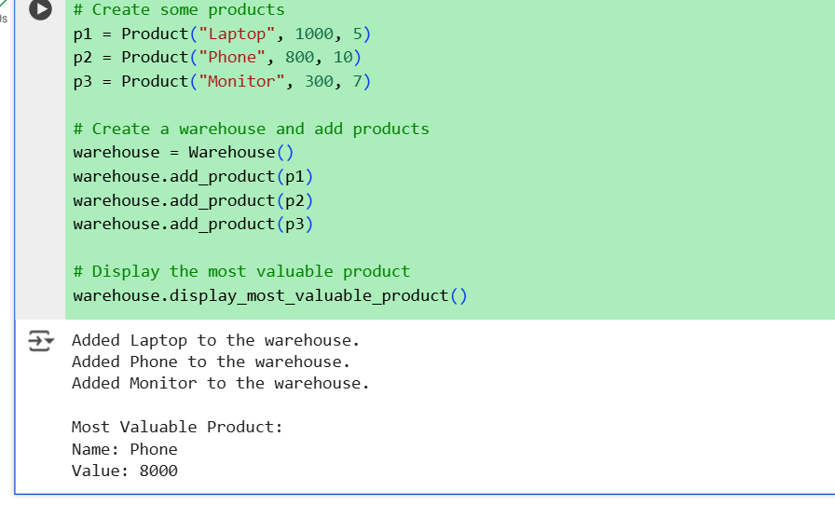  4. Reflection:  - Identify how much of the code was completed by AI and what manual edits were needed.  A significant portion of the code was initially generated using AI, including the foundational structure and key logic components. The AI provided valuable assistance in areas such as syntax, function creation, and error handling. However, manual edits were necessary to refine the logic, ensure compatibility with specific project requirements, and align the code with best practices. Some sections required complete rewriting due to contextual misunderstandings or inefficiencies in the AI's output.  - Comment on the relevance and accuracy of AI suggestions.  The AI's suggestions were generally relevant and aligned with the problem context. It demonstrated a solid understanding of coding standards and common libraries, providing efficient and syntactically correct code. However, there were occasional inaccuracies, such as assumptions about variable names or project-specific logic, which had to be corrected manually. Overall, the AI was a helpful tool for accelerating development, but human oversight was essential to ensure precision and correctness.  Requirements:  - VS Code with Github Copilot or Cursor API and/or Google Colab with Gemini  The requirements are Google Colab with Gemini.  Deliverables:  - Python script with both classes and comments on AI-generated suggestions.  - Short report (1 page) summarizing your experience with AI code completion.  . |  |  |  |  |  | 15.08.2025 EOD

