Course Title: Artificial Intelligence and Deep learning
Course Code: 24CS312PC310
Year/Sem: III/1
Date:05/08/26
Name: M.VARSHITHA
Roll No:2403A51088
Batch:03
ASSIGNMENT-1
PyTorch Fundamentals: Tensors and Autograd
Kaggle Dataset Link: https://www.kaggle.com/datasets/muthuj7/weather-dataset
Tasks:
- Load and preprocess the Student Performance dataset/example.
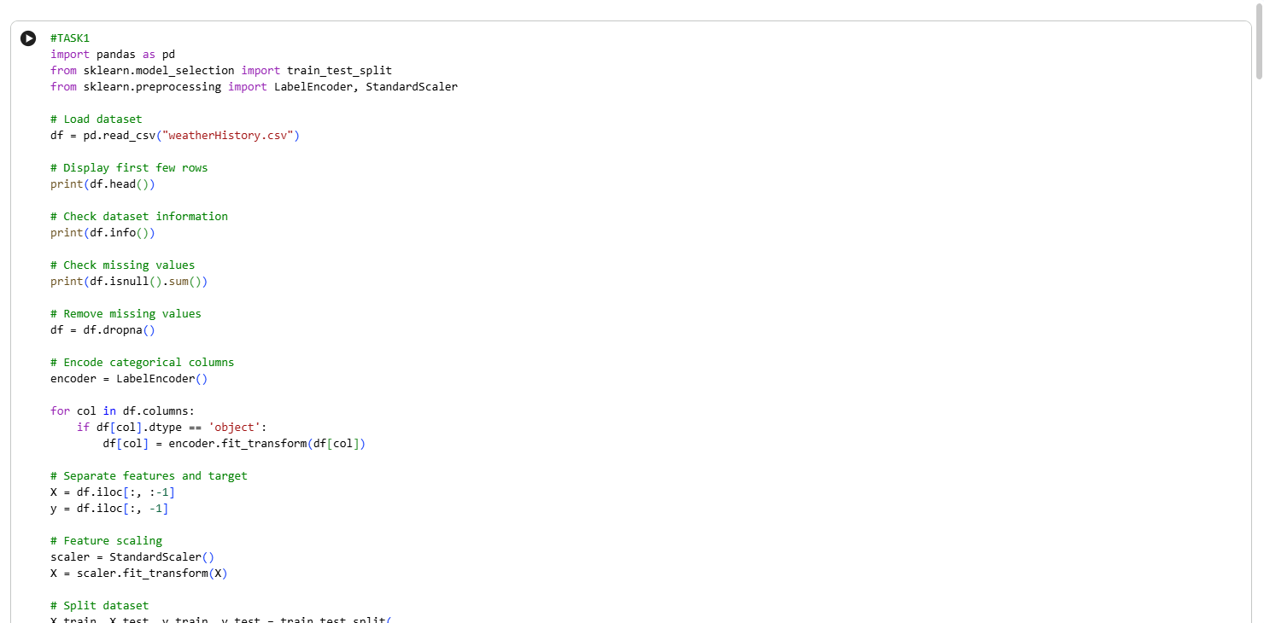

Output:
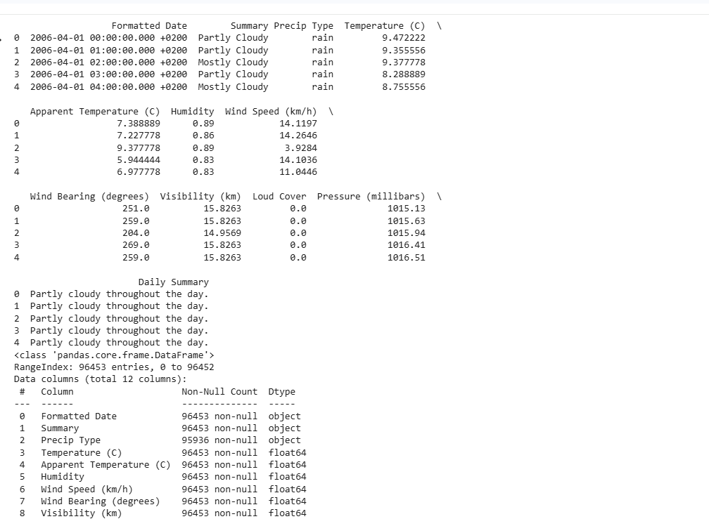

2.Build the required PyTorch model/program.
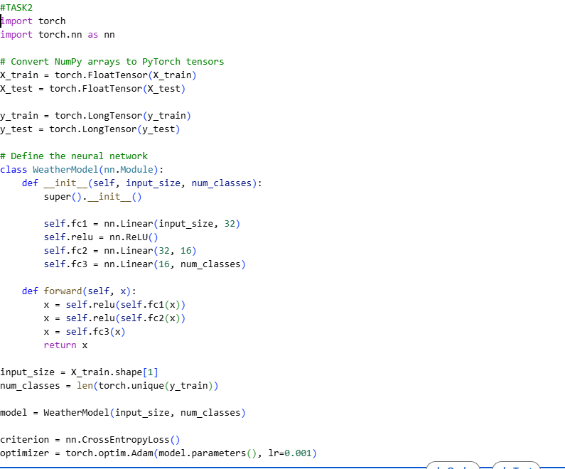
Result:
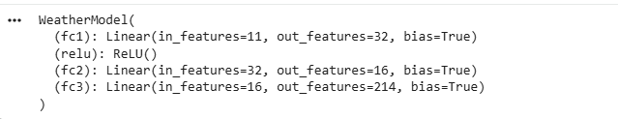
3.Train/execute the model.
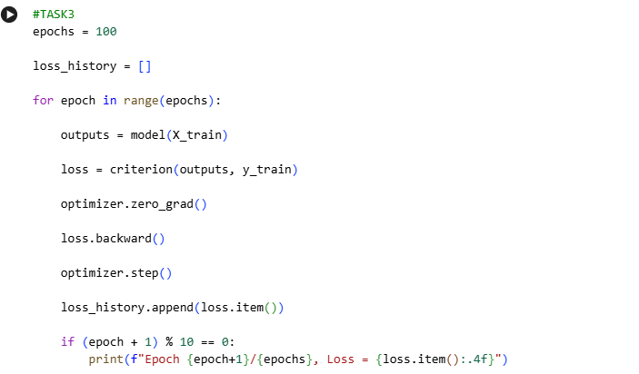
Result:
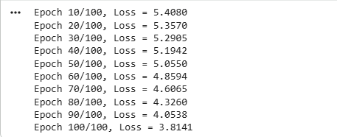

4.Evaluate using suitable metrics
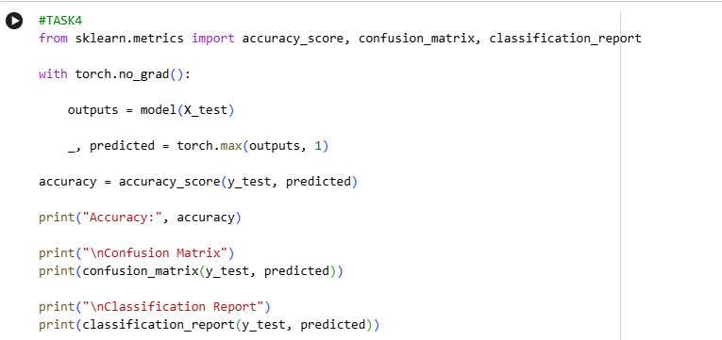
Result:
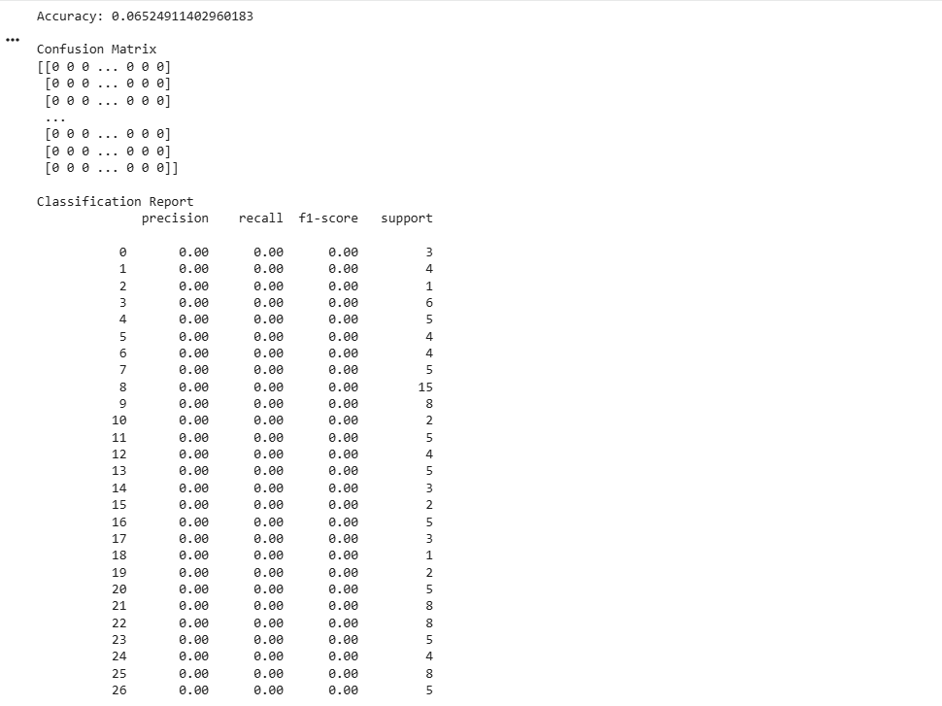

5.Visualize results using plots where applicable
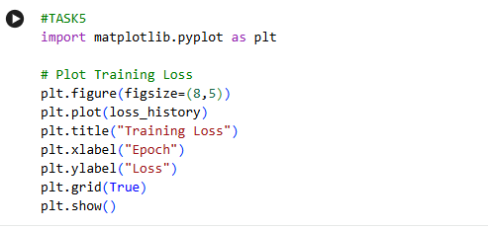
Result:
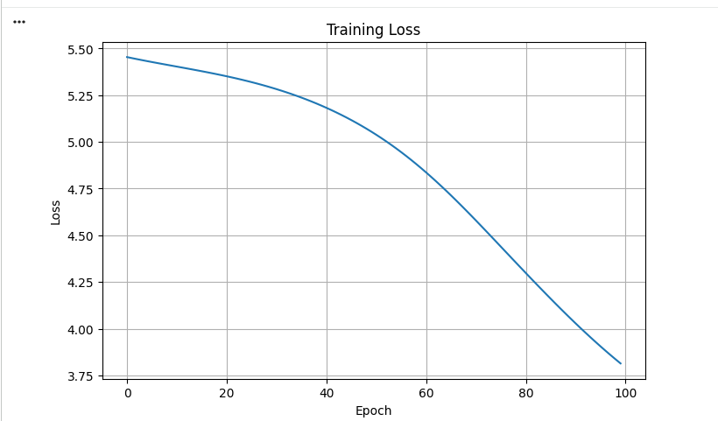
6.Write a brief conclusion comparing observations.
The Weather dataset was successfully loaded and preprocessed by handling missing values, encoding categorical features, and standardizing the input data. A feedforward neural network was built using PyTorch, demonstrating the use of tensors and the Autograd mechanism for automatic gradient computation during training. The model's training loss decreased over successive epochs, indicating that it learned meaningful patterns from the data. Evaluation metrics such as accuracy, confusion matrix, and classification report showed the model's classification performance, while the loss plot provided a clear visualization of the learning process. Overall, the experiment demonstrated that PyTorch offers an efficient framework for building, training, and evaluating neural network models, with Autograd simplifying the optimization process.

