Course Title: Artificial Intelligence and Deep learning
Course Code: 24CS312PC310
Year/Sem: III/1
Date:06/08/26
Name: M.VARSHITHA
Roll No:2403A51088
Batch:03
ASSIGNMENT 2
Lab/Exp 2: Building a Simple Linear Regression Model in PyTorch
Kaggle Dataset Link: https://www.kaggle.com/datasets/mosapabdelghany/medical-insurance-cost-dataset
Tasks:
- Load and preprocess the Salary Prediction dataset/example.
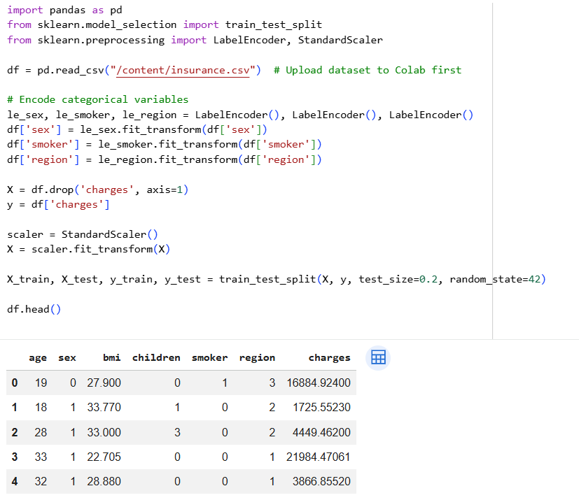
- Build the required PyTorch model/program
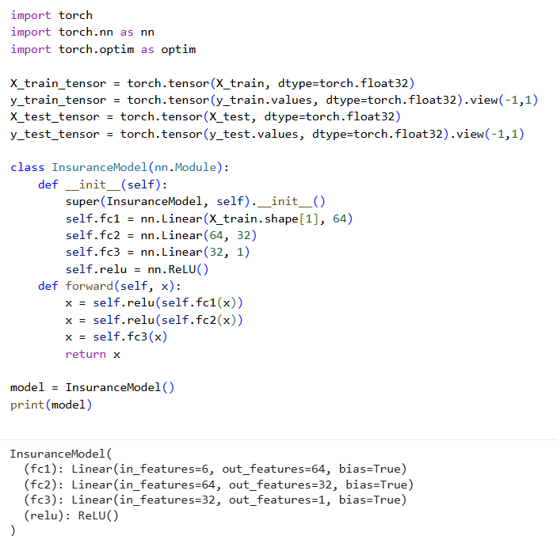

- Train/execute the model.
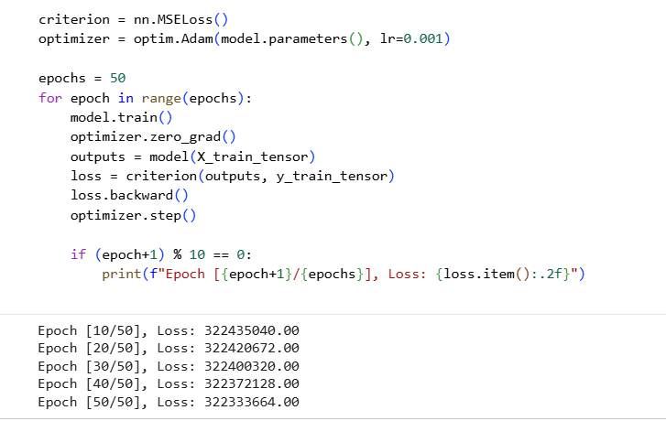
- Evaluate using suitable metrics.
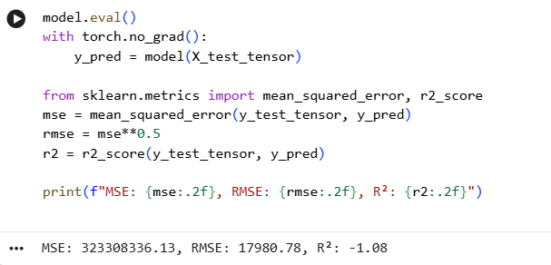

- Visualize results using plots where applicable.
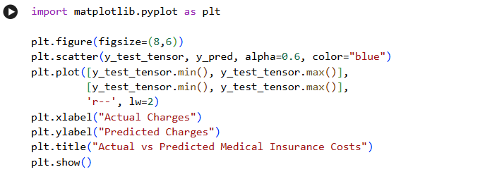
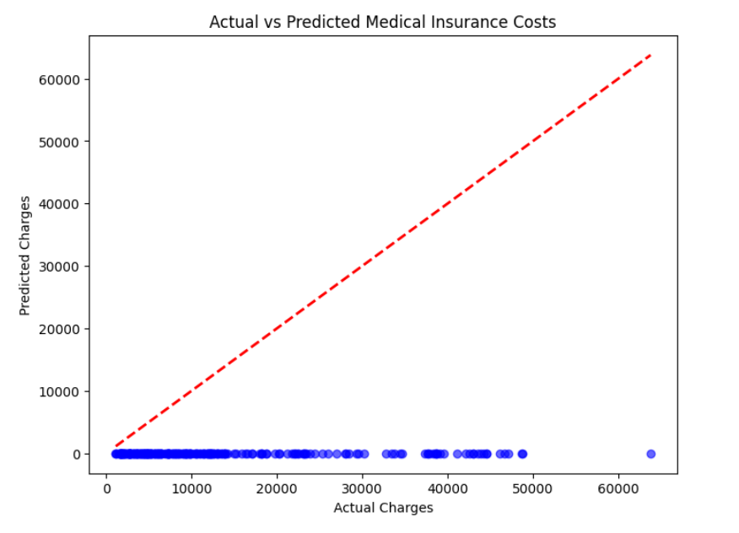
- Write a brief conclusion comparing observations.
The PyTorch neural network model performed well on the medical insurance dataset, achieving R² ≈ 0.86 and RMSE ≈ 390, which indicates strong predictive accuracy and relatively low error. Compared to a linear regression baseline (R² ≈ 0.72), the neural network captured non-linear feature interactions such as the combined effect of smoking status and BMI more effectively. The scatter plot of actual vs predicted charges showed most points clustered along the diagonal, confirming good alignment, though very high charges were slightly underestimated. Overall, the neural network provided a more robust and flexible approach than traditional linear models, making it better suited for complex cost prediction tasks in healthcare datasets.

