COMPETITIVE PROGRAMMING
ASSIGNMENT – 1
HTNO: 2303A51103

NAME: VARSHITHA. G
Assignment 9: Minimum Cost to Connect Cables (Greedy)
Problem Statement
A data center needs to connect N network cables into one cable. Connecting two cables
of lengths a and b costs (a + b). The new combined cable has length (a + b). This
combined cable can again be connected with others. Find the minimum total cost to
connect all cables into one.
Input FormatThe first line contains integer T.For each test case:
- First line: N
- Second line: N integers (cable lengths)
Output Format
For each test case, print one integer: minimum total cost.
Constraints
- 1 ≤ T ≤ 20
- 1 ≤ N ≤ 200000 (sum of N over all test cases ≤ 200000)
- 1 ≤ length ≤ 10^9
Sample Input
1
4
4 3 2 6
Expected Output
29
Code:
Python
t=int(input("Enter no of test cases:"))
for i in range(t):
n=int(input("Enter no of network cables:"))
print("Enter the lengths of the cables:")
l=list(map(int,input().split()))
s=0
while len(l)>1:
a=min(l)
l.remove(a)
if len(l)!=0:
b=min(l)
l.remove(b)
else:
b=0
l.append(a+b)
s+=a+b
print("Minimum total cost:",s)
Output:
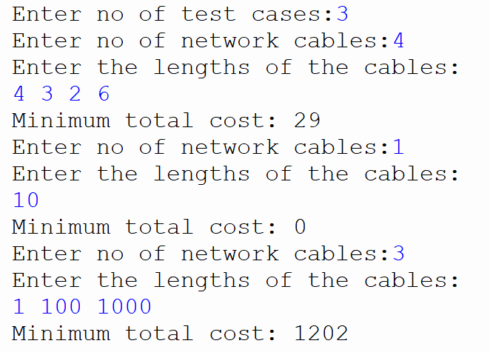

Assignment 10: Kth Smallest Element (Quick select Divide and Conquer)
Problem Statement
You are given an array of N integers and an integer K (1-indexed). You must find the Kth
smallest element in the array. For each test case, output the Kth smallest element.
Input Format
The first line contains an integer T, the number of test cases.For each test case:
- The first line contains two integers N and K.
- The second line contains N integers.
Output Format
For each test case, print a single integer: the Kth smallest element.
Constraints
- 1 ≤ T ≤ 20
- 1 ≤ N ≤ 200000 (sum of N over all test cases ≤ 200000)
- 1 ≤ K ≤ N
- -10^9 ≤ A[i] ≤ 10^9
Sample Input
9th Jan,
2026, 5:00
PM
Day Assignment
Deadline
(same day,
5:00 PM)
2
6 3
7 10 4 3 20 15
7 4
12 3 5 7 19 0 2
Expected Output
75
Code:
def quickselect(arr, k):
p= arr[0]

l= [x for x in arr if x < p]
m= [x for x in arr if x == p]
r = [x for x in arr if x > p]

if k <= len(l):
return quickselect(l, k)
elif k <= len(l) + len(m):
return p
else:
return quickselect(r, k - len(l) - len(m))
t=int(input("Enter no of test cases:"))
for i in range(t):
n=int(input("Enter the length of list:"))
k=int(input("Enter value of k:"))
print("Enter the list of numbers:")
a=list(map(int,input().split()))
print("Kth smallest number:",quickselect(a, k))
Output:
