AI ASSISTED CODING
LAB ASSIGNMENT-1.1
NAME: Varshitha. G
HTNO: 2303A51103

Lab 1: Environment Setup – GitHub Copilot and VS Code Integration + Understanding AI-assisted Coding Workflow
Task 0
● Install and configure GitHub Copilot in VS Code. Take screenshots of each step.
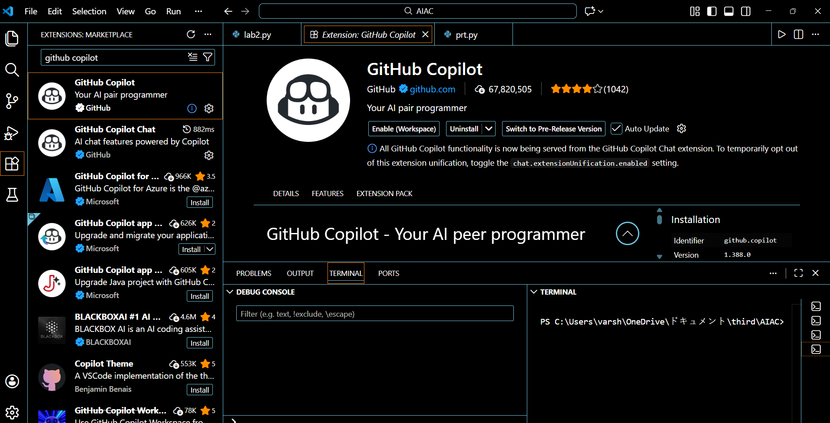
Task 1: AI-Generated Logic Without Modularization (Factorial without Functions)
• Scenario
You are building a small command-line utility for a startup intern onboarding task. The program is simple and must be written quickly without modular design.
• Task Description
Use GitHub Copilot to generate a Python program that computes a
mathematical product-based value (factorial-like logic) directly in the main execution flow, without using any user-defined functions.
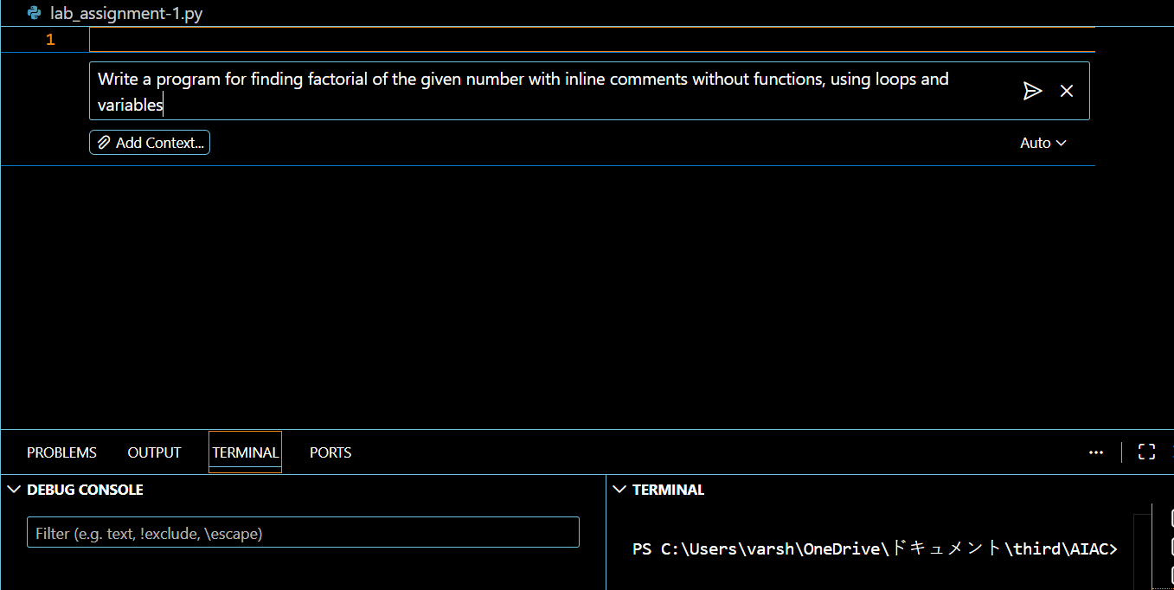
➢ Copilot’s suggestions
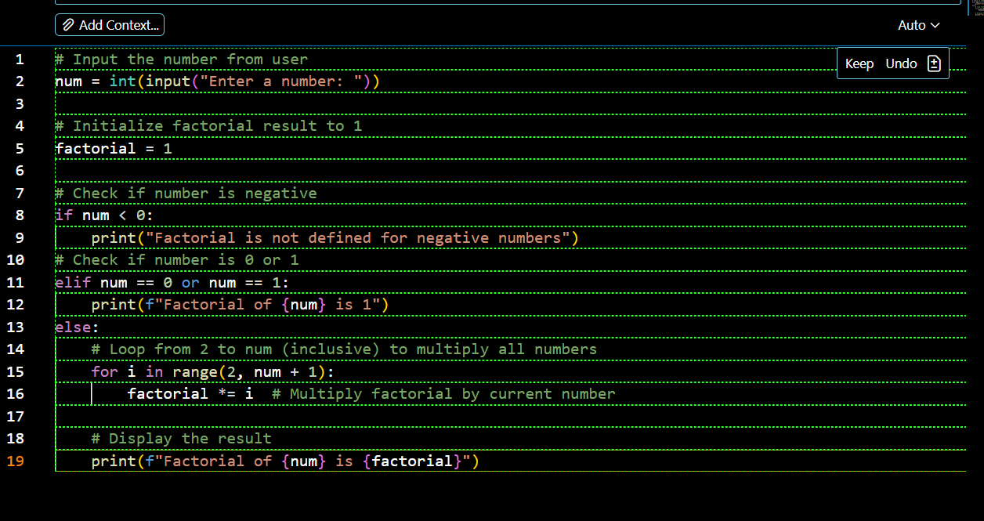
➢ Sample input/output screenshots
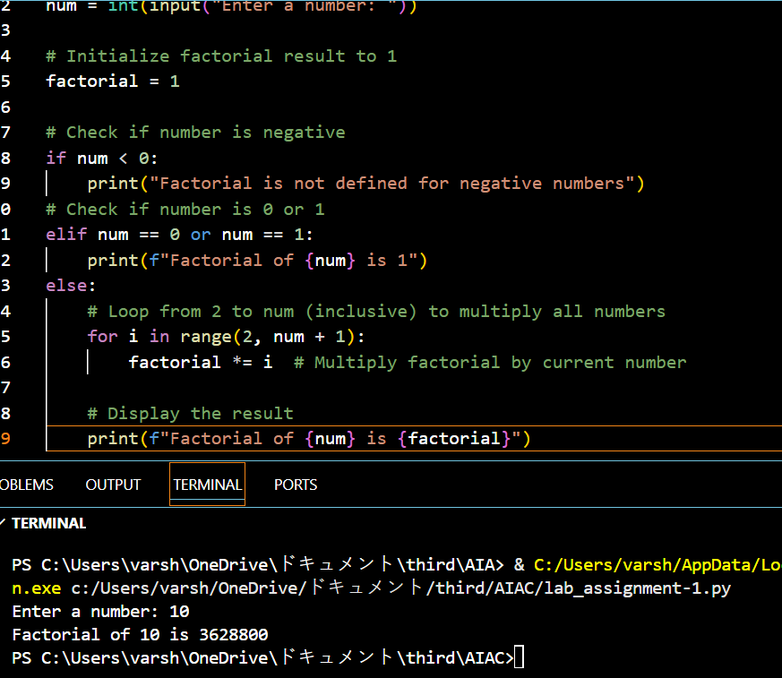
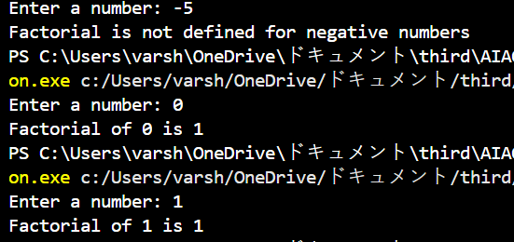
➢ Brief reflection (5–6 lines):
GitHub Copilot was very helpful for a beginner as it quickly generated correct and readable code with minimal effort. It understood the requirement of avoiding functions and used only loops and variables as instructed. The generated logic was simple, clean, and easy to understand. Copilot also followed basic best practices like input validation for negative numbers. This tool can significantly speed up learning and development for new programmers. However, understanding the logic manually is still important to avoid over-dependency.
➢ How helpful was Copilot for a beginner?
GitHub Copilot is very helpful for beginners because it quickly generates working code from simple prompts. It reduces the time spent thinking about syntax and structure. Beginners can focus more on understanding logic rather than writing code from scratch.
➢ Did it follow best practices automatically?
Yes, Copilot mostly follows basic best practices automatically.
It uses clean variable names, proper loops, and simple input handling.
However, beginners should still review the code to fully understand and improve it.

Task 2: AI Code Optimization & Cleanup (Improving Efficiency)
❖ Scenario
Your team lead asks you to review AI-generated code before committing it to a shared repository.
❖ Task Description
Analyze the code generated in Task 1 and use Copilot again to:
➢ Reduce unnecessary variables
➢ Improve loop clarity
➢ Enhance readability and efficiency
❖ Expected Deliverables
➢ Original AI-generated code
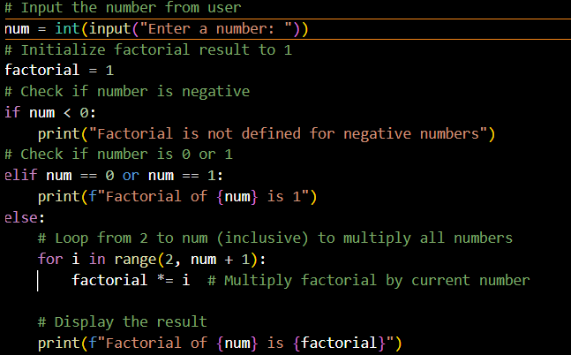
➢ Optimized version of the same code
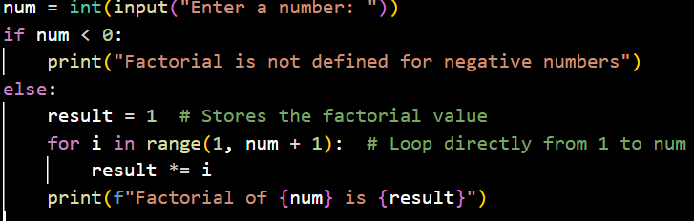
➢ Side-by-side comparison
1. Reduced Unnecessary Conditions
Previous code had a separate check for 0 and 1.
Optimized code removes it because looping from 1 naturally handles both cases. This reduces branching and improves clarity.
2. Improved Loop Clarity
Previous code looped from 2 and relied on pre-initialization.
Optimized code loops cleanly from 1 to num, making logic easier to understand for beginners.
3. Better Readability
Straightforward control flow. Easier to read, debug, and modify.
➢ Written explanation:
▪ What was improved?
The optimized version removes unnecessary conditional checks and simplifies the overall control flow. It eliminates the special-case handling for 0 and 1 by using a single loop that naturally covers all valid cases. The loop structure was made clearer by iterating directly from 1 to num. Variable usage was minimized to keep only what is essential for computation.
▪ Why the new version is better (readability, performance, maintainability.
Readability: The code is shorter and easier to understand, especially for beginners, because it has fewer branches and a straightforward loop.
Performance: Although factorial computation is already efficient, removing extra conditions slightly reduces execution steps.
Maintainability: With simpler logic and fewer cases to handle, the code is easier to modify, debug, and extend in the future.

Task 3: Modular Design Using AI Assistance (Factorial with Functions)
❖ Scenario
The same logic now needs to be reused in multiple scripts.
❖ Task Description
Use GitHub Copilot to generate a modular version of the program by:
➢ Creating a user-defined function
➢ Calling the function from the main block
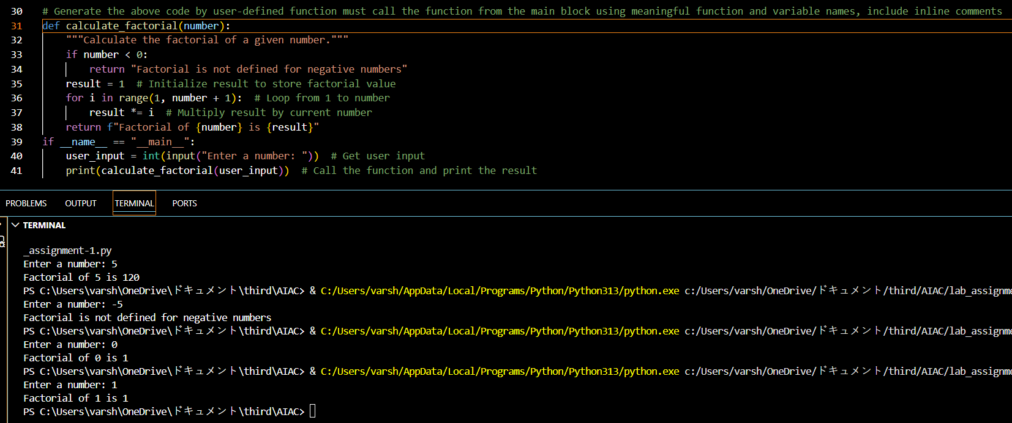

Task 4: Comparative Analysis – Procedural vs Modular AI Code (With vs Without Functions)
❖ Scenario
As part of a code review meeting, you are asked to justify design choices.
❖ Task Description
Compare the non-function and function-based Copilot-generated
programs on the following criteria:
➢ Logic clarity
➢ Reusability
➢ Debugging ease
➢ Suitability for large projects
➢ AI dependency risk

Criteria | Non-Function Program | Function-Based Program
Logic Clarity | Logic is written directly in the main flow, which is easy to understand for very small programs but confusing when the program becomes bigger. | Logic is encapsulated inside a function, making the program flow cleaner and easier to follow.
Reusability | Code cannot be reused without copying and pasting the entire logic. | The function can be reused multiple times by calling it with different inputs.
Debugging Ease | Debugging is harder because all logic is in one place. | Easier to find and fix errors because the code is separated into a function.
Suitability for Large Projects | Not suitable for large projects due to poor structure and scalability. | Good for large projects because the code can be easily expanded and maintained
AI Dependency Risk | Higher risk of blindly accepting AI-generated logic without understanding structure. | Lower risk because functions encourage logical thinking and better understanding of code flow.

The non-function version is acceptable for quick scripts or beginner practice.
The function-based version is clearly superior for readability, reuse, debugging, and real-world software development.
Copilot performs well in both cases, but modular code reduces long-term dependency on AI-generated solutions.

Task 5: AI-Generated Iterative vs Recursive Thinking
❖ Scenario
Your mentor wants to test how well AI understands different
computational paradigms.
❖ Task Description
Prompt Copilot to generate:
An iterative version of the logic
A recursive version of the same logic
❖ Expected Deliverables
Two AI-generated implementations
Execution flow explanation (in your own words)
Comparison covering:
➢ Readability
➢ Stack usage
➢ Performance implications
➢ When recursion is not recommended.
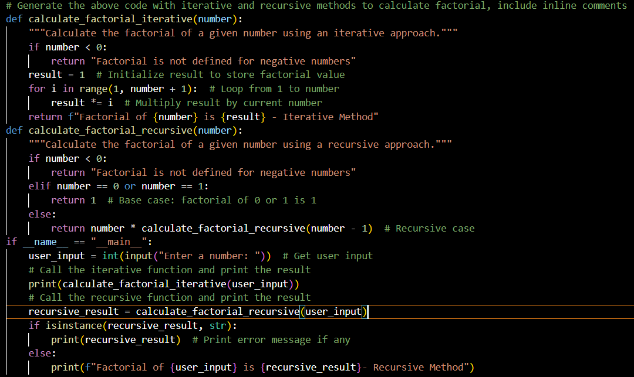
Iterative Function:
The program starts execution from the main. It takes a number as input from the user. First, the iterative function is called:
It checks if the number is negative.
If valid, it uses a loop to multiply numbers from 1 to n.
The result is returned and printed.
Recursive Function:
It checks for a base case (0 or 1) and returns 1.
Otherwise, it calls itself with number - 1.
Each call waits until the base case is reached, then results are multiplied back.
Finally, both results are displayed.
OUTPUT:
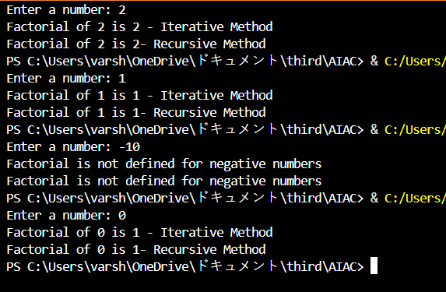
Readability
- The iterative method is easy to read and understand because it uses a simple loop. The recursive method is harder to understand since the function calls itself.
Stack Usage
- The iterative method does not use extra stack memory.
- The recursive method uses stack memory for each function call.
Performance Implications
- The iterative method is faster and more efficient, especially for large numbers. The recursive method is slower due to repeated function calls.
When Recursion is Not Recommended
- When the input number is very large.
- When memory usage needs to be low.
- When there is a risk of stack overflow.
- When a simple loop can solve the problem easily.
- Iteration is better for performance and safety, while recursion is mainly useful for understanding concepts.

