AI ASSISTED CODING
LAB ASSIGNMENT-2
NAME: Varshitha. G
HTNO: 2303A51103

Lab 2: Exploring Additional AI Coding Tools beyond Copilot – Gemini (Colab) and Cursor AI
Task 1: Statistical Summary for Survey Data
Scenario:
You are a data analyst intern working with survey responses stored as
numerical lists.
Task:
Use Google Gemini in Colab to generate a Python function that reads a list
of numbers and calculates the mean, minimum, and maximum values.
Expected Output:
➢ Correct Python function
➢ Output shown in Colab
➢ Screenshot of Gemini prompt and result

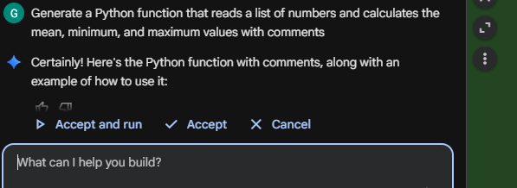
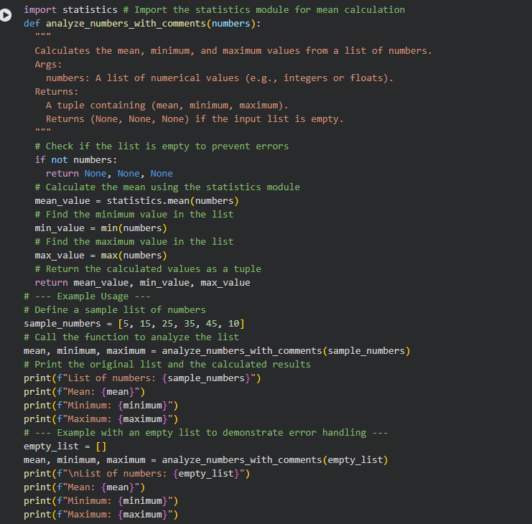
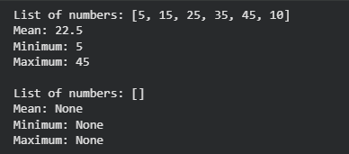
Task 2: Armstrong Number – AI Comparison
❖ Scenario:
You are evaluating AI tools for numeric validation logic.
❖ Task:
Generate an Armstrong number checker using Gemini and GitHub Copilot.
Compare their outputs, logic style, and clarity.
Gemini copilot:
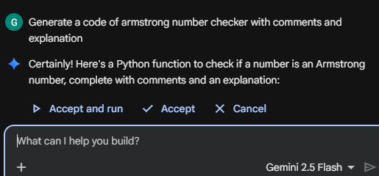
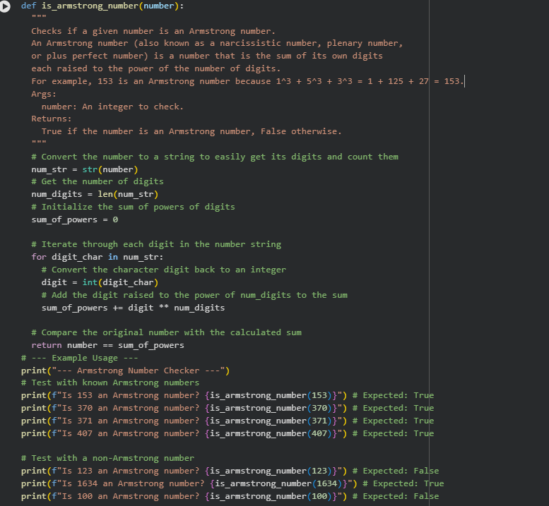
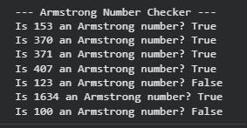
Github copilot

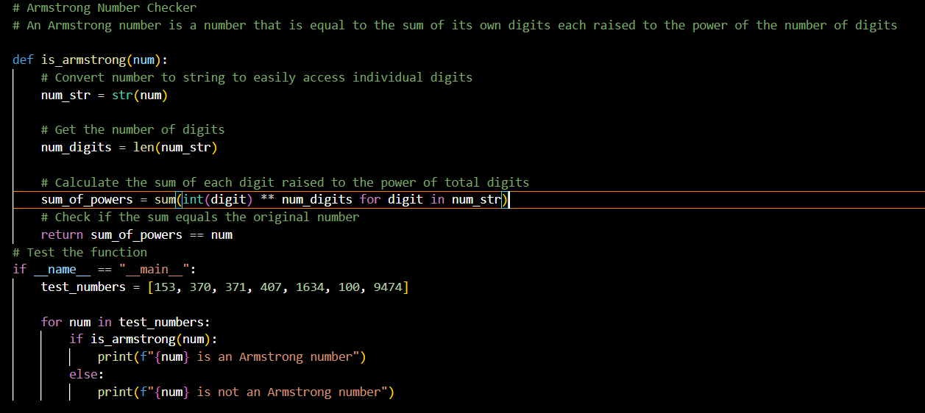
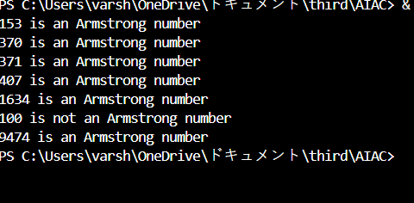
Aspect | GitHub Copilot Output | Gemini Output
Overall Style | Short and concise, focuses on direct logic | More detailed and explanatory
Logic Implementation | Uses Python’s sum() with a generator expression | Uses a loop to calculate the sum step by step
Readability | Compact but may feel slightly advanced for beginners | Very beginner-friendly and easy to follow
Use of Comments | Fewer comments, assumes basic Python knowledge | Many inline comments explaining each step
Clarity of Flow | Logic is correct but condensed into fewer lines | Logic is broken into small, clear steps
Beginner Suitability | Better for users comfortable with Python syntax | Better for beginners learning number logic
Maintainability | Easy to maintain but less descriptive | Easier to modify and debug due to clarity

Task 3: Leap Year Validation Using Cursor AI
❖ Scenario:
You are validating a calendar module for a backend system.
❖ Task:
Use Cursor AI to generate a Python program that checks whether a given
year is a leap year.
Use at least two different prompts and observe changes in code.
❖ Expected Output:
➢ Two versions of code
➢ Sample inputs/outputs
➢ Brief comparison
Prompt 1:
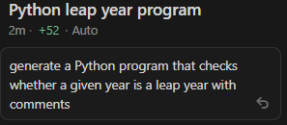
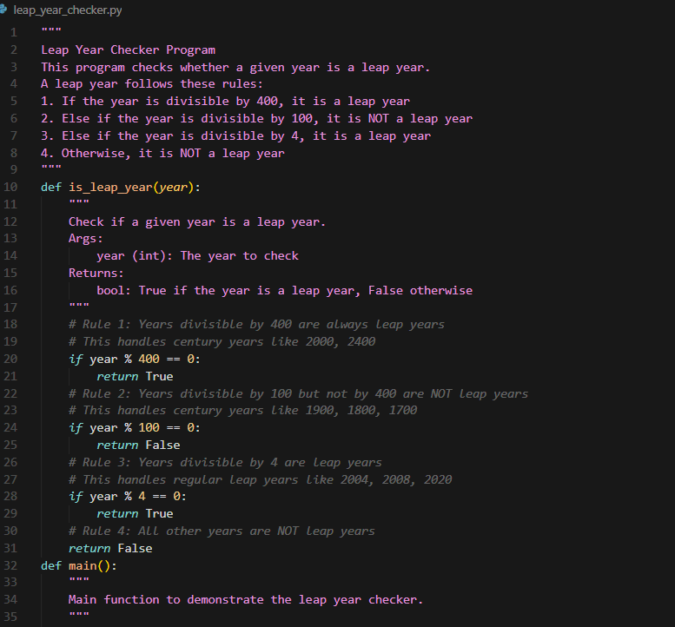
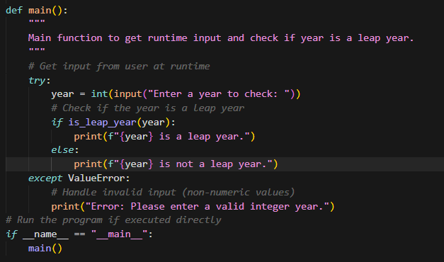
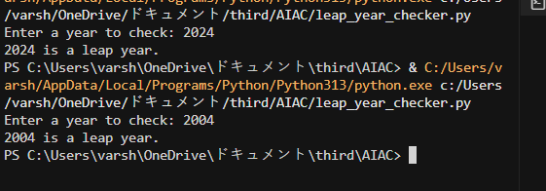
Prompt 2:
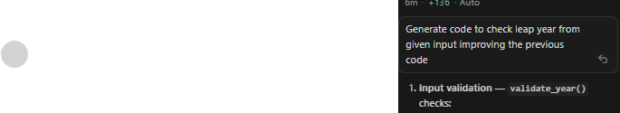
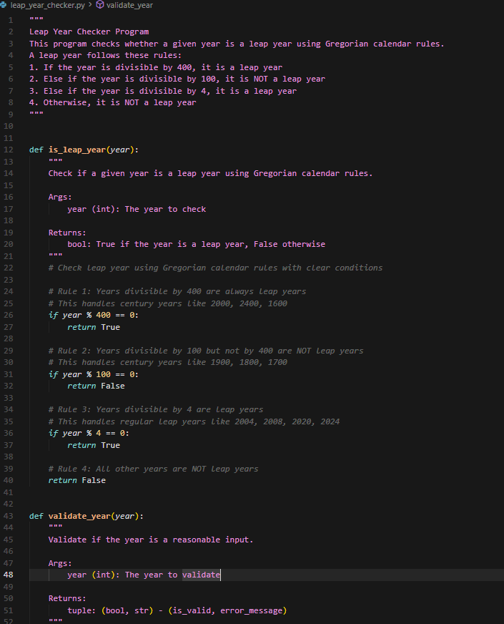
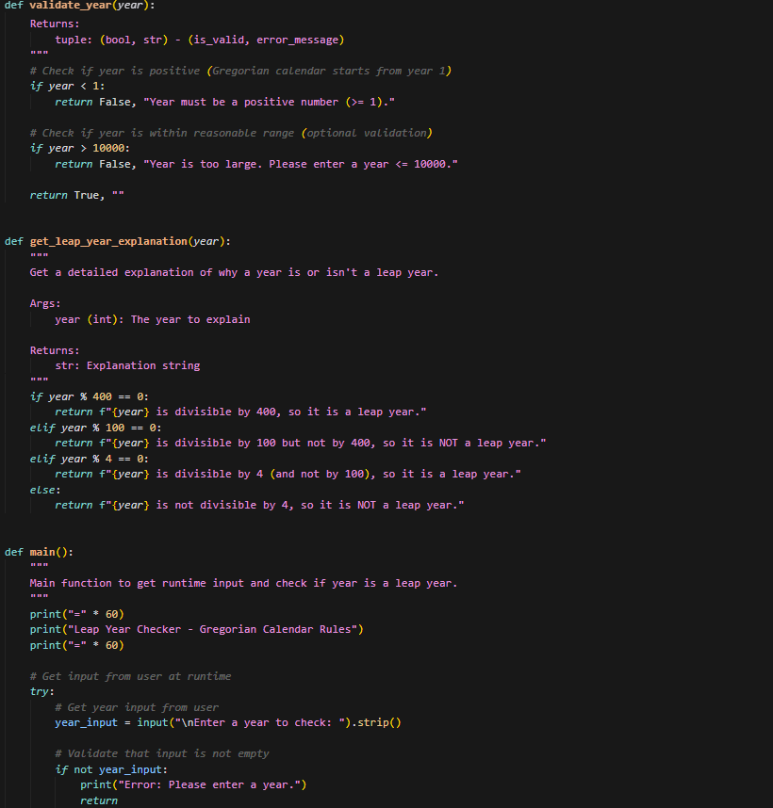
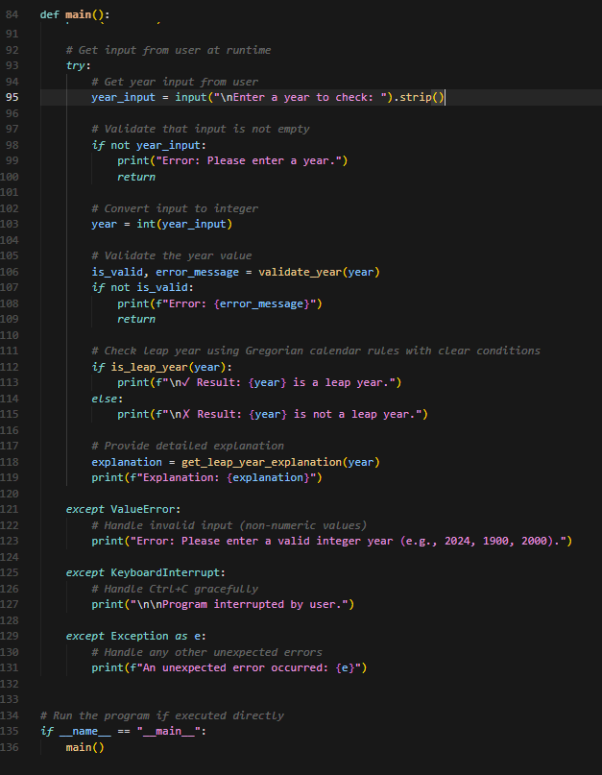
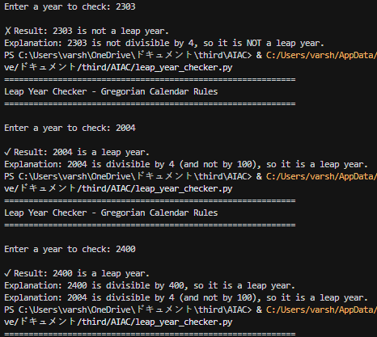

- Logic Accuracy:
Version 1 uses a basic rule and may give incorrect results for century years.
Version 2 follows proper Gregorian calendar rules and is fully accurate.
- Code Quality:
Version 2 is more reliable and suitable for real-world backend systems.
- Effect of Prompt Change:
A more detailed prompt resulted in better logic, correctness, and professional-quality code.

Task 4: Student Logic + AI Refactoring (Odd/Even Sum)
❖ Scenario:
Company policy requires developers to write logic before using AI.
❖ Task:
Write a Python program that calculates the sum of odd and even numbers
in a tuple, then refactor it using any AI tool.
❖ Expected Output:
➢ Original code
➢ Refactored code
➢ Explanation of improvements
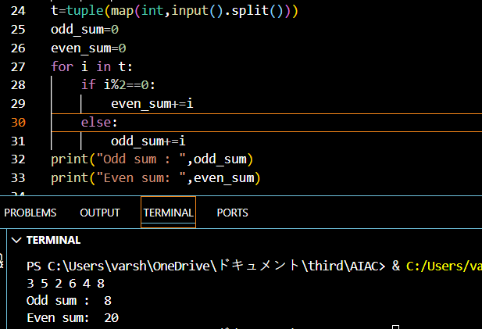
Refactored Code:
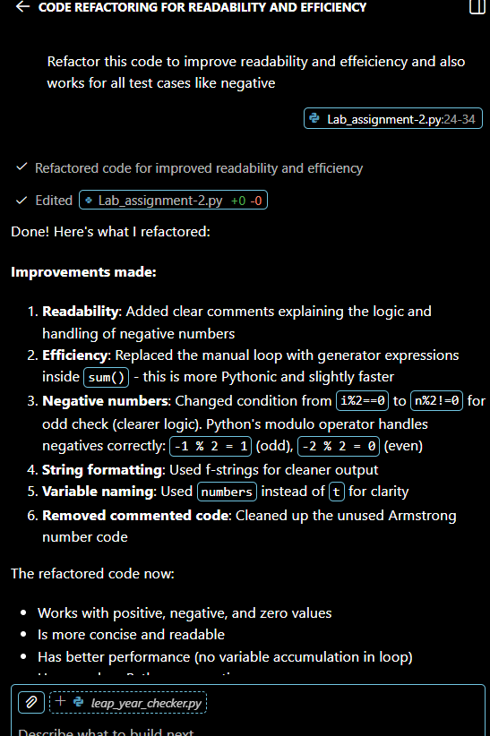
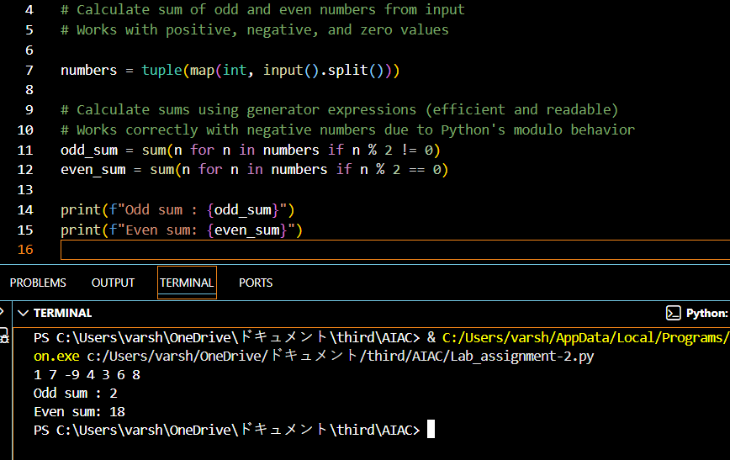
What was improved?
The loop was replaced with Python’s built-in sum() function.The code became shorter and more readable. Redundant variable updates were removed.
The refactored code better.
Readability: Easier to understand at a glance.
Efficiency: Uses Python’s optimized built-in functions.
Maintainability: Fewer lines make the code easier to modify

