AI ASSISTED CODING
ASSIGNMENT 3.5
Name: Varshitha. G
HtNo: 2303A51103
Question 1: Zero-Shot Prompting (Leap Year Check)
Write a zero-shot prompt to generate a Python function that checks whether a given year is a leap year.
Week2 -
Task:
• Record the AI-generated code.
• Test with years like 1900, 2000, 2024.
• Identify logical flaws or missing conditions.
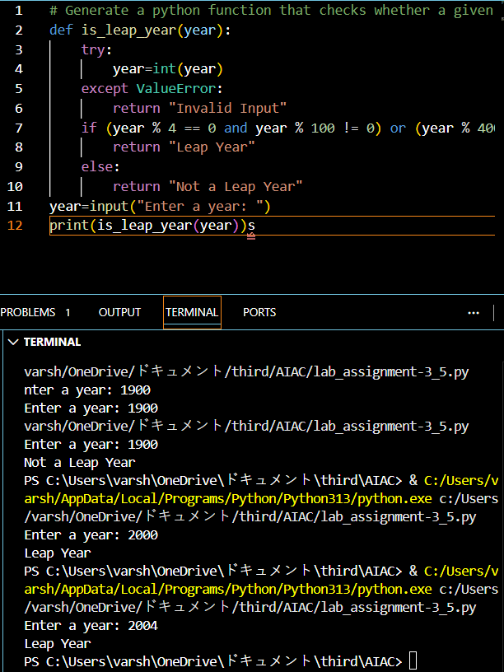
The program does not check for invalid year values such as 0 or negative numbers. It only validates non-numeric input and assumes any integer year is valid. There is no explicit condition to restrict the year to a realistic range. Apart from these missing checks, the leap year logic itself has no flaws.

Question 2: One-Shot Prompting (GCD of Two Numbers)
Write a one-shot prompt with one example to generate a Python
function that finds the Greatest Common Divisor (GCD) of two numbers.
Example:
Input: 12, 18 → Output: 6
Task:
• Compare with a zero-shot solution.
• Analyze algorithm efficiency.
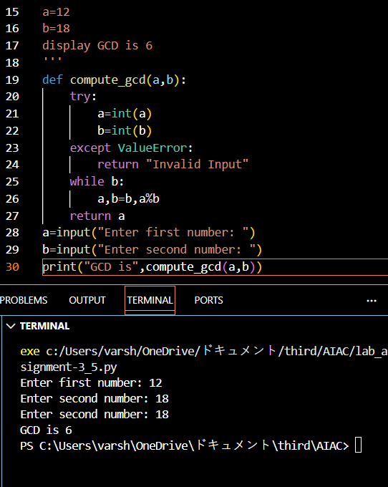
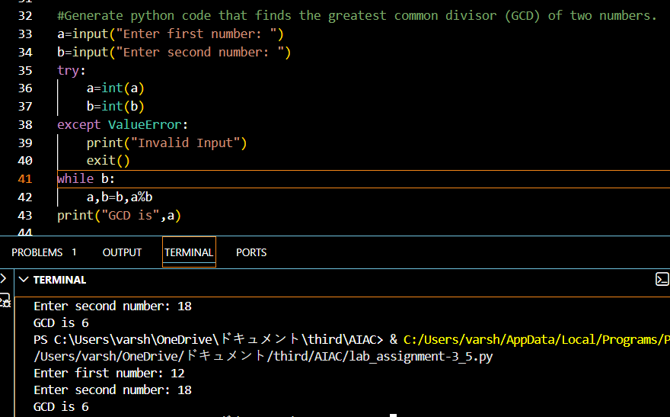
Both solutions correctly compute the GCD using the Euclidean algorithm, which is an efficient and standard approach. The zero-shot solution is more straightforward and concise, while the one shot solution is better structured and reusable. In terms of efficiency, both have the same time complexity of O(log min(a, b)), which is very fast even for large numbers. There is no performance difference between them; the main difference is code organization and reusability, not logic or efficiency.
Question 3: Few-Shot Prompting (LCM Calculation)
Write a few-shot prompt with multiple examples to generate a Python
function that computes the Least Common Multiple (LCM).
Examples:
• Input: 4, 6 → Output: 12
• Input: 5, 10 → Output: 10
• Input: 7, 3 → Output: 21
Task:
• Examine how examples guide formula selection.
• Test edge cases.
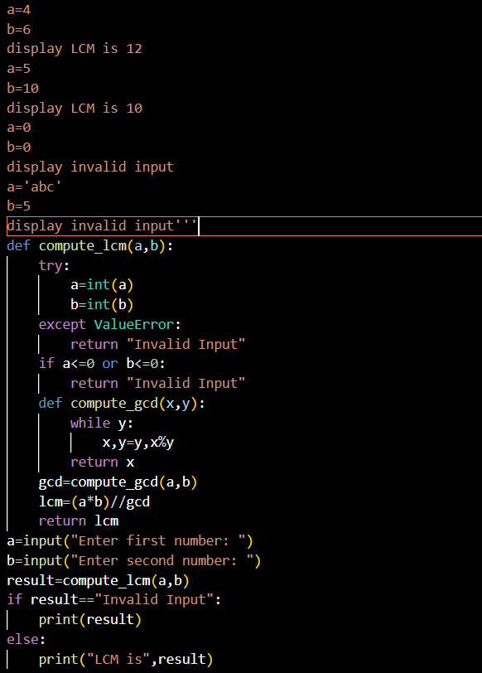
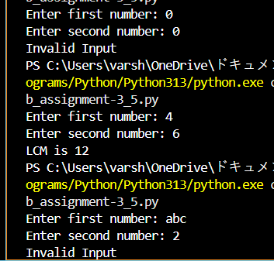
Question 4: Zero-Shot Prompting (Binary to Decimal Conversion) Write a zero-shot prompt to generate a Python function that converts a binary number to decimal.
Task:
• Test with valid and invalid binary inputs.
• Identify missing validation logic.
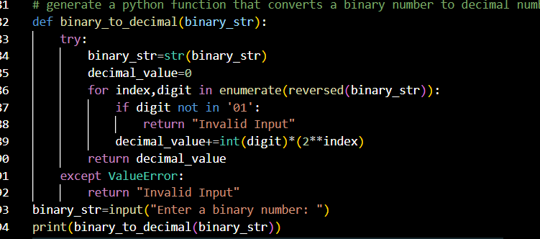
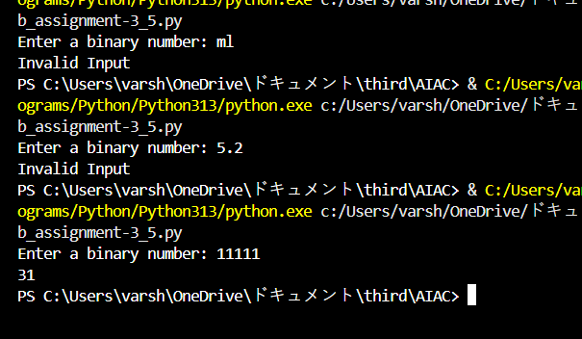
The code does not check for empty input, so an empty string would be treated as valid and return 0. It also does not handle leading/trailing spaces explicitly before processing. Negative binary values (like -101) are not considered and should be rejected clearly. Apart from these missing validations, the binary digit check (0 and 1) is correct.

Question 5: One-Shot Prompting (Decimal to Binary Conversion)
Write a one-shot prompt with an example to generate a Python function
that converts a decimal number to binary.
Example:
Input: 10 → Output: 1010
Task:
• Compare clarity with zero-shot output.
• Analyze handling of zero and negative numbers.
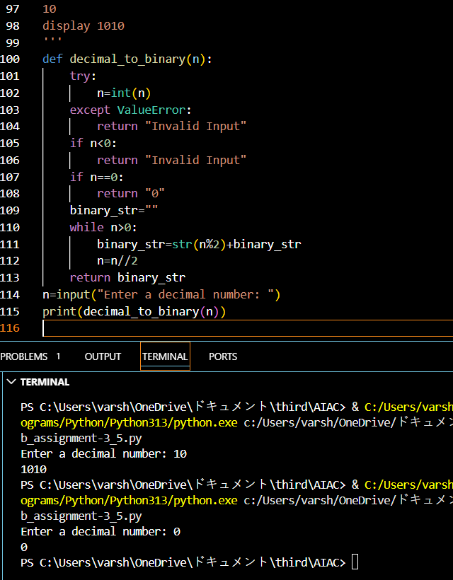
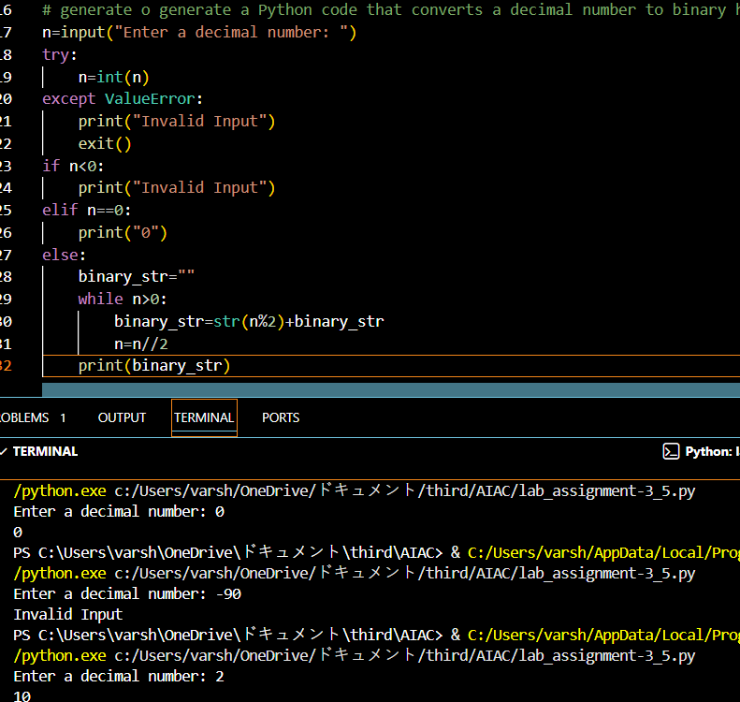
Both versions correctly convert decimal to binary and handle zero and negative inputs. The zero-shot output (second code) is clearer for beginners because it is written step by step without a function, making the flow easy to follow. The function-based version is more organized and reusable but slightly less direct. Overall, the zero-shot solution is clearer in terms of readability, while the function version is better for reuse.

Question 6: Few-Shot Prompting (Harshad Number Check)
Write a few-shot prompt to generate a Python function that checks
whether a number is a Harshad (Niven) number.
Examples:
• Input: 18 → Output: Harshad Number
• Input: 21 → Output: Harshad Number
• Input: 19 → Output: Not a Harshad Number
Task:
• Test boundary conditions.
• Evaluate robustness
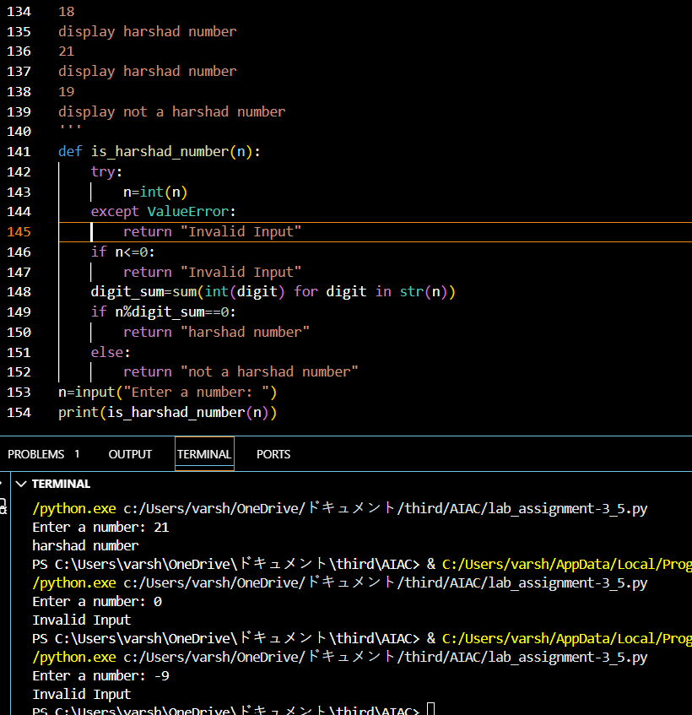
Robustness Evaluation
The program is robust as it safely handles invalid inputs using try-except.
It correctly rejects zero and negative numbers with clear error messages.
Valid Harshad numbers are accurately identified using digit-sum logic.
Edge cases like non-numeric input are handled.

