AI ASSISTED CODING
LAB ASSIGNMENT – 3
Name: Varshitha. G
HtNo: 2303A51103
Lab Experiment: Prompt Engineering – Improving Prompts and
Context Management

Question 1: Zero-Shot Prompting (Palindrome Number Program)
Write a zero-shot prompt (without providing any examples) to generate a Python function that checks whether a given number is a palindrome.
Task:
• Record the AI-generated code.
• Test the code with multiple inputs.
• Identify any logical errors or missing edge-case handling.
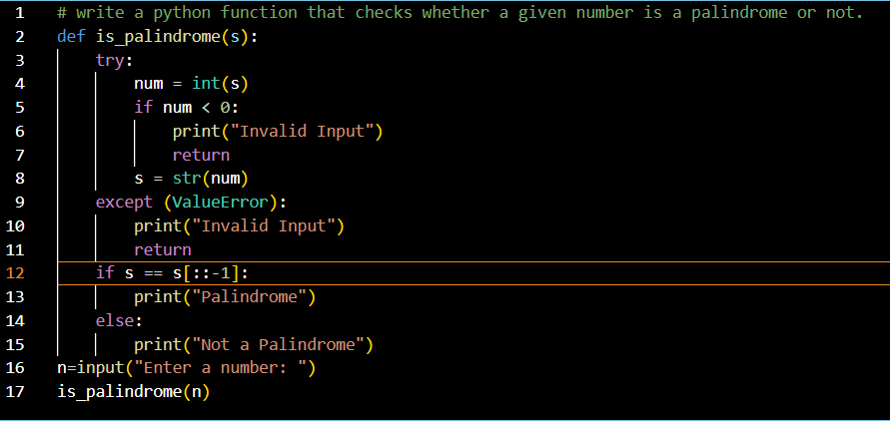
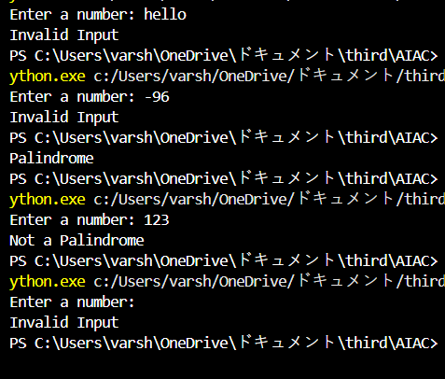
The AI -generated code is handling edge-cases like negative numbers, empty input and string inputs. And no logical errors are found.

Question 2: One-Shot Prompting (Factorial Calculation)
Write a one-shot prompt by providing one input-output example and ask the AI to generate a Python function to compute the factorial of a given number.
Example:
Input: 5 → Output: 120
Task:
• Compare the generated code with a zero-shot solution.
• Examine improvements in clarity and correctness.
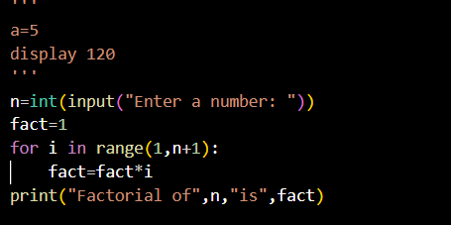
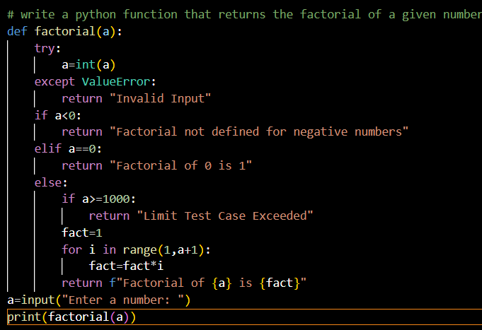
1. Clarity
Generated code
- Uses a function reusable and well-structured
- Handles invalid input, negative numbers, and special cases (0)
- Error messages clearly explain what went wrong
- More readable for understanding why something fails
Zero-shot solution
- Straightforward and short
- No function code runs only once
- No explanation for wrong inputs
- Less descriptive output
Improvement: Generated code is clearer and more user-friendly.
2. Correctness
Generated code
- Checks:
  - Non-integer input (try-except)
  - Negative numbers
  - Large numbers (a >= 1000)
- Prevents runtime errors
- Always returns a meaningful result or message
Zero-shot solution
- Assumes input is always valid
- Crashes if input is not an integer
- No handling for negative numbers
Improvement: Generated code is more correct and robust.
3. Overall
- Generated code → Better for real-world use
- Zero-shot solution → Good for quick learning or exams
Conclusion:
The generated code improves clarity, safety, and correctness, while the zero-shot solution is simpler but less reliable.

Question 3: Few-Shot Prompting (Armstrong Number Check) Write a few-shot prompt by providing multiple input-output examples to guide the AI in Generating a Python function to check whether a given number is an Armstrong number.
Examples:
• Input: 153 → Output: Armstrong Number
• Input: 370 → Output: Armstrong Number
• Input: 123 → Output: Not an Armstrong Number
Task:
• Analyze how multiple examples influence code structure and accuracy.
• Test the function with boundary values and invalid inputs.
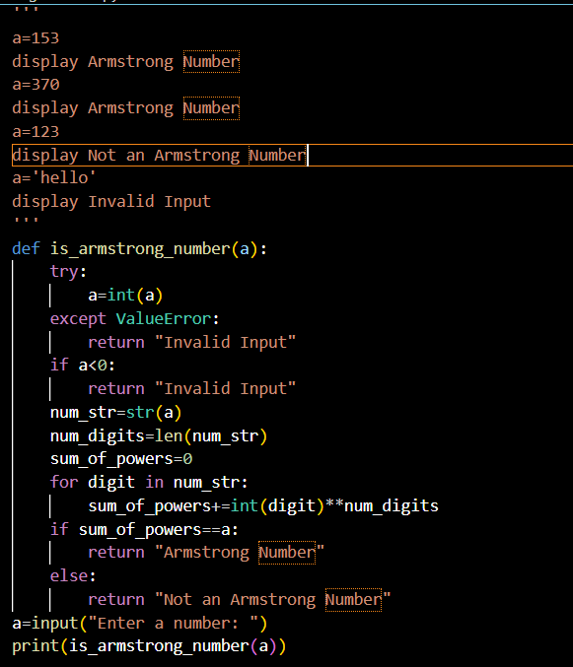
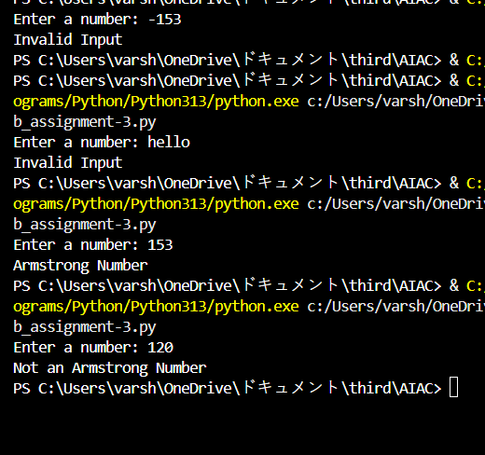
(Optional Extension)
Question 4: Context-Managed Prompting (Optimized Number Classification)
Design a context-managed prompt with clear instructions and constraints to generate an optimized Python program that classifies a number as prime, composite, or neither.
Task:
• Ensure proper input validation.
• Optimize the logic for efficiency.
• Compare the output with earlier prompting strategies.
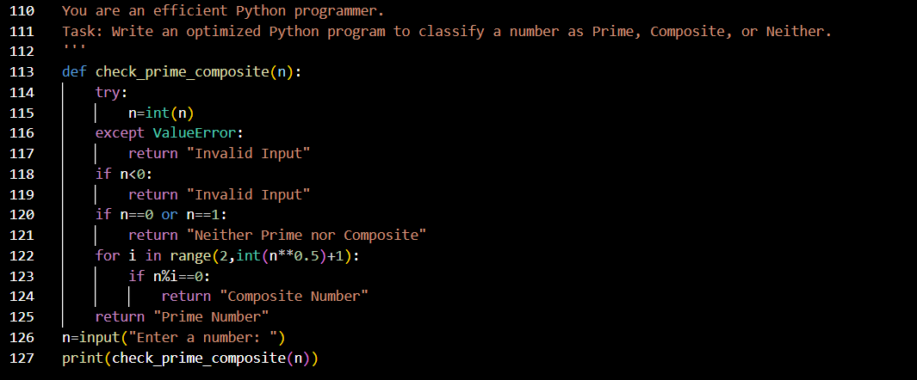
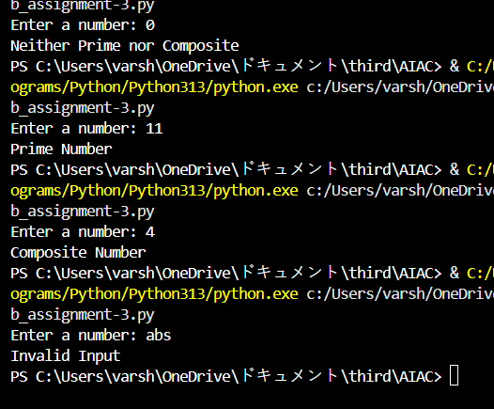

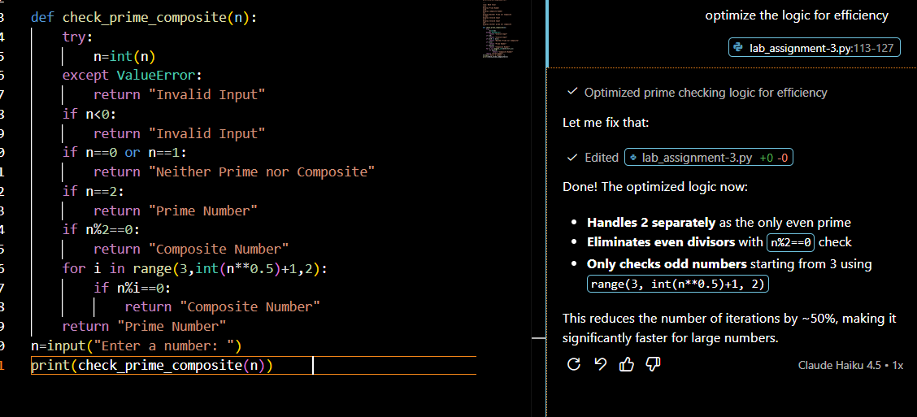
Earlier Strategy :
for i in range(2, int(n**0.5)+1):
if n%i==0:
return "Composite Number"
Checks all divisors from 2 to √n
√n iterations for any number
Optimized Strategy (current):
if n==2:
return "Prime Number"
if n%2==0:
return "Composite Number"
for i in range(3, int(n**0.5)+1, 2):
if n%i==0:
return "Composite Number"
Handles 2 separately (only even prime)
Quick reject all even numbers
Only checks odd divisors from 3 onwards
√n/2 iterations (50% fewer checks)
Key Improvements:
- Eliminated even divisor checks – 2 is the only even prime
- Step size of 2 – Skip all even numbers in the loop
- Early termination – Even numbers rejected before the loop
Time Complexity Comparison:
- Earlier: O(√n) worst case
- Optimized: O(√n/2) worst case (~2x faster)
For large numbers like 1,000,000, the optimized version performs ~500 fewer iterations compared to the earlier approach.

Question 5: Zero-Shot Prompting (Perfect Number Check)
Write a zero-shot prompt (without providing any examples) to generate a Python function that checks whether a given number is a perfect number.
Task:
• Record the AI-generated code.
• Test the program with multiple inputs.
• Identify any missing conditions or inefficiencies in the logic.
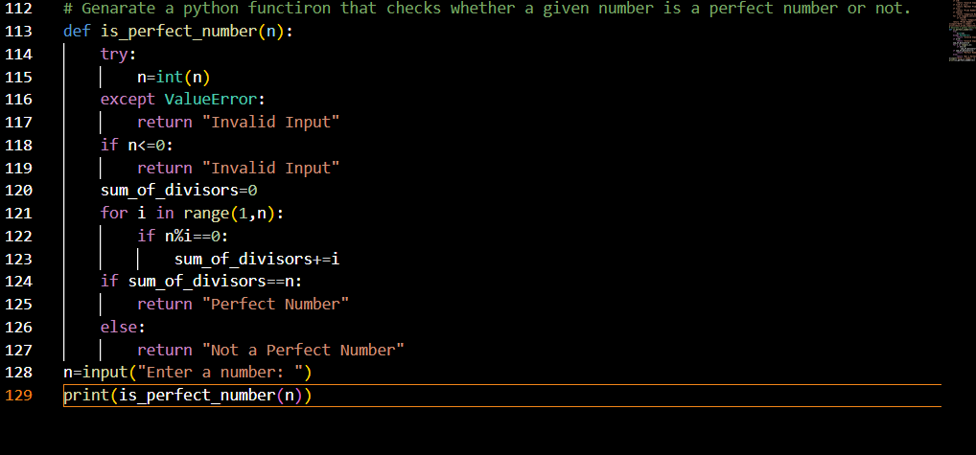
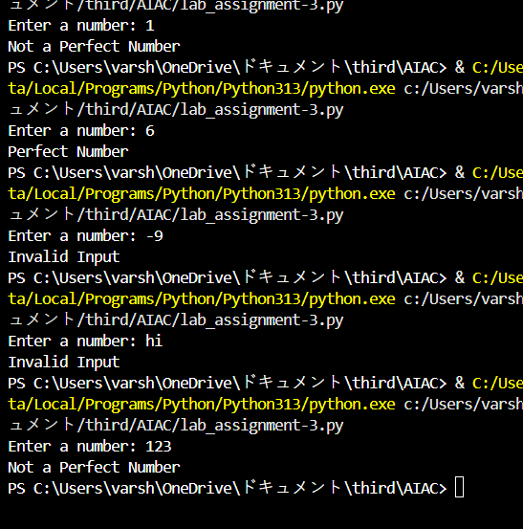
The logic correctly checks perfect numbers but lacks optimization, does not explicitly handle edge cases like negative numbers and 1, and uses an inefficient O(n) approach instead of O(√n), leading to unnecessary computations.
Question 6: Few-Shot Prompting (Even or Odd Classification with Validation)
Write a few-shot prompt by providing multiple input-output examples to guide the AI in generating a Python program that determines whether a given number is even or odd, including proper input validation.
Examples:
• Input: 8 → Output: Even
• Input: 15 → Output: Odd
• Input: 0 → Output: Even
Task:
• Analyze how examples improve input handling and output clarity.
• Test the program with negative numbers and non-integer inputs.
