JobLens: AI/ML Job Market Analysis Report

Key Findings
- Postings analysed: 1500 across 14 countries and 12 job categories.
- Most required skill: Python (942 postings), followed by SQL and Cloud.
- Median salary rises from $145,000 (entry) to $238,000 (lead).
- Countries with most postings: USA (515), UK (90), China (87).
- Data quality: 288 rows (19%) have a salary outside their own min-max range; they were flagged, not removed.
- Best model by Macro F1: Random Forest (accuracy 1.0, Macro F1 1.0).

Charts

Most Required Skills
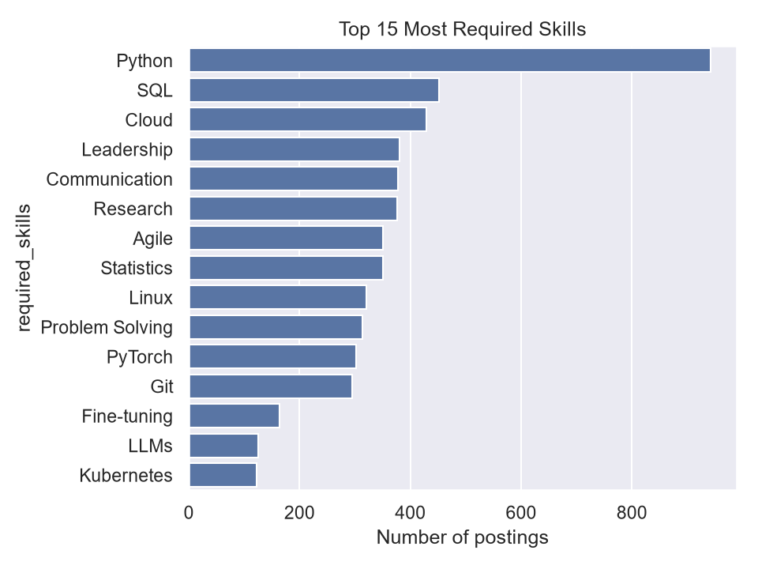

Postings by Country
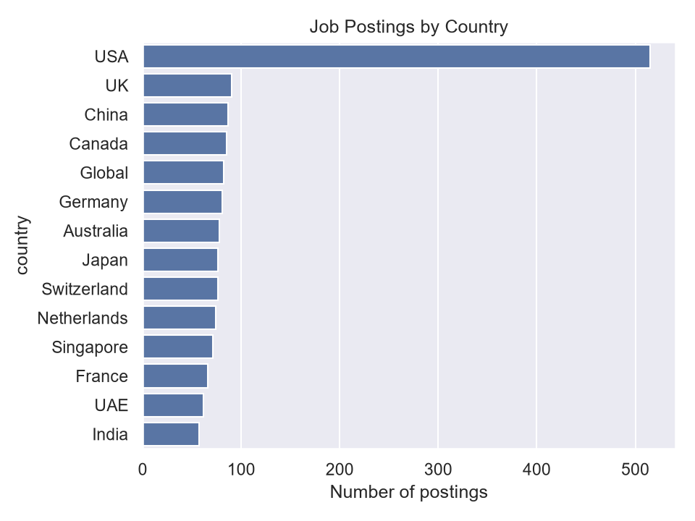

Median Salary by Experience Level
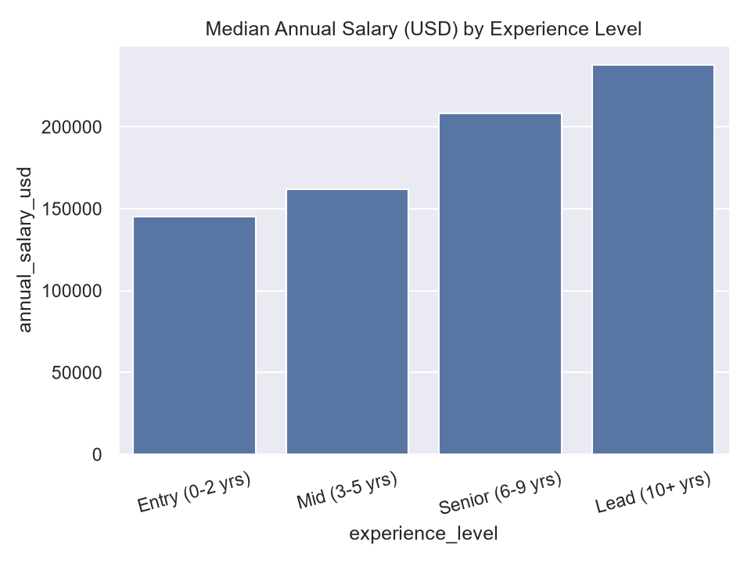

Median Salary by Job Category
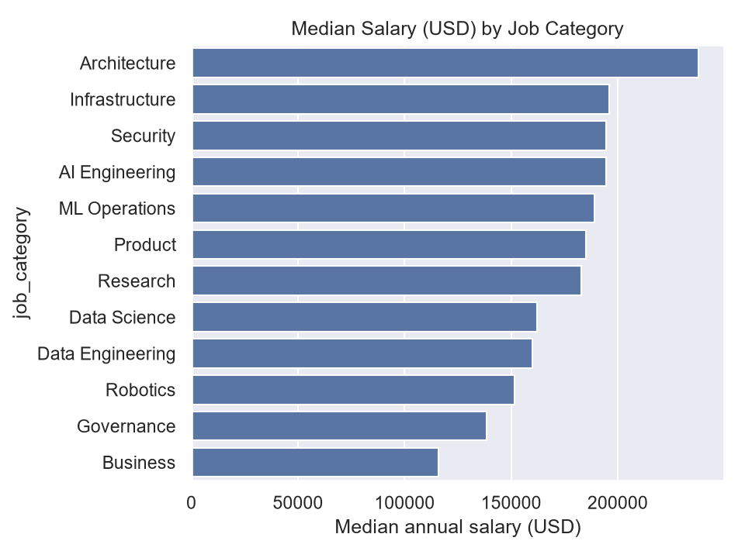

Top Skills in Entry-Level Postings
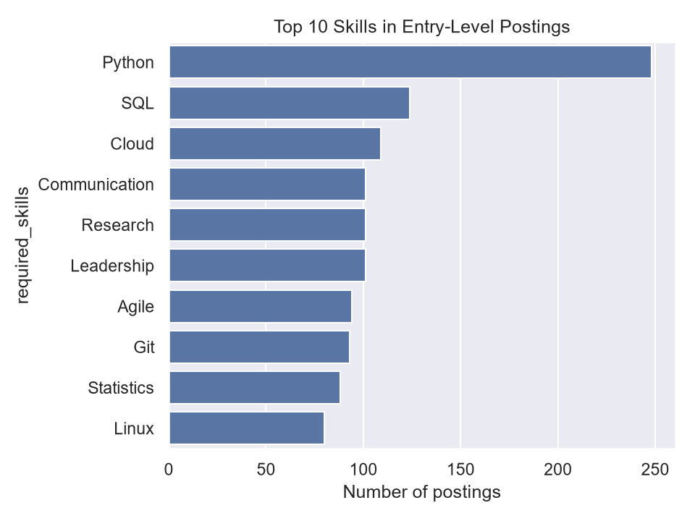

Model Comparison
Task: predict job category from required skills. The baseline always predicts the most common category.
Model | Accuracy | Macro Precision | Macro Recall | Macro F1
Baseline (always most common class) | 0.490 | 0.041 | 0.083 | 0.055
Logistic Regression | 0.997 | 0.994 | 0.997 | 0.995
Random Forest | 1.000 | 1.000 | 1.000 | 1.000
Naive Bayes | 0.987 | 0.995 | 0.967 | 0.979

