**Task Description #2  
•** A function in Python that returns the maximum of three numbers using GitHub Copilot. Use an appropriate comment as a prompt.

**Expected Output #2  
•** Python function that takes three inputs and returns the largest value. Include the code and output.

**Prompt : Generate a code for maximum of three numbers using function**

**CODE :**

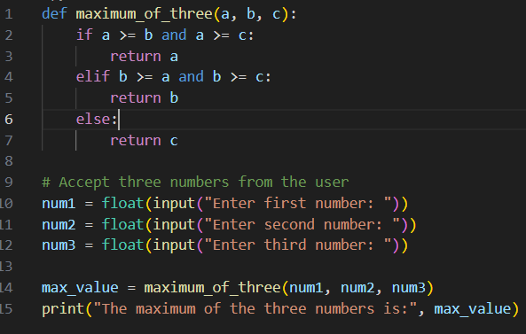

**OUTPUT :**

**Task Description #3  
•** Use GitHub Copilot to create a recursive Python function that calculates the factorial of a number.

**Expected Output #3  
•** Python function for factorial using recursion with input and output examples.

**Prompt : Generate a code for recursive Python function to calculate the factorial of a number and print the factorial of that number.**

**CODE :**

**OUTPUT :**

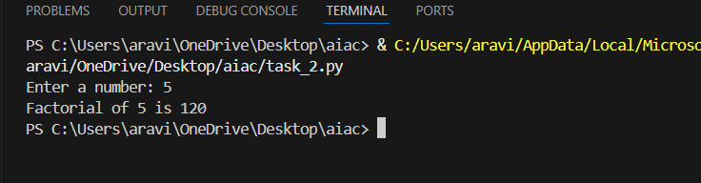

**Task Description #4  
•** Prompt GitHub Copilot to create a class named Student with attributes name, roll_no, and marks. Add a method to display student details.

**Expected Output #4  
•** Python class definition with an initializer and a display method. Include object creation and output.

**Prompt : create a python code to create a class named Student with attributes name, roll_no, and marks. Add a method to display student details . And allow the user to enter the students details.**

**CODE :**

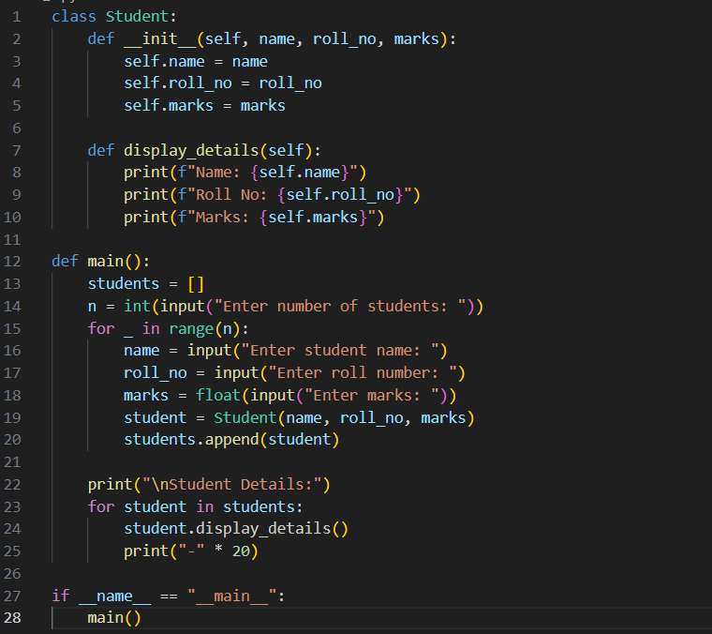

**OUTPUT :**

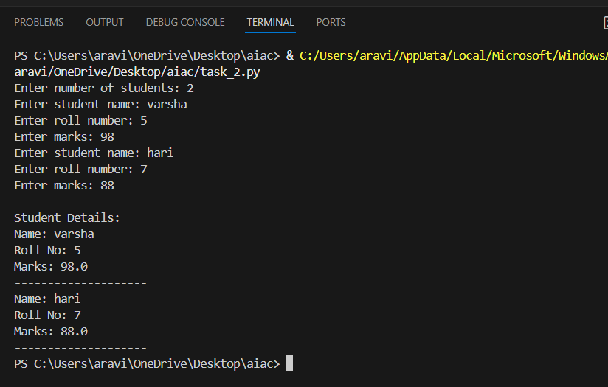

**Task Description #5  
•** Ask GitHub Copilot to generate a Python function that takes a string as input and returns the frequency of each word.

**Expected Output #5  
•** Python function that returns word frequency using a dictionary. Provide sample input and output.

**Prompt : Generate a Python function that takes a string as input and returns the frequency of each word.And alsothe input should be dynamic and display the frequency of each word.**

**CODE :**

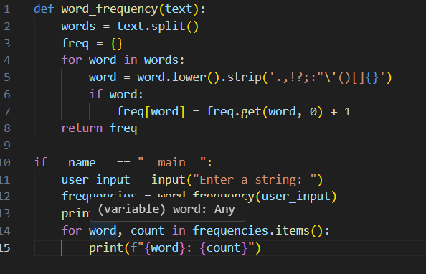

**OUTPUT :**

