Lab Test – 04
SET 5
Q1. Generate AI-assisted SQL for a Retail Store Inventory system.
• Tables: Products, Categories, Sales.
• Insert Data in to these three tables
• Write SQL to calculate total sales per category.
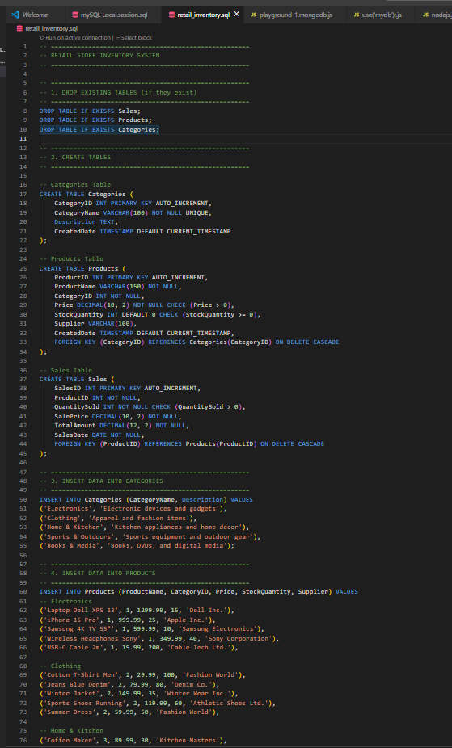
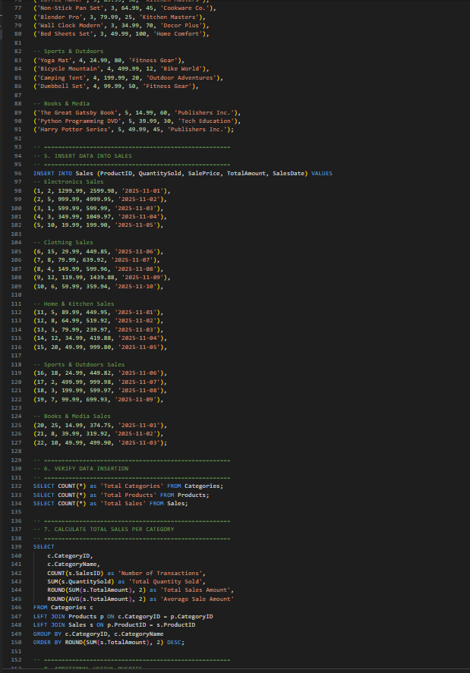
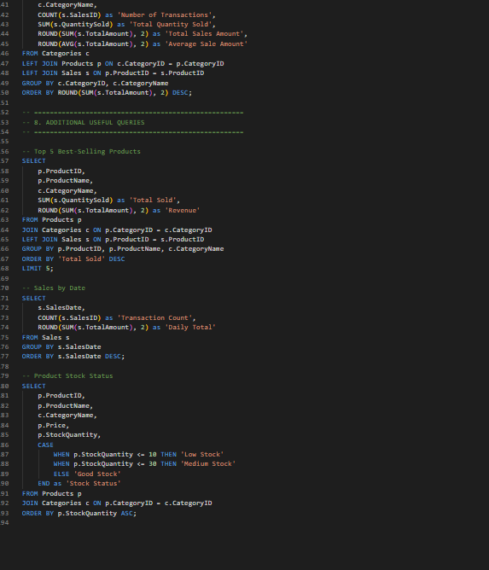
OUTPUT :
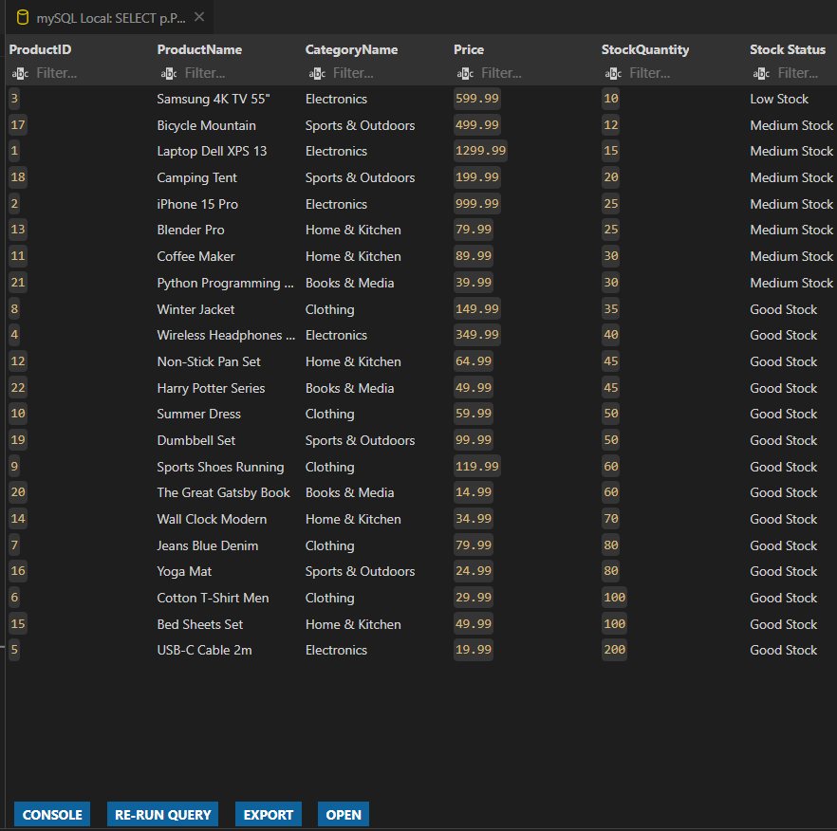
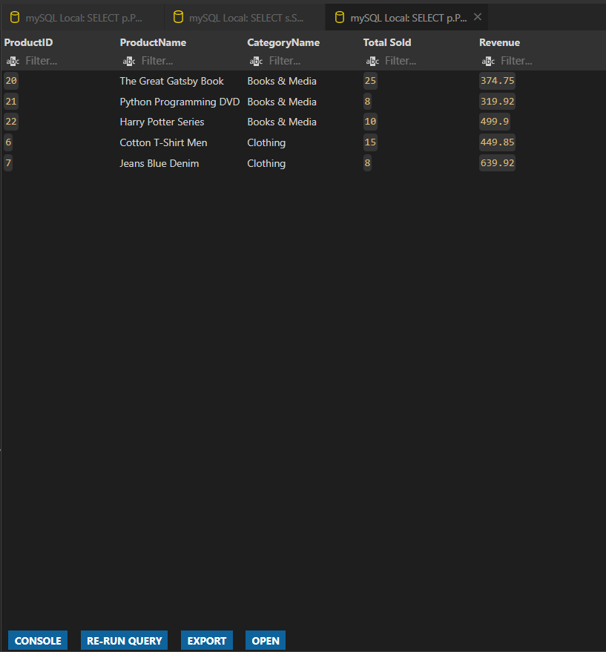
Q2. Use AI to convert a Python list comprehension that filters even numbers into equivalent
JavaScript code.
• Compare execution results and discuss differences in syntax and output.
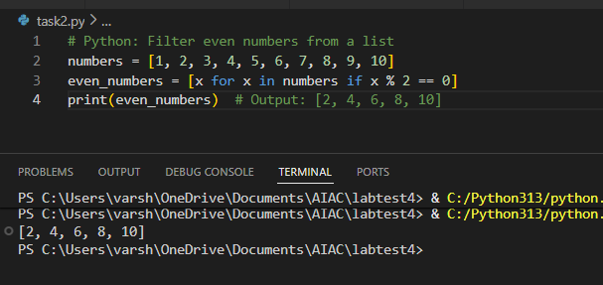
PYTHON :
JAVA SCRIPT :
