📘 SET 5
Q1. Prompt Engineering – Zero-shot (Scenario)
Your manager asks you to generate code that finds the highest-rated product from a list of ratings. Write an effective zero-shot prompt to achieve this.
(Include docs + comments + tests in the resulting code.)
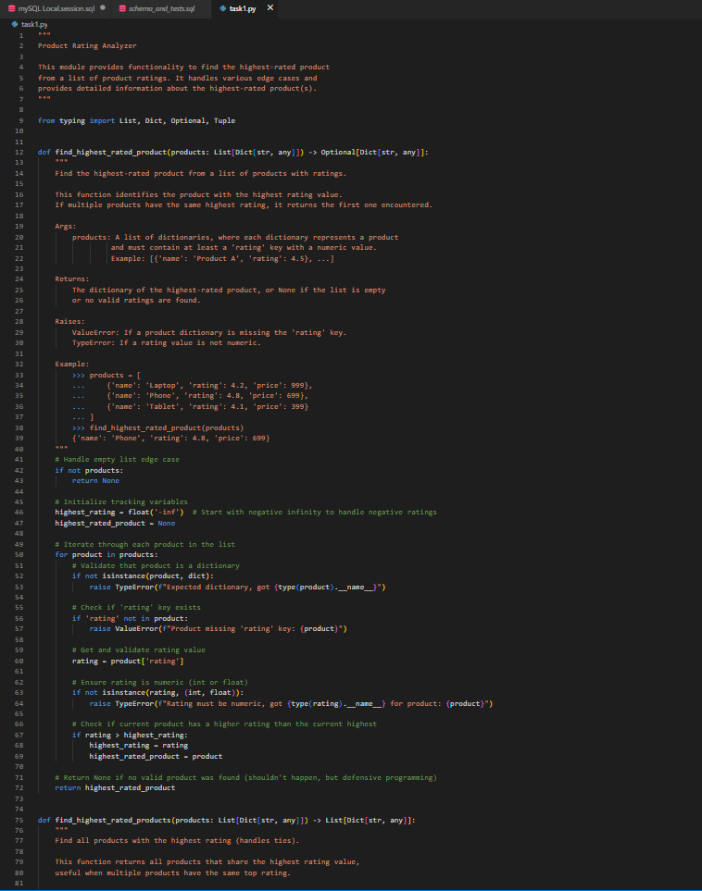
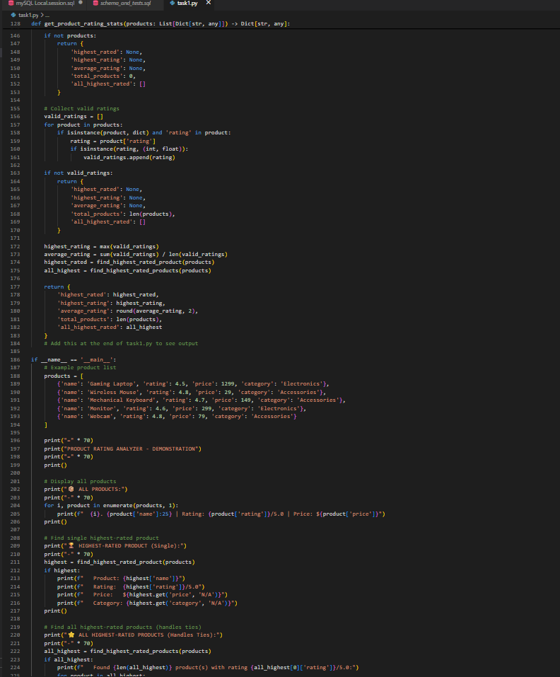
OUTPUT :
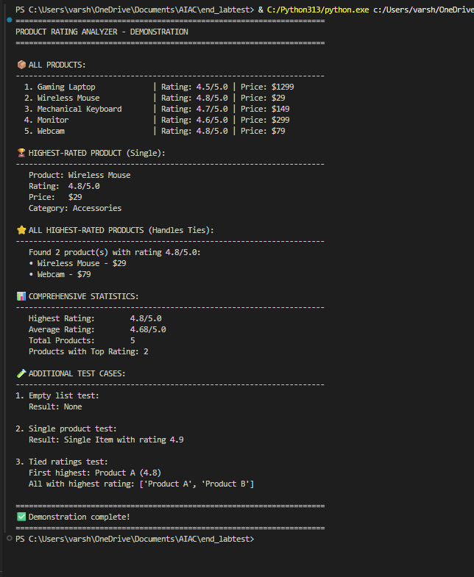
Q2. Database Design (Scenario)
A book shop wants a digital store. Use AI to design database tables for books, authors, and sales and generate SQL queries to:
- list best-selling books
- add a new author
- update stock
(Add comments + test queries.)
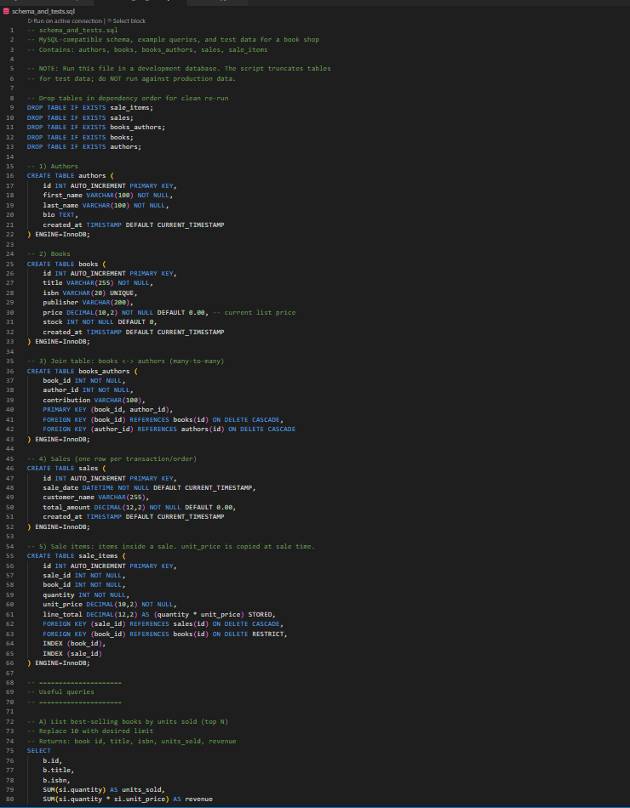
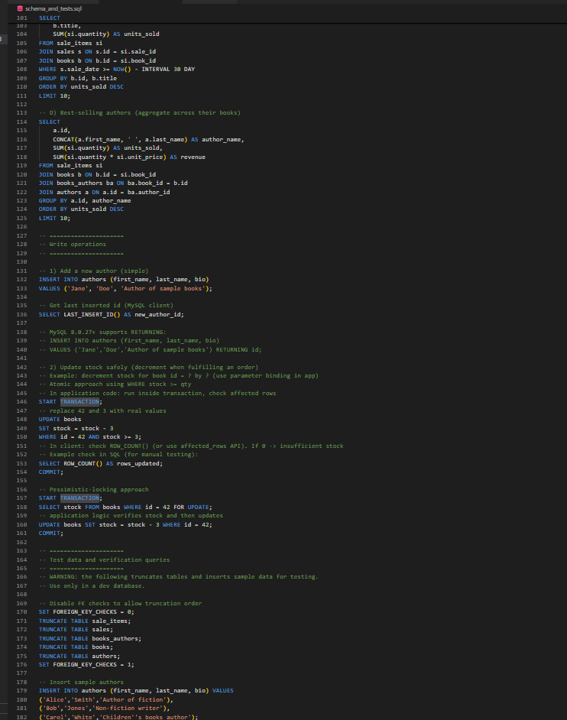
OUTPUT :
