|  |  |  |  |  |  |  |  |  |  |
| --- | --- | --- | --- | --- | --- | --- | --- | --- | --- |
| **]SCHOOL OF COMPUTER SCIENCE AND ARTIFICIAL INTELLIGENCE** | | | | | **DEPARTMENT OF COMPUTER SCIENCE ENGINEERING** | | | | |
| **ProgramName:**B. Tech | | | | **Assignment Type: Lab** | | | **AcademicYear:**2025-2026 | | |
| **CourseCoordinatorName** | | | | Venkataramana Veeramsetty | | | | | |
| **Instructor(s)Name** | | | | |  | | --- | | Dr. V. Venkataramana (Co-ordinator) | | Dr. T. Sampath Kumar | | Dr. Pramoda Patro | | Dr. Brij Kishor Tiwari | | Dr.J.Ravichander | | Dr. Mohammand Ali Shaik | | Dr. Anirodh Kumar | | Mr. S.Naresh Kumar | | Dr. RAJESH VELPULA | | Mr. Kundhan Kumar | | Ms. Ch.Rajitha | | Mr. M Prakash | | Mr. B.Raju | | Intern 1 (Dharma teja) | | Intern 2 (Sai Prasad) | | Intern 3 (Sowmya) | | NS_2 ( Mounika) | | | | | | |
| **rCourseCode** | | | 24CS002PC215 | **CourseTitle** | | AI Assisted Coding | | | |
| **Year/Sem** | | | II/I | **Regulation** | | R24 | | | |
| **Date and Day**  **of Assignment** | | | Week5- Wednesday | **Time(s)** | |  | | | |
| **Duration** | | | 2 Hours | **Applicableto**  **Batches** | |  | | | |
| **AssignmentNumber:9.3**(Present assignment number)/**24**(Total number of assignments) | | | | | | | | | |
|  | | | | | | | | | |
|  | | | | | | | | | |
|  | **Q.No.** | **Question** | | | | | | ***ExpectedTime***  ***to complete*** |  |
|  | 1 | Lab 8: Documentation Generation: Automatic documentation and code comments  **Lab Objectives:**   * To understand the importance of documentation and code comments in software development. * To explore how AI-assisted coding tools can generate meaningful documentation and inline comments. * To practice generating function-level and module-level docstrings automatically. * To evaluate the quality, accuracy, and limitations of AI-generated documentation. * To develop a small automated tool for documentation generation in Python..     **Lab Outcomes (LOs):**  After completing this lab, students will be able to:   * Apply AI-assisted coding tools to generate docstrings and inline comments for Python code. * Critically analyze AI-generated documentation for correctness, completeness, and readability. * Create structured documentation (function-level, module-level) following standard formats. * Design and implement a mini documentation generator tool to automate code commenting and docstring creation.   **Task Description#1 Basic Docstring Generation**   * Write python function to return sum of even and odd numbers in the given list. * Incorporate manual **docstring** in code with Google Style * Use an AI-assisted tool (e.g., Copilot, Cursor AI) to generate a docstring describing the function. * Compare the AI-generated docstring with your manually written one.   **Expected Outcome#1:** Students understand how AI can produce function-level documentation.  **Task Description#2 Automatic Inline Comments**   * Write python program for **sru_student** class with attributes like name, roll no., hostel_status and **fee_update** method and **display_details** method. * Write comments manually for each line/code block * Ask an AI tool to add inline comments explaining each line/step. * Compare the AI-generated comments with your manually written one.   **Expected Output#2:** Students critically analyze AI-generated code comments.  **Task Description#3**   * Write a Python script with 3–4 functions (e.g., calculator: add, subtract, multiply, divide). * Incorporate manual **docstring** in code with NumPy Style * Use AI assistance to generate a module-level docstring + individual function docstrings. * Compare the AI-generated docstring with your manually written one.   **Expected Output#3:** Students learn structured documentation for multi-function scripts  **Push documentation whole workspace as .md file in GitHub Repository**  **Note: Report should be submitted a word document for all tasks in a single document with prompts, comments & code explanation, and output and if required, screenshots** | | | | | | Week4 - Wednesday |  |

**Task Description#1 Basic Docstring Generation**

* Write python function to return sum of even and odd numbers in the given list.
* Incorporate manual **docstring** in code with Google Style
* Use an AI-assisted tool (e.g., Copilot, Cursor AI) to generate a docstring describing the function.
* Compare the AI-generated docstring with your manually written one.

**Expected Outcome#1:** Students understand how AI can produce function-level documentation.

**Prompt :** Generate docstring that describes the whole code.

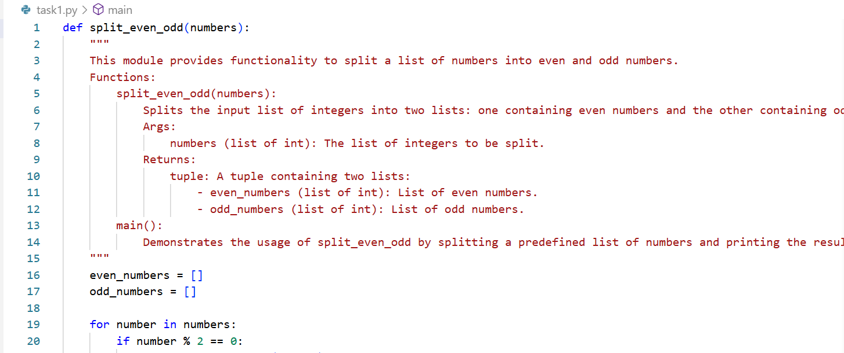

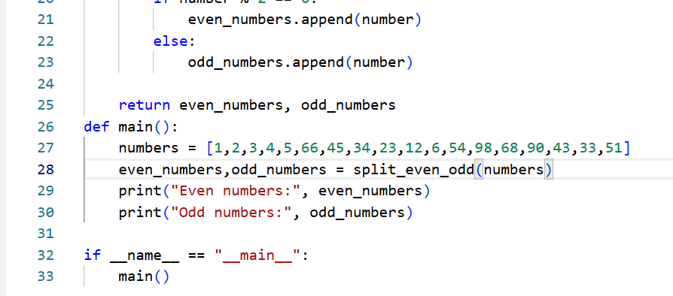

**Task Description#2 Automatic Inline Comments**

* Write python program for **sru_student** class with attributes like name, roll no., hostel_status and **fee_update** method and **display_details** method.
* Write comments manually for each line/code block
* Ask an AI tool to add inline comments explaining each line/step.
* Compare the AI-generated comments with your manually written one.

**Expected Output#2:** Students critically analyze AI-generated code comments.

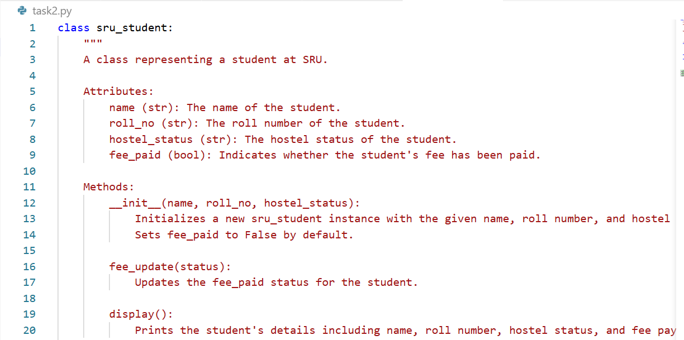

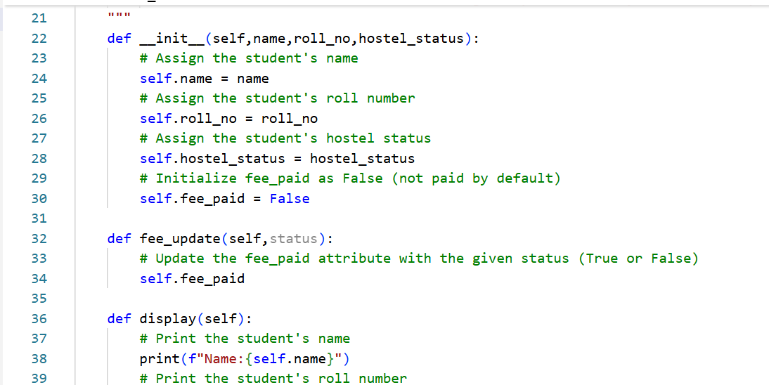

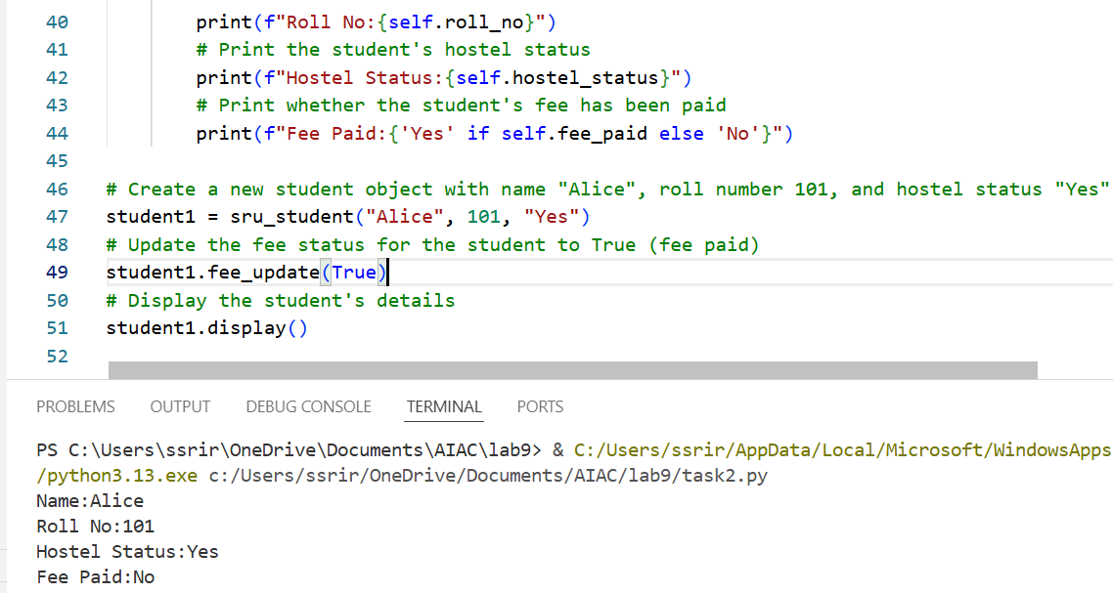

**Task Description#3**

* Write a Python script with 3–4 functions (e.g., calculator: add, subtract, multiply, divide).
* Incorporate manual **docstring** in code with NumPy Style
* Use AI assistance to generate a module-level docstring + individual function docstrings.
* Compare the AI-generated docstring with your manually written one.

**Expected Output#3:** Students learn structured documentation for multi-function scripts.

**Module level docstring:**

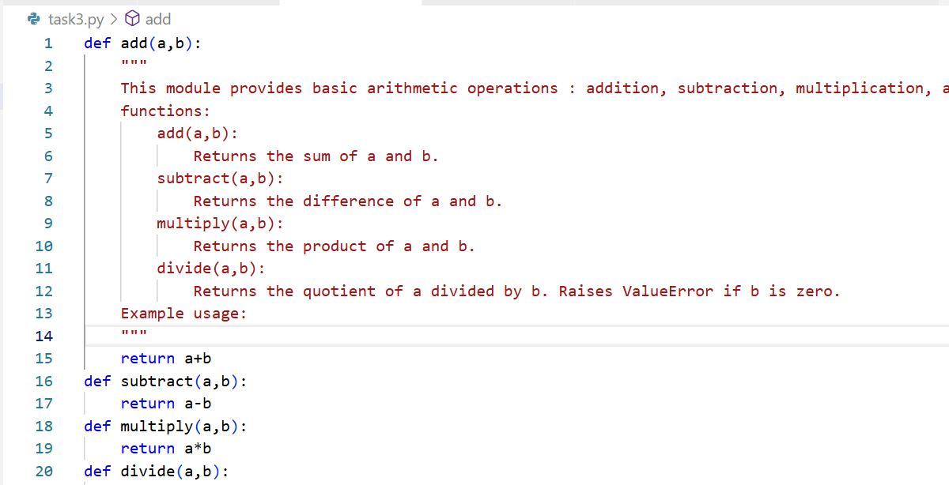

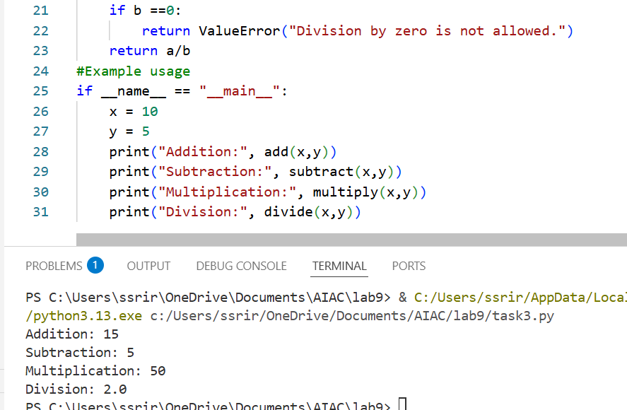

**Individual function doc string:**

