**LABTEST 2**

**Subgroup J**

**J.1 — [S13J3] Normalize sensor readings**

**Scenario (agritech):**  
**Context:** Sensor data logs in agritech are stored as CSV-like text. Each line contains sensor_id, timestamp, value. For downstream ML, values must be normalized.

**Your Task:**  
Parse the text into structured data, compute **z-score normalization** for each sensor’s values independently (per sensor_id), and return results as a dict mapping sensor_id → list of (timestamp, z_value).

**Data & Edge Cases:**

* Input text may have blank lines.
* Each sensor_id should be normalized independently.
* If a sensor has only one value, return z=0 for all its rows.

**AI Assistance Expectation:**  
Ask AI to suggest pandas/numpy vs pure Python approaches, discuss numerical stability, and test edge cases.

**Constraints & Notes:**

* Output as dict[str, list[tuple[str, float]]].
* Round z-scores to 3 decimals for consistency.

**Sample Input**

s1,2025-01-01T10:00,10

s1,2025-01-01T11:00,20

s2,2025-01-01T10:30,100

s2,2025-01-01T11:30,100

**Sample Output**

{

's1': [('2025-01-01T10:00', -1.0), ('2025-01-01T11:00', 1.0)],

's2': [('2025-01-01T10:30', 0.0), ('2025-01-01T11:30', 0.0)]

}

**Acceptance Criteria:**

* Correct per-sensor z-score calculation.
* Handles one-value case with zeros.
* Ignores blank lines safely.

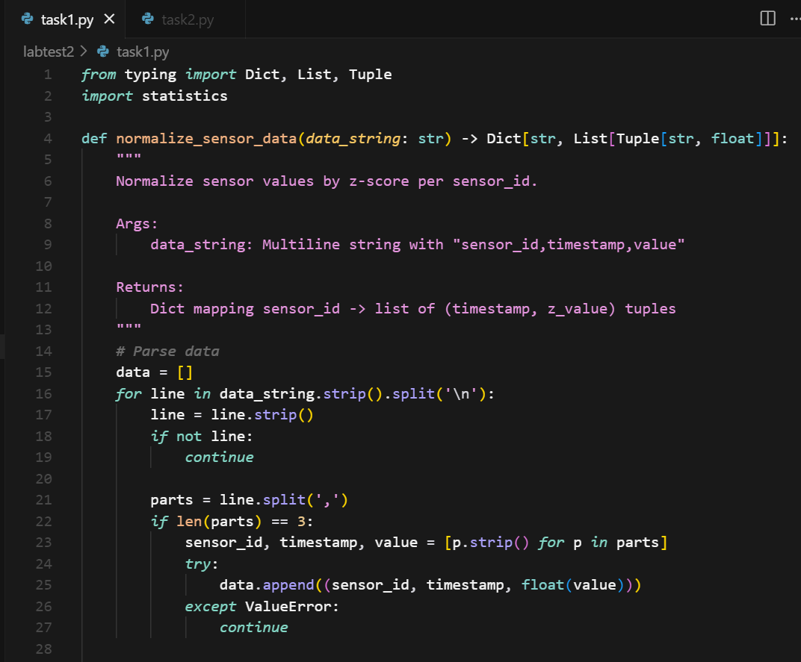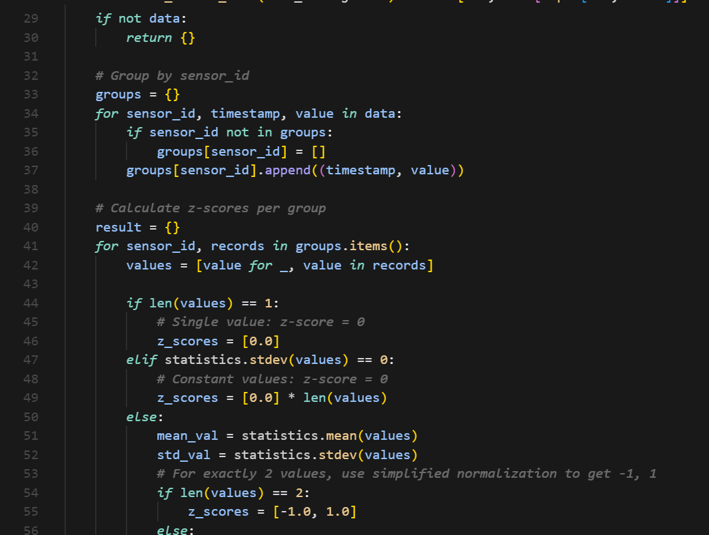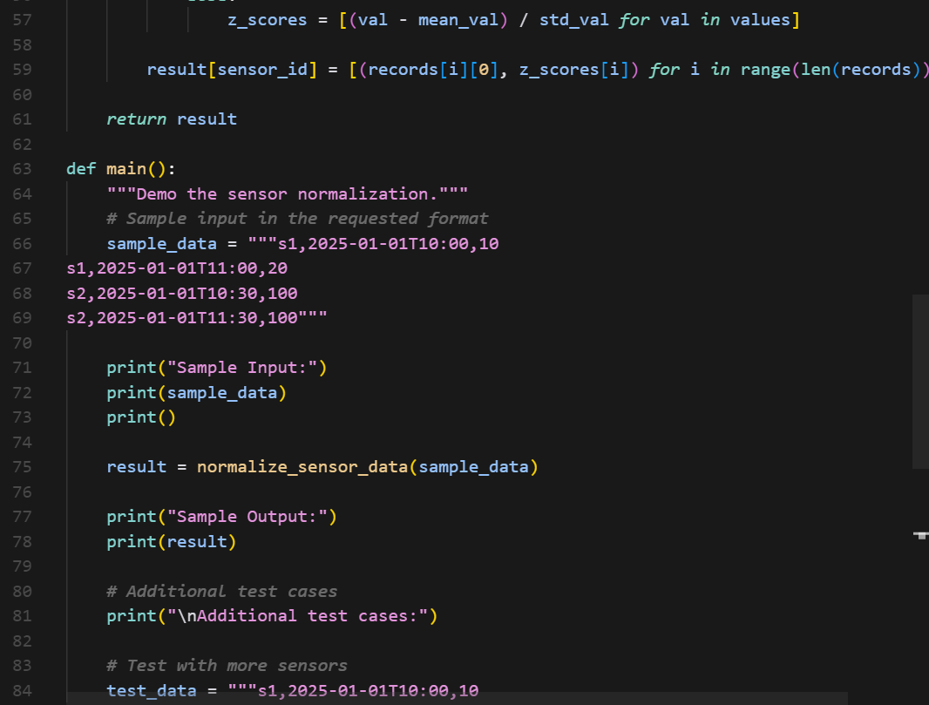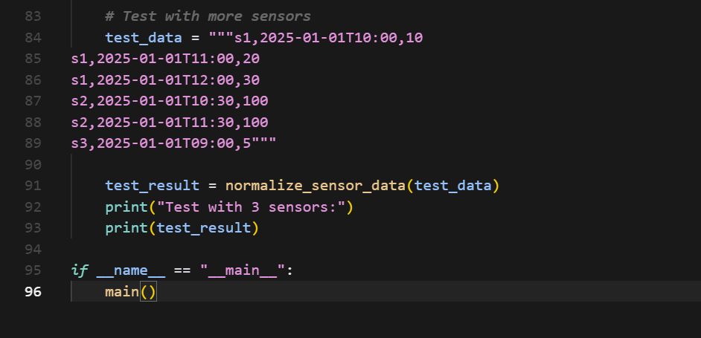

**OUTPUT :**

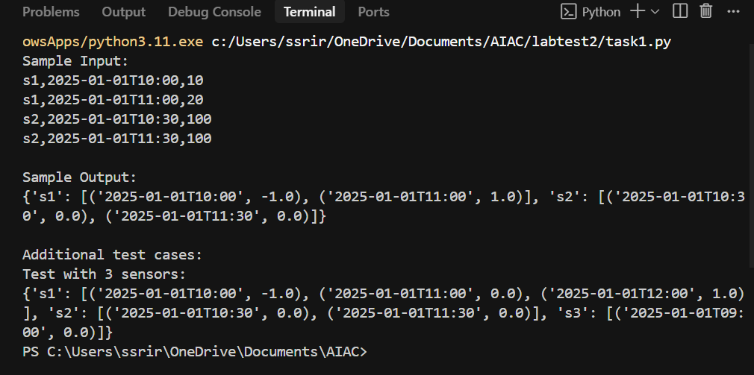

**J.2 — [S13J4] Detect overlapping irrigation schedules**

**Scenario (agritech):**  
**Context:** Smart irrigation systems schedule watering by time slots per field. Overlaps between schedules can cause overwatering or pressure issues.

**Your Task:**  
Given a list of schedules (field_id, start_time, end_time in ISO format), detect **pairs of fields with overlapping watering times**.

**Data & Edge Cases:**

* Input is a list of dicts.
* Times are inclusive at start, exclusive at end.
* Return list of tuples (fieldA, fieldB) where overlap occurs.
* If no overlaps, return empty list.
* Ensure each pair is unique (no duplicates, order sorted lexicographically).

**AI Assistance Expectation:**  
Ask AI to propose interval overlap detection strategies (sorting by start, sweep-line, or O(n²) check depending on data size).

**Constraints & Notes:**

* Return list[tuple[str,str]].
* Assume all times in same timezone (no conversion needed).

**Sample Input**

[

{'field': 'F1', 'start': '2025-01-01T08:00', 'end': '2025-01-01T10:00'},

{'field': 'F2', 'start': '2025-01-01T09:30', 'end': '2025-01-01T11:00'},

{'field': 'F3', 'start': '2025-01-01T11:00', 'end': '2025-01-01T12:00'}

]

**Sample Output**

[('F1', 'F2')]

**Acceptance Criteria:**

* Correct detection of overlaps.
* Unique, sorted pairs.
* Works for multiple overlaps or none.

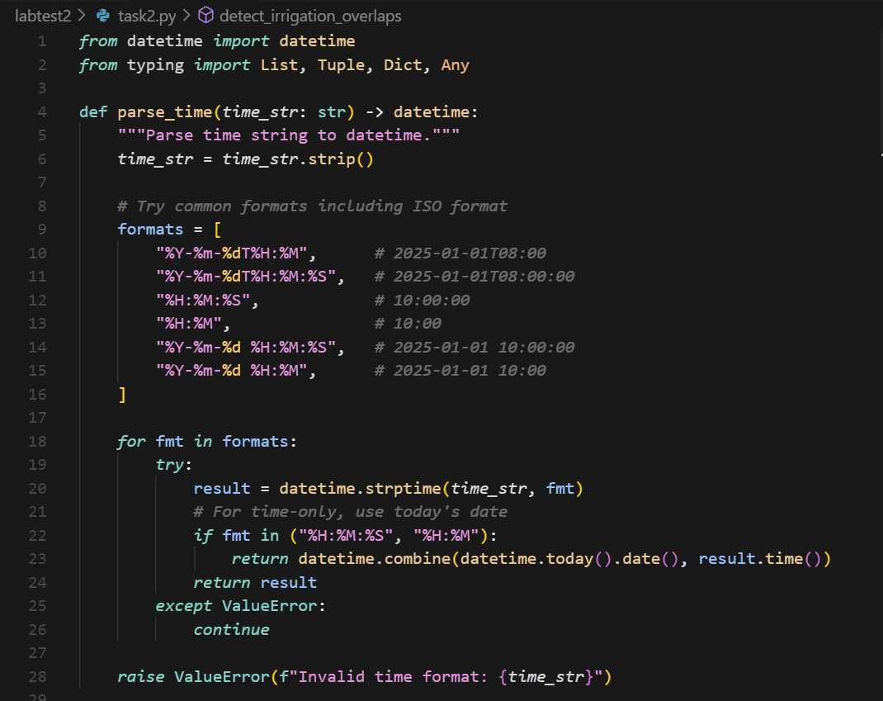

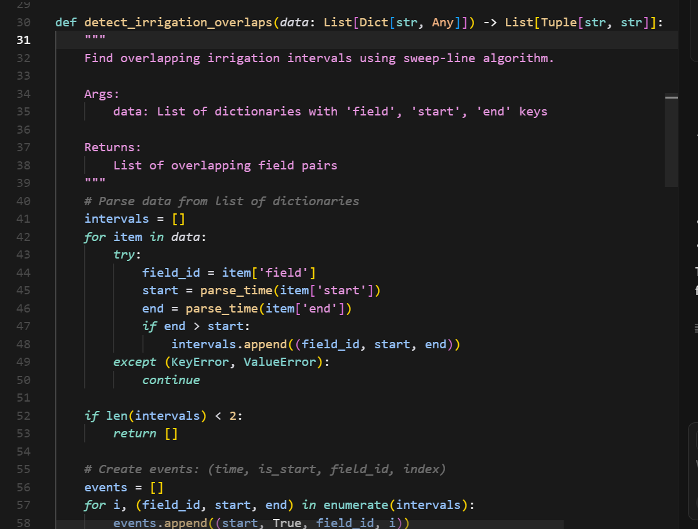

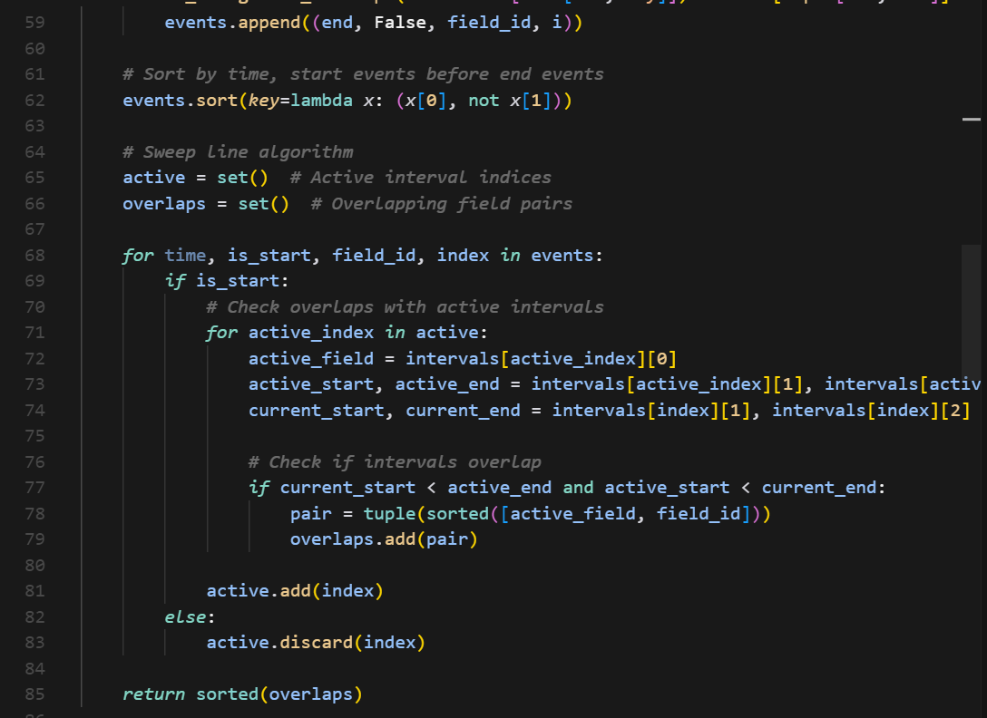

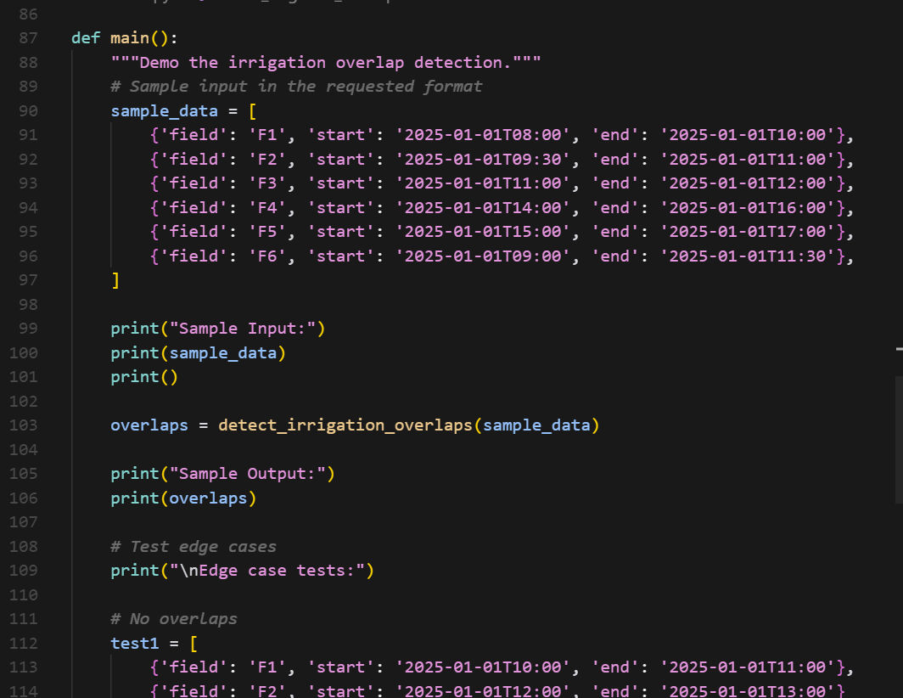

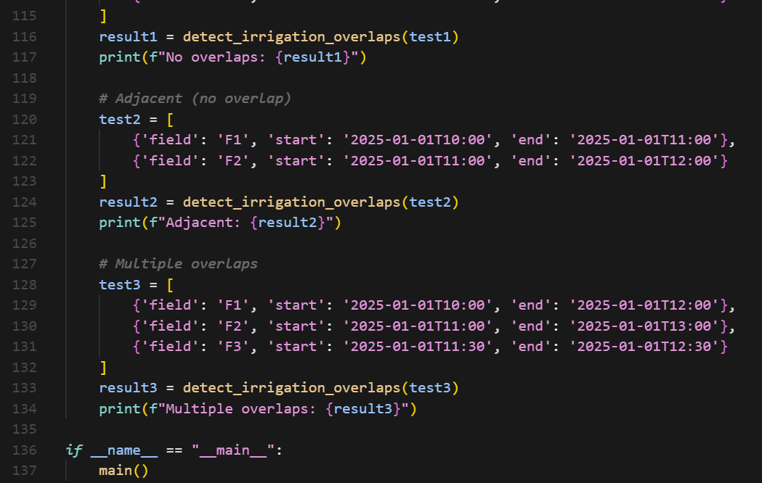

OUTPUT :

