Software Architecture and Design Specification (SAD)
Hostel Management System
Project: Hostel Management System | Version 1.1 | Status: Updated draft for team review

Document purpose | Describes the proposed architecture, modules, data model, workflows, and API contracts for the HMS.
Prepared by | Project team: Aditya Singhal (Dev Lead), Varshitha S (QA Lead), Shailaja (Tester), Krishna Tejas Voruganti (Product Owner)
Version / date | 1.1 / 10 October 2026
Status | Updated draft — diagrams and traceability added; confirm against implementation

1. Introduction

1.1 Purpose
This document translates the Hostel Management System requirements into a practical design that can be implemented and tested during the two course sprints.

1.2 Scope
The design covers the committed MVP: student records, room management, room allocation/change/vacating, search/filter, dashboard summaries, backend validation, and basic security/error handling. Fee tracking, student-facing login/self-service, and allocation history are conditional extensions and are included only if the team and instructor approve them. The selected stack in this draft is React.js, Node.js/Express.js, and MongoDB; confirm it matches the actual repository before final submission.

1.3 Design Principles
- Keep UI, business rules, and database access separate.
- Validate important rules in the backend even if the frontend also validates them.
- Treat room capacity and active allocation as integrity constraints.
- Use clear API responses and meaningful error messages.
- Keep the MVP small enough to demonstrate in the scheduled sprints.

2. Architecture

2.1 Architecture Pattern
Recommended pattern: three-layer web architecture.
Layer | Responsibilities | Examples
Presentation layer | Displays screens, gathers user input, shows validation and results. | Dashboard, Students page, Rooms page, Allocation form
Application/business layer | Validates requests, enforces permissions and allocation rules, coordinates operations. | Student service, Room service, Allocation service, Fee service if included
Data layer | Persists and retrieves records; enforces unique identifiers and relationships. | Student, Room, Allocation, FeeStatus tables/collections

2.2 Logical Component Diagram (text specification)
Admin/Warden or Student → Frontend Web UI → Backend REST API → Business Services → Database. The backend API routes requests to Student Management, Room Management, Allocation Management, and optional Fee Management. Authentication/Authorization protects restricted routes if login is implemented.
Figure 1. HMS logical component diagram. The diagram shows the proposed three-layer architecture and the optional modules that should only be built if approved.
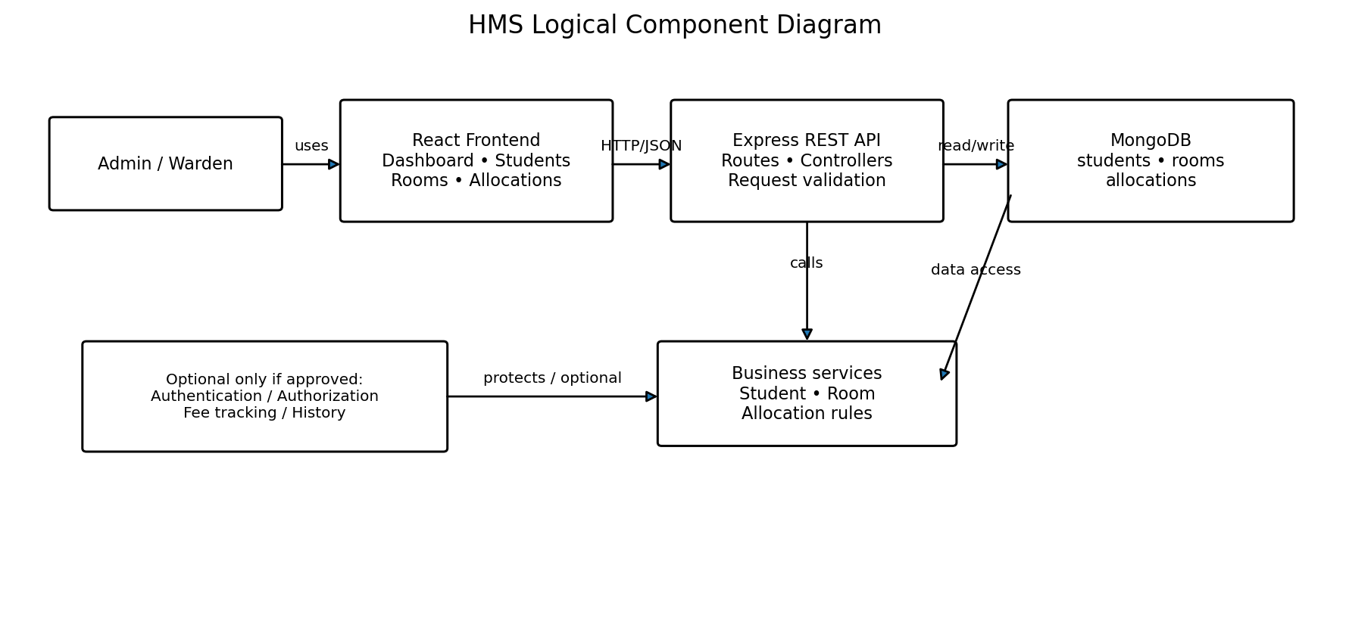

2.3 Component Descriptions
Component | Main responsibility | Key rules
Frontend UI | Forms, tables, filters, dashboard and feedback messages. | Do not rely on frontend validation alone.
Student Management | Create, read, update, search student details. | Student ID must be unique; validate required fields.
Room Management | Create and list rooms; show capacity and occupancy. | Room number unique; capacity must be a positive integer.
Allocation Management | Allocate, change, and vacate rooms. | No allocation above capacity; no duplicate active allocation for a student.
Fee Management (optional) | Maintain fee amount and Paid/Pending status. | Validate amount and allowed status values.
Authentication/Authorization (if included) | Identify user and enforce permitted operations. | Only authorized roles may perform admin actions.
Database | Store related records and preserve consistency. | Use keys/relationships and appropriate constraints.

2.4 Technology Stack
Selected stack in this design: React.js frontend, Node.js runtime with Express.js backend, and MongoDB database (MERN stack). Confirm that the team has adopted this stack. If the repository uses a different stack, update this section, the component diagram, data design, API contracts, and test environment together.
Recommended project structure:
• frontend/ — React application and reusable UI components.
• backend/ — Express application, routes, controllers/services, models, and database connection.
• .env — local configuration such as PORT and MONGODB_URI; do not commit this file.
• README.md — prerequisites, setup steps, run commands, API overview, and test instructions.
Suggested MongoDB collections: students, rooms, allocations, and fees (only if fee tracking is included). Store references such as studentId and roomId in allocation documents. Enforce one active allocation per student and ensure active allocations never exceed room capacity; perform these checks in the backend.
Area | Proposed option | Team action
Frontend | React.js | Build pages/components and call backend APIs.
Backend | Node.js + Express.js | Implement REST APIs, validation, and allocation rules.
Database | MongoDB | Store students, rooms, allocations, and optional fees.
Source control | GitHub repository and pull requests | Required by deliverables
Diagrams | draw.io or PlantUML | Export and insert diagrams
Testing | Manual test cases; API test tool such as Postman if available | Record evidence/results

3. Data Design

3.1 Entities and Attributes
Entity | Suggested fields | Notes / constraints
Student | studentId, fullName, email, phone, course, year, status, createdAt | studentId unique; required fields validated.
Room | roomId, roomNumber, block, floor, capacity, status | roomNumber unique; capacity > 0.
Allocation | allocationId, studentId, roomId, startDate, endDate, status | One active allocation per student; endDate blank for active record.
FeeRecord (optional) | feeId, studentId, amount, dueDate, paymentStatus, updatedAt | paymentStatus restricted to agreed values such as Paid/Pending.

3.2 Relationships
- A Student may have multiple historical Allocation records over time, but at most one active allocation at a time.
- A Room may be referenced by many historical allocations, but the number of active allocations must not exceed its capacity.
- A Student may have zero or more FeeRecord entries if fee tracking is implemented.
Figure 2. Logical data model. FeeRecord is optional; enforce uniqueness for studentId and roomNumber and enforce allocation integrity in backend business logic.
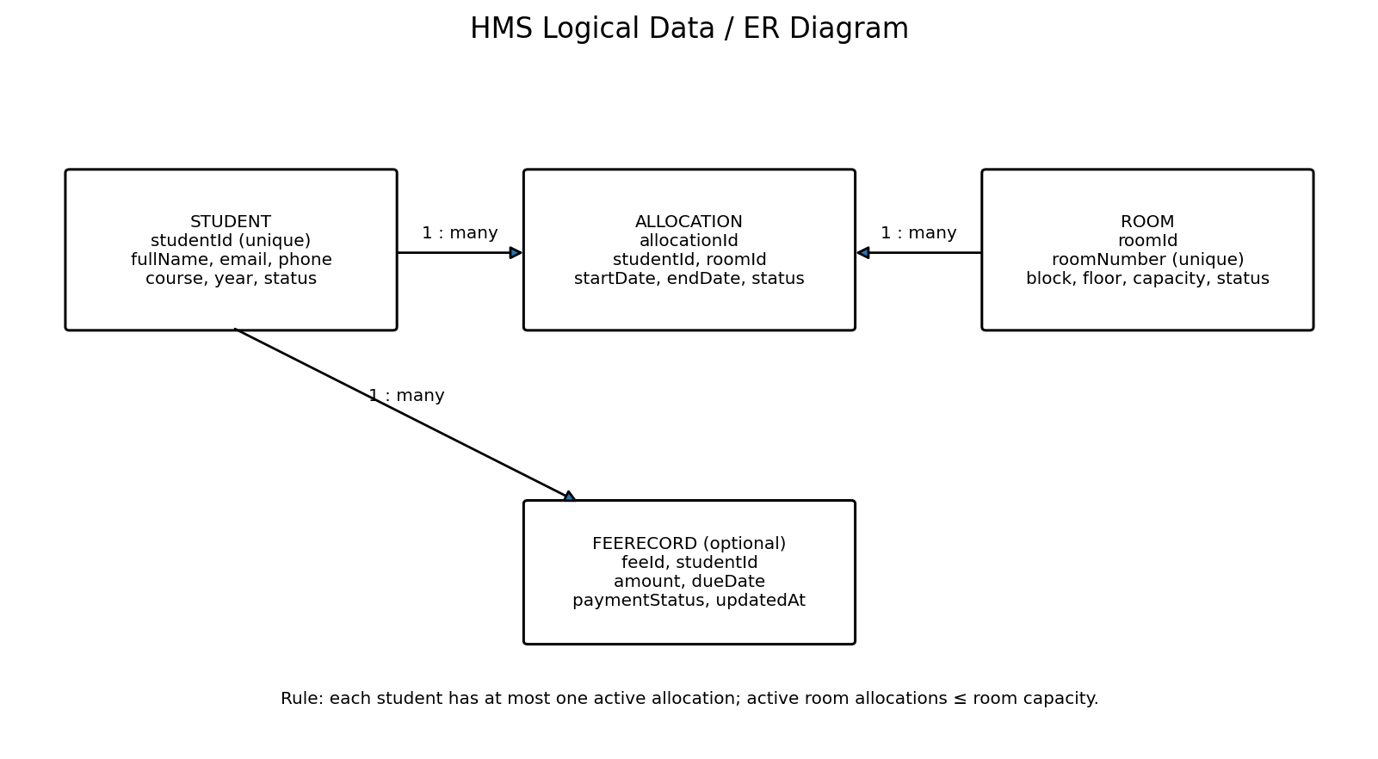

4. Design Workflows

4.1 Student Registration
- Admin opens the student form and enters required details.
- Frontend checks obvious missing/invalid fields and submits the request.
- Backend validates the payload and checks whether the student ID already exists.
- If valid, the backend saves the student and returns success; otherwise it returns a validation/conflict error.
- Frontend displays the result and refreshes the student list.

4.2 Room Allocation
- Admin selects a student and a room.
- Backend confirms the student exists and has no active allocation.
- Backend retrieves the room and calculates current active occupancy.
- If available capacity is zero, the backend rejects the request without creating an allocation.
- If capacity is available, the backend creates the allocation and returns the updated allocation/occupancy information.
- Frontend displays a success or clear error message.

4.3 Vacating a Room
- Admin selects the active allocation and confirms the vacate action.
- Backend marks the allocation as ended and records the end date/status.
- Room availability is recalculated from active allocations.
- Frontend refreshes the student allocation and room availability views.

4.4 Sequence Diagram Specifications
Sequence Diagram 1 — Allocate room: the inserted diagram shows the Admin, React UI, Allocation API/Service, student/room data, and allocation data interactions, including rejection paths.
Sequence Diagram 2 — Register student: the inserted diagram shows the Admin, React UI, Student API/validation, and MongoDB interactions, including invalid-input and duplicate-ID outcomes.
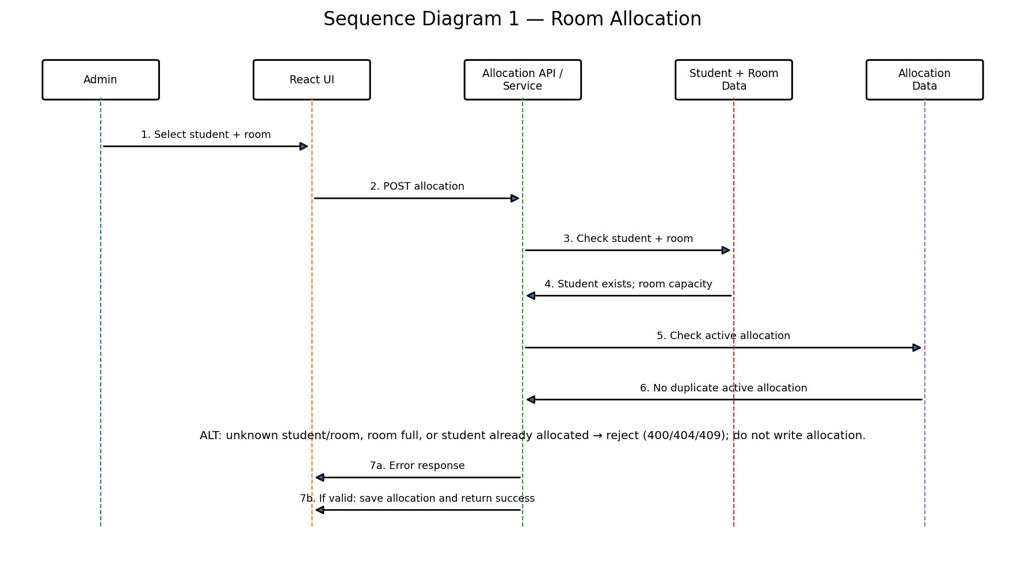
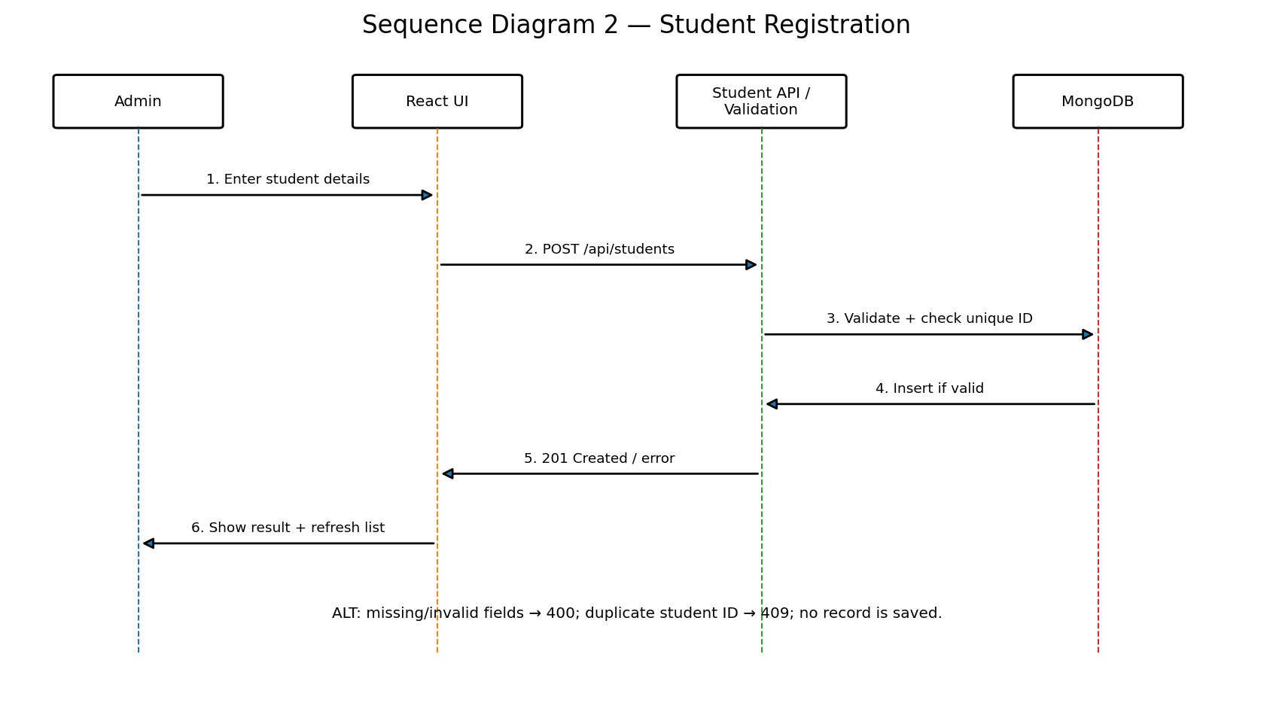

5. API Design (proposed REST examples)
These are proposed endpoint contracts, not evidence that the endpoints already exist. Before submission, compare each path, request field, and response code with the actual backend and update the table to match the implemented code.
Method / endpoint | Purpose | Example request fields | Expected response / errors
GET /api/students | List/search students | Optional query: search | 200 list; 500 server error
POST /api/students | Create student | studentId, fullName, email, phone, course, year | 201 created; 400 validation error; 409 duplicate ID
GET /api/rooms | List rooms and availability | Optional availability filter | 200 list with capacity/occupancy
POST /api/rooms | Create room | roomNumber, block, floor, capacity | 201 created; 400 invalid capacity; 409 duplicate room
POST /api/allocations | Allocate student | studentId, roomId, startDate | 201 created; 400 invalid input; 404 unknown student/room; 409 full room or active allocation
PATCH /api/allocations/{id}/vacate | End allocation | endDate or confirmation fields as agreed | 200 updated; 404 allocation not found; 409 already inactive
GET /api/dashboard | Dashboard counts | None | 200 summary counts

6. Error Handling, Logging and Security
- Return consistent JSON errors with a human-readable message and suitable HTTP status codes.
- Validate data in the backend and reject malformed IDs, missing required fields, negative capacities, and invalid status values.
- Do not include passwords, secrets, or unnecessary personal data in logs.
- Keep environment-specific credentials in environment variables and do not commit them to GitHub.
- If login is implemented, protect administrative endpoints and verify authorization on the backend.
- Handle database/API failures without showing stack traces to end users.

7. Risks and Mitigations
Risk | Impact | Mitigation
Scope expands beyond sprint time | Core features may remain unfinished | Prioritize student CRUD, rooms, and allocation for MVP.
Frontend/backend contracts differ | Integration delays | Agree API fields and response formats early; use sample responses.
Room occupancy becomes inconsistent | Incorrect room availability | Calculate from active allocations and test capacity boundaries.
Merge conflicts or unreviewed changes | Broken main branch | Use feature branches, pull requests, and repo-owner review.
Database configuration issue | Application fails to start | Document setup and provide sample environment configuration without secrets.

8. Traceability to Requirements
SRS requirement | Design component | Design evidence
HMS-FR-001 | Student Management | Student entity; POST /api/students; registration workflow
HMS-FR-002 | Student Management | GET /api/students and student detail view
HMS-FR-003 | Student Management | Update student workflow and validation
HMS-FR-004 | Student Management / Search | Search by student ID or name
HMS-FR-005 | Room Management | Room entity; unique room number; positive capacity validation
HMS-FR-006 | Room Management / Allocation Service | Occupancy and remaining capacity derived from active allocations
HMS-FR-007 | Allocation Management | POST /api/allocations and successful allocation workflow
HMS-FR-008 | Allocation Management | Reject allocation when room has no remaining capacity
HMS-FR-009 | Allocation Management | Reject a second active allocation for the same student
HMS-FR-010 | Allocation Management | Close old allocation and create new allocation for room change
HMS-FR-011 | Allocation Management | Vacate workflow; mark allocation inactive/end date
HMS-FR-012 (optional) | Fee Management | FeeRecord entity and fee workflow only if approved
HMS-FR-013 | Search / Filter | Room availability and allocation-status filters
HMS-FR-014 (conditional) | Authentication / Authorization | Protect administrative routes if login is implemented
HMS-FR-015 | Dashboard | GET /api/dashboard; counts and capacity summary
HMS-FR-016 | Frontend + Backend Validation | Required-field and invalid-input handling
HMS-FR-017 (optional) | Allocation History | Historical allocation view only if approved
HMS-NFR-001 | Frontend UI | Clear labels and common-task usability check
HMS-NFR-002 | API / Frontend | Measure common list/search response time against 3-second target
HMS-NFR-003 | Allocation Service / Data Layer | Capacity and active-allocation integrity rules
HMS-NFR-004 | Security | Authentication/access controls and password handling if implemented
HMS-NFR-005 | Code Structure / README | Separate UI, API/business logic, and data access; document setup
HMS-NFR-006 | Frontend | Check core workflows in agreed Chromium-based browser
HMS-NFR-007 | Frontend + Backend Validation | Reject invalid fields, capacities, IDs, and statuses
HMS-SR-001 | Authentication / Authorization | Deny protected admin operations without authorization if login exists
HMS-SR-002 | Backend Validation | Validate request data at the server/API
HMS-SR-003 | Configuration / GitHub | Keep secrets in environment configuration; exclude .env from commits
HMS-SR-004 | Error Handling | Return safe messages without stack traces or sensitive details
HMS-SR-005 (conditional) | Authentication | Use password hashing if passwords are stored

9. Open Issues
- Confirm that the stack and database described in this document match the actual GitHub repository.
- Record the team's final decision on authentication, student self-service, fee tracking, and allocation history; keep unapproved extensions out of the committed MVP.
- Check that the inserted component, ER, and two sequence diagrams remain readable in the exported PDF.
- Update all proposed API contracts to match the actual implementation before final submission.
Reference basis: course-provided SAD template and the Hostel Management System SRS v1.1 draft. Confirm architecture and API details against the actual implementation before submission.

Team Responsibility Alignment
Aditya is the Dev Lead and implements both frontend and backend. Varshita is the QA Lead and reviews test coverage, the RTM, CI quality checks, and testing evidence. Shailaja is the Tester and owns API test scripts, execution logs, defect reports, and retesting. Krishna is the Product Owner and owns scope decisions, backlog priority, acceptance criteria, sprint sign-offs, and the demo script. This role split does not change the proposed architecture; API contracts and modules must still be checked against the implementation before final submission.

