Software Requirements Specification (SRS)
Hostel Management System
Project: Hostel Management System | Version 1.1 | Status: Updated draft for team review

Document purpose | Defines the functions, interfaces, constraints, and acceptance criteria for the Hostel Management System.
Prepared by | Aditya Singhal (Dev Lead), Varshitha S (QA Lead), Shailaja (Tester), Krishna Tejas Voruganti (Product Owner)
Date | 10 October 2026 (update if required by course submission)
Status | Draft — confirm scope and features with instructor/team

Approvals
Role | Name | Signature/Date
QA Lead | Varshitha S | To be signed / dated
Dev Lead | Aditya Singhal | To be signed / dated
Product Owner | Krishna Tejas Voruganti | To be signed / dated

1. Introduction

1.1 Purpose
This SRS describes the requirements for a Hostel Management System (HMS) intended to manage student records, hostel rooms, room occupancy, and room allocations. It provides a shared reference for the project team and evaluator.

1.2 Scope
Core MVP scope: an authorized administrator/warden can create, view, update, and search student records; maintain room records; view capacity and availability; allocate students; change or end allocations; filter records; and view a dashboard summary. Fee tracking, student-facing login/self-service, and allocation history are optional extensions and are excluded from the committed MVP unless the team and instructor explicitly approve them.
Out of scope for the initial mini-project unless approved by the instructor: real payment gateway integration, biometric access, production identity verification, integration with university ERP, and deployment to a live hostel.

1.3 Intended Audience
- Project team and project guide/instructor.
- Developer (Aditya), responsible for both frontend and backend.
- Tester (Shailaja) executes assigned tests and records results; QA Lead (Varshita) reviews test coverage and quality evidence.
- Users evaluating the requirements and working product.

1.4 Definitions and Acronyms
Term | Meaning
HMS | Hostel Management System
FR | Functional Requirement — a capability the system must provide
NFR | Non-Functional Requirement — a quality or constraint on the system
Admin/Warden | Authorized person who manages hostel data and room allocation
Occupancy | Number of students currently allocated to a room
RTM | Requirements Traceability Matrix linking requirements to design and tests
CRUD | Create, Read, Update, Delete

2. Overall Description

2.1 Product Perspective
The HMS is a small web-based application. The frontend presents forms and dashboards; the backend validates requests and applies allocation rules; and a database stores student, room, allocation, and fee-status records.

2.2 Product Functions
- Protect administrative actions with authentication/authorization if authentication is included in the agreed implementation; otherwise document this as a known limitation of the academic demo.
- Create, view, update, and search student records.
- Create and maintain hostel room records, including room number, capacity, and status.
- Show room availability and current occupancy.
- Allocate a student to an available room without exceeding room capacity.
- Prevent duplicate active room allocations for the same student.
- Record room changes and vacating/deallocation of a room.
- Optional extension only if approved: maintain basic hostel fee amount and payment status (Paid/Pending).
- Search and filter students, rooms, and allocations.
- Provide a summary of occupied and available rooms.

2.3 User Classes and Characteristics
User class | Responsibilities | Access level
Administrator/Warden | Manage student records, rooms, and allocations; view availability and dashboard summaries. Manage fee status only if the optional fee feature is approved. | Full authorized management access
Student (optional in MVP) | Optional: view own profile, allocation, history, or fee status only if student-facing login and these features are approved. | Limited self-service access; otherwise no student-facing account in the MVP.
Tester/Evaluator | Use test accounts and sample data to verify system behaviour. | Test/demo access as agreed by team

2.4 Operating Environment
Proposed technology stack (confirm with the team before baselining): React.js frontend, Node.js/Express.js REST API, and MongoDB. The frontend will call backend endpoints over HTTP during local development. The backend must validate requests and enforce allocation rules before changing records.
- Web browser on a laptop or desktop; responsive layout is desirable.
- Development environment may use a local frontend and backend server.
- Database technology and deployment environment must be selected by the team and recorded in the SAD.
- GitHub repository used for source control, issues/backlog, pull requests, and sprint evidence.

2.5 Constraints and Assumptions
- This is an academic mini-project; only sample/demo data should be used.
- The project team will agree on the technology stack before implementation.
- A room must have a positive capacity and occupancy must never exceed that capacity.
- Only authorized users should change allocation and administrative records.
- The project will be delivered in two sprints as specified in the course deliverables.
- Requirements may be refined in the backlog before Sprint 1; changes after sprint freeze must be documented.

3. External Interface Requirements

3.1 User Interface
- A dashboard showing total rooms, occupied rooms, available capacity, and student count.
- Student form with required-field validation and clear error messages.
- Room list showing room number, capacity, occupancy, and availability.
- Allocation form allowing an authorized user to select a student and a room.
- Search/filter controls and confirmation messages for create/update/deallocate actions.

3.2 Software Interfaces
The expected implementation uses React.js → Express.js REST API → MongoDB. React must not connect directly to MongoDB. API routes will be documented in the SAD and kept consistent with the implemented code.
The frontend communicates with the backend through HTTP API endpoints. The backend communicates with the selected database. Exact framework, database, endpoint paths, and request/response schemas must be finalized in the SAD before implementation.

3.3 Communication Interfaces
During local development, services may run on localhost. If deployed, use HTTPS where supported and keep credentials/secrets out of source control.

4. System Features and Functional Requirements
ID | Requirement | Priority | Acceptance criteria
HMS-FR-001 | The system shall allow an authorized administrator to create a student record with a unique student identifier. | High | Student record is saved and visible in the student list.
HMS-FR-002 | The system shall allow an authorized administrator to view student details. | High | Selecting a student displays the stored details.
HMS-FR-003 | The system shall allow an authorized administrator to update a student's permitted details. | High | Updated values persist after refresh.
HMS-FR-004 | The system shall allow an authorized administrator to search students by student identifier or name. | Medium | Matching records are shown; no-match search displays an appropriate message.
HMS-FR-005 | The system shall allow an authorized administrator to add a room with a unique room number and positive capacity. | High | Valid room is saved; duplicate room number or invalid capacity is rejected.
HMS-FR-006 | The system shall display room capacity, current occupancy, and remaining capacity. | High | Displayed values match the allocation records.
HMS-FR-007 | The system shall allow an authorized administrator to allocate a student to a room with available capacity. | High | Allocation is recorded and occupancy is updated.
HMS-FR-008 | The system shall reject allocation when the selected room has no remaining capacity. | High | No allocation is created and a clear error is shown.
HMS-FR-009 | The system shall prevent a student from having more than one active room allocation at a time. | High | A second active allocation is rejected until the current allocation is ended.
HMS-FR-010 | The system shall allow an authorized administrator to change a student's room allocation. | Medium | The previous allocation is closed and the new allocation is recorded without exceeding capacity.
HMS-FR-011 | The system shall allow an authorized administrator to mark a student as having vacated a room. | High | The active allocation ends and available capacity increases.
HMS-FR-012 | The system shall allow an authorized administrator to update basic hostel fee amount and payment status, if fee tracking is included in the MVP. | Medium | The selected student's fee status is saved and displayed correctly.
HMS-FR-013 | The system shall provide filters for room availability and allocation status. | Medium | The list shows only records matching the selected filter.
HMS-FR-014 | The system shall require authorized access for administrative create, update, allocation, and deallocation actions when authentication is implemented. | High | Unauthenticated or unauthorized requests are denied.
HMS-FR-015 | The system shall display a dashboard summary of student count, room count, occupancy, and available capacity. | Medium | Summary values agree with stored records.
HMS-FR-016 | The system shall validate required fields and show understandable messages for invalid or incomplete input. | High | Invalid input is not saved and the user can identify the problem.
HMS-FR-017 | The system shall allow an authorized administrator to view the allocation history for a student, if history is included in the MVP. | Medium | Past and active allocations are distinguishable.

5. Non-Functional Requirements
ID | Category | Requirement | Measurement / acceptance
HMS-NFR-001 | Usability | Common tasks such as searching a student or viewing room availability should be achievable using clearly labelled controls. | At least 4 of 5 representative demo users complete the tasks without assistance (team-run usability check).
HMS-NFR-002 | Performance | For the agreed demo dataset and local test environment, common list/search operations should respond within 3 seconds under normal use. | Measure 10 repeated searches/list loads; each should complete within 3 seconds on the test machine.
HMS-NFR-003 | Reliability / Data integrity | Room occupancy must not exceed room capacity, and an allocation update must not leave contradictory active allocation records. | Allocation boundary and duplicate-allocation tests pass.
HMS-NFR-004 | Security | Administrative functions must be protected by authentication/authorization if login is implemented; passwords must not be stored as plain text. | Access-control tests pass; password storage is reviewed if authentication is implemented.
HMS-NFR-005 | Maintainability | Frontend, backend, and data access responsibilities should be separated into understandable modules. | Code is organized into named components/modules and setup steps are documented.
HMS-NFR-006 | Compatibility | The application should work in a current Chromium-based browser used for the demonstration. | Core workflows are checked in the target browser at desktop resolution.
HMS-NFR-007 | Data validation | Required fields, numeric capacity, unique identifiers, and valid status values must be validated before persistence. | Invalid-input test cases are rejected with no unintended data changes.

6. Security Objectives and Requirements
- Confidentiality: student records must only be visible to users with appropriate access.
- Integrity: only authorized users may change student, room, fee, or allocation records.
ID | Security requirement | Acceptance check
HMS-SR-001 | Administrative operations shall require an authenticated and authorized session when login is part of the implementation. | Unauthenticated request to protected action is denied.
HMS-SR-002 | The application shall validate all user-supplied data on the server, not only in the browser. | Invalid payload sent directly to API is rejected.
HMS-SR-003 | Secrets and database credentials shall be stored outside committed source code. | Repository review finds no committed credentials.
HMS-SR-004 | The application shall not expose stack traces, passwords, or sensitive details in user-facing error messages. | Trigger an invalid request and inspect response.
HMS-SR-005 | If passwords are stored, they shall be stored using a suitable password-hashing method, not plaintext. | Review authentication implementation and stored test data.

7. Quality Attributes and Acceptance
- All high-priority functional requirements implemented for the agreed MVP must have corresponding test cases.
- No known critical defect may remain in student creation, room capacity, or allocation workflows at final demonstration.
- The RTM must link each implemented requirement to design/module and test case IDs.
- The team must document any requirement not implemented and explain the deviation during the final demo, as required by the course deliverables.

8. Use Cases

8.1 Primary Actors
- Administrator/Warden
- Student (only if student-facing access is implemented)

8.2 Use-Case List
Use case | Actor | Precondition | Main outcome
Manage student records | Admin/Warden | Authorized access | Student record created, viewed, updated, or searched.
Manage rooms | Admin/Warden | Authorized access | Room details and capacity are maintained.
Allocate room | Admin/Warden | Student exists; room has capacity; student has no active allocation | Allocation saved and occupancy updated.
Change/vacate room | Admin/Warden | Student has an active allocation | Previous allocation is ended and capacity recalculated.
View room availability | Admin/Warden; Student if enabled | Application is available | Current availability is displayed.
View fee status | Admin/Warden; Student if enabled | Fee tracking approved and enabled | Fee status is displayed or updated according to access; optional extension only.

Figure 1 shows the core administrator/warden use cases. Figure 2 shows optional student self-service use cases; include those features only if student login is approved for the MVP.
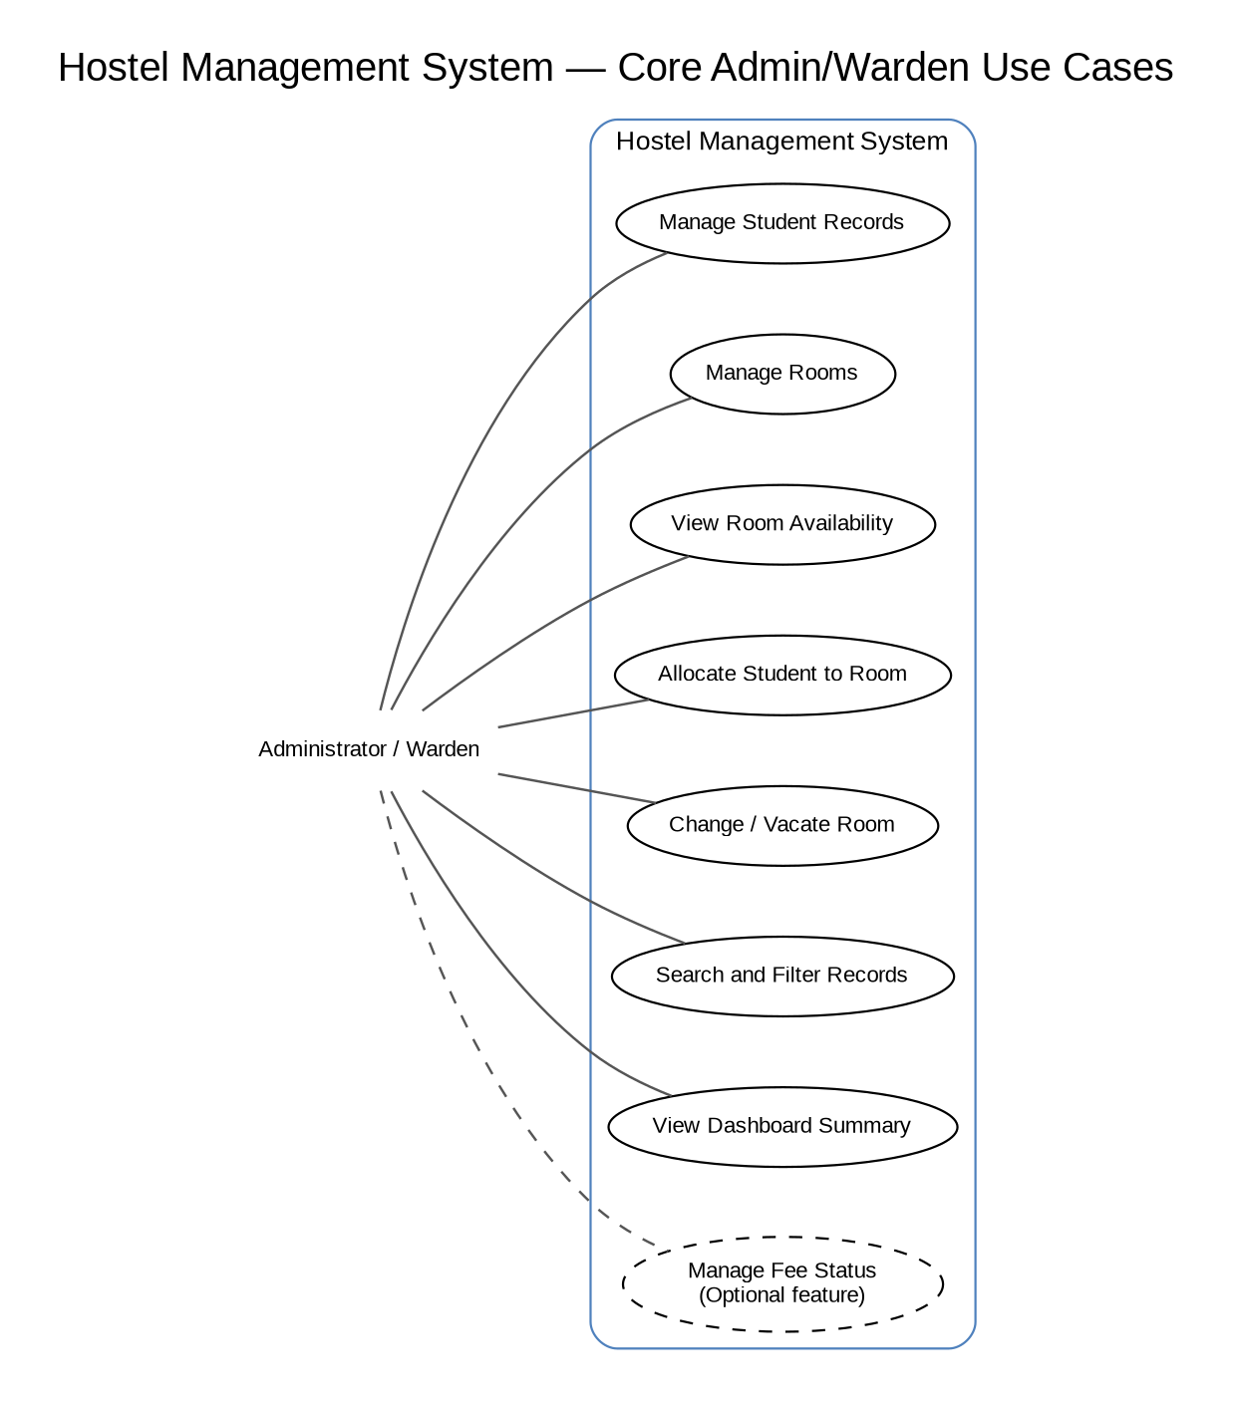
Figure 1. Core use-case diagram for the Administrator/Warden.
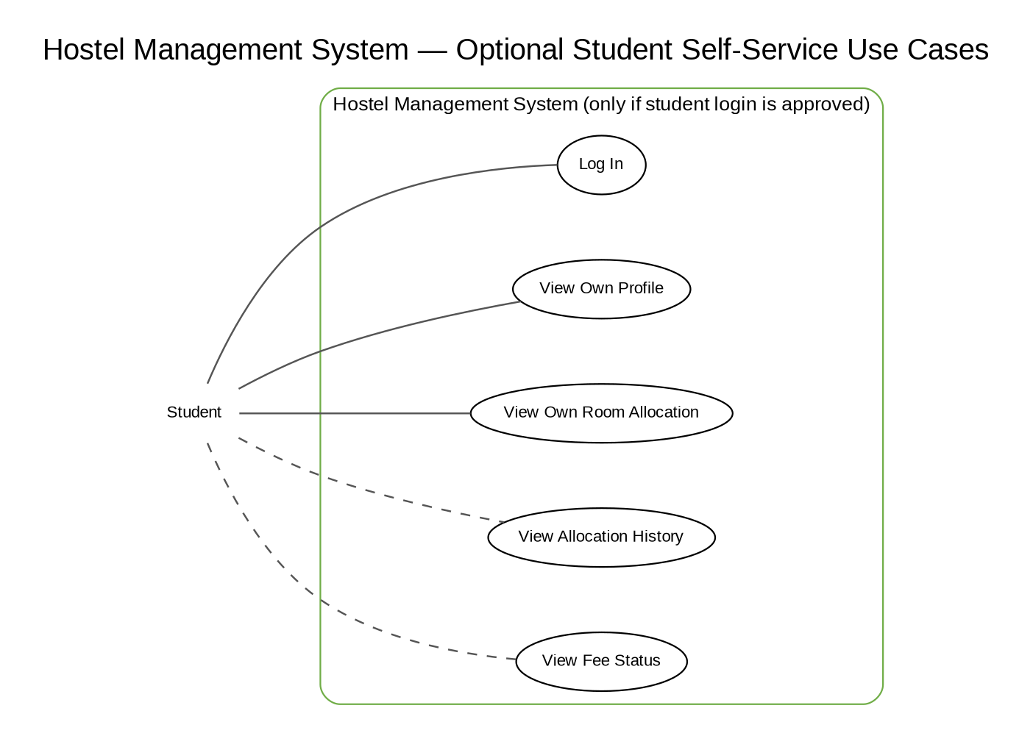
Figure 2. Optional student self-service use-case diagram; apply only if student login is approved.

9. Requirements Traceability Matrix (RTM)
Requirement ID | Design/module | Test case ID | Status
HMS-FR-001 | Student Management | TC-STU-001, TC-STU-002 | Planned
HMS-FR-002 | Student Management | TC-STU-007 | Planned
HMS-FR-003 | Student Management | TC-STU-005 | Planned
HMS-FR-004 | Student Management | TC-STU-004, TC-STU-006 | Planned
HMS-FR-005 | Room Management | TC-ROOM-001, TC-ROOM-002, TC-ROOM-003 | Planned
HMS-FR-006 | Room Management / Allocation Service | TC-ROOM-004, TC-ROOM-007, TC-ALLOC-001, TC-ALLOC-004, TC-ALLOC-005, TC-ALLOC-006 | Planned
HMS-FR-007 | Allocation Service/UI | TC-ALLOC-001, TC-ALLOC-007 | Planned
HMS-FR-008 | Allocation validation | TC-ALLOC-002, TC-ALLOC-006 | Planned
HMS-FR-009 | Allocation validation | TC-ALLOC-003 | Planned
HMS-FR-010 | Allocation Service/UI | TC-ALLOC-004 | Planned
HMS-FR-011 | Allocation Service/UI | TC-ALLOC-005 | Planned
HMS-FR-012 (optional) | Fee Management | TC-FEE-001 (if approved) | Conditional
HMS-FR-013 | Search/Filter UI/API | TC-FILT-001, TC-FILT-002 | Planned
HMS-FR-014 | Authentication/Authorization | TC-SEC-001 (if implemented) | Conditional
HMS-FR-015 | Dashboard | TC-DASH-001 | Planned
HMS-FR-016 | Input validation | TC-STU-003, TC-ROOM-003, TC-SEC-002 | Planned
HMS-FR-017 (optional) | Allocation History | TC-HIST-001, if approved and implemented | Conditional
HMS-NFR-001 | UI/Usability | TC-UX-001 | Planned
HMS-NFR-002 | API/UI performance | TC-NFR-001 | Planned
HMS-NFR-003 | Allocation/data integrity | TC-ALLOC-002, TC-ALLOC-003, TC-ALLOC-006 | Planned
HMS-NFR-004 | Authentication/Security | TC-SEC-001, TC-SEC-005 (if login enabled) | Conditional
HMS-NFR-005 | Code structure/documentation | TC-REV-001 (code review) | Planned
HMS-NFR-006 | Browser compatibility | TC-COMP-001 | Planned
HMS-NFR-007 | Validation | TC-STU-003, TC-ROOM-003, TC-SEC-002 | Planned
HMS-SR-001 | Authentication/Authorization | TC-SEC-001 (if login enabled) | Conditional
HMS-SR-002 | Backend validation | TC-SEC-002 | Planned
HMS-SR-003 | Configuration/Repository | TC-SEC-003 | Planned
HMS-SR-004 | Error handling | TC-SEC-004 | Planned
HMS-SR-005 | Password storage | TC-SEC-005 (if passwords are stored) | Conditional

10. Open Issues and References
- Core MVP baseline: student records, room management, room allocation, room change/vacating, search/filter, and dashboard. Confirm whether fee tracking, student login/self-service, and allocation history will be added as optional extensions.
- Confirm the implementation stack and database before finalizing the SAD/API details; update the proposal if the team selects a different stack.
- Confirm whether the instructor requires any additional UML diagrams beyond the two use-case diagrams embedded here.
Reference basis: course-provided SRS template. Project-specific requirements and measurable acceptance criteria in this draft are proposed by the team and must be reviewed before submission.

