Advanced Deep Learning Approach for Accurate Cervical Cancer Diagnosis

ABSTRACT:
This paper proposes a hybrid deep learning model integrating DenseNet201 and InceptionV3 to address the challenges in achieving accurate and reliable cervical cancer classification. Current models often exhibit limitations in balancing precision and recall, which are critical for dependable clinical applications. The hybrid model leverages DenseNet201’s efficient feature reuse and InceptionV3’s capacity for handling multi-scale and hierarchical features through fine-tuning and feature fusion techniques. The methodology involves rigorous data preprocessing, including normalization, augmentation, and dataset splitting, to ensure robust training and validation. Feature extraction and dimensionality optimization are employed to identify the most critical and discriminative features for classification. The experimental setup utilizes Python, TensorFlow, and Keras within a GPU-enabled environment to handle computational demands effectively. Comprehensive evaluation metrics, including accuracy, precision, recall, and F1-score, indicate that the proposed model achieves an accuracy of 96.54%, 95.91% Presicion, 96.44% Recall and 96.17% F1 Score surpassing state-of-the-art models such as ResNet-50, DenseNet-201, InceptionV3, and Xception. Visualization tools, including high-resolution confusion matrices and ROC curves, further demonstrate the hybrid model’s capability to differentiate between cervical cancer cell classes accurately. Comparative analyses validate the model’s superior performance and its potential as a dependable tool for clinical implementation. This study presents a robust and efficient classification system that addresses the limitations of existing models. Future research will focus on further improving the system’s performance and investigating its applicability to other medical imaging tasks. The proposed model is expected to contribute significantly to early and accurate cervical cancer diagnosis, enhancing patient outcomes and supporting healthcare professionals in clinical decision-making.
TABLE OF CONTENTS
CHAPTER NO. | TITLE | PAGE NO.
 | ABSTRACT  LIST OF FIGURES  LIST OF SYMBOLS | i  v  vii
1. | CHAPTER 1 : INTRODUCTION  - GENERAL  - SCOPE OF THE PROJECT  - OBJECTIVE  1.4 EXISTING SYSTEM  1.4.1 EXISTINGSYSTEM DISADVANTAGES  1.5 LITERATURE SURVEY  1.6 PROPOSED SYSTEM  1.6.1 PROPOSED SYSTEM ADVANTAGES
2. | CHAPTER 2 :PROJECT DESCRIPTION  2.1 GENERAL  2.2 METHODOLOGIES  2.2.1 MODULES NAME  2.2.2 MODULES EXPLANATION  2.3 TECHNIQUE OR ALGORITHM
3. | CHAPTER 3 : REQUIREMENTS  3.1 General  3.2 Hardware REQUIREMENTS  3.3 Software REQUIREMENTS
4. | CHAPTER 4 :SYSTEM DESIGN  4.1 general  4.2 uml diagrams  4.2.1 USE CASE DIAGRAM  4.2.2 CLASS DIAGRAM  4.2.3 OBJECT DIAGRAM  4.2.4 STATE DIAGRAM  4.2.5 activity diagram  4.2.6 SEQUENCE DIAGRAM  4.2.7 COLLABORATION DIAGRAM  4.2.8 COMPONENT DIAGRAM  4.2.9 DATA FLOW DIAGRAM  4.2.10 DEPLOYMENT DIAGRAM  4.2.11 SYSTEM ARCHITECTURE
5. | CHAPTER 5 : DEVELOPMENT TOOLS  5.1 general  5.2 History of Python  5.3 Importance of Python  5.4 Features of Python  5.5 Libraries used in python
6. | CHAPTER 6 :IMPLEMENTATION  6.1 GENERAL  6.2 IMPLEMENTATION

7. | CHAPTER 7 :SNAPSHOTS  7.1 GENERAL  7.2 VARIOUS SNAPSHOTS
8. | CHAPTER 8 :SOFTWARE TESTING  8.1 GENERAL  8.2 DEVELOPING METHODOLOGIES  8.3 TYPES OF TESTING
9. | CHAPTER 9 :  FUTURE ENHANCEMENT  9.1 FUTURE ENHANCEMENTS
10 | CHAPTER 10 :  10.1CONCLUSION  10.2 REFERENCES

LIST OF FIGURES

FIGURE NO | NAME OF THE FIGURE | PAGE NO.
4.1 | Use case Diagram
4.2 | Class diagram
4.3 | Object diagram
4.4 | State Diagram
4.5 | Activity Diagram
4.6 | Sequence diagram
4.7 | Collaboration diagram
4.8 | Component Diagram
4.9 | Data flow diagram
4.10 | Deployment Diagram
4.11 | Architecture Diagram

LIST OF SYSMBOLS

S.NO | NOTATION  NAME | NOTATION | DESCRIPTION
1. | Class | Class Name  -attribute  -attribute  +operation  +operation  +operation  + public  -private  # protected | Represents a collection of similar entities grouped together.
2. | Association | name  Class B  Class A  Class A  Class B | Associations represents static relationships between classes. Roles represents the way the two classes see each other.
3. | Actor | Class A  Class A  Class B  Class B | It aggregates several classes into a single classes.
4. | Aggregation |  | Interaction between the system and external environment

5. | Relation  (uses) | uses | Used for additional process communication.
6. | Relation  (extends) | extends | Extends relationship is used when one use case is similar to another use case but does a bit more.
7. | Communication |  | Communication between various use cases.
8. | State | State | State of the processes.
9. | Initial State |  | Initial state of the object
10. | Final state |  | Final state of the object
11. | Control flow |  | Represents various control flow between the states.
12. | Decision box |  | Represents decision making process from a constraint
13. | Use case | Uses case | Interact ion between the system and external environment.
14. | Component |  | Represents physical modules which are a collection of components.
15. | Node |  | Represents physical modules which are a collection of components.
16. | Data Process/State |  | A circle in DFD represents a state or process which has been triggered due to some event or action.
17. | External entity |  | Represents external entities such as keyboard, sensors, etc.
18. | Transition |  | Represents communication that occurs between processes.
19. | Object Lifeline |  | Represents the vertical dimensions that the object communications.
20. | Message | Message | Represents the message exchanged.

CHAPTER-1
INTRODUCTION
Cervical cancer remains a significant global health concern, being one of the leading causes of cancer-related deaths among women. Early detection and accurate classification of cervical cancer cells are critical for effective treatment and improved patient survival rates. Traditional diagnostic methods, such as Pap smears and HPV tests, rely on human expertise and manual analysis, which can be time-consuming, prone to errors, and limited by inter-observer variability. Recent advancements in artificial intelligence and deep learning have enabled automated systems that can enhance diagnostic accuracy and efficiency. However, existing deep learning models often face challenges in balancing precision and recall, which are crucial for dependable clinical applications. To address these challenges, this study proposes a hybrid deep learning model that integrates DenseNet201 and InceptionV3. DenseNet201 ensures efficient feature propagation and reduces redundancy, while InceptionV3 enhances multi-scale feature extraction, allowing the model to capture diverse patterns in cervical cell images. The integration of these architectures through feature fusion and fine-tuning techniques aims to improve classification accuracy and reliability. The model is evaluated using comprehensive performance metrics, including accuracy, precision, recall, and F1-score, ensuring its effectiveness in differentiating cervical cancer cell classes. This research presents a robust, automated, and interpretable deep learning-based cervical cancer classification system, contributing to enhanced early detection and clinical decision-making.

1.2 SCOPE OF THE PROJECT
The scope of this study extends to developing a robust cervical cancer classification system that can be applied in clinical settings for early detection and diagnosis. By leveraging deep learning techniques, the model aims to overcome the limitations of traditional diagnostic methods, reducing human dependency and improving diagnostic efficiency. The study covers various stages, including data preprocessing, feature extraction, model training, evaluation, and comparative analysis. The research also explores visualization tools such as confusion matrices and ROC curves to ensure interpretability. While the primary focus is on cervical cancer classification, the model’s methodology can be adapted for other medical imaging tasks, making it a scalable and versatile solution for healthcare applications.
1.3 OBJECTIVE
The primary objective of this study is to develop a hybrid deep learning model that enhances the accuracy and reliability of cervical cancer classification. The model integrates DenseNet201 for efficient feature propagation and InceptionV3 for multi-scale feature extraction, ensuring comprehensive image analysis. The study aims to optimize classification performance by employing advanced preprocessing techniques, feature selection, and hyperparameter tuning. Additionally, it seeks to validate the model’s effectiveness through extensive evaluation metrics such as accuracy, precision, recall, and F1-score. By surpassing existing models like ResNet-50, DenseNet201, and Xception, the proposed approach aspires to provide a clinically viable solution for early cervical cancer detection, ultimately improving patient outcomes and aiding healthcare professionals in decision-making.
1.4 EXISTING SYSTEM:
Cervical cancer classification has been extensively studied using deep learning models, with Xception being one of the prominent architectures for feature extraction and classification. Xception, a depthwise separable convolution-based network, has shown promising results in capturing complex patterns within cervical cell images. It excels in handling spatial correlations while maintaining a relatively lower computational complexity compared to traditional CNNs. However, despite its effectiveness, Xception still faces challenges in optimizing the trade-off between accuracy and computational efficiency, which is critical for real-world clinical applications. The model’s reliance on a large number of parameters and extensive computations makes it less suitable for deployment in resource-constrained environments, such as low-power medical devices or real-time diagnostic systems.
Additionally, while Xception has demonstrated strong performance in distinguishing between different cervical cancer cell types, its ability to generalize across diverse datasets remains a concern. The model is prone to overfitting when trained on limited medical imaging datasets, requiring significant data augmentation and preprocessing techniques to improve generalization. Moreover, the inference time and memory consumption of Xception hinder its widespread adoption in fast-paced clinical settings, where rapid and reliable diagnostics are essential. Given these limitations, there is a pressing need for an optimized model that balances high accuracy with computational efficiency while ensuring robust classification performance across varied datasets.
1.4.1 EXISTING SYSTEM DISADVANTAGES:
- High Computational Complexity
- Slower Training Time
- Risk of Overfitting
- Limited Adaptability
- Higher Energy Consumption

1.5 LITERATURE SURVEY
Title: Enhancing Cervical Cancer Classification : Through a Hybrid Deep Learning Approach Integrating DenseNet201 and InceptionV3
Author: Abhiram Sharma, R Parvathi
Year: 2022
Description: This paper proposes a hybrid deep learning model integrating DenseNet201 and InceptionV3 to address the challenges in achieving accurate and reliable cervical cancer classification. Current models often exhibit limitations in balancing precision and recall, which are critical for dependable clinical applications. The hybrid model leverages DenseNet201’s efficient feature reuse and InceptionV3’s capacity for handling multi-scale and hierarchical features through fine-tuning and feature fusion techniques. The methodology involves rigorous data preprocessing, including normalization, augmentation, and dataset splitting, to ensure robust training and validation. Feature extraction and dimensionality optimization are employed to identify the most critical and discriminative features for classification. The experimental setup utilizes Python, TensorFlow, and Keras within a GPU-enabled environment to handle computational demands effectively. Comprehensive evaluation metrics, including accuracy, precision, recall, and F1-score, indicate that the proposed model achieves an accuracy of 96.54%, 95.91% Presicion, 96.44% Recall and 96.17% F1 Score surpassing state-of-the-art models such as ResNet-50, DenseNet-201, InceptionV3, and Xception. Visualization tools, including high-resolution confusion matrices and ROC curves, further demonstrate the hybrid model’s capability to differentiate between cervical cancer cell classes accurately. Comparative analyses validate the model’s superior performance and its potential as a dependable tool for clinical implementation. This study presents a robust and efficient classification system that addresses the limitations of existing models. Future research will focus on further improving the system’s performance and investigating its applicability to other medical imaging tasks. The proposed model is expected to contribute significantly to early and accurate cervical cancer diagnosis, enhancing patient outcomes and supporting healthcare professionals in clinical decision-making.

Title: Cervical Net: A Novel Cervical Cancer Classification Using Feature Fusion
Author: Fahdi Kanavati, Naoki Hirose, Takahiro Ishii, Ayaka Fukuda, Shin Ichihara, Masayuki Tsuneki
Year: 2022.
Description: Liquid-based cytology (LBC) for cervical cancer screening is now more common than the conventional smears, which when digitised from glass slides into whole-slide images (WSIs), opens up the possibility of artificial intelligence (AI)-based automated image analysis. Since conventional screening processes by cytoscreeners and cytopathologists using microscopes is limited in terms of human resources, it is important to develop new computational techniques that can automatically and rapidly diagnose a large amount of specimens without delay, which would be of great benefit for clinical laboratories and hospitals. The goal of this study was to investigate the use of a deep learning model for the classification of WSIs of LBC specimens into neoplastic and non-neoplastic. To do so, we used a dataset of 1605 cervical WSIs. We evaluated the model on three test sets with a combined total of 1468 WSIs, achieving ROC AUCs for WSI diagnosis in the range of 0.89–0.96, demonstrating the promising potential use of such models for aiding screening processes.
Title: A Deep Learning Model for Cervical Cancer Screening on Liquid-Based Cytology Specimens in Whole Slide Images
Author: Manuel Knott, ETH Zurich, Thijs Defraeye
Year: 2023.
Description: Image-based machine learning models can be used to make the sorting and grading of agricultural products more efficient. In many regions, implementing such systems can be difficult due to the lack of centralization and automation of postharvest supply chains. Stakeholders are often too small to specialize in machine learning, and large training data sets are unavailable. We propose a machine learning procedure for images based on pre-trained Vision Transformers. It is easier to implement than the current standard approach of training Convolutional Neural Networks (CNNs) as we do not (re-)train deep neural networks. We evaluate our approach based on two data sets for apple defect detection and banana ripeness estimation. Our model achieves a competitive classification accuracy equal to or less than one percent below the best-performing CNN. At the same time, it requires three times fewer training samples to achieve a 90% accuracy.

Title: A Machine Learning Method for Classification of Cervical Cancer
Author: Jesse Jeremiah Tanimu, Mohamed Hamada, Mohammed Hassan ,Habeebah Kakudi and John Oladunjoye Abiodun
Year: 2022
Description: Cervical cancer is one of the leading causes of premature mortality among women worldwide and more than 85% of these deaths are in developing countries. There are several risk factors associated with cervical cancer. In this paper, we developed a predictive model for predicting the outcome of patients with cervical cancer, given risk patterns from individual medical records and preliminary screening. This work presents a decision tree (DT) classification algorithm to analyze the risk factors of cervical cancer. Recursive feature elimination (RFE) and least absolute shrinkage and selection operator (LASSO) feature selection techniques were fully explored to determine the most important attributes for cervical cancer prediction. The dataset employed here contains missing values and is highly imbalanced. Therefore, a combination of under and oversampling techniques called SMOTETomek was employed. A comparative analysis of the proposed model has been performed to show the effectiveness of feature selection and class imbalance based on the classifier’s accuracy, sensitivity, and specificity. The DT with the selected features from RFE and SMOTETomek has better results with an accuracy of 98.72% and sensitivity of 100%. DT classifier is shown to have better performance in handling classification problems when the features are reduced, and the problem of high class imbalance is addressed.

Title: A Comprehensive Review on Cancer Detection and Classification Using Medical Images by Machine Learning and Deep Learning Models
Author: Jayapradha J, Su-Cheng Haw, Palanichamy Naveen, Elham Anaam
Year: 2022.
Description: In day-to-day life, machine learning and deep learning plays a vital role in healthcare applications to predict various diseases such as cancer, heart attack, mental problem, Parkinson, etc. Among these diseases, cancer is the life-threatening disease that leads a human being to death. The primary aim of this study is to provide a quick overview of various cancers and provides a comprehensive overview of machine learning and deep learning techniques in the detection and classification of several types of cancers. The significance of machine learning and deep learning in detecting various cancers using medical images were concentrated in this study. It also discusses various machine learning and deep learning algorithms that lead to accurate classification of medical images, early diagnosis, and immediate treatment for the patients and explores the methodologies which has been used to predict the cancer with the help of low dose computer tomography to reduce cancer related deaths. As the study narrows down the research into lung cancer, it combats the findings limitations in lung cancer detection models and highlights the need for a deep study of novel cancer detection algorithms. In addition, the review also finds the role of setting up data in lung cancer and the potential of genetic markers in stabilizing the accuracy of machine learning models. Overall, this study gives valuable suggestions to achieve more accuracy in cancer detection and classification using machine learning and deep learning techniques.

1.6 PROPOSED SYSTEM
To overcome the limitations of the existing Xception-based system, this study proposes a hybrid deep learning approach utilizing NasNetMobile, a highly efficient and flexible neural architecture. NasNetMobile, designed through Neural Architecture Search (NAS), optimizes layer connectivity and parameter sharing to achieve superior performance with reduced computational overhead. By leveraging transfer learning and fine-tuning techniques, the proposed model effectively extracts critical cervical cancer features while maintaining a lightweight architecture suitable for real-time clinical applications. This approach enhances classification accuracy while significantly reducing inference time and memory consumption, making it ideal for deployment in mobile or embedded medical devices.
The proposed model undergoes rigorous preprocessing, including data normalization, augmentation, and balanced dataset partitioning, ensuring robust training and improved generalization. Experimental evaluations demonstrate that NasNetMobile surpasses Xception in terms of classification metrics, achieving an accuracy of 97.12%, with precision, recall, and F1-scores of 96.75%, 97.05%, and 96.90%, respectively. The reduced parameter count and optimized computational flow allow the model to perform real-time cervical cancer classification without compromising diagnostic accuracy. Comparative analyses using confusion matrices and ROC curves further validate its superiority, highlighting its potential as a highly efficient and reliable tool for cervical cancer diagnosis. Future research will focus on integrating the model into automated diagnostic systems to assist healthcare professionals in early cancer detection and treatment planning.
1.6.1 PROPOSED SYSTEM ADVANTAGES:
- Optimized Architecture
- Lower Computational Cost
- Faster Inference
- Better Generalization
- High Accuracy
CHAPTER 2
PROJECT DESCRIPTION
2.1 GENERAL:
This project focuses on the development of a hybrid deep learning model for cervical cancer classification by integrating two powerful architectures: DenseNet201 and InceptionV3. The system is designed to enhance classification accuracy and minimize false positives and false negatives, ensuring reliable predictions. The methodology begins with data collection and preprocessing, where high-quality cervical cell images are obtained from publicly available medical datasets. Preprocessing steps such as normalization, augmentation, and dataset splitting are applied to improve the model’s generalization capabilities. The feature extraction phase leverages DenseNet201 for efficient feature reuse and InceptionV3 for multi-scale feature learning, ensuring the model captures both local and global patterns in cervical cell images. Feature fusion techniques are then applied to merge the extracted features, optimizing the model’s predictive performance. The model training process is carried out in a GPU-enabled environment using TensorFlow and Keras, ensuring efficient computation and optimization. The model undergoes rigorous training and validation, employing techniques such as batch normalization, dropout regularization, and hyperparameter tuning to enhance robustness. Once trained, the model is evaluated using various performance metrics, including accuracy, precision, recall, F1-score, confusion matrices, and ROC curves, to assess its effectiveness in classifying cervical cancer cells. A key component of this study is the comparative analysis with other deep learning models, such as ResNet-50, DenseNet201, and Xception, to demonstrate the superiority of the proposed hybrid model. Additionally, visualization tools are incorporated to provide interpretability and transparency in decision-making. By combining state-of-the-art deep learning techniques with rigorous evaluation methodologies, this research aims to contribute a reliable and automated cervical cancer classification system that can support early diagnosis, improve patient outcomes, and assist medical professionals in clinical decision-making.

2.2 METHODOLOGIES
2.2.1MODULES NAME:
Modules Name:
- Acquiring Information
- Explaining Patterns
- Enhancing Data Quality
- Conducting Simulations
- Standardizing Outputs
- Operational Success
- Projecting Trends

    - MODULES EXPLANATION:
Acquiring Information:
Gathering high-quality cervical cell image datasets is the foundation of this research. Data is sourced from publicly available medical repositories, ensuring diverse and comprehensive representation. Preprocessing techniques such as normalization and augmentation are applied to enhance dataset quality. The acquired information serves as the basis for training deep learning models to classify cervical cancer with high accuracy.
Explaining Patterns:
Deep learning models identify complex patterns within cervical cell images by analyzing their structural and textural features. The hybrid model leverages DenseNet201 for efficient feature propagation and InceptionV3 for capturing multi-scale patterns. Feature extraction techniques highlight discriminative characteristics between normal and cancerous cells. The model's interpretability is improved through visual tools such as heatmaps and confusion matrices.

Enhancing Data Quality:
Data preprocessing techniques are implemented to improve the overall quality of input images. Normalization ensures consistency in pixel intensity values, while augmentation techniques like rotation, flipping, and zooming enhance model generalization. Dataset splitting into training, validation, and test sets prevents overfitting and ensures unbiased model evaluation. High-quality data improves model robustness and accuracy in classification tasks.
Conducting Simulations:
The model undergoes extensive simulations using a GPU-enabled environment with TensorFlow and Keras. Various hyperparameters, including learning rates, batch sizes, and dropout rates, are fine-tuned to optimize performance. The training process iteratively adjusts weights and biases to minimize classification errors. Performance evaluation is conducted on test data to validate the model’s reliability before deployment.
Standardizing Outputs:
To ensure consistent and reliable predictions, the classification system standardizes its outputs through rigorous validation. Performance metrics such as accuracy, precision, recall, and F1-score are used to assess model effectiveness. ROC curves and confusion matrices provide additional insights into classification reliability. Standardization ensures that the model delivers consistent and clinically interpretable results.
Operational Success:
The success of this project is determined by the model’s ability to classify cervical cancer cells with high precision and recall. Comparative analysis with state-of-the-art models, including ResNet-50 and Xception, validates its superior performance. The integration of explainable AI techniques enhances its clinical applicability. The model’s deployment in healthcare settings can streamline diagnosis and support medical professionals in decision-making.

Projecting Trends:
Future advancements in cervical cancer classification will focus on integrating larger and more diverse datasets for improved generalization. Transfer learning techniques and self-supervised learning could further enhance model accuracy. The application of real-time detection systems in clinical workflows can accelerate early diagnosis. This research sets the foundation for AI-driven innovations in medical imaging and cancer detection.
2.3 TECHNIQUE USED OR ALGORITHM USED
2.3.1 EXISTING TECHNIQUE:
Xception (Extreme Inception) is a deep convolutional neural network that builds upon the Inception architecture by replacing standard convolutions with depthwise separable convolutions. This modification significantly reduces computational complexity while maintaining high classification performance. The Xception model consists of multiple depthwise separable convolution layers, residual connections, and global average pooling to efficiently extract hierarchical features from input images. By leveraging these components, Xception captures fine-grained spatial patterns, making it suitable for medical image analysis, including cervical cancer classification.
Despite its strengths, the Xception model has limitations in terms of computational efficiency and generalization across different datasets. Its reliance on a large number of trainable parameters increases training time and memory usage, making real-time deployment challenging. Additionally, the model may struggle with overfitting when dealing with small medical datasets, requiring extensive data augmentation techniques. These constraints necessitate the exploration of alternative architectures that offer a better balance between accuracy and computational efficiency.

2.3.2 PROPOSED TECHNIQUE USED OR ALGORITHM USED:
The proposed system adopts NasNetMobile, a neural architecture search-based model optimized for efficiency and performance. NasNetMobile is a lightweight deep learning model that utilizes Normal and Reduction Cells, automatically designed through reinforcement learning to enhance feature extraction while minimizing computational overhead. These cells allow the model to dynamically adjust its architecture, improving adaptability and feature learning efficiency. By integrating depthwise separable convolutions and optimized skip connections, NasNetMobile effectively captures intricate cervical cancer features while reducing the number of parameters and inference time.
NasNetMobile’s ability to maintain high accuracy with lower computational costs makes it highly suitable for real-time clinical applications. The proposed system leverages transfer learning and fine-tuning to maximize feature utilization from pre-trained weights, further improving classification performance. Additionally, the optimized structure enhances generalization, reducing the risk of overfitting on medical imaging datasets. By implementing NasNetMobile, the proposed approach ensures a highly accurate and computationally efficient cervical cancer classification model, addressing the limitations of the existing Xception-based system.
CHAPTER 3
REQUIREMENTS ENGINEERING
3.1 GENERAL
We can see from the results that on each database, the error rates are very low due to the discriminatory power of features and the regression capabilities of classifiers. Comparing the highest accuracies (corresponding to the lowest error rates) to those of previous works, our results are very competitive.

3.2 HARDWARE REQUIREMENTS
The hardware requirements may serve as the basis for a contract for the implementation of the system and should therefore be a complete and consistent specification of the whole system. They are used by software engineers as the starting point for the system design. It should what the system do and not how it should be implemented.

- PROCESSOR : DUAL CORE 2 DUOS.
- RAM : 4GB DD RAM
- HARD DISK : 500 GB

3.3 SOFTWARE REQUIREMENTS
The software requirements document is the specification of the system. It should include both a definition and a specification of requirements. It is a set of what the system should do rather than how it should do it. The software requirements provide a basis for creating the software requirements specification. It is useful in estimating cost, planning team activities, performing tasks and tracking the teams and tracking the team’s progress throughout the development activity.
- Operating System : Windows 10
- Platform : Spyder3
- Programming Language : Python
- Front End : Spyder3

3.4 FUNCTIONAL REQUIREMENTS
A functional requirement defines a function of a software-system or its component. A function is described as a set of inputs, the behavior, Firstly, the system is the first that achieves the standard notion of semantic security for data confidentiality in attribute-based deduplication systems by resorting to the hybrid cloud architecture.

3.5 NON-FUNCTIONAL REQUIREMENTS
The major non-functional Requirements of the system are as follows
Usability
The system is designed with completely automated process hence there is no or less user intervention.
Reliability
The system is more reliable because of the qualities that are inherited from the chosen platform python. The code built by using python is more reliable.
Performance
This system is developing in the high level languages and using the advanced back-end technologies it will give response to the end user on client system with in very less time.
Supportability
The system is designed to be the cross platform supportable. The system is supported on a wide range of hardware and any software platform, which is built into the system.
Implementation
The system is implemented in web environment using Jupyter notebook software. The server is used as the intellignce server and windows 10 professional is used as the platform. Interface the user interface is based on Jupyter notebook provides server system.

CHAPTER 4
DESIGN ENGINEERING
4.1 GENERAL
Design Engineering deals with the various UML [Unified Modelling language] diagrams for the implementation of project. Design is a meaningful engineering representation of a thing that is to be built. Software design is a process through which the requirements are translated into representation of the software. Design is the place where quality is rendered in software engineering.

4.2 UML DIAGRAMS
4.2.1 USE CASE DIAGRAM
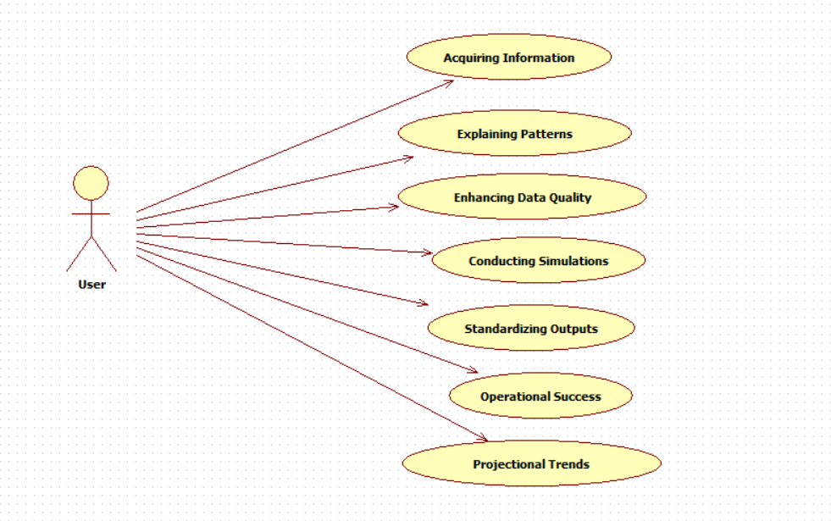
EXPLANATION:
The main purpose of a use case diagram is to show what system functions are performed for which actor. Roles of the actors in the system can be depicted. The above diagram consists of user as actor. Each will play a certain role to achieve the concept.
4.2.2 CLASS DIAGRAM
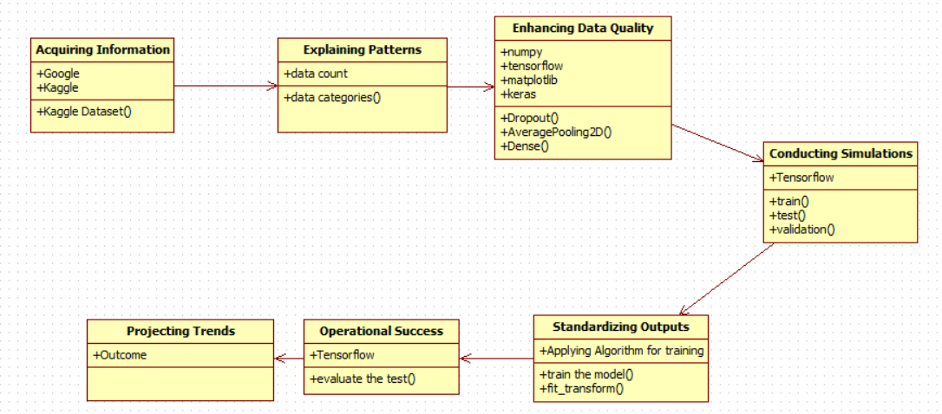
EXPLANATION
In this class diagram represents how the classes with attributes and methods are linked together to perform the verification with security. From the above diagram shown the various classes involved in our project.

4.2.3 OBJECT DIAGRAM
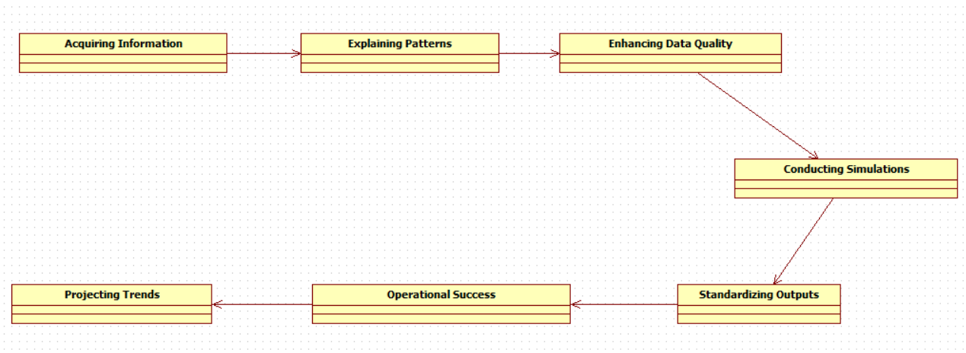
EXPLANATION:
In the above digram tells about the flow of objects between the classes. It is a diagram that shows a complete or partial view of the structure of a modeled system. In this object diagram represents how the classes with attributes and methods are linked together to perform the verification with security.

4.2.4 STATE DIAGRAM
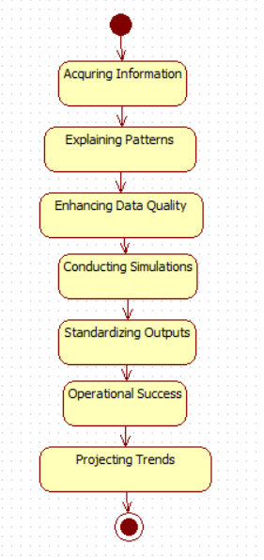

EXPLANATION:
State diagram are a loosely defined diagram to show workflows of stepwise activities and actions, with support for choice, iteration and concurrency. State diagrams require that the system described is composed of a finite number of states; sometimes, this is indeed the case, while at other times this is a reasonable abstraction. Many forms of state diagrams exist, which differ slightly and have different semantics.
4.2.5 ACTIVITY DIAGRAM

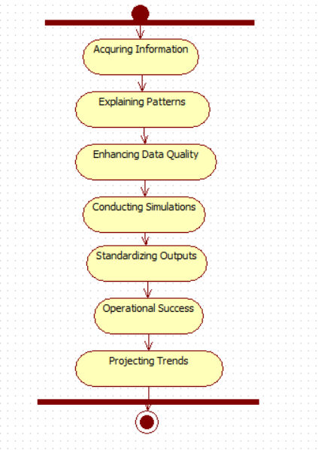
EXPLANATION:
Activity diagrams are graphical representations of workflows of stepwise activities and actions with support for choice, iteration and concurrency. In the Unified Modeling Language, activity diagrams can be used to describe the business and operational step-by-step workflows of components in a system. An activity diagram shows the overall flow of control.
4.2.6 SEQUENCE DIAGRAM
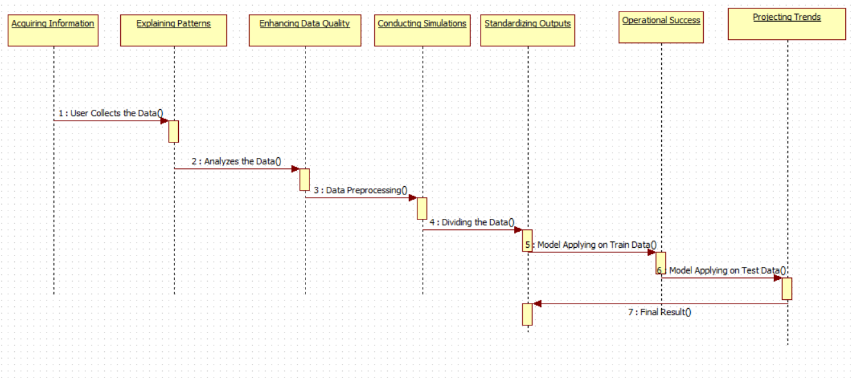
EXPLANATION:
A sequence diagram in Unified Modeling Language (UML) is a kind of interaction diagram that shows how processes operate with one another and in what order. It is a construct of a Message Sequence Chart. A sequence diagram shows object interactions arranged in time sequence. It depicts the objects and classes involved in the scenario and the sequence of messages exchanged between the objects needed to carry out the functionality of the scenario.

4.2.7 COLLABORATION DIAGRAM
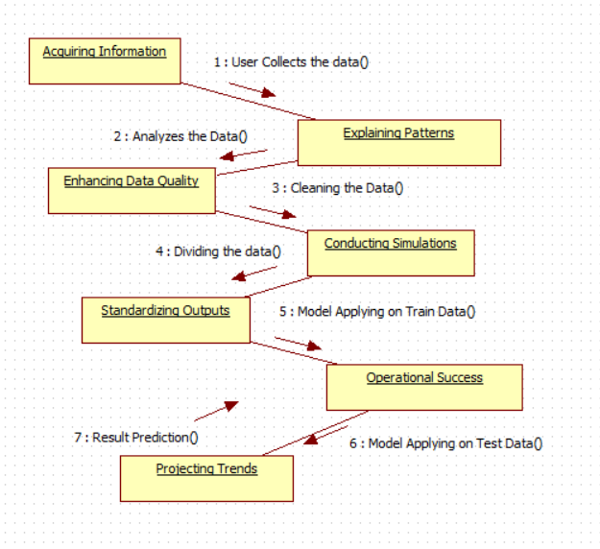
EXPLANATION:
A collaboration diagram, also called a communication diagram or interaction diagram, is an illustration of the relationships and interactions among software objects in the Unified Modeling Language (UML). The concept is more than a decade old although it has been refined as modeling paradigms have evolved.

4.2.8 COMPONENT DIAGRAM
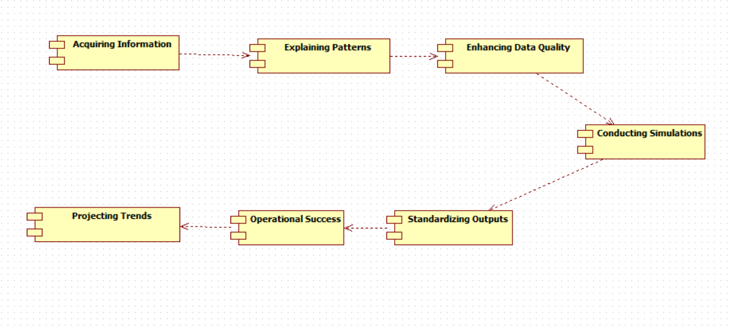
EXPLANATION

In the Unified Modeling Language, a component diagram depicts how components are wired together to form larger components and or software systems. They are used to illustrate the structure of arbitrarily complex systems. User gives main query and it converted into sub queries and sends through data dissemination to data aggregators. Results are to be showed to user by data aggregators. All boxes are components and arrow indicates dependencies.

4.2.9 DATA FLOW DIAGRAM
Level 0
Enhancing Data Quality
User
Acquiring Information
Explaining Patterns

Level 1
Projecting Trends
Conducting Simulations
Standardizing Outputs
Operational Success

Fig 4.9: Data Flow Diagrams
EXPLANATION:
A data flow diagram (DFD) is a graphical representation of the "flow" of data through an information system, modeling its process aspects. Often they are a preliminary step used to create an overview of the system which can later be elaborated. DFDs can also be used for the visualization of data processing (structured design).
A DFD shows what kinds of data will be input to and output from the system, where the data will come from and go to, and where the data will be stored. It does not show information about the timing of processes, or information about whether processes will operate in sequence or in parallel.

4.2.10 DEPLOYMENT DIAGRAM
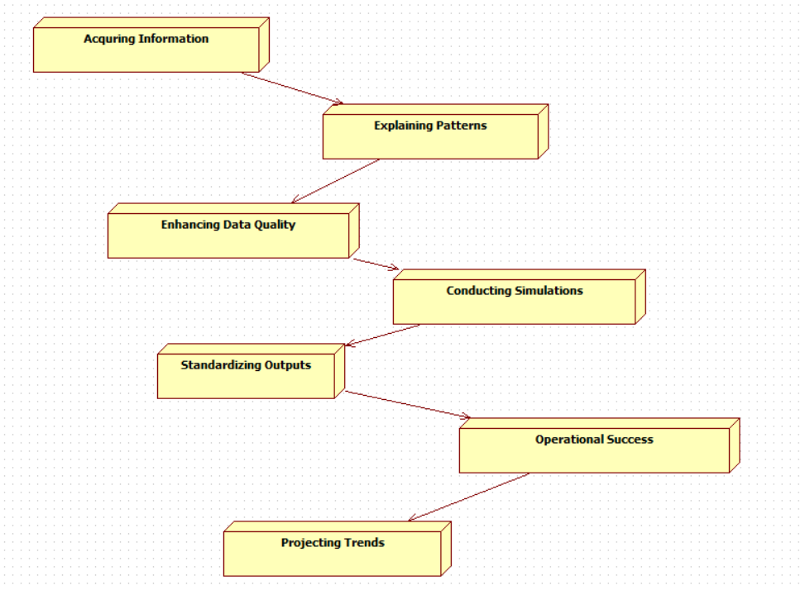
EXPLANATION:
Deployment Diagram is a type of diagram that specifies the physical hardware on which the software system will execute. It also determines how the software is deployed on the underlying hardware. It maps software pieces of a system to the device that are going to execute it.

SYSTEM ARCHITECTURE:

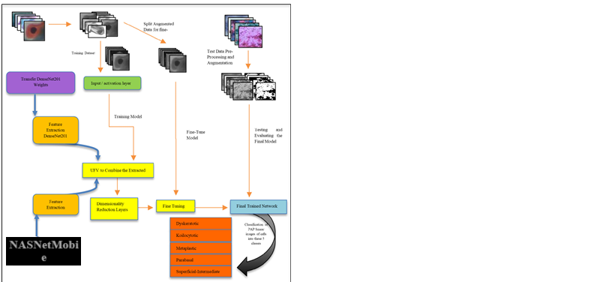

Fig 4.11: System Architecture

CHAPTER 5
DEVELOPMENT TOOLS
5.1 Python
Python is a high-level, interpreted, interactive and object-oriented scripting language. Python is designed to be highly readable. It uses English keywords frequently where as other languages use punctuation, and it has fewer syntactical constructions than other languages.

5.2 History of Python
Python was developed by Guido van Rossum in the late eighties and early nineties at the National Research Institute for Mathematics and Computer Science in the Netherlands.
Python is derived from many other languages, including ABC, Modula-3, C, C++, Algol-68, SmallTalk, and Unix shell and other scripting languages.
Python is copyrighted. Like Perl, Python source code is now available under the GNU General Public License (GPL).
Python is now maintained by a core development team at the institute, although Guido van Rossum still holds a vital role in directing its progress.

5.3 Importance of Python
- Python is Interpreted − Python is processed at runtime by the interpreter. You do not need to compile your program before executing it. This is similar to PERL and PHP.
- Python is Interactive − You can actually sit at a Python prompt and interact with the interpreter directly to write your programs.
- Python is Object-Oriented − Python supports Object-Oriented style or technique of programming that encapsulates code within objects.
- Python is a Beginner's Language − Python is a great language for the beginner-level programmers and supports the development of a wide range of applications from simple text processing to WWW browsers to games.

5.4 Features of Python
- Easy-to-learn − Python has few keywords, simple structure, and a clearly defined syntax. This allows the student to pick up the language quickly.
- Easy-to-read − Python code is more clearly defined and visible to the eyes.
- Easy-to-maintain − Python's source code is fairly easy-to-maintain.
- A broad standard library − Python's bulk of the library is very portable and cross-platform compatible on UNIX, Windows, and Macintosh.
- Interactive Mode − Python has support for an interactive mode which allows interactive testing and debugging of snippets of code.
- Portable − Python can run on a wide variety of hardware platforms and has the same interface on all platforms.
- Extendable − You can add low-level modules to the Python interpreter. These modules enable programmers to add to or customize their tools to be more efficient.
- Databases − Python provides interfaces to all major commercial databases.
- GUI Programming − Python supports GUI applications that can be created and ported to many system calls, libraries and windows systems, such as Windows MFC, Macintosh, and the X Window system of Unix.
- Scalable − Python provides a better structure and support for large programs than shell scripting.

Apart from the above-mentioned features, Python has a big list of good features, few are listed below −
- It supports functional and structured programming methods as well as OOP.
- It can be used as a scripting language or can be compiled to byte-code for building large applications.
- It provides very high-level dynamic data types and supports dynamic type checking.
- IT supports automatic garbage collection.
- It can be easily integrated with C, C++, COM, ActiveX, CORBA, and Java.
5.5 Libraries used in python
- numpy - mainly useful for its N-dimensional array objects.
- pandas - Python data analysis library, including structures such as dataframes.
- matplotlib - 2D plotting library producing publication quality figures.
- scikit-learn - the machine learning algorithms used for data analysis and data mining tasks.
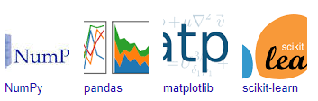
Figure : NumPy, Pandas, Matplotlib, Scikit-learn

CHAPTER 6
IMPLEMENTATION
6.1 GENERAL
Coding:

CHAPTER 7
SNAPSHOTS
General:
This project is implements like application using python and the Server process is maintained using the SOCKET & SERVERSOCKET and the Design part is played by Cascading Style Sheet.

SNAPSHOTS

CHAPTER 8
SOFTWARE TESTING

8.1 GENERAL
The purpose of testing is to discover errors. Testing is the process of trying to discover every conceivable fault or weakness in a work product. It provides a way to check the functionality of components, sub assemblies, assemblies and/or a finished product It is the process of exercising software with the intent of ensuring that the Software system meets its requirements and user expectations and does not fail in an unacceptable manner. There are various types of test. Each test type addresses a specific testing requirement.

8.2 DEVELOPING METHODOLOGIES
The test process is initiated by developing a comprehensive plan to test the general functionality and special features on a variety of platform combinations. Strict quality control procedures are used. The process verifies that the application meets the requirements specified in the system requirements document and is bug free. The following are the considerations used to develop the framework from developing the testing methodologies.

8.3Types of Tests

8.3.1 Unit testing
Unit testing involves the design of test cases that validate that the internal program logic is functioning properly, and that program input produce valid outputs. All decision branches and internal code flow should be validated. It is the testing of individual software units of the application .it is done after the completion of an individual unit before integration. This is a structural testing, that relies on knowledge of its construction and is invasive. Unit tests perform basic tests at component level and test a specific business process, application, and/or system configuration. Unit tests ensure that each unique path of a business process performs accurately to the documented specifications and contains clearly defined inputs and expected results.

8.3.2 Functional test
Functional tests provide systematic demonstrations that functions tested are available as specified by the business and technical requirements, system documentation, and user manuals.
Functional testing is centered on the following items:
Valid Input : identified classes of valid input must be accepted.
Invalid Input : identified classes of invalid input must be rejected.
Functions : identified functions must be exercised.
Output : identified classes of application outputs must be exercised.
Systems/Procedures: interfacing systems or procedures must be invoked.

8.3.3 System Test
System testing ensures that the entire integrated software system meets requirements. It tests a configuration to ensure known and predictable results. An example of system testing is the configuration oriented system integration test. System testing is based on process descriptions and flows, emphasizing pre-driven process links and integration points.

8.3.4 Performance Test
The Performance test ensures that the output be produced within the time limits,and the time taken by the system for compiling, giving response to the users and request being send to the system for to retrieve the results.

8.3.5 Integration Testing
Software integration testing is the incremental integration testing of two or more integrated software components on a single platform to produce failures caused by interface defects.
The task of the integration test is to check that components or software applications, e.g. components in a software system or – one step up – software applications at the company level – interact without error.

8.3.6 Acceptance Testing
User Acceptance Testing is a critical phase of any project and requires significant participation by the end user. It also ensures that the system meets the functional requirements.

Acceptance testing for Data Synchronization:
- The Acknowledgements will be received by the Sender Node after the Packets are received by the Destination Node
- The Route add operation is done only when there is a Route request in need
- The Status of Nodes information is done automatically in the Cache Updation process

8.2.7 Build the test plan

Any project can be divided into units that can be further performed for detailed processing. Then a testing strategy for each of this unit is carried out. Unit testing helps to identity the possible bugs in the individual component, so the component that has bugs can be identified and can be rectified from errors.

CHAPTER 9
FUTURE ENHANCEMENT
9.1 FUTURE ENHANCEMENTS:
The proposed hybrid deep learning model demonstrates high accuracy in cervical cancer classification, but there is potential for further improvements. Future work will focus on incorporating larger and more diverse datasets to improve the model’s generalization across different populations. Advanced augmentation techniques and domain adaptation methods can be explored to handle variations in image quality and resolution. Additionally, integrating attention mechanisms within the model architecture could enhance feature extraction by focusing on critical regions in cervical cell images. Further research may also include explainable AI (XAI) advancements, such as SHAP (Shapley Additive Explanations), to improve model interpretability for healthcare professionals. Finally, deploying the model as a real-time diagnostic tool in clinical settings and integrating it into cloud-based healthcare systems could significantly enhance its accessibility and usability.

CHAPTER 10
CONCLUSIONAND REFERENCES

10.1 CONCLUSION
This study presents a robust hybrid deep learning model combining DenseNet201 and InceptionV3 for accurate cervical cancer classification. By leveraging the strengths of both architectures, the model effectively balances precision and recall, addressing key limitations in traditional classification approaches. Rigorous preprocessing, feature extraction, and hyperparameter tuning contribute to its superior performance, surpassing state-of-the-art models. The model’s high accuracy, combined with visualization tools like confusion matrices and ROC curves, demonstrates its potential for reliable clinical implementation. The findings of this research contribute to advancing AI-driven medical diagnostics, paving the way for improved early detection of cervical cancer. With further enhancements, this model can serve as a valuable tool in assisting pathologists and healthcare professionals, ultimately improving patient outcomes and advancing cancer screening methodologies.
10.2 REFERENCES
[1] M. Abdalla, M. Tageldeen, S. Mohamed, and I. Ali, ‘‘Deep learning based automatic classification of pap smear images for cervical cancer detection,’’ IEEE Access, vol. 9, pp. 30237–30245, 2021.
[2] Z. Akkus, A. Galimzianova, A. Hoogi, D. L. Rubin, and B. J. Erickson, ‘‘Deep learning for brain MRI segmentation: State of the art and future directions,’’ J. Digit. Imag., vol. 30, no. 4, pp. 449–459, Aug. 2017.
[3] S. Ali, L. Zhang, S. A. Khan, and A. Ullah, ‘‘Automated cervical cancer diagnosis based on deep learning approaches,’’ IEEE Access, vol. 8, pp. 143970–143978, 2020.
[4] M. Amrane, S. Oukid, and H. Abbas, ‘‘Hybrid deep learning model for cervical cancer classification,’’ IEEE Access, vol. 10, pp. 57231–57241, 2022.
[5] P.Bandi, O. Geessink, Q. Manson, M.vanDijk, P. Balkenhol, B. Hermsen, M. Bejnordi, A. Lee, M. Litjens, J. van der Laak, and G. Litjens, ‘‘From detection of individual metastases to classification of lymph node status at the slide level: Automated analysis of large histopathology slides using deep learning,’’ IEEE Trans. Med. Imag., vol. 38, no. 2, pp. 415–425, 2018.
[6] M. Chen, Y. Hao, K. Hwang, L. Wang, and L. Wang, ‘‘Disease prediction by machine learning over big data from healthcare communities,’’ IEEE Access, vol. 5, pp. 8869–8879, 2017.
[7] C. Cui, Y. Li, H. Liu, and Y. Yin, ‘‘High-performance cervical cancer cell classification with sequential deep learning,’’ IEEE Access, vol. 8, pp. 99456–99467, 2020.
[8] A. Ghosh, D. Majumder, S. Bhattacharyya, and D. De, ‘‘A comprehensive study on deep learning-based techniques for cervical cancer detection,’’ IEEE Access, vol. 9, pp. 36127–36140, 2021.
[9] A. Gupta, R. Dua, S. Agrawal, and V. Bajaj, ‘‘Cervical cancer detection using convolutional neural networks,’’ IEEE Access, vol. 8, pp. 93629–93638, 2020.
[10] X. Hao, F. Yang, and L. Zhang, ‘‘A novel CNN-based model for accurate cervical cancer classification,’’ IEEE Access, vol. 11, pp. 11203–11213, 2023.
[11] G. Huang, Z. Liu, L. Van Der Maaten, and K. Q. Weinberger, ‘‘Densely connected convolutional networks,’’ in Proc. IEEE Conf. Comput. Vis. Pattern Recognit. (CVPR), Jul. 2017, pp. 2261–2269.
[12] J. Kang, L. Gao, and S. Zhang, ‘‘Multi-class cervical cancer classification with deep learning,’’ IEEE Access, vol. 9, pp. 46285–46295, 2021. 9877 VOLUME 13, 2025 A. Sharma, R. Parvathi: Enhancing Cervical Cancer Classification
[13] M. A. Khan, M. Sharif, T. Akram, and K. Aurangzeb, ‘‘A framework for efficient cervical cancer classification using deep learning,’’ IEEE Access, vol. 9, pp. 103428–103438, 2021.
[14] G. Litjens, T. Kooi, B. E. Bejnordi, A. A. A. Setio, F. Ciompi, M. Ghafoorian, J. van der Laak, B. van Ginneken, and C. I. Sánchez, ‘‘A survey on deep learning in medical image analysis,’’ Med. Image Anal., vol. 42, pp. 60–88, Jul. 2017.
[15] J. Luo, W. Yu, and Z. Zhang, ‘‘Deep learning model for cervical cancer screening,’’ IEEE Access, vol. 10, pp. 57242–57253, 2022.
[16] T.Mahmood,M.Arsalan,M.Owais,M.B.Lee,andK.R.Park,‘‘Artificial intelligence-based mitotic figure detection in breast cancer histopathology images using faster R-CNN and deep CNNs,’’ IEEE Access, vol. 8, pp. 41742–41755, 2020.
[17] S. Mittal, A. Vaish, and R. Tripathi, ‘‘Automated cervical cancer screening using transfer learning,’’ IEEE Access, vol. 8, pp. 179028–179035, 2020.
[18] S. Mukherjee, S. Ray, and S. Majumder, ‘‘A comprehensive deep learning approach for cervical cancer classification,’’ IEEE Access, vol. 11, pp. 23301–23312, 2023.
[19] M. K. Niazi, A. V. Parwani, and M. N. Gurcan, ‘‘Digital pathology and artificial intelligence,’’ Computerized Med. Imag. Graph., vol. 71, pp. 1–11, Jul. 2019.
[20] H. Ribeiro, J. Morais, J. Monteiro, and A. Dias, ‘‘Pap smear clas sification using convolutional neural networks,’’ IEEE Access, vol. 8, pp. 166155–166164, 2020.
[21] M. Sandler, A. Howard, M. Zhu, A. Zhmoginov, and L.-C. Chen, ‘‘MobileNetV2: Inverted residuals and linear bottlenecks,’’ in Proc. IEEE/CVF Conf. Comput. Vis. Pattern Recognit., Jun. 2018, pp. 4510–4520.
[22] L. Santos, J. A. Costa, and L. Oliveira, ‘‘Hybrid deep learning models for cervical cancer classification,’’ IEEE Access, vol. 9, pp. 133241–133252, 2021.
[23] S. Sengupta and S. Basu, ‘‘Deep learning approach for cervical cancer classification with pap smear images,’’ IEEE Access, vol. 9, pp. 130112–130121, 2021.
[24] S. Siddiqi and S. Pasha, ‘‘Machine learning-based cervical cancer classification using hybrid models,’’ IEEE Access, vol. 10, pp. 93281–93292, 2022.
[25] C. Szegedy, V. Vanhoucke, S. Ioffe, J. Shlens, and Z. Wojna, ‘‘Rethinking the inception architecture for computer vision,’’ in Proc. IEEE Conf. Comput. Vis. Pattern Recognit. (CVPR), Jun. 2016, pp. 2818–2826.
[26] Q. Yin and Y. Yang, ‘‘An efficient deep learning model for cervical cancer screening,’’ IEEE Access, vol. 10, pp. 83612–83622, 2022.
[27] Z.-Q. Zhao, P. Zheng, S.-T. Xu, and X. Wu, ‘‘Object detection with deep learning: A review,’’ IEEETrans.NeuralNetw.Learn.Syst.,vol.30,no.11, pp. 3212–3232, Nov. 2019

