1.GAN Architecture

Explain the adversarial process in GAN training. What are the goals of the generator and discriminator, and how do they improve through competition?

Generator (G): Takes random noise as input and tries to generate data (e.g., images) that looks like real data.
Goals: Generate data that is indistinguishable from real data and It takes random noise (often from a normal distribution) as input and transforms it into synthetic data resembling the training data.
Discriminator (D): Takes both real data (from the dataset) and fake data (from the generator).
Goals: Generate data that is indistinguishable from real data. It takes random noise (often from a normal distribution) as input and transforms it into synthetic data resembling the training data.
PROCESS:
The generator produces fake data from noise.
The discriminator evaluates both real and fake data and learns to improve its classification accuracy.
The generator learns based on the discriminator’s feedback—improving until it can generate data that the discriminator can't distinguish from real.
Improvement Through Competition:
The GAN training is a minimax game:
The generator tries to minimize the probability that the discriminator detects its outputs as fake.
The discriminator tries to maximize the probability of correctly classifying real and fake data.
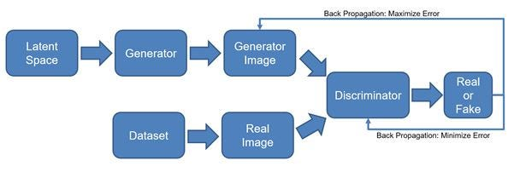

2. Ethics and AI Harm
Choose one of the following real-world AI harms discussed in Chapter 12:
- Representational harm
- Allocational harm
- Misinformation in generative AI
Describe a real or hypothetical application where this harm may occur. Then, suggest two harm mitigation strategies that could reduce its impact based on the lecture.

Misinformation in Generative AI:
Health misinformation: AI-generated research or articles promoting false cures during pandemics
Two Harm Mitigation Strategies:
1. Voter manipulation: People may believe the fake content and change their vote based on lies.
2.Fact-Checking Systems:
Integrated real-time verification tools that cross-check AI- generated content against trusted knowledge bases.

3. Legal and Ethical Implications of GenAI
Discuss the legal and ethical concerns of AI-generated content based on the examples of:
- Memorizing private data (e.g., names in GPT-2)
- Generating copyrighted material (e.g., Harry Potter text)
Do you believe generative AI models should be restricted from certain data during training? Justify your answer.

- Memorizing Private Data: Models like GPT-2 have been shown to AI memorize and regurgitate parts of their training data, including names, email addresses, phone numbers, and other private information.

- Generating Copyrighted Material:
Generative models have also produced copyrights content, like Harry Potter
Paragraphs, almost word-for-word. That creates legal risk related to intellectual property violations and copyright infringement, since the AI is recreating protected without permission.

Should Generative AI Be Restricted from Certain Data During Training?

Yes, I strongly believe AI Generative should be Restricted from Certain Data During Training because,
* Protects individual privacy.
* Respects copyright law and encourages fair use.

6. Bias & Fairness Tools
Visit Aequitas Bias Audit Tool.
Choose a bias metric (e.g., false negative rate parity) and describe:
- What the metric measures
- Why it's important
- How a model might fail this metric
Optional: Try applying the tool to any small dataset or use demo data.

Chosen Metric:
False Negative Rate Parity
What the metric measures:
The False Negative Rate is the proportion of actual positive cases that a model incorrectly predicts as negative. False Negative Rate Parity checks whether this rate is similar across different groups, such as by race, gender, or age.

Why it's important:
High False Negative Rates in one group mean qualified individuals are unfairly filtered out. For example, In hiring algorithm process, if a model has a higher False Negative Rate for older candidates, it may consistently reject capable older applicants.

How a model might fail this metric:
If training data is imbalanced (e.g., fewer positive outcomes for a certain group), the model might under learn patterns in that group.

