**Exercise 1: Control Structures**

CREATE TABLE Customers (

CustomerID NUMBER PRIMARY KEY,

Name VARCHAR2(100),

DOB DATE,

Balance NUMBER,

LastModified DATE

);

CREATE TABLE Accounts (

AccountID NUMBER PRIMARY KEY,

CustomerID NUMBER,

AccountType VARCHAR2(20),

Balance NUMBER,

LastModified DATE,

FOREIGN KEY (CustomerID) REFERENCES Customers(CustomerID)

);

CREATE TABLE Transactions (

TransactionID NUMBER PRIMARY KEY,

AccountID NUMBER,

TransactionDate DATE,

Amount NUMBER,

TransactionType VARCHAR2(10),

FOREIGN KEY (AccountID) REFERENCES Accounts(AccountID)

);

CREATE TABLE Loans (

LoanID NUMBER PRIMARY KEY,

CustomerID NUMBER,

LoanAmount NUMBER,

InterestRate NUMBER,

StartDate DATE,

EndDate DATE,

FOREIGN KEY (CustomerID) REFERENCES Customers(CustomerID)

)

CREATE TABLE Employees (

EmployeeID NUMBER PRIMARY KEY,

Name VARCHAR2(100),

Position VARCHAR2(50),

Salary NUMBER,

Department VARCHAR2(50),

HireDate DATE

);

INSERT INTO Customers (CustomerID, Name, DOB, Balance, LastModified)

VALUES (1, 'John Doe', TO_DATE('1985-05-15', 'YYYY-MM-DD'), 1000, SYSDATE);

INSERT INTO Customers (CustomerID, Name, DOB, Balance, LastModified)

VALUES (2, 'Jane Smith', TO_DATE('1990-07-20', 'YYYY-MM-DD'), 1500, SYSDATE);

INSERT INTO Accounts (AccountID, CustomerID, AccountType, Balance, LastModified)

VALUES (1, 1, 'Savings', 1000, SYSDATE);

INSERT INTO Accounts (AccountID, CustomerID, AccountType, Balance, LastModified)

VALUES (2, 2, 'Checking', 1500, SYSDATE);

INSERT INTO Transactions (TransactionID, AccountID, TransactionDate, Amount, TransactionType)

VALUES (1, 1, SYSDATE, 200, 'Deposit');

INSERT INTO Transactions (TransactionID, AccountID, TransactionDate, Amount, TransactionType)

VALUES (2, 2, SYSDATE, 300, 'Withdrawal');

INSERT INTO Loans (LoanID, CustomerID, LoanAmount, InterestRate, StartDate, EndDate)

VALUES (1, 1, 5000, 5, SYSDATE, ADD_MONTHS(SYSDATE, 60));

INSERT INTO Employees (EmployeeID, Name, Position, Salary, Department, HireDate)

VALUES (1, 'Alice Johnson', 'Manager', 70000, 'HR', TO_DATE('2015-06-15', 'YYYY-MM-DD'));

INSERT INTO Employees (EmployeeID, Name, Position, Salary, Department, HireDate)

VALUES (2, 'Bob Brown', 'Developer', 60000, 'IT', TO_DATE('2017-03-20', 'YYYY-MM-DD'));

BEGIN

FOR cust IN (SELECT CustomerID, DOB FROM Customers) LOOP

IF MONTHS_BETWEEN(SYSDATE, cust.DOB)/12 > 60 THEN

UPDATE Loans

SET InterestRate = InterestRate - 1

WHERE CustomerID = cust.CustomerID;

END IF;

END LOOP;

COMMIT;

END;

/

ALTER TABLE Customers ADD IsVIP CHAR(1);

BEGIN

FOR cust IN (SELECT CustomerID, Balance FROM Customers) LOOP

IF cust.Balance > 10000 THEN

UPDATE Customers

SET IsVIP = 'Y'

WHERE CustomerID = cust.CustomerID;

END IF;

END LOOP;

COMMIT;

END;

/

SET SERVEROUTPUT ON;

BEGIN

FOR loan IN (

SELECT l.LoanID, l.CustomerID, c.Name, l.EndDate

FROM Loans l

JOIN Customers c ON l.CustomerID = c.CustomerID

WHERE l.EndDate BETWEEN SYSDATE AND SYSDATE + 30

) LOOP

DBMS_OUTPUT.PUT_LINE('Reminder: Loan ' || loan.LoanID || ' for customer ' || loan.Name || ' is due on ' || TO_CHAR(loan.EndDate, 'YYYY-MM-DD'));

END LOOP;

END;

/

**Output:**

|  |  |
| --- | --- |
|  |  |

**Exercise 2: Error Handling**

CREATE OR REPLACE PROCEDURE SafeTransferFunds (

p_from_account_id IN NUMBER,

p_to_account_id IN NUMBER,

p_amount IN NUMBER

) AS

v_balance NUMBER;

BEGIN

SELECT Balance INTO v_balance FROM Accounts WHERE AccountID = p_from_account_id FOR UPDATE;

IF v_balance < p_amount THEN

RAISE_APPLICATION_ERROR(-20001, 'Insufficient funds');

END IF;

UPDATE Accounts SET Balance = Balance - p_amount WHERE AccountID = p_from_account_id;

UPDATE Accounts SET Balance = Balance + p_amount WHERE AccountID = p_to_account_id;

COMMIT;

EXCEPTION

WHEN OTHERS THEN

ROLLBACK;

INSERT INTO Transactions(TransactionID, AccountID, TransactionDate, Amount, TransactionType)

VALUES (Transactions_SEQ.NEXTVAL, p_from_account_id, SYSDATE, 0, 'Error');

END;

/

CREATE OR REPLACE PROCEDURE UpdateSalary (

p_emp_id IN NUMBER,

p_percent IN NUMBER

) AS

BEGIN

UPDATE Employees

SET Salary = Salary + (Salary * p_percent / 100)

WHERE EmployeeID = p_emp_id;

IF SQL%ROWCOUNT = 0 THEN

RAISE_APPLICATION_ERROR(-20002, 'Employee not found');

END IF;

COMMIT;

EXCEPTION

WHEN OTHERS THEN

ROLLBACK;

INSERT INTO Transactions(TransactionID, AccountID, TransactionDate, Amount, TransactionType)

VALUES (Transactions_SEQ.NEXTVAL, NULL, SYSDATE, 0, 'Error');

END;

/

CREATE OR REPLACE PROCEDURE AddNewCustomer (

p_id IN NUMBER,

p_name IN VARCHAR2,

p_dob IN DATE,

p_balance IN NUMBER

) AS

BEGIN

INSERT INTO Customers (CustomerID, Name, DOB, Balance, LastModified)

VALUES (p_id, p_name, p_dob, p_balance, SYSDATE);

COMMIT;

EXCEPTION

WHEN DUP_VAL_ON_INDEX THEN

ROLLBACK;

INSERT INTO Transactions(TransactionID, AccountID, TransactionDate, Amount, TransactionType)

VALUES (Transactions_SEQ.NEXTVAL, NULL, SYSDATE, 0, 'Duplicate');

WHEN OTHERS THEN

ROLLBACK;

END;

/

**Output:**

|  |  |
| --- | --- |
|  |  |

**Exercise 3: Stored Procedures**

**CREATE OR REPLACE PROCEDURE ProcessMonthlyInterest IS**

**BEGIN**

**FOR acc IN (SELECT AccountID, Balance FROM Accounts WHERE AccountType = 'Savings') LOOP**

**UPDATE Accounts**

**SET Balance = Balance + (acc.Balance * 0.01)**

**WHERE AccountID = acc.AccountID;**

**END LOOP;**

**COMMIT;**

**END;**

**/**

CREATE OR REPLACE PROCEDURE UpdateEmployeeBonus ( p_dept IN VARCHAR2, p_bonus_pct IN NUMBER ) IS BEGIN UPDATE Employees SET Salary = Salary + (Salary * p_bonus_pct / 100) WHERE Department = p_dept; COMMIT; END; /

CREATE OR REPLACE PROCEDURE TransferFunds ( p_from_acc IN NUMBER, p_to_acc IN NUMBER, p_amount IN NUMBER ) IS v_balance NUMBER; BEGIN SELECT Balance INTO v_balance FROM Accounts WHERE AccountID = p_from_acc FOR UPDATE;

IF v_balance < p_amount THEN RAISE_APPLICATION_ERROR(-20001, 'Insufficient balance'); END IF;

UPDATE Accounts SET Balance = Balance - p_amount WHERE AccountID = p_from_acc; UPDATE Accounts SET Balance = Balance + p_amount WHERE AccountID = p_to_acc;

COMMIT; END; /

**Output:**

|  |  |
| --- | --- |
|  |  |

**Exercise 4: Functions**

CREATE OR REPLACE FUNCTION CalculateAge(p_dob DATE)

RETURN NUMBER IS

BEGIN

RETURN FLOOR(MONTHS_BETWEEN(SYSDATE, p_dob) / 12);

END;

/

CREATE OR REPLACE FUNCTION CalculateMonthlyInstallment(

p_loan_amount NUMBER,

p_interest_rate NUMBER,

p_years NUMBER

)

RETURN NUMBER IS

v_monthly_rate NUMBER;

v_months NUMBER;

v_installment NUMBER;

BEGIN

v_monthly_rate := p_interest_rate / 12 / 100;

v_months := p_years * 12;

v_installment := (p_loan_amount * v_monthly_rate) /

(1 - POWER(1 + v_monthly_rate, -v_months));

RETURN v_installment;

END;

/

CREATE OR REPLACE FUNCTION HasSufficientBalance(

p_account_id NUMBER,

p_amount NUMBER

)

RETURN BOOLEAN IS

v_balance NUMBER;

BEGIN

SELECT Balance INTO v_balance FROM Accounts WHERE AccountID = p_account_id;

RETURN v_balance >= p_amount;

EXCEPTION

WHEN NO_DATA_FOUND THEN

RETURN FALSE;

END;

/

**Output:**

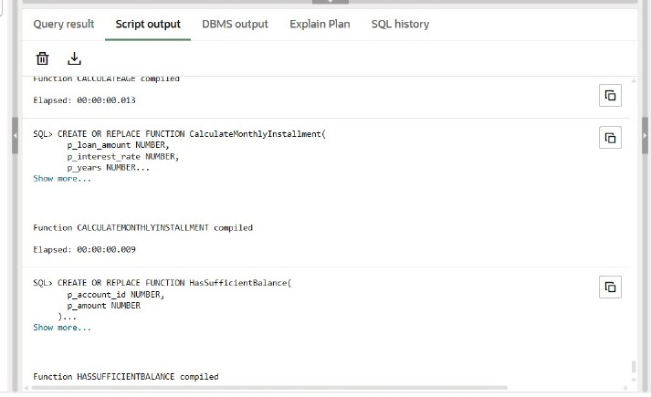

**Exercise 5: Triggers**

CREATE OR REPLACE TRIGGER UpdateCustomerLastModified

BEFORE UPDATE ON Customers

FOR EACH ROW

BEGIN

:NEW.LastModified := SYSDATE;

END;

/

CREATE TABLE AuditLog (

LogID NUMBER GENERATED ALWAYS AS IDENTITY PRIMARY KEY,

TransactionID NUMBER,

LogDate DATE,

Action VARCHAR2(50)

);

CREATE OR REPLACE TRIGGER LogTransaction

AFTER INSERT ON Transactions

FOR EACH ROW

BEGIN

INSERT INTO AuditLog(TransactionID, LogDate, Action)

VALUES (:NEW.TransactionID, SYSDATE, 'Transaction Inserted');

END;

/

CREATE OR REPLACE TRIGGER CheckTransactionRules

BEFORE INSERT ON Transactions

FOR EACH ROW

DECLARE

v_balance NUMBER;

BEGIN

IF :NEW.TransactionType = 'Withdrawal' THEN

SELECT Balance INTO v_balance FROM Accounts WHERE AccountID = :NEW.AccountID;

IF :NEW.Amount > v_balance THEN

RAISE_APPLICATION_ERROR(-20001, 'Withdrawal exceeds account balance');

END IF;

ELSIF :NEW.TransactionType = 'Deposit' THEN

IF :NEW.Amount <= 0 THEN

RAISE_APPLICATION_ERROR(-20002, 'Deposit amount must be positive');

END IF;

END IF;

END;

/

**Output:**

|  |  |
| --- | --- |
|  |  |

**Exercise 6: Cursors**

SET SERVEROUTPUT ON;

DECLARE

CURSOR cur_transactions IS

SELECT t.AccountID, t.Amount, t.TransactionDate, t.TransactionType, c.Name

FROM Transactions t

JOIN Accounts a ON t.AccountID = a.AccountID

JOIN Customers c ON a.CustomerID = c.CustomerID

WHERE TRUNC(t.TransactionDate, 'MM') = TRUNC(SYSDATE, 'MM');

v_account_id Accounts.AccountID%TYPE;

v_amount Transactions.Amount%TYPE;

v_date Transactions.TransactionDate%TYPE;

v_type Transactions.TransactionType%TYPE;

v_name Customers.Name%TYPE;

BEGIN

OPEN cur_transactions;

LOOP

FETCH cur_transactions INTO v_account_id, v_amount, v_date, v_type, v_name;

EXIT WHEN cur_transactions%NOTFOUND;

DBMS_OUTPUT.PUT_LINE('Customer: ' || v_name || ', Account: ' || v_account_id ||

', ' || v_type || ' of $' || v_amount || ' on ' || TO_CHAR(v_date, 'YYYY-MM-DD'));

END LOOP;

CLOSE cur_transactions;

END;

/

DECLARE

CURSOR acc_cursor IS

SELECT AccountID, Balance FROM Accounts;

v_acc_id Accounts.AccountID%TYPE;

v_balance Accounts.Balance%TYPE;

v_fee CONSTANT NUMBER := 100;

BEGIN

OPEN acc_cursor;

LOOP

FETCH acc_cursor INTO v_acc_id, v_balance;

EXIT WHEN acc_cursor%NOTFOUND;

UPDATE Accounts

SET Balance = Balance - v_fee

WHERE AccountID = v_acc_id;

END LOOP;

CLOSE acc_cursor;

COMMIT;

END;

/

DECLARE

CURSOR loan_cursor IS

SELECT LoanID, InterestRate FROM Loans;

v_loan_id Loans.LoanID%TYPE;

v_old_rate Loans.InterestRate%TYPE;

v_new_rate NUMBER;

BEGIN

OPEN loan_cursor;

LOOP

FETCH loan_cursor INTO v_loan_id, v_old_rate;

EXIT WHEN loan_cursor%NOTFOUND;

v_new_rate := v_old_rate + 0.5;

UPDATE Loans

SET InterestRate = v_new_rate

WHERE LoanID = v_loan_id;

END LOOP;

CLOSE loan_cursor;

COMMIT;

END;

/

**Output:**

|  |  |
| --- | --- |
|  |  |

**Exercise 7: Packages**

CREATE OR REPLACE PACKAGE CustomerManagement AS

PROCEDURE AddCustomer(p_CustomerID NUMBER, p_Name VARCHAR2, p_DOB DATE, p_Balance NUMBER);

PROCEDURE UpdateCustomer(p_CustomerID NUMBER, p_Name VARCHAR2, p_Balance NUMBER);

FUNCTION GetCustomerBalance(p_CustomerID NUMBER) RETURN NUMBER;

END CustomerManagement;

/

CREATE OR REPLACE PACKAGE BODY CustomerManagement AS

PROCEDURE AddCustomer(p_CustomerID NUMBER, p_Name VARCHAR2, p_DOB DATE, p_Balance NUMBER) IS

BEGIN

INSERT INTO Customers (CustomerID, Name, DOB, Balance, LastModified)

VALUES (p_CustomerID, p_Name, p_DOB, p_Balance, SYSDATE);

DBMS_OUTPUT.PUT_LINE('Customer added: ' || p_Name);

END;

PROCEDURE UpdateCustomer(p_CustomerID NUMBER, p_Name VARCHAR2, p_Balance NUMBER) IS

BEGIN

UPDATE Customers

SET Name = p_Name, Balance = p_Balance, LastModified = SYSDATE

WHERE CustomerID = p_CustomerID;

DBMS_OUTPUT.PUT_LINE('Customer updated: ' || p_Name);

END;

FUNCTION GetCustomerBalance(p_CustomerID NUMBER) RETURN NUMBER IS

v_Balance NUMBER;

BEGIN

SELECT Balance INTO v_Balance FROM Customers WHERE CustomerID = p_CustomerID;

RETURN v_Balance;

EXCEPTION

WHEN NO_DATA_FOUND THEN

RETURN NULL;

END;

END CustomerManagement;

/

Output:

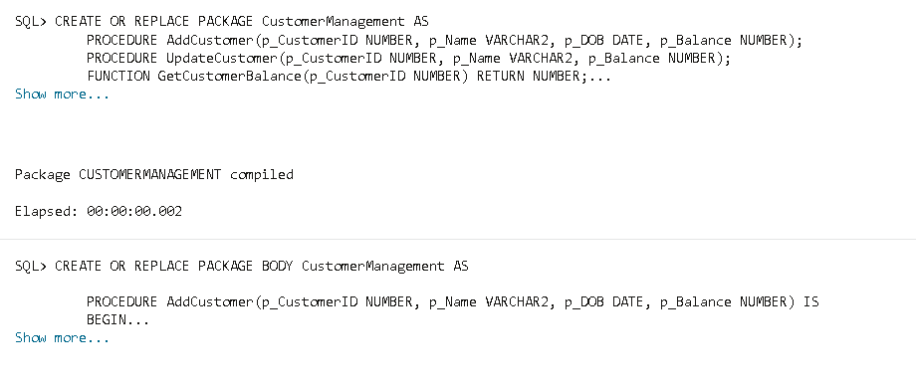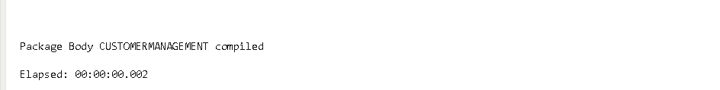

CREATE OR REPLACE PACKAGE EmployeeManagement AS

PROCEDURE HireEmployee(p_EmployeeID NUMBER, p_Name VARCHAR2, p_Position VARCHAR2, p_Salary NUMBER, p_Department VARCHAR2);

PROCEDURE UpdateEmployee(p_EmployeeID NUMBER, p_Salary NUMBER);

FUNCTION CalculateAnnualSalary(p_EmployeeID NUMBER) RETURN NUMBER;

END EmployeeManagement;

/

CREATE OR REPLACE PACKAGE BODY EmployeeManagement AS

PROCEDURE HireEmployee(p_EmployeeID NUMBER, p_Name VARCHAR2, p_Position VARCHAR2, p_Salary NUMBER, p_Department VARCHAR2) IS

BEGIN

INSERT INTO Employees (EmployeeID, Name, Position, Salary, Department, HireDate)

VALUES (p_EmployeeID, p_Name, p_Position, p_Salary, p_Department, SYSDATE);

DBMS_OUTPUT.PUT_LINE('Employee hired: ' || p_Name);

END;

PROCEDURE UpdateEmployee(p_EmployeeID NUMBER, p_Salary NUMBER) IS

BEGIN

UPDATE Employees

SET Salary = p_Salary

WHERE EmployeeID = p_EmployeeID;

DBMS_OUTPUT.PUT_LINE('Employee salary updated.');

END;

FUNCTION CalculateAnnualSalary(p_EmployeeID NUMBER) RETURN NUMBER IS

v_Salary NUMBER;

BEGIN

SELECT Salary INTO v_Salary FROM Employees WHERE EmployeeID = p_EmployeeID;

RETURN v_Salary * 12;

EXCEPTION

WHEN NO_DATA_FOUND THEN

RETURN NULL;

END;

END EmployeeManagement;

/

Output:

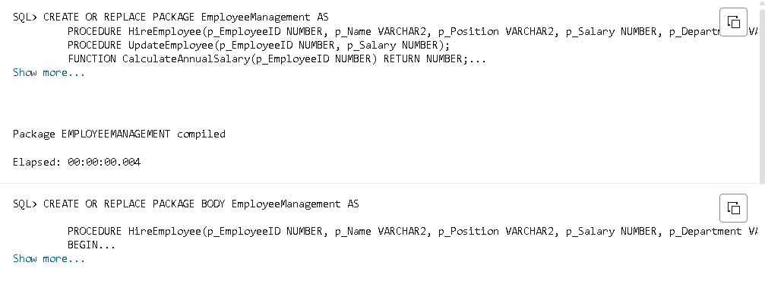

CREATE OR REPLACE PACKAGE AccountOperations AS

PROCEDURE OpenAccount(p_AccountID NUMBER, p_CustomerID NUMBER, p_AccountType VARCHAR2, p_Balance NUMBER);

PROCEDURE CloseAccount(p_AccountID NUMBER);

FUNCTION GetTotalCustomerBalance(p_CustomerID NUMBER) RETURN NUMBER;

END AccountOperations;

/

CREATE OR REPLACE PACKAGE BODY AccountOperations AS

PROCEDURE OpenAccount(p_AccountID NUMBER, p_CustomerID NUMBER, p_AccountType VARCHAR2, p_Balance NUMBER) IS

BEGIN

INSERT INTO Accounts (AccountID, CustomerID, AccountType, Balance, LastModified)

VALUES (p_AccountID, p_CustomerID, p_AccountType, p_Balance, SYSDATE);

DBMS_OUTPUT.PUT_LINE('Account opened: ' || p_AccountID);

END;

PROCEDURE CloseAccount(p_AccountID NUMBER) IS

BEGIN

DELETE FROM Accounts WHERE AccountID = p_AccountID;

DBMS_OUTPUT.PUT_LINE('Account closed: ' || p_AccountID);

END;

FUNCTION GetTotalCustomerBalance(p_CustomerID NUMBER) RETURN NUMBER IS

v_TotalBalance NUMBER;

BEGIN

SELECT SUM(Balance) INTO v_TotalBalance FROM Accounts WHERE CustomerID = p_CustomerID;

RETURN NVL(v_TotalBalance, 0);

END;

END AccountOperations;

/

**Output**

|  |  |
| --- | --- |
|  |  |