Exercise 1: Create a Spring Web Project using Maven

ApplicationContext.xml

<?xml version="1.0" encoding="UTF-8"?>

<beans xmlns="http://www.springframework.org/schema/beans"

xmlns:xsi="http://www.w3.org/2001/XMLSchema-instance"

xsi:schemaLocation="

<http://www.springframework.org/schema/beans>

<http://www.springframework.org/schema/beans/spring-beans.xsd>">

<!-- Repository Bean -->

<bean id="bookRepository" class="com.library.repository.BookRepository" />

<!-- Service Bean with Dependency Injection -->

<bean id="bookService" class="com.library.service.BookService">

<property name="bookRepository" ref="bookRepository" />

</bean>

</beans>

Com.library.repository

package com.library.repository;

public class BookRepository {

public void saveBook(String bookName) {

System.out.println("Book '" + bookName + "' saved to the repository.");

}

}

Com.library.service

package com.library.service;

import com.library.repository.BookRepository;

public class BookService {

private BookRepository bookRepository;

// Setter for dependency injection

public void setBookRepository(BookRepository bookRepository) {

this.bookRepository = bookRepository;

}

public void addBook(String bookName) {

System.out.println("Adding book: " + bookName);

bookRepository.saveBook(bookName);

}

}

Com.library

package com.library;

import com.library.service.BookService;

import org.springframework.context.ApplicationContext;

import org.springframework.context.support.ClassPathXmlApplicationContext;

public class MainApp {

public static void main(String[] args) {

// Load the Spring context from applicationContext.xml

ApplicationContext context = new ClassPathXmlApplicationContext("applicationContext.xml");

// Retrieve the BookService bean

BookService bookService = (BookService) context.getBean("bookService");

// Test adding a book

bookService.addBook("The Alchemist");

}

}

Output:



Exercise 2: Implementing Dependency Injection

ApplicationContext.xml

<?xml version="1.0" encoding="UTF-8"?>

<beans xmlns="http://www.springframework.org/schema/beans"

xmlns:xsi="http://www.w3.org/2001/XMLSchema-instance"

xsi:schemaLocation="

<http://www.springframework.org/schema/beans>

<http://www.springframework.org/schema/beans/spring-beans.xsd>">

<!-- Repository Bean -->

<bean id="bookRepository" class="com.library.repository.BookRepository" />

<!-- Service Bean with Dependency Injection -->

<bean id="bookService" class="com.library.service.BookService">

<property name="bookRepository" ref="bookRepository" />

</bean>

</beans>

Com.library.repository

package com.library.repository;

public class BookRepository {

public void saveBook(String bookName) {

System.out.println("Book '" + bookName + "' saved to the repository.");

}

}

Com.library.service

package com.library.service;

import com.library.repository.BookRepository;

public class BookService {

private BookRepository bookRepository;

// Setter for dependency injection

public void setBookRepository(BookRepository bookRepository) {

this.bookRepository = bookRepository;

}

public void addBook(String bookName) {

System.out.println("Adding book: " + bookName);

bookRepository.saveBook(bookName);

}

}

Com.library

package com.library;

import com.library.service.BookService;

import org.springframework.context.ApplicationContext;

import org.springframework.context.support.ClassPathXmlApplicationContext;

public class LibraryManagementApplication {

public static void main(String[] args) {

// Load Spring context from applicationContext.xml

ApplicationContext context = new ClassPathXmlApplicationContext("applicationContext.xml");

// Retrieve BookService bean from context

BookService bookService = (BookService) context.getBean("bookService");

// Test dependency injection

bookService.addBook("The Alchemist");

}

}

Output:

Starting LibraryManagementApplication [Main]...

Apr 24, 2024 11:56:45 AM org.springframework.context.support.ClassPathXmlApplicationContext prepareRefresh

INFO: Refreshing org.springframework.context.support.ClassPathXmlApplicationContext@3aeed9163

Adding book: The Alchemist

Book 'The Alchemist' saved to the repository

--------------------------------------

<terminated>(exit value: 0): Java was started on port 57063

Exercise 4: Creating and Configuring a Maven Project

Pom.xml

<project xmlns="http://maven.apache.org/POM/4.0.0"

xmlns:xsi="http://www.w3.org/2001/XMLSchema-instance"

xsi:schemaLocation="http://maven.apache.org/POM/4.0.0

<http://maven.apache.org/xsd/maven-4.0.0.xsd>">

<modelVersion>4.0.0</modelVersion>

<groupId>com.library</groupId>

<artifactId>LibraryManagement</artifactId>

<version>1.0-SNAPSHOT</version>

<dependencies>

<!-- Spring Context -->

<dependency>

<groupId>org.springframework</groupId>

<artifactId>spring-context</artifactId>

<version>5.3.36</version>

</dependency>

<!-- Spring AOP -->

<dependency>

<groupId>org.springframework</groupId>

<artifactId>spring-aop</artifactId>

<version>5.3.36</version>

</dependency>

<!-- Spring WebMVC -->

<dependency>

<groupId>org.springframework</groupId>

<artifactId>spring-webmvc</artifactId>

<version>5.3.36</version>

</dependency>

</dependencies>

<build>

<plugins>

<!-- Maven Compiler Plugin for Java 1.8 -->

<plugin>

<groupId>org.apache.maven.plugins</groupId>

<artifactId>maven-compiler-plugin</artifactId>

<version>3.10.1</version>

<configuration>

<source>1.8</source>

<target>1.8</target>

</configuration>

</plugin>

</plugins>

</build>

</project>

Output:

[INFO] Scanning for projects...

[INFO]

[INFO] ---------------------< com.library:LibraryManagement >---------------------

[INFO] Building LibraryManagement 1.0-SNAPSHOT

[INFO] --------------------------------[ jar ]---------------------------------

[INFO]

[INFO] --- maven-clean-plugin:2.5:clean (default-clean) @ LibraryManagement ---

[INFO] Deleting C:\Users\Varshitha\eclipse-workspace\LibraryManagement\target

[INFO]

[INFO] --- maven-resources-plugin:2.6:resources (default-resources) @ LibraryManagement ---

[INFO] Using 'UTF-8' encoding to copy filtered resources.

[INFO] skip non existing resourceDirectory C:\Users\Varshitha\eclipse-workspace\LibraryManagement\src\main\resources

[INFO]

[INFO] --- maven-compiler-plugin:3.10.1:compile (default-compile) @ LibraryManagement ---

[INFO] Changes detected - recompiling the module!

[INFO] Compiling 0 source files to C:\Users\Varshitha\eclipse-workspace\LibraryManagement\target\classes

[INFO]

[INFO] BUILD SUCCESS

[INFO] ------------------------------------------------------------------------

[INFO] Total time: 1.954 s

[INFO] Finished at: 2025-07-04T15:40:30+05:30

[INFO] ------------------------------------------------------------------------

Difference between JPA ,Hibernate and spring Data JPa

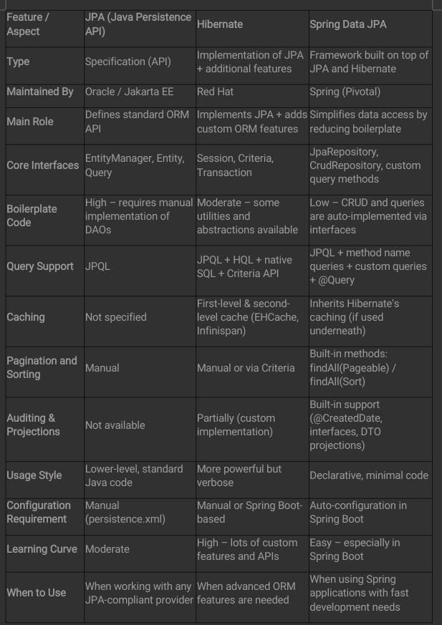

Spring Data JPA - Quick Example

Com.cognizant.ormlearn.model

package com.cognizant.ormlearn.model;

import javax.persistence.Column;

import javax.persistence.Entity;

import javax.persistence.Id;

import javax.persistence.Table;

@Entity

@Table(name = "country")

public class Country {

@Id

@Column(name = "co_code")

private String code;

@Column(name = "co_name")

private String name;

public String getCode() {

return code;

}

public void setCode(String code) {

this.code = code;

}

public String getName() {

return name;

}

public void setName(String name) {

this.name = name;

}

@Override

public String toString() {

return "Country [code=" + code + ", name=" + name + "]";

}

}

Com.cognizant.ormlearn.repository

package com.cognizant.ormlearn.repository;

import com.cognizant.ormlearn.model.Country;

import org.springframework.data.jpa.repository.JpaRepository;

import org.springframework.stereotype.Repository;

@Repository

public interface CountryRepository extends JpaRepository<Country, String> {

}

Com.cognizant.ormlearn.service

package com.cognizant.ormlearn.service;

import com.cognizant.ormlearn.model.Country;

import com.cognizant.ormlearn.repository.CountryRepository;

import org.springframework.beans.factory.annotation.Autowired;

import org.springframework.stereotype.Service;

import org.springframework.transaction.annotation.Transactional;

import java.util.List;

@Service

public class CountryService {

@Autowired

private CountryRepository countryRepository;

@Transactional

public List<Country> getAllCountries() {

return countryRepository.findAll();

}

}

Com.cognizant.ormlearn

package com.cognizant.ormlearn;

import com.cognizant.ormlearn.model.Country;

import com.cognizant.ormlearn.service.CountryService;

import org.slf4j.Logger;

import org.slf4j.LoggerFactory;

import org.springframework.boot.SpringApplication;

import org.springframework.boot.autoconfigure.SpringBootApplication;

import org.springframework.context.ApplicationContext;

import java.util.List;

@SpringBootApplication

public class OrmLearnApplication {

private static final Logger LOGGER = LoggerFactory.getLogger(OrmLearnApplication.class);

private static CountryService countryService;

public static void main(String[] args) {

ApplicationContext context = SpringApplication.run(OrmLearnApplication.class, args);

LOGGER.info("Inside main");

countryService = context.getBean(CountryService.class);

testGetAllCountries();

}

private static void testGetAllCountries() {

LOGGER.info("Start");

List<Country> countries = countryService.getAllCountries();

LOGGER.debug("countries={}", countries);

LOGGER.info("End");

}

}

Output:

