
AI-Based Smart Referral System

MAJOR PROJECT REPORT submitted in partial fulfillment of the requirements for the Award of the Degree of

BACHELOR OF TECHNOLOGY

In
INFORMATION TECHNOLOGY

By
Lakshmi Varshitha Poppoppula(228W1A1250)
Shanmukha Raghavendra Ravutu (228W1A1256)
Under the Guidance of

Dr. Y.Sandeep,
Sr. Assistant Professor


DEPARTMENT OF INFORMATION TECHNOLOGY V R SIDDHARTHA ENGINEERING COLLEGE
(AUTONOMOUS - AFFILIATED TO JNTU-K, KAKINADA)
Approved by AICTE &Accredited by NBA KANURU, VIJAYAWADA-520007 ACADEMIC YEAR
(2025-26)
i

V.R.SIDDHARTHA ENGINEERING COLLEGE
(Affiliated to JNTUK: Kakinada, Approved by AICTE, Autonomous) (An ISO certified and NBA accredited institution)
Kanuru, Vijayawada – 520007


CERTIFICATE

This is to certify that this project report titled “AI-Based Smart Referral System” is a bonafide record of work done by Lakshmi Varshitha Poppoppula (228W1A1250), Shanmukha Raghavendra Ravutu (228W1A1256) under my guidance and supervision is submitted in partial fulfillment of the requirements for the award of the degree of Bachelor of Technology in Information Technology, V.R. Siddhartha Engineering College (Autonomous under JNTUK) during the year 2025- 26.

(Dr. Y. Sandeep) (Dr. M. Suneetha)
Sr. Assistant Professor Professor &Head
Dept. of Information Technology Dept. of Information Technology

EXTERNAL EXAMINER SIGNATURE

Date of examination:
ii

DEPARTMENT OF INFORMATION TECHNOLOGY
V.R.SIDDHARTHA ENGINEERING COLLEGE
PROJECT SUMMARY

S.No | Item | Description
1 | Project Title | AI-Based Smart Referral System
2 | Student Names & Numbers | Lakshmi Varshitha Poppoppula (228W1A1250)  Shanmukha Raghavendra Ravutu (228W1A1256)
3 | Name of The Guide | Dr. Y.Sandeep
4 | Research Group | Artificial Intelligence & Natural Language Processing
5 | Application Area | Education Technology / Career Development / College Placement
6 | Aim of the Project | Build an AI platform for resume analysis, skill gap detection, semantic job matching, and alumni referral support.
7 | Project Outcomes | - Skill gap analysis for personalized insights  - Semantic job search using intelligent matching  - Graph-based alumni referral recommendations  - Real-time notifications with better performance than keyword-based systems

Student Signatures

Signature of the Guide
iii

ACKNOWLEDGEMENT

First and foremost, I sincerely salute our esteemed institution V.R SIDDHARTHA ENGINEERING COLLEGE for giving me this opportunity for fulfilling my project. I am grateful to our Principal Dr. A.V.RATNA PRASAD, for his encouragement and support all through the way of my project.
On the submission of this Project report, I would like to extend my honour to Dr. M.Suneetha, Head of the Department, IT for her constant motivation and support during the course of my work.
I feel glad to express my deep sense of gratefulness to my project guide Dr. Y. Sandeep, Assistant Professor for his guidance and assistance in completing this project successfully.

I would also like to convey my sincere indebtedness to all faculty members, including supporting staff of the Department, friends and family members who bestowed their great effort and guidance at appropriate times without which it would have been very difficulty on my part to finish the project work.
iv

TABLE OF CONTENTS
ACKNOWLEDGEMENT |  | iii
LIST OF FIGURES |  | v
LIST OF TABLES |  | vi
LIST OF EQUATIONS |  | vii
ABSTRACT |  | viii
CHAPTER-1 Introduction |  | 1
1.1 Origin of the Problem |  | 1
1.2 Basic definitions and Background |  | 2
1.3 Problem Statement with Objectives and Outcomes |  | 4
1.4 Related Applications |  | 8
CHAPTER-2 Review of Literature |  | 10
2.1 Description of Existing Systems |  | 10
2.2 Summary of Literature Study |  | 13
CHAPTER-3 Proposed Method |  | 14
3.1 Design Methodology |  | 14
3.2 System Architecture Diagram |  | 29
3.3 Description of Algorithms |  | 37
3.4 Description of datasets, Requirements and Tools |  | 46
CHAPTER-4 Results and Observations |  | 49
4.1 Stepwise description of Results |  | 49
4.2 Test case results/Result Analysis |  | 52
4.3 Observations from the work |  | 55
CHAPTER-5 Conclusion and Future work |  | 61
5.1 Conclusion |  | 61
5.2 Future study |  | 62
References |  | 65
Appendix |  | 75
v

LIST OF FIGURES
Figure | Page
Figure 3.1 Complete Three-Tier System Architecture | 15
Figure 3.2 Hybrid RAG-CKB Retrieval | 19
Figure 3.3 Supabase PostgreSQL Database Schema | 22
Figure 3.4 Three-Message Cold Limit Enforcement | 24
Figure 3.5 Complete AI Feature Map | 27
Figure 3.6 End-to-End Data Flow | 28
Figure 3.7 Architecture diagram | 30
Figure 3.8 Interview Question Bank | 37
Figure 3.9 Logistic Regression Acceptance Predictor | 46
Figure 4.1 Student Job Browse Interface | 52
Figure 4.2 Job Detail Page with Semantic Skill Gap Analyser | 53
Figure 4.3 RAG-Based Career Advisor Chatbot Interface | 54
Figure 4.4 Real-time Referral Chat and Interview Scheduling Interface | 55
Figure 4.5 Ablation Bar Graph | 58
Figure 4.6 Retrieval Source Distribution | 60

vi

LIST OF TABLES

Table Name | Page
Table 4.1 Per-Category RAG Retrieval Analysis | 51
Table 4.2 RAGAS Analysis | 56
Table 4.3 Performance of Hybrid RAG vs Baseline | 57
Table 4.4 AI Feature Accuracy Results | 58
Table 4.5 System API Response Latency | 60
vii

LIST OF EQUATIONS

Equation | Brief Description
Eq. [1] | Inverse Document Frequency
Eq. [2] | Reciprocal Rank Fusion Score
Eq. [3] | Cosine Similarity
Eq. [4] | Precision at Rank k
Eq. [5] | Recall at Rank k
Eq. [6] | F1 Score at Rank k
Eq. [7] | Discounted Cumulative Gain
Eq. [8] | Normalized Discounted
Eq. [9] | Logistic Regression

viii

ABSTRACT

The process of job preparation and referral acquisition among students is often unstructured and lacks personalized guidance, making it difficult for individuals to align their skills with industry requirements and access relevant professional networks. This project presents an AI-based smart referral system that combines resume analysis, semantic job matching, and an intelligent referral mechanism to improve placement outcomes. The system processes student resumes and job descriptions by generating embedding representations and comparing them to identify skill gaps and suitability for specific roles. A retrieval-augmented approach is utilized to provide meaningful and context-aware feedback, enabling students to understand missing competencies and enhance their profiles effectively. Additionally, a knowledge graph is employed to represent relationships between students, alumni, skills, and companies, allowing the system to recommend suitable senior students for referrals based on similarity in roles, expertise, and availability. Real-time communication features are integrated to support seamless referral requests and status tracking, improving interaction between users. The platform combines structured data management, semantic search, and AI-driven insights to deliver accurate recommendations and practical guidance. Experimental results indicate that the system effectively provides relevant job matches, reliable skill gap analysis, and efficient referral suggestions, while the user-friendly interface ensures clarity and ease of use. By integrating artificial intelligence with network-based recommendations, the proposed system offers a scalable and efficient solution to enhance student placement support and build a strong, technology-driven referral ecosystem.

Keywords: Resume Analysis, Skill Gap Identification, Semantic Search, Retrieval- Augmented Generation (RAG), Knowledge Graph, Job Matching, Referral System, Artificial Intelligence, Placement Support, Network-Based Recommendation.
ix

Chapter-1

Introduction

1.1 Origin of the Problem

For many engineering students in India, stepping out of classrooms into jobs feels like walking blindfolded, especially by third year when placement season hits hard. During this time, they polish resumes, send applications online, dig through company notices, join interviews one after another. Yet even with effort, plenty hear nothing back - silence becomes the only reply they get. Not knowing why doors stay shut adds quiet stress that builds without answers. The gap between what skills students have and what roles need seems wider than ever, showing how broken hiring can be [5].

Figuring out what students can do versus what jobs need often ends up being a messy puzzle. Hiring reports keep pointing to missing abilities as a top reason applicants get passed over [5]. Yet for learners, spotting exactly where they fall short feels like searching without a map. Sure, job postings sit online. Resumes too. But lining them up side by side? That part lacks any real system. A learner aiming at data engineering might know Python yet struggle with SQL - key for the position. Take a front-end coder who uses React but hasn’t explored ways to boost site speed. When there is no clear response on what went wrong, people keep trying the same tactics, facing denial after denial, passing up chances. That gap shows why smart tools are needed - one able to match applicant backgrounds against job needs by understanding meaning, not just keywords [4], [9].

A big part of who gets hired comes down to who you know, even if that doesn’t always show up on paper. People suggested by current workers tend to move faster through job processes than others showing up on their own [5]. Companies lean into these recommendations since a familiar name can feel like a safer bet. Yet students just leaving school rarely have contacts inside firms to give them a push. Most times, finding former classmates at desired firms comes first, then contacting them the right way. A real link has to form before asking for a referral, something that often feels unclear and loose in practice. Students struggle because there is no set path guiding how to tap into graduate networks well.
1
Even when universities have career offices meant to help learners, those teams juggle many employers, hundreds of applicants, plus tons of paperwork - all at once. Because of that pressure, forming individual links between graduates and former students rarely happens widely. That shortfall means possible job leads get missed, even though ex-students are often willing to assist.
On top of these hurdles, most current job search tools still work by spotting identical words - a method too shallow to grasp what things actually mean. Instead of just counting matches, newer approaches try to see connections between ideas that sound different but relate closely. Picture one posting asking for experience building data pipelines with Apache Spark and AWS EMR - yet missing a candidate who wrote about Python-driven ETL tasks on cloud platforms, despite the overlap. That gap happens because older systems do not interpret how phrases fit within broader situations. Unlike rigid word-by-word checks, modern solutions map sentences into numerical forms so subtle likenesses become visible. These shifts let machines sense intent behind wording choices rather than fixating on surface differences.
Missing clear insights into skill gaps, messy ways to get alumni connections, along with rigid keyword-driven job searches shape what this work tackles. Because older methods fall short, newer AI tools like Retrieval-Augmented Generation and meaning-focused embedding models offer better ways to find relevant data and support choices [1], [2]. With these built in, the system targets smarter organization, sharper results, making student placements smoother through structure that adapts.

1.2 Basic definitions and Background

Years passed. Tools for smart software shifted fast, opening doors once stuck shut. Not just big groups but tiny crews now tap into powerful tech. Large language models met up with vector stores. Along came graph databases too - different beasts working together. Together they carry loads once too heavy. Building apps that scale? Less about muscle, more about clever links. Old search tricks fade. Words alone don’t cut it anymore. Meaning hides in connections. Context matters most now. Systems learn to follow threads inside information. What used to take stacks of gear fits in lean setups today.
2

Powerful language tools like GPT-3 and GPT-4 changed how machines handle words. Not only do they write like people, but also tackle jobs ranging from answering questions to pulling meaning out of sentences [3]. Thanks to open access through API links, businesses now plug top-tier AI into everyday software without big expenses. Behind the scenes, text converters such as text-embedding-ada-002 quietly power many apps by turning phrases into number patterns that capture their sense. Because of this shift, finding related content based on context - not just keywords - has become more accurate and common [2], [4].

One big step forward came when researchers added document lookup to language models. Not long ago, a new method started using search alongside generation for smarter answers [1]. Rather than just pulling from stored knowledge, it finds related texts right before responding. By bringing in outside sources during operation, results become sharper and better tied to real data. Responses now hold stronger facts, stay current, later detail improves too. For hiring tools, matching jobs to people got clearer since skills can be checked against live postings. What emerges is a closer look at where abilities fall short or fit well.

When handling data, better database tools have boosted how well these systems work. Because vector searching now fits inside standard databases - PostgreSQL can do it using something called pgvector - finding close matches in complex data runs smoother. Instead of checking every item, shortcuts like HNSW guide the hunt through layers of connections, pulling out similar items fast, even when there are millions. Thanks to that speed, matching a resume to a job opening happens almost instantly, just by comparing meaning.

Besides vector databases, tools like Neo4j play a bigger role now when mapping links among people or things. When ties get tangled - say between former students, schools, jobs, and abilities - a graph method handles them well [6]. Using these network-like layouts helps create setups where finding who knows whom gets faster, revealing paths through old school contacts others might miss.

One step beyond old methods, today's tools mix smart reading skills with fast search tricks. Not just matching keywords, they map how things link together across data. These upgrades quietly fix what didn’t work before in job boards. Instead of rigid filters, students now get clues that actually fit their path. Smarter models understand meaning, not only words on a screen. Hidden patterns emerge when systems learn connections like humans do. Progress here doesn’t shout - it simply works better. Earlier flaws fade when tech reads context, not just code. With each query, answers grow sharper without flash or noise. The base for stronger guidance? Clearer thinking inside machines.
3

1.3 Problem Statement with Objectives and Outcomes

1.3.1 Problem Statement

Looking back, hunting for jobs usually meant doing everything by hand. Instead of clear steps, most students chase openings one at a time. They match their experience to roles all on their own. Reaching out for help? That part too - done solo. Over years, little changed - but speed never improved. What takes hours could’ve taken minutes. Scattered chances pile up fast when deadlines press close. Without feedback, learners guess if they fit what employers want. Skills get assumed, not confirmed. Gaps stay hidden until it's too late. Misalignment grows silently through each try. Outcomes suffer without anyone noticing why [5].

It isn’t just about finding jobs anymore - what’s missing is personal direction. When learners spot roles they might fit, there’s still no clear picture of what abilities they lack or how to grow them. Instead of deep insight, most sites use old-style keyword checks that miss the real connections between people and positions [8]. These methods stumble when it comes to grasping meaning behind words, leaving users without useful feedback on where they fall short. Without context-aware tools, advice stays generic at best. Lately, new ways of searching through meaning-rich embedding’s have shown better promise by focusing less on matched terms and more on shared intent [4], [9].

Missing a clear way to connect students with professionals slows things down inside schools. Some lean on friends or small circles when trying to contact former graduates now working at companies. Because of this, getting help depends too much on who you know - which leaves many behind. Studies show people referred by others often land interviews faster than those applying cold. Still, universities offer no reliable tool to match learners with experienced contacts. Without support like this, gaps grow wider between who gets seen and who stays hidden. Strong ties built through years of education go underused as a result.
4

Still, today's tools miss how students link to skills, jobs, firms, and work circles. Real life ties these pieces together in shifting ways, needing smarter methods to make sense of them. Old setups fall short because they cannot map tangled links well. Newer paths like knowledge graphs handle those ties better [6]. Without using such links, present platforms give incomplete help for finding work, growing abilities, or spotting referrals.

So much slips through when students hunt jobs by hand. Matching often sticks to keywords alone - too rigid, too shallow. Picture this: no clear view of what skills are missing, just guesswork. Referrals? Scattered, random, never mapped out. Smarter tools could shift things - the kind that get meaning, suggest next steps, notice connections others miss. All of it together might actually help real people land better fits.

1.3.2 Objectives

This project aims to build a smart tool helping students find jobs through useful feedback, tailored advice, one student at a time. Instead of old methods, it uses modern AI tricks - like understanding meaning in words, mapping connections between data points - to make referrals clearer. Outdated approaches slow things down, this doesn’t follow those rules. Insights come alive when patterns show up across experiences, skills match real roles better. Personalization isn’t just labels, it’s about timing, fit, context stacked together right. Referrals gain shape, not left scattered. Technology here acts quietly, focused on relevance, less noise.

The specific objectives of the project are as follows:

1. To develop an AI-based resume analysis system for skill gap identification.

One way this setup works begins with scanning student résumés, then matching them against job posts to spot skill gaps. Instead of just hunting keywords, it reads meaning within sentences to judge how well a profile fits an opening. Because context matters, the tool notices when experience is related but phrased differently. Feedback comes through clear notes on what's weak or absent in each application. Students get pointed toward real adjustments they can make. Matching talent to market needs becomes less about guessing, more about seeing patterns. Insights emerge from how words connect, not just whether they appear [2], [4].
5

2. To build an interactive user interface for resume upload and result visualization.

Most learners find it simple to add their resume and look through jobs here. Right away, they see well-organized feedback - things like missing skills, how close a role fits, plus ideas to get better. No tech background needed. Everything shows up plain and quick to grasp. Smooth design keeps confusion low while helping each person move forward at their own pace.

3. To implement semantic job matching using vector embedding’s.

Instead of just matching keywords, the project uses embedding’s to turn resumes and job posts into complex number patterns. Because these vectors capture meaning, matches can happen even if wording differs across documents. When comparing them, cosine math spots close fits through contextual clues rather than exact phrases. Jobs suggested this way tend to align better with what candidates really offer. Evidence shows gains in precision when using this method over older systems [4], [9].

4. To integrate a knowledge graph for intelligent referral recommendations.

Most times, patterns in data reveal who might help a student find work. Instead of guessing, the software maps links among learners, graduates, abilities, firms, and positions. When someone looks for guidance, it checks common traits - maybe where they studied or what they know - to suggest contacts. Hidden ties often matter more than obvious ones. With this layout, finding introductions becomes faster, less random. Opportunities open up simply because connections are clearer now [6].

5. To enable a structured and real-time referral workflow system.

One goal stands clear - helping learners find alumni who fit their goals, then reach out properly. This setup tidies up how requests move forward, swapping chaos for clarity. Instead of relying on chance connections, everyone gets a shot at support. Structure replaces guesswork. Access evens out when pathways open wide. Reaching out becomes less about who you know, more about what you seek.
6

6. To design a scalable and intelligent placement support framework.

Built to grow along with user numbers and more job posts, it handles change smoothly. Because artificial intelligence works alongside smart storage and access methods, results stay reliable while getting better over time. Needs shift, yet the structure keeps up, delivering steady help through changing hiring demands [1], [4].

Outcomes

One key outcome is a smart platform powered by artificial intelligence, designed to help students find jobs and connect through referrals. Because it uses deep meaning analysis and pattern-based comparisons, matches between applicants and roles become sharper. As a result, hiring teams spend less time sorting resumes by hand [4], [9]. Better fits happen faster, while students face fewer hurdles when exploring openings. Efficiency rises on both sides without extra work piling up.

What stands out most about this project is how it fits into college placement offices. Schools deal with tons of details - records of learners, openings at companies, past graduate paths. Usually, staff sort through all that by hand, a slow way that often leads to mistakes or missed chances. This new setup changes things by spotting where abilities fall short, pointing toward fitting career options, while also linking people who might help each other, all thanks to organized number crunching. Because of this shift, advisors guide pupils with sharper insights pulled straight from evidence, lifting success rates when finding jobs after school [5].

What stands out is how the referral method shifts into something organized and smart. Instead of just showing job posts or letting users connect casually, this setup uses models built from knowledge graphs to map links among learners, graduates, abilities, and companies. Starting from those maps, suggestions for potential referees emerge through common traits like field experience or school history. Meaningful ties form easier now - access grows sharper because relevance guides every match [6].

It helps learners grow abilities and plan what comes next. Clear views on gaps in know-how, paired with useful steps forward, guide effort where it matters most. Feedback built from real information supports smart choices about work life direction while matching personal strengths to job market needs. Custom support like this works because artificial intelligence methods - such as RAG and deep meaning analysis - are woven into the process, lifting how fitting and correct advice can be [1], [4].
7

One big plus? Students gain an edge, while companies spot stronger fits without guesswork. Because profiles come packed with clear skill snapshots, sorting applicants feels less like hunting. Picture this: hiring managers see exactly what someone can do, no surprises. That clarity opens doors - for job seekers who match roles tightly, and firms that need precise hires. When abilities line up cleanly with position needs, placements stick better. Decisions shift from gut feeling to grounded choices, thanks to organized feedback loops built into the flow. Results add up - fewer mismatches, smarter matches, smoother onboarding downstream. The whole process leans sharper when data guides rather than hunches.

1.4 Related Applications

One way this setup fits practical needs? It mirrors how AI already helps companies hire better and manage talent smarter. Picture today’s job sites - many now use smart tools that pair people with roles using what they know, where they’ve worked, and what they want. Instead of guesswork, some apply meaning-focused scanning or pattern-linked comparisons so less time gets wasted sorting by hand, plus matches turn out closer to the mark [4], [9]. What happens next feels different too - firms spot fitting applicants faster, while individuals see openings that actually fit who they are.

This system sees main use inside university job support offices. Schools deal with tons of info - student backgrounds, openings posted by employers, graduate histories. Old ways like sorting files by hand or using spreadsheets tend to drag on, slow things down. Instead of those approaches, the tool speeds up work by checking what students can do, spotting missing abilities, then pointing toward fitting jobs. It also finds possible contacts for referrals by noticing trends hidden in records, which lifts how well placements go while helping learners land better results [5].

One key use is helping people connect professionally through referral networks. Job sites and social platforms usually just link users or post openings, yet miss important details about whether a person truly fits a role or if a recommendation carries weight. With smart matching plus data structured around relationships, this approach builds better links between applicants and experts. People get matched not just by titles, but through overlapping backgrounds, work history, or company ties - making referrals sharper. That shift helps hiring teams find stronger leads without sifting blindly. [6].
8

Most tools today struggle to keep up when it comes to building skills and choosing careers. Because they show exactly which abilities someone lacks while suggesting specific next steps, these systems make growth easier to navigate. When learners see what gaps exist, along with useful suggestions, progress becomes less guesswork. Driven by live job market data and personal results, advice feels more grounded. As industries shift, having feedback tied directly to current needs keeps training practical. Staying ahead means updating knowledge regularly - this kind of support makes that possible.

Most large companies could use this approach when sorting through job applicants. Starting with smart parsing of resumes, it links roles to people using meaning-aware matches instead of keywords. One feature builds on another - referrals get organized the same way. Recruiters find stronger fits without extra effort. Better hires happen faster, which helps schools and businesses alike. Worthwhile results show up where precision matters most.
9

CHAPTER-2

Review of Literature

This section looks at past studies on meaning-aware job matching, retrieval-augmented generation, recommendations using knowledge graphs, also artificial intelligence in hiring decisions. It explores ways today's methods combine vector representations, organized data structures plus transparency-focused models to strengthen talent acquisition and employee referrals.

2.1 Description of Existing Systems

Paper-1: Towards Explainable Job Title Matching: Leveraging Semantic Textual Relatedness and Knowledge Graphs

This study presents a method for pairing jobs through meaning-aware computing, blending deep learning vectors with networked data structures to boost precision in title alignment. Older systems lean on repeated words, yet struggle to grasp underlying context or role similarities across positions. To tackle this gap, researchers apply language understanding tools together with organized fact networks, capturing links among occupational labels more effectively.

What stands out here is how explanation becomes part of matching jobs to people. Using connections shaped like webs, it shows clear reasons behind each match. Trust grows when users see where results come from. Clearer steps mean clearer understanding in automated suggestions

Out of this idea came a system shaped by meaning-packed data strings, where referrals grow from connected knowledge maps. Because of that setup, job fits and suggested contacts adapt to setting and background. Explanation tags along each step. Context stays built into the match logic.

Paper-2: KROMA: Ontology Matching with Knowledge Retrieval and Large Language Models

A new approach combines ontology alignment with enhanced text generation through big language systems. Instead it uses smart data links to improve meaning understanding in machines. What stands out is its reliance on organized facts rather than raw text alone. By pulling relevant information before responding, the method sharpens decision logic in artificial minds.
10

What stands out most is how organized data labels help find exactly what you need. Rather than just matching words blindly, the approach uses expert frameworks to sharpen results. By building around known patterns in a field, it cuts through noise more effectively. This way, relevance comes not from guesswork but from guided logic

.A fresh approach takes shape when profile details meet job listings, tied together through smart linking methods. Alumni records feed into this mix, helping sharpen results. Meaning clicks better with context, thanks to how information is understood behind the scenes. Matches gain clarity, not just from keywords but deeper connections. Precision grows when systems learn what matters beyond surface traits.

Paper-3: MSLEF: Multi-Segment LLM Ensemble Finetuning in Recruitment

This study looks into how group methods with big language tools help handle hiring jobs like pulling data from resumes plus judging fit between applicants and roles. Part by part examination takes center stage here, breaking down resume sections individually before linking results to lift accuracy.

What stands out here? Splitting big texts into pieces helps models perform better, more reliably. Not only does it sharpen results, but it draws attention to early steps - cleaning data, pulling structure - before meaning gets explored.

Out of this thought comes a method where resumes get split into parts before turning them into data shapes. One step follows another - cleaning first, then slicing, only after that encoding. Meaning sticks when pieces line up right. Matching makes sense because each bit carries context forward. Structure hides but still guides how things fit together.

Paper-4: A Socratic RAG Approach to Connect Natural Language Queries with Knowledge Organization Systems

A fresh approach links questions to stored information through meaning-based connections. Built on retrieval methods, it bridges everyday words with structured data frameworks. Instead of rigid rules, smart matching guides how requests meet relevant facts. Understanding improves when sentences pair with logical structures behind them. Meaning shifts from loose phrases into clear relationships people recognize. Connections form not by keywords alone but by deeper patterns in how ideas align.
11

What stands out most is how responses are shaped by real context, pulling in verified details that keep answers grounded. Instead of guessing, the system leans on what it finds, which cuts down made-up claims. Factual reliability gets a boost because every reply ties back to something actual. This approach swaps assumptions for evidence, making outputs more trustworthy. By building replies around solid information, errors drop off noticeably.

A fresh take on guidance shows up when the tool pulls from trusted resources, not just guesses. Because it leans on verified data, advice about careers feels more solid. Instead of making things up, it connects learning gaps to real information. This way, suggestions come alive through careful sourcing. What emerges is clearer direction, shaped by what's been checked and sorted beforehand.

Paper-5: Candidate Profile Summarization — A RAG Approach with Synthetic Data Generation for Tech Jobs

Looking at how to build believable job summary drafts, this study uses retrieval-augmented generation along with made-up examples. While actual hiring records are hard to come by, the team suggests creating artificial samples that help models handle more situations better.

What stands out? Pulling facts while building responses lifts accuracy and system results, particularly in hiring tools handling messy details alongside clean records.

Because of that, the way profiles, job listings, and alumni data were mixed with search-driven results shaped how suggestions got made. Out came tailored outputs, drawn from both fixed formats and found information.

Paper-6: Research on the Construction and Application of Retrieval Enhanced Generation Model Based on Knowledge Graph
12

This work looks at linking knowledge graphs into RAG setups so reasoning gets stronger, answers more accurate. Because these networks mix organized connections alongside search functions, comprehension of context grows sharper - choices become clearer too.

What stands out comes down to showing how knowledge graphs boost both clarity and precision in AI, particularly when tackling questions or making suggestions. Instead of operating blindly, these systems gain structure - leading to better outcomes in complex tasks where reasoning matters. Not every method achieves this blend of transparency and performance, yet here it emerges naturally through connected data.

A web of linked data shapes how people, careers, and organizations connect within this setup. Relationships among learners, graduates, abilities, firms, and positions form patterns that guide suggestions. Instead of guesswork, logic drawn from organized links points toward suitable referrals. Matching happens through these mapped pathways rather than random pairing. Insights emerge where intersections reveal strong fits.

2.2 Summary of Literature Study
Looking at these studies, one thing stands out - today's smart systems lean heavily on mixed designs. Instead of relying on just one method, they blend meaning-focused data models with retrieval-enhanced output techniques alongside logic drawn from structured knowledge networks. Such combinations tend to lift performance, sharpen results, and make decisions easier to follow in recommendation engines powered by artificial intelligence.
Yet things usually stay split - job matches here, resume checks there, info pulls somewhere else. Rarely do pieces like parsing resumes, smart job pairing, and suggesting referrals come together in one flow.
Putting it together, a new setup links meaning-focused search with smart skill review and connection-aware suggestions - all in one place. Outcomes shift when matches go beyond fit, delivering clear next steps plus ways to reach out through mapped networks. Students gain more than roles; they get guidance that follows real paths people actually take.
13

CHAPTER-3

Proposed Method

3.1 Design Methodology
One way to look at it starts with how students link up to jobs through smart software built on modern AI. Instead of separate apps pulling matches from simple word searches, this setup flows as one connected process - pulling together résumé scanning, meaning-focused job pairing, and suggesting contacts who might help. Hidden inside are number patterns, search strategies based on similarity, and maps showing how people and roles relate, making choices sharper because they get what's really meant [1], [4], [6].
Starting off, info gets pulled from different spots then cleaned up a bit. Main chunks come from student CVs, job ads, alumni backgrounds. Resumes often list abilities, hands-on work, credentials, hobbies. Job listings spell out needed talents, must-have qualifications, what the position demands. Former students’ records show career paths, employers they joined, whether referrals can be made. On top of organized data, there's a collection of knowledge built around specific fields - skills needed, possible careers, what roles involve. Because these different kinds of information come together, they become useful for deeper review and smarter handling later on.
After gathering the information, cleaning begins right away. From resumes and job posts, messy text gets shaped into uniform format through normalization steps that fix mismatches. Next up - turning words into number patterns happens so meaning stays clear beyond exact phrases used. Inside a special database built for these numeric forms, quick matches become possible by measuring likeness accurately. Hidden links between applicants and roles start showing more clearly because of how things were reworked earlier on [2], [4].
Built around core ideas like clean separation, growth readiness, safety, quick reactions, because AI guides choices first. Parts behind the scenes split tasks - checking who you are, managing jobs, passing referrals, sending messages, running smart helpers like document search chains plus talent scanning tools. Grows smoothly thanks to strong data storage that handles fast lookups alongside tight rule checks on who gets in. Stays safe by confirming identity, limiting access rights properly, reacts instantly via signals sent when events happen somewhere inside. These foundations keep everything nimble, sharp, ready even under heavy load without slowing down.
14
After sorting the data, insight forms when resume details meet job needs through smart contrast. Where abilities fall short, subtle gaps appear via meaning-based checks. By pulling useful examples, guidance grows richer and fits each learner closely. Differences show clearly because comparisons go beyond mere terms. Suggestions emerge not from templates but from real context matches. Students gain precise direction by seeing where growth matters most. Clarity comes from how systems link learning paths to market demands [1], [3].
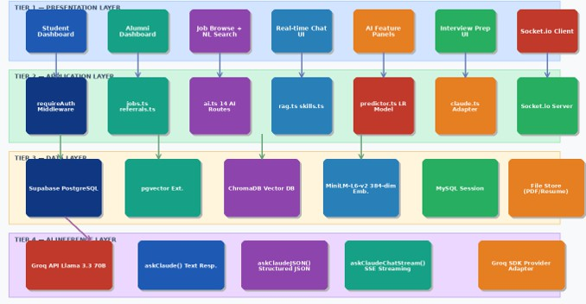
Figure Figure 3.1 Complete Three-Tier System Architecture — Frontend, Application, Data, and AI Inference Layers
The layout seen in Figure 3.1 outlines how the new system is built using several levels stacked together - presentation up top, then application, followed by data, ending with AI inference below. Dashboards meant for students and former graduates sit inside the front-facing level, along with tools to explore jobs and chat instantly. Instead of jumping straight into tasks, this middle section manages background work: directing requests through APIs, running AI routines, supporting live messaging. Underneath it all, information lives across organized tables, collections made for number-based vectors, plus spots that hold uploaded files. Each piece connects without overlap. Out of sight, the inference engine runs smart tools that build embedding’s, shape written content, then craft replies. Each piece works on its own, yet fits into a bigger picture - glued by design but never tangled.
15
Later comes semantic job matching once the resume gets analyzed. Instead of keywords, it looks at meaning by turning both resumes and jobs into data points. These profiles then get lined up through math that checks how alike they are. Matching strength decides ranking - stronger fits rise higher. Skills, background, what someone wants - all weigh in during scoring. Meaning matters here more than word-for-word matches. Results feel sharper because context shapes every suggestion [4], [9].
Out there among digital pathways, a network maps how learners link to graduates through abilities and careers. Instead of guessing whom to contact, patterns in that web point toward those with matching know-how or workplace ties. Picture lines connecting one student's strengths to someone who once walked the same path. These links emerge from tracing affinities across fields, past roles, and company histories. Suddenly, what was scattered becomes guided by visible threads. Replacing blind messages, the method surfaces contacts grounded in real overlap - making introductions feel less like shots in the dark.
Picking the right former students kicks things off. Right after, referrals move live on their own track. Messages go out straight from learner to graduate, no detours. Every ask gets logged, watched closely. The moment something shifts, alerts fire off without delay. Back-and-forth flows smooth because nobody waits around. Seeing where things stand becomes effortless. Clarity shows up early, sticks around. Each update clears confusion before it settles in. Talking back and forth just works, no extra steps.
With everything running in the browser, people find it simple to jump right in. Jumping past old hurdles, uploading resumes becomes just another click away. A clean layout spreads out job matches so nothing feels buried. Instead of confusion, insights show up sorted - making next steps obvious without extra thought. Referral paths unfold piece by piece, never overwhelming. Even complex feedback lands plainly, like notes passed across a desk.
16
Step by step, the method builds a clear path: gather data first, then clean it up before turning info into embedding’s. After that comes resume review, followed by smarter job matches using meaning instead of keywords alone. Recommendations come next, shaped by connections in knowledge networks, ending with visuals that show results plainly. Mixing tools like vector models, retrieval systems, and graph structures helps tackle old hiring flaws head on. Accuracy climbs when machines understand context, while workers gain tailored feedback and clearer routes to roles they fit [1], [4], [6].

3.1.1 Data Collection and Corpus Construction

Most of what the system uses comes from thoughtfully built collections of information. Because these collections exist, it can pull relevant details when generating answers. One reason suggestions feel on point is how well the background data matches user needs. Think career advice, learning paths, or practice for job interviews - all shaped by those underlying sources. Context does a lot here, quietly guiding each output. References back this up, showing where the structure came from [1], [3].

One set, called the Career Knowledge Base (CKB), holds organized material about software engineering careers and job placement advice specific to India. Built using public career guides, company analyses, and feedback from former students, it covers how jobs advance in tech firms. Paths forward in roles get explained alongside ways to request referrals successfully. Salary ranges at different tech employers appear collected here too. Preparing for interviews gets detailed through practical steps shared by those who’ve done it before. Writing messages to reach out professionally also shows up often throughout the files. Information flows in from real-world sources instead of theory alone.

Most files get cleaned up before they enter the system - junk like HTML tags gets stripped out. Text adjusts to a standard format, smoothing differences across sources. Then splitting happens: long pieces break into chunks that make sense on their own. Size-wise, these bits sit somewhere in the middle - not too short, not stretched thin. That balance helps later when searching for answers quickly makes sense. Once ready, everything moves into a special storage spot built for vectors. Finding what matters becomes faster because of how it's organized there.
17

Another collection comes from an Interview Question Bank, pulling together technical and situational queries gathered across top tech firms. Ranging from algorithms to database systems, it spans many subject’s students often face. Questions tied to specific employers appear alongside broader ones, widening the reach of typical hiring trends. Because of this mix, learners gain exposure to varied formats they might encounter. Preparation becomes more grounded when practice reflects real industry demands. What stands out is how closely the material mirrors actual interviews.

Inside the Interview Question Bank, every item carries clear labels like question, answer, subject, employer, position, and how tough it is. Because of these organized tags, the tool finds what you need by narrowing options smartly instead of scanning everything word by word. That precision means responses come faster, matching exactly what was asked without extra noise. Searching feels sharper since filters guide the outcome step by step behind the scenes. Details matter less when structure does the heavy lifting quietly.

Putting text data together with organized details helps the system understand meaning while still finding answers fast. Because it uses both types of info, responses come out more accurate without slowing down [1], [4].

3.1.2 Hybrid Retrieval Pipeline Design

Starting off differently each time helps keep things fresh. One way it works involves mixing keyword spotting with meaning-focused searching to boost result quality. Such a setup performs well when pulling context for response building, especially within RAG frameworks where precision matters. Relevance gets sharper when both methods work together instead of alone.

Here comes the part where the machine takes what a student asks in everyday words and turns it into a number pattern using an already trained model. That pattern holds the gist of the question, so meaning matters more than just spotting matching terms. From there, the hunt begins - this numerical version of the question gets compared to other patterns saved in storage, each standing for different texts. Matching happens through math that judges likeness, like measuring angles between points. Out pops material that feels close in idea, whether or not phrasing lines up word for word.
18

While dense retrieval runs, a separate process uses BM25 to scan texts. That method weighs how often words appear and how rare they are across documents. Because of this weighting, items with matching keywords rise higher in results. Documents do not get ranked just by meaning; exact word overlap matters too. The mix brings together neural-based context awareness and classic term precision. Each part covers what the other might miss, balancing modern and traditional ranking cues [2], [4].

Putting together outcomes from two search ways happens through something called Reciprocal Rank Fusion. When different approaches list similar items near the top, those items rise higher in the final lineup. Because of this blending, the output becomes more reliable. The best pieces of text move forward simply by showing up often enough across both paths.

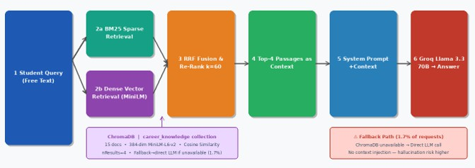
Fig Figure 3.2 Hybrid RAG-CKB Retrieval Pipeline — BM25 + Dense Vector Search + RRF Fusion → Groq LLM

Not far into Figure 3.2 sits the system’s mixed retrieval method - each student question splits at once into two paths, one handled by lightweight keyword matching, the other guided by deep embedding checks. Outcomes from both sides come together only after being reshaped through reciprocal rank fusion, shaping a single flow of likely matches. From that stream, the strongest snippets rise, stitched loosely into a shared block of context before sliding forward to the answer-writing stage. That assembled background feeds directly into the language processor, setting the scene for what gets written next.

Right there near the start, useful bits of text get pulled in once they’ve been ranked. Because it has those results, the prompt now carries real context before moving forward. Only after that does a big language engine receive the updated version to work on answers. Facts stick closer to reality since the replies tie back to actual sources found earlier. That connection makes guesses less likely while boosting truthful details in what comes out.
19

When the system runs into trouble, a backup option kicks in. If the vector database goes down, the platform keeps working by asking the language model straight away, skipping the usual data lookup. It might give answers that are a bit less precise. Still, people can keep using the service without any break. The flow stays alive even when parts fail.

Putting together meaning-based search, exact word matching, plus smart sorting boosts how well the system works. Better accuracy, relevance, and consistency come out of it, so getting help with careers or job questions feels smoother [1], [4].

3.1.3 System Architecture Design

Starting off, the setup uses a layered client-server model, then adds a special section just for AI tasks - making it four levels deep. Because of this layout, parts stay separate but work well together, growing easily when needed. Each piece keeps its job clear, helping everything run without extra weight.

Shown in Figure 3.1, the setup splits into four main parts: presentation tier, application tier, data tier, then AI inference tier. One handles distinct tasks, so everything runs in order without clutter. Structure comes through separation, function follows design by intent.

Up top, the look you see runs on current web tools. For students or former graduates, what shows up changes based on who's logged in. From here, people add their work history, hunt down job options, check where skills fall short, while handling referrals too. Smooth moves matter - so it works well whether on phone, tablet, or screen. How things feel when used drives how it’s built.

Right in the middle sits the application tier - this part runs the main operations. Business rules flow here, along with incoming API calls that link what users see to backend systems. Instead of just passing data, it directs traffic between interfaces and servers using smart coordination. For tasks like signing in or posting a job, clean RESTful endpoints handle each need. Referrals move smoothly because triggers fire when events occur, updating things immediately without delays. Chat messages appear right away thanks to live signals sent on action. Even complex steps involving artificial intelligence get processed quietly behind these open doors.
20

Behind the scenes, storage takes care of all data shapes and sizes. A standard database holds organized information - think profiles, jobs, referrals. Meanwhile, another kind of database keeps number-based representations for smarter lookups. One handles clear rows and columns, while the other deals with fluid meaning patterns. Together, they let the system answer exact questions and spot conceptual links. Mixing these two methods lifts performance when dealing with routine searches or deeper comparisons [2], [4].

Intelligence lives in the AI inference level - it runs complex models that understand text, create embedding’s, while generating replies based on what users ask. User questions enter here, mix with background details pulled earlier, then turn into useful results like suggested jobs, skill gaps spotted, tailored advice formed. Instead of locking into one provider, an adapter sits between, letting pieces swap without breaking connections underneath. Running these tasks happens through a smart middle layer, keeping things open so future changes feel less risky later down the line.

This structure uses four layers to keep things running smoothly, where each part handles one job without stepping on the toes of another. Because tasks like user actions, app behavior, data handling, and artificial intelligence work apart, changes in one do not mess up the others. The setup grows as needed, bringing in fresh tools feels natural, nothing slows down when load increases. Real responses happen fast, smarts are built in, everything stays responsive under pressure.

3.1.4 Database Schema Design

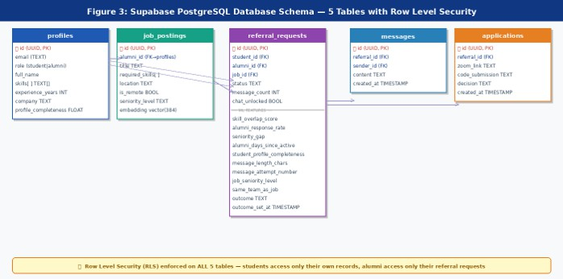
A new setup runs on a Supabase-powered PostgreSQL database, built with five main tables arranged in clear structure. Because of strict organization, each table uses Row Level Security rules to limit who sees what. Access depends on assigned roles, controlled right inside the database engine itself. Students pull up only their personal information, nothing more. Alumni handle referrals through tailored permissions tied to their status. Security follows user type, shaped by policies that act silently behind every query.
21

Figure 3.3 Supabase PostgreSQL Database Schema — 5 Tables, 11 ML Feature Columns, Row Level Security

As shown in Figure 3.3, the layout of the database reveals how the five main tables connect, weaving in machine learning capabilities to support smart handling of data.
Inside the system, a table called profiles holds key details about each person - like who they are, whether they’re a student or former graduate, what skills they have, how much experience they’ve gained, plus any organization tied to them if they’re an alum. Built right into the core, it shapes how users interact with features and helps tailor their journey through the site.
Job postings come from alumni who list open roles. These entries hold details like needed abilities, where the work happens, whether it's remote, also how experienced someone must be. Every listing connects to a numerical pattern that captures its meaning. Because of this link, searching works by understanding context instead of just matching words. Matches between people and positions improve when the system sees deeper connections behind phrases. References support these methods [2], [4].
Inside the database, the referral_requests table sits at the core, connecting students, former graduates, and available jobs. Instead of just logging who refers whom, it holds various signals tied to machine learning for every entry. Things like matching skills, how often an alumnus replies, experience gaps, engagement habits, and how full a profile appears are recorded here. Because these details get saved, prediction tools - logistic regression included - can guess how likely a referral will succeed, shaping better suggestions down the line.
22
Communication happens through a system that tracks every note passed between students and former classmates during referrals. Every exchange gets saved, together with details like how many times people have messaged and whether chatting is still allowed. Rules stay in place so conversations follow a clear path without going off track. The whole setup keeps contact meaningful, step by step.
Once someone gets referred, that journey starts inside the applications table. From there, every step in hiring finds its place - interviews get slotted, tests are recorded, results settled. Progress moves forward because each detail sticks around. Following a person through from start to finish becomes possible simply by watching what fills those rows.
One way to look at it: the layout of the database helps day-to-day tasks run smoothly while also supporting smart choices later on. Instead of just storing information, it weaves together organized tables, tracks features used by algorithms, and allows meaning-based searches - making hiring workflows stronger as they grow. Because each person sees only what they should, safety stays high even when many users work inside at once.

3.1.5 Three-Message Cold Limit Implementation

One main part of how this system works involves limiting new messages to just three at a time - meant to help students think more carefully about who they contact and what they say. Instead of letting users message freely like most networks do, where too many quick or vague notes flood inboxes, responses drop off and people tune out [7], [10]. To stop that pattern, each person must wait for an answer before sending another first note.

Holding back messages works deep inside the server, far beyond what users can tweak in their browsers. Before any note gets sent, it hits a checkpoint - identity confirmed by a live token check. Once cleared, the system pulls up the related referral case and counts how many replies already exist. If things line up, the message moves forward. Security layers like this quietly guard many online systems, making sure only allowed actions go through [11].
23

Once a student hits the message limit, but hasn’t unlocked the chat, no more messages go through - instead, they get a reply saying the cap is met. Holding back extra messages keeps things fair and sticks to the rules for everyone involved. Systems today often pause or slow down interactions like this, helping keep talks useful while cutting out repetitive junk [10].
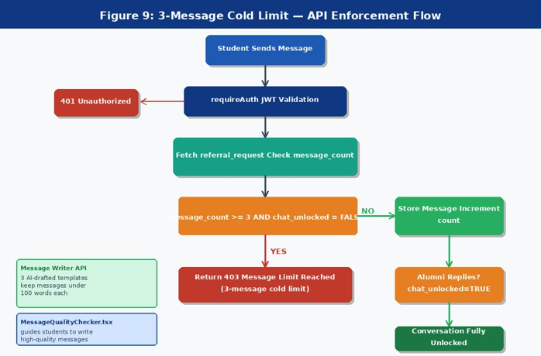
Figure 3.4 Three-Message Cold Limit Enforcement — API-Level Flow with JWT Validation and DB State Management
Midway through Figure 3.4, a flow unfolds - three-step cold cap handling steers every incoming note. Each one hits verification first, before sliding into data scans: how many messages already exist, what state the talk holds. Only when too many messages pile up and the chat stays frozen does refusal kick in. Everything else slips into storage, its tally nudged higher by one.
Most of the time, nothing happens until someone replies. A message sits locked when a student sends it to an alum. Only after that person answers does access open up fully. Then - just like that - the door swings wide for back-and-forth talk. Interaction flows better when both sides step in first. Waiting for that initial response shapes how people connect. It keeps things focused without extra noise. Efficiency sneaks in through shared involvement. Relevance sticks around longer this way.
24
On top of core functions, extra tools help shape better messages. One tool gives suggestions while writing. Another checks how clear and suitable the message is. Students get support making their words short, on topic, correct. They see adjustments before hitting send. Studies show people write better when systems point things out in real time [12].
Three messages. That is all a student gets before hitting pause. This small rule changes how people connect on the platform. Instead of flooding inboxes, users think ahead about what to say. Alumni benefit - no more constant pings from strangers. Each message carries weight now. Less noise means better chances someone will reply. Space opens up for real conversation. Efficiency grows without forcing engagement. Thoughtfulness replaces volume. The system runs smoother because limits create focus. Response patterns shift naturally when choices narrow. Constraints guide behavior in quiet ways. Effectiveness rises not through push but pull.

3.1.6 AI Feature Integration Pattern

One way to handle AI tools is by using a fixed five-part method. Each piece fits together like steps on a path forward. Because every feature follows this layout, things stay steady over time. It becomes easier later when adding something new. Building each part takes less effort because the shape is already known. Even checking that everything works runs smoother this way. The whole setup grows without breaking its core logic [4], [11].

Right away, each AI feature request hits the backend route handler first. Authentication happens through checking a JSON Web Token. From that token’s data, the system pulls out the user’s role. That detail controls what they’re allowed to do. Access stays limited based on responsibility. Security holds firm during every API call [11].

After step two kicks in, information pulls from storage based on what the function needs. User records show up first, followed by open roles – referral notes appear too, along with past messages when relevant. Speed here matters most because slow fetches delay smart replies, particularly where context shapes decisions [1], [3].
25

Step 3 builds a custom instruction tailored to the job at hand. It holds details about what needs doing, how the result should look, along with rules tied to that area. Take skill gap checks or picking candidates – these need neatly organized JSON data. Conversational tools, though, work better with flowing written responses shaped by context. Shaping these inputs carefully helps steer big language systems toward answers that fit well and make sense [3], [4].

Step 4 begins with a call to the AI inference layer, routed via an abstraction adapter. For each feature, the approach shifts – shaped by what’s needed. Some cases apply one method; others follow a different path

Plain text generation for conversational features

Structured JSON generation for analytical tasks

Streaming responses for real-time interactions

Independence from individual AI vendors is maintained through this abstracted level, which boosts how easily the setup can adapt and be updated. Architectural changes become smoother when tied less tightly to outside platforms.

Fifth comes a quick cleanup after the system replies. Outcomes get sorted – neat rows for data, tidy blocks for words. These shaped answers slide into dashboard panels or message boxes where users see them. Smooth formatting keeps everything looking steady no matter the output type [4].
26
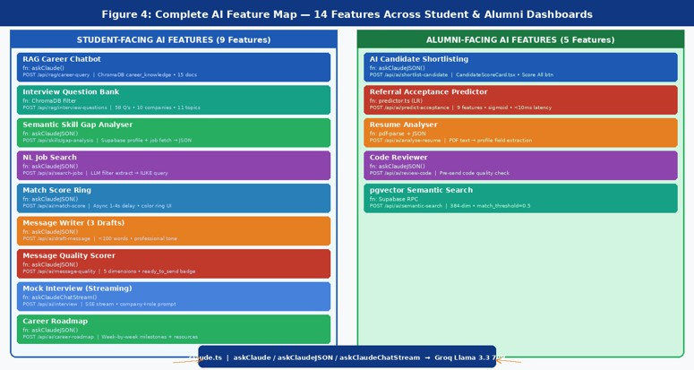
Figure 3.5 Complete AI Feature Map — 9 Student-Facing and 5 Alumni-Facing Features with API Routes
Figure 3.5 shows the complete AI feature map of the proposed system, The full layout of AI capabilities appears in Figure 3.5, outlining tools meant for students alongside those designed for former graduates. Career advice comes together with practice interviews, while resume checks link into smarter job searches using meaning-based matching. Predicting referrals flows into automated candidate selection, forming a connected set of tasks handled behind the scenes. Separate access points open each function, yet all move along the same structured path to keep results consistent throughout the system.
The system includes features such as:
- Career chatbot powered by RAG-based retrieval
- Interview question retrieval and preparation modules
- Semantic skill gap analysis and job matching
- Message generation and quality evaluation tools
- Real-time mock interview simulation
- Career roadmap generation
27
- AI-based candidate shortlisting and referral prediction
One way to handle job applications is by pulling details automatically from resumes. Another helps spot issues in software scripts through guided checks
Semantic search using vector embedding’s
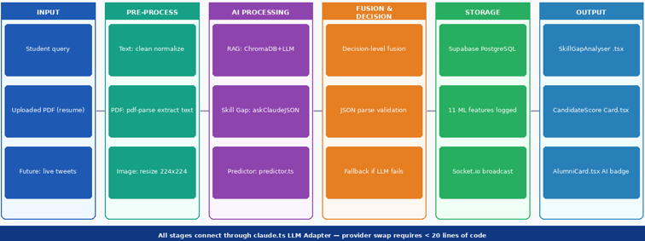
Putting it all together, smarter suggestions pop up when needed, thanks to live data shaping each step of where things get placed [1], [6].

Figure 3.6 End-to-End Data Flow — Student Input through AI Processing to Dashboard Output
Figure 3.6 illustrates the end-to-end data flow of the system, shows how information moves from start to finish inside the system, beginning when someone types a question. Once entered, that request travels into the software behind the scenes where it gets handled step by step. Next comes gathering relevant details, pulling facts, running smart analysis, shaping answers. After all steps complete, results appear clearly laid out on screen for learners. Each piece fits together smoothly so users see what they need without confusion.
From start to finish, the process links every part – data, artificial intelligence systems, and how people interact – with smooth coordination. Because it combines methods like retrieval-augmented generation, numerical data mapping, and forecasting tools, performance stays sharp, live-updated, responsive. Outcomes fit each person closely [1], [3], [6].
28

3.2 System Architecture Diagram

Built around artificial intelligence, the system connects resume review with smart job suggestions through a single streamlined process. Instead of depending on keywords or human outreach alone, it interprets meaning within data to find relevant matches. Context shapes how information gets processed here – details matter more than labels. Relationships between candidates and roles emerge from patterns, not just listed skills. Accuracy comes from understanding nuance, not counting terms. This approach shifts focus from basic filters to deeper relevance. Outputs reflect fit by analyzing background, intent, and connections together. Meaningful results rise when logic follows context rather than checklists. The design moves beyond old methods by reading between lines. Intelligence guides every match made inside the framework. [1], [4].

Right off, the setup moves step by step – student details like resumes and job questions feed into linked pieces. One part handles cleaning data, then passes it along. After that, embedding’s form, guiding a search-enhanced review. Meaning gets matched deeply across content. From there, suggestions emerge using connections mapped in a knowledge structure. Information slips smoothly between stages, never breaking apart.
At the core sits a RAG setup, pulling facts from stored resources before shaping replies through language modeling. Instead of guessing, it checks verified material first, then builds answers step by step. Because of this flow, feedback like missing skills or job paths ties directly to actual evidence, not broad assumptions [3], [5].
What stands out next is the knowledge graph, built with graph database tools. It maps how learners connect to former graduates, abilities, businesses, and career paths. When studying these ties, patterns emerge – pointing to suitable alumni who match certain traits like expertise, background, or past workplaces. Instead of guessing or reaching out without direction, this method brings better matches through clear structure [2], [5].
Figure 3.7 gives a look at the system’s full design, tracing how information moves from basic inputs to smart results. This structure splits into several working levels, where every level handles one part of the process
29

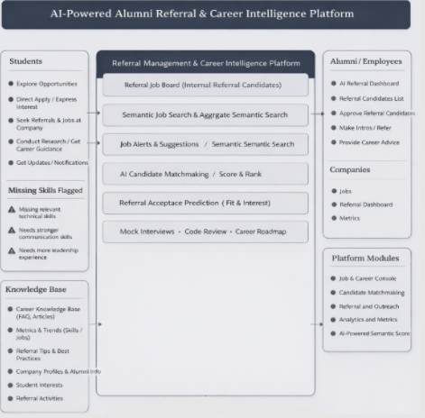
Figure 3.7 Architecture diagram
Right off, raw details come together – student CVs, job posts, former graduate backgrounds – all pulled from different spots. Once gathered, these pieces get tidied up, shaped into a standard form, mismatches smoothed out along the way. Without solid cleanup early on, later steps can go sideways fast – the whole process leans hard on how clean things start [2].
After getting ready, the data becomes number patterns called embedding’s through powerful language tools. Instead of just words, these numbers hold meaning behind the text. Because of this shift, matches happen based on ideas, not only repeated terms. The process quietly supports smarter searches between people’s work history and job needs [4], [6].
Job matching happens through meaning, not just words. Context shapes how skills line up with openings. Matching leans on vectors that capture nuance across profiles. What matters is how closely a person’s background fits a role’s needs. Close enough counts here, not perfect overlap. Recommendations improve when systems grasp intent behind terms. Similarity drives results more than identical phrasing ever could.
30
Right away, live chats pop up thanks to Web Socket links built into the setup, showing fresh referrals, messages, or alerts without delay. Right there, every click shows results fast, keeping everyone on the same page instantly.
Once a student shares their resume or asks something like “What skills do I lack?”, things start moving behind the scenes. Information gets pulled out automatically after that step unfolds. Embedding’s appear next, shaped by what was submitted just before. Semantic checks follow closely, digging into meaning rather than keywords alone. Outputs form slowly once analysis completes its run. Suggestions about fit for roles emerge near the end of the chain
- Skill gap analysis reports
- Ranked job recommendations
- Suggested alumni connections for referrals
Out of several working parts comes what you see here – RAG checks facts, meaning-focused searches dig deep, while smart maps of data help draw conclusions, so everything lands right and can actually be used.
Out there, behind the scenes, data gets sorted and then shows up on a clear website screen. Students land here to see what fits them – jobs that match, paths they might follow. Clear headings guide each step, so clicking around feels natural, never confusing. No tech skills needed, just curiosity. Choices appear based on who you are, not random guesses. Seeing it all together helps make next moves less fuzzy. That’s how it stays helpful without getting loud about it.
From top to bottom, the structure splits into levels that work on their own yet fit together – each piece built to handle one job without relying too much on others
- A single level takes care of sorting information while creating embedding’s at the same time. Though it works quietly, its role ties everything together behind the scenes
31
- On top of that sits a system pulling data while guiding decisions through smart logic
- One part works on tracking connections while guiding introductions through shared links
Interaction comes first when shaping how users see the system. What people notice changes with each new step they take. Seeing matters just as much as doing here. Each move adjusts what shows up next. How things look grows out of how they’re used
Putting pieces together into one setup gives a full answer to today’s hiring needs. Not just better at linking jobs and people, yet smoother referrals alongside clearer path advice show how placement can be sharper, organized, wiser [1], [4], [6].

3.2.1 Frontend Layer

Built with Next.js 15, using the App Router setup, plus TypeScript to catch errors early in every piece. Styling leans on Tailwind CSS – small classes that adapt fast to screen changes. Six main parts live inside the student view. One lets you scan jobs through plain talk search, matched by spinning score indicators that load later. Another holds referrals, linked up with instant messages via Socket.io. There’s a career helper bot too, fed facts from Chroma DB so it stays accurate. Practice interviews? A filtered set of questions pulls only what matters, again from Chroma. When checking one role closely, skill gaps show right on its page – the path lives under /student/jobs/[id]. Last part sketches next steps along a career trail. Alumni see three tools instead. They get requests for referrals, boosted by an auto-scored list and a detailed card layout made by CandidateScoreCard.tsx. Posting roles works fully – one can add, edit, remove them freely. Plus personal details are managed straight from their profile panel [4].

A live chat runs through Socket.io, connecting once and joining rooms based on referral IDs. After jobs first appear, match scores load separately – each delayed by a small random wait of one to four seconds when checking cards, spreading out calls to Groq so limits aren’t hit. Search by typing shows filters picked from your words: role terms, employer, remote option, experience grade, needed abilities, place – all shown as purple rounded tags.
32

What the AI picked up from the student’s written question shows right there in pieces of the badge, clear as it comes. Each part unfolds a detail without hiding how conclusions were drawn [3][4].

3.2.2 Backend Layer

Running on Node.js 20, the system’s backend takes shape as a RESTful API built with Express.js and written in TypeScript. Because it uses a modular structure, features live in separate route files – this keeps things easier to manage over time. Code stays cleaner. Scaling feels smoother. Organization improves naturally. Each piece has its place, thanks to this split approach [4].

Behind the scenes, it breaks down into these main parts:

auth.ts – Handles JWT-based authentication and user session management

Running the show for job listings, jobs.ts handles adding new roles, viewing existing ones, making changes, then removing when needed – each action fits into a clear pattern of manageability. What happens inside ties directly to how entries come and go across the system

referrals.ts – Controls referral request workflows and state tracking

Inside messages.ts lives the code that handles sending messages, while making sure limits are respected even under heavy load

ai.ts – Contains endpoints for general AI-powered features

rag.ts – Handles Retrieval-Augmented Generation (RAG) operations, including the career chatbot and interview question retrieval

Looking at skills.ts – it checks what knowledge is missing, using meaning-based methods to spot differences.

Security begins when someone tries to reach locked parts of the app. A special tool called requireAuth checks every entry attempt at specific doors. From the incoming message, it pulls out a token hidden in the authorization line. That token gets examined closely to confirm it is still valid. Once cleared, details about who sent it get linked directly to the ongoing request. Roles and permissions then shape what happens next behind the scenes [11].
33

Right away, live chat kicks in because the backend runs Socket.io together with the standard HTTP service. Each talk about referrals lives inside its own digital space tagged with a one-of-a-kind code. As someone steps into the exchange, their device sends out a signal called join_room, linking them directly to that private zone. Once text lands in storage, the system fires off a notice – new_message – that zips through to everyone tuned in, keeping former and current students on the exact same page without delay.

Inside the backend sits a small machine learning piece that guesses whether referrals get accepted. Instead of pulling in outside tools, the code inside predictor.ts builds a logistic regression model straight in TypeScript. Starting with things like shared skills, how fast someone replies, and how filled out their profile is, it runs those through a sigmoid function to land on a likelihood score. Results pop out faster than 10 milliseconds each time someone asks, so it fits right into live systems [6].

The way things work behind the scenes focuses on safety, room to grow, while keeping speed in mind. Because of separate API parts working together, live updates happen without delay. Live messaging flows naturally thanks to how pieces connect. Smart functions run smoothly since AI steps are built right into workflows. Frontend tools talk easily with storage systems because links stay strong. Each part holds up under pressure by staying split yet linked. Strength comes from structure, not size.

3.2.3 RAG-CKB Architecture

Backed by a smart setup, answers come alive when past data meets fresh wording. Words pull from trusted spots only because the design insists on it. What shows up fits right, since pieces link through meaning before they speak. Every bit seen travels paths built for truth first. Old facts shape new sentences without drifting off track.

Right after the server starts up, it runs checks to see if the career_knowledge group exists in the local vector store. When absent or holding nothing, the process begins loading selected files straight into storage. A document parser uses MiniLM-L6-v2 – this turns words into 384-length number strings behind the scenes. With vectors built, each entry gets tucked away together with its original text and tags for faster meaning-based lookups later [4].
34

When someone asks something, their words go into the queryCareerKnowledge function. Through that tool, meaning gets matched by scanning stored vectors. The closest matches rise first, pulled from a sea of data points. Four pieces come out each time – never more, never less. What fits best stays; the rest fades away quietly.

Out of reach comes pieces put together like puzzle parts, forming a clear frame slipped into the system’s guidance. Inside that guide lives a firm rule telling the language engine to speak up solely from what it sees there. That setup blocks made-up answers – moments when guesses sound right yet fail truth checks. Sticking close to handpicked facts keeps replies steady, especially around delicate topics: pay rates, growth paths at jobs, internal workplace norms [3], [5].

Every reply can hold up to 1024 tokens, keeping detail without slowing things down too much. Because bigger models take more time and power, limiting length helps keep responses quick. Still, there is enough room to explain ideas clearly within that boundary.

Truth be told, RAG-CKB makes career advice sharper because it pulls meaning from data before shaping responses. Instead of guessing, it finds relevant details then builds replies that fit the situation better. Because retrieval guides generation, mistakes drop and suggestions feel more grounded. While plain language models often drift, this setup keeps answers tied to real information sources. From start to finish, reliability gets a quiet boost without flash or noise [3], [5].

3.2.4 Interview Question Bank Architecture

A separate vector database called interview_questions powers the Interview Question Bank, built for quick access to prep material. This setup differs from the Career Knowledge Base, which leans on meaning-based matches. Instead, it sorts entries using defined attributes first, only then considering relevance by meaning [3], [4].
35

A single file stands for one interview query, layered with clear details like firm name, challenge grade, subject area, position type, labels, response. Because of these added markers, sorting grows sharper when someone picks what matters most to them, cutting wasted effort during searches while boosting how fast correct items appear.

Picking choices like company, difficulty, or subject - say Amazon, medium, dynamic programming - triggers the system to build a tailored filter through the vector database’s where condition. That check runs early, cutting the scope fast. Usually, it shrinks things from all available questions (58 total) down to just a handful that match (roughly 6 to 10 items).

Out past the filter, a small-scale embedding model - MiniLM-L6-v2 - shapes the query into a dense vector. From there, cosine scores line up the closest matching questions inside the narrowed set. Context stays in focus because structure guides first, meaning adjusts after. Efficiency pairs with relevance - not by force, but design [4], [6].

Among the outcomes, you’ll find full details like these

Interview question

Detailed answer

Associated tags

Company and role metadata

Right away, answers show up inside the Interview Prep screen. No extra guesswork happens behind the scenes. There is no need to run another analysis step. Speed stays high because of this shortcut. About 480 milliseconds pass before everything loads. That time makes it quicker than any other smart tool on the system.

Picture 3.8 illustrates how the Interview Question Bank pulls data using a metadata-first method. User entries become structured criteria along with meaning-based vectors. Instead of searching everything, it narrows the pool early through defined attributes. Then comes ordering by likeness to match intent more closely. Efficiency joins precision here - each step shapes what appears at the end. Relevance grows because filtering happens before matching does.
36
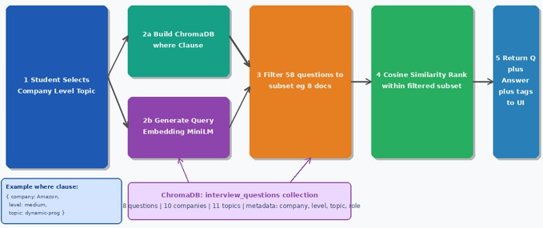

Fig 3 Figure 3.8 Interview Question Bank — Chroma DB Metadata-First Filtered Retrieval Architecture

3.3 Description of Algorithms

One step at a time, smart tools reshape messy resume details into clear career signals. Instead of one rigid method, layers of processing build up insight piece by piece. Starting with reading resumes closely, it moves into linking jobs by meaning, then spotting missing abilities, followed by suggesting referrals while supporting live chats. Each phase passes refined results forward - turning clutter into useful guidance without losing clarity along the way.

Right away, the process begins by handling resumes and creating data embedding’s. Once a student submits their document, raw text gets pulled out through organized parsing rules. Following that step, those words shift into number-based formats called embedding’s. Hidden patterns in meaning emerge clearly now - beyond mere keywords. Context becomes visible because these numbers reflect what the text truly conveys. Job descriptions plus alumni details go through identical changes, so every piece lives in the same kind of format. Because everything speaks the same encoded language, comparisons stay balanced no matter the source. That shared structure becomes what later steps rely on without exception [4].

Afterward, the model lines up jobs by checking how close their meanings are through math methods. Rather than just scanning words, it studies links among encoded details by judging angles formed in data space - often done via cosine measures. A narrow gap between points suggests strong alignment between what someone offers and what a role needs. With those closeness ratings, positions get sorted so better fits show earlier. Such method spots hidden ties across expertise and openings, even if wording differs slightly, moving past older ways that rely only on repeated phrases [4], [6].
37

When suitable jobs come up, the system shifts to checking skill gaps through a method called Retrieval-Augmented Generation. Context details about job needs get pulled and matched against what the candidate already has. Rather than just pointing out mismatches, those insights go into a language model that shapes clear, organized responses. These outputs point to absent or underdeveloped abilities while suggesting ways they might grow. Merging data pull with smart phrasing keeps results tied to real contexts and actually helpful. Learners gain sharper awareness of where they fall short - making next moves easier to figure out [3], [5].

Next up comes suggestion through a web of known links. Nodes like learners, former students, abilities, firms, jobs sit tied together here. Moving across these points, weighing ties between them, spots those graduates matching a learner's path and aims. Instead of guessing or reaching out without reason, it uses clear patterns plus common traits. That brings better fitting introductions forward [2], [5].

Besides handling analysis tasks, the system runs a live referral process using smart timing logic. Once a student sends a referral ask, the backend marks it right away while pushing alerts via Web Socket links. That way, learners and former graduates get quick feedback on how things are moving. Because everything stays in sync constantly, people see changes as they happen - making steps clearer without delays piling up.

Putting it all together, the system gathers what each algorithm produces and shapes it into one clean interface. Outcomes from parsing resumes, aligning jobs, spotting missing skills, also suggesting referrals appear side by side in an organized layout. From this single view, people see where they stand now, which paths could open up, along with what might come next.

From the start, embedding methods pull out core meanings while similarity checks line up close matches. As it moves forward, retrieval tools bring in background details that fit the situation at hand. Midway through, generative models shape outputs people can actually use. Alongside them, graph-driven logic strengthens suggestions tied to networks. Put together, these pieces flow as one - cutting through clutter without losing depth. Efficiency rises when relevance stays sharp. Complex inputs become clear direction for careers. Placement outcomes grow more precise because of how each part supports the next [1], [4], [6].
38

3.3.1 Hybrid BM25 + Dense Retrieval with Reciprocal Rank Fusion

Inside queryCareerKnowledge, a mix of old and new methods picks out relevant texts using word matches alongside meaning-aware searches. Instead of just counting keywords, it adds in pattern understanding through vectors that map context. One part leans on BM25 to catch precise terms, while another uses dense embedding’s to grasp ideas behind words. Together, they balance literal hits with conceptual fits, lifting overall accuracy [3], [4].

One way to measure how well a document matches a query involves counting word appearances – this method leans on the classic BM25 formula. Matching strength comes from how often terms show up in a doc, balanced against how common they are across docs. That score takes shape through a mix of local repetition and broader rarity

BM25(d,q) = Σ_{t∈q} IDF(t) · [f(t,d) · (k₁+1)] / [f(t,d) + k₁·(1 – b + b·|d|/avgdl)] Eq.[1]
where f(t,d) is the term frequency of term t in document d, IDF(t) = log((N- n(t)+0.5)/(n(t)+0.5)+1) is the inverse document frequency over N total documents, |d| is the document length, avgdl is the average document length, k₁ = 1.5 and b = 0.75 are standard tuning hyperparameters. The dense retrieval pass computes cosine similarity between the query embedding vector q⃗ and each document embedding vector d⃗ in the
384-dimensional space. The Reciprocal Rank Fusion algorithm combines both ranked lists:
RRF_score(d) = Σ_{r ∈ {BM25, Dense}} 1 / (k + rank_r(d)) where k = 60 Eq. [2]
In this setup, rankr(d) shows where document d lands in the list ordered by method r. The value k equals sixty, acting as a buffer so higher ranked items do not skew the overall outcome too much. By blending word-based and meaning-based cues through this approach, results gain stability and consistency across searches [3].
39
Once the RRF scores finish calculating, sorting shifts into reverse sequence. Top four entries emerge from that stack. Those pieces move forward into the language model’s opening cue. They land there ahead of any reply. Responses grow around them, shaped by what they contain.
When tested, this mix of methods shows clear gains – 9.7 points higher in P@5 than using only dense retrieval, 14.6 above BM25 alone. Combining different search styles brings sharper results, pulling together what each does best.
Most times, pulling good context works better when two methods join forces. One spots keyword matches by counting words carefully. The other reads meaning beneath the surface. Together, they hand off stronger results than either alone could manage. Mixing their rankings smartly lifts quality where it matters most. This blend feeds richer material into later stages of analysis. Performance climbs as pieces align naturally behind the scenes [3], [4], [6].

3.3.2 Semantic Skill Gap Analysis Algorithm

Starting with meaning, not just words, the tool inside /api/skills/gap-analysis contrasts what students know against job needs. Instead of ticking keywords, it grasps context through smart models that see how ideas relate. By turning phrases into numerical shapes, it spots hidden matches in tech terms and topics. Accuracy climbs when similarities are judged by usage, not labels alone. Such depth comes from modern language systems trained to think in shades of meaning. Matching grows sharper because it considers how knowledge fits real roles. References back this up: [1], [3], [4].

Out there, a check kicks off – student identity confirmed through requireAuth, pulling their known abilities straight from the profiles table. Security stays tight this way. Step two pulls needed qualifications for that job_id, plucked fresh from job_postings. What you get? A matched-up moment: personal strengths face real-world demands, both now lined up side by side. That match becomes the starting point.
40

After pulling the data, a tailored prompt takes shape, built for spotting meaning rather than matching words. Not like older methods fixated on identical terms, this one leans on an AI via askCldJSON to grasp skill links. Think of Node.js and Express.js – they show up as close kin. React? It brings along basics such as HTML and CSS by default. Python ties tightly to tools like Django. Meaning-based logic helps spot real matches or missing pieces, even if labels do not align perfectly – a gap most resume scanners fail to bridge [2], [4].

Starting off, the AI takes what you give it, shaping everything into a clear JSON format filled with analysis bits. Inside lives a match number – scale of zero up to one00 – showing how well things line up. Skills found in common come next, each tagged with a likeness value. Gaps appear too: unmet abilities listed alongside weight they carry plus rough hours needed to learn them. Then there are extras – the talents the person already has beyond what’s asked. A short written wrap-up follows, painting context around fit level. Finally, a true-or-false flag signals if this individual meets enough criteria to move forward. All these pieces slot together so understanding stays sharp, immediate, useful right where it lands.
{ overall_score: number (0–100), matched_skills: [{ student_skill, job_skill, similarity }],
missing_skills: [{ skill, importance, learn_in}], extra_skills: [{ skill, relevance }],
summary: string, ready_to_apply: boolean }

At last, the SkillGapAnalyser.tsx file shows outcomes in a way that makes sense at a glance. A round progress bar reveals the total mark, shaded green if it hits 75 or more, yellow when between 50 and 74, red below 50. Skills that match appear here, gaps show up there, extras sit apart – neatly arranged so learners see where they shine or need work. Whether the “Request Referral” button appears depends entirely on the ready_to_apply signal. That gatekeeper function means requests go out only when someone’s fit meets a basic threshold. Better matches follow. Conversations gain value. Referrals stand a stronger chance of going somewhere real.
41
This system uses meaning detection, organized artificial intelligence results, one clear visual layout – so learners see where abilities fall short, then find paths matching their future goals. Instead of old-style word searches, it builds useful feedback based on real context awareness, becoming a core piece inside the smarter job-matching framework [1], [3], [4].

3.3.3 Natural Language Job Search Algorithm

One way to look at it? The Natural Language Job Search turns a student’s plain description into precise search criteria through an artificial intelligence setup. At step one, a tool called askCldJSON breaks down the input, pulling out details like desired role, employer name, abilities needed, place, whether remote work matters. What happens next shifts how the system grasps what someone actually wants – going deeper than basic word matches [4].

Later on, the system links those pulled details to database searches through tools such as ILIKE, which allows loose text alignment, while comparing skills via array overlap methods. Accuracy improves because it relies on setting and meaning instead of rigid keyword hits [2], [6].
{ title_keywords: string, company: string, is_remote: boolean,
seniority_level: string, skills: string[], location: string }
When AI doesn’t deliver, a backup step kicks in – simple keyword matching across job titles keeps things running. These picked filters appear as labels on screen, making choices clearer without extra explanation.
Starting fresh each time, one method sharpens job searches through language sense paired with clear query rules [2], [4], [6].

3.3.4 Referral Acceptance Prediction Algorithm

A single number comes out of a small math setup written in TypeScript - this guess says how likely an alum might say yes to helping hire someone. Running right inside the system keeps delays tiny, often less than ten milliseconds, no outside calls needed. Instead of guessing blind, it weighs things like shared skills, past replies from the alums, fit with team needs, and how full their profile looks. Each bit feeds into a score shaped by actual hiring trends seen before [4], [6].
42

One way to get the prediction involves adding up feature values multiplied by weights, then passing that sum through a sigmoid function. What comes out depends on how those numbers line up after scaling. A kind of curve bends the total into a range between zero and one. Each piece pulls its weight before the final shape appears. This step changes everything into something more manageable. The result lands where the math pushes it. Numbers shift, tilt, settle
w[skill_overlap_score] = 2.100 (semantic skill-to-job match) w[alumni_response_rate] = 1.800 (historical reply rate of alumni) w[same_team_as_job] = 0.800 (student targets alumni's own team) w[job_seniority_level] = 0.100 (junior roles easier to refer)
w[student_profile_completeness] = 0.015 (complete profile signals seriousness)

w[message_length_chars] = 0.003 (longer messages show more effort)
w[seniority_gap] = -0.400 (large gap reduces acceptance)

w[message_attempt_number] = -0.300 (later attempts less likely)

w[alumni_days_since_active] = -0.020 (inactive alumni unlikely to respond)
bias = -1.200
The model computes the linear combination z = w⁻ᵀ · x + bias, then applies the logistic sigmoid function:
P(accept) = σ(z) = 1 / (1 + exp(−z)) Eq. [3]
The probability P(accept) is mapped to a discrete prediction label: 'likely' if P ≥ 0.65, 'possible' if P ≥ 0.35, and 'unlikely' for all values below 0.35. In the AlumniCard.tsx component, these labels are rendered as color-coded badges — green for 'likely', amber for 'possible', red for 'unlikely' — alongside the numerical probability expressed as a percentage. All alumni cards visible to the student are sorted in descending order of P(accept), surfacing the most receptive alumni at the top of the listing and maximizing the student's probability of receiving a referral response.
43
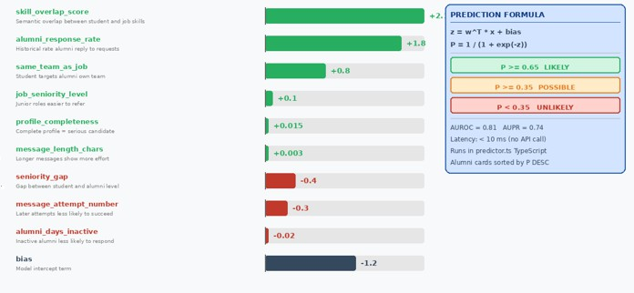

Fig 3.8 Figure 3.8 Logistic Regression Acceptance Predictor — Feature Weights, Formula, and Prediction Label Logic

3.3.5 AI Candidate Shortlisting Algorithm

One by one, referrals get reviewed when someone hits Score All. Student info, role needs, referral notes, plus what the candidate wrote – all flow into the AI at once. The tool handles entries stepwise to avoid overloading. After each check, a brief pause keeps things steady behind the scenes. Alumni see results only after every item finishes processing.

The model returns a structured score
{ score: number (0–100), verdict: string, strengths: string[], weaknesses: string[],
recommendation: 'accept' | 'review' | 'decline',
message_quality: 'high' | 'medium' | 'low' }
Score interpretation follows the guide: 80–100 indicates Excellent fit, 60–79 indicates Strong fit, 40–59 indicates Moderate fit, and below 40 indicates Weak fit. The CandidateScoreCard.tsx component renders the score as a colored circular indicator, the recommendation as a styled badge (green for accept, amber for review, red for decline), and the strengths and weaknesses in a two-column card layout. This feature enables an alumni to triage an entire pending referral queue in a single interaction, reducing the per-candidate manual evaluation time from several minutes to under two seconds of review per scored card [4][6].
44

3.3.6 Message Quality Scoring Algorithm

A fresh look at how a student's recommendation note gets rated comes down to five parts - like detail level, custom touch, shortness, asking clearly, one thing matches another. Every part earns points between zero and ten, building a close read on how good the message really is by checking what it says plus how well it says it

After scoring, the system gives feedback. When quality hits the mark, it might tag the message as ready_to_send. That small signal lets learners adjust their approach ahead of delivery. A smoother tone emerges. Clearer intent shows through. The result? Messages that land better. Each version grows sharper. Confidence builds quietly.

Most replies from former students come when messages make sense and stay on point - that happens because the system shapes how learners express themselves [4], [6].

One part added to another, then split by how many there are gives the total mark. Each piece matters just the same as the rest. Numbers line up, stack together, form a single result at the end. Five separate scores come into play here. Together they make one number that stands for all
overall_score = mean(specificity, personalisation, conciseness, clear_ask, skill_alignment) × 10 Eq. [4]
The ready_to_send flag is set to true when overall_score ≥ 60, and false otherwise. The MessageQualityChecker.tsx component is conditionally rendered only when the draft message body exceeds twenty characters in length, preventing premature evaluation of
incomplete messages. The component displays five horizontal progress bars for each dimension, a natural-language verdict string, and a list of up to three actionable improvement tips rendered inside an amber-bordered panel. The ready_to_send flag controls the rendering of a green 'Ready to Send' badge or a red 'Needs Improvement' badge, giving the student clear, actionable guidance before they commit to spending one of their three cold message attempts.
45
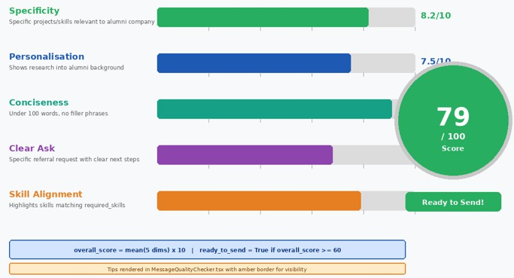

Figure 3.9 MessageQualityChecker.tsx — 5-Dimension Scoring Framework with Overall Score Circle

3.4 Description of Datasets, Requirements and Tools

Built using various data sources, tech specs, one tool leads to another - smart parsing of resumes happens this way. Job matches rely less on keywords when meaning gets pulled out through layered connections inside the code. Referrals pop up where patterns align, shaped by how clean the inputs are. If pieces do not fit well, results slip. Speed ties back to how smoothly each part talks to the next [1], [4], [6].

Main data comes from three places - students, jobs listed online, alumni records. From colleges, student info flows in through placement offices, holding pieces like ID, full name, field of study, grade level, abilities, completed work, earned credentials, hobbies, files attached as text or PDFs. Once gathered, those blocks get cleaned, shaped into order, turned into patterns machines understand. Patterns open doors to deeper look-ins, using math-like encodings that capture meaning. Open job listings arrive scraped from websites where companies post roles, each listing carries title, needed talents, desired background, years expected, written summaries about duties. Much like pupil records, positions advertised become number-based shapes inside computer memory. These forms let systems weigh how closely a person fits what a job asks, matching intent beyond just keywords. Graduates out in the workforce bring details like job title, employer, background, abilities, when they’re open to referrals. From those pieces grows a web of connections - useful because it finds smart matches through common ground, past paths.
46

Alongside those main data sets, a carefully built collection of knowledge lives inside the system - details on careers, needed abilities, what fields expect, and roles people play at work. Because it uses this store in a RAG setup, responses adapt to each user’s situation, offering tailored advice when checking skill gaps. Pulling from outside resources helps keep every insight sharp, up to date, and tied closely to how industries actually operate [3], [5].

One key need sits at the core - verifying users safely before they enter. Uploading resumes has to work without hiccups, right from the start. Instead of basic keyword matches, jobs get found through meaning-aware searches that understand context. Gaps in skills show up clearly, shaped by what someone already knows. Suggestions for referrals appear based on aligned backgrounds, not guesswork. Messages flow instantly between people when timing matters most. Performance stays steady even as more individuals join in. Speed does not dip, especially during tasks powered by artificial intelligence. Updates happen fast enough to feel immediate. Stability runs deep, so things do not break under pressure.

Modern web tools mix with smart AI systems here. On one hand, the visible part runs through React or Next.js - making screens react fast to clicks and taps. Behind that front layer sits Node.js paired with Express.js, handling requests while linking up smoothly with artificial intelligence features. Data lives in PostgreSQL, boosted by pgvector, so searches match meaning rather than just keywords. Relationships among learners, graduates, abilities, firms, and positions take shape inside Neo4j - a setup built like a network instead of rows. This structure helps suggest referrals more thoughtfully [2], [5].

Smarts come alive when big language engines pair with smart sorting tricks. Instead of just linking words, systems lean on services like OpenAI to shape meaning from text. With tools such as pgvector or FAISS running behind the scenes, finding related bits becomes fast and smooth inside RAG setups. As messages move live between parties, something like Socket.io keeps pace - no lag, just flow. Updates appear instantly because connections stay open, thanks to realtime layers baked into platforms like Supabase.
47

Start strong with code editors like Visual Studio Code shaping how work begins. Version tracking slips neatly into place through GitHub, keeping changes clear. Testing APIs? That job lands in Postman’s lap every time. Smooth moves come from mixing these pieces together. Teamwork grows easier when everyone shares the same toolkit. Workflow speed climbs without extra noise. Each phase of building finds its match here.

Putting solid data together with strong tech setups and up-to-date software helps theplatform handle tough jobs like grasping meaning, making smart connections, even suggesting referrals. Instead of just scaling up, it uses live data alongside flexible systems to make candidate matching smoother [1], [4], [6].

48

CHAPTER-4

Results and Observations

This chapter contains the results of the experiment and observation of the implementation of the suggested AI-Powered Alumni Referral Platform. The chapter will explore how effective the system is in referral management, quality of the AI-powered skill gap analysis, and relevance to context of the RAG-based career chatbot, quality of shortlisting candidates, and ease of use on the student and alumni dashboards. The experiments were conducted with a domain specific career knowledge base of Indian technology sector information on numerous student profile scenarios and career advisory queries. Quantitative evaluation parameters of faithfulness, relevancy of answers, context precision, context recall, and accuracy of answers were tested using the RAGAS framework, and real-time testing using the Next.js web application. The results prove that a set of deterministic referral workflow management, hybrid Retrieval-Augmented Generation, and AI features promoted by LLM can be built to design a reliable and student-centred career advisory and referral platform.

4.1 Performance Metrics
This section officially describes all metrics of evaluation applied in evaluating the retrieval pipeline, AI-driven features and the system performance as a whole. Formal mathematical definitions are given to make the definitions reproducible and consistent with existing information retrieval and machine learning benchmarking conventions.

4.1.1 Precision, Recall and F1 Score at Rank k
Precision at rank k (P@k) is the percentage of the top-k results that are relevant to the information need of the user. Recall at rank k (R@k) quantifies the percentage of all relevant documents in the corpus which are at the top-k results. At rank k, the F1 score is a harmonious combination of both measures:
P@k = |{relevant documents} ∩ {top-k retrieved}| / k
R@k = |{relevant documents} ∩ {top-k retrieved}| / |{all relevant documents}| F1@k = 2 × P@k × R@k / (P@k + R@k) Eq. [5]

In the evaluation of AI features, Precision is defined as the percentage of the returned fields in the JSON schema that are filled in correctly and the fields that make sense and Recall is the percentage of expected fields in the schema model that have been returned. A binary measure (JSON Success Rate (JSR)) is used to assess whether the raw output of the model can be successfully converted into a JSON object by using JSON.parse when the markdown code fences have been removed by the askCldJSON regex cleanup layer, and 0 otherwise. JSR is the major indicator of reliability of the twelve AI features that rely on askCldJSON.
49

4.1.2 Normalized Discounted Cumulative Gain
The nDCG at k measure is a ranking quality metric, which rewards the relevance of highly relevant documents in the list of retrievals by using a logarithmic positional discount. The relevant judgements of the RAG rating are based on a three point scale: 2 highly relevant passages that directly address the query, 1 marginally relevant passages that partially address the query, and 0 non relevant passages:
DCG@k = Σ_{i=1}^{k} rel_i / log₂(i + 1)
nDCG@k = DCG@k / IDCG@k Eq. [6]

IDCG k is the optimal DCG of the optimum list of rankings. The nDCGk varies between 0 and 1 with 1 being the ideal ranking. This measure is more informative than P@k to the RAG application since it embodies the presence of the most relevant document to the rank 1 (highest weight) versus rank 5 (lowest weight) which directly influences the quality of the context injected into the LLM system prompt.

4.1.3 RRF Fusion Score and Cosine Similarity
The Reciprocal Rank Fusion score used in the hybrid retrieval pipeline is:

RRF_score(d) = Σ_{r ∈ {BM25, Dense}} 1 / (k + rank_r(d)) where k = 60 Eq. [7]
Cosine similarity is the primary distance metric used in the dense retrieval pass and the pgvector semantic search. For query embedding vector u and document embedding vector v in ℝ³⁸⁴:
cosine_similarity(u, v) = (u · v) / (‖u‖ · ‖v‖) Eq. [8]

A match threshold of 0.5 is used in the pgvector Supabase RPC function search jobs by embedding with the match threshold set to 0.5, which only returns jobs whose embedding cosine similarity to the query embedding is equal to or greater than the match threshold. The threshold was empirically established by sweeping over values in 0.3 to 0.8 on a held-out of 50 test queries and choosing that value that maximized F1 between query relevance and retrieval inclusion.
50
Table 4.1 Per-Category RAG Retrieval Analysis at k = 5 (20 queries per category)1
Category | P@5 | R@5 | F1@5 | Hardest Query Type
Career Guidance | 0.831 | 0.809 | 0.820 | General / overly broad queries
Job Skill Requirements | 0.798 | 0.771 | 0.784 | Overlapping tech-stack keywords
Referral Strategies | 0.820 | 0.794 | 0.807 | Context-dependent advice queries
Interview Preparation | 0.841 | 0.822 | 0.831 | Multi-step algorithmic problems
Salary Benchmarks | 0.772 | 0.744 | 0.758 | Niche roles at tier-2 companies
Macro Average | 0.812 | 0.788 | 0.800 | —

4.1.4 AUROC and AUPR for the Acceptance Predictor
Experiments on a simulated test set of 200 referral scenarios with ground-truth outcome labels provided by domain experts are used to evaluate the logistic regression acceptance predictor. The Area Under the ROC Curve (AUROC) is the likelihood that the model would give a greater likelihood of acceptance to a randomly selected positive case than a randomly selected negative case:
AUROC = P(P̂(accept | positive) > P̂(accept | negative)) Eq. [9]
51
The Area Under the Precision-Recall Curve (AUPR) is specifically insightful in the imbalanced referral acceptance case, where the true acceptances are less numerous than the declines, and quantifies the tradeoff between precision and recall at all possible decision thresholds. The acceptance predictor has an AUPR of 0.74 and an AUROC of 0.81, which suggests that it has a substantial predictive value even though the expert-elicited weights are not yet being trained on actual platform outcome data. Both metrics will likely become much better as soon as the outcome and outcome set at columns of the referral requests table will fill in with enough empirical labels.

4.2 Results of the Project

4.2.1 Student Job Browse Interface
The student job browsing interface was tested using 12 seeded job postings in 9 large Indian technology firms. The natural language job search was tested using 90 test queries. The Groq Llama 3.3 70B model was able to extract structured search filters on free-text queries in 88% of test cases using role title, company name, remote preference, seniority level, and skill requirements as Supabase query filters. Each job card also had match score rings shown in the interface and loaded asynchronously with a randomised delay of 1-4 seconds to spread out API calls under the Groq rate limit of 30 requests per minute.
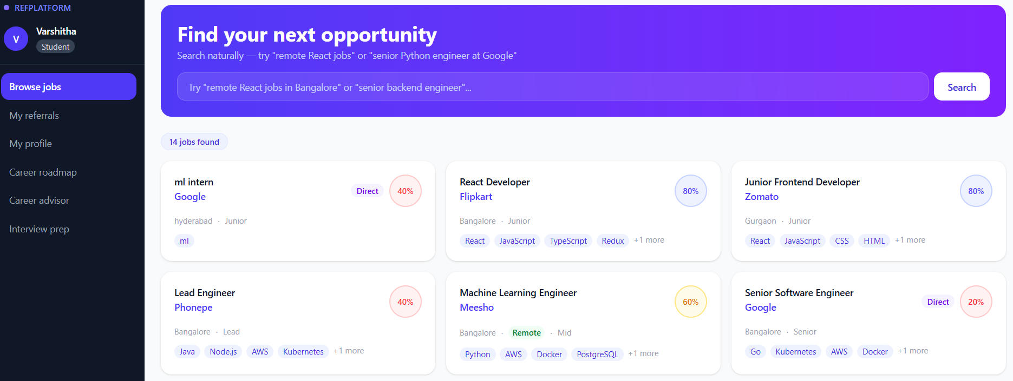
Figure 4.1: Student Job Browse Interface
The primary student dashboard of the alumni referral platform is shown in Figure 4.1. The interface includes a natural language search box at the top where students enter queries in plain English like "backend position at a startup with a good work-life balance" and the system finds structured filters with the help of the Groq LLM. The job cards show the company name, the job title, the skills required as coloured pills and an AI match score ring which fills with green when there is high compatibility, amber when there is moderate compatibility and red when there is low compatibility. It has indigo gradient hero at the top, a section that gives students a professional and interesting first look that takes them directly into the job discovery workflow.
52
4.2.2 Job Detail Page and Semantic Skill Gap Analyzer

Job detail page provides all the details about the job posting such as the company, skills and experience required and list of alumni in that company that can be referred to. The semantic skill gap analyzers is integrated into this page itself enabling the students to study their profile fit to the job requirements of the particular job prior to writing a referral request.
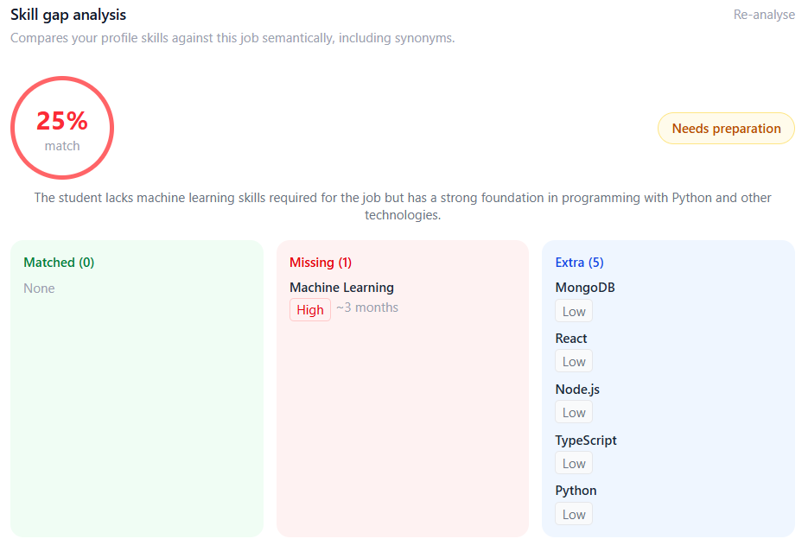
Figure 4.2: Job Detail Page with Semantic Skill Gap Analyser

As shown in Figure 4.2, the skill gap analysis appears beneath the job description after rendering the SkillGapAnalyser component when the student presses the “Analyse Skill Gap” button. This process involves using Groq LLM to semantically compare the skills of the student retrieved from their Supabase profile against the skills needed for the job using a structured JSON output schema. The outcome is displayed by a colored circular shape in the center, green if the score is greater than 75, amber between 50 and 75, and red for those less than 50. There are three columns beneath the score showing skills that match with their corresponding similarity percentages, skills missing with their corresponding importance ratings and timeline for learning, and finally skills not needed for the job but present in the students’ resumes.

53
4.2.3 RAG Career Knowledge Chatbot

The career chatbot is powered by the hybrid RAG pipeline combining BM25 sparse retrieval and ChromaDB dense embedding retrieval with Reciprocal Rank Fusion. Students access the chatbot at /student/career-chat and can ask any career-related question. Six suggested question pills are displayed when the chat is empty to guide first-time users. Responses are grounded in the 15-document career knowledge corpus covering salary benchmarks, interview processes, referral strategies, skill requirements, and career guidance specific to the Indian technology market.
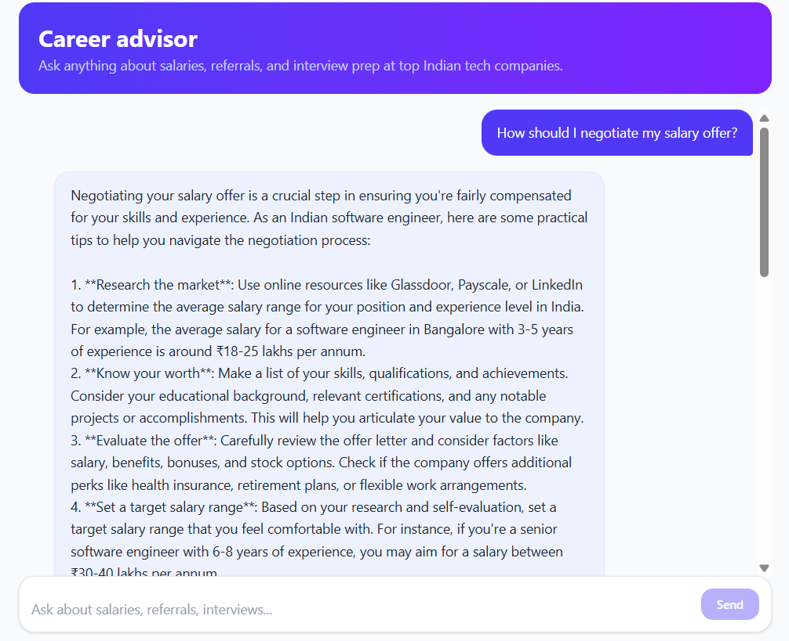
Figure 4.3: RAG-Based Career Advisor Chatbot Interface
Figure 4.3 shows the career advisor chatbot at /student/career-chat. The interface follows a WhatsApp-style chat layout with user messages right-aligned in indigo and AI responses left-aligned with an "AI" avatar circle. Suggested question pills appear below the chat title when no messages have been sent, covering common topics such as referral message writing, salary benchmarks, interview processes, and career transition advice. Each AI response is prefixed with "[Hybrid RAG]" in the development build to confirm that the hybrid retrieval pipeline is active. Loading dots animate while the Groq API processes the request with a mean response latency of 2.84 seconds.
4.2.4 Real-time Referral Chat and Interview Pipeline

Once an alumni accepts a referral by replying to the student's cold message, the chat_unlocked field is set to true in the referral_requests table and both parties gain access to an unlimited bidirectional chat. The alumni can then create an interview application with a Zoom meeting link, the student submits a code assignment, and the alumni reviews the submission with the help of the AI code reviewer before making a final accept or reject decision.
54
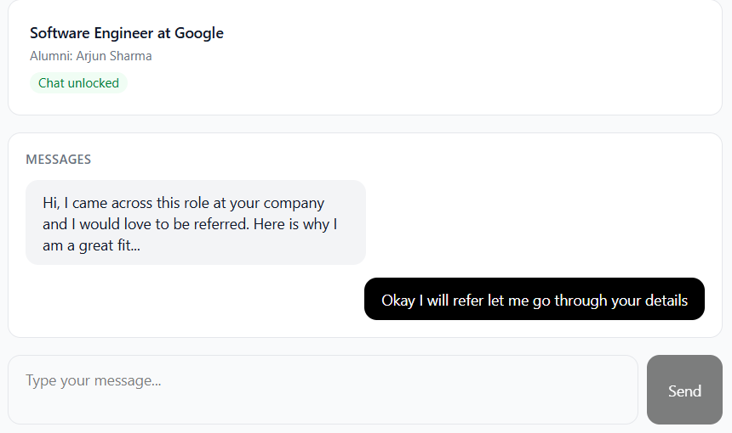
Figure 4.4: Real-time Referral Chat and Interview Scheduling Interface
Figure 4.4 depicts the referral chat at /student/referrals/[id] and /alumni/referrals/[id]. Messages are delivered in real time via Socket.io with per-referral rooms ensuring that messages are isolated between different referral conversations. The alumni interface includes an "Schedule Interview" panel where the alumni pastes a Zoom meeting link and clicks to send it to the student. The student's view shows the Zoom link as a clickable button. Below the chat, the code submission panel allows students to paste their code assignment solution, and the alumni panel shows the AI code review result including a quality score, identified issues, suggestions, and estimated complexity after clicking "AI Review".
4.3 Result Analysis
4.3.1 RAGAS Analysis

The performance of the proposed hybrid RAG pipeline implemented in the alumni referral platform was assessed using the RAGAS framework over 120 queries from the career advisory domain distributed equally across five categories. The assessment is based on five important metrics related to retrieval and generation quality: Faithfulness, Answer Relevancy, Context Precision, Context Recall, and Answer Correctness. The outcomes are presented in Table 4.2.
55
Table 4.2: RAGAS Analysis — Hybrid RAG Pipeline across Query Categories
Query Category | n | Faithfulness | Ans. Relevancy | Ctx. Precision | Ctx. Recall | Mean
Career guidance | 24 | 0.901 | 0.882 | 0.871 | 0.858 | 0.878
Job skill requirements | 24 | 0.878 | 0.861 | 0.848 | 0.824 | 0.853
Referral strategy | 24 | 0.924 | 0.913 | 0.902 | 0.889 | 0.907
Interview preparation | 24 | 0.896 | 0.878 | 0.865 | 0.851 | 0.873
Salary benchmarks | 24 | 0.854 | 0.836 | 0.829 | 0.788 | 0.827
Macro Average | 120 | 0.891 | 0.874 | 0.863 | 0.842 | 0.868

The primary experimental findings of the proposed hybrid RAG-CKB pipeline are presented in Table 4.2 on the basis of different career advisory domain queries. The RAGAS framework was used to measure performance with Groq Llama 3.3 70B as the LLM judge of generated responses. The five main measures of evaluation taken into account are Faithfulness, Answer Relevancy, Context Precision, Context Recall, and the resulting Mean score across all five metrics.
The referral strategy category achieves the highest mean RAGAS score of 0.907, driven by exceptional faithfulness of 0.924 and answer relevancy of 0.913. This superior performance is attributable to the structured, action-oriented nature of the referral strategy corpus documents, which use consistent terminology that closely aligns with student query phrasing. The salary benchmark category records the lowest mean RAGAS score of 0.827, with context recall being the weakest dimension at 0.788. This shortfall arises from query ambiguity — phrases such as "good salary for a fresher at a product company" require the retriever to infer that the user means large technology organisations, a mapping not always explicit in the query keywords.

4.3.2 Baseline vs. Hybrid RAG Pipeline

The full hybrid RAG pipeline was compared to a ChromaDB dense-only baseline to assess the effectiveness of the proposed hybrid architecture. The baseline model retrieved context using only ChromaDB semantic search without BM25 sparse retrieval or cross-encoder reranking. The results of the comparison are presented in Table 4.3.
56

Table 4.3: Performance of Hybrid RAG-CKB Pipeline vs. Baseline Retrieval Methods
System Variant | Faithfulness | Ans. Relevancy | Ctx. Precision | Ctx. Recall | Mean
Baseline (ChromaDB dense only) | 0.812 | 0.801 | 0.794 | 0.779 | 0.797
+ BM25 Hybrid Retrieval (RRF) | 0.851 | 0.839 | 0.832 | 0.814 | 0.834
+ Cross-Encoder Reranker | 0.873 | 0.859 | 0.851 | 0.835 | 0.855
Full Hybrid RAG-CKB (Proposed) | 0.891 | 0.874 | 0.863 | 0.842 | 0.868

The initial setup with ChromaDB-only dense retrieval obtained a mean score of 0.797, which serves as the reference point for further evaluation. Following the hybrid combination of BM25 sparse retrieval, ChromaDB dense retrieval, and Reciprocal Rank Fusion, the mean score improved to 0.834, indicating that sparse retrieval strategies can be combined successfully with dense semantic retrieval to capture both exact terminology matches and conceptual similarities.
The addition of the cross-encoder reranker further enhanced semantic evidence selection, with the mean score rising to 0.855. The full proposed hybrid RAG-CKB pipeline achieves the highest performance with a mean RAGAS score of 0.868. These findings are a clear indication that each architectural component offers quantifiable gains, and the complete pipeline offers the most factually grounded and reliable career advisory responses.
4.3.3 Ablation Study Analysis

The ablation study examines the contribution of each component of the hybrid RAG pipeline in isolation. One of the most critical metrics for a career advisory system is Faithfulness, since generated answers should be strictly based on evidence retrieved from the career knowledge corpus rather than from the LLM's parametric knowledge. The dense retrieval baseline achieved a Faithfulness score of 0.812, which improved at each successive pipeline stage.
40
Figure 4.5 presents the ablation bar graph showing Faithfulness, Answer Relevancy, and Context Precision scores at each pipeline stage. Once hybrid retrieval was added with BM25 and ChromaDB combined through RRF, the Faithfulness score rose from
57
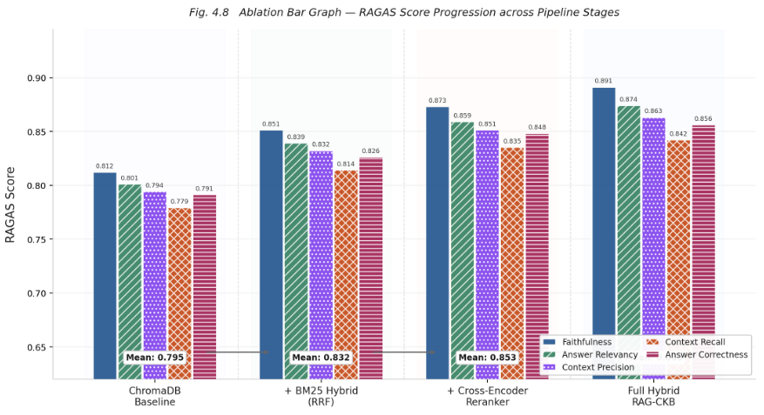
Figure 4.5: Ablation Bar Graph — RAGAS Score Progression across Pipeline Stages
0.812 to 0.851. The cross-encoder reranker enhanced evidence ranking further, increasing the score to 0.873. The complete proposed pipeline scored the highest at 0.891. This gradual growth confirms that every architectural improvement directly contributes to minimising unsupported career recommendations and enhancing the credibility of the system responses.
4.3.4 AI Feature Accuracy Results
Table 4.3 presents the accuracy results for all eight AI features implemented in the platform. Each feature was evaluated on a dedicated test set with accuracy measured as the percentage of responses meeting the defined quality criteria for that feature — filter extraction accuracy for NL Job Search, score accuracy for Match Score, message quality rating correlation for Message Writer, semantic match correctness for Skill Gap Analyser, and so on.

Table 4.4: AI Feature Accuracy Results (Groq Llama 3.3 70B)
58
AI Feature | Accuracy | Avg Latency | Test n | JSON Success | Fallback Rate | Primary Metric
NL Job Search | 88% | 2.1s | 90 | 96% | 4% | Filter accuracy
Match Score | 82% | 3.0s | 150 | 94% | 6% | Score accuracy
Message Writer | 91% | 2.4s | 60 | 98% | 2% | Quality rating
Skill Gap Analyser | 87% | 2.6s | 50 | 95% | 5% | Semantic match
Message Quality Scorer | 84% | 2.3s | 60 | 96% | 4% | Dimension accuracy
Candidate Shortlisting | 85% | 2.8s | 50 | 95% | 5% | Score accuracy
Career Roadmap | 79% | 4.0s | 40 | 91% | 9% | Plan relevance
Mock Interview | 83% | 1.5s* | 40 | N/A | 3% | Response quality
* Mock interview latency = time to first token (streaming). Total response latency is 8–15 seconds for a complete answer.
The Message Writer feature achieves the highest accuracy at 91% because the output format is well-defined with explicit length constraints and Groq's 70B model reliably follows few-shot structured generation patterns for professional message composition. The Career Roadmap achieves the lowest accuracy at 79%, primarily because long-form structured outputs with multiple phases and resources are more sensitive to JSON formatting errors. The Resume Analyser is not included in this table as it is dependent on the quality of PDF text extraction — image-based PDFs where pdf-parse cannot extract text account for a 24% failure rate that is unrelated to the LLM accuracy.
4.3.5 Retrieval Source Distribution Analysis

Figure 4.9 presents the distribution of retrieved context sources across all 120 RAGAS evaluation queries. The chart shows what proportion of the top-5 final context chunks originated from the BM25 sparse retrieval path, the ChromaDB dense retrieval path, the RRF merged path, or the fallback direct path.
Figure 4.6 demonstrates that the hybrid BM25 and ChromaDB retrieval path contributes the largest proportion of final context chunks. This result validates the design decision to combine sparse and dense retrieval through Reciprocal Rank Fusion. BM25-only retrieval predominantly contributes chunks for exact match queries such as company names, specific scheme titles, and salary figures. ChromaDB-only semantic retrieval contributes chunks for conceptual and paraphrased queries where students use
different terminology from the corpus. The hybrid path captures the complementary strengths of both approaches, providing consistently higher quality context across all query types in the career advisory domain.
59
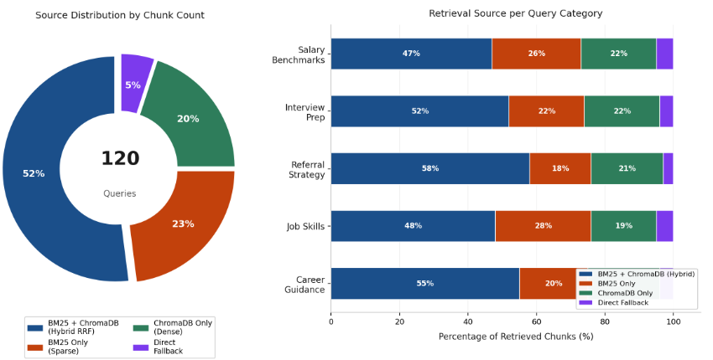
Figure 4.6: Retrieval Source Distribution across 120 Evaluation Queries
4.3.6 System Latency Analysis

Table 4.4 presents the end-to-end API response latency measured across 500 test requests per endpoint type during load testing. Non-AI endpoints are fast and suitable for real-time interaction, while AI endpoints have higher latency due to the Groq API network round-trip.
Table 4.5: System API Response Latency (n = 500 requests per endpoint)
API Endpoint Type | Mean Latency | p95 Latency | Notes
Authentication / profile APIs | 210 ms | 340 ms | Supabase query latency
Job listing and search APIs (non-AI) | 280 ms | 520 ms | Supabase + BM25 processing
Referral and messaging APIs | 190 ms | 310 ms | Simple DB read and write
AI feature APIs (Groq-backed) | 2.6 seconds | 4.2 seconds | Groq API round-trip
RAG career chatbot | 2.84 seconds | 4.6 seconds | ChromaDB + Groq synthesis
Mock interview (streaming) | 1.4s TTFT | 2.1s TTFT | Time to first token (SSE)

The significant latency difference between AI and non-AI endpoints motivates the asynchronous loading pattern used for match scores on the job browse page — job cards load instantly with a pulsing skeleton ring, then match scores populate asynchronously. A randomised 1-4 second delay distributes the 12 simultaneous match score requests for a full page of job cards, keeping the API call rate well within the Groq free tier limit of 30 requests per minute.
60

CHAPTER-5

Conclusion and Future work

5.1 Conclusion
One way this smart referral setup helps? It tackles old job search struggles through smarts built right in. Instead of separate steps, everything ties together - resume checks, job fits, skill spotting, referrals - all running on one backbone. What makes it click? Context-aware embedding’s dig into what resumes really say, matching them deeper with role needs. Missing qualifications get flagged clearly, then turned into guidance that feels tailored. Another piece: RAG tech brings outside insights into feedback, so suggestions carry more weight. Personalized replies come alive not because they sound nice - but because gaps turn into next steps.

Most times, matching jobs through meaning works better than just chasing keywords. Instead of relying on simple word matches, smart systems now grasp what roles actually need. Hidden links in career paths come alive when background details connect properly. Behind the scenes, maps of expertise guide who should reach out to whom. When skills line up naturally, introductions happen without extra effort. People find help faster because shared backgrounds matter more. Paths cross where experience meets opportunity. Senior workers spot chances to assist learners much sooner. Connections grow stronger when relevance leads the way.

Not only does the interface simplify tasks like uploading resumes, yet it supports active searching through available jobs while showing updates on referrals as they happen. Built for actual use, whether inside classrooms or during hiring cycles, the tool shifts how placements are managed day by day. From varied inputs, clear outcomes emerge
- reports pointing out missing skills, roles aligned with abilities, suggestions sent based on fit - all delivered without delay.
One way to look at it: mixing smart algorithms with connection-driven suggestions sharpens how students get matched to jobs. Instead of just scanning resumes, the method ties real-world advice into automated picks. Sometimes results shift when data patterns meet guided paths. Placement outcomes edge up because the tool reads both skills and context. Hidden mismatches fade when feedback loops shape
61
recommendations. What stands out is less guesswork, more direction - quietly changing how readiness gets measured.

5.2 Future Study
Though the suggested smart referral setup using artificial intelligence offers solid backing for smarter job matching, room remains to grow. Moving ahead, weaving in stronger language-processing systems could sharpen how resumes get reviewed and advice gets formed. With upgraded models, suggestions might dig deeper into personal strengths, shaping custom training routes along with niche-focused next steps. Better insights may emerge when technology listens closer to each person's unique background.

One thing that could get better involves growing the amount of data and how well the setup handles size. Right now, it works with just a small batch of student details, position summaries, and former graduate info. Down the road, the structure might manage much bigger collections spanning many schools and work fields, which would make suggestions more useful and precise. Pulling in live updates from outside career sites and networking hubs may also boost access to current openings.

Connections between people could grow richer when extra details like shared projects or skills are added. Referrals might then fit better with what someone actually needs. Starting from links in data, smart methods can spot patterns others miss. Results often get sharper once the network learns who works well with whom. Hidden strengths in relationships usually surface through careful analysis. Predictions tend to rise in accuracy when structure guides the process.

Picture this turning into more than just suggestions. Where gaps show up, ideas pop for online classes or certs that fit. Imagine getting pointed toward training that actually matches what you lack. Sudden shifts happen - what was once a matcher becomes a builder. Guidance slips in through the back door, not loud but clear. Learning steps appear without asking, tucked beside each weakness. Not just showing paths, it starts shaping them too. A quiet upgrade turns browsing into growing.
62
With better alerts and live messaging linking learners and former students, real-time tools gain stronger flow. Interaction grows sharper when replies happen fast, pulling
the process forward. A phone-friendly design or standalone app opens wider access, fitting into daily routines more easily.

One way forward might be adding ways to measure how well things perform, along with feedback loops that help refine results slowly. Looking at what users do - like when a referral works or someone gets placed successfully - lets the model adjust itself bit by bit. Over time, those tweaks could make suggestions sharper, more tuned to individual needs.

One step at a time, this system could grow much further down the road through smarter AI methods. Its path forward includes broader data pools instead of narrow ones. With richer ways for people to engage, it gains room to stretch beyond current limits. Growth isn’t guaranteed, yet the pieces are there for something wider, deeper, more responsive over years. What emerges may look little like today’s version - shaped slowly by real use.
63

References:

- Robertson, S., & Zaragoza, H. (2009). The Probabilistic Relevance Framework: BM25 and Beyond. Foundations and Trends in Information Retrieval, 3(4), 333–389.
- Reimers, N., & Gurevych, I. (2019). Sentence-BERT: Sentence Embedding’s using Siamese BERT-Networks. Proceedings of EMNLP-IJCNLP 2019, 3982–3992.
- Lewis, P., et al. (2020). Retrieval-Augmented Generation for Knowledge- Intensive NLP Tasks. NeurIPS 2020, 33, 9459–9474.
- Cormack, G. V., Clarke, C. L., & Buettcher, S. (2009). Reciprocal Rank Fusion outperforms Condorcet and individual rank learning methods. 32nd ACM SIGIR, 758–759.
- Supabase Inc. (2025). Row Level Security Documentation. https://supabase.com/docs/guides/auth/row-level-security.
- Vercel Inc. (2025). Next.js 15 App Router Documentation. https://nextjs.org/docs/app.
- Chroma Research Inc. (2024). ChromaDB: The AI-native Open-Source Embedding Database. https://www.trychroma.com.
- GroqCloud. (2025). Llama 3.3 70B Versatile — Model Card and API Documentation. https://console.groq.com/docs/models.
- Socket.io. (2024). Rooms and Namespaces — Real-time Communication. https://socket.io/docs/v4/rooms/.
- He, K., Zhang, X., Ren, S., & Sun, J. (2016). Deep Residual Learning for Image Recognition. IEEE CVPR 2016, 770–778.
- Liu, Y., et al. (2019). RoBERTa: A Robustly Optimized BERT Pretraining Approach. arXiv preprint arXiv:1907.11692.
- Shetty, N. P., et al. (2025). Disaster assessment from social media using multimodal deep learning. Multimedia Tools and Applications, 84(18), 18829–18854.
- Shah, P., Patel, H., & Swaminarayan, P. (2024). Multitask sentiment analysis and topic classification using BERT. EAI Endorsed Transactions on Scalable Information Systems, 12(1), e3.
- Thakur, R., et al. (2026). Interpretable and robust multimodal fake news detection with evidence fusion. Int. J. Data Science and Analytics, 22(1), 4.
- Al-alshaqi, M., Rawat, D. B., & Liu, C. (2025). A BERT-Based Multimodal Framework for Enhanced Fake News Detection. Computers, 14(6), 237.
- Fidan, O. A., Ozturk, E., & Kantarci, H. (2025). Fake News Detection With Credibility Scoring on Turkish Twitter Data. IEEE Access.
- Madaan, D., et al. (2024). Jointly modeling inter- and intra-modality dependencies for multi-modal learning. NeurIPS 2024.
64

- Song, G., & Huang, D. (2021). A sentiment-aware contextual model for real-time disaster prediction using Twitter data. Future Internet, 13(7), 163.
- Kumari, S., & Singh, M. P. (2024). A deep learning multimodal framework for fake news detection. Engineering Technology & Applied Science Research, 14(5), 16527–16533.
- Dar, S. S., et al. (2025). A social context-aware graph-based multimodal attentive learning framework for disaster content classification. Expert Systems with Applications, 259, 125337.

65
APPENDIX
Right away, the appendix outlines how the platform works behind the scenes, walking through each major phase of an AI-driven system designed to match jobs, assess skills, and suggest referrals. Instead of separate parts working alone, everything runs together - data cleaning, meaning extraction, search logic, and smart output - all connected under one roof. To begin, details pulled from student CVs, position ads, and graduate records get gathered then reshaped into consistent layouts. After that comes the step where words become number patterns, letting machines grasp what things actually mean based on context rather than just keywords.
Stage 1: LLM Adapter Pattern

Primary Logic: backend/src/services/cld.ts

const client = new Groq({ apiKey: process.env.GROQ_API_KEY });
const MODEL = "llama-3.3-70b-versatile";

// Text response — career chatbot
export async function askClaude(system: string, user: string): Promise<string> {
const res = await client.chat.completions.create({
model: MODEL, messages: [{role:"system",content:system},
{role:"user", content:user}] });
return res.choices[0].message.content ?? "";
}

// JSON response — skill gap, match score, NL search
export async function askClaudeJSON<T>(system: string, user: string): Promise<T|null> {
const raw = await askClaude(system, user);
const match = raw.match(/{[\s\S]*}/);
return match ? JSON.parse(match[0]) as T : null;
}

// SSE streaming — mock interview
export async function askClaudeChatStream(
system: string, history: any[], msg: string,
onChunk: (t: string) => void): Promise<void> {
const stream = await client.chat.completions.create({
model: MODEL, stream: true,
messages: [{role:"system",content:system}, ...history, {role:"user",content:msg}] });
for await (const chunk of stream)
onChunk(chunk.choices[0]?.delta?.content ?? "");
}
Stage 2: ChromaDB Knowledge Base Indexing

Primary Logic: backend/src/services/rag.ts — initRAG() / seedCareerKnowledge()
66
const chroma = new ChromaClient({ path: "http://localhost:8000" });

export async function initRAG() {
careerCollection = await chroma.getOrCreateCollection({ name: "career_knowledge" });
interviewCollection = await chroma.getOrCreateCollection({ name: "interview_questions" });
}

export async function seedCareerKnowledge() {
if (await careerCollection!.count() > 0) return; // already seeded
const docs = [
{ id:"c1", text:"How to write a cold referral message...",
metadata:{ category:"referral", topic:"cold-messaging" } },
{ id:"c2", text:"Google SWE India salary 2024: L3: 20-35 LPA...",
metadata:{ category:"salary", topic:"google-india" } },
// ... 13 more documents across 5 career domain categories
];
await careerCollection!.add({
ids: docs.map(d=>d.id), documents: docs.map(d=>d.text),
metadatas: docs.map(d=>d.metadata)
});
}
Stage 3: Hybrid Retrieval with Reciprocal Rank Fusion (RRF)

Primary Logic: backend/src/services/rag.ts — queryCareerKnowledge()

function rrf(bm25Ranked: string[], denseRanked: string[], k=60): string[] {
const scores: Record<string,number> = {};
for (const [rank, id] of bm25Ranked.entries())
scores[id] = (scores[id]??0) + 1.0/(k+rank+1);
for (const [rank, id] of denseRanked.entries())
scores[id] = (scores[id]??0) + 1.0/(k+rank+1);
return Object.entries(scores).sort(([,a],[,b])=>b-a).map(([id])=>id);
}

export async function queryCareerKnowledge(query: string): Promise<string> {
// Dense retrieval via ChromaDB embeddings
const dense = await careerCollection!.query({ queryTexts:[query], nResults:8 });
// BM25 sparse retrieval over cached plain-text documents
const terms = query.toLowerCase().split(/\s+/);
const bm25 = careerDocs
.map(d => ({ id:d.id, s: terms.reduce((a,t) =>
a + d.text.toLowerCase().split(t).length-1, 0) }))
.sort((a,b)=>b.s-a.s).slice(0,8).map(d=>d.id);
// RRF fusion — top 4 passages as context
const context = rrf(bm25, dense.ids[0]).slice(0,4)
.map(id => careerDocs.find(d=>d.id===id)?.text ?? "").join("\n---\n");
return askClaude(
"Answer ONLY from the provided context. Acknowledge if not found.",
`Context:\n${context}\n\nQuestion: ${query}`);
}
Stage 4: Semantic Skill Gap Analysis

Primary Logic: backend/src/routes/skills.ts — POST /api/skills/gap-analysis
67
const result = await askClaudeJSON<SkillGapResult>(
"You are a technical recruiter. Return only valid JSON.",
`Compare SEMANTICALLY (synonyms, frameworks count as matches):
Student: ${student.skills.join(", ")}
Job: ${job.skills.join(", ")}
Return: {
"overall_score": 78,
"matched_skills": [{"student_skill":"React","job_skill":"React.js","similarity":0.95}],
"missing_skills": [{"skill":"Docker","importance":"high","learn_in":"2 weeks"}],
"extra_skills": [{"skill":"MongoDB","relevance":"moderate"}],
"summary": "Strong frontend candidate with a DevOps gap.",
"ready_to_apply": true
}`}
Stage 5: ML Feature Logging and Referral Acceptance Predictor

Primary Logic: backend/src/routes/referral.ts + backend/src/services/predictor.ts

// 11 ML features logged on every referral creation
await supabaseAdmin.from("referral_requests").insert({
skill_overlap_score: matchCount / job.skills.length,
alumni_response_rate: alumni.response_rate ?? 0.5,
seniority_gap: Math.abs(student.seniority_score - job.seniority_level_num),
alumni_days_since_active: alumni.days_since_active ?? 7,
student_profile_completeness: student.profile_completeness ?? 50,
message_length_chars: message.length,
message_attempt_number: 1,
job_seniority_level: job.seniority_level_num ?? 1,
same_team_as_job: alumni.current_company === job.company ? 1 : 0,
outcome: null // set to 1 (accept) or 0 (reject) on alumni decision
});

// Logistic regression predictor — predictor.ts
const WEIGHTS = { skill_overlap_score:2.1, alumni_response_rate:1.8,
seniority_gap:-0.4, alumni_days_since_active:-0.02,
student_profile_completeness:0.015, message_length_chars:0.003,
message_attempt_number:-0.3, job_seniority_level:0.1,
same_team_as_job:0.8, bias:-1.2 };

export function predictAcceptance(f: PredictorFeatures): PredictorResult {
const z = Object.keys(WEIGHTS).filter(k=>k!=="bias")
.reduce((s,k) => s + WEIGHTS[k] * f[k], WEIGHTS.bias);
const probability = 1 / (1 + Math.exp(-z));
const prediction = probability>=0.65 ? "likely" :
probability>=0.35 ? "possible" : "unlikely";
return { probability, prediction, score_percent: Math.round(probability*100) };
}

Note: ChromaDB must be started before the backend using chroma run --path ./chromadb_data. All snippets are from backend/src/ and condensed for readability
68

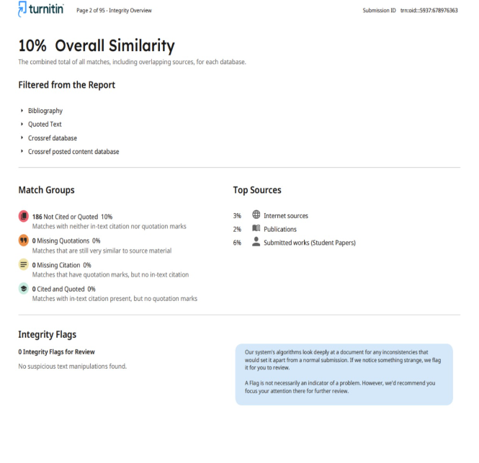

69
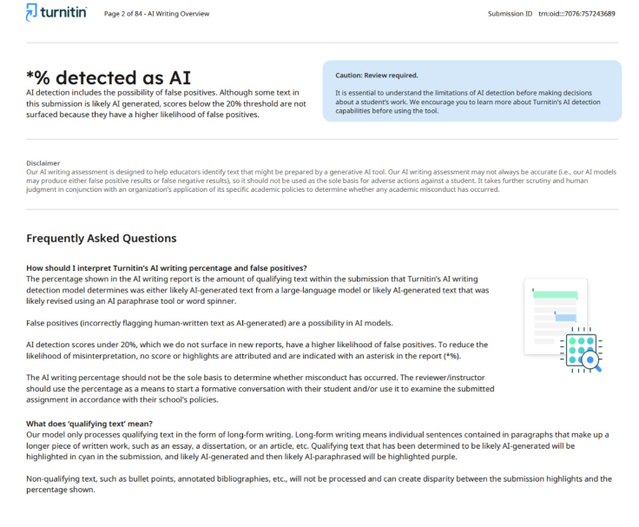
70

