

IMPROVEMENT AREA

IMAGES

THIS IS OUR LISTINGS IMAGE THIS IS OUR COMPETITOR LISTING IMAGES

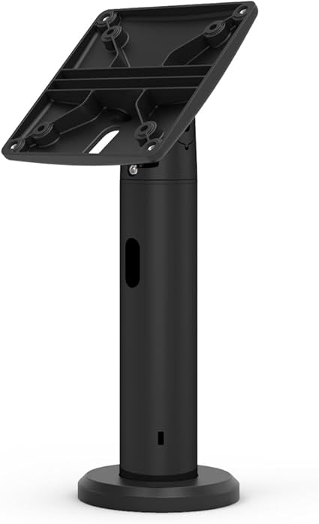
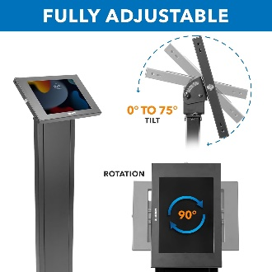
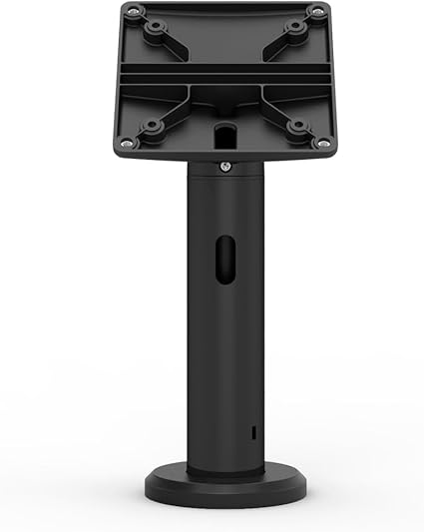

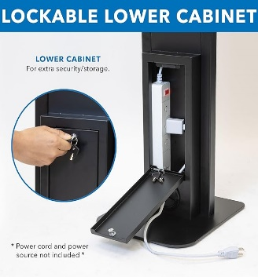

- We have to change the images of the product.
- We can add info graphic and lifestyle images in our listings.
- We can add unto 6 to 7 images which clicks from other-2 angle.
- We can add variation (color)
- r and design) in our listings.

TITLE
Compulocks Rugged Edge Case for Galaxy Tab A9+ 11"

- We have to change the title. We can improve the length of the title with add on of the product details like which material we are using, which models are compatible and we can add benefits of this Mount pole stand.

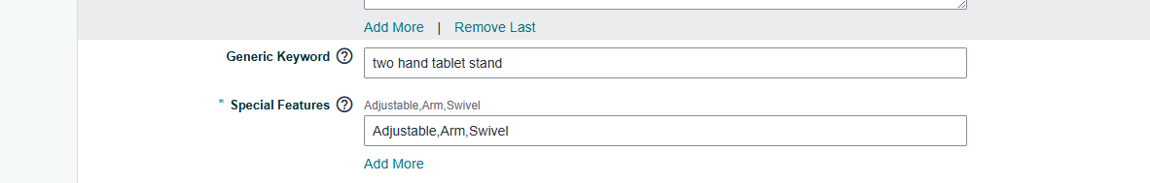
GENERIC KEYWORDS
- We have to change the generic keywords from the listings.
- And we can add more special features in the listings.

BULLET POINTS
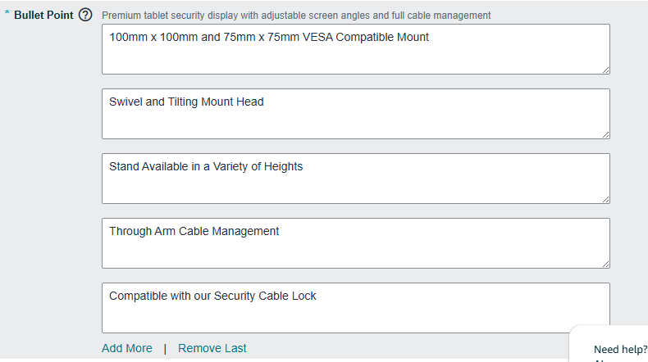

- We can brief more about the product in bullet points.
- We can add on benefits of the product.
- We can add on compatible models for this vesa mount pole stand.

DESCRIPTION
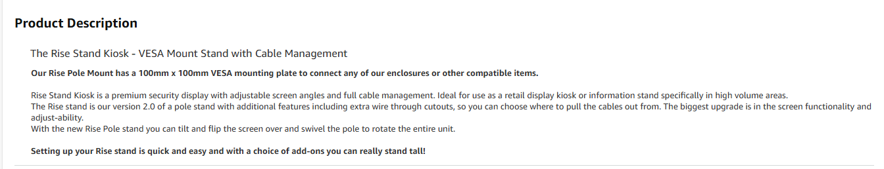
- We Can brief more about the product in lengthy description.
- And we can add A+ content in our listings.
- Benefits of A+ content is that when will buyer comes in our listings they will give more time in our listings.
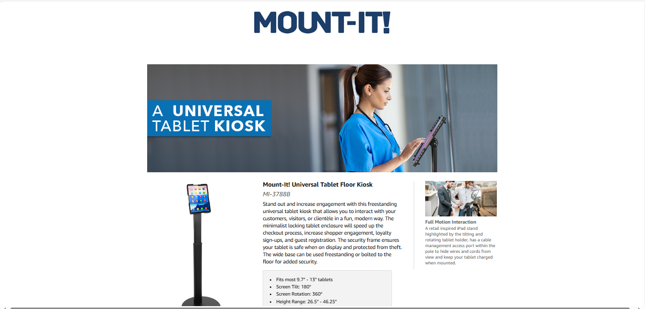
- Because in A+ content we are brief about the product with the help of info graphic and lifestyle images.
- In A+ Content we have to add 5 to 6 banners in our listings.

OUR COMPETITORS
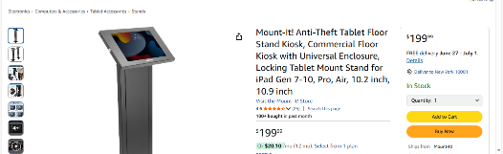
- Mount It

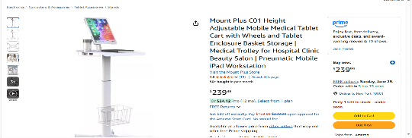
- Mount Plus

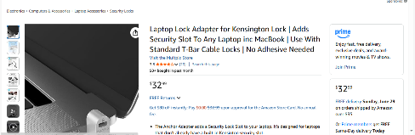
- Multplx

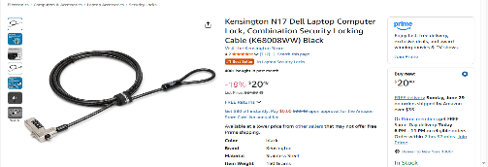

- Kensington

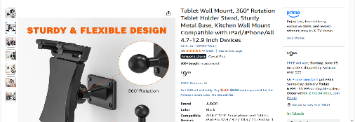
- JUBOR

TOP SELLING ITEMS

SKU | ASIN | Shipped Revenue | Shipped COGS | Sold in 30 Days
MMEN24 | B0DS65LRBD | $8,517.85 | $7,854.00 | 202
BLD01 | B00QPXDC5G | $2,136.39 | $1,686.40 | 56
MMEN76 | B00B1SB3K6 | $2,308.41 | $1,885.78 | 50

ADVERTISMENT
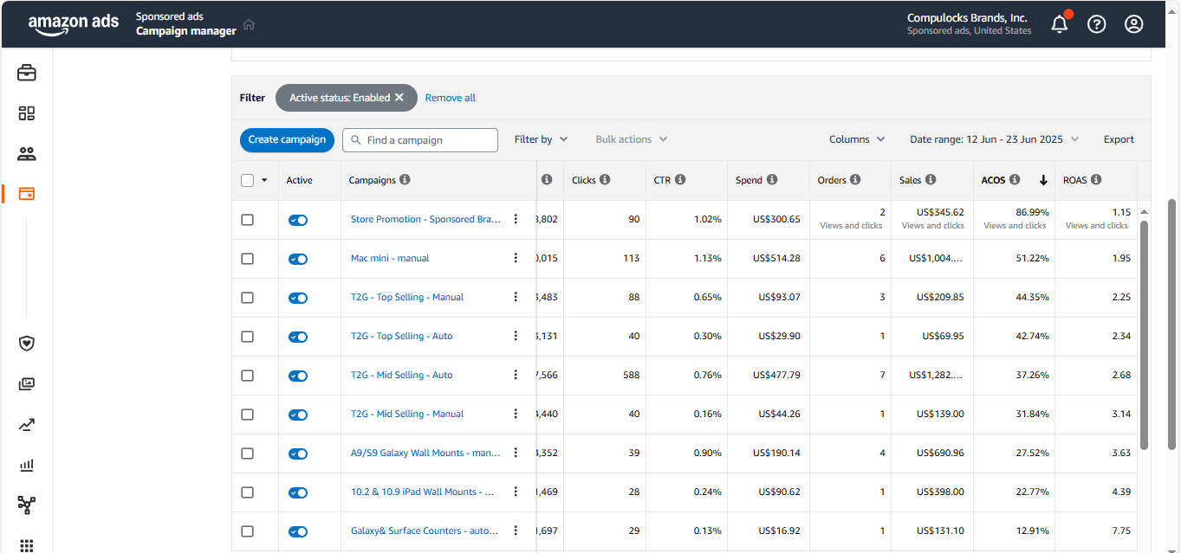

TARGETING
- To control the ACOS we have to pause the low performing keywords and ASIN’s.
- Focus on High performing Keywords and ASIN’s
- Increase the bid on high performing ASIN’s and keywords
- By pausing the low performing ASINs in the campaign group, only run advertisements on the high performing ASINs so that the entire group's budget is focused on high performing products.
NEGATIVE TARGETING
- In negative we have to add those keywords and ASIN’s who are spending more and sales conversion is too low.
BID ADJUSTMENT
- We should place higher bids on those products that are converting to more sales and are top-selling products.

