ZedSort the Loop – High-Speed Cross Belt Loop Sorter

Revolutionize Your Parcel Sorting with ZedSort the Loop
ZedSort the Loop is Muvro’s flagship high-speed Cross Belt Loop Sorter system designed to streamline automated parcel sorting for e-commerce, retail, and logistics operations. Built for speed, precision, and scalability, it transforms traditional warehouse workflows into fast, reliable, and future-ready intralogistics ecosystems.

Why Choose ZedSort the Loop?
✈️ High-Speed Sorting Performance
ZedSort delivers exceptional throughput ranging from 10,000 to 40,000 parcels per hour at speeds exceeding 2.7 meters per second. Ideal for 24/7 operations, it ensures rapid processing without compromising accuracy.
🔄 Flexible Loop Layouts
Customize your layout with a variety of supported configurations: Rectangular, Oval, Z-Type, U-Type, C-Type, or even double-tiered mezzanine installations. ZedSort adapts to your warehouse footprint.
🚚 Wide Range Parcel Handling
From cartons and totes to polybags, zippy bags, pouches, and envelopes, ZedSort can handle parcels weighing up to 30 kg and measuring up to 600 x 400 x 500 mm.
✉️ Precision Cross Belt Technology
Each cart is equipped with a bi-directional motorized conveyor for left/right discharge. With advanced servo control, it ensures accurate and smooth parcel diversion at every point.
🌐 Smart Induction System
The infeed line features a three-stage setup: loading, buffer, and merge conveyors (30°-45°). Integrated sensors, barcode readers, and dimensioning systems ensure reliable parcel positioning and data capture.
📊 Real-Time Scanning & Data Sync
Using Cognex/Sick 1D & 2D scanners, ZedSort captures parcel IDs with optional OCR and weighing. Data is transmitted in real time to the Warehouse Control System (WCS) for intelligent sorting logic.
🤖 Advanced Control Architecture
Equipped with industry-grade PLCs (Siemens, Mitsubishi, Rockwell), the system integrates seamlessly with WMS and offers live sorter diagnostics, performance dashboards, and failover-redundant servers for uninterrupted operation.
🌬️ Low Noise & Energy Efficient
Built with linear synchronous motors (LSMs) or friction drive systems, the sorter operates below 72 dBA, ensuring quiet and smooth functioning while consuming less power.
⚙️ Modular & Scalable
ZedSort's plug-and-play architecture allows for future upgrades, layout reconfigurations, and throughput expansion without disrupting existing workflows.
↻ Re-Circulation Conveyor (Optional)
Parcels that fail to discharge correctly are automatically routed back into the loop for re-sorting, improving accuracy and reducing manual intervention.

Built with Robust, Reliable Components
🛏️ Loop Track
Heavy-duty steel structure with powder-coated MS framework, designed to reduce friction and enhance durability under continuous operations.
🚗 Cart & Carrier System
PU wheel-supported carts ensure smooth motion. Choose Twin-Carrier or Two-Tier Deck configurations for increased throughput. Powered by servo motors and LSMs for maintenance-free travel.
🧳 Outfeed Chutes
Choose from gravity, spiral, straight, bagging, or telescopic chute options. Each includes sensors and tower lights to confirm successful sorting and indicate system status.
📊 Empty Carrier Detection
Ensures every cart is verified post-discharge. Any mis-sort triggers automatic routing correction or alerts, ensuring near-zero error rates.

Technical Specifications Snapshot
- Sorter Speed: 2.7+ m/s
- Capacity: Up to 40,000 PPH
- Parcel Size: 100 x 100 mm to 600 x 400 x 500 mm
- Weight Capacity: 100 g to 30 kg
- Induct Angle: 30° ~ 45°
- Chute Type: Smart chutes, Gravity, roller, bagging chutes, 2 Tier.
- Power Supply: 380~460 Vac, 3 Phase, 50/ 60 Hz
- Operating Temp: +5°C to 40°C, RH 10-95% (non-condensing)
- Color Code: Gray RAL-7016 + Orange Glossy HGS 2302

Integrate with Your Digital Ecosystem
ZedSort communicates directly with your WCS/WMS through modern API architecture. Real-time updates, seamless tracking, and complete control over your logistics data flow.

Industries We Serve
- E-commerce & Fulfillment Centers
- 3PL & Courier Services
- Postal & Parcel Networks
- Retail & Omni-channel Warehousing

Ready to Upgrade Your Sorting System?
Let ZedSort the Loop take your operations to the next level. Whether you’re scaling your warehouse or building a new one, Muvro delivers end-to-end support.
✅ Book a Consultation
🌍 Explore a Demo Site
✏️ Request a Customized Quote

Primary key words:
- Loop sortation system
- Loop sorter solutions
- tray loop sortation

Missing:
- Proper Introduction
- Small content
- Clear CTA
- FAQs
- Keyword optimized Subheadings

Content generated by AI detected by 2 AI detector.
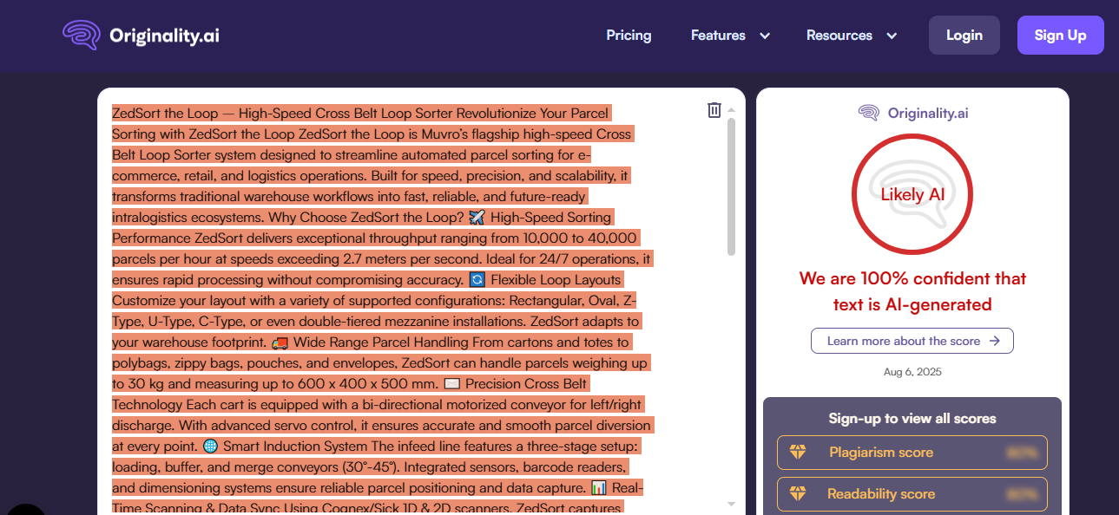
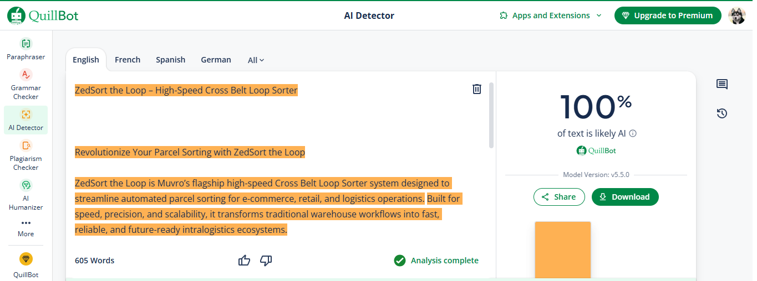

One AI site in favour of human written text
