Step-by-step implementation plan:
Step 1: Understand the flow
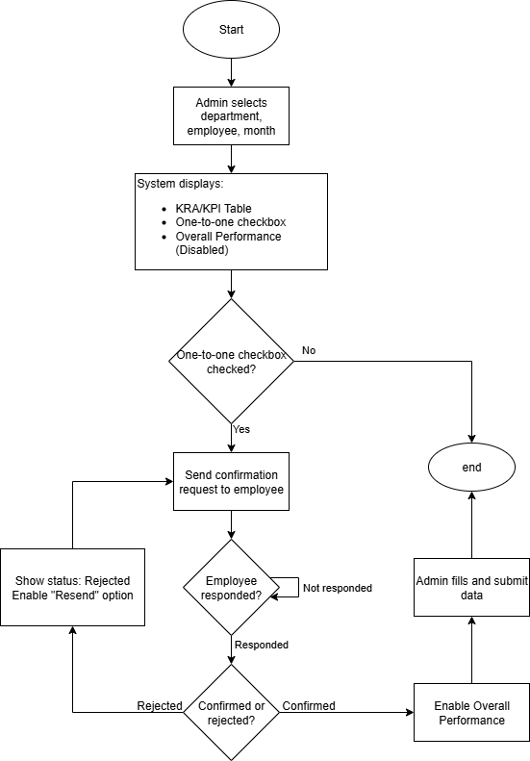
Step 2: Create a table for one-to-one meeting
In database add a table for one-to-one meeting. The table will include:
- Id
- Employee_id
- Manager_id
- Month(evaluation month)
- Meeting_done_by_manager(bool)
- Meeting_confirmed_by_employee(bool)
- Status(Pending/Confirmed/Rejected)
- Created at
Step 3: Design the Wireframe/UI
What to add:
- A checkbox:
One to one meeting conducted
- A status badge next to it:
Pending/ confirmed/ rejected
- A button:
Send confirmation request
- A resend button:
Send confirmation request again
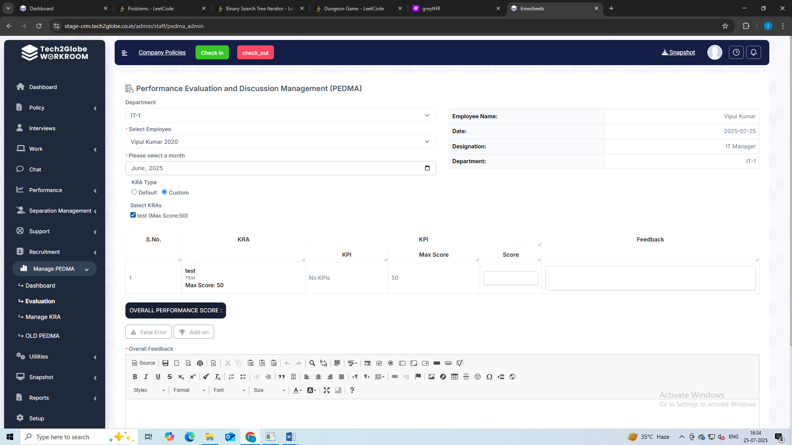
Disabled
One-to-one meeting:
Meeting Done:
Status Badge: (Pending/Done/Denied)
Disabled
Resend
Send Confirmation Request

Step 4: Logic on “Send confirmation request” and “Resend”
When the admin clicks the “Send Confirmation Request” and “Resend”:
- API triggers notification to employee whose id will be taken from database
- Show status: Pending
Step 5: Employee Side – Confirmation Screen
In the employee dashboard:
- Add a section in PEDMA for the confirmation of one to one meeting
- The section would consist of the message that “One-to-one meeting has been held”, status indicator that is whether the employee has submitted the verification or not and button for yes or no to verify
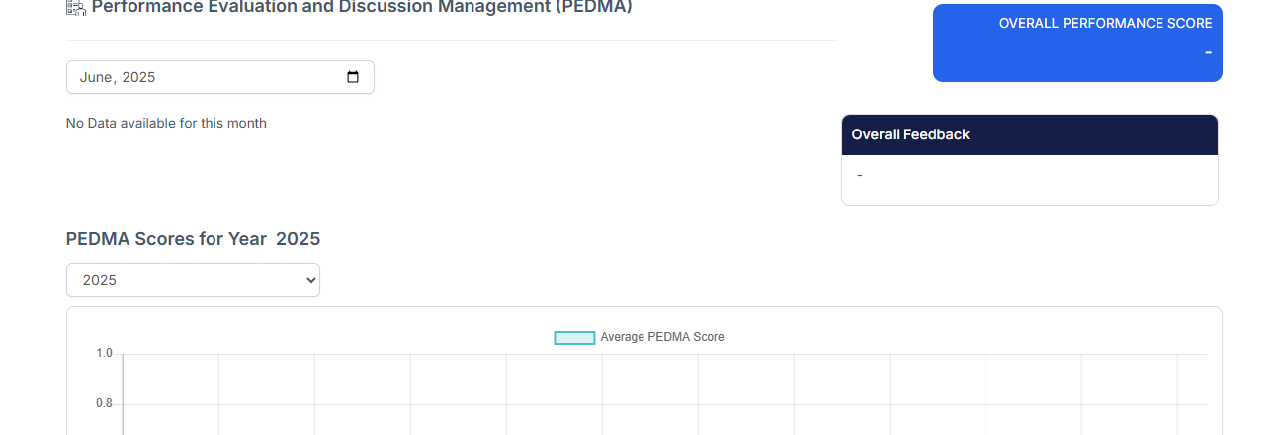
No
Yes
One-to-one meeting has been held:
Status: (Submitted/ Not Submitted)
Step 6: Based On Employee Response
Response | Admin Sees This UI
Confirmed | Status=Confirmed  Enable “Overall Performance” button  Email sent
Rejected | Status=Rejected  Enable “Resend” button  Email sent
Pending | Status=Pending

Step 7: Email send
Email would be send after it is confirmed or rejected:
- Email would be sent on employee and manager mail id which is taken by using the employee and manager id from database
- And email would also be sent on Harpreet Sir mail by default

