Website Development Proposal

Contents
Introduction 3
Project Objectives 3
Proposed Solution 3
Front-end (What customers see) 3
Back-End (Admin Panel – What you will control) 8
Technology Stack 10
Project Timeline 10
Budget Estimate & Payment Plan 11
Prerequisites 11
Notes & Assumptions 12

Introduction
This proposal outlines the development of a high-performance, scalable, and feature-rich web platform. It includes a modern front-end, a robust administrative backend, and specialized modules for service listings, content management, and lead generation. Built on the latest technologies such as React/Next.js, Node.js, and MongoDB, this platform is designed to elevate customer engagement, improve backend efficiency, and support long-term business scalability.

Project Objectives
Website should:
- Look clean and works on all devices
- Show your services, products, or training programs
- Lets you update the content easily from an admin panel
- Helps collect customer leads and inquiries
- Allows posting blogs, events, and job openings
- Support future updates and improvements

Proposed Solution

Front-end (What customers see)
- Develop responsive and appealing web pages using React.js to ensure a consistent, modern, and mobile-friendly experience
- Smooth & Intuitive Experience: Focus on delivering a highly performant and engaging user experience with smooth transitions and logical navigation, designed for maximum intuitiveness
- Mobile Responsiveness: Full mobile responsiveness and cross-device compatibility, thoroughly tested on iOS and Android platforms to ensure consistent display and functionality
- News-letter integration: Newsletter Integration: Seamless integration with platforms like MailChimp (or similar) for customer sign-ups and future promotional mailings
- Call-to-Action buttons: Prominent and strategically placed Call-to-Action (CTA) buttons throughout the homepage and other relevant pages to guide user interaction and conversions
- Key pages and their sections:
        - Home Page
- Eye catching banner with a short intro
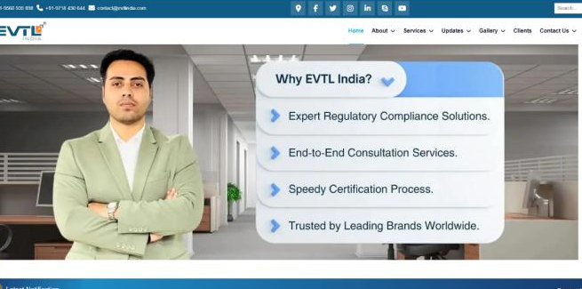
- Quick links to services/products
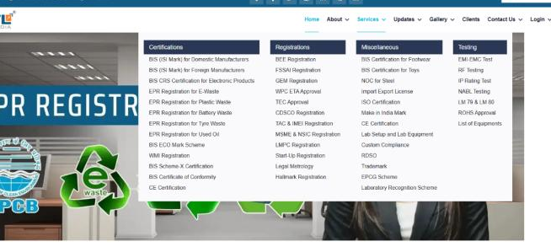
- Testimonials preview
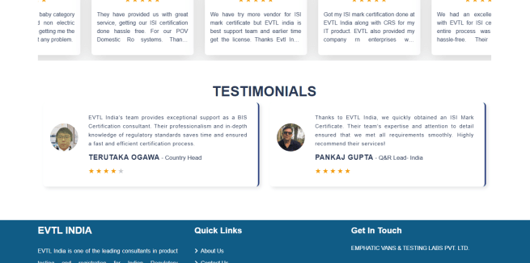
- Newsletter signup
- Survey form (optional)
        - About Us Page
- Company Overview
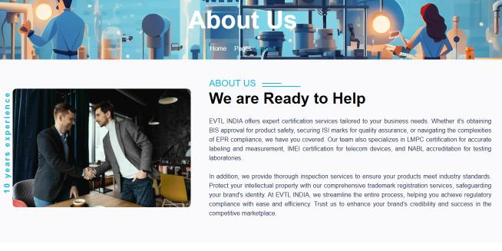
- Vision, mission, and values
- Team member highlights
- Contact Us Page
- Comprehensive Contact Form, including fields for meeting time and date option to select the call-back schedule
- Location
- Email and phone display
- Social media links
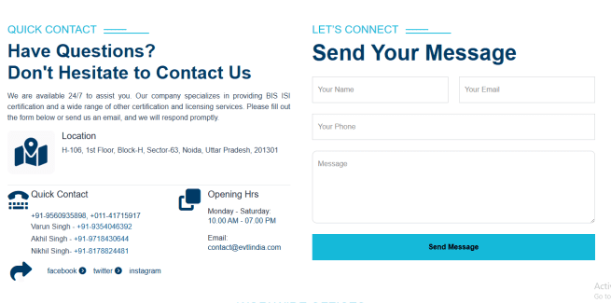
- Service Page(s)
Dynamic rendering of 8 unique page type layouts for services, capable of including Service Descriptions, FAQs, Table structures, embeddable PDFs, and Images.
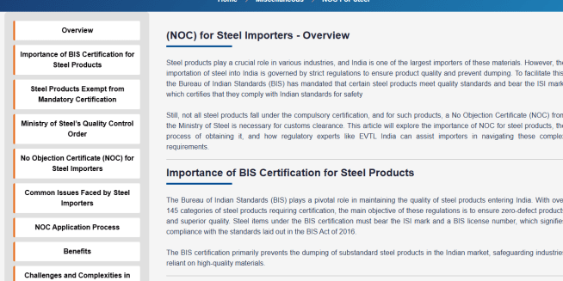
- Blog section
- Clean listing of blog posts with images
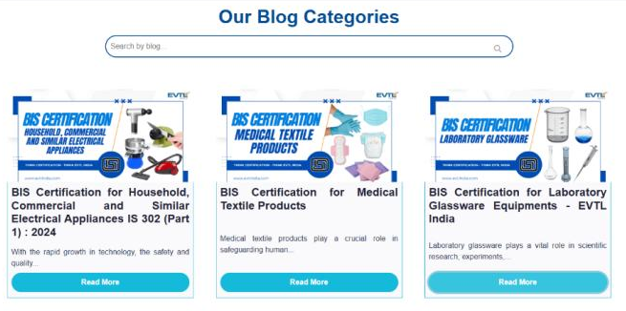
- Individual blog pages
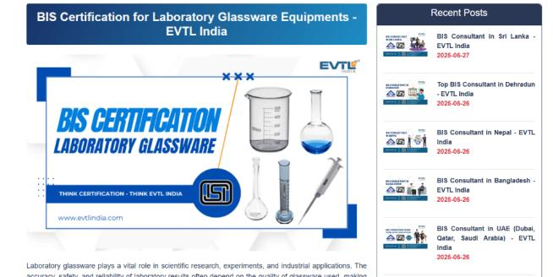
- Events Page
- List of upcoming events
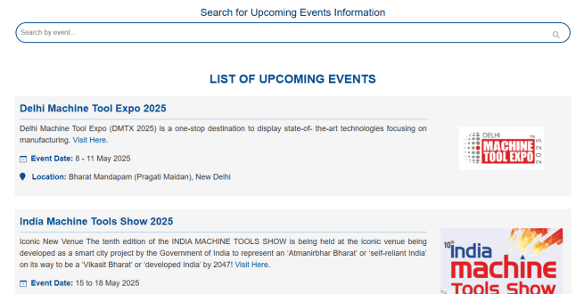
- Event detail pages with inquiry button
- Careers Page
- Job listings (position, location, skills, description).
- Apply now button with resume upload and a function to send applications (including resume) to a specific email address
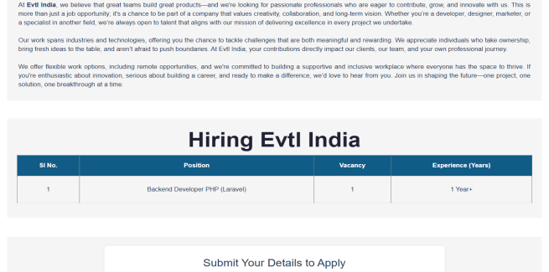
- Gallery Page
- Media section for images and videos, with the ability to embed YouTube iframes for video content.
- Organized by service/training categories
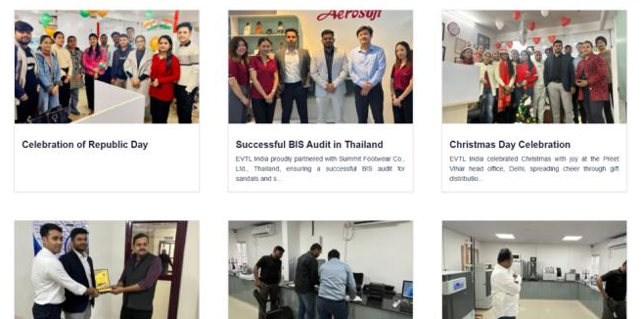
- Feedback Page
- Feedback form with submit feedback button
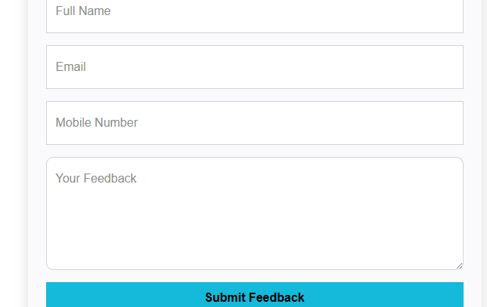

Back-End (Admin Panel – What you will control)
We will build a user-friendly Admin Dashboard with the following modules:
- Dashboard Overview
Summary of activity (recent inquiries, blog updates, etc.)
- CMS Pages Module
Create/edit/delete pages like – About, Contact, Careers, How to Buy, How it works, Partner with us, Privacy, T & C etc.
- Blog Module
Add/edit/delete blogs and assign categories, tags, cover images
- Service Category & Sub-category Management
This section allows the business to organize all services or products into clear categories and subcategories.
- Categories can be created for broader groups, and subcategories can be added under them.
- Each service or product can be linked to the correct group
- Categories and subcategories can be edited or removed at any time. This ensures that the website stays organized and easy to manage from the backend.
- Service Type Pages Module
Different services may require different page layouts. This module offers multiple layout designs that can be selected while creating each service page.
- Layouts can include features like text sections, FAQs, image galleries, video blocks, tab views, or downloadable documents.
- The preferred layout can be selected based on the content requirement.
- No design skills are needed-just selecting a template and entering the content is enough. This helps in presenting services in a professional and flexible format.
- Service/Product Management
This module allows full control over all the services or products displayed on the website.
- New services/products can be added with details like title, description, images, etc.
- Each item can be assigned to a category/subcategory and a layout type.
- Items can be set as Active or Inactive, or marked as Featured to highlight on the homepage.
- Editing or removing any item can be done anytime from the backend. This keeps the offerings up to date and easy to manage.
- Lead & Enquiries Management
This feature helps keep track of all people who show interest in the services-whether they submit a form on the website or reach out through phone calls or offline methods.
      - Every inquiry or lead is saved with their name, contact details, and message.
      - The source of inquiry is also recorded.
      - The team can add notes, assign the lead to a staff member, mark the status and schedule follow-ups.
      - It ensures that no inquiry or lead is missed, and all responses are timely.
This system makes it easier to manage communication and follow-ups with potential customers in an organized way.
- Testimonial Manager
Add client reviews, with optional image or video
- Event Manager
Post, edit, or remove upcoming events
- Career Module
Add job listings, download resumes or forward them to HR
- Gallery Module
Ability to manage pictures and videos, including uploading photos and embedding YouTube iframes for videos, organized by different service categories
- Multi-user with Permissions Module (User Access Controls)
An admin can create users with limited access to specific modules (For ex – Listings, Leads etc.)
- Settings Panel
Manage footer text, social links, email settings, logos, etc. Manage newsletter integration (e.g., MailChimp or alternatives) to send promotional emails and updates to customers.
- Notification Module
A section to show important updates. Each update opens in a detailed page when clicked, and a PDF file can be attached for viewing or download.

Technology Stack
Function | Technology
UI/UX Design | Figma
Front-End | React.js/Next.js
Back-End | Node.js
Database | MongoDB

Project Timeline
Phase | Description | Time Estimate
Planning | Finalize requirements and flow | 1 week
UI/UX Design | Wireframes and mockups will be designed, followed by a review and iterative feedback process to finalize the design | 1 week
Front-end development | Build responsive interfaces | 2 weeks
Back-end development | Admin panel, database, & APIs | 3 weeks
Testing & QA | Bug fixes, UAT, speed optimization | 1 week
Launch | Go live & monitor | 1 week

Budget Estimate & Payment Plan
Estimated budget:
Payment Schedule
Stage | Payment (%)
Project start | 25%
After design completion | 25%
After front-end completion | 25%
After back-end completion | 20%
After final launch | 5%

Prerequisites
- Company Information
  - Company name and logo
  - Tagline & slogan
  - About the company
  - Team member names and roles
- Website Content
  - List of all services/products/training programs
  - Text content for all pages
  - FAQs for relevant pages
  - Testimonials
  - Event details
  - Career/job openings
  - Any existing blog content
- Media & Visuals
  - Brand guidelines
  - Images and videos for banners, services, or gallery
  - Brochures or downloadable PDFs
  - Social media profile links
- Technical Info
  - Domain name details
  - Hosting login or provider info
  - Business email addresses for form connections
  - Mailchimp account
  - Google maps location link
- Legal Documents
  - Privacy policy
  - Terms and Conditions
  - Cookie policy
- Communication
  - One main point of contact for approvals

Notes & Assumptions
To ensure a smooth and efficient development process, the following notes and assumptions apply:
- Client Content Provision: All website content (text, images, videos, FAQs, PDF documents for service pages, blog posts, etc.) will be provided by the client in a timely manner and in a digital, organized format (e.g., Word documents, high-resolution image files). Delays in content provision may impact the project timeline.
- Third-Party Accounts: The client will provide necessary access credentials or API keys for any required third-party services, such as MailChimp, Google Analytics, social media accounts, etc.
- Revisions: The proposal includes a reasonable number of revision rounds (e.g., 2 rounds for UI/UX design, 1-2 rounds per module during development). Extensive additional revisions beyond these may incur extra charges.
- Browser & Device Compatibility: The website will be developed to be compatible with the latest versions of major web browsers (Chrome, Firefox, Safari, Edge) and across modern iOS and Android mobile devices. Older browser versions or niche devices may require additional effort if compatibility is required.
- Domain & SSL: The client is responsible for domain registration, DNS management, and the purchase/renewal of any necessary SSL certificates.
- Ongoing Maintenance & Support: This proposal covers the development and launch of the platform. Ongoing maintenance, support, and future feature enhancements will be subject to a separate agreement.
- Competitor Website as Reference: The competitor website (Evtlindia.com) serves as a visual and functional reference point for style and certain features, but the final design and functionality will be custom-built to meet the specific requirements outlined in this proposal, ensuring a unique and effective solution.

