Scope of Work: Raised Ticket
On
Tech2Globe

Table of Contents
Purpose 3
Scope 3
Departments and Tickets: 3
Steps for Raising a Ticket in the T2G Workroom 4
Step 1: Accessing the T2G Workroom 4
Step 2: Raising a Ticket 5
Step 3: Ticket Escalation Process 6
Step 4: What if the ticket is not resolved during the given timeline? 8
Workflow Diagram: 9

Purpose
This SOP outlines the procedure for raising tickets within the T2G Workroom, ensuring that tickets are directed at the appropriate department dashboards. Specifically:
- HR-related tickets should appear on the HR dashboard.
- IT-related tickets should appear on the IT dashboard.
- Similarly, tickets for other departments should be routed to their respective dashboards.

Scope
This SOP applies to all tickets raised within the organization and is intended for use by HR, IT, and other relevant departments.

Departments and Tickets:
- The organization consists of 5 departments: IT, Ops HOD, Compliance, Admin and HR.
- Employees are allowed to submit tickets to any of these departments.
- Each ticket should be visible only to the relevant department and the employee who submitted it.
- The ticket status can only be updated by the employee who raised it or the department that has resolved the issue

Steps for Raising a Ticket in the T2G Workroom

Step 1: Accessing the T2G Workroom
- Log in to the T2G Workroom using your assigned credentials. 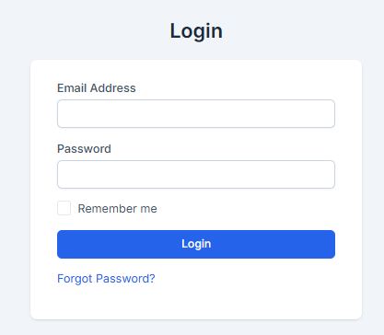

- Navigate to the "Raised Ticket" module from the main dashboard. 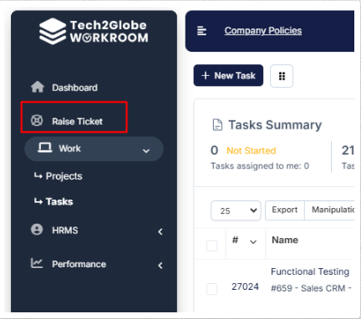

Step 2: Raising a Ticket
- Click on the "New Ticket" button to raise a new ticket. 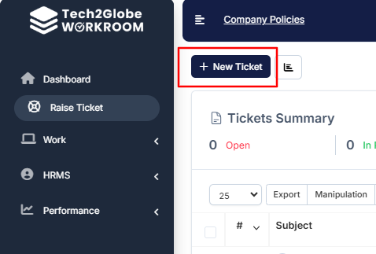

- Fill in the following mandatory fields: 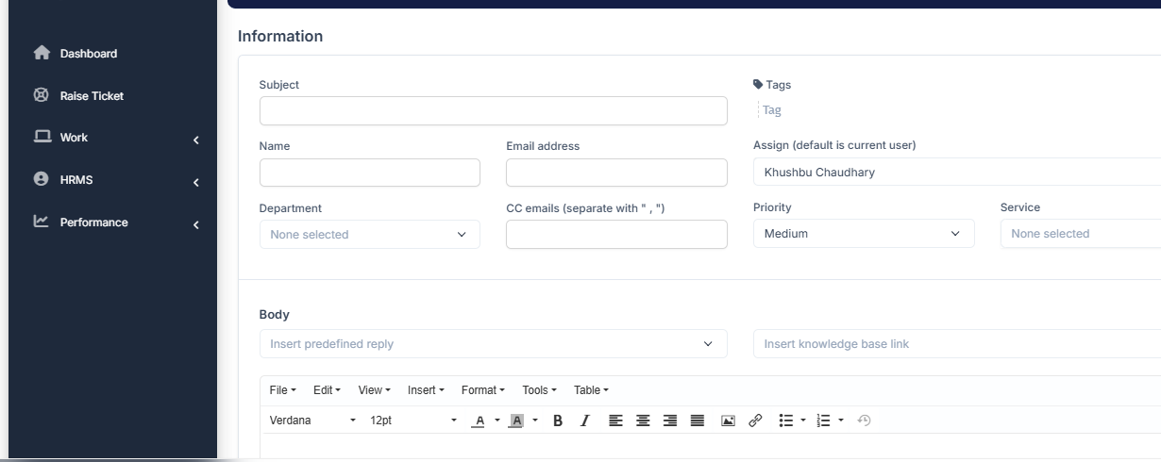
  - Subject: Enter a brief title for the issue.
  - Name: Provide the name of the employee raising the ticket.
  - Email: Enter your email address.
  - Department: Select the relevant department from the available options.
  - CC Emails: Add the email addresses of individuals you want to notify about the issue.
  - Priority: Choose the priority level for your ticket (e.g., Low, Medium, High).
  - Body: Provide a detailed description of the issue.
  - Attachments: Upload any relevant files or screenshots.
- Click the "Open" button to proceed.

Step 3: Ticket Escalation Process
Level 1:
- Accessibility: All employees have access to the ticket system.
- Ticket Creation: All newly created tickets begin at Level 1.
- Escalation Levels: There are two additional escalation levels beyond Level 1.
- Email Notifications: Emails are sent to the respective departments (IT, HR, Compliance, Ops HOD, Admin).

Note: - If a manager from any department needs to directly escalate a ticket, they can skip Level 2 and escalate directly to Level 3 by contacting Admin.

Level 2:
- Escalation Authority: Only the department handling the ticket can escalate it from Level 1 to Level 2. For example, the HR department can escalate HR-related tickets to Level 2.
- Visibility: All Level 2 tickets are visible to the managers of the respective departments.
- Email Notifications: Emails for Level 2 escalation are sent to:
- manager@tech2globe.in
- Ishan.negi@tech2globe.in [For now]

Level 3:
- Escalation Authority: Only Admin has the authority to escalate tickets to Level 3.
- Visibility: Admin is the only one who can view all tickets across all levels.
- Email Notifications: Emails for Level 3 escalation are sent to:
- admin@tech2globe.in

Step 4: Levels of Priority
- Low Priority: It takes 72 hours for tickets to be handled. The user will receive an email notification stating, "Your ticket will be resolved within the next 72 hours."

- Medium Priority: Tickets should be resolved within 48 hours. A notification email will be sent to the user with the message: "Your ticket will be resolved within the next 48 hours."

- High Priority: Tickets have a 24-hour turnaround time. The user will receive an email notification stating, "Your ticket will be resolved within the next 24 hours."

Note:- If a ticket is raised at Level 1, the resolution time will be based on its priority level. However, once the ticket is escalated from Level 1 to a higher level, it is considered high priority and must be resolved within 24 hours.

Step 4: What happens if the ticket isn't resolved within the given timeline?
- Action 1: The first email, asking "Why has this ticket not been resolved yet?" will be sent to the department responsible for resolving the ticket.

- Action 2: The admin will receive a second email notifying them that the responsible department has not resolved the ticket.
- Action 3: The user will receive a third email with the following status: "Sorry for the inconvenience; your ticket has not been resolved yet." This email will inform the user that their issue has not yet been addressed.

Note: After a ticket is raised, you will receive an email 24 hours later. This email will be sent only once.ss

Workflow Diagram:

