Customizable T-Shirts E-Commerce Website Development Proposal

Contents
Introduction 2
Project Objectives 2
Proposed Solution 2
Front-end (What customers see) 2
Back-End (Admin Panel – What you will control) 5
Technology Stack 5
Project Timeline 5
Budget Estimate & Payment Plan 6
Prerequisites 6
Notes & Assumptions 7

Introduction
This proposal outlines the development of a fully functional and interactive e-commerce website focused on selling customizable T-shirts. The platform will allow users to select T-shirts, upload images or designs, and preview how their chosen design looks before purchasing. The site will offer a smooth, user-friendly experience that enhances customer confidence and encourages conversions.

Project Objectives
The main goals of the website are to:
- Provide a modern, responsive, and visually appealing e-commerce experience
- Allow customers to customize T-shirts by uploading their own images or designs
- Enable live preview of the customized T-shirt using a WordPress plugin
- Ensure secure checkout, order tracking, and admin control for inventory and content management
- Make the platform scalable and easy to maintain for future updates

Proposed Solution

Front-end (What customers see)
- Develop responsive and appealing web pages to ensure a consistent, modern, and mobile-friendly experience
- Key pages and their sections:
        - Home Page
- Eye catching banner with a short intro
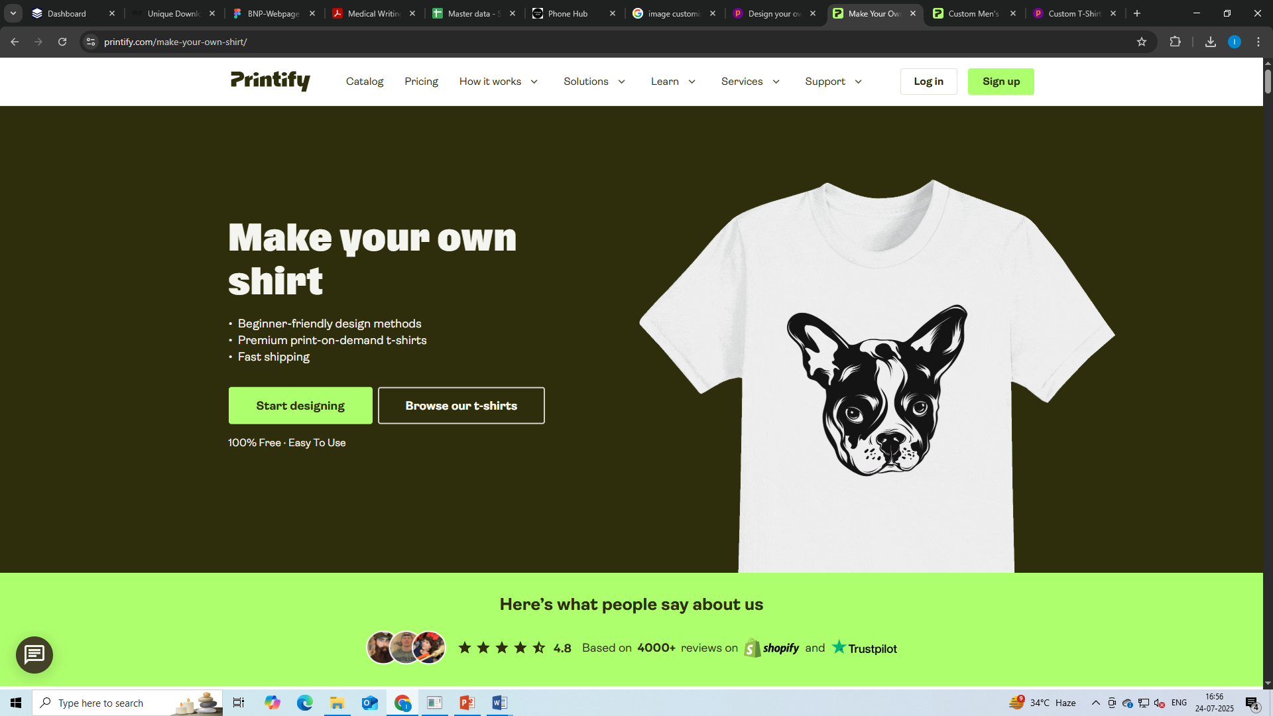
- Featured T-shirt categories
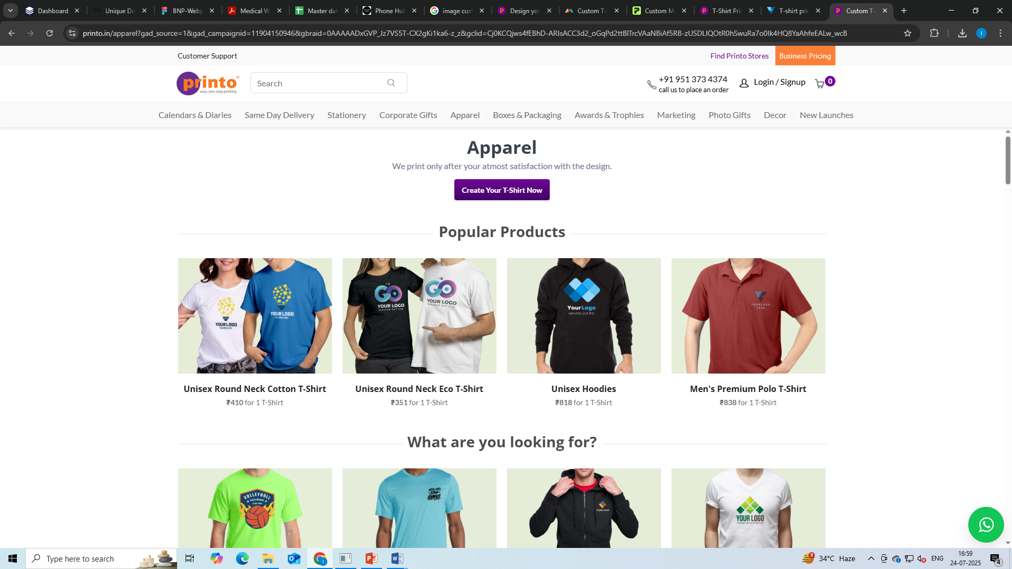
- Quick links to “Customize Now,” “Try Before Buy,” etc.
- Testimonials preview
- Newsletter signup
        - Product Listing Page
- Grid of T-shirt styles and types
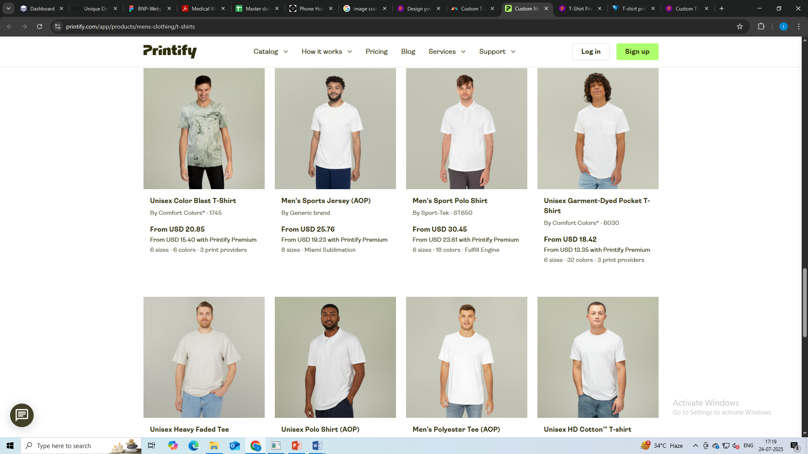
- Filter by size, color, type, price
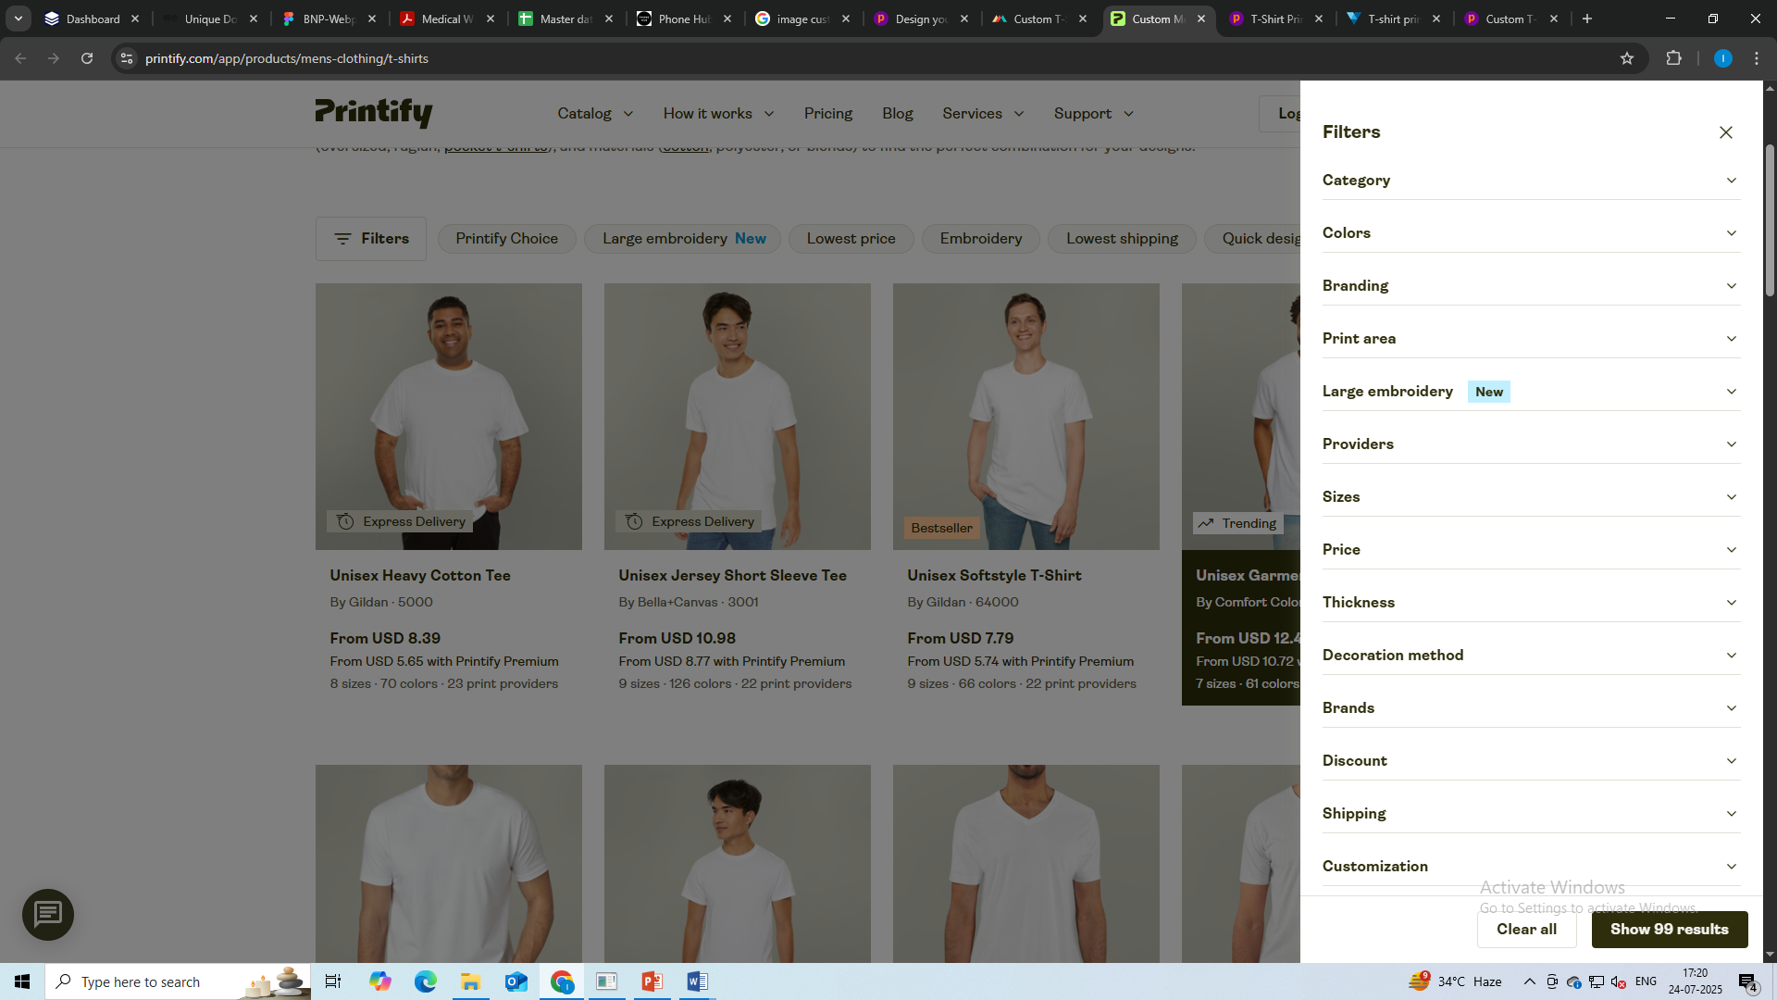
- “Customize” and “Buy Now” options
- Product Display Section
- High-Quality T-shirt image
- Product title
- Price
- Available sizes
- Color options
- Print locations
- Print size
- Quantity
- Continue To Design Button
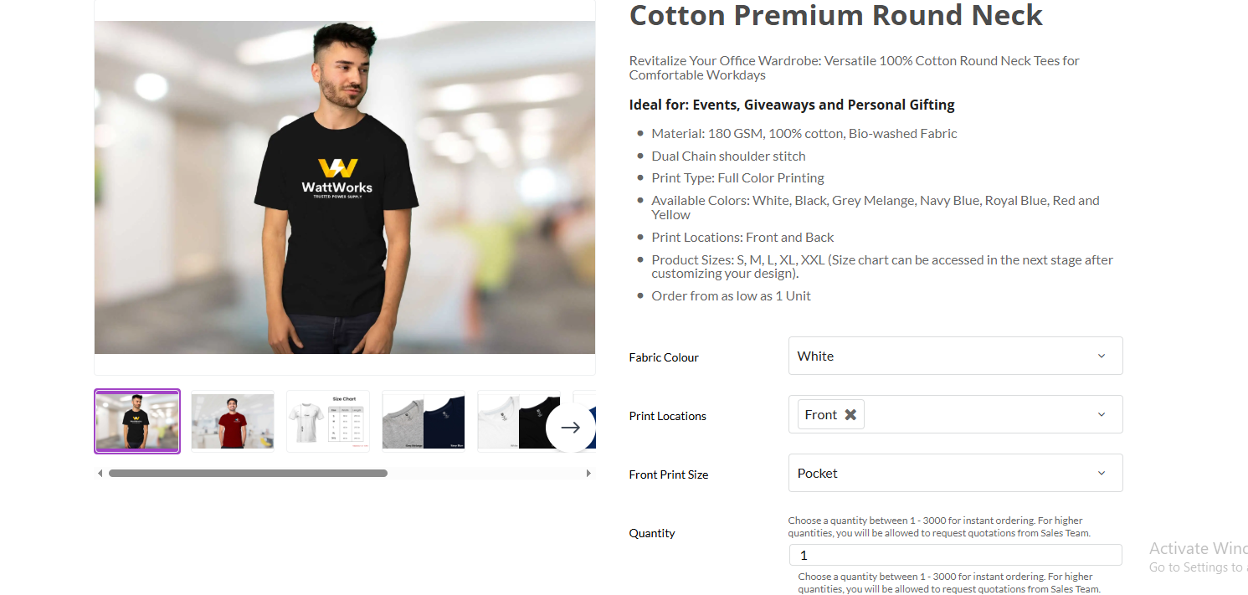
- Product Customization Page
- Upload Image Feature
- Live Preview
- T-Shirt mockup updates dynamically based on image uploaded
- Option to reset or change image before adding to cart
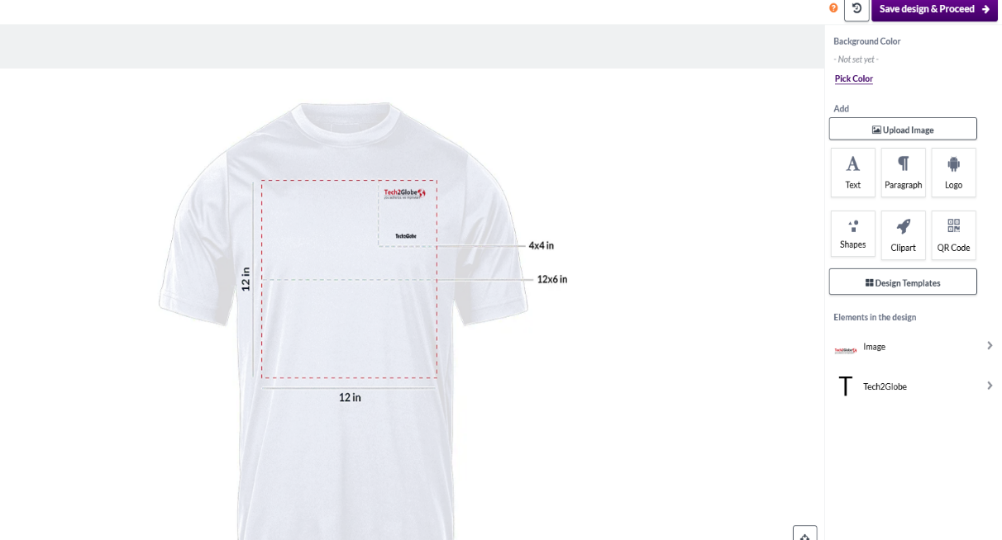
- Cart And Checkout
- Standard cart features with product image, description, price, and customization preview
- Secure checkout
- Order summary and confirmation email
- Other Pages
- About Us
- Contact Us (form with Google Maps)
- FAQ

Back-End (Admin Panel – What you will control)
We will build a user-friendly Admin Dashboard with the following modules:
- Product Management
- Add/edit/delete T-shirt products with size, color, and image variations
- Set base price, custom printing fee, discounts
- Inventory tracking
- Customization plugin management
- Configure WooCommerce Product Add-on and Live preview plugin to manage customization
- Enable/disable “Try” feature for specific products
- View uploaded images per order
- Order Management
- Dashboard showing new/pending/completed orders
- Access customer uploaded images for printing
- Content Management
- Easily edit content of About, FAQ, Policy, etc. pages
- Upload banners and update testimonials
- Marketing Tools
- Promo code and discount systems

Technology Stack
Function | Technology
UI/UX Design | Figma
Front-End | HTML/CSS/JS
Back-End | PHP
Database | MySQL

Project Timeline
Sr. No. | Task | Flow of Task | Estimated Hours | Days Required | Milestones
1 | Figma & Design Development |  |  |  | Milestone 1
 | Wireframing | Create wireframes for homepage, contact, about us, product listing, product display page | 10-12 | 2-3 | Milestone 1
 | UI/UX Design | Convert wireframes into UI designs using Figma | 12-15 | 3 | Milestone 1
 | Feedback & Revisions | Apply stakeholder feedback to design | 8-10 | 1-2 | Milestone 1
2 | Frontend Development |  |  |  | Milestone 1
 | Homepage | Build homepage with banners, CTAs, testimonials, newsletter, signup | 8-10 | 2 | Milestone 1
 | Static pages | Create about, contact, terms & conditions | 8-10 | 1-2 | Milestone 1
 | Product Listing Page | Build product listing page with various T-shirts, filter, and buy button | 6-8 | 2 | Milestone 1
 | Product Display Section | Build product display section for various products present that should include high quality images of the product, size, color, etc. | 6-8 | 1 | Milestone 1
 | Product Customization Page | Build product customization page with upload image option and live preview | 6-8 | 1 | Milestone 1
 | Cart And Checkout | Build cart and checkout page in which there will be the products that are added and also the price, promo codes, etc. | 10-12 | 2 | Milestone 1
3 | Backend Development |  |  |  | Milestone 2
 | Admin Dashboard Overview | Central panel for controlling all website sections | 10-12 | 2 | Milestone 2
 | Product Management | Add/edit/delete product and its details | 6-8 | 1-2 | Milestone 2
 | Customization plugin management | Configure plugin for the preview of the customization | 4-5 | 1 | Milestone 2
 | Order Management | Dashboard showing new/ pending/ completed orders | 6-8 | 1 | Milestone 2
 | Content Management | Easily edit content of the static pages | 4 | 1-2 | Milestone 2
 | Marketing tools | Integrate promo codes and discount systems | 4-5 | 1 | Milestone 2
4 | Final Phase |  |  |  | Milestone 3
 | Testing & QA | Full testing for functions, forms, responsiveness, and bug fixing | 8-10 | 2 | Milestone 3
 | Deployment | Move to live server and final handoff | 4-5 | 1 | Milestone 3
Total |  |  | 120-150 | 25-30

Prerequisites
To start the project. The client is expected to provide:
- Business logo and brand colors
- Content for About, FAQ, Policy pages
- T-shirt images for different categories
- Domain and hosting credentials
- List of T-shirt types and pricing

