Fire Safety Services Company: Website Design & Development.

Background
A leading fire safety company serving in Seattle for over _______ years. As an expert in design-build fire safety solution, the company has positioned itself as a valued partner in construction, managing demanding projects with precision, adaptability and reliable results. A modern & professional website was needed for them to better promote their services and elevate their online identity.

Challenges
The previous website was developed on a custom PHP platform that with several notable limitations:
Technical Limitations
- An old custom PHP framework that was hard to manage and modernize.
- There was limited content management features which required technical assistance for simple updates.
- The weak mobile optimization adversely affected usability across multiple devices.

Design, Content & SEO Issues
- There was poor presentation of the business’s remarkable achievements and industry awards.
- Outdated design with insufficient imagery to support technical details and establish trust.
- Lack of clear separation between ‘repair’ services and ‘systems’ solutions, creating confusion among potential clients.
- Low content on essential service pages reduced SEO performance and lead generation opportunities.

- No dedicated pages for key offerings, including fire safety storage tanks, fire pumps and underground fire lines.

Outdated Visual Identity
An old fashioned website layout that did not reflect their progressive and innovative approach for managed IT services and cybersecurity solutions.

Solution
- Developing a detailed online platform to effectively present the firm’s expert fire safety services and solutions.
- Adding a Service Trade Customer Portal to enhance client management capabilities.
- Creating location based pages to focus on the company’s targeted service regions.
- Applying proper SEO techniques to improve the website’s visibility in search results.
- Completing the project within a strict timeline before the client’s existing hosting renewal date.

Platform Migration & Modern Professional Design
Built a modern, adaptive WordPress platform with a video masthead and clear categorization of services.

Comprehensive Content Structure
Created detailed webpages for each fire safety system and geographic service area.

Service Trade Portal Integration
Effectively integrated the Service Trade plugin to enable client access to service records.

Results
The company’s website was successfully launched before the deadline, providing:
- A well-designed website that accurately highlights the company’s service offerings.

- Enhanced user experience through intuitive navigation and concise service details.

- Added client portal to support efficient management of services.

- Improved lead generation using strategically designed request forms.

Tech2Globe’s partnership with the fire safety company highlights how a thoughtful website redesign can enhance a business’s online identity, driving growth and reducing operational challenges.

The fire safety firm now has an effective website platform that complements its leading industry standing and prepares it for sustained success in the competitive fire protection sector.

From: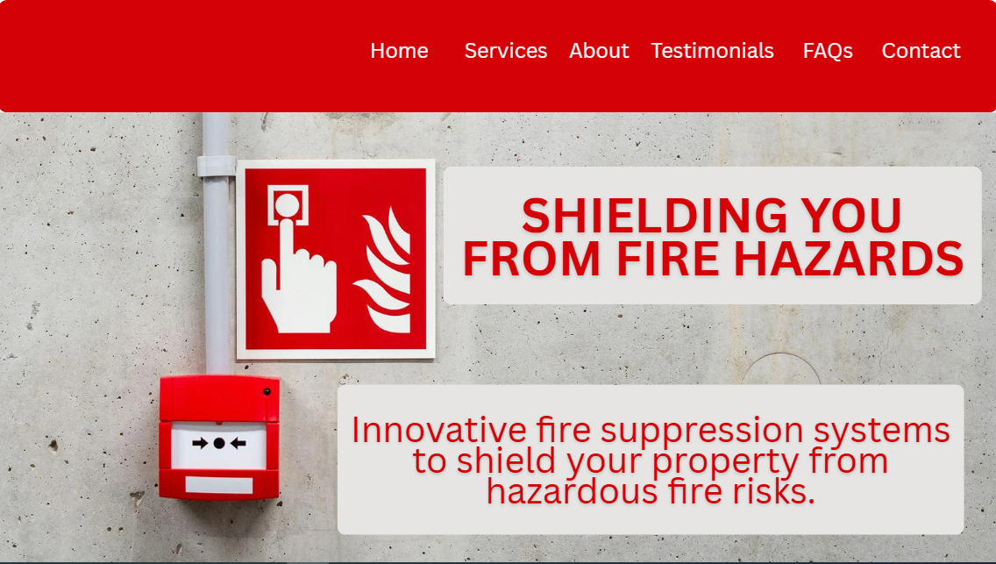

To This:

