Web application development proposal for Kyra Tax Advisors
1. Document details 2
2. Confidentiality 2
3. Project Overview 2
4. Core Features / Modules 2
6. Flowchart 6
5. Timeline 6
6. Suggested Tech Stack 7
7. Engagement Model 8
8. Why Tech2Globe Web Solutions LLP 8

1. Document details
Client: Kyra Tax Advisors
Prepared by: Tech2globe Web Solutions LLP
Created on: 10-07-2025
Document Version: V1.0

2. Confidentiality
This material contained in our response and any material or information disclosed during discussions of the proposal represents the proprietary, confidential information pertaining to Tech2globe Web Solutions LLP services, methodologies and methods. Other products and brand names may be trademarks or registered trademarks of their respective owners.
By accepting this response, client agrees that the information in this proposal will not be disclosed outside the Organization and will not be duplicated, used, or disclosed for any purpose other than to evaluate this proposal. This proposal is subject to a mutually approved agreement or contract specifying full terms and conditions.
The contents of this document are provided to the client in confidence solely for the purpose of evaluating whether the contract should be awarded to Tech2globe Web Solutions LLP

3. Project Overview
We are building a powerful web platform that gathers and presents verified public data about companies and their directors from trusted sources.
The platform will allow:
- Public users to explore company and director profiles
- Registered directors to manage their company details, upload financials, and offer equity/shares for sale
- Investors and researchers to access deeper insights by subscribing to premium data
Monetization strategy:
- Freemium Access: Certain data can be viewed up to 10 times for free
- Premium Data: Some data is locked and requires a subscription
- IP tracking: Tracks usage to enforce limits and encourage signups.

4. Core Features / Modules
- Company Master Data Importer
This module automatically collects company information from Attestr API.
Functionality:
- Scheduled scripts fetch and update the database with the latest company records.
- Data validation ensures only accurate and complete information is saved.
- Admin can manually trigger re-sync or correct mismatches or get updated data from API.
- System logs all fetches and update attempts with timestamps.
User Interaction:
- Public users can search and view summarized company data.
- Detailed records are shown depending on user subscription access (free/premium).
- Director Profile Management
Each company director’s information will be fetched and displayed dynamically.
Data includes:
- DIN, Full Name, Designation
- Appointment and Cessation Dates
- Shareholding and Offer-for-Sale Percentage (Directors can update by themself)
- Linked Professional Background (Directors can update by themself)
Features (Profile update):
- Display of profile summary with option to update data which is updated only after the authentication by the admin (Director can update profile details and once admin verify and publish that data can be visible to normal users)
- Sign Up/Sign In Module
Manages user registration and login process securely.
Functionality:
- Supports email/password login and OAuth (Google, LinkedIn).
- Verifies credentials and creates sessions using secure tokens.
- Admin can manage login rules and reset user access.
User Interaction:
- New users register and verify email
- Returning users sign in to access saved dashboards and view history.
- About Us - Editable Section
Allows companies to define their identity and describe services on their public profile.
Functionality:
- Editable text area for creating company introductions.
- Admin moderation of updates to prevent inappropriate content.
User Interaction:
- Directors can update 'About Us' from their dashboard.
- Content is visible after admin review.
- Balance Sheet & Income Statement Upload (Admin Verified)
Directors can upload financial documents securely.
Functionality:
- File uploads restricted to allowed formats (PDF, XLS, CSV).
- Uploaded documents are flagged for admin verification.
- Visibility can be set to public or private by the director.
Admin Role:
- Admin views pending uploads/updates and approves/rejects with reason.
- Approved uploads/updates are timestamped and shown on company profiles.
- Equity/Shareholding Offers and Buyer Interest Module
Facilitates share offerings from company directors to potential buyers.
Functionality:
- Directors can set offer terms (e.g., share %, price).
- Interested buyers can express interest directly on the listing.
- Admin can review offers and disable inappropriate ones.
User Interaction:
- Directors post offers and track responses.
- Buyers can submit interest forms and wait for a response.
- Buyers and directors can discuss their norms as per them with weather that is online or offline and director can update the detail after deal is done or pending.
- Subscription Model (Feature Gating + IP-based lock after 10 visits)
Controls access to premium content through a mix of free and paid plans.
Functionality:
- Tracks user sessions and IPs to limit free views (e.g., 10 free data views).
- Locks sensitive sections like financials or historical performance unless subscribed.
- Integrated with Stripe/Razorpay for secure payments.
Admin Role:
- Admin can change pricing, update view limits, and offer promo codes.
- Admin Panel (for verification, approvals, content management)
The Admin Panel acts as the central dashboard for platform administrators. It allows admins to manage users, content, documents, and system settings to keep the platform running smoothly and securely.
- User Management
View all registered users (active/inactive, free/paid).
Activate, deactivate, or delete user accounts.
Filter users based on subscription or activity.
- Content & Profile Verification
Review and approve changes made by directors (e.g., company details, financials).
Compare old and updated information before approval.
Approve or reject updates with feedback.
- Document Verification
Access uploaded balance sheets/income statements.
Preview and verify documents before making them public.
Reject incorrect uploads with notes to the director.
- Equity Offer Oversight
Monitor shareholding offers made by directors.
Approve or disable misleading or incomplete offers.
- Payment & Subscription Logs
View all user payments and active subscription plans.
Issue refunds or apply discounts manually if needed.
- Notification Management
Send system alerts or emails to users.
Schedule reminders like subscription expiry or content approval.
- Static Page Management
Edit platform content (About Us, FAQs, Terms, etc.).
Preview and publish updates to static pages.
- System Settings
Configure freemium limits (e.g., 10 free views).
Notification toggle features on/off without needing code changes.
Update pricing plans and promotional settings.
- Notification Module (Subscription alerts)
Automates and manages communication between system and users.
Functionality:
- Sends reminders (subscription expiry), status updates (content approval), and announcements.
- Admin can broadcast messages or schedule alerts.
User Interaction:
- Users receive alerts via email and in-app banner.
- Preferences can be configured to opt in/out of types of alerts.
- Static pages
These are the foundational info pages on the site. They include:
- About Us – who we are and what we do
- Contact Us – how to reach our team
- FAQs – common questions with answers
- Terms & Privacy – all the legal stuff
They don’t change often, but they’re always available when you need them.
- Search Module
Provides a powerful unified search across companies, directors, trademarks, and locations.
Functionality:
- Implements autocomplete and fuzzy search suggestions.
- Search filters allow narrowing by category or location.
User Interaction:
- Users can type queries and browse real-time matching results.
- Clicking results takes them to detailed profile pages.

6. Flowchart
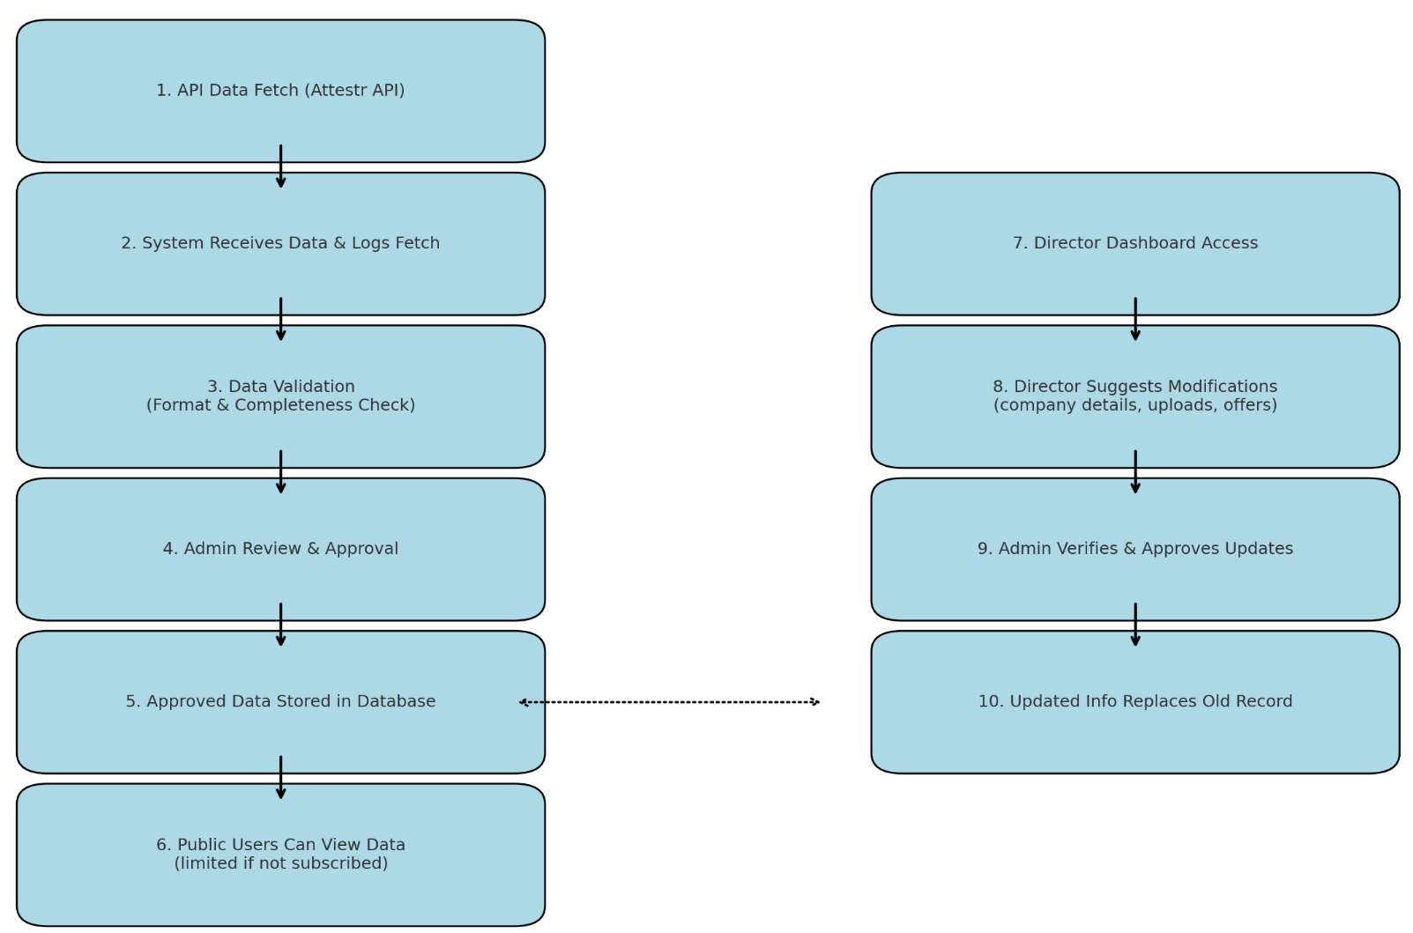

5. Timeline
Sr. No. | Task | Flow of Task | Estimated Hours | Days Required | Milestones
1 | Figma & Design Development |  |  |  | Milestone 1
 | Wireframing | Create wireframes for company search, director profiles, login, about us, financial upload, offers module, subscription, and admin dashboard | 12-15 | 2-3 | Milestone 1
 | UI/UX Design | Convert wireframes to final UI screens in Figma for public & admin panels | 15-18 | 3-4 | Milestone 1
 | Feedback & Revisions | Apply stakeholder feedback and iterations for UI approval | 8-10 | 1-2 | Milestone 1
2 | Frontend Development |  |  |  | Milestone 1
 | Company/Director Pages | Build views for company search, director profiles, and summarized data with search filters | 10-12 | 2-3 | Milestone 1
 | Static pages | About us, contact us, FAQs, Terms of use, Privacy policy | 8-10 | 1-2 | Milestone 1
 | Sign Up/Login Forms | Secure registration with email/OAuth, session tokens, email verification | 8-10 | 1-2 | Milestone 1
 | Upload financials | Frontend interface for uploading balance sheets, selecting public/private, viewing status | 6-8 | 1-2 | Milestone 1
 | Share offer module | UI for directors to list offers and buyers to express interest | 6-8 | 1-2 | Milestone 1
 | Subscription Gating UI | Alert banners, IP limit messages, and upgrade prompts for premium data access | 4-5 | 1 | Milestone 1
 | Notification system (User) | Show notifications via dashboard banners and email integrations | 4-5 | 1 | Milestone 1
3 | User Features |  |  |  | Milestone 2
 | Inquiry & Contact forms | Forms for reaching out, callbacks, general questions - email routed to admin | 6-8 | 1-2 | Milestone 2
 | Search module | Advanced autocomplete search across companies, directors, and categories with filters | 8-10 | 1-2 | Milestone 2
 | Subscription module | IP tracking, view count, feature locking, stripe/ Razorpay integration | 8-10 | 1-2 | Milestone 2
4 | Backend Development (Admin Panel) |  |  |  | Milestone 2
 | Dashboard overview | Summary of activities, alerts, user stats | 8-10 | 1-2 | Milestone 2
 | User management | Activate/deactivate/delete users; filter by role or subscription | 6-8 | 1-2 | Milestone 2
 | Document verification | Approve/reject uploaded financials with notes | 6-8 | 1-2 | Milestone 2
 | Profile verification | Approve director/company edits | 6-8 | 1-2 | Milestone 2
 | Offer oversight | Approve or disable equity/shareholding listings | 6-8 | 1-2 | Milestone 2
 | Payment Logs & Refunds | View payment history, issue refunds, apply promo codes | 6-8 | 1-2 | Milestone 2
 | Static page management | Edit About us, FAQs, legal pages | 4-5 | 1-2 | Milestone 2
 | System settings | Toggle features (e.g., lock limit), update pricing, configure thresholds | 6-8 | 1-2 | Milestone 2
5 | Notification Module (Admin) |  |  |  | Milestone 2
 | Notification admin panel | Upload notification messages, attach downloadable PDFs, and schedule messages | 4-5 | 1-2 | Milestone 2
 | Email & banner integration | Email templates and dashboard notification display | 10-12 | 2-3 | Milestone 2
7 | Final Phase |  |  |  | Milestone 3
 | Testing & QA | Cross-browser/device testing, security review, bug fixes | 10-12 | 2-3 | Milestone 3
 | UAT & Feedback | Internal walkthrough, client feedback loop | 6-8 | 1-2 | Milestone 3
 | Deployment | Deploy final build to AWS or production server | 4-6 | 1 | Milestone 3
Total |  |  | 185-235 | 32-55

6. Suggested Tech Stack

Component | Technology | Purpose
Frontend | React / Next.js | What the user sees: pages, search, login, forms etc.
Backend | Node.js / Express OR Django | Handles data, logic, security, and APIs
Database | PostgreSQL / MongoDB | Stores user data, financials, company profiles etc.
Authentication | OAuth 2.0 / Firebase Auth | Secure user login, password protection
Hosting | AWS | Runs the website on secure and scalable cloud servers
Payment Gateway | Stripe or Razorpay | Manages subscription payments securely
Data APIs | Attestr API | To fetch official company and director data

7. Engagement Model
We propose a milestone-based delivery model, ensuring transparent progress:
- Step-by-Step Modules: Delivered in phases
- Dedicated Team: PM, frontend & backend developers assigned
- Weekly Progress Demos: Client gets weekly updates & working demos
- Final Delivery: All code, credentials, and documentation handed over

8. Why Tech2Globe Web Solutions LLP
- Global Presence
- Skilled IT Professionals
- State-of-art infrastructure
- Proven offshore outsourcing model
- Multi culture and multi-location understandings
- Quick Turnaround time
- Satisfied clients globally
- Proximity to skilled manpower source
- Establishment work execution and delivery process 24 X 7 Services
- High quality and cost-effective solutions
- Rapid communication
- Vast experience from system implementation, integration and migration for some competitive customers.

