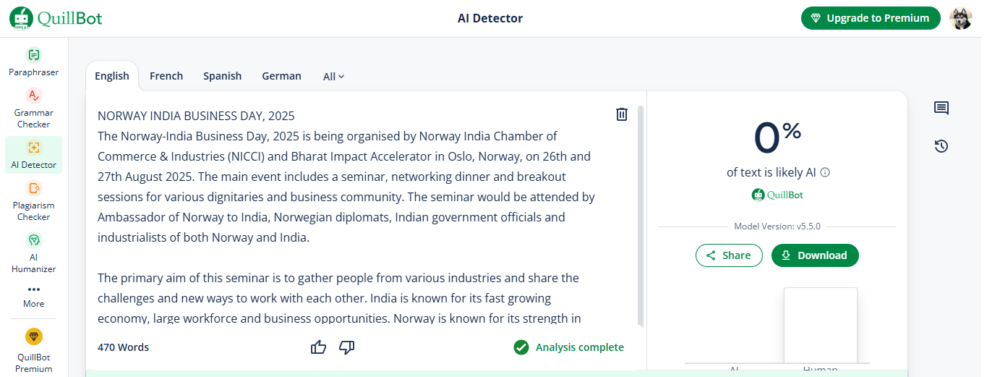

NORWAY INDIA BUSINESS DAY, 2025
The Norway-India Business Day, 2025 is being organised by Norway India Chamber of Commerce & Industries (NICCI) and Bharat Impact Accelerator in Oslo, Norway, on 26th and 27th August 2025. The main event includes a seminar, networking dinner and breakout sessions for various dignitaries and business community. The seminar would be attended by Ambassador of Norway to India, Norwegian diplomats, Indian government officials and industrialists of both Norway and India.

The primary aim of this seminar is to gather people from various industries and share the challenges and new ways to work with each other. India is known for its fast growing economy, large workforce and business opportunities. Norway is known for its strength in renewable energy, technology and practices. These two countries coming together can give rise to new business opportunities.

Attendees will get updates on current trade policies, market conditions and new areas where the two nations can work more closely. This event is designed to create long-term relationships between the businesses as we go forward.

Join this seminar to:
- Stay informed and get new ideas.
Keep up to date with the latest developments in the trade between the two countries. The seminar will have panels and updates on topics such as:
- India’s green transition, economic outlook, investment opportunities and market entry.
- Norway India economic engagement on climate & sustainable development.
- Building Digital Partnerships, from AI to Cyber security.
- TEPA & Beyond – building the next phase of Norway-India trade.

- Learn from real-world experience of experts
Listen to prominent speakers such as May-Elin Stener, Norwegian Ambassador to India, Helge Tryti, Chairman of NICCI, various heads, partners from several industries such as Bharat Technology & Impact Accelerator, Trilegal, ICICI bank, TBC and Larsen & Toubro. You can learn about India’s growing market, trade agreements and new updates on policies.

- Find out new business opportunities.
You can participate in business-to-business meetings and detect large-scale projects in renewable energy, growing economy, digital innovations and green transition. You can learn how Norwegian expertise in these fields can work for India as well. This event can connect you with new opportunities to explore in India.

- Build network and connections
This seminar can give you amazing opportunities for making meaningful relations with NICCI members and other entrepreneurs. You can meet Indian representatives, various representatives of embassies, ministries and industrialists.
Join us:
Tech2Globe, a top IT and digital solutions company, is going to attend the Norway-India Business Day 2025 in Oslo, Norway on 26th and 27th August. Senior representatives of our firm plan to build new cooperation and highlight our skills at digital innovations. Our team will participate in discussions and networking events to learn about the new opportunities in Norway-India trade. Our firm wants to connect with global professionals and bring innovation in trade between the two nations.

