**C Language Live Community Classes Assignment 1**

**Assignment-1**

1. Why do computers understand only binary language?

**Answer-**

computers understand only binary language because it's only understand 1s and 0s. A computer's main memory consists of transistors that switch between high and low voltage levels — high voltage means 1 and low voltage means 0.

1. What is the full form of IDE?

**Answer-**

**Integrated Development Environment**

1. What is the difference between a text editor and a code editor?

**Answer-**

A text editor that is specialized for writing software. A code editor may be a stand-alone program or part of an integrated development environment (IDE). They make writing and reading the source code easier by differentiating the elements and routines so programmers can more easily look at their code.

1. What are the steps to develop software using the C language?

**Answer-**

First we write the Source code with the help of code editor or text editor ,

Then we send the Source code to build process which includes pre-processor , compiler and linker.

After build process we have .exe (Executable File) and this .exe file is a software.

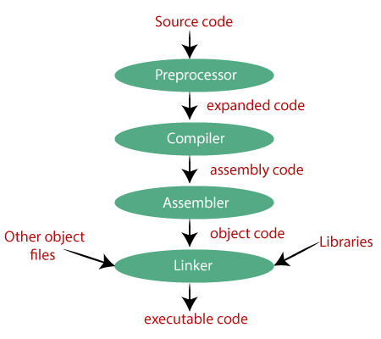

1. Explore by your own

A. What is the latest version of C Language?

**Answer-**

C17 is the informal name for **ISO/IEC 9899:2018**, the most recent standard for the C programming language, prepared in 2017 and published in June 2018. It replaced C11 (standard ISO/IEC 9899:2011).

1. Who developed C Language?

**Answer-**

Dennis Ritchie invented C language in 1972.

1. What is the difference between System and Application Software?

**Answer-**

A System Software acts as an interface between the system and the application software. The various Operating systems are the best example as it allows the user to download and work with various applications on their device.

On the other hand, Application Software is designed for users. The applications can be added to system software. For example, Notepad is an application of [MS Windows](https://byjus.com/govt-exams/microsoft-windows/), which is system software.

1. How to convert a number from a decimal number system to a binary number system?

**Answer-**

**The rules to convert decimal to binary numbers are given below:**

1. Write down the number.
2. Divide it by 2 and note the remainder.
3. Divide the quotient obtained by 2 and note the remainder.
4. Repeat the same process till we get 0 as the quotient.
5. Write the values of all the remainders starting from the bottom to the top.