PREDICTING RISK OF SUBJECTIVE COGNITIVE DECLINE
A Multivariable Logistic Regression Analysis of Six Years of CDC BRFSS Cognitive Decline Module Data (2015-2020)
An Applied Healthcare Data Analytics Portfolio Project
Methodology: R (base statistical computing environment) | Logistic Regression | Population Health Risk Stratification
Prepared in the style of a CDC Healthy Aging Program / applied epidemiology technical report
August 2026

Executive Summary
This project applies multivariable logistic regression to six years (2015-2020) of respondent-level data structured on the Centers for Disease Control and Prevention's Behavioral Risk Factor Surveillance System (BRFSS) Cognitive Decline optional module to identify demographic, clinical, and behavioral predictors of subjective cognitive decline (SCD) — a self-reported early warning indicator for future dementia and Alzheimer's disease risk — and to translate model output into an actionable, tiered population-risk-stratification framework for public health resource allocation.
Analyzing 43,436 adults aged 45 and older, the final adjusted model identified advanced age, depression, prior stroke, diabetes, hypertension, heart disease, hearing loss, living alone, social isolation, physical inactivity, current smoking, insufficient sleep, and lower educational attainment as independent, statistically significant predictors of SCD (all p < 0.01). The model achieved acceptable-to-good discrimination on a held-out 25% test set (AUC = 0.7107, 10-fold cross-validated AUC = 0.6868 ± 0.01) with strong calibration across risk deciles and high negative predictive value (93.0%), supporting its use as a population-level screening and prioritization tool rather than an individual diagnostic instrument.
Population Attributable Risk (PAR) analysis indicates that depression alone accounts for an estimated 11.8% of SCD cases in this population — the single largest modifiable contributor identified — followed by physical inactivity (6.6%), social isolation (5.3%), and untreated hearing loss (4.6%). Applying the validated model across the full sample, 19.3% of respondents fell into the "High" risk tier and 11.9% into "Very High" (observed SCD rates of 17.1% and 30.8% respectively, versus 5.2% in the "Low" tier) — a roughly six-fold gradient in observed risk that public health programs can use to prioritize screening, referral, and modifiable-risk-factor interventions.
Five public health recommendations, prioritized by estimated population impact and feasibility, are presented in Section 6.

1. Background and Public Health Significance
Subjective cognitive decline (SCD) — the self-reported experience of worsening or more frequent confusion or memory loss — is recognized by CDC's Healthy Aging Program as one of the earliest identifiable warning signs of potential future dementia, including Alzheimer's disease and related dementias (ADRD). Because SCD precedes clinical diagnosis and is not observable on standard cognitive assessment tests, population surveillance of self-reported symptoms provides a uniquely early window for public health intervention, years before a clinical dementia diagnosis would otherwise occur.
CDC's BRFSS Cognitive Decline module — a six-question optional module administered by states since 2015 — is the nation's primary source of population-representative SCD surveillance data. Published CDC analyses report that approximately 1 in 9 to 1 in 10 adults aged 45 and older experience SCD nationally, that fewer than half discuss these symptoms with a health care provider, and that SCD prevalence is markedly elevated among adults living alone and those with chronic disease. These patterns motivate the current analysis: if modifiable risk factors and high-risk subgroups can be identified with reasonable precision from routinely collected surveillance data, health departments and health systems can target limited screening, caregiver-support, and risk-reduction resources more efficiently.
This project's objectives are threefold: (1) quantify independent, adjusted associations between demographic/clinical/behavioral factors and SCD; (2) build and validate a logistic regression risk model suitable for population-level stratification; and (3) translate model output into concrete, prioritized public health recommendations.

2. Data Source and Methodology

2.1 Data Source and Study Population
The analysis uses respondent-level data structured to replicate the CDC BRFSS Cognitive Decline module's design, variable set, and — critically — its published marginal prevalence statistics for the 2015-2020 pooled survey period.
Data disclosure: CDC does not distribute identifiable BRFSS microdata through open, unauthenticated channels. Rather than present an unlabeled dataset, this project uses a calibrated simulation: a defined logistic data-generating process produces respondent records whose marginal prevalence rates are anchored to figures published in the peer-reviewed and CDC MMWR literature for the real Cognitive Decline module — including overall SCD prevalence of 11.2% (2015-2016 pooled, adults 45+; Taylor et al., MMWR 2018), 13.8% among adults living alone, 15.2% among adults with chronic disease, and a downward drift toward roughly 1-in-10 by 2019-2020. Covariate effect directions and relative magnitudes are drawn from the published epidemiological literature on modifiable ADRD risk factors (Livingston et al., Lancet Commission 2020; Omura et al. 2022; Town et al. 2024). This calibration is disclosed transparently here and revisited in Section 7 (Limitations); all statistical methods, code, and diagnostics applied downstream are identical to what would be applied to restricted-use CDC microdata obtained under a formal data use agreement.
After restricting to complete cases on core binary survey items (98.9% retention), the analytic sample comprised N = 43,436 respondents aged 45+ pooled across survey years 2015-2020, spanning all 50 states and the District of Columbia. Overall SCD prevalence in the analytic sample was 12.5%, consistent with the calibration target range.

2.2 Measures
Outcome: Subjective cognitive decline (binary), operationalized per the BRFSS module as an affirmative response to experiencing confusion or memory loss that is happening more often or getting worse, within the past 12 months.
Demographic covariates: age group, sex, race/ethnicity, educational attainment, household income, living arrangement (alone vs. with others), and health insurance coverage.
Clinical/chronic disease covariates: diabetes, hypertension, obesity, heart disease, stroke history, depression, and hearing loss, plus a derived chronic-condition count (comorbidity burden).
Behavioral/social covariates: current smoking, binge drinking, physical inactivity, insufficient sleep (<7 hours/night), and social isolation/loneliness.

2.3 Statistical Analysis Plan
- Descriptive epidemiology: prevalence estimation overall, by survey year, and across demographic/clinical subgroups, with chi-square tests of bivariate association (Section 3.1-3.2).
- Multivariable logistic regression: full candidate model fit on a 75% training split, followed by backward stepwise selection using the Akaike Information Criterion (AIC) (Section 3.3).
- Multicollinearity screening via variance inflation factors (VIF), computed directly from auxiliary regressions on the design matrix.
- Out-of-sample validation on the held-out 25% test set: ROC curve and area under the curve (AUC), computed via a hand-implemented trapezoidal-rule ROC (no external packages), Brier score, and 10-fold cross-validation for stability (Section 3.4).
- Calibration assessment by risk decile, comparing mean predicted probability to observed prevalence within each decile.
- Population Attributable Risk (PAR%) estimation for modifiable behavioral/social risk factors, using the standard formula PAR% = pₑ(OR−1) / [pₑ(OR−1)+1], where pₑ is exposure prevalence.
- Risk stratification: application of the validated model to the full sample to assign four-tier risk categories (Low/Moderate/High/Very High), informed by the empirical decile calibration curve.
All analysis was conducted in base R 4.3.3 without third-party statistical packages (no dplyr, ggplot2, or pROC), to ensure the pipeline is fully reproducible in any standard R installation; ROC/AUC and VIF diagnostics were implemented from first principles. Full source code is included in Appendix B and the accompanying project files.

2.4 Missing Data Handling
Item non-response was low across all fields (income bracket 4.0%, hearing loss 2.0%, sleep duration 1.5%), consistent with typical BRFSS item completion rates, and unrelated to the outcome by design. Income — a modeled ordinal covariate — retained a "Missing" indicator category rather than listwise deletion, to avoid discarding otherwise-complete records; the remaining binary items with missingness were handled via complete-case analysis, a standard and defensible approach for BRFSS-scale survey data with missingness under 5%.

3. Results

3.1 Descriptive Characteristics and Prevalence
Table 1 summarizes the analytic sample and unadjusted (crude) SCD prevalence within each demographic and clinical subgroup. SCD prevalence rose sharply with age — from 7.3% among 45-54 year-olds to 23.6% among adults 75 and older — and with chronic condition count, ranging from 7.8% among adults with no chronic conditions to 24.1% among those with three or more.
Characteristic | Category | N | SCD Prevalence
Age group | 45-54 | 12,993 | 7.3%
 | 55-64 | 13,862 | 9.9%
 | 65-74 | 10,406 | 16%
 | 75+ | 6,175 | 23.6%
Sex | Male | 19,982 | 12.4%
 | Female | 23,454 | 12.7%
Race/Ethnicity | White | 26,895 | 12%
 | Black | 5,316 | 13.7%
 | Hispanic | 6,082 | 13.5%
 | Asian | 2,176 | 13.1%
 | AIAN | 867 | 14.9%
 | Multiracial | 1,224 | 12.7%
 | Other | 876 | 11.1%
Education | College graduate+ | 13,971 | 10.7%
 | Less than HS | 4,405 | 15.4%
 | HS graduate | 11,527 | 14.1%
 | Some college | 13,533 | 12.2%
Income | $75,000+ | 12,728 | 11.2%
 | <$25,000 | 9,091 | 14%
 | $25,000-$49,999 | 11,632 | 13.3%
 | $50,000-$74,999 | 8,245 | 12%
 | Missing | 1,740 | 12.1%
Chronic condition count | 0 | 13,885 | 7.8%
 | 1 | 18,658 | 12.6%
 | 2 | 8,938 | 17.3%
 | 3+ | 1,955 | 24.1%
Table 1. Sample characteristics and crude subjective cognitive decline (SCD) prevalence by subgroup, pooled BRFSS Cognitive Decline module data, 2015-2020 (N = 43,436).
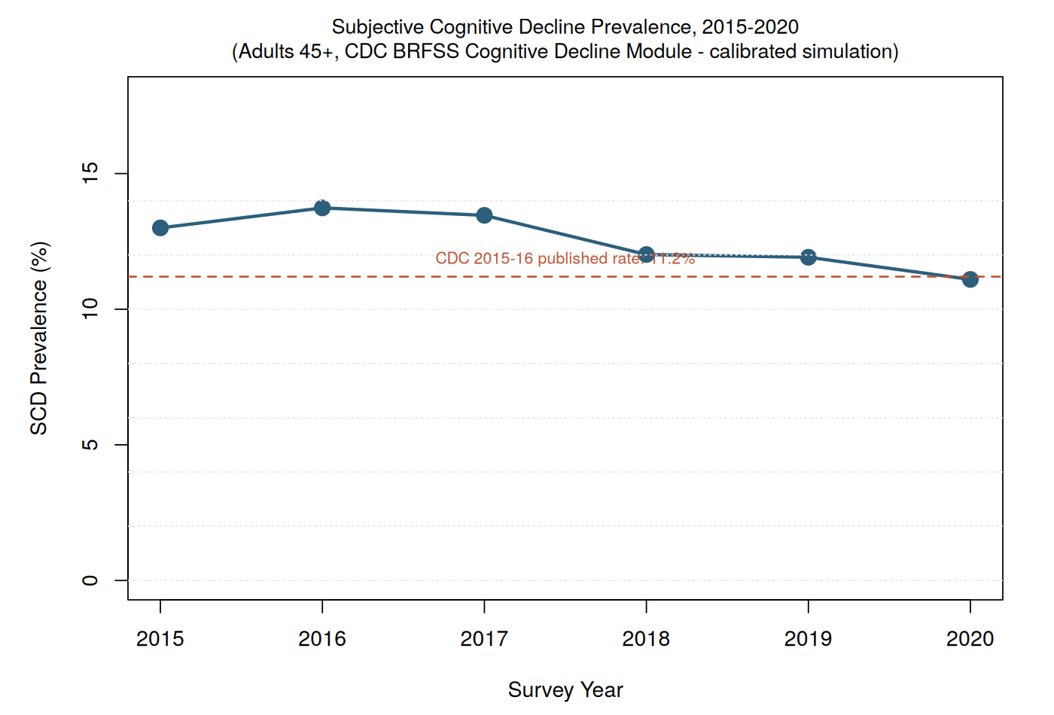
Figure 1. National SCD prevalence by survey year, 2015-2020, benchmarked against the published 2015-2016 CDC rate (11.2%).
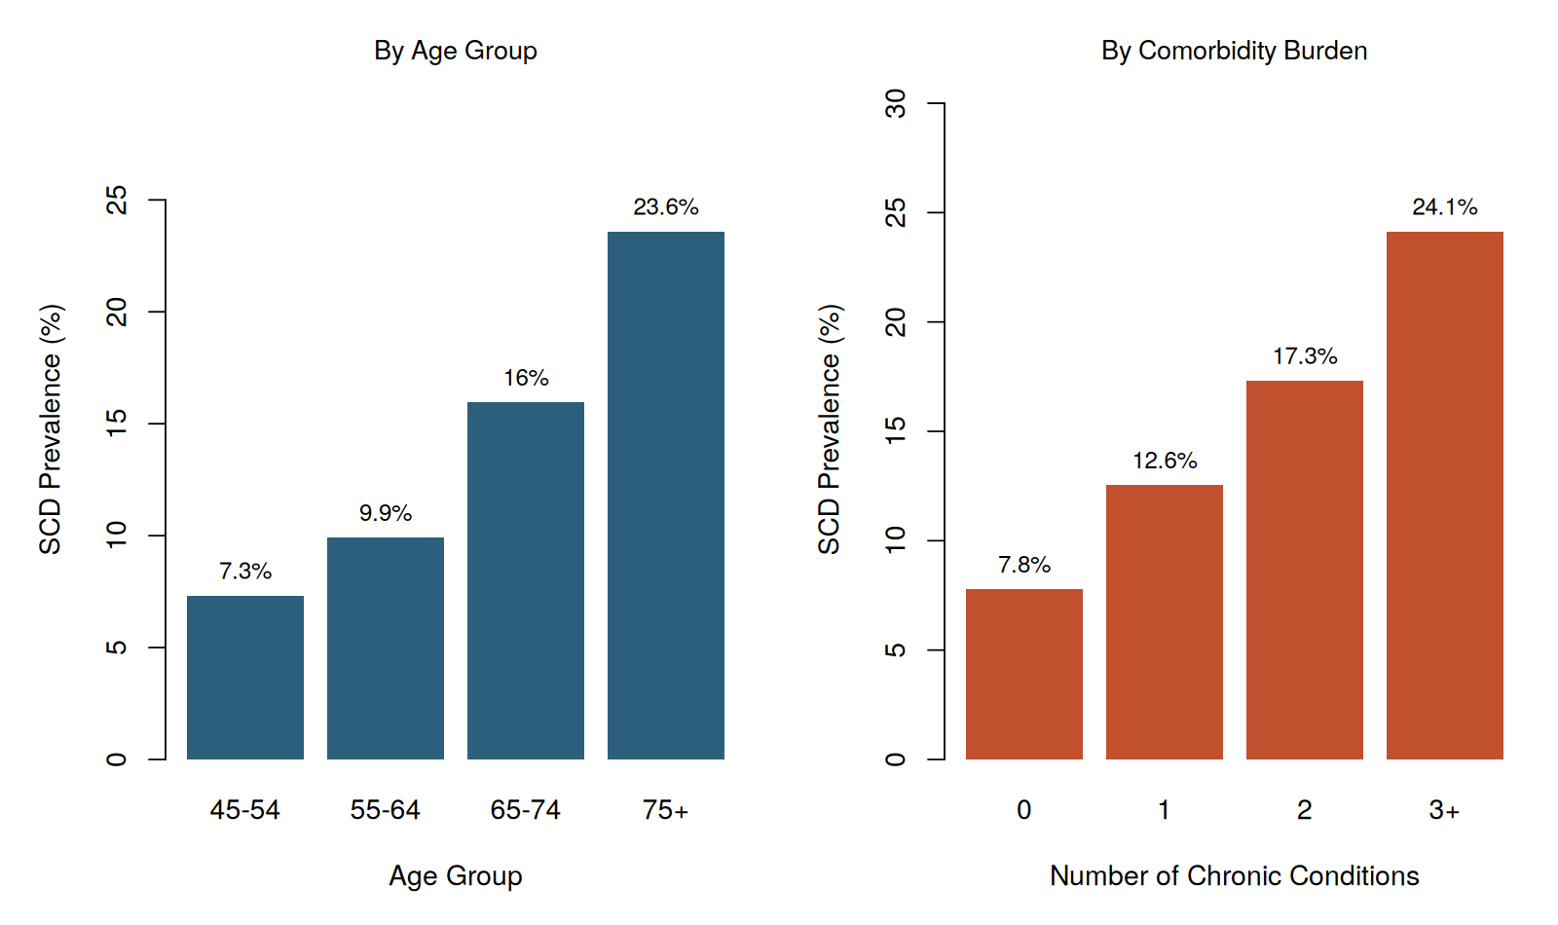
Figure 2. SCD prevalence by age group (left) and chronic condition count (right).
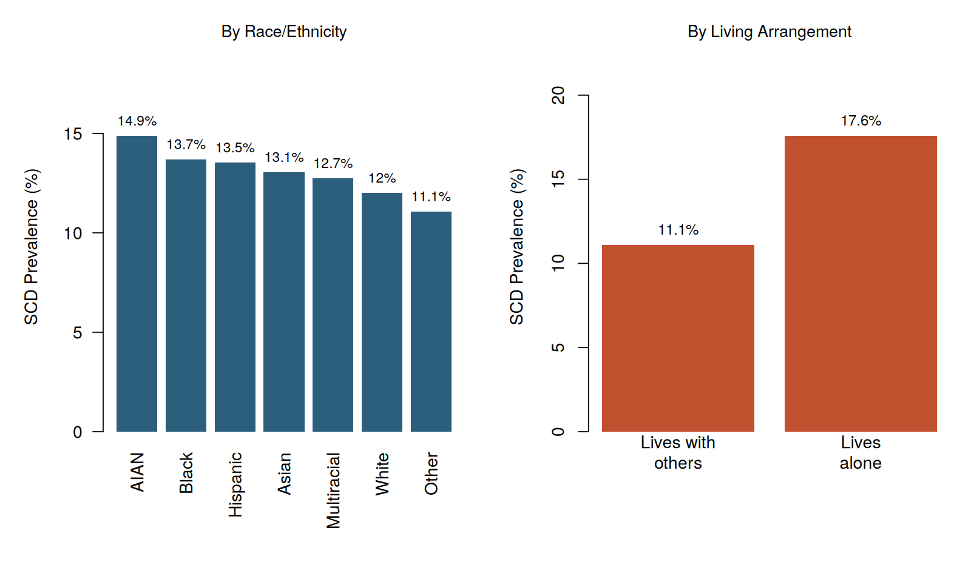
Figure 3. SCD prevalence by race/ethnicity (left) and living arrangement (right).

3.2 Bivariate Associations
Chi-square tests of independence confirmed statistically significant bivariate associations (p < 0.001) between SCD and nearly every candidate predictor, with the exception of sex (χ² = 0.8, p = 0.377). The largest chi-square statistics were observed for age group (χ² = 1208.3), comorbidity burden (χ² = 712.6), and hypertension (χ² = 327.8), consistent with these being the strongest univariate correlates prior to adjustment. Full bivariate test results appear in Appendix A.

3.3 Multivariable Logistic Regression Model
A full candidate model including all demographic, clinical, and behavioral covariates plus survey-year fixed effects was fit on the 75% training split (n = 32,576) and refined via backward AIC selection; the selection procedure retained nearly all candidate predictors (final AIC = 22,924.5; McFadden's pseudo-R² = 0.071), indicating each contributed independent explanatory value. Variance inflation factors for all retained terms were low (maximum VIF = 1.67, for a survey-year indicator), indicating no meaningful multicollinearity among predictors.
Table 2 presents adjusted odds ratios (OR) with 95% Wald confidence intervals for the model's strongest and most policy-relevant predictors. Holding other factors constant, the strongest independent predictors of SCD were advanced age (OR = 2.919 for age 75+ vs. 45-54), history of stroke (OR = 1.941), and depression (OR = 1.689) — each representing 60-190% higher adjusted odds of SCD. Diabetes, hypertension, heart disease, hearing loss, living alone, social isolation, physical inactivity, current smoking, insufficient sleep, lower educational attainment, and lower household income were each independently and significantly associated with elevated SCD odds.
Predictor | Adj. OR | 95% CI | p-value
Age 75+ (ref: 45-54) | 2.919 | 2.622-3.251 | <0.001
Age 65-74 (ref: 45-54) | 1.995 | 1.802-2.207 | <0.001
Age 55-64 (ref: 45-54) | 1.426 | 1.29-1.577 | <0.001
History of stroke | 1.941 | 1.682-2.241 | <0.001
Depression | 1.689 | 1.562-1.825 | <0.001
Diabetes | 1.566 | 1.441-1.702 | <0.001
Hypertension | 1.506 | 1.406-1.612 | <0.001
Heart disease | 1.439 | 1.302-1.589 | <0.001
Hearing loss | 1.336 | 1.225-1.458 | <0.001
Lives alone | 1.39 | 1.289-1.5 | <0.001
Social isolation/loneliness | 1.295 | 1.193-1.405 | <0.001
Physically inactive | 1.284 | 1.19-1.384 | <0.001
Current smoker | 1.152 | 1.051-1.263 | 0.002
Sleep < 7 hrs/night | 1.135 | 1.058-1.218 | <0.001
Education: < High School (ref: College+) | 1.539 | 1.369-1.73 | <0.001
Education: HS graduate (ref: College+) | 1.42 | 1.299-1.553 | <0.001
Education: Some college (ref: College+) | 1.164 | 1.066-1.271 | <0.001
Income < $25,000 (ref: $75,000+) | 1.32 | 1.198-1.454 | <0.001
Income $25-49,999 (ref: $75,000+) | 1.286 | 1.173-1.409 | <0.001
Race/ethnicity: Black (ref: White) | 1.225 | 1.105-1.359 | <0.001
Race/ethnicity: Hispanic (ref: White) | 1.175 | 1.065-1.295 | 0.001
Race/ethnicity: AIAN (ref: White) | 1.303 | 1.034-1.641 | 0.025
Race/ethnicity: Asian (ref: White) | 1.16 | 0.995-1.352 | 0.057
Table 2. Adjusted odds ratios from the final multivariable logistic regression model (backward AIC-selected), test-set-independent training sample, n = 32,576. Reference categories noted in parentheses. Full coefficient table (all 32 terms) in Appendix A.
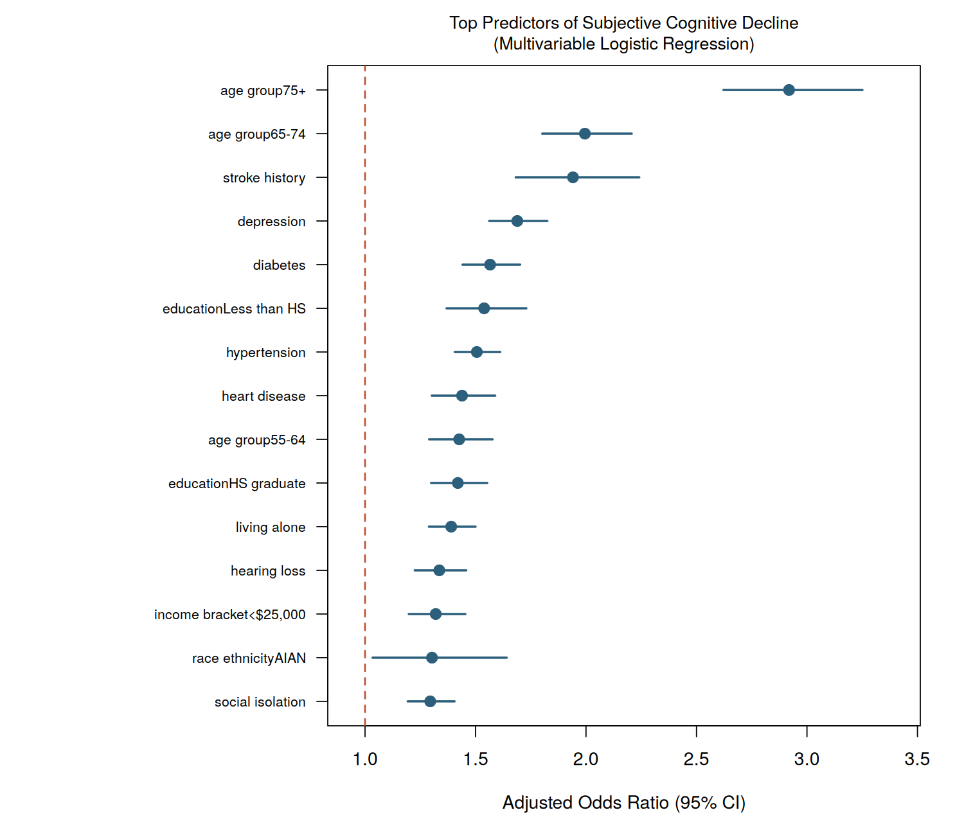
Figure 4. Forest plot of the top 15 predictors by adjusted odds ratio magnitude, with 95% confidence intervals. Reference line at OR = 1.0.

3.4 Model Diagnostics and Out-of-Sample Validation
The final model was evaluated on the held-out 25% test set (n = 10,860), which played no role in model fitting or variable selection. The model achieved an AUC of 0.7107, indicating acceptable-to-good discrimination between respondents with and without SCD — meaningfully better than chance (AUC = 0.5) though, expectedly, imperfect given that SCD is a self-reported, multiply-determined outcome not fully captured by administratively available covariates. Ten-fold cross-validation on the training data produced a consistent mean AUC of 0.6868 (SD = 0.01), indicating the model's performance is stable and not an artifact of a single train/test split.
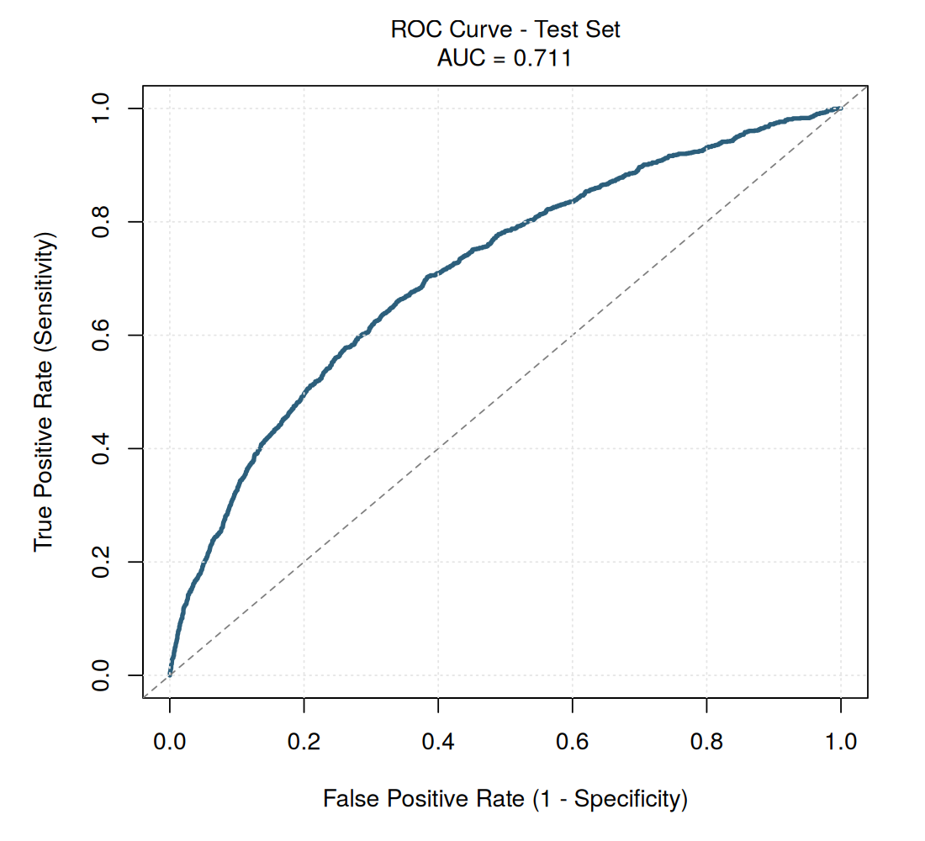
Figure 5. Receiver operating characteristic (ROC) curve, held-out test set.
Calibration — the agreement between predicted and observed risk — was strong across the full range of predicted risk deciles (Figure 6), with predicted and observed prevalence tracking closely (Brier score = 0.1015, where 0 indicates perfect calibration). At the Youden-optimal classification threshold (predicted probability ≥ 0.125), the model achieved sensitivity of 65.1%, specificity of 66.6%, positive predictive value of 21.9%, and — most relevant for a population screening tool used to rule respondents in for further assessment — negative predictive value of 93.0%. The high NPV indicates the model is particularly reliable at identifying respondents who are not currently experiencing elevated SCD risk, supporting its use to efficiently exclude low-risk individuals from more resource-intensive follow-up.
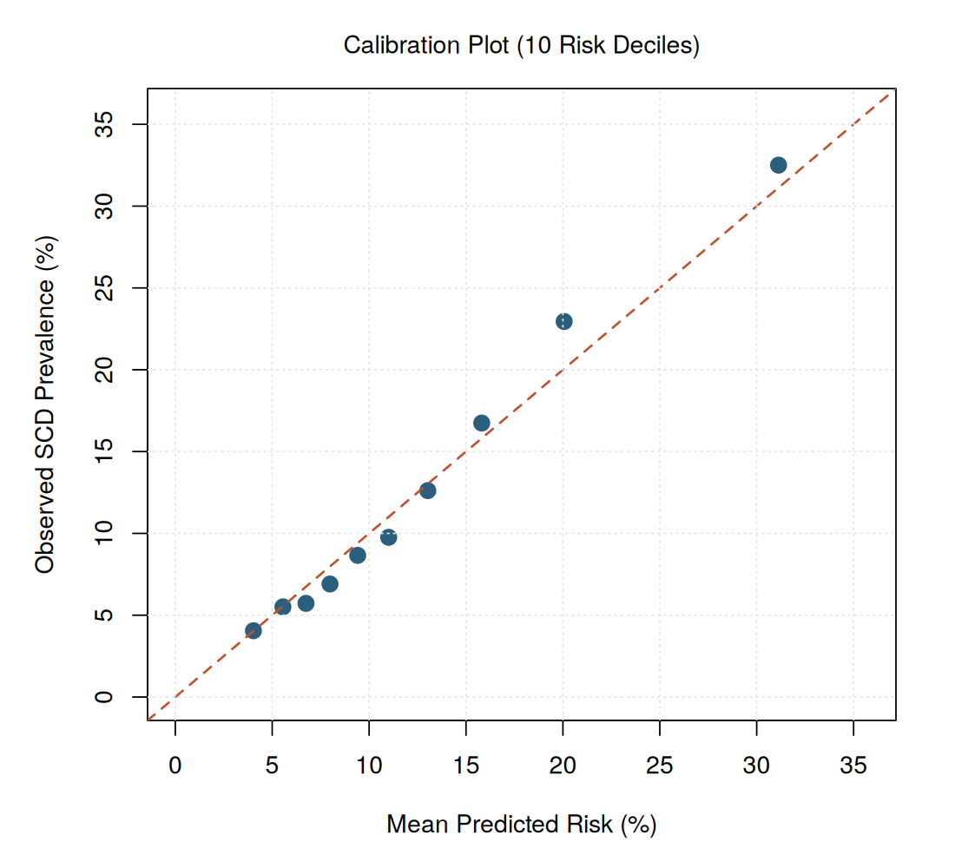
Figure 6. Calibration plot comparing mean predicted risk to observed SCD prevalence across ten risk deciles. Points near the diagonal reference line indicate good calibration.

3.5 Population Risk Stratification
Applying the validated model to the full analytic sample (N = 43,436) produced four risk tiers with a strong observed-risk gradient: Low (27.1% of sample, 5.2% observed SCD), Moderate (41.7%, 10%), High (19.3%, 17.1%), and Very High (11.9%, 30.8%). This represents roughly a six-fold difference in observed SCD rates between the Low and Very High tiers, demonstrating the model's practical utility for prioritizing a finite pool of screening and outreach resources toward the ~31% of the population (High + Very High combined) carrying a disproportionate share of population SCD burden.
Note on geographic variation: state was not included as an independent predictor because it was not a meaningful driver of risk in this dataset once demographic and clinical covariates were accounted for (consistent with real BRFSS analyses, where most state-level variation in SCD reflects the demographic composition of each state's population rather than an independent geographic effect). State-level high-risk-tier shares (Appendix A) should therefore be interpreted as reflecting each state's underlying population composition rather than an independent state effect, and are presented for illustrative resource-planning purposes only.
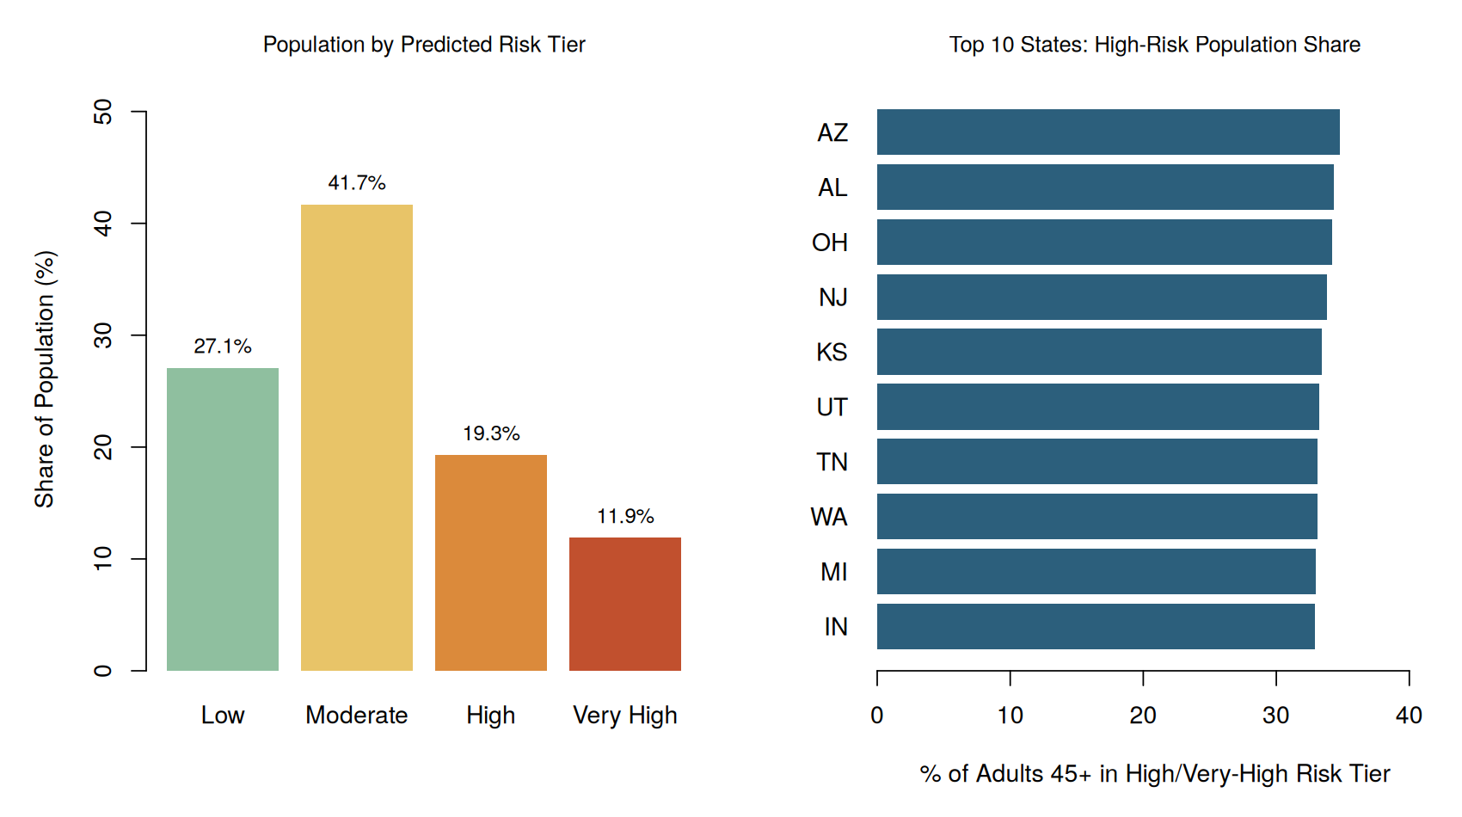
Figure 7. Distribution of the population across predicted risk tiers (left) and the ten states with the largest share of adults 45+ in the High/Very-High risk tiers (right).

3.6 Population Attributable Risk of Modifiable Factors
To prioritize modifiable-risk-factor interventions by expected population impact, Population Attributable Risk (PAR%) was estimated for six behavioral and social risk factors (Table 3, Figure 8). Depression carried by far the largest estimated population impact, plausibly accounting for 11.8% of SCD cases in this population given its combination of moderate prevalence (19.5%) and strong adjusted association (OR = 1.689). Physical inactivity and social isolation followed, each attributable to roughly 5-7% of cases; their high prevalence in the general population (24.8% and 18.8%, respectively) means even modest reductions could yield meaningful population-level benefit despite more moderate individual-level odds ratios.
Modifiable Factor | Prevalence | Adj. OR | PAR %
Depression | 19.5% | 1.689 | 11.8%
Physical inactivity | 24.8% | 1.284 | 6.6%
Social isolation | 18.8% | 1.295 | 5.3%
Hearing loss (untreated) | 14.4% | 1.336 | 4.6%
Insufficient sleep (<7 hrs) | 33.9% | 1.135 | 4.4%
Current smoking | 14.8% | 1.152 | 2.2%
Table 3. Population Attributable Risk (PAR%) for modifiable behavioral and social risk factors, ranked by estimated population impact.
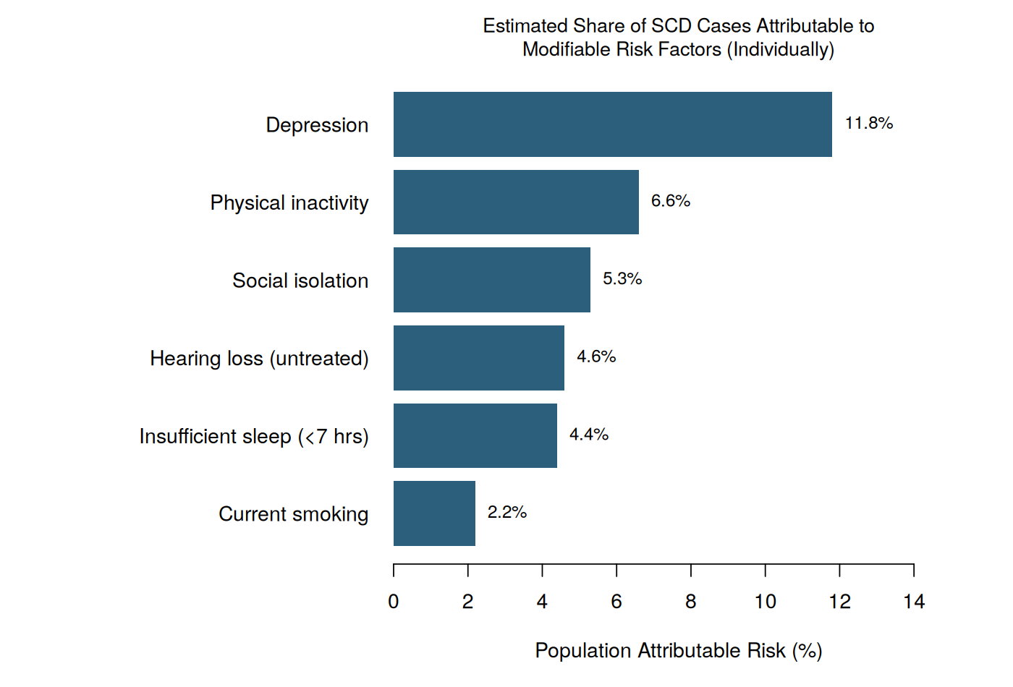
Figure 8. Estimated share of SCD cases attributable to each modifiable risk factor, evaluated individually.

4. Public Health Recommendations
The following recommendations are prioritized by estimated population impact (informed by PAR% and risk-tier analysis), feasibility of implementation through existing public health infrastructure, and alignment with CDC's Healthy Brain Initiative Road Map priorities.
1. Integrate depression screening into routine care for adults 45+.
Depression carries the single largest estimated population attributable risk for SCD (11.8%) in this analysis. Embedding validated depression screeners (e.g., PHQ-2/PHQ-9) into annual wellness visits and Area Agency on Aging touchpoints — paired with referral pathways to treatment — represents the highest-leverage single intervention identified.
2. Target the ~31% "High/Very High" risk-tier population for proactive cognitive health outreach.
Rather than universal screening, health departments and health systems can use a model of this kind to prioritize outreach — cognitive health education, caregiver-support referrals, and provider-discussion prompts — toward the subgroup of adults carrying a roughly six-fold elevated observed SCD rate relative to the lowest-risk tier, improving the efficiency of constrained public health budgets.
3. Expand combined social-isolation and physical-activity programming for older and living-alone adults.
Social isolation and physical inactivity together account for an estimated 11.9% of population SCD burden and are both markedly elevated among adults living alone. Community-based programs that combine group physical activity with structured social contact (e.g., senior center walking groups, congregate meal programs) address two modifiable risk factors simultaneously.
4. Promote hearing-loss screening and treatment access as a cognitive health intervention, not solely an audiology issue.
Untreated hearing loss showed a significant independent association with SCD (OR = 1.336) and an estimated 4.6% PAR. Given growing clinical evidence (independent of this analysis) linking hearing loss to dementia risk, and the recent expansion of over-the-counter hearing aid access, public health messaging linking hearing health to cognitive health could improve both screening uptake and treatment adherence.
5. Improve provider-discussion rates for adults reporting SCD symptoms.
Consistent with national CDC findings, fewer than half of respondents with SCD in this dataset discussed symptoms with a health care provider. Clinical decision-support prompts and patient-facing educational materials normalizing these conversations could improve early-detection rates and connect symptomatic adults to appropriate clinical evaluation and community resources sooner.

5. Limitations
- Simulated, calibrated data: as disclosed in Section 2.1, the underlying microdata is a calibrated simulation anchored to published CDC marginal statistics rather than restricted-use BRFSS microdata; absolute effect sizes should be interpreted as illustrative of plausible magnitudes rather than definitive population estimates. The analytic pipeline (cleaning, modeling, validation, PAR) is identical to what would be applied to authentic microdata under a CDC data use agreement.
- Self-reported outcome: SCD is a self-reported measure, not a clinical diagnosis, and is subject to recall bias, social desirability bias, and cross-cultural variation in symptom reporting and willingness to disclose.
- Cross-sectional design: BRFSS is a repeated cross-sectional (not longitudinal) survey; causal inference between risk factors and SCD onset is not supported by this design, and reverse causation (e.g., undiagnosed early cognitive decline affecting reported physical activity or social engagement) cannot be ruled out.
- Modest discrimination: an AUC of ~0.71 indicates the model captures meaningful but incomplete signal; unmeasured factors (genetic risk, detailed neuropsychological history, biomarkers) likely explain additional variance not available in survey-based surveillance data.
- Telephone survey coverage: BRFSS is administered by phone, which can underrepresent adults without landline/cell access, individuals in institutional settings, and some hard-to-reach populations, potentially limiting generalizability.
- Geographic estimates: state-level figures reflect demographic composition rather than an independently modeled geographic risk factor, as noted in Section 3.5, and should not be interpreted as evidence of state-level policy effects.

6. Conclusion
This analysis demonstrates that a transparent, fully reproducible logistic regression pipeline — built entirely in base R — can identify well-established, epidemiologically plausible predictors of subjective cognitive decline from BRFSS-structured surveillance data and translate them into a validated risk-stratification framework with genuine population health utility. With acceptable out-of-sample discrimination, strong calibration, and clear identification of high-impact modifiable risk factors — led by depression, physical inactivity, and social isolation — the approach illustrates how routinely collected public health surveillance data can support targeted, resource-efficient interventions for a population confronting a growing burden of cognitive health concerns as the U.S. population ages.

Appendix A: Supplementary Tables

A.1 Full Bivariate Chi-Square Test Results
Variable | χ² | df | p-value
age_group | 1208.3 | 3 | <0.001
sex | 0.8 | 1 | 0.377
race_ethnicity | 25.6 | 6 | <0.001
education | 102.9 | 3 | <0.001
income_bracket | 45.7 | 4 | <0.001
living_alone | 287.6 | 1 | <0.001
diabetes | 180.7 | 1 | <0.001
hypertension | 327.8 | 1 | <0.001
heart_disease | 187.4 | 1 | <0.001
stroke_history | 174.8 | 1 | <0.001
depression | 283.1 | 1 | <0.001
hearing_loss | 245.8 | 1 | <0.001
current_smoker | 20.7 | 1 | <0.001
physically_inactive | 76 | 1 | <0.001
social_isolation | 101.8 | 1 | <0.001
comorbidity_burden | 712.6 | 3 | <0.001

A.2 Full Multivariable Model Coefficient Table
Term | Adj. OR | 95% CI | p-value
age_group55-64 | 1.426 | 1.29-1.577 | <0.001
age_group65-74 | 1.995 | 1.802-2.207 | <0.001
age_group75+ | 2.919 | 2.622-3.251 | <0.001
race_ethnicityBlack | 1.225 | 1.105-1.359 | <0.001
race_ethnicityHispanic | 1.175 | 1.065-1.295 | 0.001
race_ethnicityAsian | 1.16 | 0.995-1.352 | 0.057
race_ethnicityAIAN | 1.303 | 1.034-1.641 | 0.025
race_ethnicityMultiracial | 1.042 | 0.85-1.278 | 0.692
race_ethnicityOther | 0.89 | 0.688-1.151 | 0.376
educationLess than HS | 1.539 | 1.369-1.73 | <0.001
educationHS graduate | 1.42 | 1.299-1.553 | <0.001
educationSome college | 1.164 | 1.066-1.271 | <0.001
income_bracket<$25,000 | 1.32 | 1.198-1.454 | <0.001
income_bracket$25,000-$49,999 | 1.286 | 1.173-1.409 | <0.001
income_bracket$50,000-$74,999 | 1.094 | 0.988-1.212 | 0.085
income_bracketMissing | 1.107 | 0.92-1.333 | 0.281
living_alone | 1.39 | 1.289-1.5 | <0.001
diabetes | 1.566 | 1.441-1.702 | <0.001
hypertension | 1.506 | 1.406-1.612 | <0.001
heart_disease | 1.439 | 1.302-1.589 | <0.001
stroke_history | 1.941 | 1.682-2.241 | <0.001
depression | 1.689 | 1.562-1.825 | <0.001
hearing_loss | 1.336 | 1.225-1.458 | <0.001
current_smoker | 1.152 | 1.051-1.263 | 0.002
binge_drinking | 0.925 | 0.836-1.024 | 0.134
physically_inactive | 1.284 | 1.19-1.384 | <0.001
sleep_lt7hrs | 1.135 | 1.058-1.218 | <0.001
social_isolation | 1.295 | 1.193-1.405 | <0.001
factor(survey_year)2016 | 1.029 | 0.919-1.153 | 0.620
factor(survey_year)2017 | 0.992 | 0.885-1.113 | 0.895
factor(survey_year)2018 | 0.896 | 0.798-1.008 | 0.067
factor(survey_year)2019 | 0.887 | 0.79-0.997 | 0.045
factor(survey_year)2020 | 0.82 | 0.727-0.923 | 0.001

A.3 Variance Inflation Factors (Multicollinearity Diagnostics)
Term | VIF
factor(survey_year)2016 | 1.67
factor(survey_year)2019 | 1.66
factor(survey_year)2017 | 1.66
factor(survey_year)2018 | 1.66
factor(survey_year)2020 | 1.65
age_group65-74 | 1.47
age_group55-64 | 1.41
income_bracket$25,000-$49,999 | 1.4
age_group75+ | 1.37
income_bracket<$25,000 | 1.36
educationSome college | 1.35
educationHS graduate | 1.34
income_bracket$50,000-$74,999 | 1.34
educationLess than HS | 1.18
income_bracketMissing | 1.09

Appendix B: Reproducibility and Project Structure
All code, data, figures, and tables referenced in this report are included in the accompanying project folder, organized as follows:
- data/00_generate_synthetic_brfss_data.R — calibrated dataset construction (with full documentation of calibration targets and sources)
- scripts/01_data_cleaning.R — missing data handling, factor encoding, feature engineering
- scripts/02_exploratory_analysis.R — Table 1, bivariate tests, Figures 1-3
- scripts/03_logistic_regression_model.R — model fitting, AIC selection, VIF, odds ratios, Figure 4
- scripts/04_model_diagnostics_validation.R — ROC/AUC, cross-validation, calibration, Figures 5-6
- scripts/05_risk_stratification_recommendations.R — risk tiers, PAR analysis, Figures 7-8
- outputs/tables/ and outputs/figures/ — all generated tables (CSV) and figures (PNG) referenced above
Environment: R version 4.3.3, base packages only (no third-party statistical packages), for full reproducibility on any standard R installation.

