Question1:
A Database management system is a computerized record-keeping system. It is a repository or a container for collection of computerized data files. The overall purpose of DBMS is to allow he users to define, store, retrieve and update the information contained in the database on demand. Information can be anything that is of significance to an individual or organization.
- Database is used to store students’ details in a place
- Easy Query processing and management
- Easy to understand and user friendly
- Store Students marks evaluation details
- Store Employee details.
- Store final year project Submission.
- Easy to implement Security and integrity of data
- Fast access of information
- Data sharing in other department of IGNOU.
- Better data accuracy
Question 2:
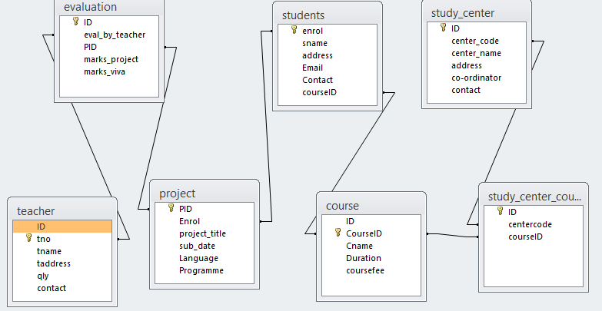
Question3.

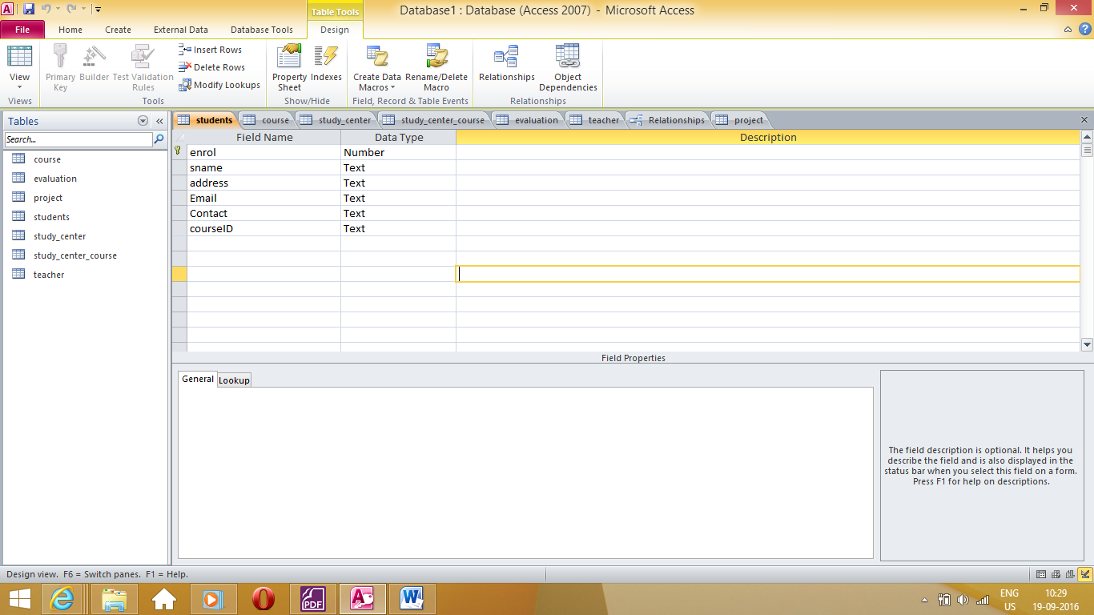

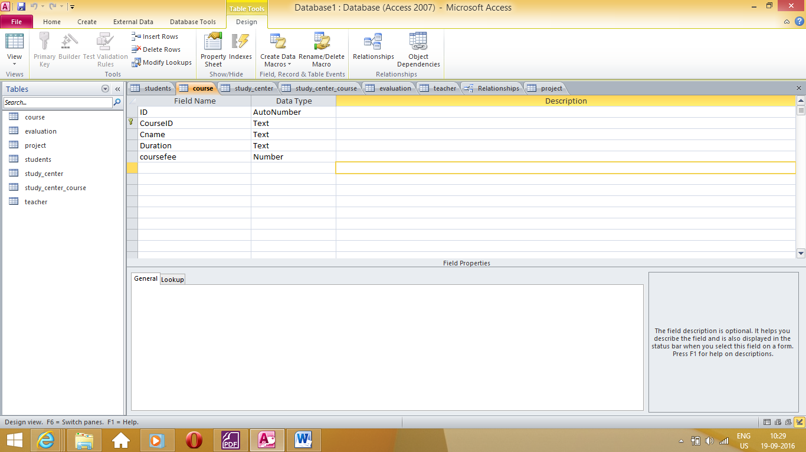

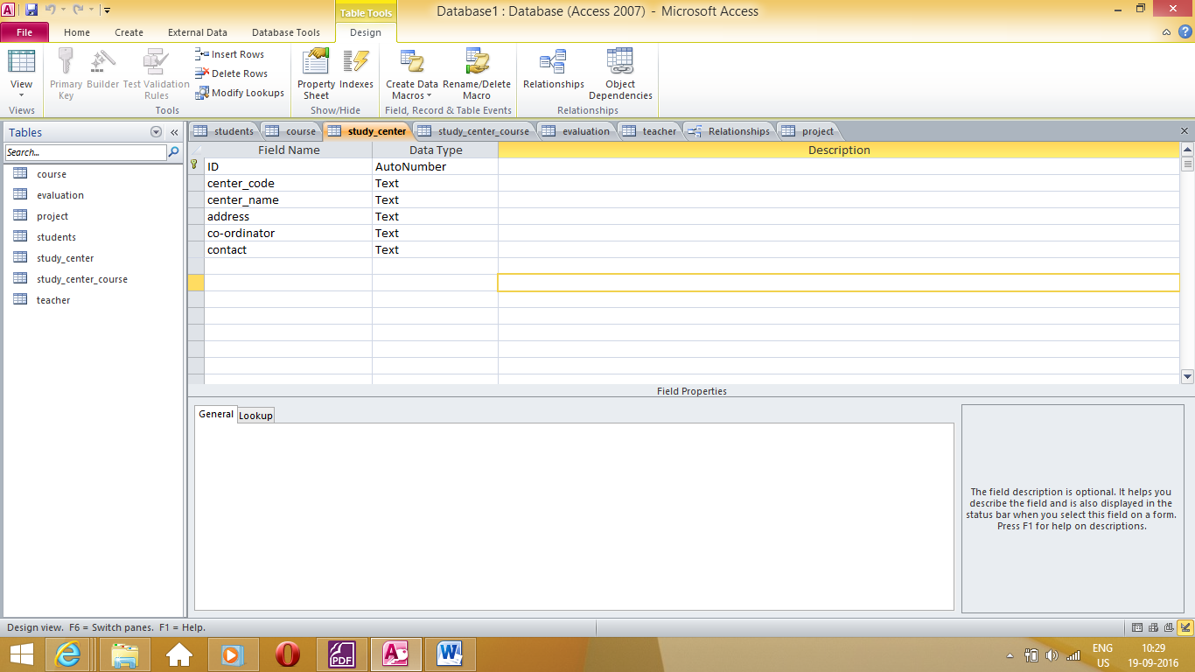

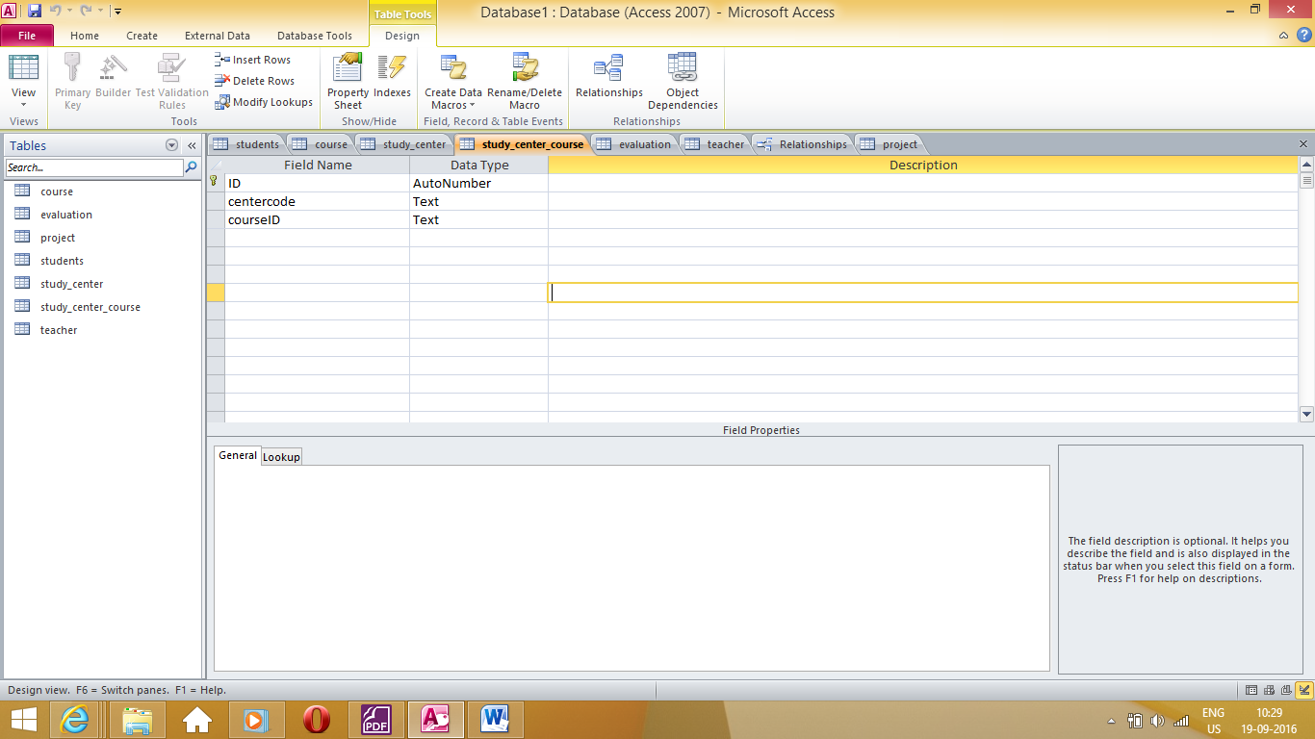

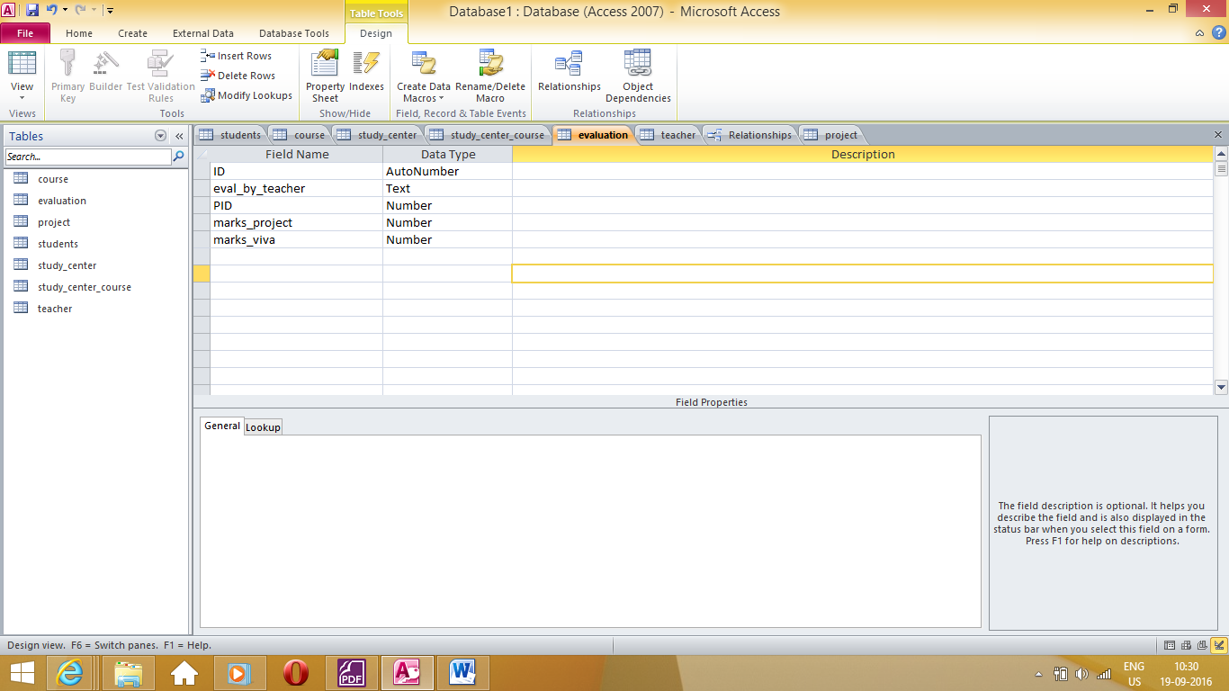

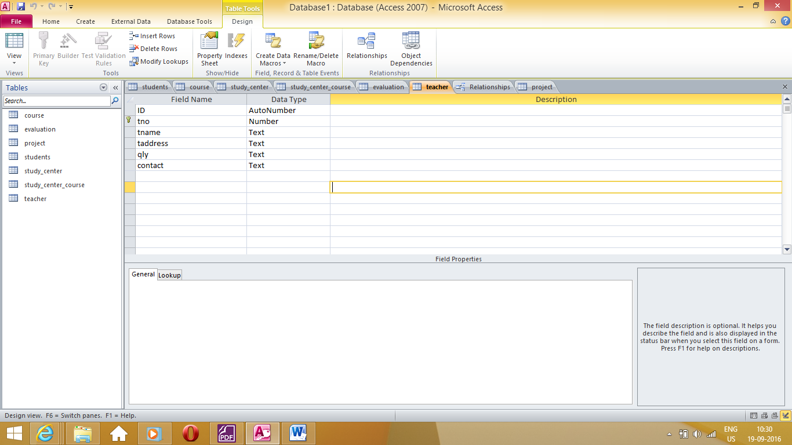

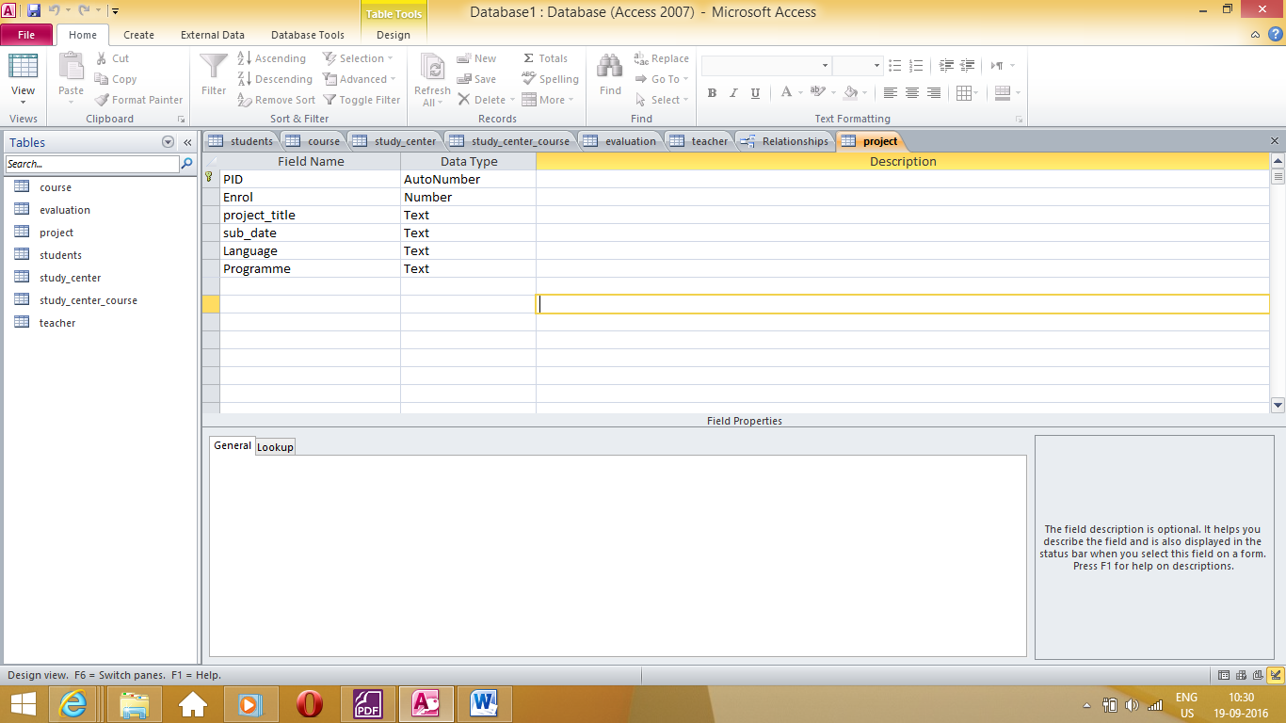
Question 4:
Find the m_id and m_name of the members who have got maximum number of un_returned books.
- Select m_id,m_name from members, from issue_return where member.mid=issue_return.mid and issue_return.actual_date_of_return=””;
- Select * from book where year_of_copyright=2014;
- Select isbn_no, book_title, author1, accession_no, isbn_no, m_id, expected_date_of_return from Book, Book_Accession, Issue_return where book.isbn_no=book_accession and book_accession.mid=issue_return.mid and book.auther1=”ABC”
- isbn_no, book_title, accession_no, isbn_no, date_of_purchase from book, Book_Accession where book.isbn_no= Book_Accession.isbn_no and date_of_purchase=2014

question5


