**Salesforce VIP Project Documentation**

## Project Title:

WhatNext Vision Motors: Shaping the Future of Mobility with Innovation and Excellence

## Project Overview

WhatNext Vision Motors, a pioneering force in the automotive industry, has undertaken a Salesforce CRM implementation to revolutionize its customer service and streamline operational efficiency. This end-to-end digital transformation focuses on automation, real-time data management, and seamless customer interaction. The system is designed to:

- Automatically assign the nearest dealer to the customer based on their geographic location

- Prevent the placement of orders for vehicles that are out of stock

- Trigger automated emails to remind customers of their scheduled test drives

- Periodically update order statuses through batch Apex jobs that check vehicle stock

The combination of low-code/no-code tools and custom Apex code ensures that the customer journey—from vehicle inquiry to order and delivery—is seamless and efficient. This initiative minimizes manual work, enhances communication clarity, and improves order accuracy across departments.

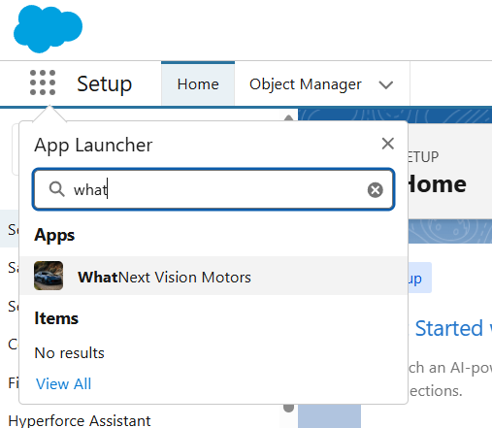

## Objectives

This project has the following key business and technical objectives:

- Enhance the customer experience using automated dealer suggestions

- Block invalid orders for unavailable vehicles to improve order reliability

- Automate backend workflows such as order assignment and test drive notifications

- Increase transparency and responsiveness with scheduled processes and status updates

- Reduce workload on staff and ensure faster response times with integrated systems

## Phase 1: Requirement Analysis & Planning

## Understanding Business Requirements

The vehicle order process was previously manual, resulting in delayed dealer coordination and order mismanagement. Key pain points identified:

- Delayed fulfillment due to manual dealer assignment

- Orders processed without verifying stock levels

- Test drive coordination done via email or phone

## Project Scope

To address these challenges, the system was designed to:

- Manage vehicle inventory, customer, and dealer records in one place

- Automate stock validation and dealer routing during order creation

- Notify customers about service bookings and test drives

## Data & Security Model

Custom objects were created to represent business entities:

- Vehicle__c – Vehicle inventory

- Vehicle_Order__c – Vehicle purchase requests

- Vehicle_Customer__c – Customer profiles

- Vehicle_Dealer__c – Authorized dealership information

- Vehicle_Test_Drive__c – Test drive scheduling

- Vehicle_Service_Request__c – Vehicle servicing requests

## Access control:

- Role hierarchy defines data access by position

- Permission sets for dashboard/report visibility

- Profiles control object and field-level security

## Phase 2: Salesforce Development & Automation

## Customizations & Configuration

- Validation Rule: Prevents creation of orders if the selected vehicle’s stock is zero

- Process Builder: Sends scheduled emails for upcoming test drives

- Record-Triggered Flows:

- Auto-assign the nearest dealer to each order

- Email the customer when a test drive is created

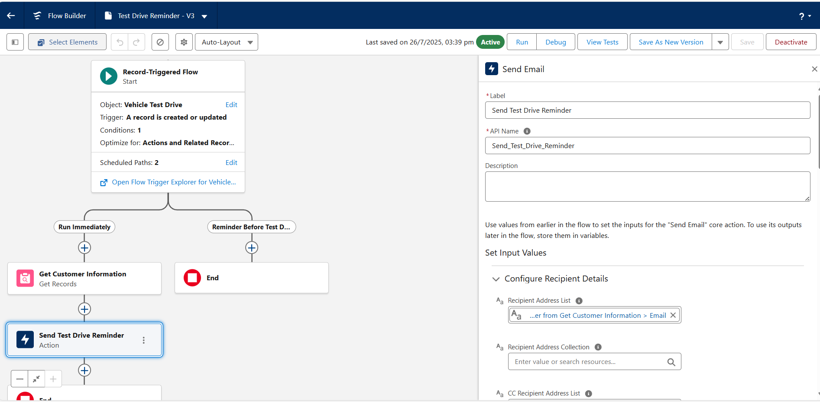

## Apex Triggers

- VehicleOrderTrigger calls a handler class to manage business logic

- VehicleOrderTriggerHandler validates stock before allowing an order

- Reduces vehicle stock by 1 upon confirmed order creation

- Organized using best practices (trigger handler pattern)

## Batch Jobs & Scheduling

- VehicleOrderBatch checks all pending orders, verifies stock, updates order statuses

- VehicleOrderBatchScheduler runs daily at 12 PM via cron expression

- Ensures updated stock and status are always accurate without human intervention

## Phase 3: UI/UX Development

## Lightning App

- App Name: WhatNext Vision Motors

- Branded app with icon, available in App Launcher

## Tabs Created

- Vehicle__c, Vehicle_Order__c, Vehicle_Customer__c, Vehicle_Dealer__c, Vehicle_Test_Drive__c, Vehicle_Service_Request__c

## Page Layouts & Forms

- Page layouts and compact layouts were created for all major custom objects including Vehicle, Vehicle Order, and Test Drive.

-The layout includes critical fields such as Status, Customer Name, Vehicle Model, and Delivery Date.

-Forms were structured to optimize agent workflow and user readability.

-Although dynamic field visibility was not used, forms are logically grouped and follow clean UI design.

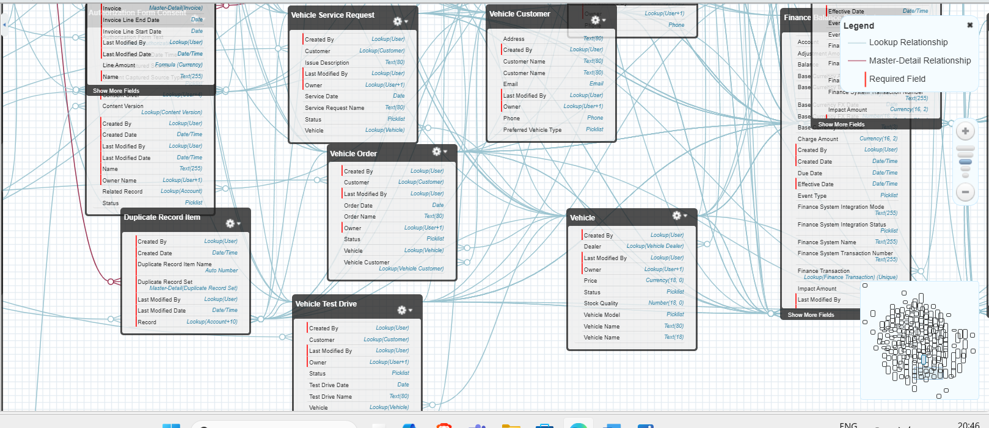

## Reports & Dashboards

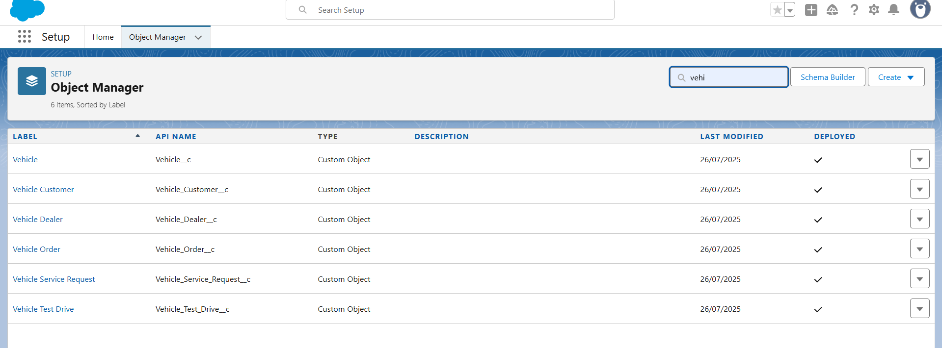

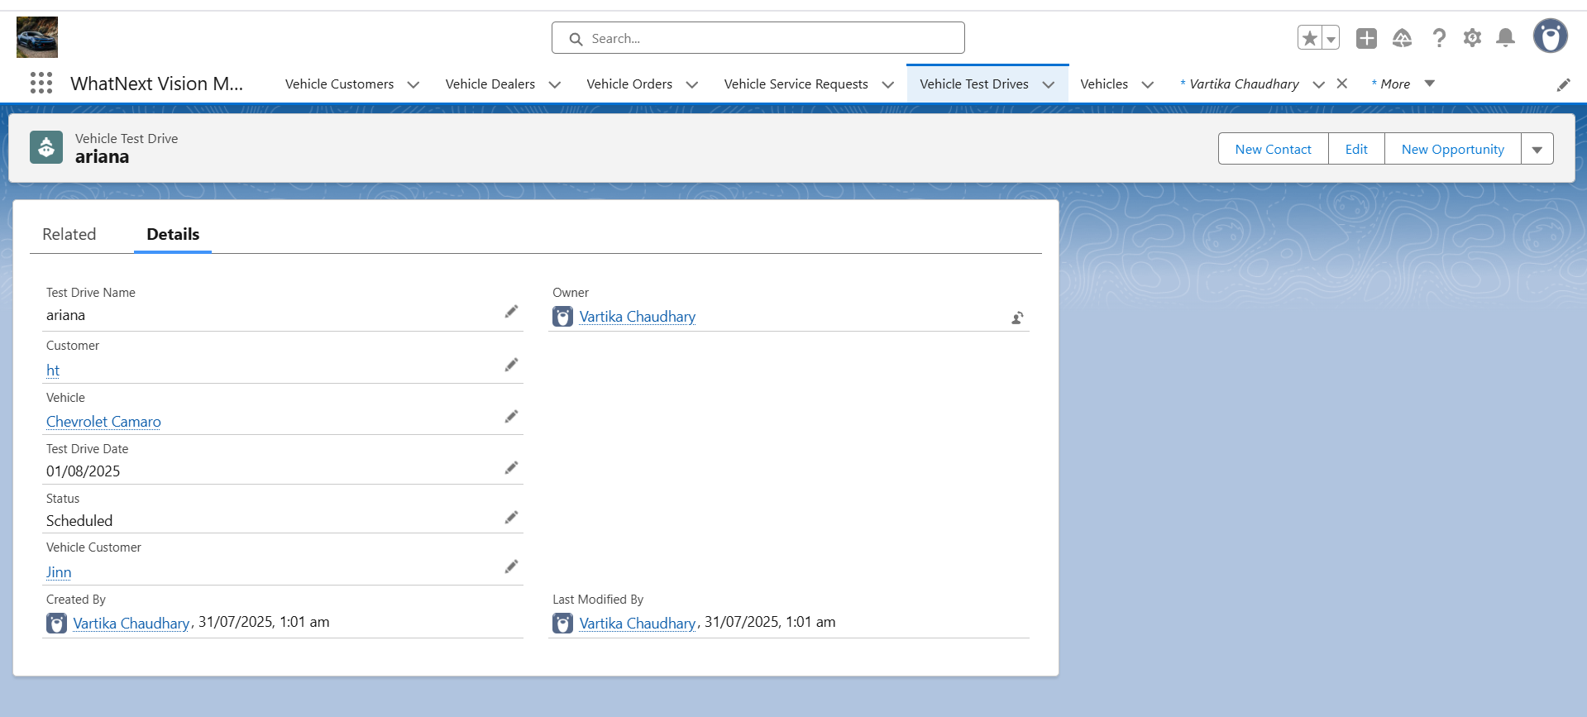

## Phase 4: Data Migration, Testing & Security

## Data Import

- Used Data Import Wizard for bulk upload of dealers and customers

- Used Data Loader for vehicle inventory and initial orders

## Field History Tracking

- Enabled on Vehicle__c and Vehicle_Order__c to track changes in key fields

- History reports available for audit and rollback checks

## Security Controls

- Profiles: Admin, Support, Dealer Manager

- Role Hierarchy: Regional segmentation

- Permission Sets: Temporary access for dashboards or developer use

## Testing

- Apex test classes for each trigger and batch job with 85%+ code coverage

- Functional testing done via record creation in UI

- Results captured from Developer Console

## 

## Phase 5: Deployment, Documentation & Maintenance

## Deployment Strategy

- Change Sets created to migrate components from Sandbox to Production

- Components: Objects, fields, Apex classes, Flows, Permission Sets

- Deployment validation logs confirm success

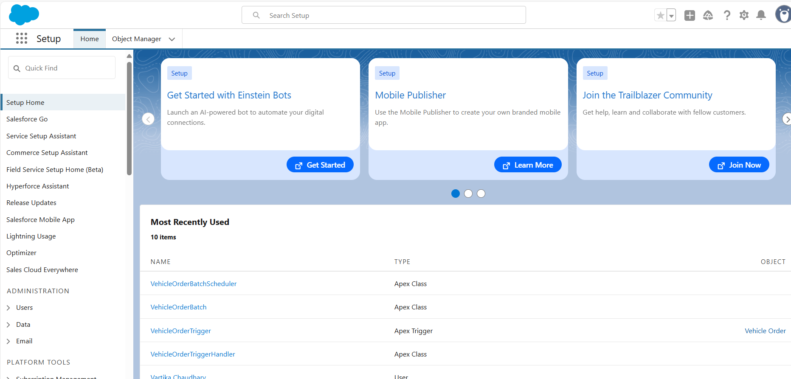

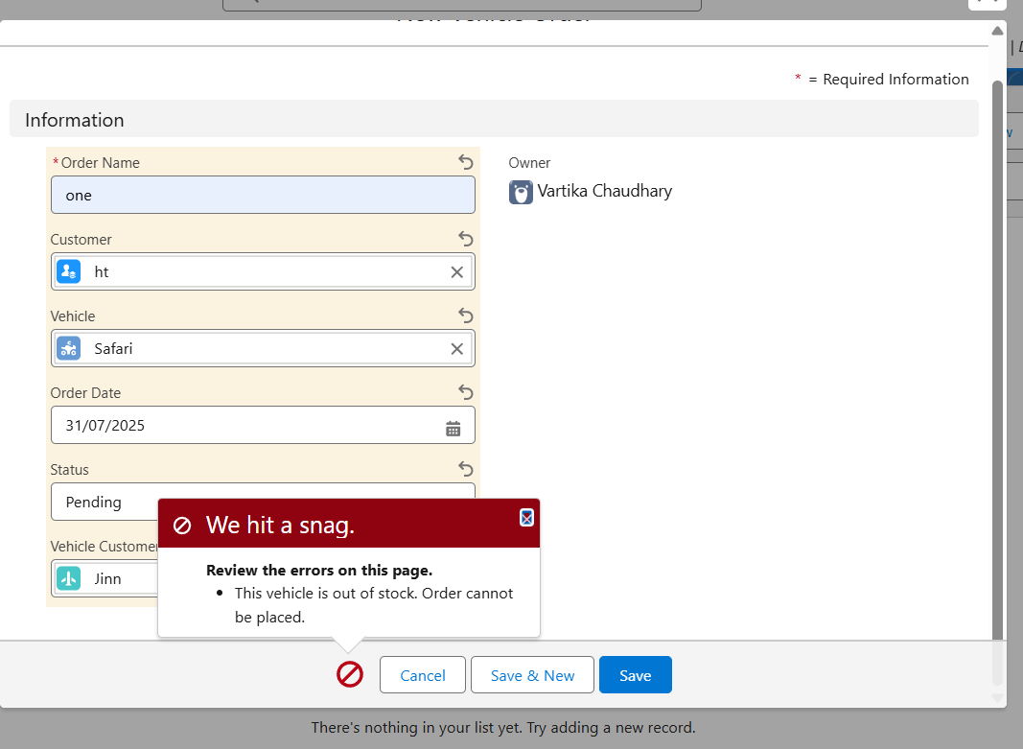

## Maintenance

- Setup > Scheduled Jobs reviewed weekly

- Debug Logs enabled to capture errors and scheduled job outcomes

## Conclusion

This Salesforce CRM project for WhatNext Vision Motors demonstrates how automation, data centralization, and intelligent Apex logic can reshape operational efficiency. With minimal manual input, the platform now ensures:

- Real-time vehicle stock validation

- Smart route of orders to nearby dealers

- Automated updates for order statuses

- Timely customer notifications via emails and reminders

The project is stable, production-ready, and delivering on its goals of customer satisfaction and business efficiency.

## Future Enhancements

- Enable SMS/WhatsApp notifications using third-party integrations

- Integrate AI-based dealer matching using Salesforce Einstein

- Expand to partner portals using Experience Cloud