**FA**

**Goian Tudor – 933/2**

<https://github.com/VaruTudor/Formal-Languages-and-Compiler-Design>

The Finite Automaton is structured as a class having:

self.Q = Q # a finite set of states

self.E = E # a finite set of input symbols called the alphabet

self.q0 = q0 # an initial or start state

self.F = F # a set of accept or final states

self.S = S # a set of state transitions represented as a HashMap

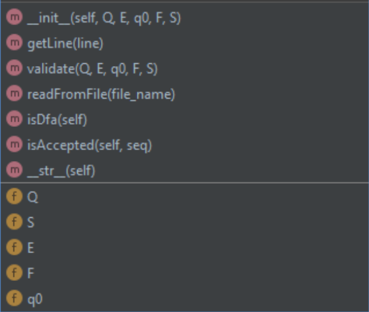

Checking DFA:

DFA refers to Deterministic Finite Automaton. A Finite Automata(FA) is said to be deterministic, if corresponding to an input symbol, there is single resultant state i.e., there is only one transition. This means going through the dictionary keys and checking if any list has more than one element.

def isDfa(self):  
 for k in self.S.keys():  
 if len(self.S[k]) > 1:  
 return False  
 return True

Checking accepted sequence:

Iterating through symbols from the sequence and checking if it can be reached by following the transitions. Also, it must end in a final state.

def isAccepted(self, sequence):  
 if self.isDfa():  
 current = self.q0  
 for symbol in sequence:   
 if (current, symbol) in self.S.keys():  
 current = self.S[(current, symbol)][0]  
 else:  
 return False  
 return current in self.F  
 return False