**Parser**

**Goian Tudor – 933/2**

<https://github.com/VaruTudor/Formal-Languages-and-Compiler-Design>

The Grammar has 5 fields:

N – non-terminals

E – terminals

P – productions

S – start symbol

isCFG – flag which checks is the grammar is context-free

For the production we use a dictionary, where for each key (symbol) there is a list of tuples (symbol, destination). Most methods are for file parsing except checkCFG(rules, N) which receives the rules and the set of non-terminals and getProductionsFor(nonTerminal) which receives a non-terminal symbol. Bellow there are some test examples.

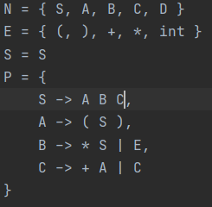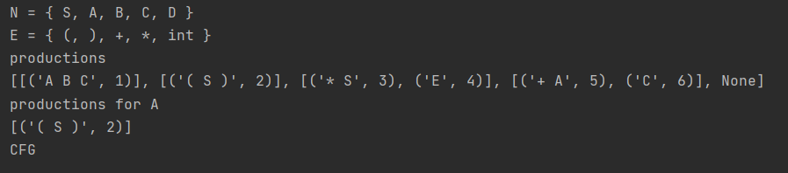

closure(itemList): *For each item in the item list, if after dot there is a non-terminal, add it to the list of items and repeat the process.* ***pseudocode:*** *repeat  
 for any [A -> α.Bβ] in C do  
 for any B -> γ in P do  
 if [B -> .γ] 2/ C then  
 C = C U [B -> .γ]  
 end if  
 end for  
 end for  
 until C stops changing* ***input:***

*itemList: a list of LR(0) items* ***:return****:*

*the resulting state*

goto(state, symbol): *For each LR0 item in the state move the dot if the symbol follows it. Perform closure on the modified item.* ***pseudocode:***

*goto(s, X) = closure({[A → αX.β]|[A → α.Xβ] ∈ s})* ***input:***

*state: the state to be checked* *symbol: the symbol to be checked*

***output:****closure of the updated items*

computeCanonicalCollection(): *For each state s in the canonical collection, for each symbol X (in both terminals and non-terminals), check if goto(s,X) result is not an empty list nor exists already in the canonical collection and if so add it to the canonical collection  
 pseudocode:  
 repeat  
 for any s in C do  
 for any X in N U ß do  
 if goto(s,X) != ∅ and goto(s,X) not in C then  
 C = C U goto(s,X)  
 end if  
 end for  
 end for  
 until C stops changing*

Bellow there is a test example computing the Canonical Collection for a grammar.