|  |  |  |  |  |
| --- | --- | --- | --- | --- |
| Vertices_covering | Edges | Vertex_degrees | V | Max_degree_vertex |
| 3 | (0,1),(1,2),...,(0,3) | 0:2, 1:3, 2:3,…,5:3 |  | 3 |
|  | -||- \ (3,0), (0,3) |  | 0 |  |
|  | -||- \ (3,1),(1,3) |  | 1 |  |
|  | -||- \ (3,2),(2,3) |  | 2 |  |
|  | -||- \ (3,4),(4,3) |  | 4 |  |
|  | -||- \ (3,5),(5,3) | -||- \ 3:5 | 5 |  |
| 1,3 | -||- \ (1,0),(0,1) |  | 0 | 1 |
|  | -||- \ (1,2),(2,1) |  | 2 |  |
|  |  | -||- \ 1:3 | 3 |  |
| 1,2,3 |  |  | 1 | 2 |
|  |  |  | 3 |  |
|  | -||- \ (2,5),(5,2) | -||- \ 2:3 | 5 |  |
| 1,2,3,5 |  |  | 2 | 5 |
|  |  |  | 3 |  |
|  | -||- \ (5,4),(4,5) | -||- \ 5:3 | 4 |  |

MANUAL EXECUTION

Not using aproximation alg.

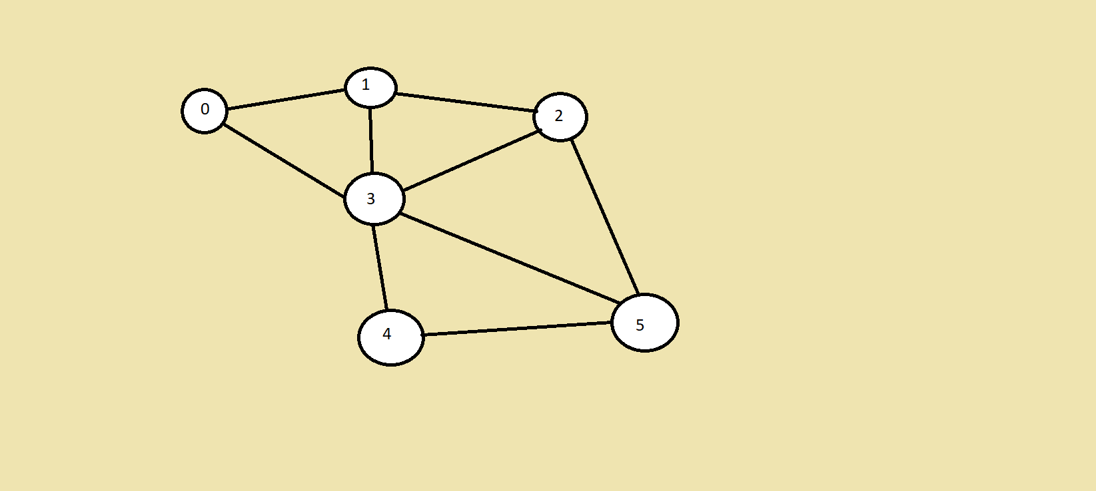

Using aproximation alg.

|  |  |  |  |  |
| --- | --- | --- | --- | --- |
| Vertices_covering | Edges | i | Edges[i] | Edge |
|  | (0,1),(1,2),...,(0,3) |  |  |  |
| 0,1 | -||- \ (0,1) | 0 | (0,1) | (0,1) |
|  | -||- \ (1,0) |  | (1,0) |  |
|  | -||- \ (0,3) |  | (0,3) |  |
|  | -||- \ (3,0) |  | (3,0) |  |
|  | -||- \ (1,2) |  | (1,2) |  |
|  | -||- \ (2,1) |  | (2,1) |  |
|  | -||- \ (1,3) |  | (1,3) |  |
|  | -||- \ (3,1) |  | (3,1) |  |
|  |  | 1..10 |  |  |
| 0,1,2,3 | -||- \ (2,3) | 0 | (2,3) | (2,3) |
|  | -||- \ (3,2) |  | (3,2) |  |
|  | -||- \ (2,5) |  | (2,5) |  |
|  | -||- \ (5,2) |  | (5,2) |  |
|  | -||- \ (3,4) |  | (3,4) |  |
|  | -||- \ (4,3) |  | (4,3) |  |
|  | -||- \ (3,5) |  | (3,5) |  |
|  | -||- \ (5,3) |  | (5,3) |  |
|  |  | 1..2 |  |  |
| 0,1,2,3,4,5 | -||- \ (4,5) | 0 | (4,5) | (4,5) |
|  | -||- \ (5,4) |  | (5,4) |  |



@Goian Tudor George