**Name: Akash Shivaji Varude**

**Roll No: 231110006**

**Assignment 2**

**Naming Conventions for this report:**

The program which does not contains any unknown variable : NoHoleProgram

The program which contains unknown variable : HoleProgram

1. **Implementation Details:**

I have Implemented this assignment on kachua version2. All test cases Programs are stored in kachuacore/tests folder

**Steps to run this assignment:**

**Step1**: Make Json files for both codes

To make Json file run following command (following is example to make json file for test program 'eqtest4')

*kachua.py -t 10 -se tests/eqtest4.tl -d{':x':5,':y':100} -c{':c1':1,':c2':1}*

Similarly, make json file for program cotaining unknown variables also

**Step2** : Make .kw file

Run following command on any empty .tl file.

*python kachua.py -O filename.tl*

This will generate optimized.kw file in kachuacore folder. I have copied it in chironframework/Submission folder and renamed it as eqtest.kw

**Step3** : Run symbSubmission.py file

first goto Submission folder and run following command

*symbSubmission.py eqtest.kw -e'["x", "y"]'*

By default symbSubmission.py reads *testData1.json* and *testData2.json* files. If you want to read different files then just change names of files in checkEq() function

1. **Example of expression given to z3 solver by checkeq() function:**

Hardcoded Example:

tmp="And(Implies(And(x<=42,Not(False)),And(m==x,o==x+c1+c2)),Implies(Not(x<=42),And(m==x,o==x+c2)))

s.addConstraint("And(Implies((And(x==5,y==100)),And("+tmp+",And(m==5,o==45))),Implies((And(x==43,y==100)),And("+tmp+",And(m==43,o==65))))")

1. **Programs and Outputs for testCases:**

eqtest5.tl eqtest6.tl

Output is:

Eqtest1.tl eqtest2.tl

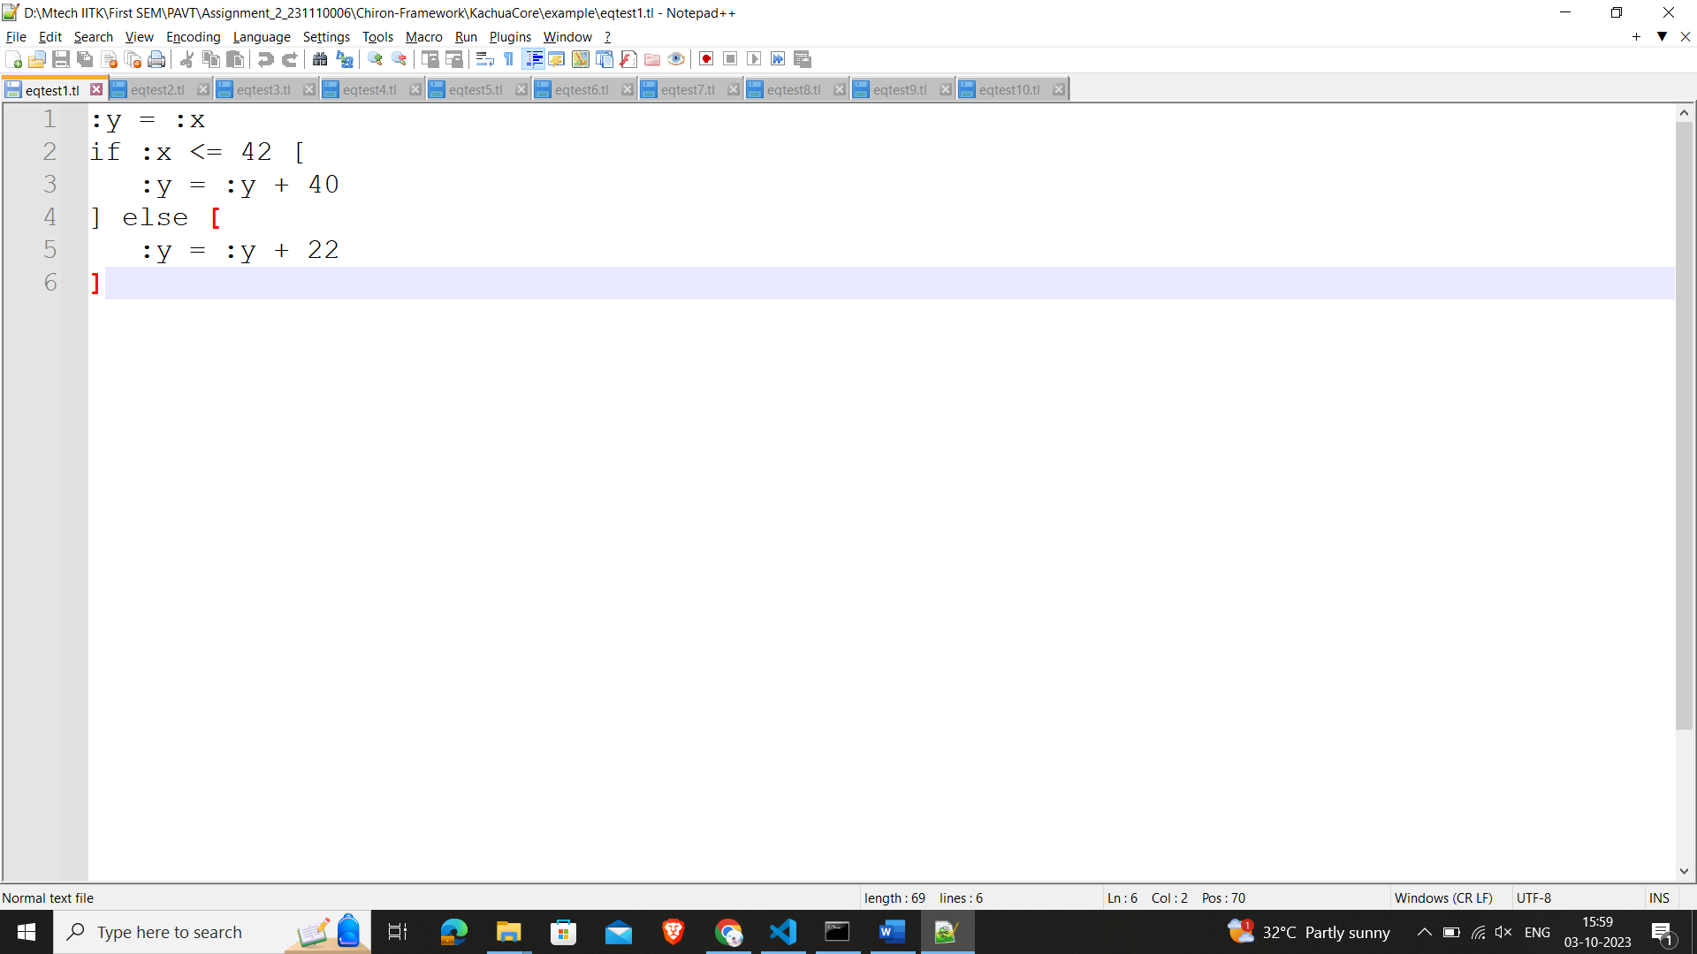

Output is:

Eqtest11.tl eqtest12.tl

Output is: