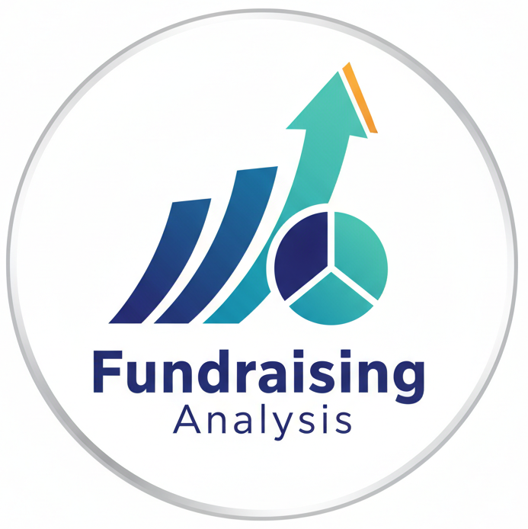

Project Report

Varun Prajapati
Github : Varun-2605/FundRaising_Analysis

Abstract
This report presents a detailed fundraising performance analysis using Power BI. The purpose of this dashboard is to evaluate donor contributions, campaign efficiency, and the impact of social media and media coverage on fundraising outcomes. The visualization provides insights into currency performance, category-wise donations, and top-performing countries. This analysis helps identify areas for strategic improvements in fundraising campaigns.

Table of Contents

- Executive Summary………………………… 2

- Problem Definition & Introduction ……….... 2

- Statistical Analysis …………………………. 3

- Data Visualization & Insights ……………… 3

- SWOT Analysis ……………………………. 4

6. Conclusions & Recommendations …………. 4

1. Executive Summary
The Fundraising Analysis Project visualizes multiple performance indicators from global fundraising activities. Key findings include:
- Total Donors: 1,984
- Average Media Coverage Score: 49.95
- Average Social Media Reach: 499.27K
- Top Performing Country: Korea
- Major Donation Categories: Startup and Climate (each ~17.4% of total donations)
The analysis reveals that online and hybrid campaigns have a strong correlation with higher donation volumes and donor engagement. Currency fluctuations and campaign types also play an important role in determining overall fundraising success.

2. Problem Definition & Introduction

Problem Definition
Organizations often struggle to understand which campaign types, regions, or funding categories contribute most effectively to their fundraising goals. Without proper data visualization and analytics, it is difficult to measure campaign success and donor engagement accurately.

Introduction
This Power BI dashboard was created to:
- Identify top-performing countries and campaigns.
- Analyze donation trends by category and currency.
- Measure media and social engagement impact on fundraising outcomes.
- Support data-driven decision-making for future fundraising strategies.

3. Statistical Analysis
- Count of Donors: 1,984 total donors contribute to global fundraising initiatives.
- Average Media Coverage: 49.95 indicates moderate publicity effectiveness.
- Average Social Media Reach: 499.27K suggests strong digital influence.
- Top 5 Country Performance:
- Korea (≈22M)
- Congo (≈19M)
- Honduras, Andorra, and Cocos Islands (~15M each)
- Category-wise Donations (Top 3):
- Startup (17.4%)
- Climate (17.4%)
- Education (16.8%)
- Funding Type Insights:
- External funding is higher in Korea and Congo.
- Online and hybrid campaigns show greater reach and engagement compared to offline campaigns.

4. Data Visualization & Insights

Visual Components
- Top 5 Country Performance Bar Chart: Highlights Korea as the leader in fundraising with substantial contribution differences.
- Currency vs Campaign Type Waterfall Chart: Demonstrates how campaign types influence fundraising across different currencies.
- Category-Wise Donut Chart: Reflects the distribution of donations across key categories, showing Startup and Climate as dominant sectors.
- Geo Map Visualization: Shows global fundraising spread with significant activity across Asia and Africa.

Key Insights
1. Korea leads globally with the highest amount raised, showing strong internal and external funding support.
2. Startup and Climate initiatives attract the most donor attention, likely due to innovation and sustainability trends.
3. Online Campaigns outperform offline ones in reach and engagement, driven by digital marketing efforts.
4. Currency Fluctuations impact donations, with certain currencies showing higher contributions during campaign surges.
5. Media and Social Reach are key contributors to campaign success — higher visibility directly correlates with donor count.

5. SWOT Analysis
Strengths | Weaknesses
- High donor count and strong social media reach.  - Effective online fundraising campaigns.  - Positive response in innovation and climate categories. | - Limited offline campaign engagement.  - Uneven regional distribution of donations.  - Moderate media coverage score indicates limited publicity impact.
Opportunities:  - Expand hybrid and digital fundraising campaigns.  - Improve collaboration with global partners.  - Leverage data to enhance targeted marketing. | Threats:  - Currency fluctuation risks affecting donation totals.  - Donor fatigue or reduced public trust in certain regions.  - Competition from other fundraising organizations.

6. Conclusions & Recommendations

Conclusions
The fundraising analysis highlights significant performance variation across countries and campaign types. Korea emerges as the top-performing country, while digital campaigns (especially online and hybrid) demonstrate higher engagement and donor participation. The data suggests a clear link between digital visibility and fundraising success.

Recommendations
1. Increase Digital Campaign Investment: Continue expanding online and hybrid campaigns for broader reach.
2. Enhance Media Coverage: Improve storytelling and press engagement to increase the media score beyond 50+.
3. Focus on Top-Performing Categories: Allocate more resources to startup and climate-related initiatives.
4. Diversify Regional Focus: Strengthen campaigns in underperforming regions to balance global contribution levels.
5. Monitor Currency Impact: Regularly analyze currency trends to optimize global donation collection timing.
6. Integrate Predictive Analytics: Use forecasting models to predict donor behavior and improve campaign targeting.

