

**Vasavi College of Engineering, Ibrahimbagh**

**Department Of**

**Information Technology**

**Report On**

**Optical Code Recognition Using Node JS**

Submitted by

G.Varun dev(1602-17-737-053)

V.Abhayveer(1602-17-737-001)

S.Vaishnavi(1602-17-737-307)

Under the guidance of

Internal guide:

Mr.Shyam Sundar Reddy

Mentor:

A.Vamshi (1602-16-737-114)

**Vasavi College of Engineering**

**(Affiliated to Osmania University)**

**Hyderabad-500 031**

**Department of Information Technology**



**DECLARATION BY THE CANDIDATE**

We **VARUN DEV and ABHAYVEER and VAISHNAVI** bearing hall ticket number, **1602-17-737-053 and 1602-17-737-001**and **1602-17-737-307** hereby declare that the project report entitled **OPTICAL CODE RECOGNITION USING NODE JS** Department of Information Technology, Vasavi College of Engineering, Hyderabad, is submitted in partial fulfilment of the requirement for the award of the degree of **Bachelor of Engineering** in **Information Technology.**

This is a record of bonafide work carried out by me and the results embodied in this project report have not been submitted to any other university or institute for the award of any other degree or diploma.

**VARUN DEV**

**1602-17-737-053**

**ABHAYVEER**

**1602-17-737-001**

**VAISHNAVI**

**1602-17-737-307**

**ABSTRACT**

**Optical Code Recognition**

**Using Node JS**

Need to search any data from a PDF. Data present in the PDF

is a combination of English, Telugu and Urdu languages. The

font used for Telugu is Shreelipi and for Urdu is Noori

Nastaliq . Format of Data present in PDF will be in pdf

and some data will be in image format. We need to search

the data present in English, Telugu and Urdu languages

which is present in Unicode as well as in image format.

**TABLE OF CONTENTS**

CHAPTER PAGE

ABSTRACT.........................................................................................................................3

CHAPTERS

CHAPTER 1 – Introduction................................................................................................7

CHAPTER 2 – Related Work

2.1 Purpose...............................................................................................................8

2.2 Project Scope......................................................................................................8

2.3 Existing System..................................................................................................8

2.4 Drawback of Existing System............................................................................9

2.5 Proposed System.................................................................................................9

2.6 Benefits of Proposed System..............................................................................9

2.7 Architecture of Proposed System.......................................................................9

CHAPTER 3 – Software Requirements Analysis

3.1 Problem Statement............................................................................................10

3.2 Modules and their Functionalities.....................................................................10

3.2:1 Document Processing.....................................................................................11

3.2:2 System Training Module................................................................................11

3.2:3 Document Recognition Module......................................................................11

3.2:4 Document Editing Module..............................................................................12

3.2:5 Document Searching Module..........................................................................12

CHAPTER 4 – Software Design .........................................................................................13

4.1 List Of Figures..................................................................................................14

4.2 Screenshots........................................................................................................20

4.3 Implementation..................................................................................................21

4.4 Github links and Testing....................................................................................

CHAPTER 5 – Conclusion and Future Scope......................................................................25

BIBLIOGRAPHY................................................................................................................26

REFERENCES.....................................................................................................................

LIST OF FIGURES

FIGURE PAGE

Fig 1. Architecture of the ocr proposed system 6

Fig 2. Data Flow Diagram 13

Fig 3.Use Case Diagram 14

Fig 4. Class Diagram 14

Fig 5. Sequence Diagram 15

Fig 5(a). Sequence Diagram for Training 15

Fig 5(b). Sequence Diagram for Recognition 16

Fig 5(c). Sequence Diagram for Editing 16

Fig 5(d). Sequence Diagram for Searching 17

Fig 6. Activity Diagram 17

Fig 6(a) Activity Diagram for Document Processing 17

Fig 6(b) Activity Diagram for Document Retrieval 18

Fig 6(c). Activity Diagram for Document Storage 17

Fig 7. Component Diagram 18

Fig 8. Deployement Diagram 18

**INTRODUCTION**

Optical Character Recognition ( OCR) is a technology that recognizes text within a digital  image. It is commonly used to recognize text in scanned documents, but it serves many other purposes as well. OCR software processes a digital image by locating and recognizing characters ,such as letters, numbers, and symbols. Some OCR software will simply export the text, while other programs can convert the characters to editable text directly in the image. Advanced OCR software can export the size and formatting of the text as well as the layout of the text found on a page.

OCR technology can be used to convert a hard copyof a document into an electronic version or soft copy. For example, if you scan a multipage document into a digital image, such as a TFF file, you can load the document into an OCR program, which will recognize the text and convert the document to an editable text file. Some OCR programs allow you to scan a document and convert it to a word processing document in a single step.

While OCR technology was originally designed to recognize printed text, it can be used to recognize and verify handwritten text as well. For example, postal services such as USPS use OCR software to automatically process letters and packages based on the address. The  algorithm checks the scanned information against database of existing addresses to confirm the mailing address. The Google Translate app includes OCR technology that works with your device's camera. It allows you to capture the text from documents, magazines, signs, and other objects and translate it to another language in  real-time.

**NODEJS:**

**Node**. **js** is a platform built on Chrome's JavaScript runtime for

easily building fast and scalable network applications. **Node. js**

**uses** an event-driven, non-blocking I/O model that makes it

lightweight and efficient, perfect for data-intensive real-time

applications that run across distributed devices.

**JAVASCRIPT:**

**JavaScript** is a client scripting language which is used for

creating web pages. It is a standalone language developed in

Netscape. It is used when a webpage is to be made dynamic

and add special effects on pages like rollover, roll out and many

types of graphics.

**2.1 PURPOSE**

The main purpose of Optical Character Recognition (OCR) system based on a grid infrastructure is to perform Document Image Analysis, document processing of electronic document formats converted from paper formats more effectively and efficiently. This improves the accuracy of recognizing the characters during document processing compared to various existing available character recognition methods. Here OCR technique derives the meaning of the characters, their font properties from their bit-mapped images. The primary objective is to speed up the process of character recognition in document processing. As a result the system can process huge number of documents with-in less time and hence saves the time. Since our character recognition is based on a grid infrastructure, it aims to recognize multiple heterogeneous characters that belong to different universal languages with 3 different font properties and alignments.

**2.2 PROJECT SCOPE**

The scope of our product Optical Character Recognition on a grid infrastructure is to provide an efficient and enhanced software tool for the users to perform Document Image Analysis, document processing by reading and recognizing the characters in research, academic, governmental and business organizations that are having large pool of documented, scanned images. Irrespective of the size of documents and the type of characters in documents, the product is recognizing them, searching them and processing them faster according to the needs of the environment.

**2.3 EXISTING SYSTEM**

In the running world there is a growing demand for the users to convert the printed documents in to electronic documents for maintaining the security of their data. Hence the basic OCR system was invented to convert the data available on papers in to computer process able documents, So that the documents can be editable and reusable. The existing system/the previous system of OCR on a grid infrastructure is just OCR without grid

functionality. That is the existing system deals with the homogeneous character recognition or character recognition of single languages.

**2.4 Drawback Of EXISTING SYSTEM**

The drawback in the early OCR systems is that they only have the capability to convert and recognize only the documents of English or a specific language only. That is, the older 4 OCR system is uni-lingual.

**2.5 Proposed System**

Our proposed system is OCR on a grid infrastructure which is a character recognition system that supports recognition of the characters of multiple languages. This feature is what we call grid infrastructure which eliminates the problem of heterogeneous character recognition and supports multiple functionalities to be performed on the document. The multiple functionalities include editing and searching too where as the existing system supports only editing of the document. In this context, Grid infrastructure means the infrastructure that supports group of specific set of languages. Thus OCR on a grid infrastructure is multi-lingual.

**2.6 Benefit of Proposed System**

The benefit of proposed system that overcomes the drawback of the existing system is that it supports multiple functionalities such as editing and searching. It also adds benefit by providing heterogeneous characters recognition**.**

**2.7 Architecture Of Proposed System**

The Architecture of the optical character recognition system on a grid infrastructure consists of the three main components. They are:- Scanner ,OCR Hardware or Software and Output Interface.

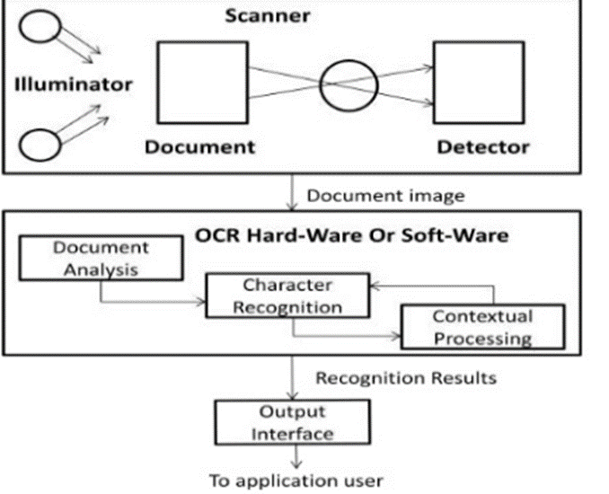

FIG 1: OCR ARCHITECTURE

**3: Software Requirement Analysis:**

**3.1 Problem Statement**

The problem here is for the software systems to recognize characters in computer system when information is scanned through paper documents as we know that we have number of newspapers and books which are in printed format related to different subjects. Whenever we scan the documents through the scanner, the documents are stored as images such as jpeg, gif etc., in the computer system. These images cannot be read or edited by the user. But to reuse this information it is very difficult to read the individual contents and searching the contents form these documents line-by-line and word-by-word. These days there is a huge demand in “storing the information available in these paper documents in to a computer storage disk and then later editing or reusing this information by searching process”.

**3.2 Modules and their Functionalities**

Our software system Optical Character Recognition on a grid infrastructure can be divided into five modules based on its functionality.The modules classified are as follows:- Document Processing Module ,System Training Module,Document Recognition Module, Document Editing Module and Document Searching Module.

**3.2 :1 Document Processing Module**

This module is accessed by administrator whose role in our application is a librarian.This module perform certain activities such as scanning documents, storing them as images, recognizing characters in images to transfer them into word format. During the recognition process, this module uses the OCR methodology in support of grid infrastructure datastructure. The module supports the following services:- Scanning printed documents, Storing the documents as snapshots or images,Processing those image-based documents,Converting these image-based documents into e-documents(also called structured documents),Recognizing the characters in documents,Generating grid infrastructure datastructure.

**3.2 :2 System Training Module**

This module can be accessed by both the administrator and the end-user. Before converting the printed documents in to editable and searchable documents, the first and the mandatory step is providing training to the system. Here training in the sense the font followed in the scanned document should be identified by the user. Then the user types all the characters that are required for recognition from the scanned document as an image file. This image file should be provided as an input during the training process. The user then clicks the train button provided in the recognition module. Then the training gets completed. Thus the system gets familiar with the new font. This module supports:- Training the system with the pre-defined fonts,Training the system with the new fonts that are not present in the system and that cannot be identified by the system.

**3.2 :3 Document Recognition Module**

This module can be accessed by both the administrator and the end-user. Once the printed documents are converted into structured documents, any user can recognize the characters present in the document. That means the user can recognize the characters of any language he chooses which makes OCR more flexible. This flexibility is due to the adaptation of grid infrastructure. This is the module where the main functionality of OCR is tested. Under this module, there are two types of recognition. They are handwritten recogniiton and scanned document recognition. In handwritten recognition, the handwriting of the user in any language is trained to the system only for the first time. From there on-wards, the system recognizes the characters or words written by the user. Thus handwritten document recognition recognizes the human handwriting. In scanned document recognition, the system is first trained with the font characters in the document in the training module itself. Now in the recognition module, the system takes the scanned documents image as an input file, first crops the image and then extracts/recognizes the characters from the document and makes these documents editable and searchable. Thus the scanned document recognition recognizes the chracters from the scanned document image and makes the document editable and searchable. Hence the document recogniiton module on a whole supports the following services:- Converts the document into specific format Recognizes the characters , Heterogeneous character Recognition.

**3.2 :4 Document Editing Module**

This module can be accessed by both the administrator and the end-user during document editing to implement the character recogniiton process. Once the scanned documents are stored, they reside in computer memory. This data resides in the form of an image that is just viewable in an image viewer. Hence, the document is first coverted into a form such that it is editable. The desired form of the document may be MS-Word,Text,… as specified by the user.The objective of this module is to let the user perform :- Addition of specific content to the documents ,Deletion of certain content from documents , Any other modification of documents.

**3.2 :5 Document Searching Module**

This module can be accessed by both the administrator and the end-user during the search of the user required document to implement the character recogniiton process on it. The user requests the system to search for a particular document. Then the system finds the documents based on OCR methodology and returns the result of the search to the user.

**4.Software Design**

**4.1(1) Data Flow Diagram**

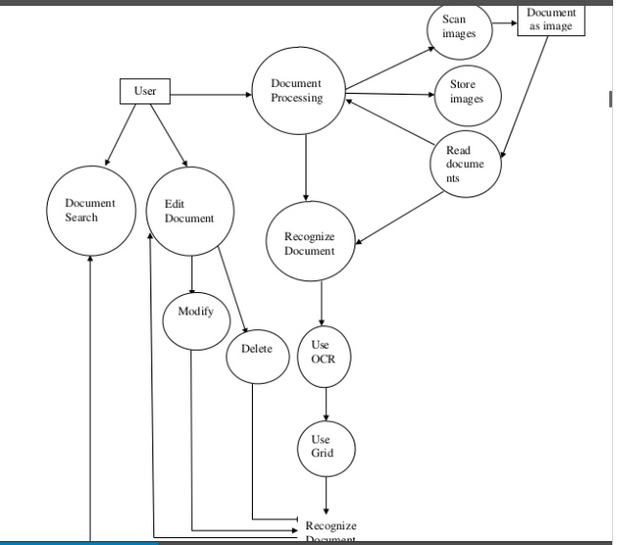

FIG 2: OCR Data Flow Diagram

**4.1(2) Use Case Diagram**

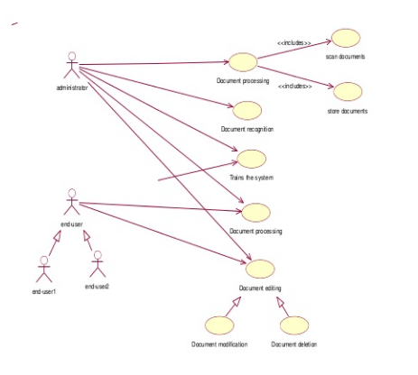

FIG 3: OCR Use Case Diagram

**4.1(3) Class Diagram**

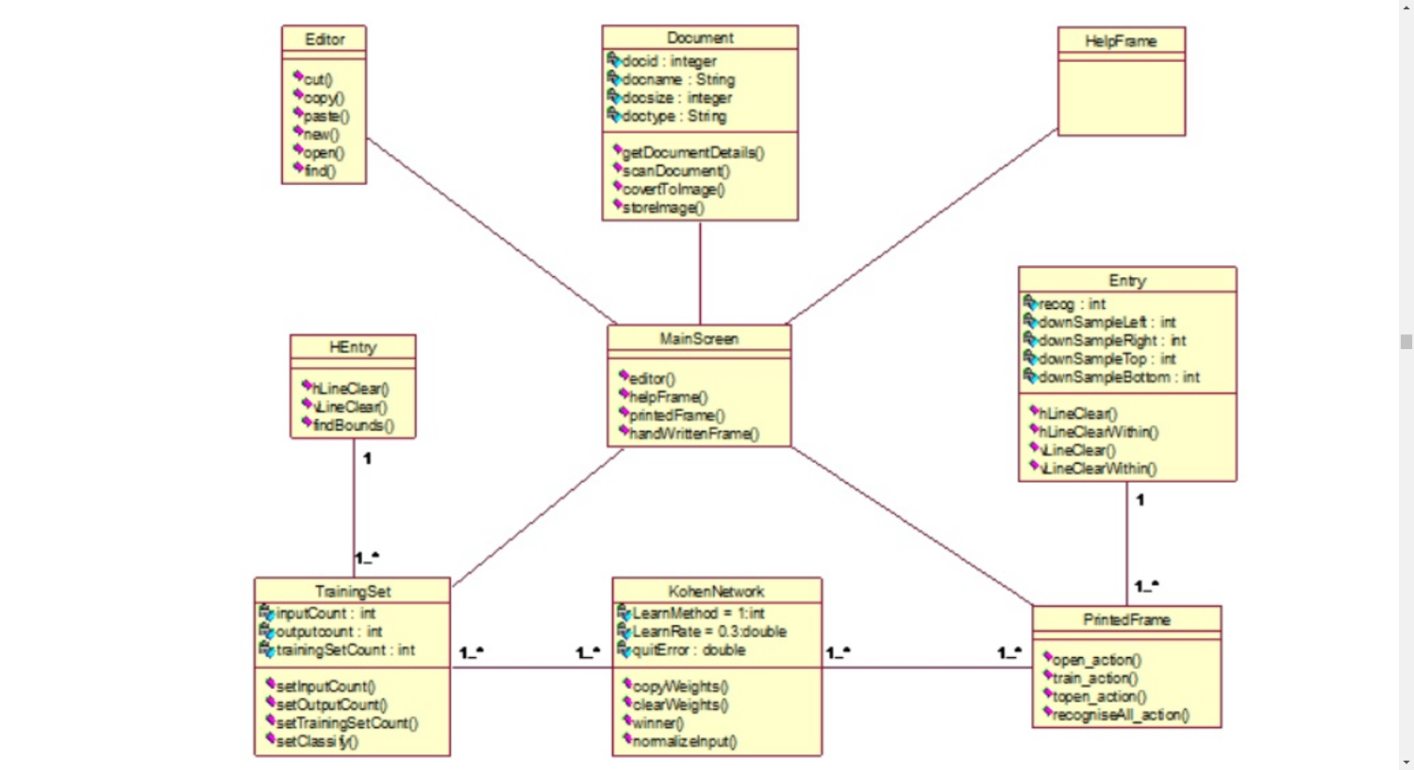

FIG 4: OCR Class Diagram

**4.1 (4) Sequence Diagram**

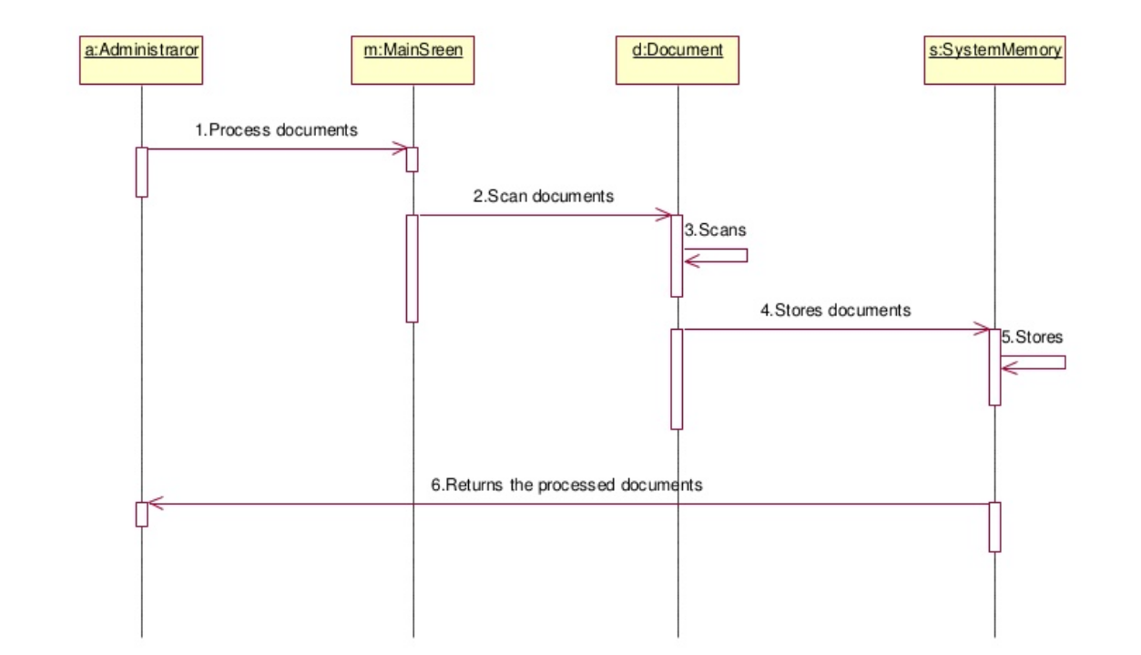

FIG 5: OCR Sequence Diagram

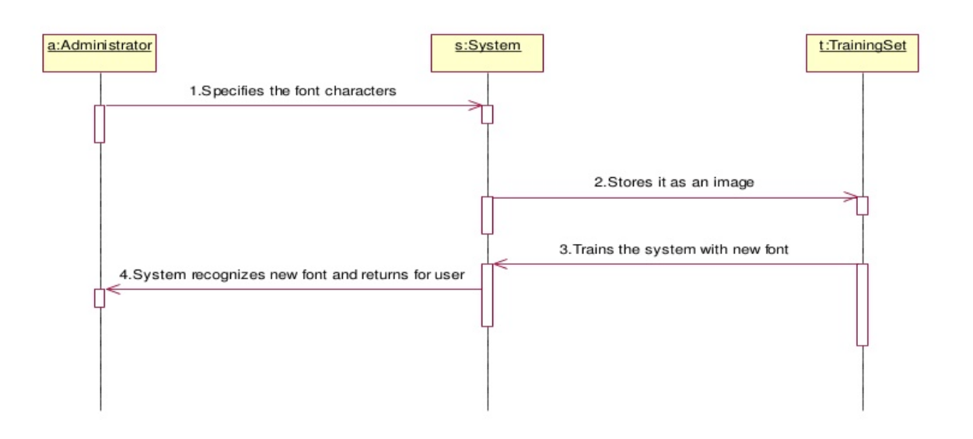

FIG 5(a): Sequence Diagram For Training

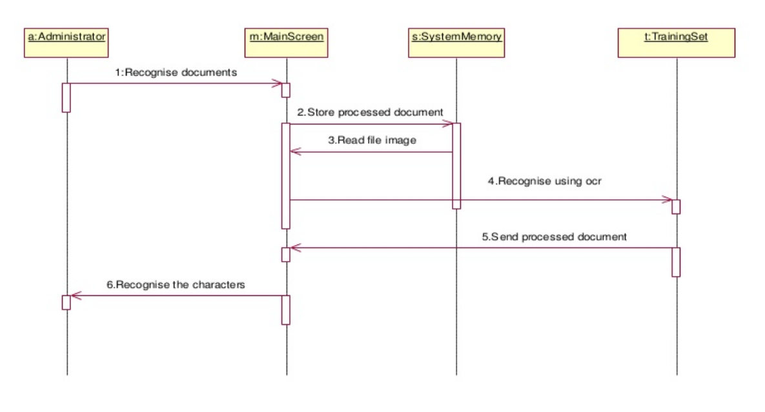

FIG 5(b): Sequence Diagram For Recognition

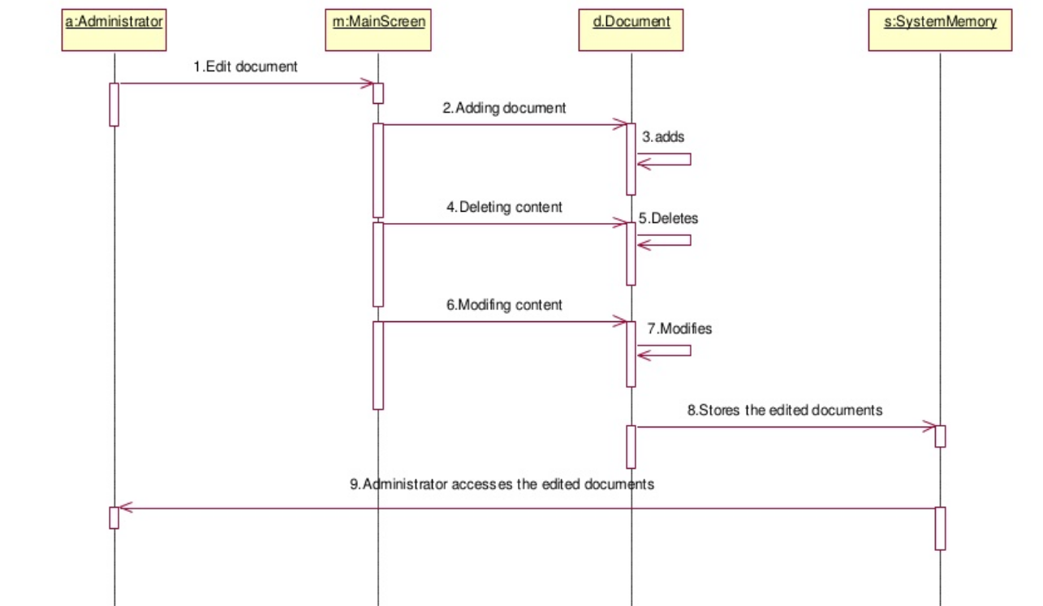

FIG 5(c): Sequence Diagram For Editing

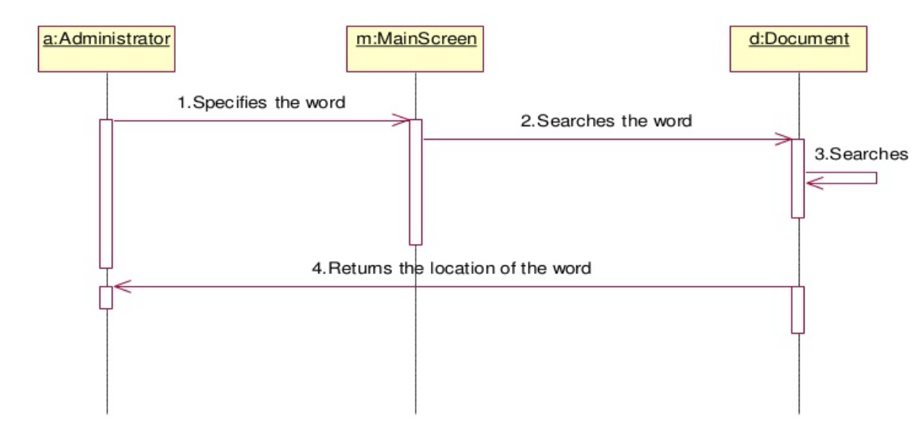

FIG 5(d): Sequence Diagram For Searching

**4.1(5) Activity Diagram**

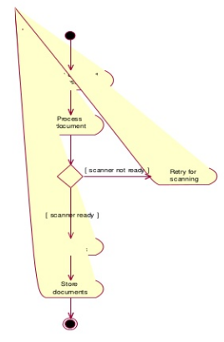

FIG 6(a):Activity Diagram For Document Processing

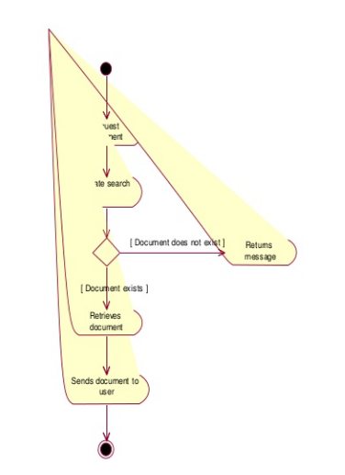

FIG 6(b):Activity Diagram For Document Retrieval

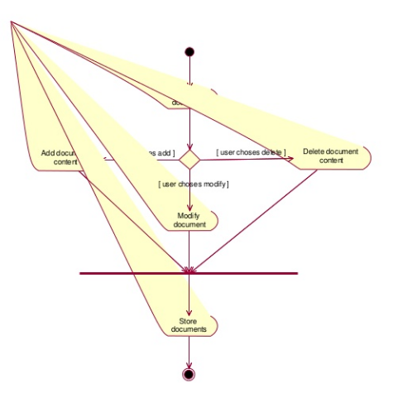

FIG 6(c):Activity Diagram For Document Storage

**4.1(6) Component Diagram**

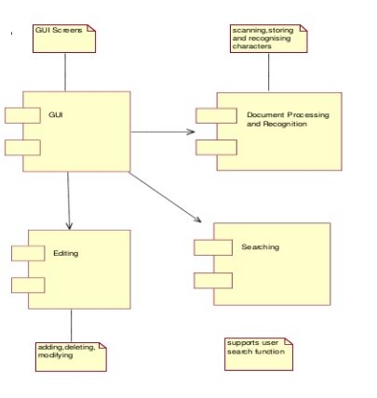

FIG 7 :Component Diagram

**4.1(7) Deployment Diagram**

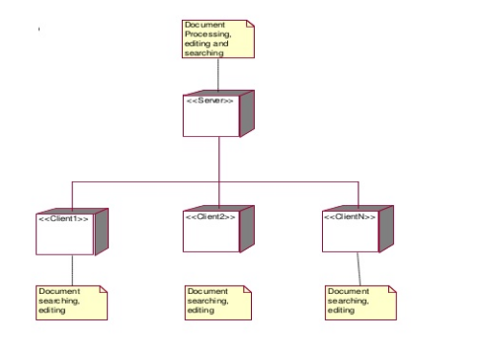

FIG 8 :Deployment Diagram

**4.2 Screenshots**

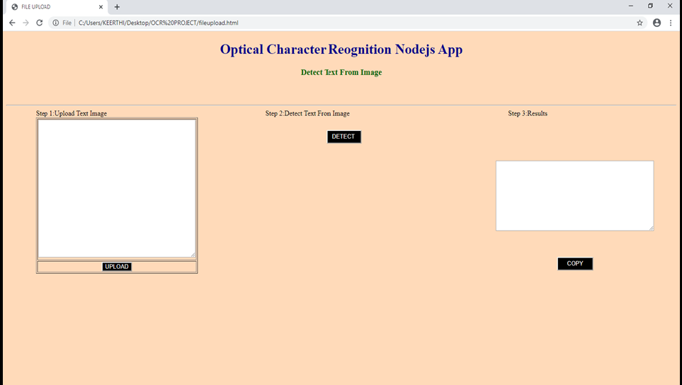

**4.3 Implementation**

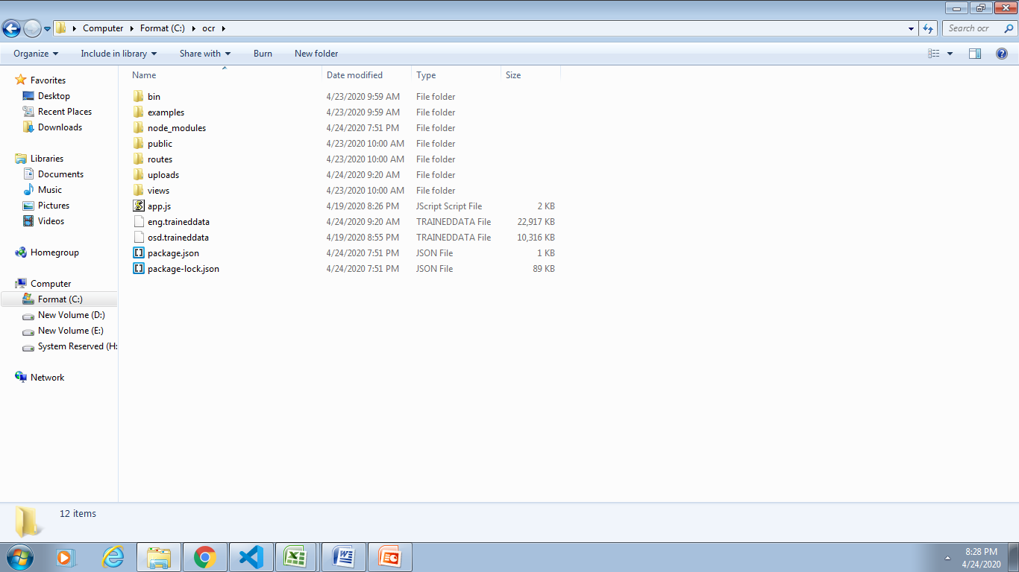

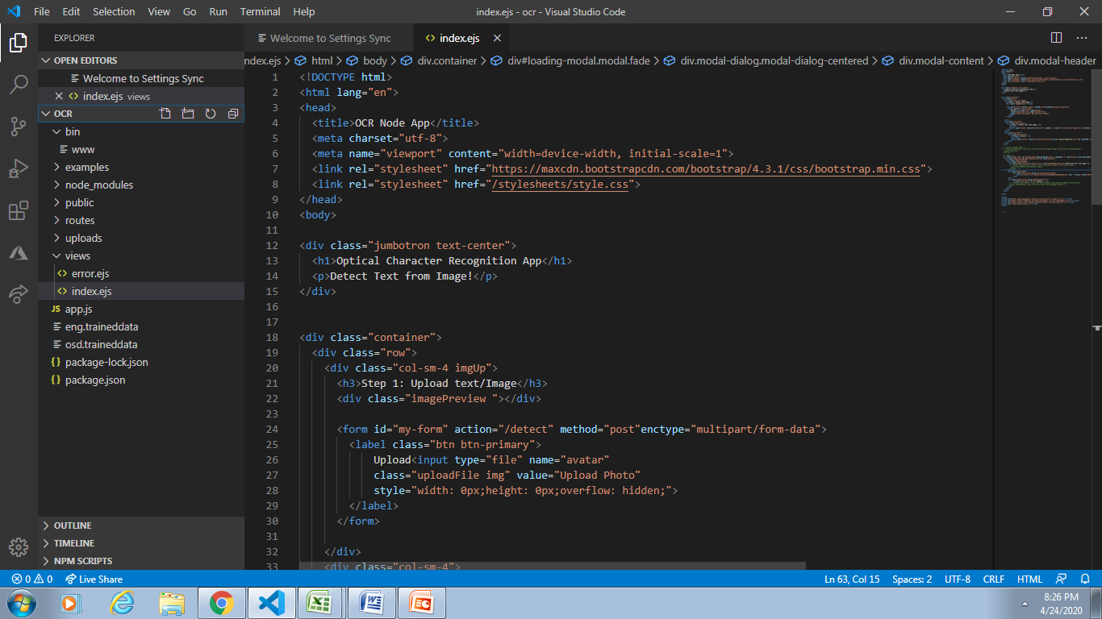

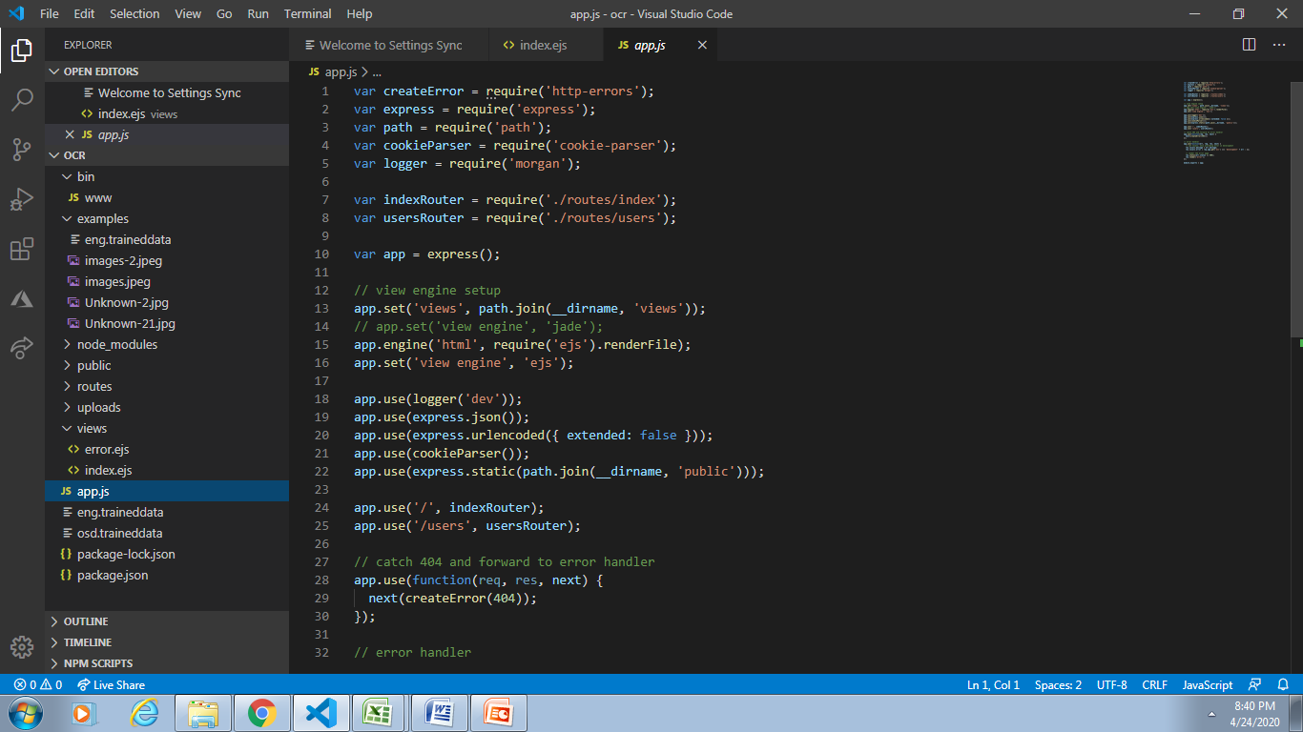

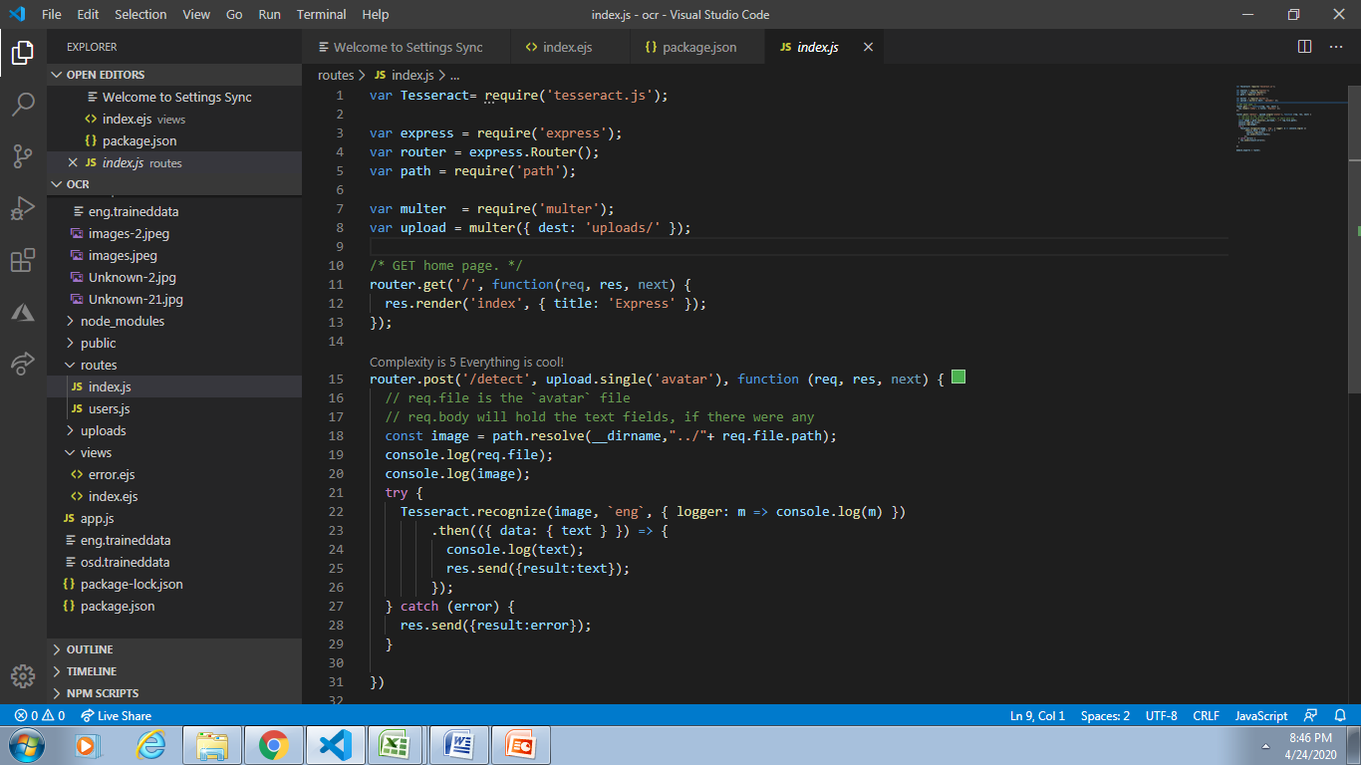

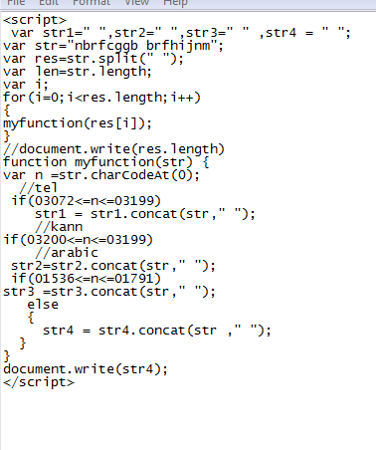

Code for searching the required languages

**Conclusion and Future Scope:**

What does the future hold for OCR? Given enough entrepreneurial designers and sufficient research and development dollars, OCR can become a powerful tool for future data entry applications. However, the limited availability of funds in a capital-short environment could restrict the growth of this technology. But, given the proper impetus and encouragement, a lot of benefits can be provided by the OCR system. They are:-

* The automated entry of data by OCR is one of the most attractive, labor reducing 85 technology
* The recognition of new font characters by the system is very easy and quick.
* We can edit the information of the documents more conveniently and we can reuse the edited information as and when required.
* The extension to software other than editing and searching is topic for future works.

The Grid infrastructure used in the implementation of Optical Character Recognition system can be efficiently used to speed up the translation of image based documents into structured documents that are currently easy to discover, search and process.

**FUTURE ENHANCEMENTS :**

The Optical Character Recognition software can be enhanced in the future in different kinds of ways such as:

Training and recognition speeds can be increased greater and greater by making it more user-friendly.

Many applications exist where it would be desirable to read handwritten entries. Reading handwriting is a very difficult task considering the diversities that exist in ordinary penmanship.However, progress is being made.

**BIBLIOGRAPHY:**

Build a javascript OCR App Tutorial:

<https://youtu.be/a1I3tcALTlc>

Project video link:

Hosting Node.js**:** <https://youtu.be/MxfxiR8TVNU>

Website Link: <https://ocr-node-app.herokuapp.com/>

Github Link: <https://github.com/Varun-3/Optical-code-recognition>