A PROJECT REPORT ON

**“MATLAB APPLICATION ON   
BATTERY MANAGEMENT SYSTEM (BMS)”**

SUBMITTED IN PARTIAL FULFILLMENT OF THE

REQUIRMENTS FOR THE AWARD OF

DIPLOMA IN COMPUTER ENGINEERING  
BY

**GROUP MEMBERS:  
S.DHANUSH 20054-CM-062  
P.SAIVARUN 20054-CM-102**

UNDER THE GUIDENCE OF MR. S.VAMSI SIR,  
TRAINER AT CITD  
  
  


**GOVERNMENT INSTITUTE OF ELECTRONICS,  
SECUNDERABAD**(Approved by SBTET,Hyderabad)  
East Marredpally,Secunderabad-500026  
2020-2023

## ACKNOWLEDGEMENT

With the great pleasure and deep sense of gratitude, we acknowledge the contribution of all the faculty for the successful completion of this project.

We deem to be great honor to thank **Mr. G. Venkateshwara prasad** garu M.Tech, Principal **GOVERNMENT INISTITUTE OF ELECTRONICS** who is an axle behind our studies and for having given us a chance to pursue my Diploma course in this esteemed institution.

Our thanks are due to Smt. **K. Radhika** garu **M.TECH** , Head of the department for her excellent, expert support rendered to me during my tenure in the institute. We would like to express our gratitude and appreciation to all the people who gave us the possibility to complete this report and training at Central Institute of Tool Design(CITD). It is always a pleasure to remind the fine people for their sincere guidance we received to uphold our practical as well as theoretical skills in this industrial training.

Finally we would like to thank all the trainers at Central Institute of Tool Design(CITD) who gave us all the support required to understand all the technical aspects both in theory and practice in the training.

**---------------**

**SUBMITTED BY:**  
 S.DHANUSH 20054-CM-062  
 P.SAIVARUN 20054-CM-102

**Declaration**

We hereby declare the project report entitled  
 **“MATLAB APPLICATION ON   
BATTERY MANAGEMENT SYSTEM (BMS)”**

Is the result in training given to us   
during  
**December 2022 to May 2023**  
in  
**“Central Institute Of Tool Design”**

C:\Users\SREEKANTH\Downloads\WhatsApp Image 2023-04-18 at 01.06.02.jpeg

**STATE BOARD OF TECHNICAL EDUCATION  
AND   
TRAINING HYDERABAD TELANGANA**

We hereby declare that this project was outcome of our efforts and is not been submitted to any other university for the award of any degree or diploma.

**SUBMITTED BY:**  
 S.DHANUSH 20054-CM-062  
 P.SAIVARUN 20054-CM-102

**ABSTRACT**

A battery management system (BMS) is a critical component of modern electrical energy storage systems, ensuring that batteries are charged and discharged in a safe and efficient manner.The below application takes a lithium-ion battery as an example. The BMS monitors the battery's state of charge, (SOC),State of Health (SOH),temperature, and voltage, and communicates with the intelligent power supply to regulate the charging and discharging of the battery.

The proposed application on BMS has several features, including overvoltage and undervoltage protection, overcurrent protection, and temperature monitoring,indicating SoC,SoH. The BMS also provides battery health diagnostics, such as estimating the remaining battery life and predicting potential faults. The proposed BMS application design is flexible to use and can be understood by every person.

This application shows the evaluated results of various parameters of the BMS to the user. The simulation results demonstrate that the BMS effectively manages the battery, maintaining safe and efficient operation . Its application in electric vehicles has significant implications for improving the vehicle's range, performance, and safety, ultimately making electric transportation a more viable and sustainable option for the future.

# 

# CONTENTS

**CHAPTER – 1 : MATLAB(R2021a) ----------------------------------------- 7**

## 1.1 - Features of Matlab

## 1.2 - Matlab App Designer User Interface

## CHAPTER – 2 : INTRODUCTION -----------------------------------------8-9

## 2.1 - Definition and Importance of BMS

## 2.2 - Project Objectives

## 2.3 - Types of Batteries and their Characteristics

## CHAPTER – 3 : EXISTING SYSTEM-------------------------------------10-14

3.1 - Battery Management Functions  
 3.2 - Safety Features

## CHAPTER – 4 : BMS COMMUNICATION PROTOCOLS ---------15-16

## 4.1 – Bluetooth Serial Port Profile(SPP)

## 4.2 - CAN protocol

**CHAPTERS -5 : APPLICATIONS OF BMS ----------------------------**17-19

5.1 - Electric Vehicles  
 5.2 - Energy storage systems  
 5.3 - Portable electronic devices  
 5.4 - Aerospace and defense

## CHAPTER –6 : FLOWCHART & EXECUTION -----------------------20-29

## 6.1 - Flowchart of BMS 6.2 - Code & Implementation

## 6.3 - Application working

## CHAPTER - 7 : OUTPUT -------------------------------------------------30-31

## CHAPTER – 8 : CONCLUSION ------------------------------------------32

**CHAPTER - 9 :REFERENCES -------------------------------------------**33

## 1.Software:MATLAB(R2021a)

## Matlab Features:

* It is designed for numerical as well as symbolic computing.
* It's a high-level language used mainly for engineering and scientific computing.
* It works within a Desktop environment providing full features for iterative exploration, design, and problem-solving.
* Creation of custom plots for visualizing data and tools, with the help of built-in Graphics.
* Specific applications are designed to work with any particular type of problems, such as data classification, control system design and tuning, signal analysis.
* Provides several add-on toolboxes to build a wide range of engineering, scientific, and custom user interface applications.
* Provide interfaces to work with other programming languages such as C, C++, Java, .NET, Python, SQL, Hadoop.

**Matlab App Designer User Interface:**

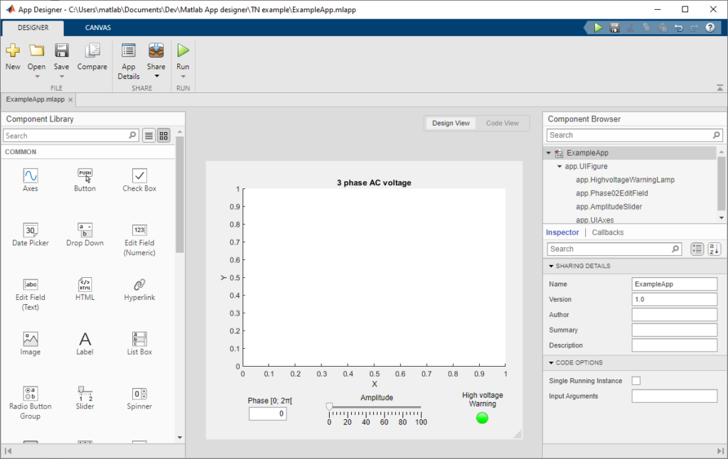

**2.Introduction To Battery Management  
 System (BMS)**

**Definition and Importance of BMS :**

A battery management system (BMS) is an electronic system that manages and monitors the performance, health, and safety of rechargeable batteries. It is responsible for ensuring that the battery operates within its safe operating limits, preventing overcharging, over-discharging, and overheating, and ensuring that the battery remains in good condition over its lifetime.

The BMS is essential in modern battery-powered applications, such as electric vehicles, renewable energy systems, and portable electronics. It plays a critical role in optimizing battery performance, extending battery life, and ensuring safe and reliable operation.

**Project Objective**

The importance of a BMS and the objective is to maximize the performance and lifespan of a battery while minimizing the risk of failure or damage. A well-designed BMS can provide the following benefits:

1. **Battery protection:** A BMS protects the battery from overcharging, over-discharging, and overheating, which can cause permanent damage to the battery or even result in a fire or explosion.
2. **State-of-charge (SOC) estimation:** A BMS monitors the battery's SOC and provides accurate information about the battery's remaining capacity and operating range.
3. **Battery balancing:** A BMS ensures that all cells in the battery pack are charged and discharged evenly, preventing imbalances that can lead to reduced performance and shortened battery life.
4. **Fault detection and diagnostics:** A BMS can detect and diagnose faults in the battery system, allowing for timely repairs and maintenance.
5. **Optimization of battery performance:** A BMS can optimize the battery's charging and discharging parameters, extending battery life and improving performance.

**Types of Batteries and their Characteristics :**

**Types of batteries**:

* Lead-acid batteries: These are commonly used in automotive and backup power applications. They have a low energy density but can deliver high current output.
* Lithium-ion batteries: These are widely used in portable electronics, electric vehicles, and grid storage applications. They have a high energy density, low self-discharge rate, and a long cycle life.
* Nickel-metal hydride batteries: These are commonly used in hybrid vehicles and portable electronics. They have a higher energy density than lead-acid batteries but lower than lithium-ion batteries

**Characteristics of a Battery Management System:**

* Cell balancing: A BMS ensures that each cell in a battery pack is charged and discharged evenly, preventing overcharging or over-discharging of individual cells.
* State of charge monitoring: A BMS monitors the state of charge (SOC) of the battery pack to ensure that it is within safe limits and to provide accurate information to the user.
* Temperature management: A BMS monitors the temperature of the battery pack and can take action to prevent thermal runaway, which can lead to fires or explosions.
* Overvoltage and undervoltage protection: A BMS protects thebattery pack from overcharging or over-discharging, which can damage the battery or reduce its lifespan.
* Fault detection and isolation: A BMS can detect faults in the battery pack and isolate the affected cells to prevent further damage.
* Communication interface: A BMS provides real-time data and alerts to the user or system, allowing for proactive maintenance and preventing catastrophic failures.

**3.Existing System**

**BMS Functions:**

**State Of Charge (SOC) estimation:**

State of charge (SOC) is a critical parameter that describes the remaining energy level in a battery. In a battery management system (BMS), SOC is a crucial parameter that determines the amount of energy that can be delivered by the battery and helps to prevent overcharging or discharging, which can cause damage to the battery or reduce its lifespan.

BMS uses various techniques to estimate the SOC of a battery, such as voltage-based methods, current integration methods, and model-based methods. Voltage-based methods are the most commonly used techniques and rely on measuring the voltage across the battery terminals to estimate the SOC. However, this method has limitations, as the voltage is not a direct measure of the battery's energy capacity.

To improve the accuracy of the SOC estimation, BMS also considers other factors such as temperature, battery age, and charge/discharge rates. The BMS continuously monitors these parameters and adjusts the SOC estimation to account for any changes in battery performance.

Accurate SOC estimation is essential for maximizing the battery's performance, ensuring safety, and prolonging its lifespan. Therefore, the development of advanced SOC estimation techniques is an active area of research in battery management systems.In a battery electric vehicle (BEV), SOC for the battery pack is the equivalent of a fuel gauge. It is important to mention that state of charge, presented as a gauge or percentage value on any vehicle dashboard, especially in plug-in hybridvehicles, may not be representative of a real level of charge.

The SOC of a battery is defined as the ratio of its current capacity (Q(t)) to the nominal capacity (Qn). Nominal Capacity, Qn, is the maximum amount of charge that can be stored in the battery. This rating is given by the manufacturer.

**SOC(t) =Q(t)/Qn**

* ***(*Q(t)*) =*** Current Capacity
* ***(*Qn*) =***  Nominal Capacity

**State Of Health (SOH) estimation:**

The State of Health is a "measurement" that reflects the general condition of a battery and its ability to deliver the specified performance compared with a fresh battery. It takes into account such factors as charge acceptance, internal resistance, voltage and self -discharge.

It is a measure of the long term capability of the battery and gives an "indication" not an absolute measurement, of how much of the available "lifetime energy throughput" of the battery has been consumed, and how much is left. Using the automotive analogy, it can be compared to the "odometer" display function which indicates the number of miles travelled since the vehicle was new.

During the lifetime of a battery, its performance or "health" tends to deteriorate gradually due to irreversible physical and chemical changes which take place with usage and with age until eventually the battery is no longer usable or dead.The SOH is an indication of the point which has been reached in the life cycle of the battery and a measure of its condition relative to a fresh battery.

The SOH of a battery is the ratio of its maximum instantaneous releasable capacity, (Qmax(t)) to the capacity of the new battery (Qnew).

**SOH(t) *= (*Qmax(t)*) / (*Qnew*).***

* **Qmax(t)*=***Maximum instantaneous releasable capacity
* **Qnew =** Capacity of the new battery

The SOH could be derived by capacity and the internal resistance, and it could also be derived from other battery parameters like AC impedance, self-discharge rate, and power density.

The SOH decrement of a battery cell is mostly caused by battery aging and degradation, namely, durability problems. That means with the using or storing of the battery cells, the battery capacity would decrease and the internal resistance would increase. Thus the SOH of the battery cells worsens.

**Temperature Management:**

Temperature management is an essential aspect of battery management systems (BMS) and critical to the safe and efficient operation of batteries. Batteries generate heat during charging and discharging, which can cause temperature increases that need to be monitored and controlled by the BMS.

The BMS must ensure that the temperature of the battery remains within a safe range, which varies based on the type of battery chemistry. For example, Lithium-ion batteries have a recommended temperature range between 0°C and 45°C, beyond which they can suffer from performance degradation, reduced capacity, and even damage.

There are several techniques that the BMS may use to manage the temperature of the battery. Passive cooling methods involve designing the battery pack with proper insulation and ventilation to dissipate heat naturally. For instance, the battery pack can have fins or heat sinks to increase surface area for better heat transfer, and fans to draw cool air into the pack and exhaust hot air out. Passive cooling is simple, cost-effective, and reliable, but it may not be sufficient for applications that generate a lot of heat, such as electric vehicles or high-power systems.

Active cooling techniques, on the other hand, use fans or liquid cooling systems to regulate the temperature actively. Fans are common in small or portable devices, where the BMS can use a temperature sensor to activate the fan when the battery temperature exceeds a set threshold. The fan then cools down the battery by drawing cool air in or pushing hot air out. Liquid cooling systems are more complex and expensive but offer higher cooling capacity and efficiency. They use a liquid coolant, such as water or glycol, that circulates through the battery pack and exchanges heat with a heat exchanger. The BMS can use a pump to regulate the coolant flow rate and a temperature sensor to monitor the temperature of the coolant.

**Charge and Discharge Control:**

The BMS must monitor and control the charging and discharging of batteries to prevent overcharging, over-discharging, and other related issues.The BMS uses several techniques to control the charging and discharging of batteries. One of the primary methods is the use of voltage and current sensors to monitor the state of charge (SOC) and state of health (SOH) of the battery. The SOC refers to the amount of charge stored in the battery, while the SOH measures the battery's capacity and overall health. Based on these measurements, the BMS can adjust the charging and discharging rates to ensure that the battery remains within the safe operating limits.

The BMS can use various charging algorithms, such as constant current-constant voltage (CC-CV), pulse charging, or trickle charging, depending on the type of battery chemistry and the charging requirements. The CC-CV algorithm is commonly used for lithium-ion batteries and involves charging the battery with a constant current until it reaches a certain voltage, then switching to constant voltage until the current decreases to a specific level. Pulse charging involves delivering short bursts of current to the battery, which can help reduce the charging time and improve the battery's performance. Trickle charging involves delivering a low-level current to the battery continuously, which can help maintain the battery's charge level and prevent over-discharging.

Similarly, the BMS can use various discharging algorithms, such as constant current or constant power, depending on the application's requirements. The constant current algorithm involves discharging the battery at a constant rate until the voltage drops to a certain level. The constant power algorithm involves discharging the battery at a constant power level, which can help maintain the battery's performance and capacity.

**Safety Features:**

A BMS is an electronic system that manages and protects a battery pack, which is commonly used in electric vehicles and other applications. Safety features of a BMS include:

* Overvoltage Protection: The BMS monitors the battery voltage to ensure it stays within safe limits. If the voltage exceeds the maximum safe limit, the BMS will disconnect the battery from the load to prevent damage.
* Undervoltage Protection: The BMS also monitors the battery voltage to ensure it doesn't go below a certain limit. If the voltage drops below the minimum safe limit, the BMS will disconnect the load to prevent damage to the battery.
* Overcurrent Protection: The BMS limits the amount of current that can flow through the battery to prevent overheating and damage. If the current exceeds the maximum safe limit, the BMS will disconnect the battery from the load.
* Temperature Monitoring: The BMS monitors the temperature of the battery to prevent it from overheating. If the temperature exceeds the maximum safe limit, the BMS will disconnect the battery from the load.
* Cell Balancing: The BMS ensures that all the cells in the battery pack are balanced, meaning they have the same state of charge. This prevents overcharging or undercharging of individual cells, which can damage the battery.

**4. BMS Communication & Protocols**

**Bluetooth Communication:**

Bluetooth is a wireless technology that allows two devices to communicate with each other over a short distance. Here are some key points about Bluetooth communication between a BMS and a BMS app:

* Bluetooth is typically used for communication between a BMS and a BMS app. Bluetooth is well-suited for use with battery-powered devices.
* The BMS typically has a Bluetooth module that allows it to communicate with the BMS app. The app may use Bluetooth APIs to establish a connection with the BMS.
* Once a connection is established, the BMS can send data to the BMS app, such as battery voltage, current, temperature, and state of charge. The app can then display this data to the user.
* The BMS app can also send commands to the BMS, such as turning on or off charging, or setting charge limits. The BMS will then carry out these commands.
* Security is an important consideration when using Bluetooth communication. The BMS and the app should use encryption and authentication to ensure that only authorized users can access the battery data and control functions.
* Bluetooth communication can be affected by interference from other devices, such as Wi-Fi routers or microwave ovens. The BMS and the app should be designed to handle such interference and maintain a stable connection.

Overall, Bluetooth communication is a convenient and reliable method for connecting a BMS to a BMS app. It allows users to monitor and control their battery systems from a mobile device, providing greater convenience and flexibility.

**CAN Protocol:**

The CAN (Controller Area Network) protocol is a widely used communication standard in the automotive and industrial automation industries. It is also commonly used for communication between a battery management system (BMS) and an intelligent power supply. Here are some key points about using the CAN protocol for communication between a BMS and an intelligent power supply:

* The CAN protocol is a message-based communication protocol that allows multiple devices to communicate with each other over a shared bus. Each device on the bus has a unique identifier, and messages are sent between devices based on these identifiers.
* In a BMS and intelligent power supply system, the BMS typically acts as the master device, controlling and monitoring the power supply. The power supply acts as a slave device, responding to commands and providing power to the battery.
* The BMS and power supply may exchange a variety of messages over the CAN bus, including battery voltage, current, temperature, and state of charge. The BMS may also send commands to the power supply, such as setting the charging rate or turning the power supply on or off.
* The CAN protocol is highly reliable and resistant to noise and interference, making it ideal for use in industrial environments.
* However, the CAN protocol requires careful design and implementation to ensure that messages are transmitted and received correctly. In particular, error checking and fault tolerance mechanisms should be implemented to detect and correct errors in the data.
* Security is also an important consideration when using the CAN protocol, as it is vulnerable to attacks such as message spoofing and replay attacks. Authentication and encryption mechanisms should be used to protect against such attacks.

**5. Applications of BMS**

**Electric Vehicles:**

An electric vehicle (EV) is an application of a battery management system (BMS) because it relies on a battery pack to power its electric motor. A BMS is essential in managing the performance of the battery pack, ensuring that it operates safely and efficiently.

The BMS is responsible for monitoring the state of charge (SOC), state of health (SOH), and temperature of the battery cells. It ensures that the battery is charged and discharged within safe limits, preventing any overcharging, over-discharging, or overheating of the cells. The BMS also controls the charging and discharging of the battery pack, ensuring that it operates at optimal voltage and current levels.

In an EV, the BMS plays a crucial role in optimizing the range of the vehicle. It helps to maximize the use of the battery pack, ensuring that it is used efficiently and extending its life. The BMS also provides an interface for the driver to monitor the battery's performance, including the remaining range, charging status, and battery health.

**Energy storage systems:**

BMS plays a critical role in ESS applications by providing various functions   
 including:

* Monitoring battery state-of-charge (SOC), state-of-health (SOH), and state-of-function (SOF) to ensure optimal battery performance and prevent overcharging and over-discharging.
* Balancing the charge between the batteries to ensure that each cell in the battery pack is charged equally.
* Providing safety features such as temperature control and voltage protection to prevent thermal runaway and damage to the battery pack.
* Controlling the charging and discharging of the batteries to ensure that they operate within their safe operating range.

**Portable electronic devices:**

BMS in portable electronic devices is responsible for several functions, including:

* Monitoring battery status: BMS monitors the battery's state-of-charge (SOC) and state-of-health (SOH) to ensure that it is operating efficiently and can accurately predict how much power is remaining.
* Charge control: BMS controls the charging of the battery to ensure that it is charged within safe limits and prevents overcharging, which can damage the battery.
* Temperature control: BMS monitors the temperature of the battery and takes appropriate action to ensure that it remains within the safe operating temperature range.
* Voltage protection: BMS ensures that the battery is operating within a safe voltage range to prevent damage to the battery and the device.
* Balancing charge: BMS balances the charge between the battery cells to ensure that the battery is charged equally and operates efficiently.

**Aerospace and defense:**

Battery Management Systems (BMS) are critical components in Aerospace and   
 Defense applications. These applications require high-reliability battery systems  
 that can operate under harsh environments, withstand extreme temperatures, and   
 provide long battery life. Here are a few ways BMS is used in Aerospace and   
 Defense applications:

1. Uninterruptible Power Supply (UPS): BMS is used in Aerospace and Defense applications to ensure continuous power supply in case of power failures. UPS systems provide backup power to critical systems and equipment, such as communication systems, radar systems, and avionics.
2. Electric propulsion systems: BMS is used in electric propulsion systems to ensure that the batteries provide the required power to the electric motor. This includes monitoring the battery's state-of-charge, state-of-health, and temperature control.
3. Energy storage systems: Energy storage systems (ESS) are used in Aerospace and Defense applications to store energy from renewable sources or during periods of low demand. BMS is used to ensure that the batteries are charged and discharged within their safe limits and to manage the battery pack's thermal performance.
4. Mission-critical applications: In Aerospace and Defense applications, BMS is used in mission-critical systems such as satellites, space vehicles, and military vehicles. BMS ensures that the batteries provide the necessary power to critical systems and equipment, even in harsh environments.

**6.FLOWCHART & EXECUTION**

**Flowchart Of BMS:**

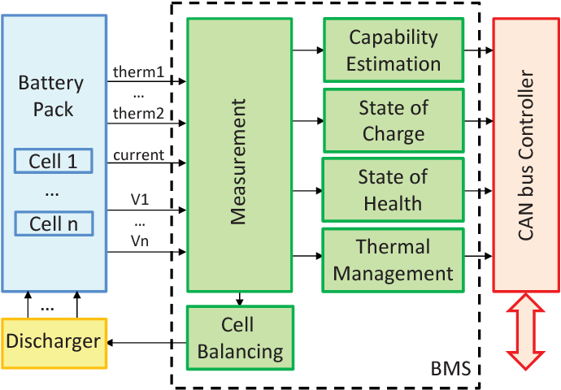

The above flowchart represents the internal architecture of BMS. All the parameters   
 are calculated and sent to the application (This one).Our application shows the  
 required parameters to the user through user interface in way that every person can  
 perceive and analyze the data of their battery

**Project Code:**

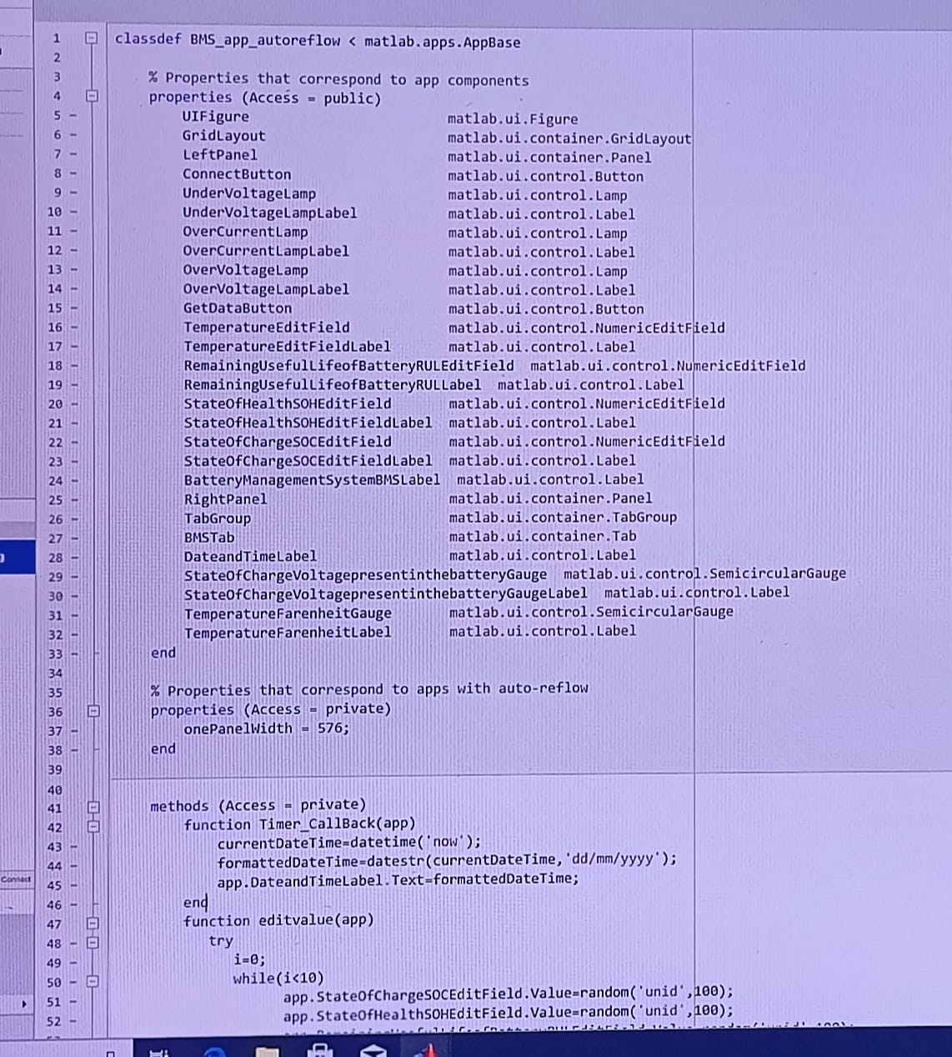

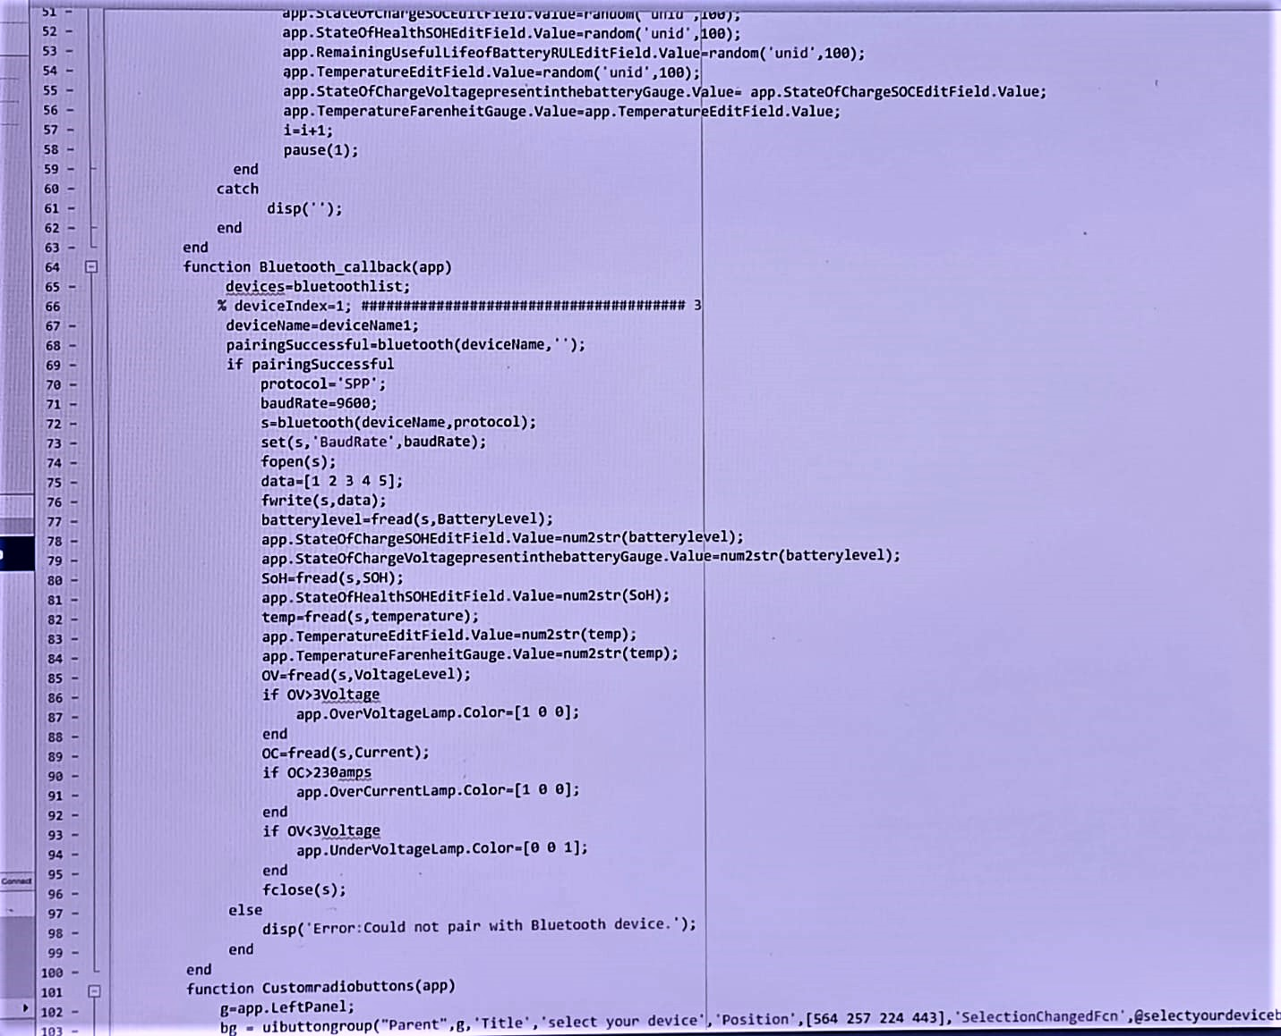

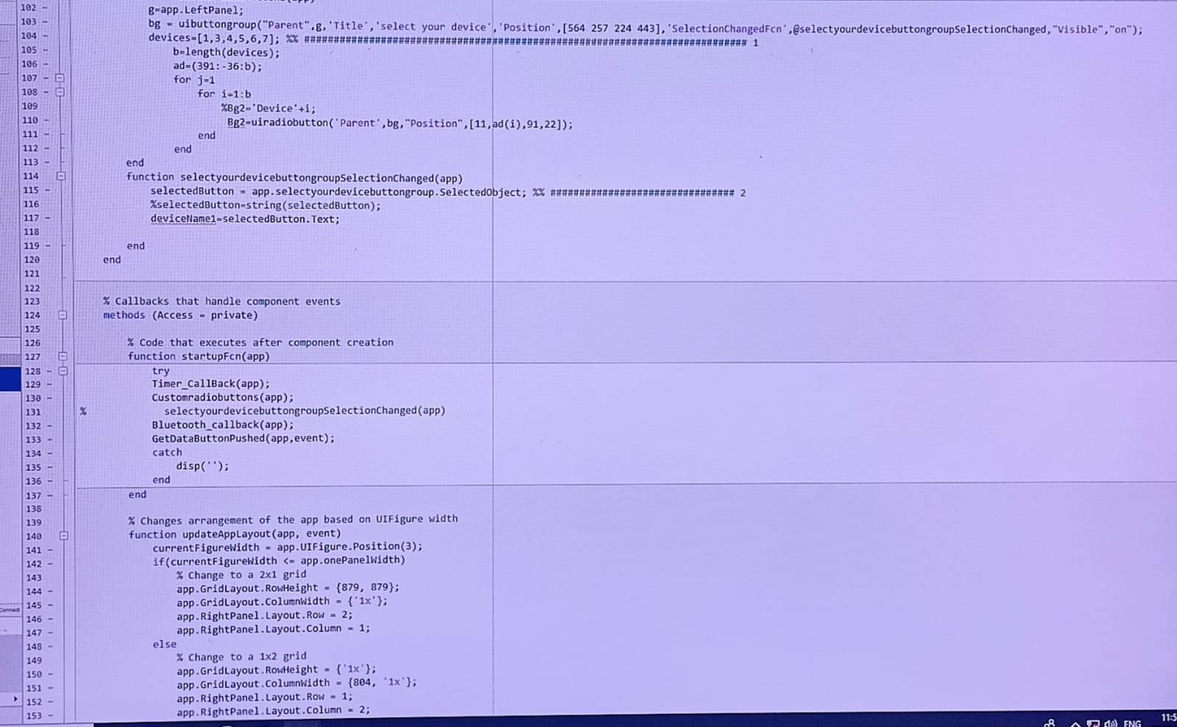

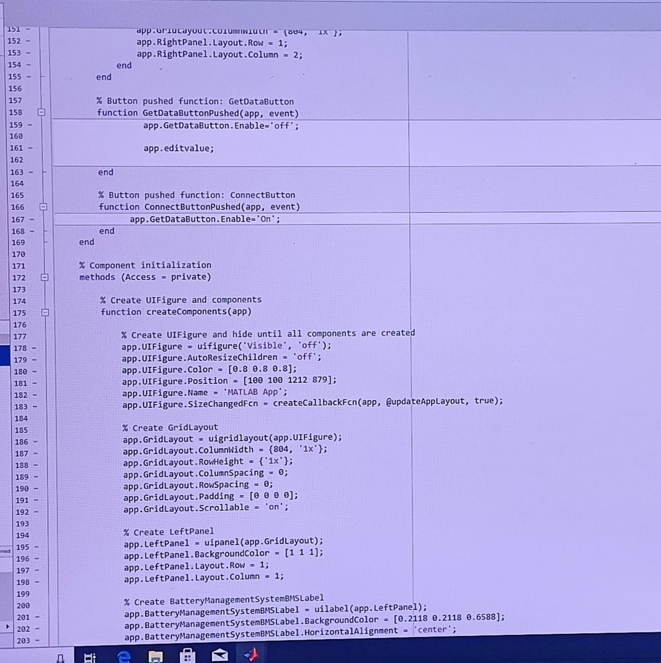

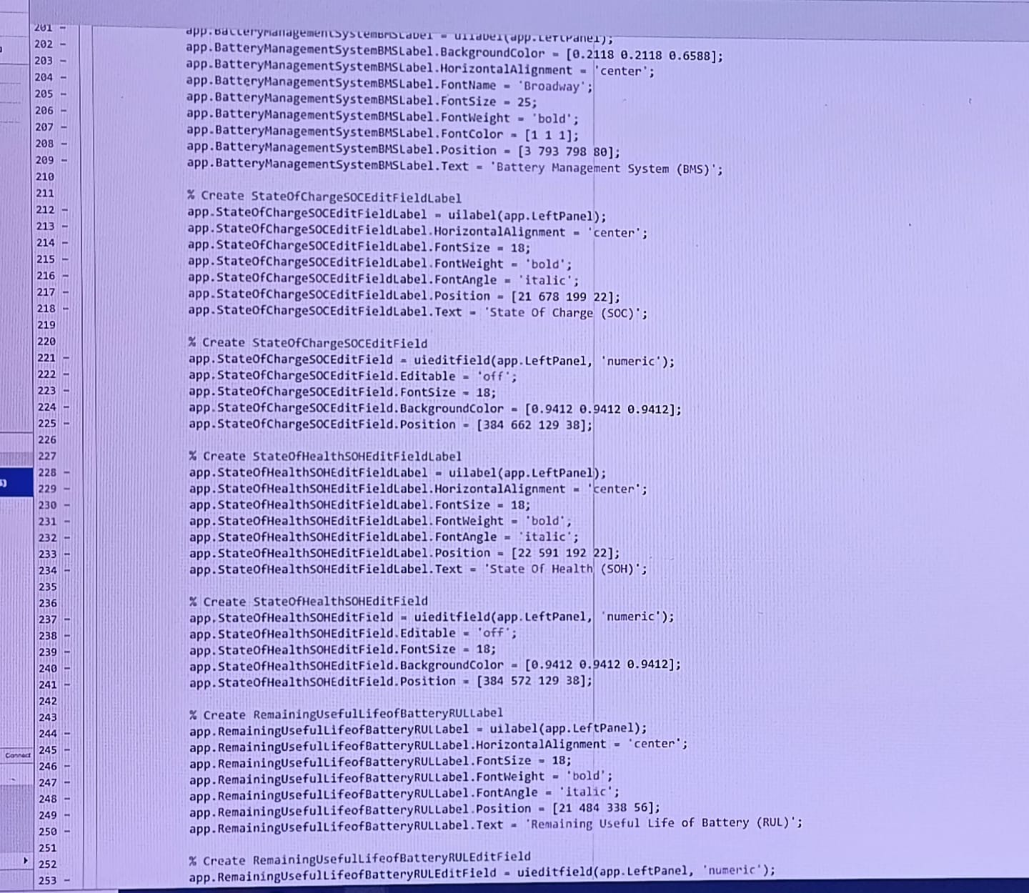

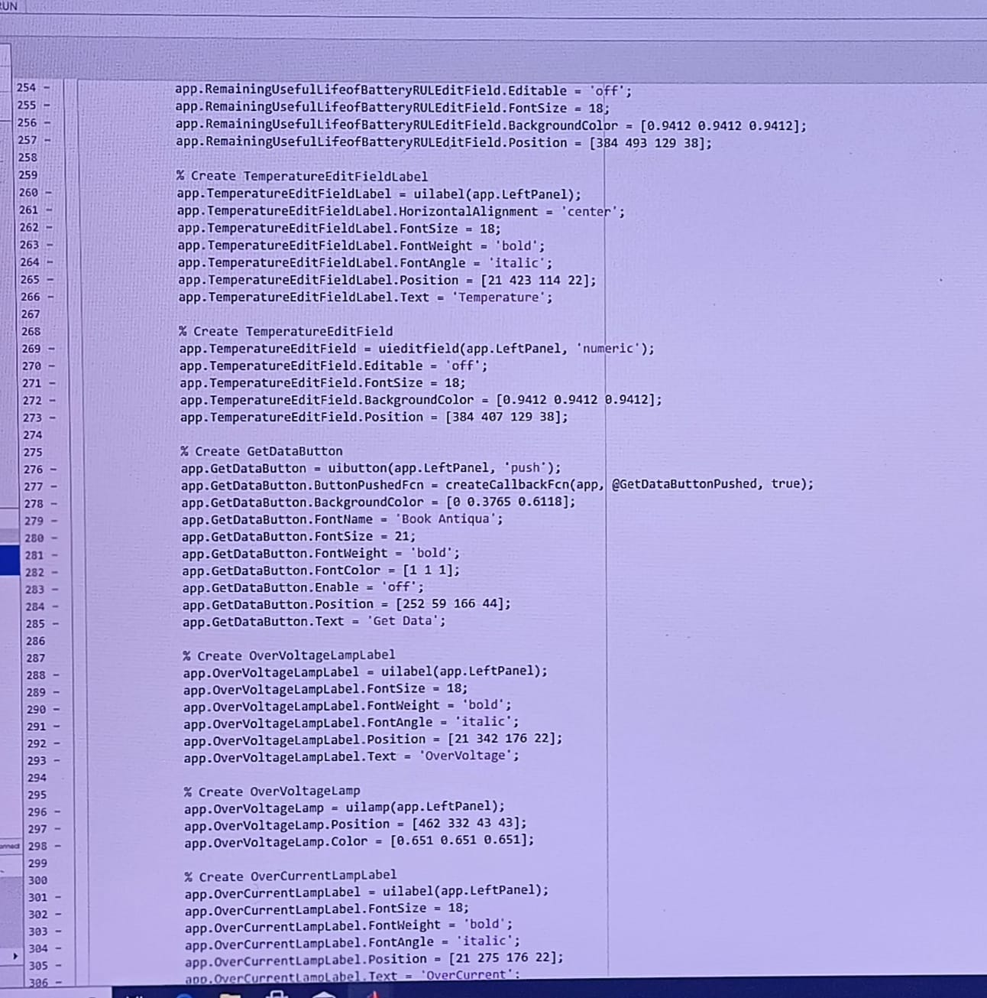

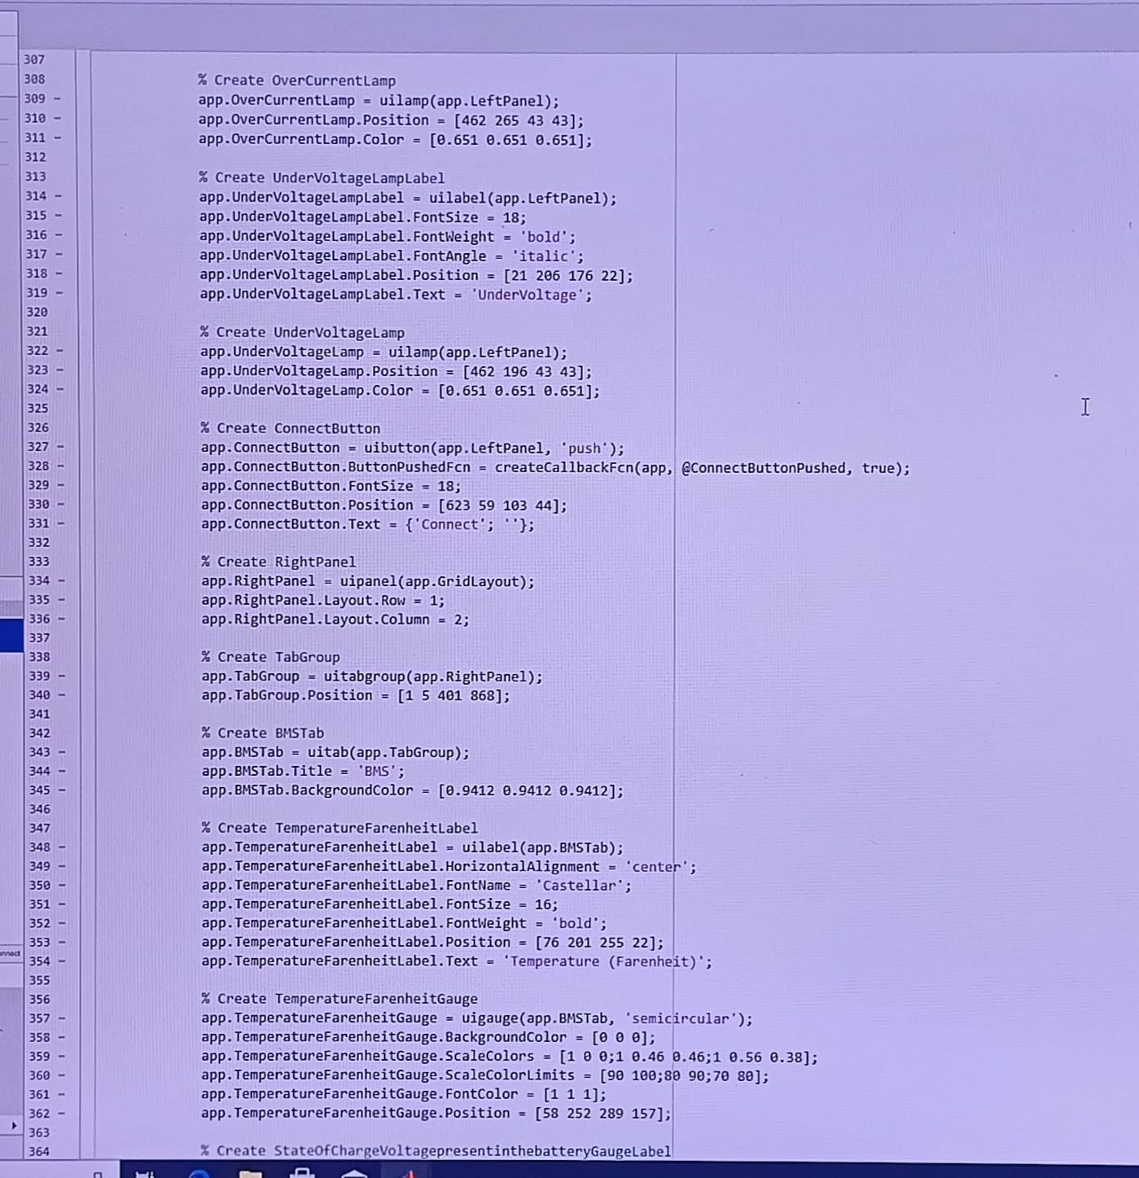

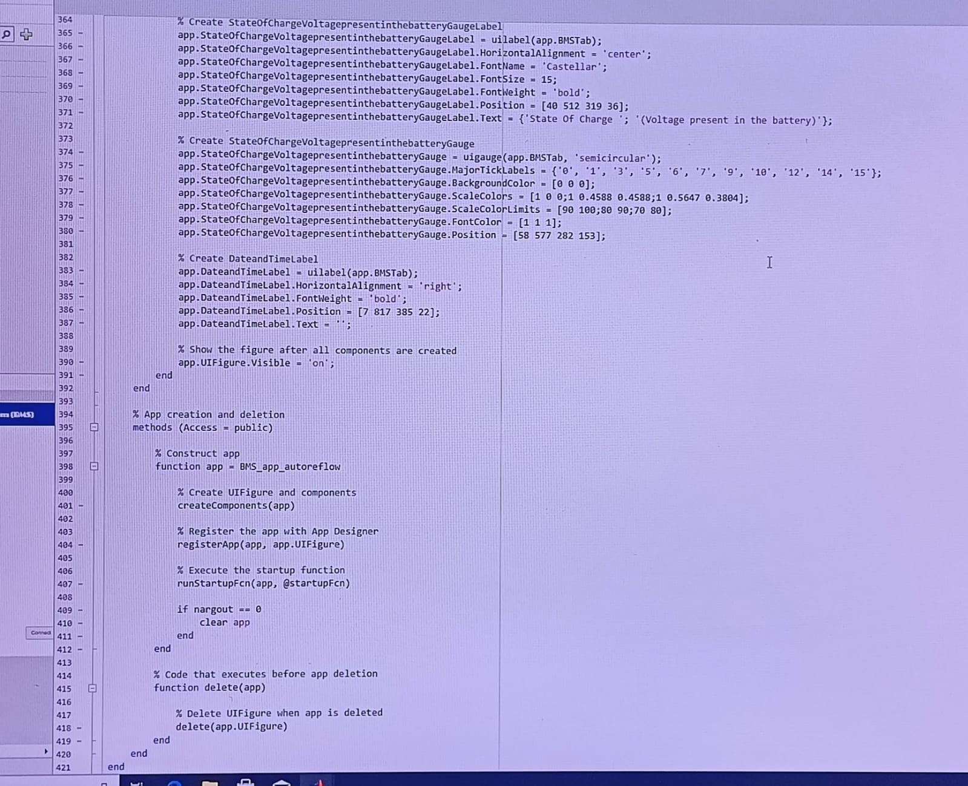

**Application Working:**

There are mainly functions which drive this BMS applicaton to work, they are:  
   
 **Timer_Callback function:**This function is used to display date(and also time if we   
 wish to show user).As we know date is one of the first thing we see on device,  
 So to appear when app runs this function is invoked/called in Startup function.

**Editvalue function:** This function is used to retrieve parameters from BMS device.  
 Later, this function is going to be merged with Bluetooth function(which will be   
 explained down)to reduce code complexity.

**Bluetooth function :** This function involves main units of work like – discovering   
 the list of bluetooth devices, Connecting to desired devices, reading and writing  
 data/info from and to the device.

**Customradiobuttons function:** This function is used to read the no of devices   
 available and according to that is generates radiobutton with their respective names  
 on that button.  
 **Selectionchanged function:** This function is used to select the desired device i.e   
 radiobutton, and the selected device is sent to ‘Bluetooth function’ above.  
 **Startup function:** As I said above , when the code executes this is the first function  
 that runs i.e executed. So any default or preinitailised values which are to be shown   
 for user is passed to this function.  
 **Connect button and Get data button**: These are callback functions which are used   
 to enable and to retrieve the data respectfully.

**7.Output**

**Before pressing “Get data button”:**

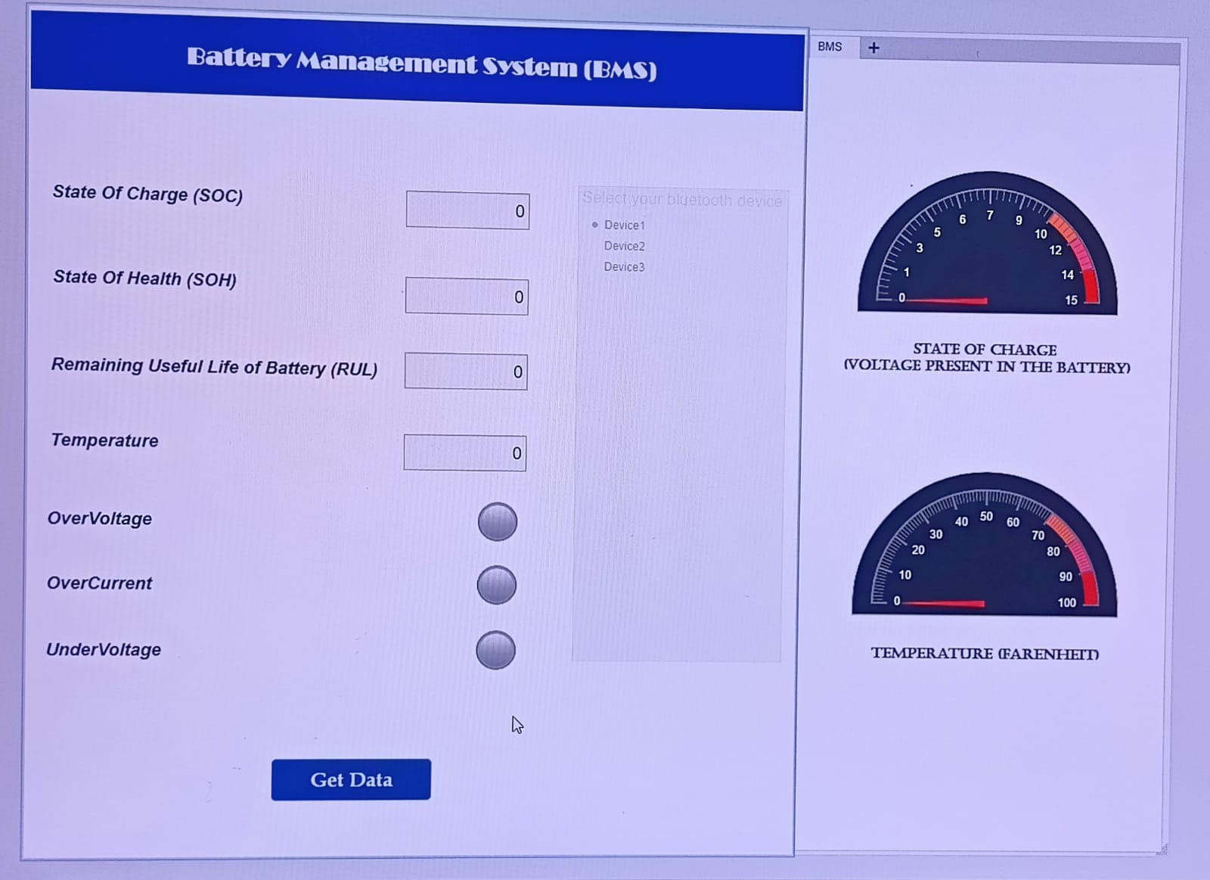

**After pressing "Get data button”:**

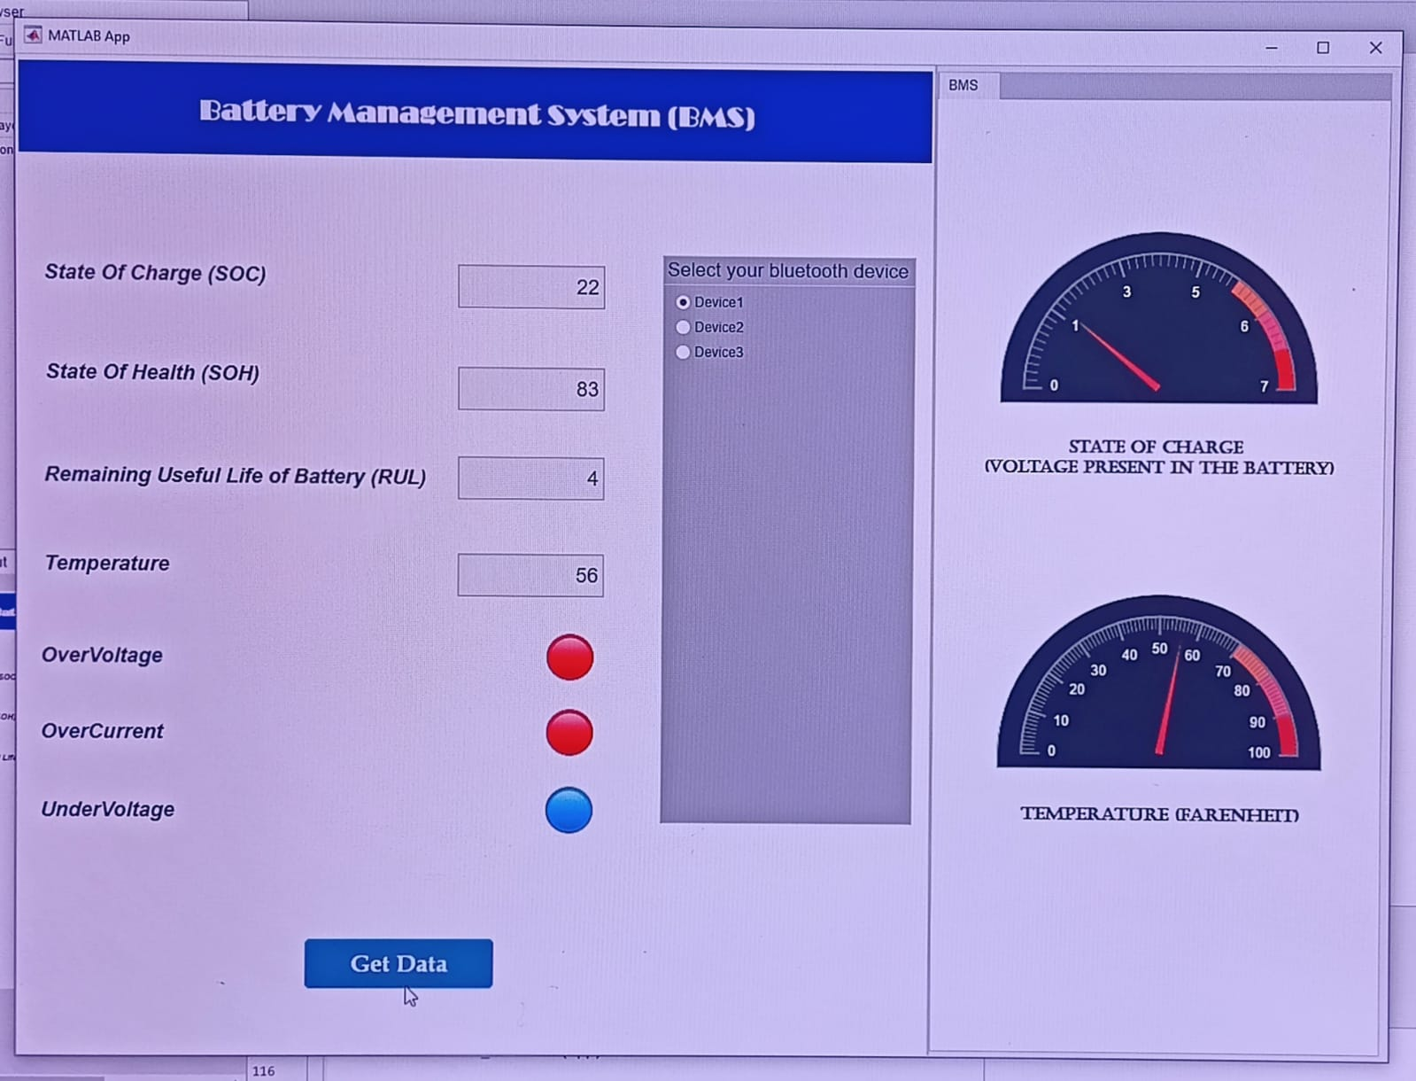

**8.Conclusion**

This project exhibits a novel app for battery management system which actively monitors the critical parameters like voltage, capacity and performs as an active balancing of cells in a battery pack whenever required.   
  
This application is mainly developed keeping in context of new emerging EV vehicle’s   
 battery management system, by controlling the crucial parameters such as current,   
 state of charge, state of health, state of life, temperature.   
  
It is every important that the BMS should be well maintained with battery reliability and safety. This present report focusses on the exhibiting parameters of BMS and optimizes the power performances of electric vehicles and many more battery powered devices. Moreover, the target of reducing the greenhouse gases can greatly be achieved by using battery management system.

**7. REFERENCES**

* **https://in.mathworks.com/**
* [**https://www.synopsys.com/glossary/what-is-a-battery-management-system.html**](https://www.synopsys.com/glossary/what-is-a-battery-management-system.html)
* [**https://www.techtarget.com/whatis/definition/battery-management-system-BMS**](https://www.techtarget.com/whatis/definition/battery-management-system-BMS)
* [**https://www.mpoweruk.com/soh.htm**](https://www.mpoweruk.com/soh.htm)
* [**https://www.sciencedirect.com/science/article/pii/S2405896318320329**](https://www.sciencedirect.com/science/article/pii/S2405896318320329)
* [**https://en.wikipedia.org/wiki/Battery_management_system**](https://en.wikipedia.org/wiki/Battery_management_system)
* [**https://www.mdpi.com/2032-6653/13/5/80**](https://www.mdpi.com/2032-6653/13/5/80)