A PROJECT REPORT ON
“END-TO-END MLOPS PIPELINE
FOR SOUND CLASSIFICATION”

SUBMITTED IN PARTIAL FULFILLMENT OF THE
REQUIRMENTS FOR THE AWARD OF

B.TECH IN COMPUTER SCIENCE AND ENGINEERING(AIML)
BY
P. SAIVARUN

UNDER THE GUIDENCE OF
MR. S.VAMSI ,
MACHINE LEARNING ENGINEER
MR P VENKATA SIVAMANI DHANUSH
MACHINE LEARNING ENGINEER
AT CITD


GOKARAJU RANGARAJU INSTITUTE OF ENGINEERING
AND TECHNOLOGY,
BACHUPALLY
(Affiliated To JNTUH,Hyderabad)
Bachupally,Hyderabad-500026
07/2025-09/2025

ACKNOWLEDGEMENT

With great pleasure and a deep sense of gratitude, I wish to acknowledge the contributions of all those who made the successful completion of this project possible.
I would like to extend my heartfelt thanks to my guides, S. VAMSI and P. VENKATA SIVAMANI DHANUSH, for their continuous assistance, guidance, and support. Their encouragement and valuable feedback were instrumental; without them, this project would have remained a distant dream.
My sincere thanks to G. SANATH KUMAR, Deputy Director(Trg.) and Head of the Department.
I wish to express my gratitude to the MSME Tool Room, Hyderabad (CITD) for providing the opportunity for my industrial training. I extend my deep appreciation to Dr. G. Arun Manohar, Incharge ( Short-Term Trg), and DR. T. VIJAY KRISHNAKANTH, Principal Director and all the trainers and employees who contributed, directly or indirectly, for their kind cooperation and for sharing their technical knowledge, which enhanced both my practical and theoretical skills.

---------------

SUBMITTED BY:
P.SAIVARUN

Declaration
We hereby declare the project report entitled
“END-TO-END MLOPS PIPELINE
FOR SOUND CLASSIFICATION”
Is the result in internship given to us
during
JULY 2025 to SEPTEMBER 2025
in
“Central Institute Of Tool Design”


BACHELORS IN TECHNOLOGY
HYDERABAD TELANGANA
We hereby declare that this project was outcome of my effort and is not been submitted to any other university for the award of any degree or diploma.

SUBMITTED BY:
P.SAIVARUN

ABSTRACT

This project demonstrates the design and implementation of a comprehensive Machine Learning Operations (MLOps) pipeline to productionize a deep learning model for urban sound classification. The primary objective was to transition a Convolutional Neural Network (CNN), trained on the UrbanSound8K dataset, from an experimental Jupyter Notebook script into a robust, automated, and scalable web service. The MLOps lifecycle was systematically implemented using a suite of industry-standard tools. Git was used for source code versioning, while Data Version Control (DVC) was integrated to manage the large audio dataset, ensuring complete reproducibility of both code and data. Experimentation was systematized using MLflow, which tracked key parameters, performance metrics, and model artifacts, enabling systematic model selection and governance through its Model Registry. The selected production model was then served via a REST API created with FastAPI, chosen for its high performance and automatic data validation. To ensure portability and resolve environmental dependencies, the entire application—including the trained model, preprocessing artifacts, and the API server was containerized using Docker.
A Continuous Integration and Continuous Deployment (CI/CD) pipeline was established using GitHub Actions. This pipeline automatically builds the Docker image and pushes it to a Docker Hub container registry upon any changes to the main codebase, ensuring that a production-ready artifact is always available. The final stage of the project involved deploying this containerized application to Google Cloud Run, a serverless platform, making the classification service available as a scalable, public-facing API endpoint. This project successfully showcases the transformation of a standalone ML model into a production-grade system, emphasizing the MLOps principles of automation, versioning, reproducibility, and continuous delivery.

CONTENTS

Chapter 1: Project Foundation and Tooling
1.1 Introduction to Python for Machine Learning-------------------------------------------------------------1
1.2 Core Libraries: Pandas, Scikit-learn, TensorFlow/PyTorch---------------------------------------------1
1.3 Environment Management with Docker--------------------------------------------------------------------1
1.4 Version Control with Git and GitHub ----------------------------------------------------------------------1-4

Chapter 2: Analysis of the Existing System
2.1 The Starting Point: Jupyter Notebook Prototype----------------------------------------------------------5
2.2 Key Limitations and Challenges-----------------------------------------------------------------------------5
2.3 The Business Case for MLOps Transformation -----------------------------------------------------------5

Chapter 3: Data Engineering and Preparation
3.1 Data Sourcing and Collection-------------------------------------------------------------------------------6
3.2 Data Preprocessing and Feature Engineering-------------------------------------------------------------6
3.3 Data Version Control (DVC) -------------------------------------------------------------------------------6-18

Chapter 4: Model Development and Training
4.1 Experiment Tracking with MLflow------------------------------------------------------------------------19-24
4.2 Model Training and Hyperparameter Tuning-------------------------------------------------------------24
4.3 Model Evaluation and Validation --------------------------------------------------------------------------24-25

Chapter 5: Continuous Integration and Delivery (CI/CD)
5.1 Automating Workflows with GitHub Actions------------------------------------------------------------26
5.2 Continuous Integration: Automated Testing and Linting-----------------------------------------------26
5.3 Continuous Delivery: Building Docker Containers------------------------------------------------------26
5.4 Storing Artifacts: Docker Hub and Model Registries----------------------------------------------------26-29

Chapter 6: Model Deployment
6.1 Creating a REST API with FastAPI-----------------------------------------------------------------------30-34
6.2 Containerization with Docker------------------------------------------------------------------------------34-41
6.3 Deployment to a Cloud Platform (Google Cloud Run)-------------------------------------------------41-44

Chapter 7: Monitoring and Maintenance
7.1 Operational Monitoring: Logging and Metrics-----------------------------------------------------------45-46
7.2 Model Performance Monitoring: Data & Concept Drift------------------------------------------------46-47
7.3 Setting Up Alerting Policies--------------------------------------------------------------------------------47-48
7.4 Code and Errors ----------------------------------------------------------------------------------------------48-76
Chapter 8: Conclusion
8.1 Conclusion and Future Enhancements---------------------------------------------------------------------77

CHAPTER 1: PROJECT FOUNDATION AND TOOLING

1.1 - Introduction to Python for Machine Learning
The project is built using Python, with an initial state in a Jupyter Notebook that is later modularized into scripts like model.py, train.py, config.py, main.py,data_processing.py,and predict.py. The environment and dependencies are managed through a requirements.txt file, which lists all necessary Python libraries. The overall workflow demonstrates a transition from an interactive development environment to a structured and version-controlled Python project.

1.2 - Core Libraries: Pandas, Scikit-learn, TensorFlow/PyTorch
The technology stack relies on several key libraries to handle different aspects of the machine learning lifecycle:
- Deep Learning Frameworks: The sources provide examples using both PyTorch (torch, torchvision) for model definition and training and TensorFlow for logging models with MLflow (mlflow.tensorflow.log_model).
- API Development: FastAPI is used as the web framework to build the REST API for model serving, with Uvicorn acting as the server. python-multipart is used for handling file uploads.
- Experiment Tracking: MLflow is the primary tool for logging experiments, parameters, metrics, and managing the model lifecycle.
- Configuration: PyYAML is used to load external configurations from .yaml files, which helps in managing hyperparameters and paths without hardcoding them.
- Monitoring: Google cloud run is used to instrument the FastAPI application to expose performance metrics.

1.3 - Environment Management with Docker
Docker is the primary tool used for creating reproducible and isolated environments.
- Purpose: Docker packages the application—including the code, Python libraries, configurations, and OS components—into a single, portable unit called a container. This solves the "it works on my machine" problem by ensuring the environment is consistent everywhere.
- Implementation: A Dockerfile is created to define the build steps for the container image. This file includes instructions to:
  - Start from a base Python image (e.g., python:3.9-slim).
  - Set a working directory inside the container.
  - Copy the requirements.txt file and install all dependencies.
  - Copy the application source code into the container.
  - Define the command (CMD) to start the application server (e.g., uvicorn) when the container runs.

1.4 - Version Control with Git and GitHub
Git is used for versioning all source code, while GitHub is used as the remote repository.

Part 1: Setting Up Your Git Repository (One-Time Setup)
Think of this part as creating the "save file" for your project's entire history. You only have to do this once.

Prerequisite: Install Git
If you haven't already, download and install Git from the official website: https://git-scm.com/downloads. Accept the default settings during installation.

Step 1: Open the Command Line (Git Bash)
The easiest way to use Git is through a command-line tool. When you installed Git, it included a program called Git Bash.
- Click your Windows Start Menu.
- Type Git Bash and open the application.
You will see a black window where you can type commands.

Step 2: Navigate to Your Project Folder
You need to tell Git Bash where your project is located. From my project screenshot, the path is C:\Users\home\FtoL .
Type the cd (change directory) command below into Git Bash and press Enter:
cd C:/Users/home/urbnmlops/urbnmlops.
(Note: In Git Bash, it's better to use forward slashes / for paths, even on Windows).
Your command prompt should now show that you are in the correct folder.

Step 3: Initialize the Git Repository
Now, you'll turn this folder into a Git repository. This creates a hidden .git subfolder where Git will store all the history and tracking information.
In Git Bash, type this command and press Enter:
git init
You'll see a message like: Initialized empty Git repository in C:/Users/home/urbnmlops/urbnmlops/.git/

Step 4: Create a .gitignore File (Very Important!)
You need to tell Git to ignore certain files and folders. You don't want to save temporary files, large datasets, or trained models in your version control history.
Your screenshot shows a folder called .ipynb_checkpoints. We will tell Git to ignore this.
- Create the file: In your Git Bash window, type the following command and press Enter. This creates a new file named .gitignore.
touch .gitignore
- Edit the file: Open the urbnmlops folder in Windows Explorer. You should now see the .gitignore file. Open it with any text editor (like Notepad) and add the following lines:
# Ignore Jupyter Notebook checkpoints
.ipynb_checkpoints/
# Ignore Python's cache folder
__pycache__/
# Ignore virtual environment folders (if you use them)
venv/
.venv/
# Ignore trained models and data artifacts
*.h5
*.joblib
*.pkl
*.npy
- Save and close the .gitignore file.

Step 5: Make Your First "Save" (Commit)
Now you will save the initial state of all your Python files. This is a two-step process: "staging" and "committing".
- Stage all your files: Think of this as putting all your files into a box, ready to be saved. The . means "all files in this folder".
git add .
Commit the files: Think of this as sealing the box and writing a label on it that describes what's inside. This saves the snapshot to your project's history.
git commit -m "Initial commit: Add all project Python files"

Part 2: How to Track Changes You Make (Your Daily Workflow)
Now, let's say you edit one of your files. Here is the simple, 3-step process you will follow every time you want to save your changes.

Scenario: You modify your model.py file.
After you've edited and saved model.py in your code editor, go back to your Git Bash window.

Step 1: Check the Status (git status)
This is your most important command. It tells you what Git sees has changed.
git status
Git will show you something like this:
On branch main
Changes not staged for commit:
(use "git add <file>..." to update what will be committed)
(use "git restore <file>..." to discard changes in working directory)
modified: model.py
This tells you that the model.py file has been modified since your last save.

Step 2: See the Exact Changes (git diff)
If you want to see exactly which lines of code you changed, use the git diff command.
git diff
Git will show you the lines you removed (in red) and the lines you added (in green). This is great for double-checking your work before you save it.

Step 3: Save Your Changes (Stage and Commit)
This is the same two-step process as before.
- Stage the specific file you changed.
git add model.py
- Commit the change with a descriptive message about what you changed.
git commit -m "Update model architecture with a new Dropout layer"
You have now successfully saved your new version!

Viewing Your History (git log)
If you ever want to see the list of all the commits (saves) you've made, use the git log command.
git log –oneline or just, git log
It will show you a clean history of your project, with each commit having its own unique ID and message.
Set up GitHub with Git Bash so you can push and pull code from your repos. Here’s a clear step-by-step guide:

🔧 Step 1: Configure Git (only once per system)
Open Git Bash and set your username & email (must match your GitHub account):
git config --global user.name "Your GitHub Username"
git config --global user.email "your_email@example.com"
Verify:
git config --list

CHAPTER 2: ANALYSIS OF THE EXISTING SYSTEM

2.1 - The Starting Point: The Jupyter Notebook Prototype
The project originates from a common starting point in machine learning development: a Jupyter Notebook. In this initial system, all logic for a proof-of-concept model—specifically, loading a pre-trained ResNet-18, fine-tuning it on the CIFAR-10 dataset, and saving the final model weights—is contained within a single, interactive document. This notebook represents an isolated, manual workflow focused purely on model creation.

2.2 - Key Limitations and Challenges
While effective for initial exploration, the notebook-based system has several critical limitations that prevent it from being a reliable, production-ready solution.
- Lack of Reproducibility: The primary challenge is the absence of robust versioning. Without a tool like DVC, it is impossible to link a specific version of the code to the exact version of the data it was trained on, making experiments difficult or impossible to reproduce accurately.
- Manual and Error-Prone Workflow: The entire process is manual, from running notebook cells to saving model files. There is no automated experiment tracking to log parameters and metrics, making it difficult to compare different model runs systematically.
- Monolithic and Inflexible Code: The code is not modular. All data loading, training, and evaluation logic is intertwined in one script. Furthermore, crucial parameters like learning rate, batch size, and file paths are often hardcoded directly into the notebook, making the code inflexible and hard to reuse or reconfigure for new experiments.
- No Version Control for Code or Data: The existing system lacks formal version control. Git is not initialized, meaning there is no history of code changes. More importantly, large data files cannot be tracked by Git, and without DVC, they remain unversioned, leading to the "it works on my machine" problem. A .gitignore file is also absent, risking the accidental commitment of large or unnecessary files.
- Absence of Deployment and Monitoring Strategy: The final output of the existing system is merely a saved model file (e.g., cifar_resnet18.pth). There is no mechanism to serve this model as an API, no containerization for consistent deployment, and no monitoring to observe its performance or health in a live environment.

2.3 - The Business Case for MLOps Transformation
The limitations of the existing notebook-based system create significant business risks, including an inability to reliably reproduce results, slow development cycles, and a high probability of errors when moving from research to production. The goal of the MLOps transformation is to evolve this prototype into an automated, reliable, and efficient system that can be retrained, deployed, and monitored continuously, thereby ensuring the model provides consistent value over time.

CHAPTER 3: DATA ENGINEERING AND PREPARATION

3.1 - Data Sourcing and Collection
In the project, the urbansound8k dataset is used. The data is sourced and collected automatically via a script; the train.py script uses the torchvision.datasets.CIFAR10 class with download=True to fetch the data into a local directory.

3.2 - Data Preprocessing and Feature Engineering
Data preprocessing is handled within the training script. For the image classification task, torchvision.transforms is used to define a sequence of transformations, such as converting images to tensors (transforms.ToTensor()) and normalizing pixel values (transforms.Normalize()). In a broader MLOps pipeline, this stage can be orchestrated to perform cleaning, transformation, and feature engineering, with the resulting features stored in a feature store like Feast.

3.3 - Data Version Control (DVC)
DVC is essential for managing large datasets that cannot be stored in Git.
- Purpose: DVC works alongside Git to version data, linking a specific version of the code to the exact version of the data it was trained on, ensuring full reproducibility.
- Setup:
  - Install DVC and its extensions (e.g., for Google Drive): pip install dvc "dvc[gdrive]".
  - Initialize DVC in the Git repository with dvc init.
  - Configure remote storage, such as a Google Drive folder, using dvc remote add. This step may require setting up custom Google Cloud credentials to avoid authentication issues with Google's default security measures.
- Workflow:
  - Track Data: Use dvc add <data_folder> to start tracking a dataset. This creates a small .dvc pointer file and adds the actual data folder to .gitignore.
  - Commit Pointer: Commit the .dvc file to Git to link the data version to the code version.
  - Save to Cloud: Upload the data to remote storage with dvc push.
  - Retrieve Data: On a new machine, use dvc pull to download the correct data version from remote storage.
configuring Google Drive as remote storage using your own Google Cloud credentials, and pushing your dataset. Steps provided for creating custom credentials to avoid Google's "unverified app" block.

End-to-End Guide: DVC with Google Drive Storage
This walkthrough will take you from a local project to having your dataset versioned with DVC and securely stored on your personal Google Drive.

Prerequisites
- A Google Account.
- Python and pip installed on your system.
- Git installed and configured.

Step 1: Initial Project and DVC Setup (Local)
First, we'll set up the project directory, initialize DVC, and add your dataset for tracking.
- Navigate to Your Project Directory
Open your terminal or Git Bash and navigate to your project.
cd mlops-project
- Install DVC with Google Drive Support
Install the DVC library along with the necessary gdrive dependencies.
Bash
pip install "dvc[gdrive]"
- Initialize DVC
This command sets up the internal DVC structure (a .dvc directory) in your project.
Bash
dvc init
- Add Your Dataset to DVC Tracking
Create a data directory inside your project and place your dataset file(s) there. Then, use dvc add to start tracking the data folder.
Bash
# For this example, let's create a dummy data directory
mkdir data
echo "This is my dataset" > data/dataset.csv

# Now, track the folder with DVC
dvc add data
This command replaces data with a small text file named data.dvc that acts as a pointer to the original data, which is now stored in DVC's cache.
- Commit the Pointer File to Git
You should never add the large data files to Git. Instead, you commit the small pointer file that DVC created.
Bash
git add data.dvc .gitignore
git commit -m "Track initial dataset with DVC"

Step 2: Configure Google Drive as Remote Storage
Now, let's set up the folder in Google Drive where your data will actually be stored.
- Create a Folder in Google Drive
Go to your Google Drive and create a new, empty folder. For example, name it dvc-storage.
- Get the Folder ID
Open the new folder. The Folder ID is the long string of letters and numbers in the URL after folders/.
For example, if the URL is https://drive.google.com/drive/folders/1a2b3c4d5e6f7g8h9i0j, your folder ID is 1a2b3c4d5e6f7g8h9i0j.
- Add the DVC Remote
Tell DVC where to upload the data using the folder ID you just copied. We'll name our remote gdrive_storage. The -d flag sets it as the default remote.
Bash
dvc remote add -d gdrive_storage gdrive://YOUR_FOLDER_ID_HERE
Replace YOUR_FOLDER_ID_HERE with your actual ID. This command will update the .dvc/config file, which you should also commit to Git.
Bash
git add .dvc/config
git commit -m "Configure Google Drive remote storage"

Step 3: Authorize DVC with Custom Google Credentials
This is the crucial part where we create our own "app" on Google Cloud to securely connect DVC to our Google Drive, bypassing the common authentication blocks.
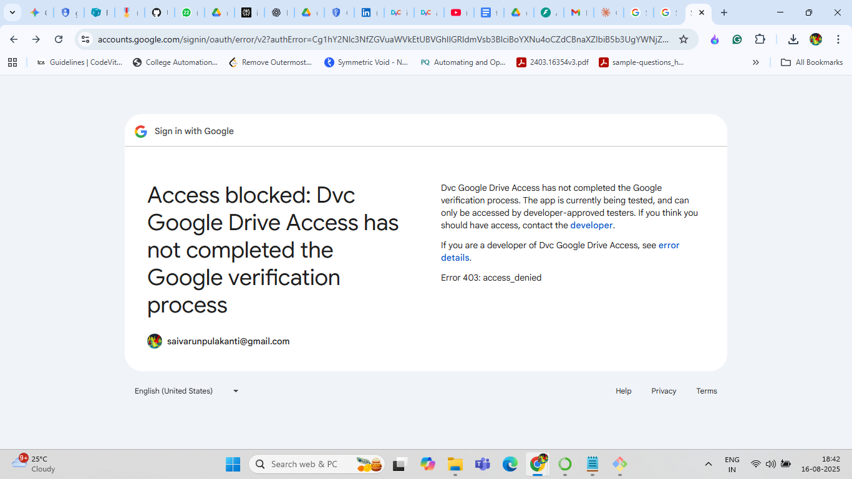

Why This is Necessary
Google blocks applications it doesn't recognize from accessing your data as a security measure. By creating your own private credentials, you are explicitly telling Google, "I am a developer, and I approve this connection to my own Google Drive."

Create a Google Cloud Project
- Go to the Google Cloud Console: https://console.cloud.google.com/
- In the top-left corner, click the project selector dropdown and click NEW PROJECT.
- Name your project (e.g., dvc-auth-project) and click CREATE.

Enable the Google Drive API
- Make sure your new project is selected in the top-left dropdown.
- Click the navigation menu (☰), go to APIs & Services > Library.
- Search for Google Drive API, click on it, and then click the blue ENABLE button.

Configure the OAuth Consent Screen
- In the navigation menu (☰), go to APIs & Services > OAuth consent screen.
- Choose User Type: Select External and click CREATE.
- Fill in the required information:
- App name: DVC Data Uploader (or any name you like).
- User support email: Select your own Google email address.
- Developer contact information: Enter your Google email address again at the bottom.
- Click SAVE AND CONTINUE.
- On the "Scopes" page, don't add anything. Just click SAVE AND CONTINUE.
- On the "Test users" page, click + ADD USERS. Add your own Google email address and click ADD. This is a critical step!
(NOTE: If for some reason the Test users page isn’t visible, then go to audience inside OAuth consent screen to add your own Google email address as a test user.)
- Click SAVE AND CONTINUE, then BACK TO DASHBOARD.

Create and Download Your Credentials
- In the navigation menu (☰), go to APIs & Services > Credentials.
- At the top, click + CREATE CREDENTIALS and choose OAuth client ID.
- For Application type, select Desktop app.
- Leave the name as the default and click CREATE.
- A popup will appear. Click the DOWNLOAD JSON button and save the file to your computer. This file contains your client_id and client_secret.

Configure DVC to Use Your New Credentials
- Open the JSON file you just downloaded with a text editor.
- In your terminal (in your project directory), run the following commands. Copy and paste the client_id and client_secret values from the JSON file to prevent typos.
Bash
dvc remote modify gdrive_storage gdrive_client_id YOUR_CLIENT_ID_FROM_JSON
dvc remote modify gdrive_storage gdrive_client_secret YOUR_CLIENT_SECRET_FROM_JSON
Note on Service Accounts vs. OAuth: The method you provided uses OAuth, which requires you to authenticate via a browser. The step in google drive...add client email from the json file applies to a different method called Service Accounts, which are non-interactive "robot" accounts often used in automated CI/CD pipelines. Since we created "Desktop app" credentials, sharing the folder is not necessary.

Step 4: Push Your Data to Google Drive
You're all set! Now you can push your DVC-tracked data to your Google Drive remote storage.
- Run the DVC Push Command
Bash
dvc push
- Authenticate in Your Browser
A browser window will open, asking you to grant permission for your "app" (DVC Data Uploader) to access your Google Drive.
- You may see a "Google hasn't verified this app" warning. This is expected and safe.
- Click "Advanced" and then "Go to DVC Data Uploader (unsafe)" to proceed.
- Allow the permissions.
Once you authorize it, your terminal will show the upload progress.
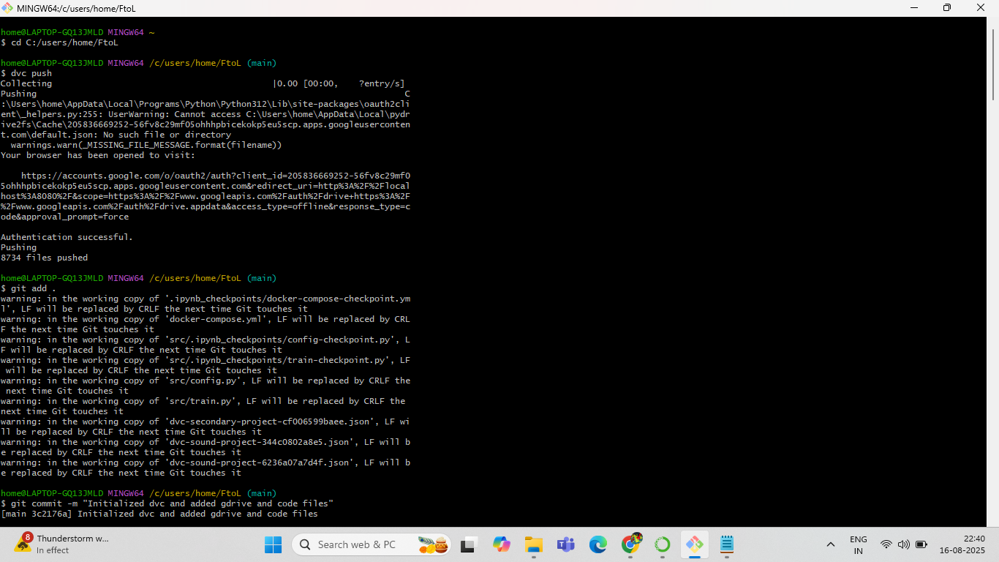

- Verify the Upload
Check your dvc-storage folder in Google Drive. You will see new folders with two-letter names (e.g., d1, a3). Inside them, you'll find your dataset files with long, unique names. This is DVC's content-addressable storage structure, and it's completely normal.
Versioning data with DVC and pushing it to secure remote storage is complete.
NOTE: Do not implement service account or any steps mentioned below while performing authorize dvc with google cloud credentials.(i.e Oauth credentials)
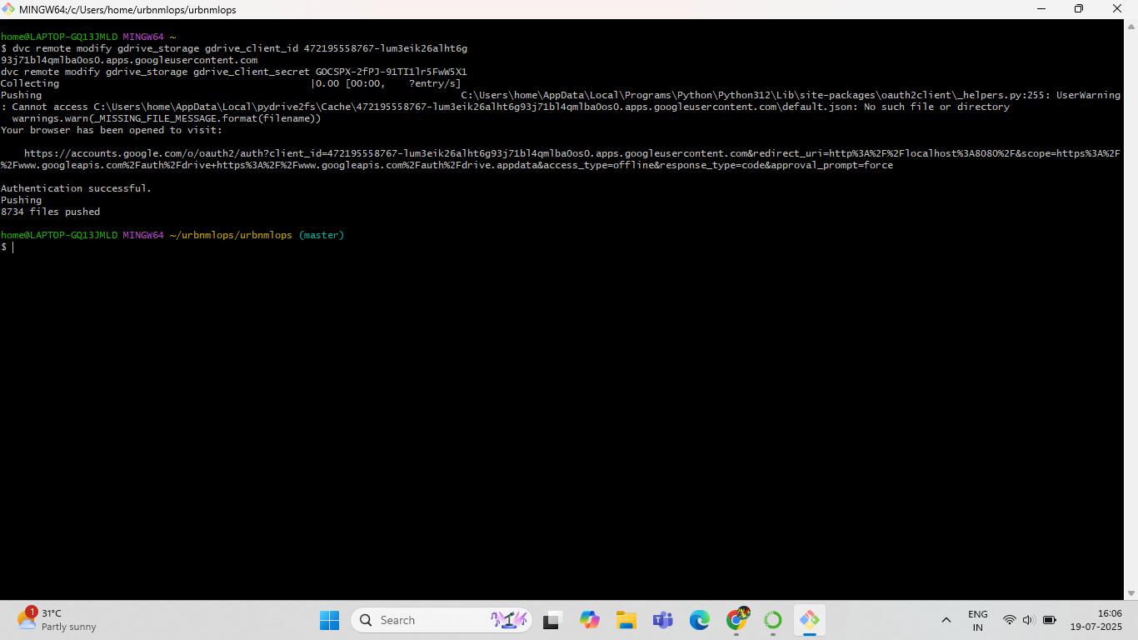
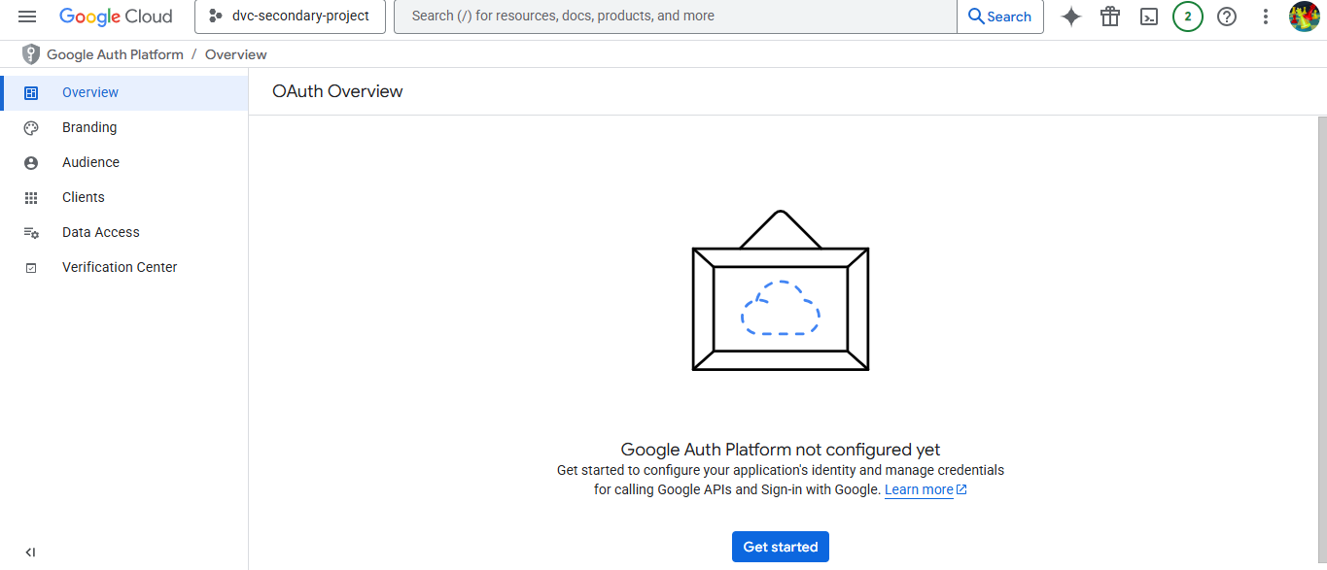
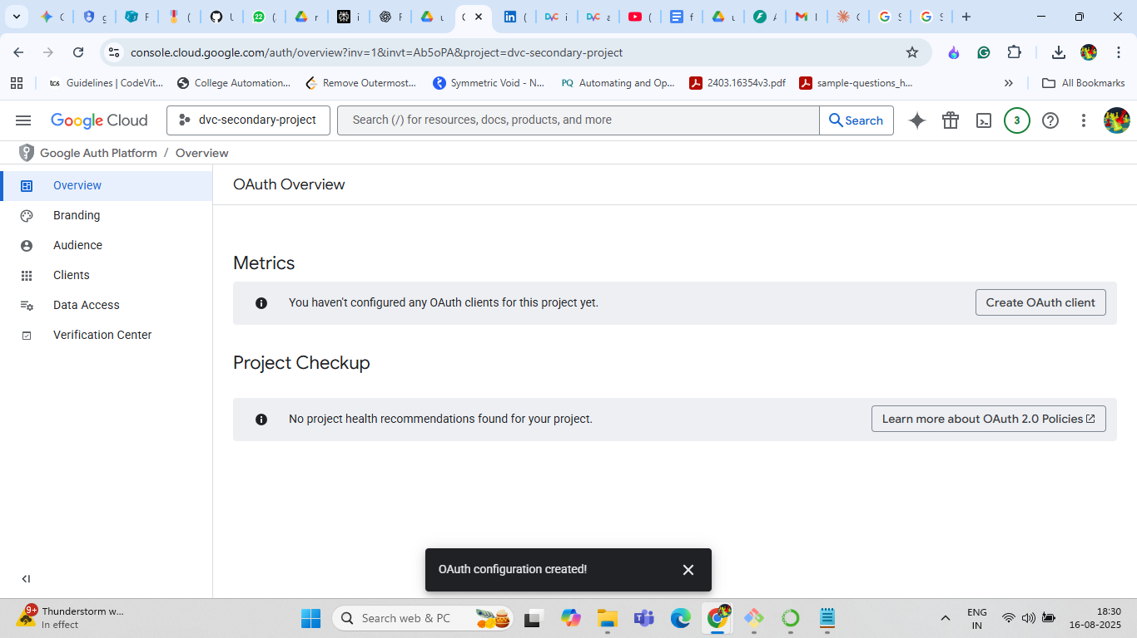
NOTE: The state of .dvc/config file during the above process should look like below picture:
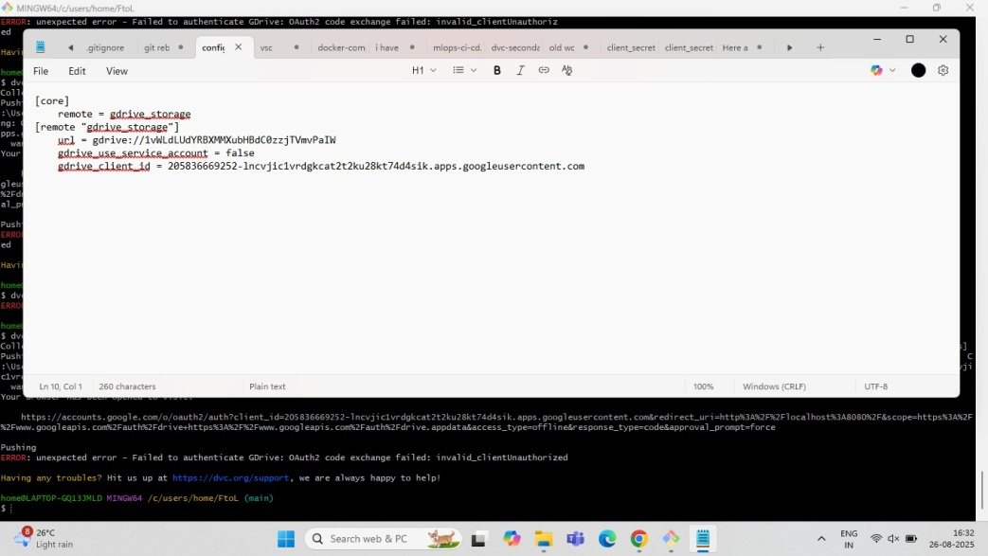
Return to the below steps once you are going to start with Continuous integration.
The process of sharing the Google Drive folder with a client_email is specific to using a Service Account.
This method is different from the previous OAuth workflow and is ideal for non-interactive environments like automated scripts, CI/CD pipelines (e.g., GitHub Actions), or servers where you can't manually authorize through a browser.
Here are the complete steps for setting up and using a Google Cloud Service Account with DVC.

Guide: Using a Service Account for DVC with Google Drive
This method creates a non-human, "robot" account that DVC can use to directly access your Google Drive folder without requiring a browser login each time.

Prerequisites
- You have already initialized your DVC project (dvc init).
- You have created a folder in Google Drive to use as remote storage.
- You have added it as a DVC remote (e.g., dvc remote add -d gdrive_storage gdrive://<YOUR_FOLDER_ID>).

Step 1: Create a Google Cloud Service Account
First, we need to create the identity for our "robot" user in Google Cloud.
- Navigate to the Service Accounts Page
- Go to the Google Cloud Console.
- Make sure your project (e.g., dvc-auth-project) is selected in the top navigation bar.
- Open the navigation menu (☰) and go to IAM & Admin > Service Accounts.
- Create the New Service Account
- At the top of the page, click + CREATE SERVICE ACCOUNT.
- Service account name: Give it a descriptive name, like dvc-storage-manager. The "Service account ID" will be filled in automatically.
- Description: Add a description for your future reference, such as "Service account for DVC to access Google Drive storage."
- Click CREATE AND CONTINUE.
- Grant Permissions (Optional but Recommended)
- The "Grant this service account access to project" step appears. While not strictly required for Drive access (which is managed in Drive itself), it's good practice to grant the Viewer role or Editor role. This allows the account to see project resources.
- Select the role "Viewer" and click CONTINUE.
- Click DONE on the final step.

Step 2: Generate and Download the Service Account Key
Now we create the "password" for this robot account—a JSON key file that DVC will use to authenticate.
- Find Your New Service Account
- You will be back on the Service Accounts list page. Find the account you just created.
- Click the three vertical dots (⋮) under the Actions column and select Manage keys.
- Create a New Key
- Click on ADD KEY and select Create new key.
- Choose the JSON key type. This is the only format DVC uses.
- Click CREATE.
- Download and Secure the Key
- A JSON file will be automatically downloaded to your computer.
- Treat this file like a password. Do not commit it to Git or share it publicly. Store it in a secure location on your machine. (add this json file to .gitignore to avoid commiting to the repository).

Step 3: Share the Google Drive Folder with the Service Account
This is the most critical step. You must give your new service account explicit permission to read and write to your DVC storage folder in Google Drive.
- Find the client_email
- Open the downloaded JSON key file with a text editor.
- Find the field named "client_email" and copy the entire email address. It will look something like dvc-storage-manager@your-project-id.iam.gserviceaccount.com.
- Share the Folder in Google Drive
- Go to your Google Drive and find the folder you are using for DVC storage.
- Right-click the folder and select Share, or click the three dots (⋮) and then Share.
- In the "Add people and groups" field, paste the client_email you copied from the JSON file.
- Ensure that the service account is given the Editor role. This is required for DVC to be able to add, delete, and modify files.
- Uncheck the "Notify people" box (since this is not a real person) and click Share.

Step 4: Configure DVC to Use the Service Account Key
Finally, tell DVC where to find the key file.
- Modify the DVC Remote
- In your terminal, navigate to your project's root directory.
- Run the following command, replacing <remote_name> with your remote's name (e.g., gdrive_storage) and providing the full path to the downloaded JSON file.
Bash
dvc remote modify gdrive_storage gdrive_service_account_json_file_path /path/to/your/downloaded-key-file.json
Example:
If you stored the file in /home/user/secrets/dvc-key.json, the command would be:
Bash
dvc remote modify gdrive_storage gdrive_service_account_json_file_path /home/user/secrets/dvc-key.json
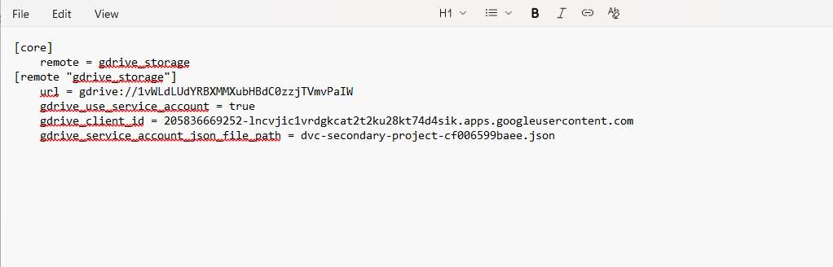

- Commit the Configuration Change
This command modifies your .dvc/config file. You should commit this change to Git.
Bash
git add .dvc/config
git commit -m "Configure DVC remote with service account"

Step 5: Push Data Non-Interactively
You are now ready to push your data.
Bash
dvc push

Note: if you are executing the continuous integration file then the following steps need to be implemented:

Part 2: Fix Your GitHub Actions Workflow
Now that your local machine is working, we must provide these new user credentials to your CI/CD workflow.
Step 1: Find the New Credentials File
After the successful push, DVC created a new file. Look inside your .dvc folder for a file named gdrive-user-credentials.json.
Step 2: Create a New GitHub Secret
- Open the gdrive-user-credentials.json file in a text editor.
- Copy the entire contents of this file.
- Go to your GitHub repository.
- Go to Settings -> Secrets and variables -> Actions.
- Click New repository secret.
- Name the new secret: GDRIVE_USER_CREDENTIALS
- Paste the JSON content you copied into the "Secret" value box.
- Click Add secret.
Step 3: Update the GitHub Actions Workflow File
Finally, edit your .github/workflows/your-workflow-file.yml. Replace the old "Configure DVC" step with this new one that uses the user credentials.
- Verify Your .dvc/config File
Make sure your .dvc/config file is set up to use the service account. It should look like this (this is likely its current, correct state):
Ini, TOML
[remote "gdrive_storage"]
url = gdrive://<your_folder_id>
gdrive_use_service_account = true

Replace this:
YAML
- name: Configure DVC with Google Drive Service Account
run: |
echo '${{ secrets.GDRIVE_SEC_CRED_DATA }}' > .dvc/dvc-secondary-project-cf006599baee.json

with this:
YAML
- name: Configure DVC with Google Drive User Credentials
run: |
echo '${{ secrets.GDRIVE_USER_CREDENTIALS }}' > .dvc/gdrive-user-credentials.json

Step 4: Commit and Push Your Changes
Don't forget to commit the changes you made to .dvc/config and your workflow file to Git.
Bash
git add .dvc/config .github/
git commit -m "fix: Switch to DVC user authentication for GDrive"
git push
Your local machine and your GitHub Actions workflow will now be fully functional.
The key difference now is that no browser window will open. DVC will use the JSON key file to authenticate directly with Google's servers and upload your files. The process will run entirely within your terminal, making it perfect for automation.
- GENERATE DOCKERHUB TOKEN:
Why it’s necessary: GitHub Actions runner tries to pull the base image (python:3.11-slim) from Docker Hub. Docker Hub imposes strict rate limits on anonymous (unauthenticated) pulls. Since GitHub Actions runners often share IP addresses, these limits are hit very easily, causing the connection to be denied.
- Solution: You need to log in to Docker Hub as part of your workflow before building the images. Add this step to your YAML workflow file right before the docker compose build step:
YAML
- name: Log in to Docker Hub
uses: docker/login-action@v3
with:
username: ${{ secrets.DOCKERHUB_USERNAME }}
password: ${{ secrets.DOCKERHUB_TOKEN }}
Note: You must first save your Docker Hub username and a personal access token as secrets named DOCKERHUB_USERNAME and DOCKERHUB_TOKEN in your GitHub repository's settings.

Summary: OAuth vs. Service Account
Feature | OAuth (Desktop App Method) | Service Account Method
Use Case | Local development, personal machines. | Servers, CI/CD pipelines, automated scripts.
Authentication | Interactive. Opens a browser for you to log in and grant permission. | Non-interactive. Uses a downloaded JSON key file.
Google Drive Setup | No sharing required. You authorize access to your own account. | Must share the Drive folder with the Service Account's client_email as an Editor.
Security | Credentials (client ID/secret) are public but require your login. | The downloaded JSON key file is a highly sensitive secret and must be protected.
DVC Command | dvc remote modify <remote> gdrive_client_id ... | dvc remote modify <remote> gdrive_service_account_json_file_path ...

CHAPTER 4: MODEL DEVELOPMENT AND TRAINING

4.1 - Experiment Tracking with MLflow
MLflow is integrated directly into the training script to ensure reproducibility and easy comparison of experiments.
- Logging: Inside a with mlflow.start_run(): block, you can log parameters, metrics, and model artifacts. The model itself should be logged using a framework-specific function like mlflow.pytorch.log_model() or mlflow.tensorflow.log_model() to ensure it can be registered. Using generic functions like mlflow.log_artifact() for the model file will prevent the "Register Model" button from appearing in the UI.
- Viewing Experiments: The MLflow UI is launched with the mlflow ui command, providing a web interface to view, sort, and compare all logged runs.
- If you want to manually push a model run to production then click on the model under run name column and click blue colored register model button at the top right and give the name as production.
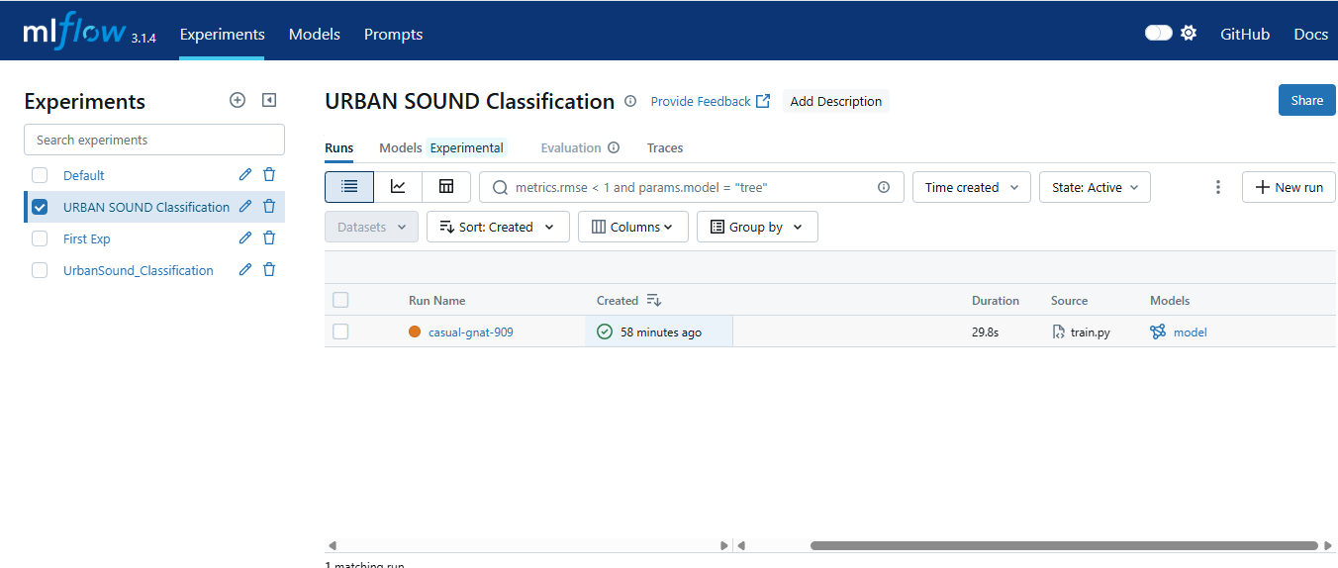
Home page of MLFLOW: After running the experiment
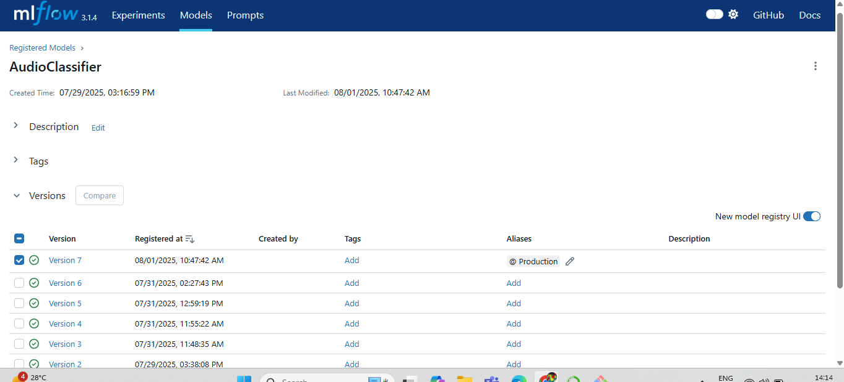
List of Registered models page: Under models section
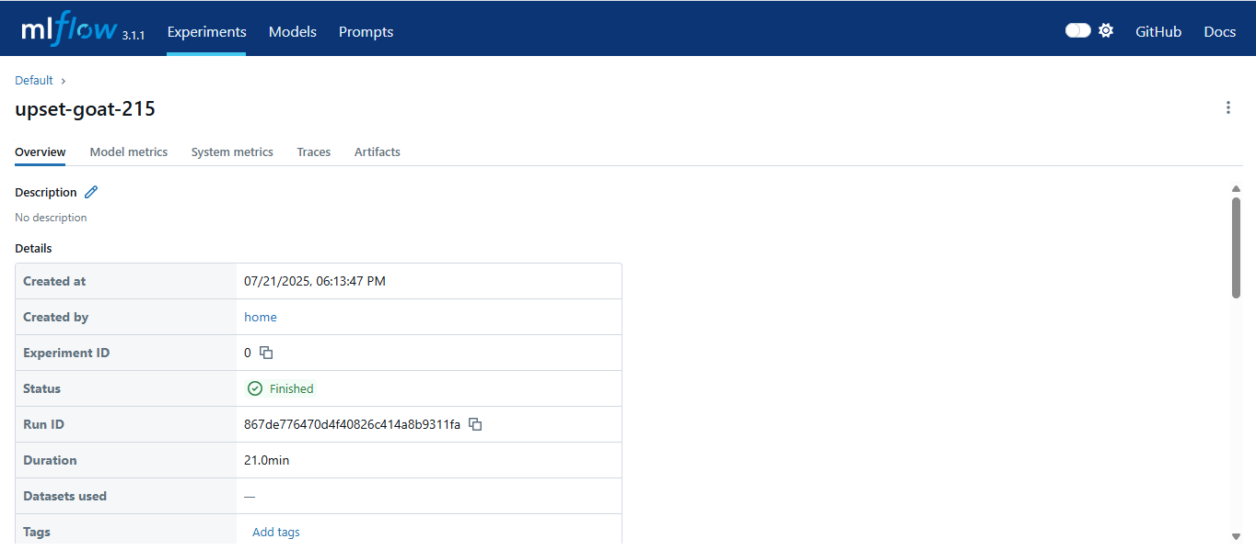
Experiment run information: After clicking the model run under run name column
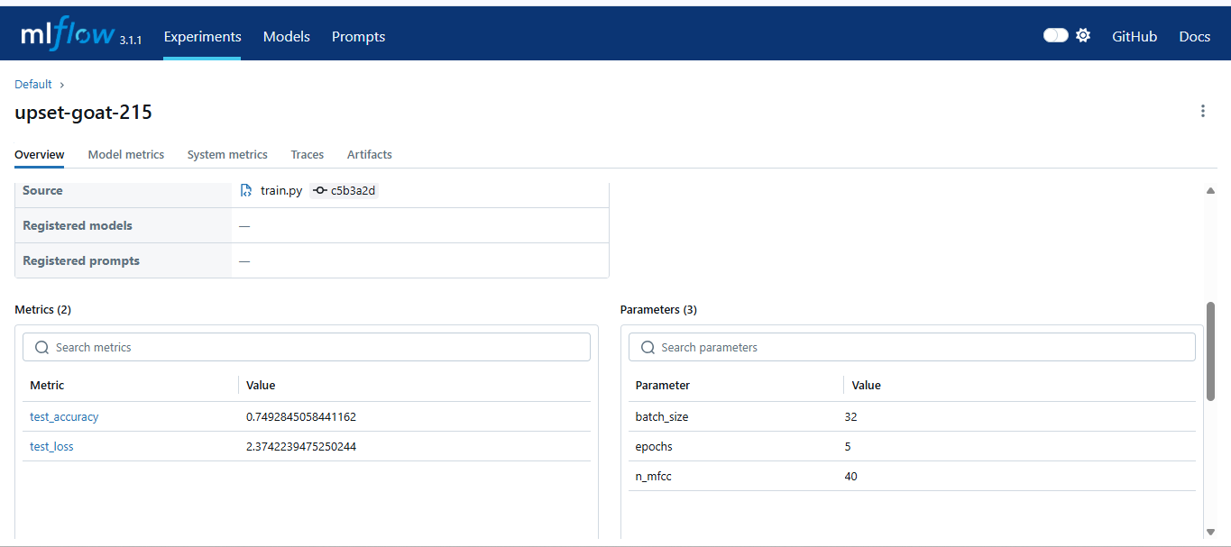
Experiment run information
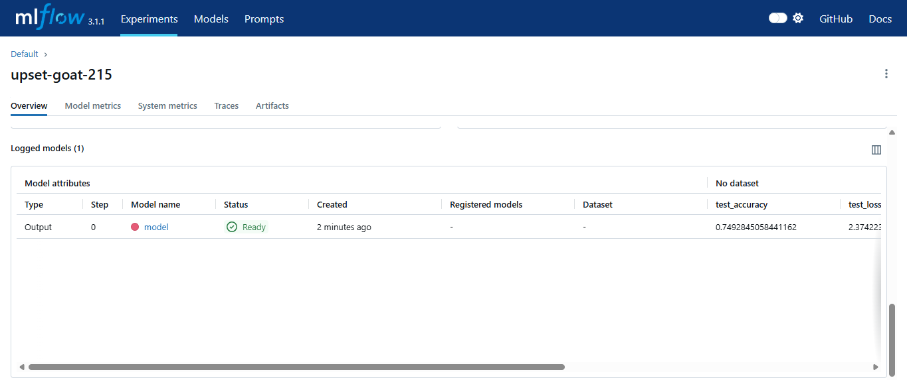
Overview of the model run
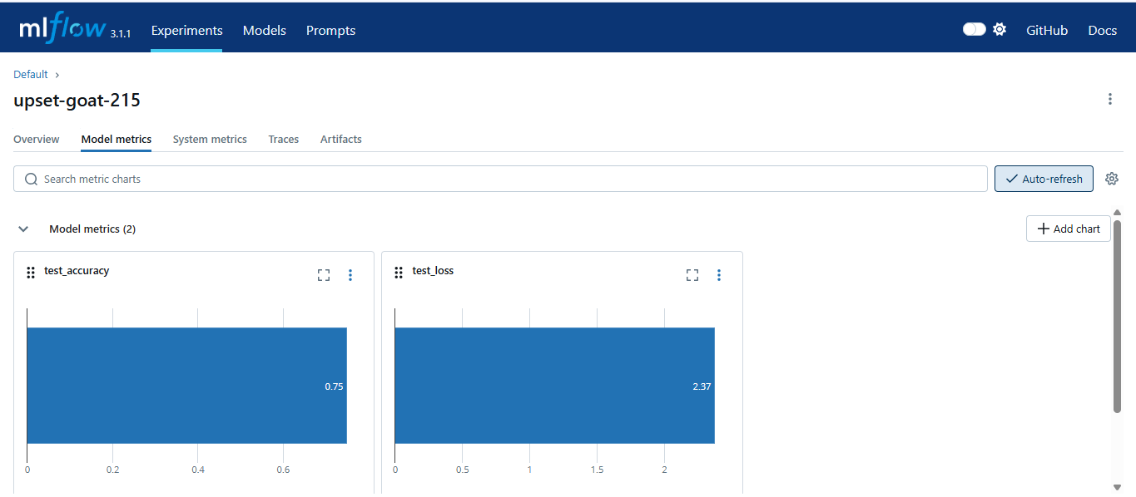
Model metrics of a model run
Here’s the roadmap:
- Install MLflow
pip install mlflow
- Run MLflow UI locally
mlflow ui --port 5000
- Test with a Hello World script
Log a param + metric.
- Set tracking URI & experiment
Decide between local file:./mlruns or server http://127.0.0.1:5000.
- Prepare your data & preprocessing
Load → normalize → encode labels.
- Start MLflow run
  - Log params.
  - Train model.
  - Log metrics.
  - Save preprocessing artifacts.
- Log + Register Model
Use mlflow.tensorflow.log_model and mlflow.register_model.
- Promote Best Model
Compare accuracies → set alias "Production".
Detailed version of above steps:

Install MLflow
On your local machine:
pip install mlflow
If you’re using TensorFlow + scikit-learn, also install:
pip install tensorflow scikit-learn joblib

Start an MLflow Tracking Server
You need a backend to log runs.

Option A: Local File-Based
Just set:
mlflow.set_tracking_uri("file:./mlruns")
This saves experiments to a folder mlruns/ in your project.

Option B: Local Server (UI)
Run MLflow UI server locally:
mlflow ui --port 5000
Then browse at http://127.0.0.1:5000.

Option C: Docker Server
You can run an MLflow server in Docker Compose and point to:
mlflow.set_tracking_uri("http://mlflow-server:5000")
Your script even has a helper function is_port_open() that decides whether to use the local UI or fallback to file-based logging.

Basic Experiment Logging (Hello World)
Before touching your audio classifier, try a simple example:
import mlflow
#if running locally i.e option B then the mlruns folder will be created #automatically. The above line explanation about mlruns folder in option B
mlflow.set_tracking_uri("file:./mlruns")#Fetches models from the local mlruns folder
mlflow.set_experiment("hello-world-exp")

with mlflow.start_run():
mlflow.log_param("alpha", 0.5)
mlflow.log_metric("accuracy", 0.87)
mlflow.log_artifact("some_file.txt")
Run this, then open MLflow UI (mlflow ui) to see results.

Integrate with TensorFlow / Keras
MLflow has autologging for TensorFlow:
import mlflow.tensorflow
mlflow.tensorflow.autolog()
That way, training + metrics are automatically logged. In your final script, you chose manual logging (more control).

Set Up Experiment for Your Project
In your script:
EXPERIMENT_NAME = "Final-sound-cls-model"
experiment = mlflow.get_experiment_by_name(EXPERIMENT_NAME)
if experiment is None:
mlflow.create_experiment(EXPERIMENT_NAME)
mlflow.set_experiment(EXPERIMENT_NAME)
This ensures your runs are grouped under one experiment.

Prepare Your Data & Artifacts
You load audio → extract MFCCs → preprocess → encode labels.
Artifacts saved:
joblib.dump(le, config.LABEL_ENCODER_ARTIFACT_NAME)
joblib.dump({'mean': mean, 'std': std}, config.NORMALIZATION_STATS_ARTIFACT_NAME)
Then logged to MLflow:
mlflow.log_artifact(config.LABEL_ENCODER_ARTIFACT_NAME, "preprocessing")
mlflow.log_artifact(config.NORMALIZATION_STATS_ARTIFACT_NAME, "preprocessing")
So, later, anyone can download your preprocessing objects.

Train & Log Model
Inside with mlflow.start_run():
- Log params (epochs, batch_size).
- Log metrics (accuracy, loss).
- Train & evaluate CNN.
- Save + log model:
mlflow.tensorflow.log_model(cnn_model, "model", input_example=input_example)

Register & Promote Models
Your script includes conditional registration:
- Check if a "Production" model exists.
- Compare new model’s accuracy with previous.
- If better → register as a new version and tag "Production".
- Else → skip.
That’s a CI/CD style promotion flow.

4.2 - Model Training and Hyperparameter Tuning
- Training Script: The train.py script contains the complete logic for training. It loads data, initializes the model, defines the loss function (nn.CrossEntropyLoss) and optimizer (optim.SGD), and executes the training loop.
- Configuration: All hyperparameters (e.g., batch_size, epochs, learning_rate) and paths are externalized into a config.py file, allowing for easy modification of experiments without changing the source code.

4.3 - Model Evaluation and Validation
After training, the model undergoes evaluation and validation.
- Model Registration: In the MLflow UI, you navigate to the artifacts of a specific run, click on the model folder, and then click the "Register Model" button. The model is then assigned a version number and can be promoted through lifecycle stages, such as from None to Staging and finally to Production.
Note: From the below part of code:
- try:
- # --- THIS IS THE FIX ---
- # Get the model version currently tagged with the 'Production' alias
- latest_prod_version = client.get_model_version_by_alias(REGISTERED_MODEL_NAME, "Production")

- # Get the run associated with this model version
- prod_run = client.get_run(latest_prod_version.run_id)

- # Get the accuracy from that run's metrics
- previous_accuracy = prod_run.data.metrics.get("test_accuracy", -1.0)
- print(f"Found existing 'Production' model (Version: {latest_prod_version.version}) with accuracy: {previous_accuracy:.4f}")

- except MlflowException as e:
- # This will happen if the alias "Production" doesn't exist yet (e.g., first run)
- if "not found" in str(e).lower():
- print("No 'Production' model found. This run will create the first one.")
- else:
- # Handle other potential exceptions
- raise e

- # Perform the comparison and register/promote if better
- if test_acc > previous_accuracy:
- print(f"New model accuracy ({test_acc:.4f}) is better than previous ({previous_accuracy:.4f}).")
- print("Registering new model version and setting alias to 'Production'...")

- # Register the model logged earlier in this run
- result = mlflow.register_model(
- model_uri=f"runs:/{run_id}/model",
- name=REGISTERED_MODEL_NAME
- )

- # Set the 'Production' alias for the new version. MLflow automatically
- # moves the alias if it already exists on another version.
- client.set_registered_model_alias(
- name=REGISTERED_MODEL_NAME,
- alias="Production",
- version=result.version
- )
- print(f"✅ Successfully registered Version {result.version} and set 'Production' alias.")

- else:
- print(f"New model accuracy ({test_acc:.4f}) is not better than the current 'Production' model ({previous_accuracy:.4f}).")
- print("❌ Model will not be registered or promoted.")
NOTE:I’m setting the highest accuracy model as production version by fetching the model through get_model_version_by_alias method. We are fetching the model through alias name because in current version of mlflow , we can only fetch it this way unlike in previous versions where model is fetched through stage attribute representing stage level For eg:Production stage.

CHAPTER 5: CONTINUOUS INTEGRATION AND DELIVERY (CI/CD)

5.1 - Automating Workflows with GitHub Actions
GitHub Actions is used to automate the CI/CD pipeline. Workflows are defined in YAML files located in the .github/workflows/ directory and are triggered by events like a push to a branch or a manual trigger (workflow_dispatch).

5.2 - Continuous Integration: Automated Testing and Linting
The CI pipeline focuses on code and data quality. A typical CI workflow includes jobs for setting up the environment, installing dependencies, running code quality checks like linting, executing unit tests, validating data, and running a quick model training test on a small dataset.

5.3 - Continuous Delivery: Building Docker Containers
Upon successful CI, the Continuous Delivery (CD) stage begins. A key step is automatically building a Docker image of the application using the Dockerfile. The GitHub Actions workflow uses actions like docker/build-push-action to build the image.

5.4 - Storing Artifacts: Docker Hub and Model Registries
- Container Images: The built Docker image is pushed to a container registry like Docker Hub, which offers free public repositories. The workflow requires secrets (e.g., DOCKERHUB_USERNAME, DOCKERHUB_TOKEN) to log in and push the image.
- Model Artifacts: The trained model is stored and versioned in the MLflow Model Registry, which serves as a central hub for managing the model's lifecycle.
You don’t have to manually execute the ci file everytime you incorporate changes to the files in your repository.
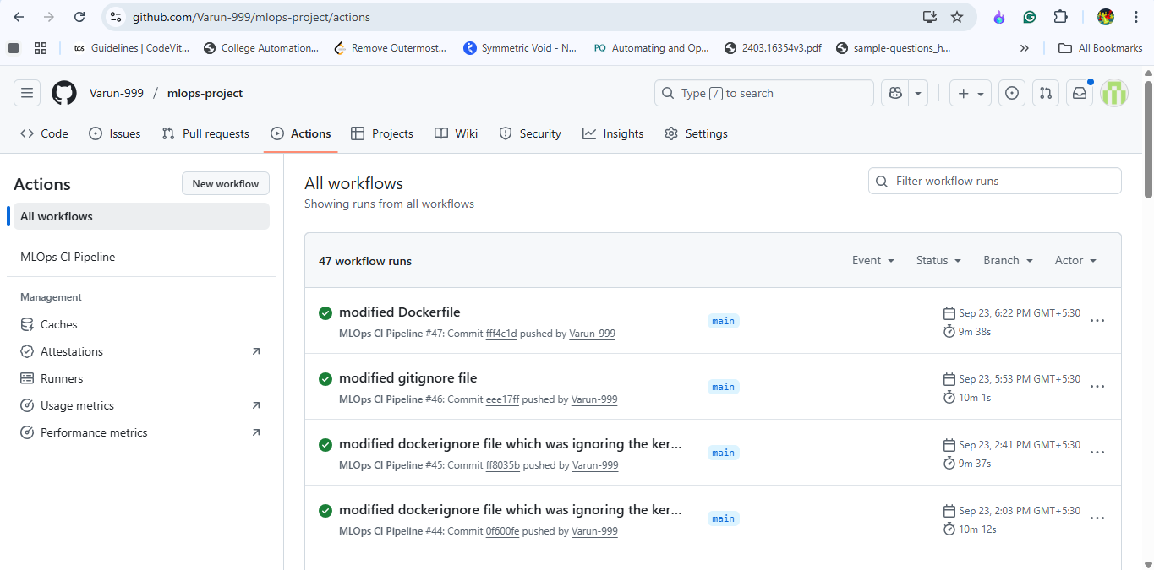
Github Actions page
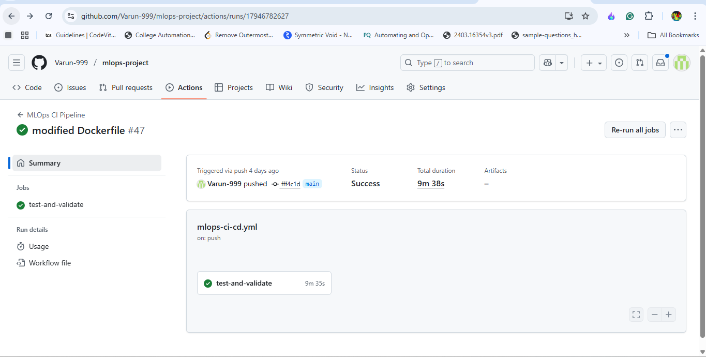
Click on any run under workflow runs
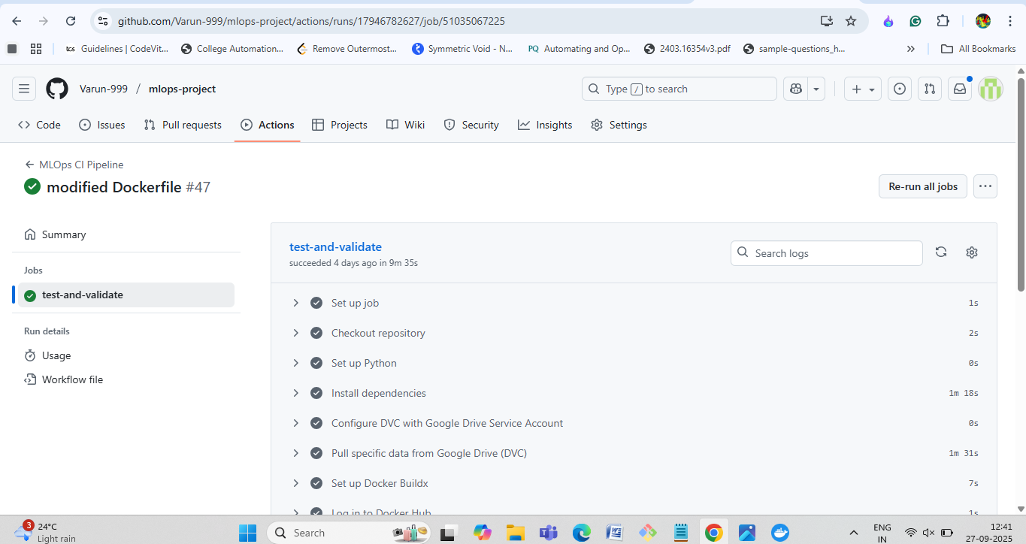
After clicking on the test and validate from previous picture will lead to this above picture
- Create an account on dockerhub, so that we can download images and push local images to it.
- For our docker image push to work, we have to setup an account then create a repository as shown in below picture.

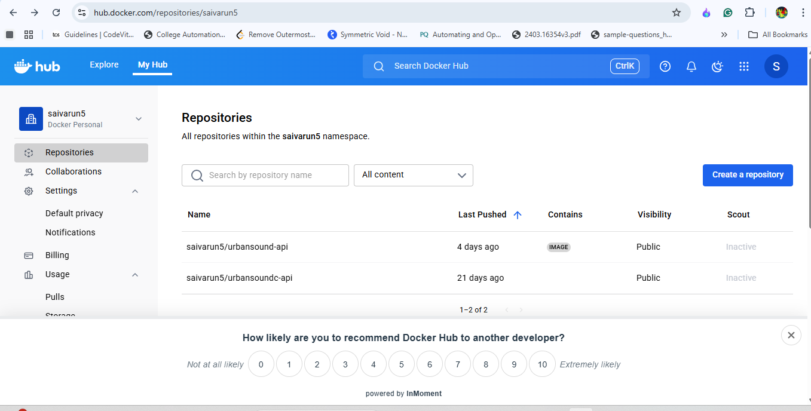
Dockerhub home page after log in
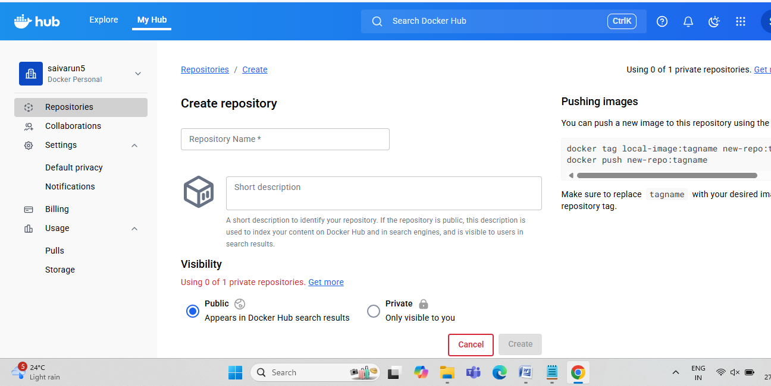
After clicking the create repository button
Create a repository with a name and the same name should be given when building image locally.
Steps for pushing a Docker image to DockerHub.

🔹 1. Login to DockerHub
docker login
- Enter your DockerHub username and password (or token).
- If successful → you’ll see: Login Succeeded.

🔹 2. Build your Docker image
Assume you have a Dockerfile in the current directory.
docker build -t username/repository-name:tag .
✅ Example:
docker build -t saivarun/my-fastapi-app:v1 .
- username → your DockerHub username.
- repository-name → name of the repo on DockerHub (will be created automatically if it doesn’t exist).
- tag → version label (v1, latest, etc.).

🔹 3. Verify the image is built
docker images
You should see something like:
REPOSITORY TAG IMAGE ID SIZE
saivarun/my-fastapi-app v1 abc12345 200MB

🔹 4. Push the image to DockerHub
docker push username/repository-name:tag
✅ Example:
docker push saivarun/my-fastapi-app:v1

🔹 5. Pull the image anywhere
On another machine (or server), you can pull it with:
docker pull saivarun/my-fastapi-app:v1
⚡ Tip: If you want the image to always update without versioning, use the tag latest:
docker build -t saivarun/my-fastapi-app:latest .
docker push saivarun/my-fastapi-app:latest
- The above part is automated in CI.yml file, i.e whenever new changes to the code are made, upon git push command the ci workflow triggers and an automated job is done which processes the docker build and push commands.
- The CI file for GitHub actions contains all the jobs that will run on specific event triggering. I used GitHub actions to build-test-run the code everytime push/pull occurs on the GitHub repository
- For smooth execution of CI file all the credentials json files generated on google cloud and others MUST BE ADDED TO THE GITHUB SECRETS and saved with any name and the same should be reflected in your program because when CI file needs these credentials it fetches these from the secrets.

Then setting up google cloud run for deployment is the next step.
- The docker image pushed from CI step is now fetched by the cloud run by providing the image url in the docker image url field as shown in below picture.
- Then specify remaining fields according to your use, refer the below pictures to get to know of conventional options.
- After filling all the fields, click CREATE. This will start the process of deploying the service and once it’s done the deployed service can be accessed through the URL as shown below.

CHAPTER 6: MODEL DEPLOYMENT

6.1 - Creating a REST API with FastAPI
FastAPI is used to wrap the trained model in a REST API for serving real-time predictions.
- Implementation: An API script (e.g., app.py, main.py) is created to house the API logic. The model is loaded from the MLflow Model Registry once when the application starts up using a @app.on_event("startup") handler for efficiency. A prediction endpoint (e.g., @app.post("/predict")) accepts file uploads, processes the input, and returns a JSON prediction. A /health endpoint is included for basic health checks by cloud providers.
- Testing: FastAPI automatically generates interactive Swagger UI documentation at the /docs URL for testing the endpoint directly in the browser.

Install Requirements
Start by installing FastAPI + Uvicorn:
pip install fastapi uvicorn
For ML/audio later:
pip install tensorflow scikit-learn joblib librosa python-multipart

Basic FastAPI (Hello World)
main.py
from fastapi import FastAPI

app = FastAPI()

@app.get("/")
def root():
return {"message": "Hello, FastAPI is running!"}
Run:
uvicorn main:app --reload
Check at 👉 http://127.0.0.1:8000
Docs at 👉 http://127.0.0.1:8000/docs

Simple Prediction Endpoint (Hardcoded Model)
Simulation of ML inference with a dummy function.
from fastapi import FastAPI
from pydantic import BaseModel

app = FastAPI()

class PredictRequest(BaseModel):
x: float

class PredictResponse(BaseModel):
prediction: float

@app.post("/predict", response_model=PredictResponse)
def predict(request: PredictRequest):
# Fake model: multiply input by 2
result = request.x * 2
return {"prediction": result}
Test with:
curl -X POST "http://127.0.0.1:8000/predict" -H "Content-Type: application/json" -d '{"x": 5}'

Load a Real Model (Scikit-learn Example)
Train and save model (outside FastAPI):
from sklearn.linear_model import LogisticRegression
import joblib

X = [[0], [1], [2], [3]]
y = [0, 0, 1, 1]
model = LogisticRegression().fit(X, y)
joblib.dump(model, "model.joblib")
Now load in FastAPI:
from fastapi import FastAPI
from pydantic import BaseModel
import joblib

app = FastAPI()
model = joblib.load("model.joblib")

class PredictRequest(BaseModel):
x: float

@app.post("/predict")
def predict(request: PredictRequest):
prediction = model.predict([[request.x]])[0]
return {"prediction": int(prediction)}

File Upload Prediction (Audio Example Minimal)
Switch from JSON input → audio file upload.
from fastapi import FastAPI, UploadFile, File
import librosa
import numpy as np

app = FastAPI()

@app.post("/predict")
async def predict(file: UploadFile = File(...)):
# Load audio file
y, sr = librosa.load(file.file, sr=22050, duration=4)
mfccs = librosa.feature.mfcc(y=y, sr=sr, n_mfcc=13)

# Fake model logic: classify by average energy
avg_val = np.mean(mfccs)
if avg_val > 0:
label = "Positive"
else:
label = "Negative"

return {"predicted_class": label}
Upload a .wav file in Swagger UI at 👉 /docs

Production-Ready Advanced Version (Your Script)
Finally → the script you pasted adds:
- Startup event: Loads TensorFlow model + preprocessing artifacts.
- CORS middleware: Allows frontend apps to call API.
- Multiple endpoints: /, /health, /info, /predict.
- Graceful fallback: If artifacts missing, API runs in demo mode.
- Error handling: HTTPException with proper messages.
- Structured responses with Pydantic models.
Run this with:
uvicorn main:app --host 0.0.0.0 --port 8000 --reload
Artifacts expected in /app/artifacts/:
- model.keras
- label_encoder.joblib
- normalization_stats.joblib

Command Progression Recap
- Start server:
- uvicorn main:app --reload
- Call GET root:
- curl http://127.0.0.1:8000/
- Call POST predict (JSON version):
- curl -X POST "http://127.0.0.1:8000/predict" -H "Content-Type: application/json" -d '{"x": 5}'
- Call POST predict (File version):
- curl -X POST "http://127.0.0.1:8000/predict" -F "file=@sample.wav"
When you use different decorators in FastAPI, they tell FastAPI how to handle requests for specific endpoints.

1. @app.get("/...")
- Means: "When someone sends a GET request to this path, run this function."
- GET = fetching data (no body usually).
- Example:
@app.get("/ping")
def ping():
return {"message": "pong"}
👉 If you open http://localhost:8000/ping, you’ll see {"message": "pong"}.

2. @app.post("/...")
- Means: "When someone sends a POST request, run this function."
- POST = sending data (usually JSON in the body).
- Example:
@app.post("/predict")
def predict(input: dict):
return {"result": input}
👉 You send JSON via POST, it returns processed output.

3. @app.put("/...")
- Means: "Handle a PUT request."
- PUT = update an existing record with new info.
- Example:
@app.put("/update/{item_id}")
def update_item(item_id: int, data: dict):
return {"item_id": item_id, "updated_data": data}

4. @app.delete("/...")
- Means: "Handle a DELETE request."
- DELETE = remove something.
- Example:
@app.delete("/remove/{item_id}")
def remove_item(item_id: int):
return {"message": f"Item {item_id} deleted"}

How it flows (step by step when you run script):
- FastAPI app starts (with uvicorn app:app).
- FastAPI scans all decorators (@app.get, @app.post, etc.) and registers routes in memory.
- When a request comes in:
  - It checks URL path + HTTP method (GET/POST/PUT/DELETE).
  - Matches it to the right function.
  - Extracts input (query, body, path).
  - Calls your function and gets a result.
  - Converts result to JSON automatically and sends it back.
⚡ So decorators = routing instructions for FastAPI.
They tell FastAPI “If this type of request comes to this path → run this function.”
6.2 - Containerization with Docker
The Dockerfile and docker-compose.yml files are used to create and manage containerized applications with Docker, ensuring your project runs consistently across any environment.
Dockerfile: The Blueprint
The Dockerfile is a script containing a set of instructions to build a single Docker image.
Think of it as a recipe for creating a standardized, self-contained environment for one piece of your application (like your web API). It specifies everything needed to run that service: the base operating system, system dependencies, Python packages, your source code, and the default command to start the application.

Its primary purpose is to define what goes inside one container.
docker-compose.yml: The Orchestrator
The docker-compose.yml file is a configuration file used to define and run a multi-container Docker application.
Think of it as the master plan or the conductor of an orchestra. It tells Docker how to run and connect multiple services together to form a complete application stack. For example, it defines your web API, your MLflow server, and a training job, and manages their network, ports, and shared data volumes.
Its primary purpose is to define how multiple containers work together.

How They Work Together
The two files are designed to be used together:
- You create a Dockerfile for each custom service in your application (e.g., your FastAPI app, your training job).
- In the docker-compose.yml file, you reference these Dockerfiles (using the build: key) to build the images.
- You then use the single command docker compose up to build, run, and connect all the services defined in your docker-compose.yml file at once.
The FastAPI application is packaged into a Docker container for consistent deployment.
- Create requirements.txt: A list of all Python dependencies is generated with pip freeze > requirements.txt.
- Create a Dockerfile: This file provides instructions to build the image, including copying source code, installing dependencies, and specifying the command to run the uvicorn server.
- Build and Run: The image is built using docker build -t <image-name> . and run locally for testing with docker run -p 8000:8000 <image-name>.
- Run docker compose locally: Run docker-compose locally through docker compose up command, mind you while running this command the docker desktop app should be running in the background.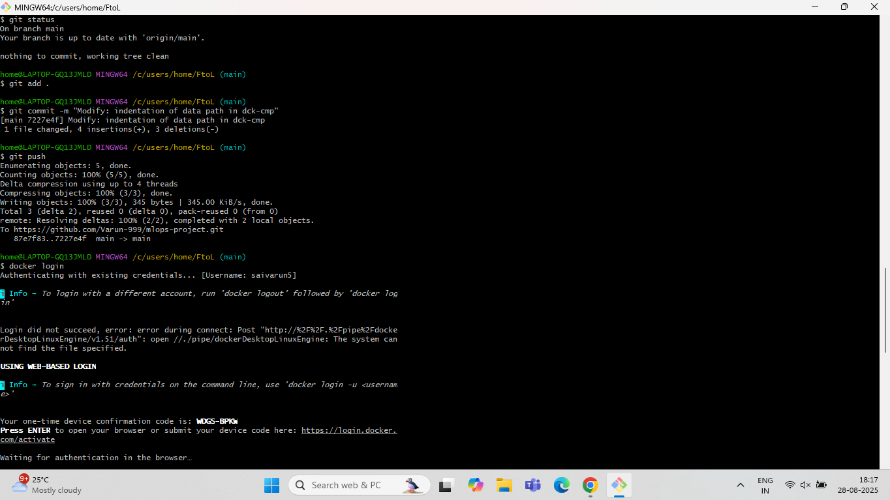
Initial docker login setup from CLI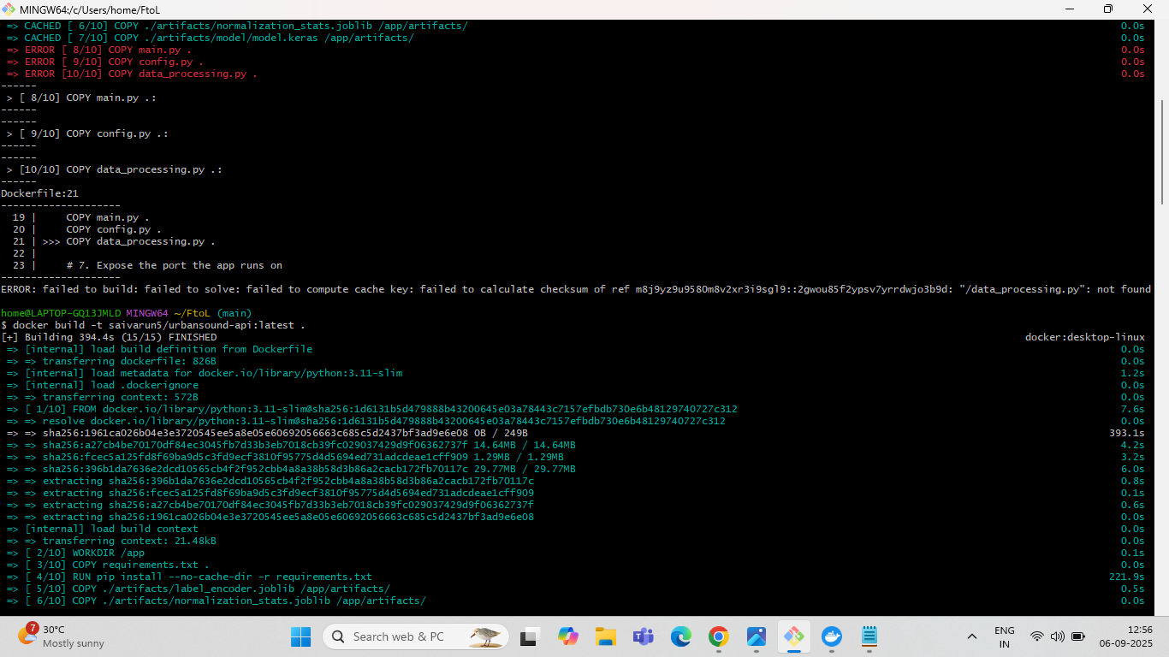
Docker build Image command
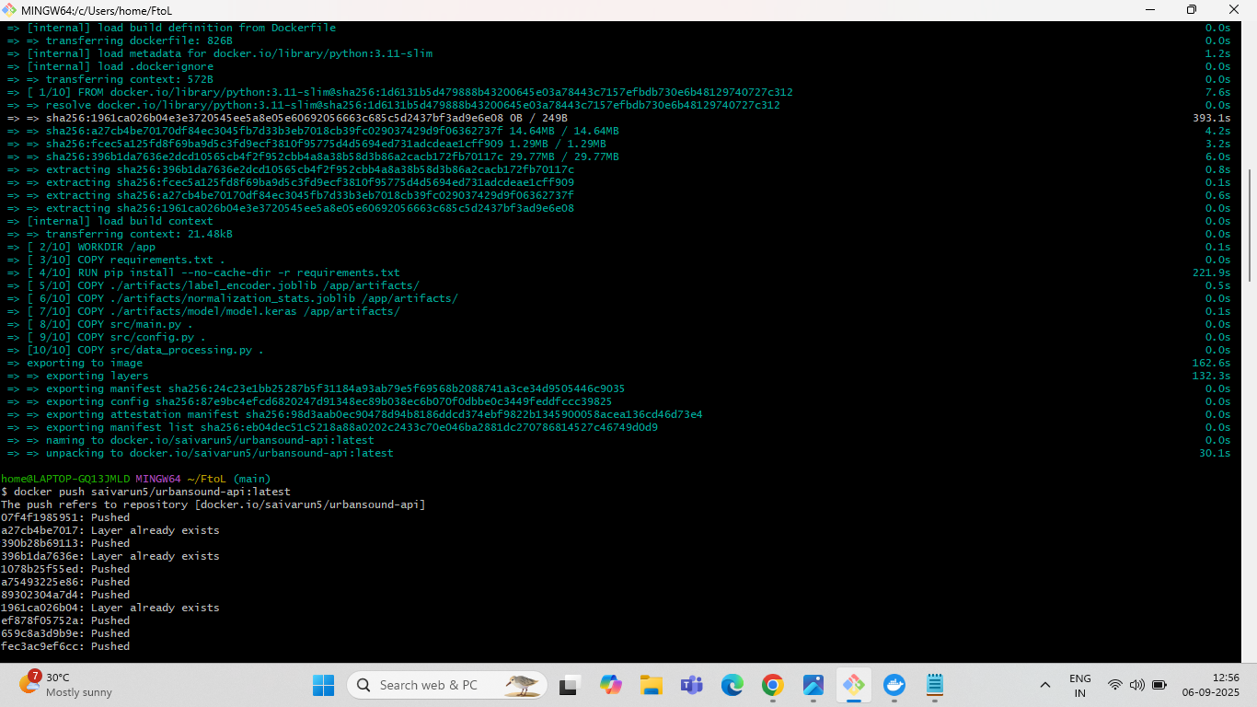
Pushing the docker image to the dockerhub
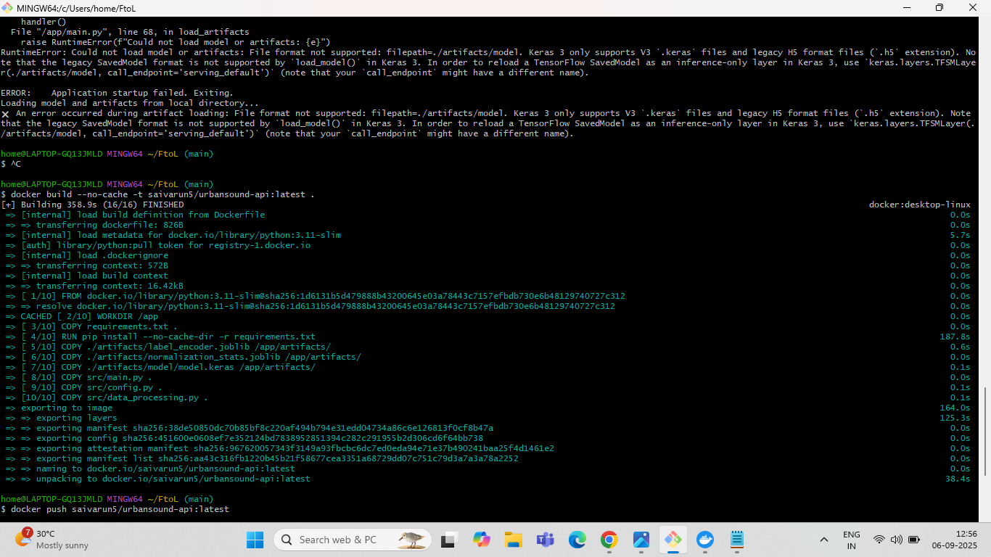
No cache is a attribute to ignore any existing build cache

Dockerfile - The Image Blueprint
This is a text file with a set of sequential instructions for building a custom Docker image. Each instruction creates a new layer in the image.

Dockerfile Instructions
FROM python:3.11-slim
  - Syntax: FROM <base_image>:<tag>
  - Explanation: This must be the first instruction. It specifies the base image to build upon. Here, you are starting with an official lightweight Python 3.11 image.
WORKDIR /app
  - Syntax: WORKDIR /path/to/directory
  - Explanation: Sets the working directory for any subsequent RUN, CMD, ENTRYPOINT, COPY, and ADD instructions. It's like running cd /app.
RUN apt-get update && ...
  - Syntax: RUN <command>
  - Explanation: Executes a command in the shell during the image build process. This is used to install system packages (libsndfile1, ffmpeg) and Python dependencies (pip install). Chaining commands with && is a best practice to keep image layers small.
COPY requirements.txt .
  - Syntax: COPY <source_on_host> <destination_in_image>
  - Explanation: Copies files or directories from the host's build context into the image's filesystem.
ENV PYTHONPATH=/app:/app/src
  - Syntax: ENV <KEY>=<VALUE>
  - Explanation: Sets a permanent environment variable within the image. PYTHONPATH tells Python where to look for modules.
EXPOSE 8000
  - Syntax: EXPOSE <port>
  - Explanation: This is metadata that documents which port the application inside the container is intended to listen on. It does not actually publish the port to the host. The ports mapping in the docker-compose.yml file is what actually exposes the port.
CMD ["uvicorn", "src.main:app", ...]
  - Syntax: CMD ["executable", "param1", "param2"]
  - Explanation: Provides the default command to execute when a container is started from this image. This command can be easily overridden, as demonstrated by the entrypoint in the train-job service.
Dockerfile:
FROM python:3.11-slim

WORKDIR /app

# # Install system dependencies for audio processing
RUN apt-get update && apt-get install -y \
libsndfile1 \
ffmpeg \
libsndfile1-dev \
&& rm -rf /var/lib/apt/lists/*

# Copy requirements file
COPY requirements.txt .

# Install Python dependencies
RUN pip install --no-cache-dir -r requirements.txt

# Create artifacts directory (empty for now)
RUN mkdir -p /app/artifacts

# Copy model artifacts (these will now be included from your repository)
COPY ./artifacts/model.keras /app/artifacts/
COPY ./artifacts/label_encoder.joblib /app/artifacts/
COPY ./artifacts/normalization_stats.joblib /app/artifacts/

# Copy source code
COPY src/ /app/src/

# Set environment variables
ENV PYTHONPATH=/app:/app/src
ENV PYTHONUNBUFFERED=1

EXPOSE 8000

# Command to run the app
CMD ["uvicorn", "src.main:app", "--host", "0.0.0.0", "--port", "8000"]

docker-compose.yml - The Orchestrator
This file uses YAML syntax to define and orchestrate multiple related Docker containers (called services). It tells Docker what containers to run and how they should connect to each other.

Top-Level Key
- services:: This is the main root key. Everything nested under it defines a container that will be part of this application stack.

Service Definitions
mlflow-server:, fastapi-app:, and train-job: are the user-defined names for each service. Under each name, a set of keys defines the configuration for that specific container.

Service-Specific Keys (Instructions)
image: ghcr.io/mlflow/mlflow:v2.14.2
  - Syntax: image: <repository>:<tag>
  - Explanation: This tells Docker to pull a pre-built image from a container registry (in this case, GitHub Container Registry). It's used when you don't need to build the image yourself.
build:
  - Explanation: This tells Docker Compose to build a custom image from a Dockerfile instead of pulling one.
  - context: .: Specifies the build context, which is the directory containing the Dockerfile and any source code needed for the build. . means the current directory.
  - dockerfile: Dockerfile: The name of the Dockerfile to use for building this service.
container_name: mlflow_server
  - Syntax: container_name: <string>
  - Explanation: Assigns a specific, static name to the running container, making it easier to reference.
ports:
  - Syntax: - "<HOST_PORT>:<CONTAINER_PORT>"
  - Explanation: This maps a port from your host machine to a port inside the container. For example, - "5000:5000" means that traffic hitting port 5000 on your computer will be forwarded to port 5000 inside the mlflow-server container.
volumes:
  - Syntax: - <HOST_PATH>:<CONTAINER_PATH>
  - Explanation: This mounts a directory from your host machine into the container's filesystem, creating a shared folder. It's used for:
    - Persisting data: ./mlruns:/mlruns ensures that the data written by MLflow inside the container is saved to the mlruns folder on your host machine.
    - Live code changes: ./src:/app allows you to edit code in your src folder, and the changes will be reflected inside the fastapi-app container without rebuilding the image.
command: > ...
  - Syntax: command: <command_to_run>
  - Explanation: Overrides the default command that an image runs when it starts. The > allows you to write a multi-line command for readability. Here, it's used to start the MLflow server with specific arguments.
entrypoint: ["python", "train.py"]
  - Syntax: entrypoint: ["executable", "param1", "param2"]
  - Explanation: Overrides the default entrypoint of the image. This is a more forceful way to specify the main process for the container. For the train-job service, it ensures that instead of starting the web server (the default CMD in the Dockerfile), it runs the train.py script.
environment:
  - Syntax: - <VARIABLE_NAME>=<VALUE>
  - Explanation: Sets environment variables inside the container. This is how the fastapi-app knows the address of the MLflow server (MLFLOW_TRACKING_URI=http://mlflow-server:5000). Docker Compose has its own internal DNS, so containers can refer to each other by their service name.
depends_on:
  - Syntax: - <service_name>
  - Explanation: Controls the startup order. This ensures that the mlflow-server service is started before the fastapi-app and train-job services, which depend on it.

Docker-compose:
# Note: The 'version' attribute is obsolete and has been removed.

services:
mlflow-server:
# --- THIS IS THE FIX ---
# Updated to a newer, compatible version of MLflow
image: ghcr.io/mlflow/mlflow:v2.14.2
container_name: mlflow_server
ports:
- "5000:5000"
volumes:
- ./mlruns:/mlruns
command: >
mlflow server
--host 0.0.0.0
--port 5000
--backend-store-uri sqlite:////mlruns/mlflow.db
--default-artifact-root file:///mlruns

fastapi-app:
build:
context: .
dockerfile: Dockerfile # This tells Compose to build from the Dockerfile in this directory
container_name: my-audio-api
ports:
- "8000:8000"
environment:
# This tells our app how to find the MLflow server
- MLFLOW_TRACKING_URI=http://mlflow-server:5000
volumes:
- ./mlruns:/mlruns
- ./src:/app
depends_on:
- mlflow-server

train-job:
build:
context: .
dockerfile: Dockerfile
entrypoint: ["python", "train.py"]
volumes:
- ./mlruns:/mlruns
- ./src:/app # This ensures your code/data is available inside the container
- ./data/urbansound8k:/dataset
# - /c/users/home/FtoL/data/urbansound8k:/dataset # Add this line (WSL/Docker Desktop/Linux path style)
# - ./data/urbansound8k:/dataset
environment:
- MLFLOW_TRACKING_URI=http://mlflow-server:5000
depends_on:
- mlflow-server

6.3 - Deployment to a Cloud Platform (e.g., Google Cloud Run)
The final Docker container is intended for deployment on a cloud platform like Google Cloud Run. The CI/CD pipeline would deploy the new Docker image from the container registry to this cloud environment.
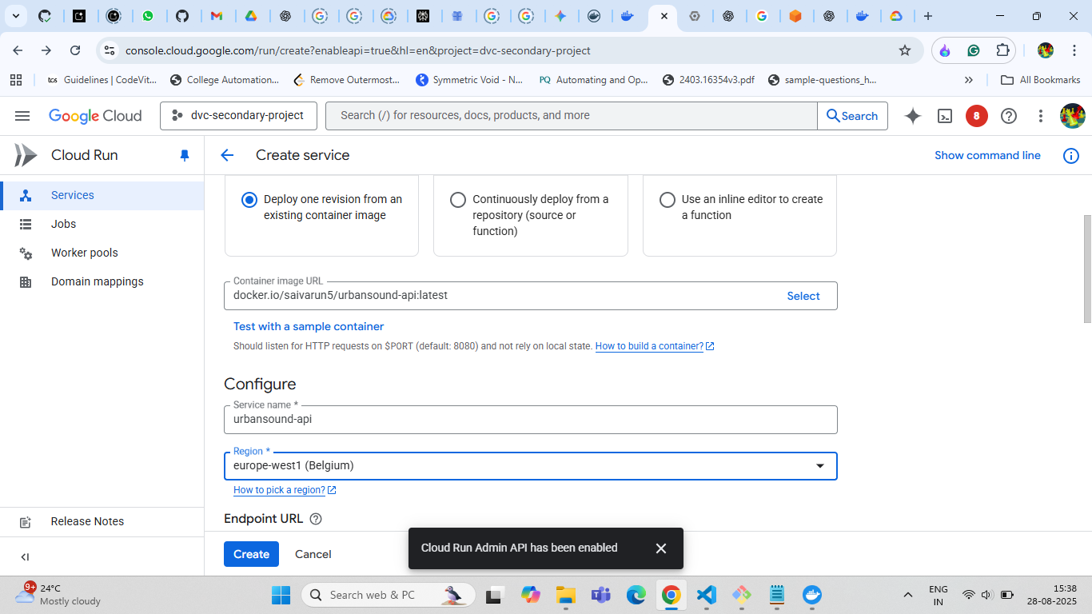
Google cloud run- Services page after clicking create service button
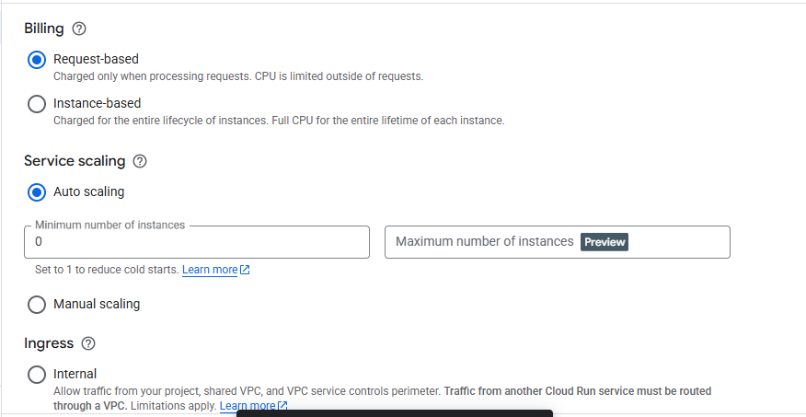
Billing type and scaling of instances

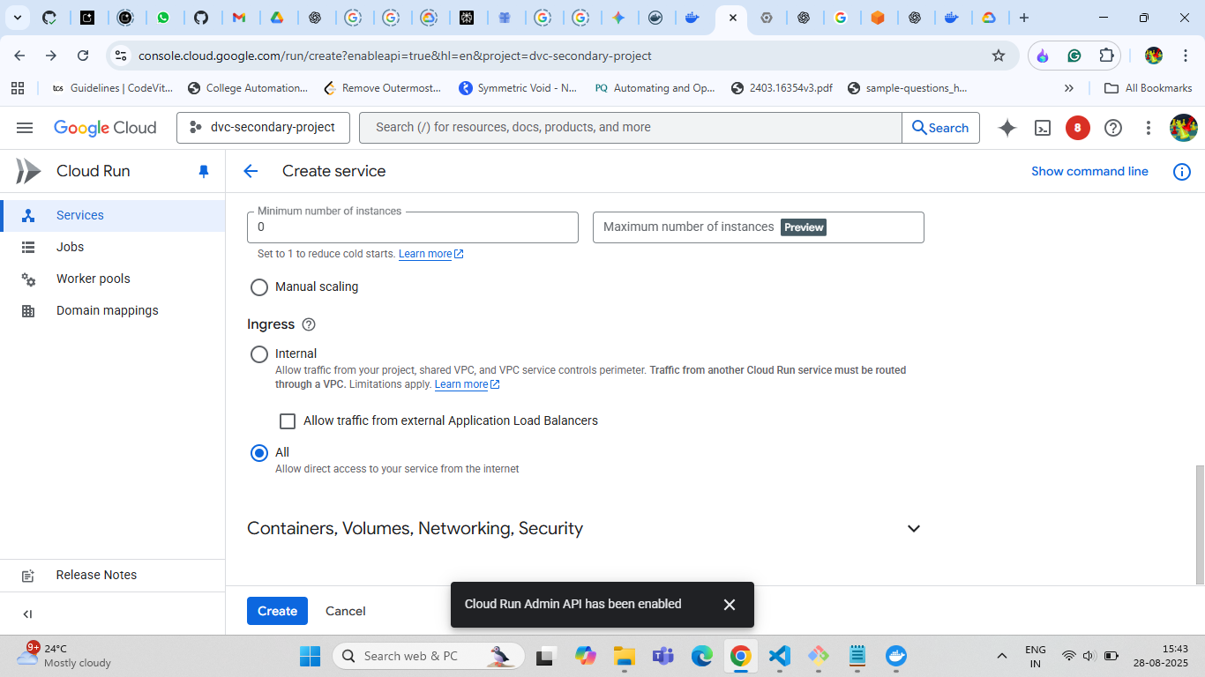
Other Fields in defining service
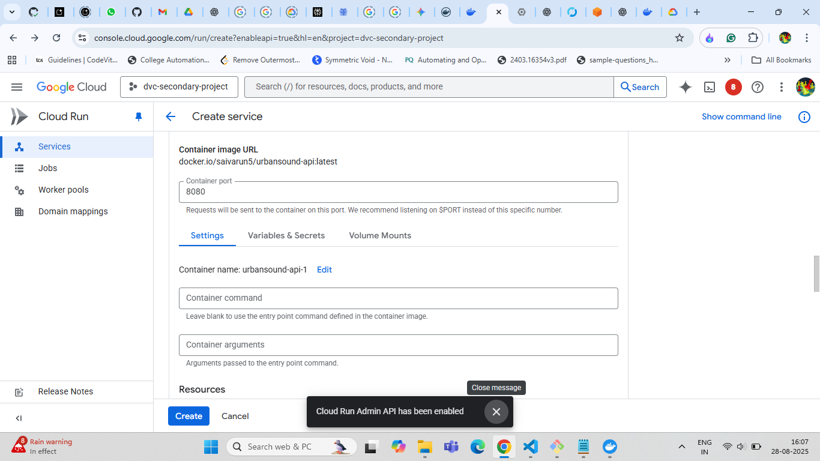
Other Fields in defining service

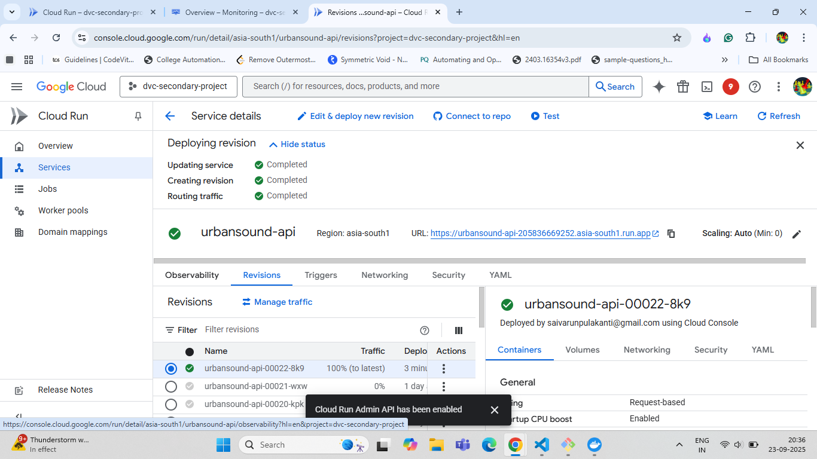
Cloud run Page after successful deployment service

CHAPTER 7: MONITORING AND MAINTENANCE

7.1 Understanding MLOps Monitoring
Monitoring in MLOps can be broken down into two main categories:
- Operational Monitoring: Is the service running correctly? This is about the health of your application, including metrics like traffic, error rates, and response times.²
- Model Performance Monitoring: Is the model still making good predictions? This involves tracking things like data drift (are the new data different from the training data?) and concept drift (is the relationship between inputs and outputs changing?).

Step 1: Use Built-in Google Cloud Tools
For a project on Cloud Run, you don't need to install anything to get started. Google Cloud automatically collects key metrics and logs for you.⁴

Cloud Logging
Anything your application prints to standard output (like using print() in Python) is automatically captured by Cloud Logging.⁵ You can use this to log important information, such as the predictions your model makes.
How to Use It:
- Go to the Google Cloud Console.
- Navigate to Cloud Run and select your service.
- Click on the "LOGS" tab.
- Here, you can see real-time logs from your application. You can filter by severity (like "Error") to quickly find problems.

Cloud Monitoring
This is where you can see performance charts and set up alerts.⁶ Cloud Run is pre-integrated with Cloud Monitoring to give you key operational metrics out of the box.
Key Metrics to Watch:
- Request Count: How much traffic is your service receiving?
- Request Latency: How long does it take for your model to process a request and return a prediction?
- Container CPU and Memory Utilization: Is your service properly resourced, or is it close to hitting its limits?
- Billable Instance Time: This helps you keep an eye on costs.
How to Use It:
- In the Cloud Console, go to Cloud Run and select your service.⁷
- Click on the "METRICS" tab. You'll see dashboards for the metrics listed above.
- For more advanced monitoring, you can go to the main Cloud Monitoring service in the console to create custom dashboards and set up Alerting Policies (e.g., "send me an email if the error rate goes above 5% for 10 minutes").

7.2 Implement Model-Specific Monitoring
While Google Cloud tells you if your service is running, you need to add some of your own logic to know if your model is still accurate. This is a crucial part of MLOps.

Detecting Data and Concept Drift
The most significant challenges for models in production are data drift and concept drift.
- Data Drift: The incoming data your model is seeing in production is statistically different from the data it was trained on. For example, a loan prediction model trained on pre-recession data might perform poorly when it sees data from a recessionary period.
- Concept Drift: The underlying relationship between the input data and the output you are trying to predict has changed.⁹ For example, the features that once predicted customer churn are no longer relevant because of a new competitor in the market.

How to Monitor for Drift
You can start by logging key information about your model's predictions and then analyzing that data.
- Log Prediction Data: In your application code, after making a prediction, log the input features and the model's output to Cloud Logging as a structured JSON payload. This makes it easy to analyze later.
- Analyze Logs: You can create a "log sink" to export these prediction logs to BigQuery.¹⁰ From there, you can run scheduled queries to compare the statistical properties (like mean, median, and standard deviation) of the new data with your original training data. If you see a significant difference, you may have data drift.
- Use Google Cloud's AI Platform: For a more automated and advanced solution, you can leverage Vertex AI Model Monitoring.¹¹ This service is specifically designed to detect drift and anomalies in your model's predictions. While it's more involved to set up than just using Cloud Run's built-in monitoring, it is the next professional step in a mature MLOps pipeline.

Creating a Custom Dashboard
A custom dashboard gives you a single view of all the important metrics for your MLOps application, combining operational health with model-specific data.
- Navigate to Monitoring: In the Google Cloud Console, use the search bar to find and go to "Monitoring".
- Go to Dashboards: In the Monitoring navigation pane on the left, select "Dashboards".
- Create Dashboard: Click "+ Create Dashboard" at the top. Give your dashboard a name, like "ML Model Performance".
- Add Your First Widget: A dashboard is made of widgets (charts, gauges, tables).
- Click "+ Add Widget".
- Choose the visualization you want, for example, a "Line" chart.
- In the "Metric" field, search for the resource and metric you want to visualize.
- Resource Type: Start typing and select "Cloud Run Revision".
- Metric: Choose a metric like "Request Latencies" or "Request Count".
- Filter the Data: This is the most important step. You need to tell the chart to only show data for your specific Cloud Run service.
- Click on "+ Add Filter".
- For the label, select service_name.
- For the value, select the name of your Cloud Run service.
- You can add more filters. For example, to see only errors, add a filter for response_code_class and set the value to 5xx.
- Configure and Save: Adjust the chart's appearance and click "Apply". You can now add more widgets to track different metrics on the same screen. Once you're done, your dashboard will save automatically.

7.3 Setting Up an Alerting Policy
Alerts proactively notify you when something goes wrong, so you don't have to watch dashboards 24/7. Let's create the alert you described: "send an email if the error rate goes above 5% for 10 minutes."
- Navigate to Alerting: In the Monitoring navigation pane, select "Alerting".
- Create Policy: Click "+ Create Policy" at the top.
- Select a Metric: Click "Select a Metric". This is the same process as creating a dashboard widget.
- Resource Type: "Cloud Run Revision".
- Metric: "Request Count".
- Filter: Add a filter for service_name to select your service. Crucially, add another filter for response_code_class and set its value to 5xx to only count server errors.
- Click "Apply".
- Set the Trigger Condition: This is where you define what is considered "bad".
- Scroll down to the "Configure trigger" section.
- Condition type: Leave it as "Threshold".
- Alert trigger: Set it to "Any time series violates".
- Threshold Position: "Above threshold".
- Threshold Value: Enter a number, for example, 5. This means the alert will trigger if there are more than 5 errors.
- For: In the "Advanced Options", set the "Re-test window" to "10 minutes". This tells the system to wait and see if the condition persists for 10 minutes before firing the alert.
- Configure Notifications: Click "Next". This is where you tell Google Cloud how to contact you.
- Under "Notification Channels", click the dropdown and select "Manage Notification Channels".
- This will open a new page where you can add your email, Slack, PagerDuty, or other services. Add your email and follow the verification steps.
- Go back to the alerting policy page and select the email channel you just created.
- Click "OK".
- Name and Save the Policy: Click "Next" again.
- Give your alert a clear name, like "High Server Error Count on ML Service".
- Use the "Documentation" box to write instructions for your future self or your team on what to do when this alert fires (e.g., "Check the Cloud Run logs for recent stack traces.").
- Click "Create Policy".
Your alert is now active. If your Cloud Run service experiences more than 5 server errors within a 10-minute window, you will receive an email notification.

7.4 CODE:
The project structure that is followed is shown below:
Of course. Based on the screenshots you provided, here is the project structure for your MLOps project, named FTOL.

FTOL/
├── .dvc/
│ ├── cache/
│ ├── tmp/
│ ├── .gitignore
│ ├── config
│ ├── config.local
│ └── dvc-secondary-project-cf006599baee.json
│
├── .github/
│ └── workflows/
│ └── mlops-ci-cd.yml
│
├── artifacts/
│ ├──model/
│ ├── label_encoder.joblib
│ ├── model.keras
│ └── normalization_stats.joblib
│
├── data/
│ └── urbansound8k/
│ ├── fold1/
│ ├── fold2/
│ │ ... (and so on up to fold10)
│ ├── .gitignore
│ ├── fold1.dvc
│ └── UrbanSound8K.csv
│
├── mlruns/
│ └── ... (MLflow experiment tracking data and previous runs)
│
├── src/
│ ├── __pycache__/
│ ├── config.py
│ ├── data_processing.py
│ ├── main.py
│ ├── model.py
│ ├── predict.py
│ └── train.py
│
├── tests/
│ └── ... (files for testing the source code)
│
├── .dockerignore
├── .dvcignore
├── .gitignore
├── client_secret_*.json
├── docker-compose.yml
├── Dockerfile
├── label_encoder.joblib
├── mlflow.db
├── normalization_stats.joblib
├── render.yaml
└── requirements.txt

Main machine learning model code:
Config.py:
from pathlib import path
# Old (absolute Windows path): ####PATH FOR DATASET FOR LOCAL EXECUTION
# DATA_DIR = r'C:/users/home/FtoL/data/urbansound8k/'
# METADATA_PATH = r'C:/users/home/FtoL/data/urbansound8k/UrbanSound8K.csv'

# New (Docker volume path): #####PATH FOR DATASET FOR GLOBAL EXECUTION
DATA_DIR = '/dataset/'
METADATA_PATH = '/dataset/UrbanSound8K.csv'

# # New (Continous integration path):
# DATA_DIR = 'data/urbansound8k/'
# METADATA_PATH = 'data/urbansound8k/UrbanSound8K.csv'
# --- Model & Feature Parameters ---
SAMPLE_RATE = 22050
DURATION = 4 # seconds
N_MFCC = 40
MAX_TIME_STEPS = 175
# --- Training Parameters ---
EPOCHS = 10 # Example of a training parameter
BATCH_SIZE = 32 # Example of a training parameter
MODEL_ARTIFACT_NAME = "model"
LABEL_ENCODER_ARTIFACT_NAME = "label_encoder.joblib"
NORMALIZATION_STATS_ARTIFACT_NAME = "normalization_stats.joblib"

NOTE:you have to switch between dataset paths as shown above when running locally and deploying.
data_processing.py:
# In data_processing.py
import os
import librosa
import numpy as np
import pandas as pd

# Note: These constants would ideally be loaded from config.py
SAMPLE_RATE = 22050
DURATION = 4 # seconds
N_MFCC = 40
MAX_TIME_STEPS = 174

def load_audio_data(file_path):
"""
Loads an audio file, pads/trims it to a fixed duration.

Args:
file_path (str): The path to the audio file.

Returns:
np.ndarray: The loaded and processed audio waveform.
"""
try:
audio, sr = librosa.load(file_path,
sr=SAMPLE_RATE,
duration=DURATION,
res_type='kaiser_fast')

# Pad or trim the audio to ensure consistent length
required_length = SAMPLE_RATE * DURATION
if len(audio) < required_length:
audio = np.pad(audio, (0, required_length - len(audio)), mode='constant')
elif len(audio) > required_length:
audio = audio[:required_length]

return audio
except Exception as e:
print(f"Error loading audio file {file_path}: {e}")
return None

def extract_mfcc(audio):
"""
Extracts MFCC features from an audio waveform.

Args:
audio (np.ndarray): The audio waveform.

Returns:
np.ndarray: The extracted MFCC features, transposed to (time_steps, n_mfcc).
"""
mfccs = librosa.feature.mfcc(y=audio, sr=SAMPLE_RATE, n_mfcc=N_MFCC)

# Pad or trim to a fixed number of time steps
if mfccs.shape[1] < MAX_TIME_STEPS:
mfccs = np.pad(mfccs, ((0, 0), (0, MAX_TIME_STEPS - mfccs.shape[1])), mode='constant')
else:
mfccs = mfccs[:, :MAX_TIME_STEPS]

return mfccs.T # Transpose to get shape (time_steps, n_mfcc)

def load_and_process_data(metadata_path, dataset_path):
"""
Loads metadata, processes all audio files, and combines features and labels.

Args:
metadata_path (str): Path to the metadata CSV file.
dataset_path (str): Path to the root directory of the audio dataset.

Returns:
tuple: A tuple containing:
- np.ndarray: The feature matrix (X).
- np.ndarray: The label vector (y).
"""
metadata = pd.read_csv(metadata_path)
features = []
labels = []

print("Processing all audio files...")
for index, row in metadata.iterrows():
file_name = row['slice_file_name']
fold = row['fold']
class_label = row['class']
# file_path = os.path.join(dataset_path, f"fold{fold}", file_name)
file_path = config.DATA_DIR / f"fold{row['fold']}" / row['slice_file_name']

audio = load_audio_data(file_path)
if audio is not None:
mfcc = extract_mfcc(audio)
features.append(mfcc)
labels.append(class_label)

# Convert lists to numpy arrays
X = np.array(features)
y = np.array(labels)

return X, y

main.py(FASTAPI CODE FILE):
import os
import io
import tensorflow as tf
import joblib
import numpy as np
import librosa
from fastapi import FastAPI, UploadFile, File, HTTPException
from fastapi.middleware.cors import CORSMiddleware
from pydantic import BaseModel
import logging

# Try to import custom modules - handle gracefully if missing
try:
import config
SAMPLE_RATE = config.SAMPLE_RATE
DURATION = config.DURATION
except ImportError:
SAMPLE_RATE = 22050
DURATION = 4
logging.warning("Config module not found, using default values")

try:
import data_processing
except ImportError:
data_processing = None
logging.warning("Data processing module not found, will use fallback methods")

# Configure logging
logging.basicConfig(level=logging.INFO)
logger = logging.getLogger(__name__)

# FastAPI app instance
app = FastAPI(
title="Urban Sound Classification API",
description="Audio classification API for Urban Sound dataset",
version="1.0.0",
docs_url="/docs",
redoc_url="/redoc"
)

# Add CORS middleware
app.add_middleware(
CORSMiddleware,
allow_origins=["*"],
allow_credentials=True,
allow_methods=["*"],
allow_headers=["*"],
)

# Global variables
ml_model = None
label_encoder = None
norm_stats = None
model_loaded = False

# Response models
class PredictionResponse(BaseModel):
predicted_class: str

class HealthResponse(BaseModel):
status: str
message: str

@app.on_event("startup")
async def load_artifacts():
"""Load model artifacts on startup if available"""
global ml_model, label_encoder, norm_stats, model_loaded

logger.info("Starting artifact loading process...")

try:
# Define artifact paths
artifacts_dir = "/app/artifacts"
model_path = os.path.join(artifacts_dir, "model.keras")
le_path = os.path.join(artifacts_dir, "label_encoder.joblib")
stats_path = os.path.join(artifacts_dir, "normalization_stats.joblib")

logger.info(f"Checking artifacts directory: {artifacts_dir}")
logger.info(f"Directory exists: {os.path.exists(artifacts_dir)}")

if os.path.exists(artifacts_dir):
logger.info(f"Contents of artifacts directory: {os.listdir(artifacts_dir)}")

# Check if all required files exist
missing_files = []
for path, name in [(model_path, "model.keras"), (le_path, "label_encoder.joblib"), (stats_path, "normalization_stats.joblib")]:
if not os.path.exists(path):
missing_files.append(name)
logger.info(f"Missing file: {name} at {path}")
else:
logger.info(f"Found file: {name} at {path}")

if missing_files:
logger.warning(f"Missing artifact files: {', '.join(missing_files)}")
logger.info("API will run in demo mode without prediction capability")
model_loaded = False
return

# Try to load artifacts
logger.info("All artifact files found, attempting to load...")

logger.info("Loading TensorFlow model...")
ml_model = tf.keras.models.load_model(model_path)

logger.info("Loading label encoder...")
label_encoder = joblib.load(le_path)

logger.info("Loading normalization stats...")
norm_stats = joblib.load(stats_path)

model_loaded = True
logger.info("SUCCESS: Model and artifacts loaded successfully!")
logger.info(f"Model input shape: {ml_model.input_shape}")
logger.info(f"Available classes: {len(label_encoder.classes_)}")

except Exception as e:
logger.error(f"Error during artifact loading: {str(e)}")
logger.info("API will run in demo mode without prediction capability")
model_loaded = False
# Don't raise the error - let the app start in demo mode

@app.get("/", response_model=HealthResponse)
async def root():
"""Root endpoint"""
if model_loaded:
return {
"status": "ready",
"message": "Urban Sound Classification API is running with full prediction capability! Visit /docs for API documentation."
}
else:
return {
"status": "demo",
"message": "Urban Sound Classification API is running in demo mode (no model loaded). Visit /docs for API documentation."
}

@app.get("/health", response_model=HealthResponse)
async def health_check():
"""Health check endpoint for monitoring"""
if model_loaded:
return {
"status": "healthy",
"message": "All systems operational - ready for predictions"
}
else:
return {
"status": "healthy",
"message": "API running in demo mode - service is healthy but no model loaded"
}

@app.get("/info")
async def get_model_info():
"""Get information about the loaded model and current status"""
base_info = {
"tensorflow_version": tf.__version__,
"sample_rate": SAMPLE_RATE,
"duration": DURATION,
"model_loaded": model_loaded
}

if model_loaded:
return {
**base_info,
"status": "ready",
"model_input_shape": str(ml_model.input_shape),
"available_classes": label_encoder.classes_.tolist(),
"message": "Model loaded and ready for predictions"
}
else:
return {
**base_info,
"status": "demo mode",
"message": "No model loaded. Prediction functionality not available. API running in demo mode.",
"available_endpoints": ["/", "/health", "/info", "/docs"]
}

@app.post("/predict", response_model=PredictionResponse)
async def predict(file: UploadFile = File(...)):
"""Audio classification endpoint"""

# Check if model is loaded
if not model_loaded:
raise HTTPException(
status_code=503,
detail="Prediction service not available. Model artifacts not loaded. API is running in demo mode. Please check /info for current status."
)

# Validate file type
allowed_extensions = ('.wav', '.mp3', '.m4a', '.flac', '.ogg')
if not file.filename.lower().endswith(allowed_extensions):
raise HTTPException(
status_code=400,
detail=f"Invalid file format. Supported formats: {', '.join(allowed_extensions)}"
)

logger.info(f"Processing prediction for file: {file.filename}")

try:
# Read uploaded audio file
audio_bytes = await file.read()
logger.info(f"File size: {len(audio_bytes)} bytes")

# Load audio data from memory
audio, _ = librosa.load(
io.BytesIO(audio_bytes),
sr=SAMPLE_RATE,
duration=DURATION
)
logger.info(f"Audio loaded: {len(audio)} samples at {SAMPLE_RATE}Hz")

# Extract MFCC features
if data_processing:
mfccs = data_processing.extract_mfcc(audio)
else:
# Fallback MFCC extraction
mfccs = librosa.feature.mfcc(y=audio, sr=SAMPLE_RATE, n_mfcc=13)
mfccs = mfccs.T # Transpose to match expected shape

logger.info(f"MFCC features extracted: shape {mfccs.shape}")

# Normalize features
mfccs_normalized = (mfccs - norm_stats['mean']) / (norm_stats['std'] + 1e-8)

# Reshape for model input (batch, time_steps, n_mfcc, channels)
mfccs_reshaped = mfccs_normalized[np.newaxis, ..., np.newaxis]
logger.info(f"Input shape for model: {mfccs_reshaped.shape}")

# Make prediction
prediction_vector = ml_model.predict(mfccs_reshaped, verbose=0)

# Post-process prediction
predicted_index = np.argmax(prediction_vector, axis=1)[0]
predicted_class = label_encoder.inverse_transform([predicted_index])[0]
confidence = float(np.max(prediction_vector))

logger.info(f"Prediction: {predicted_class} (confidence: {confidence:.4f})")

return {"predicted_class": predicted_class}

except Exception as e:
logger.error(f"Prediction failed: {str(e)}")
raise HTTPException(
status_code=500,
detail=f"Failed to process file or make prediction: {str(e)}"
)

model.py:
# In model.py
from tensorflow.keras.models import Sequential
from tensorflow.keras.layers import Conv2D, MaxPooling2D, Flatten, Dense, Dropout, BatchNormalization
from tensorflow.keras.regularizers import l2

def build_model(input_shape, num_classes):
"""
Builds and compiles the CNN model.
"""
model = Sequential([
Conv2D(32, (3,3), activation='relu', input_shape=input_shape),
BatchNormalization(),
MaxPooling2D((2,2)),

Conv2D(64, (3,3), activation='relu', kernel_regularizer=l2(0.001)),
BatchNormalization(),
MaxPooling2D((2,2)),

Conv2D(128, (3,3), activation='relu'),
BatchNormalization(),
MaxPooling2D((2,2)),

Flatten(),
Dense(256, activation='relu', kernel_regularizer=l2(0.0001)),
Dropout(0.4),

Dense(num_classes, activation='softmax')
])

model.compile(optimizer='adam',
loss='categorical_crossentropy',
metrics=['accuracy'])

return model

train.py:
import os
import numpy as np
import pandas as pd
import joblib
from sklearn.preprocessing import LabelEncoder
from sklearn.model_selection import train_test_split
from tensorflow.keras.utils import to_categorical
import mlflow
import mlflow.tensorflow
from mlflow.tracking import MlflowClient
from mlflow.exceptions import MlflowException

# Import your custom modules
import config
import data_processing
import model

# --- 1. Load and Prepare Data ---
print("Loading data and extracting features...")
metadata = pd.read_csv(config.METADATA_PATH)
features = []
labels = []

for index, row in metadata.iterrows():
file_path = os.path.join(config.DATA_DIR, f"fold{row['fold']}", row['slice_file_name'])
result = data_processing.load_audio_data(file_path)
if result is not None:
audio = result
mfcc = data_processing.extract_mfcc(audio)
features.append(mfcc)
labels.append(row['class'])

X = np.array(features)
y = np.array(labels)

# --- 2. Preprocess Data ---
mean = np.mean(X, axis=(0, 1))
std = np.std(X, axis=(0, 1))
X = (X - mean) / (std + 1e-8)
X = X[..., np.newaxis]

le = LabelEncoder()
y_encoded = le.fit_transform(y)
y_categorical = to_categorical(y_encoded)
num_classes = len(le.classes_)

X_train, X_test, y_train, y_test = train_test_split(
X, y_categorical, test_size=0.2, stratify=y_encoded, random_state=42
)

input_example = X_train[:5]
REGISTERED_MODEL_NAME = "AudioClassifier"

# --- 3. Save Preprocessing Artifacts ---
joblib.dump(le, config.LABEL_ENCODER_ARTIFACT_NAME)
joblib.dump({'mean': mean, 'std': std}, config.NORMALIZATION_STATS_ARTIFACT_NAME)

# --- 4. MLflow Experiment Tracking ---

# This is the only block you need for setting the tracking URI and experiment.
# Delete all other versions.
#this is for running on docker
# mlflow.set_tracking_uri("http://mlflow-server:5000")
#this is for running locally on machine
# The below code is correct for local execution need to switch whenever using either one
import socket

def is_port_open(host, port):
try:
with socket.create_connection((host, port), timeout=2):
return True
except:
return False

if is_port_open("127.0.0.1", 5000):
mlflow.set_tracking_uri("http://127.0.0.1:5000")
else:
mlflow.set_tracking_uri("file:./mlruns")

EXPERIMENT_NAME = "Final-sound-cls-model"

# Check if the experiment exists. If not, create it.
experiment = mlflow.get_experiment_by_name(EXPERIMENT_NAME)
if experiment is None:
print(f"Experiment '{EXPERIMENT_NAME}' not found. Creating now.")
mlflow.create_experiment(name=EXPERIMENT_NAME)

# Set the experiment for the current run
mlflow.set_experiment(experiment_name=EXPERIMENT_NAME)

with mlflow.start_run() as run:
print(f"Starting MLflow Run ID: {run.info.run_id}")
run_id = run.info.run_id

# Point to the MLflow server running via Docker Compose

mlflow.log_params({
"epochs": config.EPOCHS,
"batch_size": config.BATCH_SIZE,
"n_mfcc": config.N_MFCC,
"test_split_ratio": 0.2
})

input_shape = X_train.shape[1:]
cnn_model = model.build_model(input_shape=input_shape, num_classes=num_classes)
cnn_model.summary()

print("\nTraining the model...")
history = cnn_model.fit(
X_train,
y_train,
validation_data=(X_test, y_test),
epochs=config.EPOCHS,
batch_size=config.BATCH_SIZE,
verbose=1
)

print("\nEvaluating the model...")
test_loss, test_acc = cnn_model.evaluate(X_test, y_test, verbose=0)
print(f"\nTest Accuracy: {test_acc*100:.2f}%")

mlflow.log_metrics({
"test_accuracy": test_acc,
"test_loss": test_loss
})

for epoch in range(config.EPOCHS):
mlflow.log_metrics({
'train_loss': history.history['loss'][epoch],
'train_accuracy': history.history['accuracy'][epoch],
'val_loss': history.history['val_loss'][epoch],
'val_accuracy': history.history['val_accuracy'][epoch]
}, step=epoch)

# Log the model as an artifact WITHOUT registering it yet
mlflow.tensorflow.log_model(cnn_model, "model", input_example=input_example)

# Log preprocessing artifacts
mlflow.log_artifact(config.LABEL_ENCODER_ARTIFACT_NAME, "preprocessing")
mlflow.log_artifact(config.NORMALIZATION_STATS_ARTIFACT_NAME, "preprocessing")

# --- 5. Conditional Registration Logic ---
print("\n--- Starting Conditional Model Registration ---")
client = MlflowClient()
previous_accuracy = -1.0 # Initialize with a value lower than any possible accuracy

try:
# --- THIS IS THE FIX ---
# Get the model version currently tagged with the 'Production' alias
latest_prod_version = client.get_model_version_by_alias(REGISTERED_MODEL_NAME, "Production")

# Get the run associated with this model version
prod_run = client.get_run(latest_prod_version.run_id)

# Get the accuracy from that run's metrics
previous_accuracy = prod_run.data.metrics.get("test_accuracy", -1.0)
print(f"Found existing 'Production' model (Version: {latest_prod_version.version}) with accuracy: {previous_accuracy:.4f}")

except MlflowException as e:
# This will happen if the alias "Production" doesn't exist yet (e.g., first run)
if "not found" in str(e).lower():
print("No 'Production' model found. This run will create the first one.")
else:
# Handle other potential exceptions
raise e

# Perform the comparison and register/promote if better
if test_acc > previous_accuracy:
print(f"New model accuracy ({test_acc:.4f}) is better than previous ({previous_accuracy:.4f}).")
print("Registering new model version and setting alias to 'Production'...")

# Register the model logged earlier in this run
result = mlflow.register_model(
model_uri=f"runs:/{run_id}/model",
name=REGISTERED_MODEL_NAME
)

# Set the 'Production' alias for the new version. MLflow automatically
# moves the alias if it already exists on another version.
client.set_registered_model_alias(
name=REGISTERED_MODEL_NAME,
alias="Production",
version=result.version
)
print(f"✅ Successfully registered Version {result.version} and set 'Production' alias.")

else:
print(f"New model accuracy ({test_acc:.4f}) is not better than the current 'Production' model ({previous_accuracy:.4f}).")
print("❌ Model will not be registered or promoted.")

predict.py(for testing locally):

# In predict.py
import numpy as np
import joblib
from tensorflow.keras.models import load_model

# Import the processing functions we just defined
import data_processing

# --- Paths to Saved Artifacts ---
# These would be loaded from a config file or passed as arguments
MODEL_PATH = 'urban_sound_model.h5'
LABEL_ENCODER_PATH = 'label_encoder.joblib'
NORMALIZATION_STATS_PATH = 'normalization_stats.joblib' # To save mean/std

def predict_sound(audio_file_path):
"""
Loads a trained model and makes a prediction on a single audio file.

Args:
audio_file_path (str): The path to the audio file to classify.

Returns:
str: The predicted class name, or an error message.
"""
try:
# 1. Load the trained model and artifacts
model = load_model(MODEL_PATH)
le = joblib.load(LABEL_ENCODER_PATH)
norm_stats = joblib.load(NORMALIZATION_STATS_PATH)
mean = norm_stats['mean']
std = norm_stats['std']

# 2. Load and process the audio file using our functions
audio = data_processing.load_audio_data(audio_file_path)
if audio is None:
return "Error: Could not process audio file."

mfcc = data_processing.extract_mfcc(audio)

# 3. Normalize and reshape the features exactly as done in training
mfcc_normalized = (mfcc - mean) / (std + 1e-8)
mfcc_reshaped = mfcc_normalized.reshape(1, mfcc_normalized.shape[0], mfcc_normalized.shape[1], 1)

# 4. Make a prediction
prediction = model.predict(mfcc_reshaped)

# 5. Decode the prediction
predicted_index = np.argmax(prediction, axis=1)[0]
predicted_class_name = le.inverse_transform([predicted_index])[0]

return predicted_class_name

except FileNotFoundError:
return f"Error: Ensure model ('{MODEL_PATH}'), label encoder ('{LABEL_ENCODER_PATH}'), and stats ('{NORMALIZATION_STATS_PATH}') exist."
except Exception as e:
return f"An error occurred: {e}"

# --- Example Usage ---
if __name__ == '__main__':
# This is a placeholder path. Replace with an actual audio file path.
# For this to work, you must first run train.py to generate the .h5 and .joblib files.
EXAMPLE_AUDIO_FILE = "E:\urban soundscape project\urbansound8k\fold1\15564-2-0-0.wav"

print(f"Attempting to classify sound from: {EXAMPLE_AUDIO_FILE}")

# Before running, make sure the file exists and the model artifacts are in the same directory.
import os
if not os.path.exists(EXAMPLE_AUDIO_FILE):
print("\n---")
print(f"WARNING: Example audio file not found at '{EXAMPLE_AUDIO_FILE}'.")
print("Please replace this placeholder path with a real .wav file to test the prediction script.")
print("You must also have the trained model artifacts ('urban_sound_model.h5', 'label_encoder.joblib', 'normalization_stats.joblib') available.")
print("---\n")
else:
predicted_label = predict_sound(EXAMPLE_AUDIO_FILE)
print(f"\nPredicted Sound Class: {predicted_label}")

For other file contents which include: .dvc/.gitignore, .dvc/config, .github/workflows/mlops-ci-cd.yml, .dockerignore, .dvcignore, .gitignore, docker-compose.yml, Dockerfile, requirements.txt, refer this github link to get access to the source code:
https://github.com/Varun-999/mlops-project.git
Rest all the files and folders from the project structure are generated from application execution.

7.4 THE ERRORS AND THEIR SOLUTIONS AND CAUTIOUS STEPS:
EVERY IMAGE SHOWS ERROR AND FOLLOWED BY ITS SOLUTION
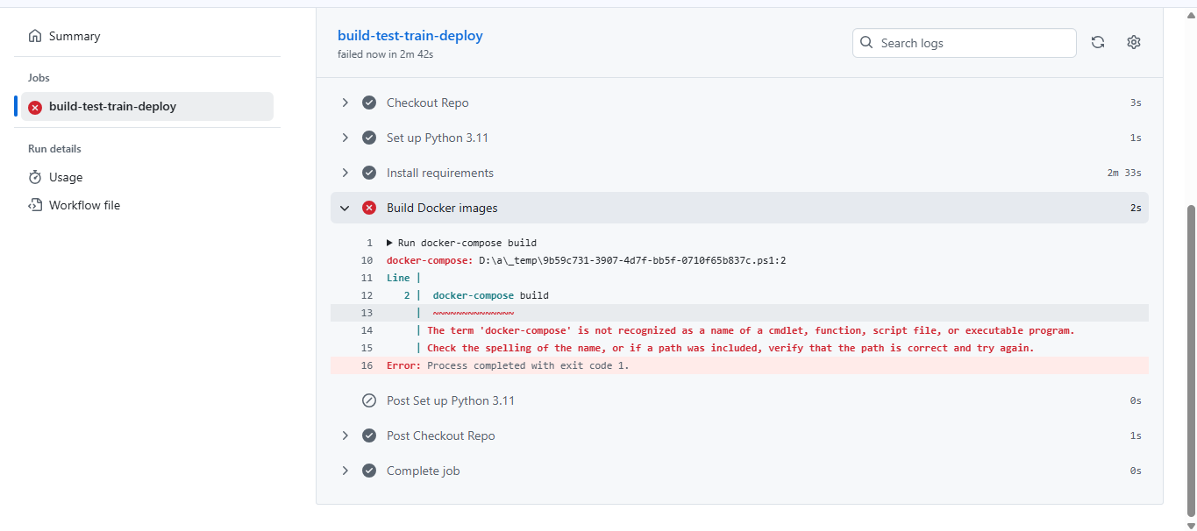
The reason for the error: Defined wrong name for executing docker compose file in continuous integration file i.e CI.yml present inside the .github/workflows/ directory.
Solution: Name correction needed.
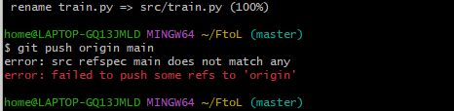
The reason: Current local branch is named master. However, your command git push origin main is explicitly telling Git to push a branch named main. Since there is no local branch named main, Git cannot find it and fails the push.This is a very common issue, especially since GitHub changed the default branch name from master to main for new repositories.
Solution: You need to tell Git to push your current local branch (master) to the remote.
Option 1: change the branch name in your push command to match your local branch:
Bash
git push origin master
Option 2: Rename your local branch to main
If you want your local branch to match the modern default (main), you can rename it and then push. This is a good practice for consistency.
Bash
# Step 1: Rename the local branch from 'master' to 'main'
git branch -m main
# Step 2: Now push the 'main' branch to the remote
git push origin main
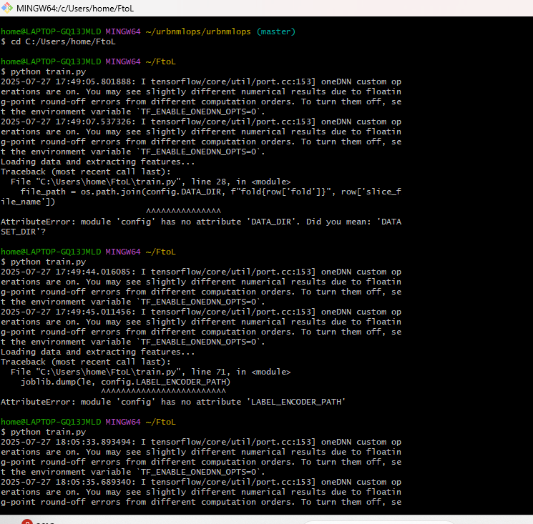
The reason: Wrong path given inside the config.py file and wrong variable name defined inside config.py.
Solution: Corrected the path from global to local version and corrected name.

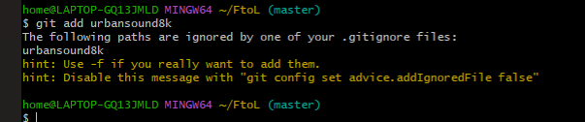
The reason: Mentioned the urbansound8k dataset folder in the .gitignore file which is being ignored when trying to track the dataset.
Solution: Remove the urbansound8k name from the .gitignore file.

Types of dvc commands that shouldn’t be executed:
Avoid these commands(wrong syntax)-
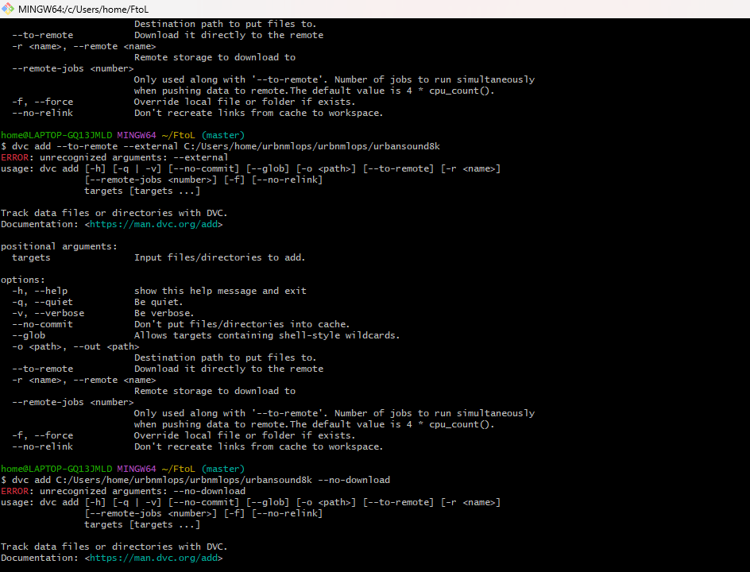
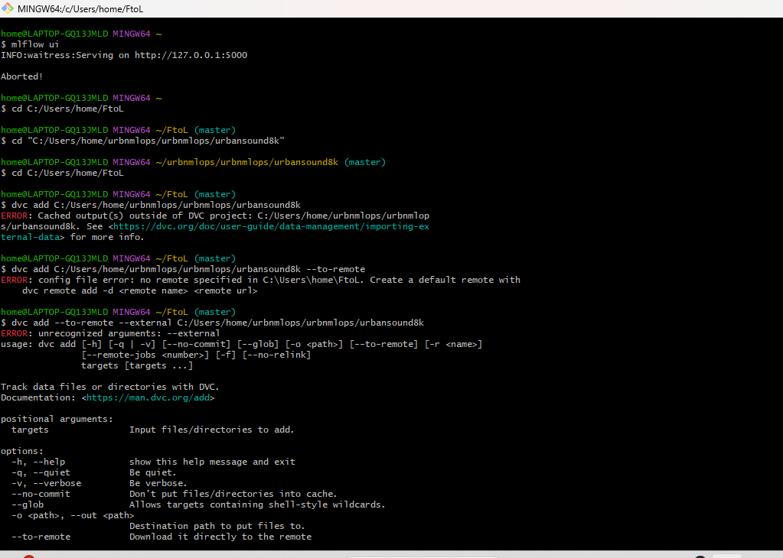
The reason: The dataset that I’m trying to track is present outside the project folder, that is why operation can’t be done.
Solution: Make sure the dataset you are using is present inside your project folder under data folder.
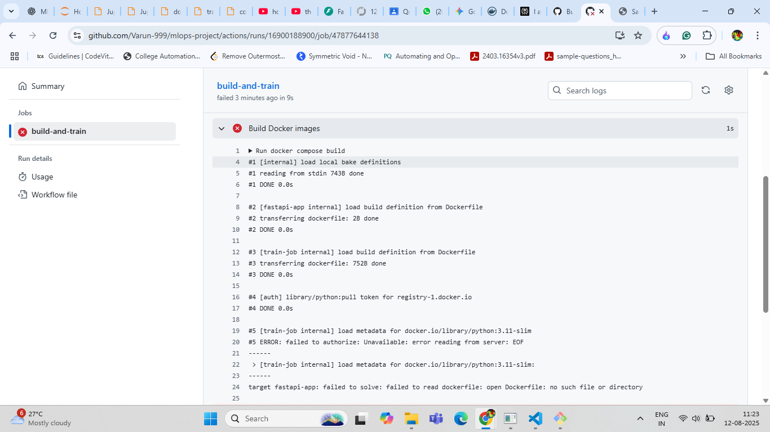
There are two separate errors happening during the docker compose build step.
Error 1: Docker Hub Authorization Failure
This is the first error that appears in the log.
Log Message:
ERROR: failed to authorize: unavailable: error reading from server: EOF
Cause: This error occurs when your GitHub Actions runner tries to pull the base image (python:3.11-slim) from Docker Hub. Docker Hub imposes strict rate limits on anonymous (unauthenticated) pulls. Since GitHub Actions runners often share IP addresses, these limits are hit very easily, causing the connection to be denied.
Solution: You need to log in to Docker Hub as part of your workflow before building the images.Add this step to your YAML workflow file right before the docker compose build step:
YAML
- name: Log in to Docker Hub
uses: docker/login-action@v3
with:
username: ${{ secrets.DOCKERHUB_USERNAME }}
password: ${{ secrets.DOCKERHUB_TOKEN }}
Note: You must first save your Docker Hub username and a personal access token as secrets named DOCKERHUB_USERNAME and DOCKERHUB_TOKEN in your GitHub repository's settings.

Error 2: Dockerfile Not Found
This is the final error that causes the build to fail.
Log Message:
target fastapi-app: failed to solve: failed to read dockerfile: open Dockerfile: no such file or directory
Cause: Your docker-compose.yml file is trying to build a service named fastapi-app, but it cannot find the Dockerfile for it. This is because the context path specified in your docker-compose.yml for that service is incorrect, or the Dockerfile is misspelled.
Solution: Check your docker-compose.yml file. Find the entry for the fastapi-app service and verify that the build configuration is correct.
For example, it might look something like this:
YAML
services:
fastapi-app:
build:
context: ./src # <-- Verify this path is correct
dockerfile: Dockerfile # <-- Verify this filename is correct
Ensure that the context directory contains a file with the exact name specified by dockerfile.
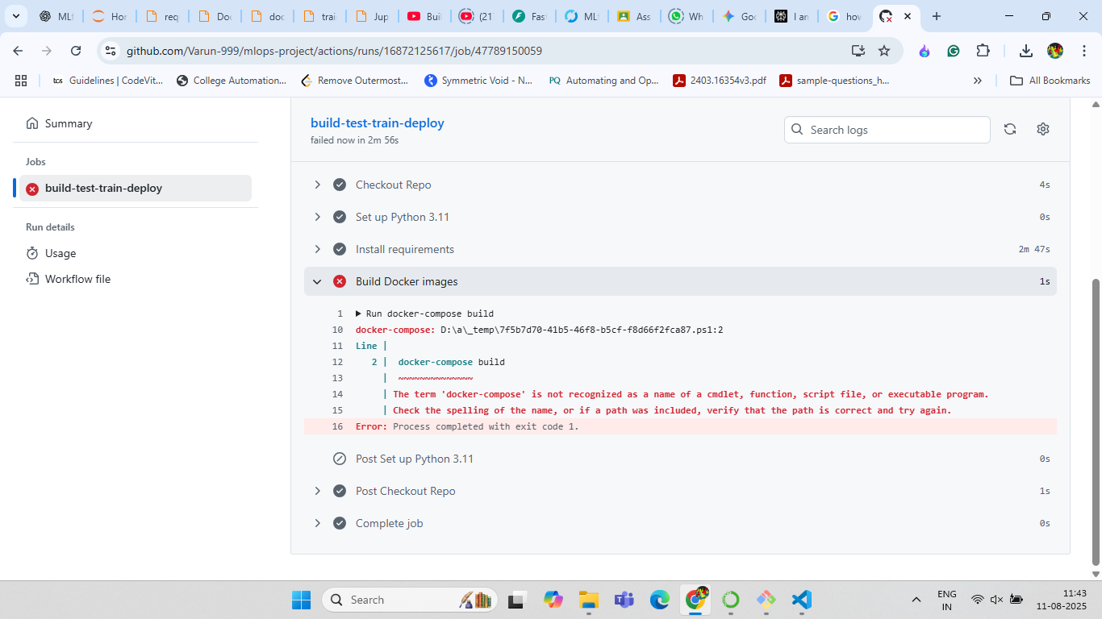
Cause: Wrong syntax of docker compose in CI yaml workflow.
Solution: Correct syntax without any hyphen in between the word docker and compose.
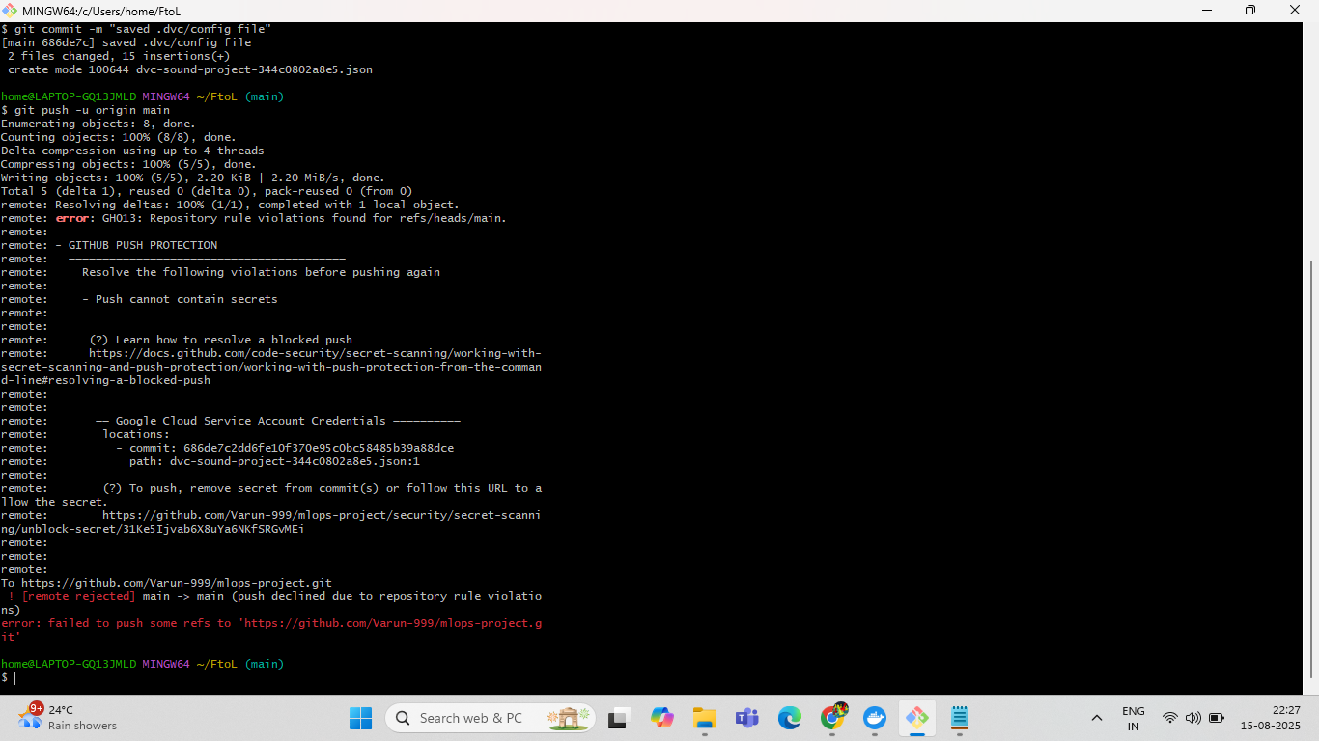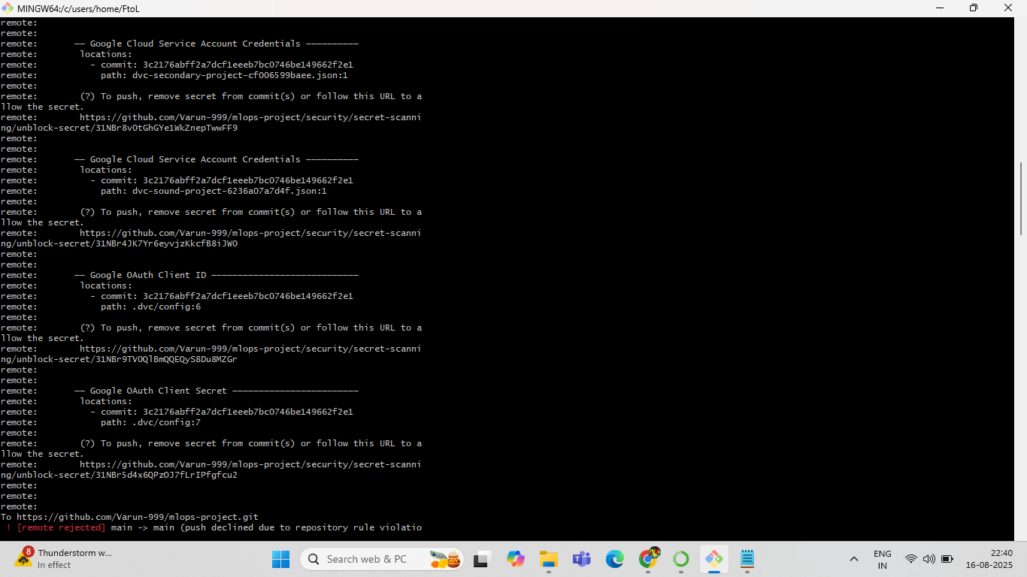
DON’T PUSH THE CREDENTIALS CREATED IN GOOGLE CLOUD OR DOCKERHUB
TO YOUR GITHUB, IT SHOULD ONLY BE PRESENT IN THE LOCAL DIRECTORY OR/AND IN GITHUB SECRETS.
To avoid pushing the secrets present in your directory to github is by adding them to the .gitignore files and .dockerignore files. For eg: if the json credential file name is credentials.json, just mention the same file name along with extension in the .gitignore file. If pushed you may get the message shown in above picture.
If you have commited the credentials unknowginly, then follow commands shown in the picture of this drive link: https://drive.google.com/drive/folders/10UYt6Zer_HaqRabdL3kOz6RAt7LmNpBK?usp=sharing
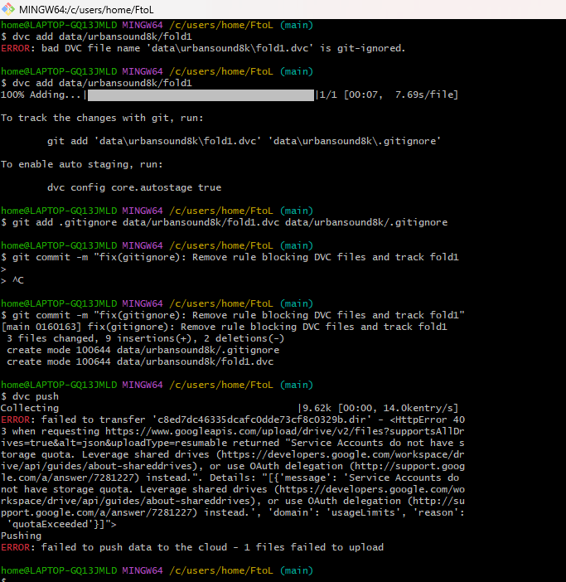
ERROR: failed to upload data to the cloud - 1 files failed to upload
<HttpError 403 when requesting https://www.googleapis.com/upload/drive/v2/files?...
{
"message": "Service Accounts do not have storage.quota or user settings",
"domain": "usageLimits",
"reason": "forbidden"
}

Reason for the error
- You’re using Google Drive as DVC remote storage.
- The Service Account you configured does not have permission to upload files to Google Drive.
- Google Drive doesn’t allow Service Accounts to use personal storage quota unless you explicitly share a folder with that Service Account.

How to fix it
- Share the target Google Drive folder with your Service Account email (something like xxxx@project-id.iam.gserviceaccount.com).
  - Go to Google Drive → Right-click the folder → Share → Add your Service Account email → Give Editor access.
- Update your DVC remote configuration (if needed):
- dvc remote modify gdrive_remote gdrive_use_service_account true
- dvc remote modify gdrive_remote gdrive_service_account_json_file_path path/to/creds.json
- Push again:
- dvc push

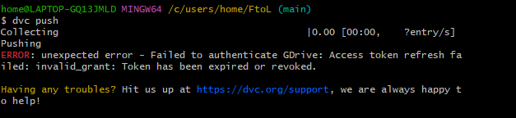
Reason for the error of above picture is because the access token that has provided to the program has expired. Create a new one on google cloud OAuth consent screen. And update the .dvc/config file with the new client id.
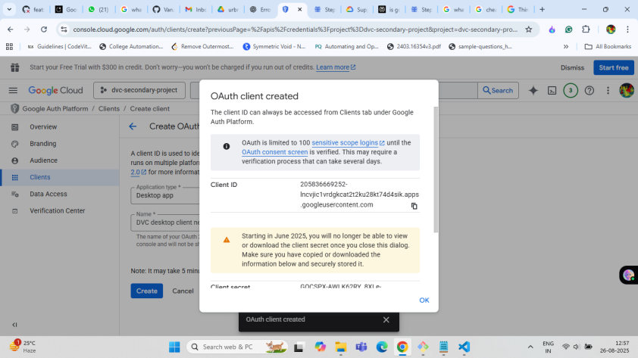
After updating the client id in the .dvc/config file if you try pushing again by executing dvc push command then you will face error as below:
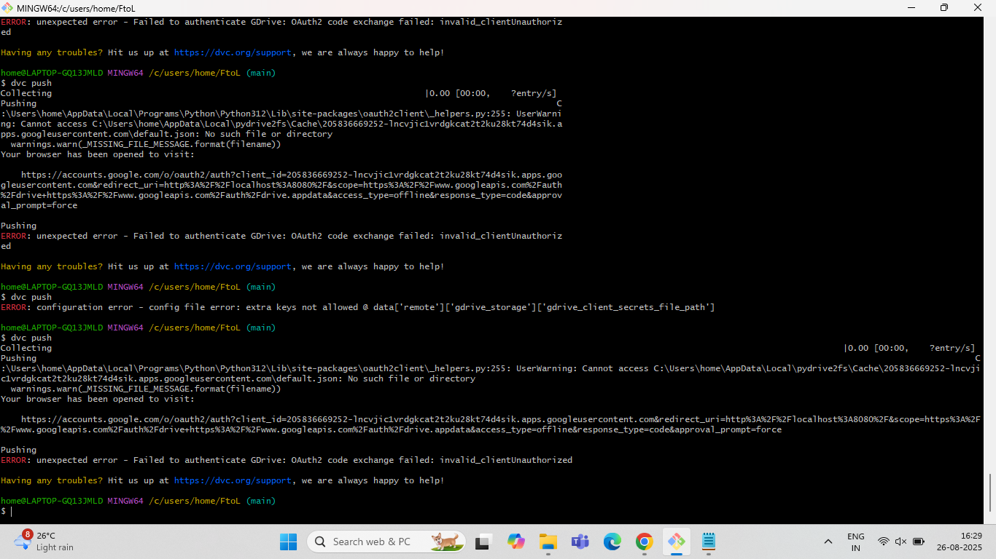

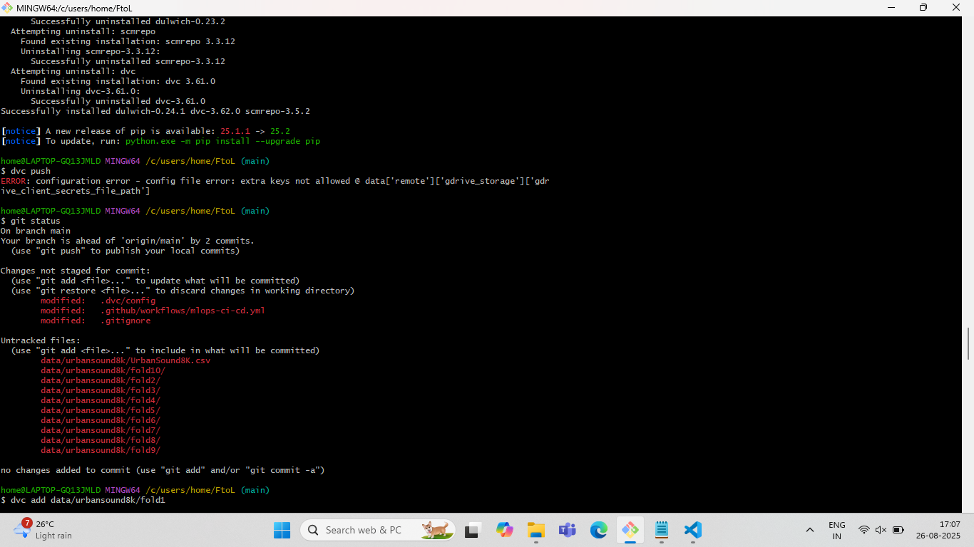

Just update the client secret with the one from the newly created json file, refer the below picture.
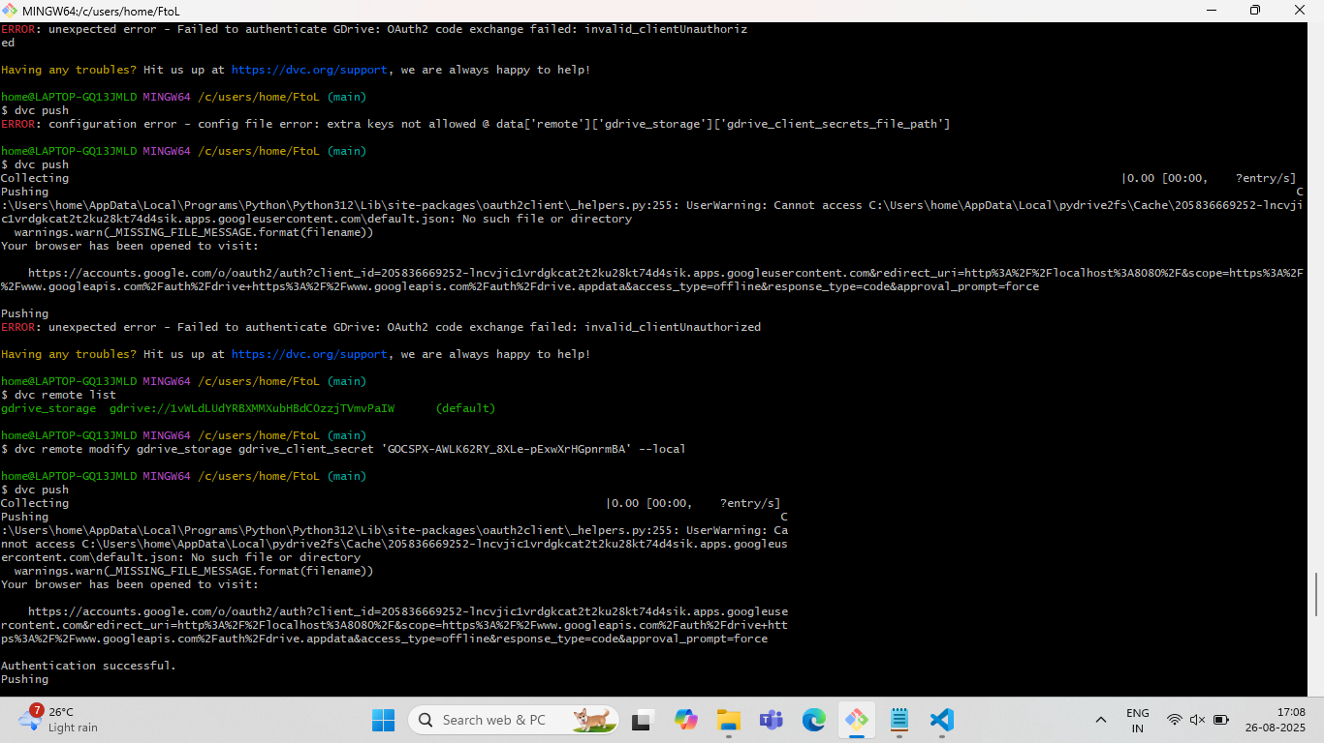
The reason for above error is docker desktop is not running in the background.
Solution: docker desktop should be opened in background, then docker commands are to be executed.
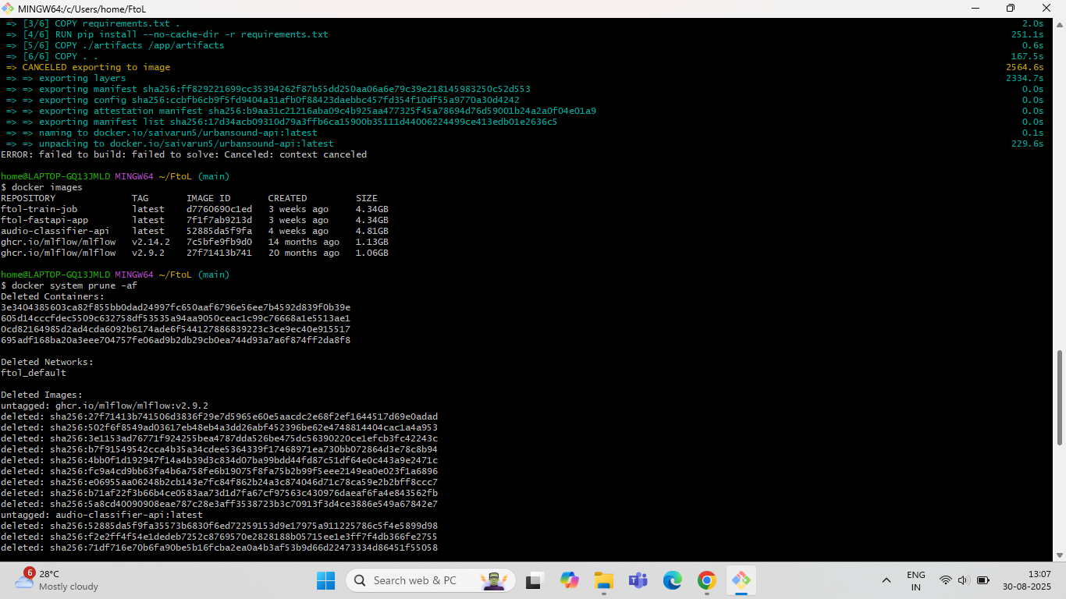
If docker images size gets bigger then use the above command in the picture to free up some space.
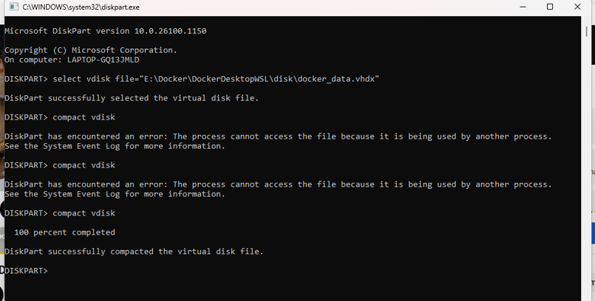

If the docker_data.vhdx file which is the docker storage disk file get enormously larger overtime and you want to get rid of all the data then use the commands as shown in the above picture. In command prompt, enter diskpart then new window pops up(this window is the picture shown above). Here execute the commands shown in the picture above.
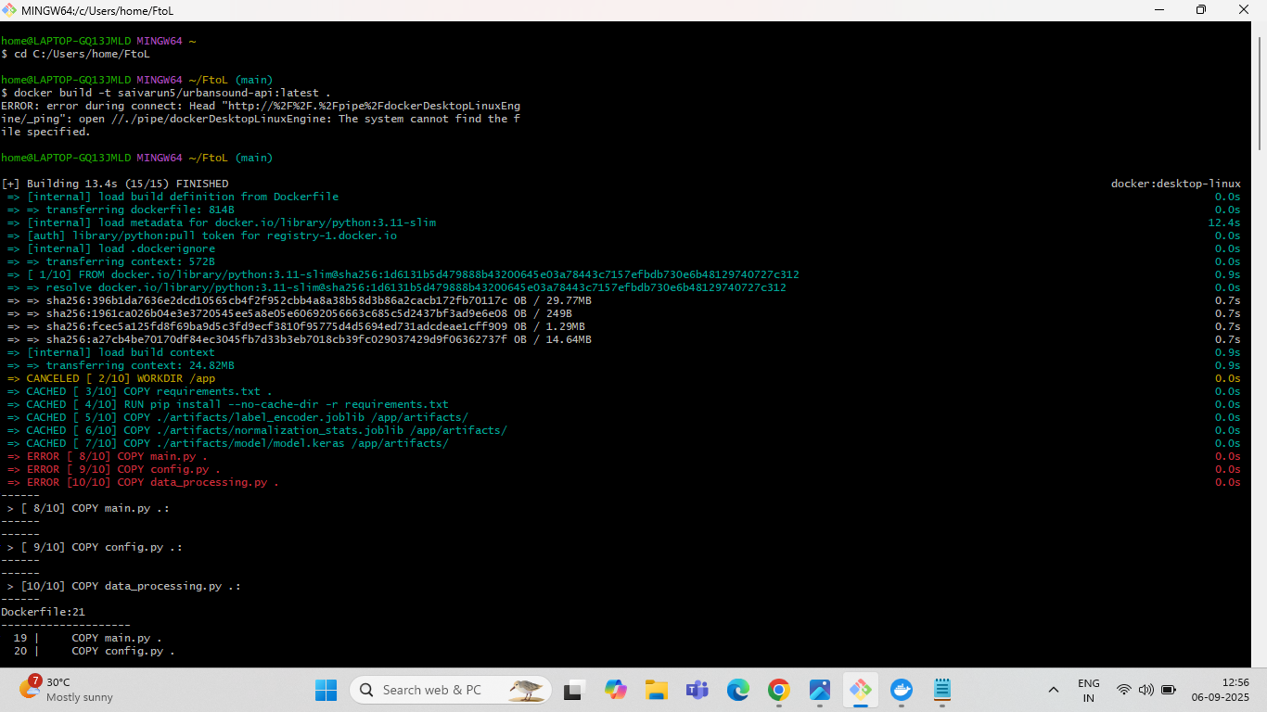

Reason for the above error: Wrong path provided in the Dockerfile of source code files.
Solution: Correct path is given to the files marked in red in Dockerfile.
TIP: COPY ONLY THE ESSENTIAL CODE FILES AND AVOID LARGE FILES LIKE DATASET(IF IT IS LARGE)AND OTHER FILES TO AVOID BUILDING LARGE DOCKER IMAGE.
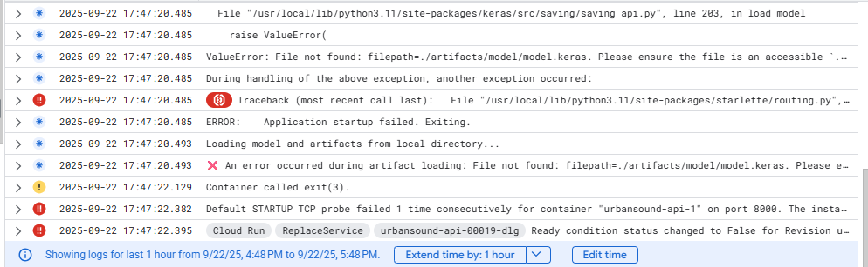
Since deploying on google cloud requires accessing the model from the mlflow server, but mlflow server is a localhost service it can’t be accessed by the google cloud and we have to manually download the artifacts by running our program once locally before deploying to the google cloud and download the artifacts from the mlflow artifacts section and download all the files.
After downloading the files, make sure the artifacts: which include: model.keras, normalization.joblib,label_encoder.joblib (in my case these three files are main files) are present in these directory hierarchy: Root-project-folder/.artifacts/

├── artifacts/│
│ ├── label_encoder.joblib
│ ├── model.keras
│ └── normalization_stats.joblib

After doing the above steps, commit the files using git and (if not implemented the automated workflow of docker then execute the docker build and push command again to update the image) and perform git push.
Try deploying again on google cloud run now you will see no error.

TIP:Whenever transitioning from local to deployment your will get errors mostly related to the paths of the files so any change made to a file also check path access to that file is correct in all necessary areas.(For eg: if if you ran your model locally and want to shift to deployment and containerization with docker, then you have to change the path of dataset in the config file to avoid errors.)

8.Conclusion

This project successfully executed the end-to-end transformation of an experimental urban sound classification model into a production-grade, automated system. What was accomplished involved transitioning a Convolutional Neural Network (CNN) from a standalone Jupyter Notebook into a robust and scalable web service. Key achievements include establishing complete reproducibility by versioning all source code with Git and the large audio dataset with Data Version Control (DVC). The model development lifecycle was systematized using MLflow for rigorous experiment tracking, logging, and governance through a model registry. Furthermore, a complete Continuous Integration and Continuous Delivery (CI/CD) pipeline was engineered using GitHub Actions to automate testing, linting, and the building of Docker containers, which are then pushed to Docker Hub. The final, validated model was then served via a high-performance REST API built with FastAPI and deployed as a containerized application on Google Cloud Run, making it a scalable, public-facing service.

The implemented MLOps approach is a significant improvement over the existing system an isolated, manual Jupyter Notebook prototype. The initial notebook-based workflow suffered from critical limitations, including a lack of reproducibility, an error-prone manual process, monolithic code, and no strategy for deployment or monitoring. The MLOps transformation directly solved these issues by introducing formal version control for both code and data, ensuring that any experiment can be accurately recreated. The manual process of running notebook cells was replaced by an automated and governed workflow managed by MLflow, allowing for systematic model comparison and promotion. Code inflexibility was resolved by modularizing the project into distinct scripts and externalizing all configurations, which promotes reusability. Finally, where the original system's only output was a saved model file, the new system delivers a continuously integrated and deployed API, complete with a foundational strategy for operational and model performance monitoring

Future Enhancements
Building upon this robust MLOps foundation, several future enhancements can be implemented to further mature the system and create a more intelligent, self-sustaining service. These future directions include:
• Implement Automated Model Retraining: Develop an automated pipeline that can be triggered by monitoring alerts (such as performance degradation) to retrain, evaluate, and deploy a new model version without manual intervention, creating a closed-loop system.
• Establish Proactive Drift Detection: Move beyond foundational monitoring by implementing automated systems to detect data drift (statistical changes in input data) and concept drift (changes in the relationship between inputs and outputs), using tools like Vertex AI Model Monitoring or custom analysis jobs.
• Integrate a Centralized Feature Store: To improve feature consistency and prevent training-serving skew, a feature store like Feast could be integrated to manage the lifecycle of preprocessed features, ensuring they are consistently available for both training and real-time inference.
• Manage Infrastructure as Code (IaC): Define and manage all cloud resources, such as the Google Cloud Run service and alerting policies, programmatically using Infrastructure as Code. This makes the entire deployment environment version-controlled, repeatable, and easier to scale.

7. REFERENCES
- https://www.python.org/
- https://git-scm.com/
- https://github.com/
- https://dvc.org/
- https://mlflow.org/
- https://hub.docker.com/
- https://fastapi.tiangolo.com/

